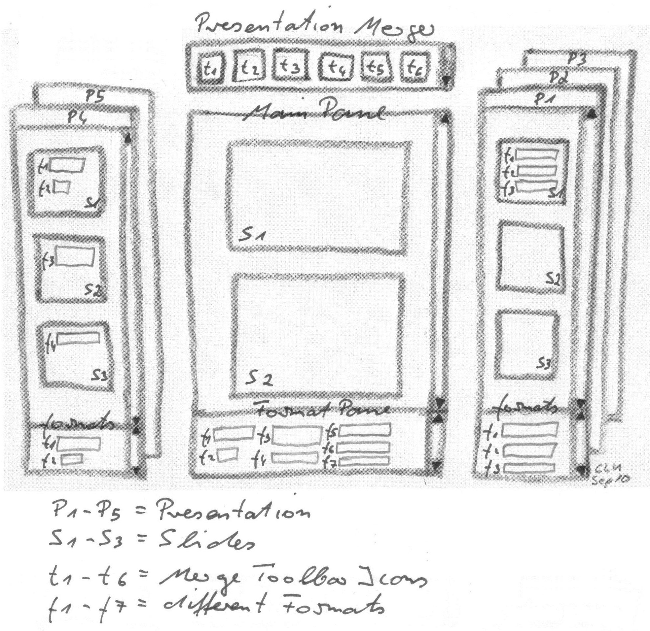
Presentation Merger

1. most people do not create new presentations but rather create presentations from several olds.
2. different presentations use different formats.

-> to join them to one look and feel you must do a lot of merge work manually, which costs a lot of time and nerves.

=> as creating presentations is a rather professional skill, a presentation merger could be a good differentiater between OOo and OOO and maybe a gainful surplus.

the presentation merger idea has two steps:

1. draw slides from different presentations confortable into a new one (pic.1).

2. merge the formats in the new created presentation to one look and feel (pic.2).

userscenario:

1. choose some präsis or templates to join
2. d&d slides from pane into working area
(to create the slide order)
3. choose the new look & feel
4. let the automerger run over the new doc
5. correct single formats with formatbrush
=> ready



