

Draw Guide
Chapter 1
Introduction to Draw
OpenOffice.org’s Vector Drawing Component

Copyright
This document is Copyright © 2005–2008 by its contributors as listed in the section titled Authors. You can distribute it and/or modify it under the terms of either the GNU General Public License, version 3 or later (http://www.gnu.org/licenses/gpl.html) or the Creative Commons Attribution License, version 3.0 (http://creativecommons.org/licenses/by/3.0/) or later.
All trademarks within this guide belong to their legitimate owners.

Authors
Agnes Belzunce
Daniel Carrera
Martin Fox
Peter Hillier-Brook
Gary Schnabl
Jean Hollis Weber
Linda Worthington

Feedback
Please direct any comments or suggestions about this document to:
authors@user-faq.openoffice.org

Acknowledgments
This chapter is based on an original French document written for OpenOffice.org 1.x by Michel Pinquier (translated to English by Alex Thurgood) and previous content revised by Jim Taylor. The chapter was revised for OpenOffice 2.0 by the authors listed above, and later translated into German by Wolfgang Uhlig; the German revisions were then translated into English by Martin Fox.

Publication date and software version
Published 6 April 2008. Based on OpenOffice.org 2.4.
Contents
Copyright i
Authors i
Feedback i
Acknowledgments i
Publication date and software version i
Introducton 1
The Draw workplace 1
Rulers 2
Status bar 3
Toolbars 5
Floating toolbars 5
Standard toolbar 7
Line and Filling toolbar 7
Drawing toolbar 7
Color bar 7
Options toolbar 9
Drawing grid and guides 10
Customizing toolbars 11

Introducton
Draw is a vector graphics drawing tool, although it can also perform some operations on raster graphics (pixels). It offers a series of powerful tools that enable you to quickly create a wide variety of graphical images.
Vector graphics store and display a picture as simple geometric elements (lines, circles, polygons, among others) rather than as a collection of pixels (points on the screen). This permits simpler storage and supports precise scaling of the picture elements.
Draw is fully integrated into the OpenOffice.org (OOo) suite, and this simplifies exchanging graphics with all components of the suite. For example, if you create an image in Draw, reusing it in a Writer document is as simple as doing a copy-and-paste. You can also work with drawings directly from within Writer or Impress, using a subset of the functions and tools from Draw.
Draw’s functionality is extensive, and even though it was not designed to rival high-end graphics applications, it possesses significantly more functionality than the drawing tools that are generally integrated with most office productivity suites.
A few examples of the drawing functions are: layer management, magnetic grid-point system, dimensions and measurement display, connectors for making organization charts, 3D functions that enable small three-dimensional drawings to be created (with texture and lighting effects), drawing and page-style integration, and Bézier curves.
The Draw Guide is not a course book that must be worked through from beginning to end. Rather, it is a reference work in which you can browse for guidance on particular topics.
This document describes only the functions associated with Draw. Some notions, such as file management or the way the OOo environment works, are mentioned only briefly, as they are covered in the Getting Started guide.

The Draw workplace
The main components of the Draw interface are shown in Figure 1.
The large area in the center of the window is where you make the drawings. You can surround the drawing area with toolbars and information areas. The number and position of the visible tools vary as a function of the task at hand or user preferences. Therefore, your setup may appear a little different. For example, many users put the main Drawing toolbar on the left-hand side of the workspace—not at the bottom, as shown here. The setup procedure is described in detail in Chapter 4 (Menus and Toolbars) in the Getting Started guide.
You can split drawings in Draw over several pages. Multipage drawings are used mainly for presentations. The Pages pane, on the left side of the Draw window in Figure 1 gives an overview of the pages that you create. If the Pages pane is not visible on your setup,you can enable it from the View menu (View > Page Pane). To easily make changes to the page order, drag and drop one or more pages.
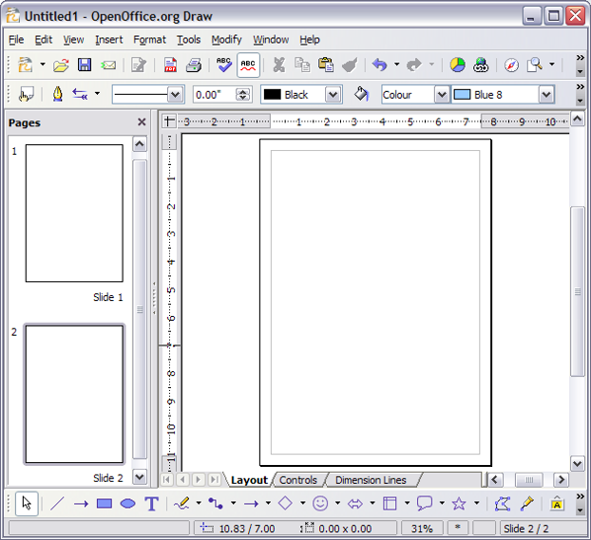Figure 1: Initial Draw window

Rulers
You should see rulers (bars with numbers) on the upper and left-hand sides of the workspace. If they are not visible, you can enable them by selecting them from the View menu (View > Ruler).
The rulers show the size of a selected object on the page (see the gray double lines, highlighted in Figure 2). When no object is selected, they show the location of the mouse pointer, which helps to accurately position drawing objects.
You can also use the rulers to manage object handles and guide lines, making it easier to position objects.
The page margins in the drawing area are also represented on the rulers. You can change the margins directly on the rulers by dragging them with the mouse.
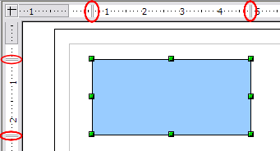Figure 2: Rulers show the size of the selected object
To modify the units of measurement of the rulers (which you can define independently), right-click on the desired ruler, as illustrated for the horizontal ruler in Figure 3.
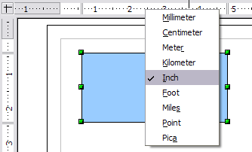Figure 3: Rulers in a drawing

Status bar
The Status bar is located at the bottom of the screen (in all OOo components) and includes several Draw-specific fields, as identified in Figure 4.
The Information field shows which action is being carried out, or which object type is selected.
The Position field shows different information, depending on whether objects are currently selected or not:
- When no object is selected, the left number pair shows the current position (in X,Y Cartesian coordinates) of the mouse cursor.
- While an object is being resized with the mouse, the right number pair shows the size of the object (width and height).
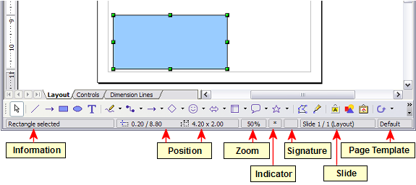Figure 4: Items on the Draw status bar
Note | The sizes are given in the current measurement unit (not to be confused with the ruler units). This unit is defined in Tools > Options > OpenOffice.org Draw > General, where you can also change the scale of the page. Another way to change the scale is to double-click on the number shown in the status bar.
- If an object is selected, the left number pair shows the X,Y coordinates of the upper-left corner, and the right number pair displays the size of the object, as seen in Figure 4. These numbers do not relate to the solid object, but to the rectangle forming the selection outline. This outline is the smallest possible rectangle that can contain the visible part or parts of the object; see also Chapter 3 (Working with Objects and Object Points).
- When an object is selected, a double-click on this field opens the Position and Size dialog, which is described in detail in Chapter 4 (Changing Object Attributes).
The percentage shown in the Zoom field gives information about the current zoom factor. A double-click or right-click on this field opens the Zoom dialog, where you can quickly change the zoom factor.
In the Indicator field, an asterisk (*) is shown whenever any change is made to the document but not yet saved to disk.
If you wish to digitally sign the document, a double-click or right-click in the Signature field brings up the signature box. Note that a document must be saved at least once before it can be signed. After it is signed, an indicator is present in this field.
The Slide field shows the page-sequence number for the current drawing page, in addition to the total number of pages that you created so far. This is useful when your drawing has a number of pages. If you select an object, the field enclosed by parentheses shows the layer in which the object resides within the drawing. In the example of Figure 4, the object is on the Layout layer of Slide 1, and there is a total number of one slide, so far.
The Template field shows which page template is being used for the current page. If you saved several slide designs, you can select one for the current page by double-clicking in this field (see Figure 5) and selecting Load after choosing a slide design.
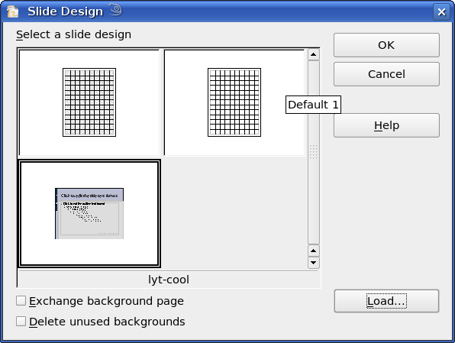Figure 5: Selecting a slide (page) design

Toolbars
You can display or hide the various Draw toolbars, according to your needs. To display or hide a toolbar, click View > Toolbars. On the menu that appears, choose which toolbars you want to display.
You can also select the icons that you wish to appear on the toolbars. Some toolbars have icons that are not displayed by default, but you can choose to display them. You can also hide any icons that do appear on the toolbars, by default. To change the visible icons on any toolbar, click the arrow at the right-hand end of the toolbar and select Visible Buttons. On the list of the available icons that appears, select or deselect the icons you want to be visible. A checkmark next to an icon indicates that it is visible.

Floating toolbars
Many toolbar icons are marked with a small arrow. The arrow indicates that this icon has additional functions. Click the arrow, and a submenu or floating toolbar appears, showing its additional functions (see Figure 6).
You may wish to keep this submenu displayed on your screen, but in a different position. You can make a submenu into a floating toolbar. To do so, click the area at the top of the submenu, drag it across the screen to a location you want, and then release the mouse button. Floating toolbars can be redocked on an edge of the screen or within one of the existing toolbar areas at the top of the screen, as described in Chapter 4 (Changing Object Attributes).
An icon marked with a small arrow can often become a floating toolbar. The floating-toolbar capability is common to all components of OOo.
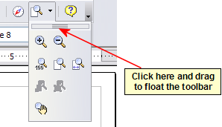
Figure 6: An arrow next to an icon indicates additional functions.
Tip | If you double-click on an icon on a floating toolbar, the command corresponding to that icon will run. You can then repeat this action as often as you like. To exit from this mode, press the Esc key or click on another icon (for example ).
Note | The icon of a floating toolbar always shows the last command you used. This means that the icon you see on your screen may differ from any icon shown in this Guide.
Similarly, click on the arrow on the title bar of a floating toolbar to display additional functions (see Figure 7).
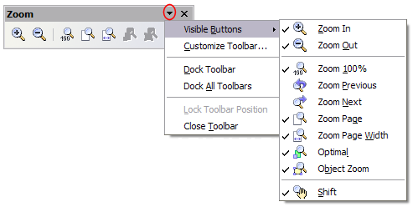Figure 7: An arrow on a floating toolbar indicates that there are additional functions available.
In Draw, as in all OOo components, a toolbar can move to a new position by using the mouse. Hover the mouse over the end of the toolbar (look for two vertical columns of dots) until the cursor becomes two crossed arrows and then drag-and-drop, as desired.
The tools available in the various toolbars are explained in the following sections.

Standard toolbar
The Standard toolbar is the same for all OOo components and is not described in detail here.
Figure 8: Standard toolbar

Line and Filling toolbar
The Line and Filling toolbar (Figure 9) lets you modify the main properties of a drawing object: the icons and pulldown lists vary, according to the type of object selected. For example, to change the thickness of a line with the spinner, hover the mouse over the spinner and click the up or down arrow to achieve the desired thickness.
Figure 9: Line and Filling toolbar
In the example above, the available functions enable you to change the color, style, and width of the line drawn or the fill color, style, and other properties of an object. The object must first be selected with a mouse click. If the selected object is a text frame, the buttons for line style and fill color are changed to Invisible.
When text is selected, the Line and Filling toolbar changes to the Text Formatting toolbar (Figure 10), which is very similar to the Formatting toolbar in Writer. A more detailed explanation of the buttons on this toolbar can be found in Chapter 4 (Changing Object Attributes).
Figure 10: Text Formatting toolbar

Drawing toolbar
The Drawing toolbar (Figure 11) is the most important toolbar in Draw. It contains all the necessary functions for drawing various geometric and freehand shapes and for organizing them on the page. It is described in detail in Chapter 2 (Drawing Basic Shapes).
Figure 11: Drawing toolbar

Color bar
To display the Color bar (Figure 12), use View > Toolbars > Color Bar. The toolbar then appears at the bottom of the workspace and displays the current color palette.
Figure 12: Color bar
This toolbar lets you rapidly choose the color of the various objects (lines, areas, and 3D effects) in your drawing. The first box in the panel corresponds to transparency (no color).
You can access several specialized color palettes in Draw, as well as change individual colors to your own taste. This is done using the Area dialog, reached by choosing Format > Area, as shown in Figure 13, or the pouring can icon on the Line and Filling toolbar (Figure 9).
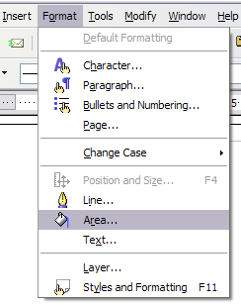
Figure 13: Two ways to display the Area dialog
On the Area dialog, choose the tab marked Colors (Figure 14).
To load another palette, click on the Load Color List button (circled). The file selector dialog asks you to choose one of the standard OOo palettes (files bearing the file extension *.soc). For example, web.soc is a color palette that is particularly adapted to creating drawings that are going to appear in Web pages. The colors will correctly display on workstations with screens displaying at least 256 colors.
A more detailed description of color palettes and their options can be found in Chapter 8 (Tips and Tricks).
.
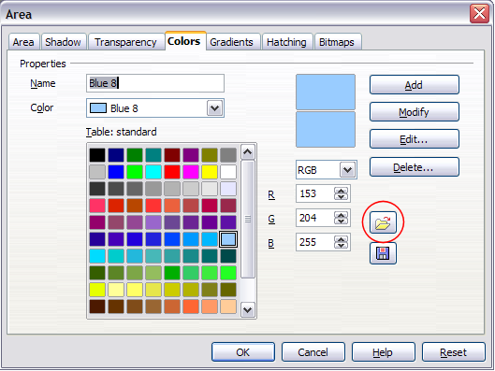Figure 14. Changing the color palette

Options toolbar
The Options toolbar lets you activate or deactivate various drawing aids. The Options Bar is not one of the toolbars displayed by default. To display it, select View > Toolbars > Options.
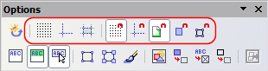Figure 15: Options toolbar
The most important options to learn when starting to work in Draw are enclosed in red above. Their functions are described in the table below. The other buttons are described in greater detail in other chapters of the Draw Guide.
Table 1: Functions on the Options toolbar
Icon | Function
 | Rotation Mode after Clicking Object
 | Display (or hide the) Grid
 | Display (or hide the) Guides
 | Display (or hide Guides) When Moving
 | Snap to Grid
 | Snap to Guides
 | Snap to Page Margins
 | Snap to Object Borders
 | Snap to Object Points
 | Allow Quick Editing
 | Select Text Area Only
 | Double-click to edit Text
 | Simple Handles
 | Large Handles
 | Create Object with Attributes
 | Picture Placeholders
 | Contour Mode
 | Text Placeholders
 | Line Contour Only
 | Exit All Groups

Drawing grid and guides
Draw offers a grid as a drawing aid. The grid can be turned on or off by clicking on the Grid icon on the Options toolbar. The points of the grid displayed on the screen are not shown on the printed drawing. The color, spacing, and resolution of the grid points can be individually chosen for each axis. This is described in more detail in Chapter 8 (in the section titled “Configuring the grid”).
Guides are special “helper lines” that can be turned on or off by clicking on the Guides icon on the Options toolbar. Draw offers a “Snap” function, with which you can place drawings exactly on these guides. All snap functions are described in detail in Chapter 8 (Tips and Tricks).
Showing the position of the object while moving it makes positioning the object much easier. If this function is activated, pairs of vertical and horizontal lines enclosing the object are shown while moving the object. These lines extend to the edges of the drawing area. This function is also described in detail in Chapter 8.

Customizing toolbars
For greater control, you can add other functions to a toolbar and move tools between toolbars. To do this, in the View > Toolbars menu select Customize, select the Toolbars tab (see Figure 16), select the toolbar you want to change, and then select the desired buttons for that toolbar. Each toolbar has a different list of buttons.
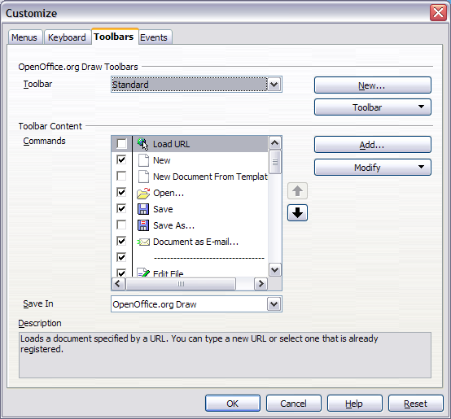Figure 16: Customizing a toolbar

Drawing objects can be snapped—that is, they can be attached to a grid point, a guide, a page margin, or a border or point of another object.

