

Getting Started Guide
Chapter 6
Getting Started with Writer
OpenOffice.org's Word Processor

Copyright
This document is Copyright © 2005–2008 by its contributors as listed in the section titled Authors. You can distribute it and/or modify it under the terms of either the GNU General Public License, version 3 or later (http://www.gnu.org/licenses/gpl.html), or the Creative Commons Attribution License, version 3.0 (http://creativecommons.org/licenses/by/3.0/) or later.
All trademarks within this guide belong to their legitimate owners.

Authors
Agnes Belzunce
Camillus Gerard Cai
Daniel Carrera
Spencer E. Harpe
Peter Hillier-Brook
Peter Kupfer
Janet Swisher
Jean Hollis Weber
Linda Worthington

Feedback
Please direct any comments or suggestions about this document to:
authors@user-faq.openoffice.org

Publication date and software version
Published 20 April 2008. Based on OpenOffice.org 2.4.
Contents
Copyright i
Authors i
Feedback i
Publication date and software version i
What is Writer? 1
The Writer interface 1
Changing document views 2
Creating a new document 2
Creating a document from a template 2
Saving a document 3
Saving as a Microsoft Word document 3
Working with text 4
Selecting items that are not consecutive 4
Selecting a vertical block of text 5
Cutting, copying, and pasting text 6
Moving paragraphs quickly 6
Finding and replacing text and formatting 6
Inserting special characters 7
Setting tab stops and indents 8
Checking spelling 9
Using AutoCorrect 10
Using word completion 10
Using AutoText 11
Inserting dashes and non-breaking spaces 11
Formatting text 12
Using styles 12
Formatting paragraphs 12
Formatting characters 13
Autoformatting 13
Creating numbered or bulleted lists 14
Using the Bullets and Numbering toolbar 14
Hyphenating words 14
Undoing and redoing changes 16
Tracking changes to a document 17
Recording changes 17
Inserting notes 18
Accepting or rejecting changes and comments 19
Formatting pages 20
Which layout method to choose? 20
Creating headers and footers 22
Numbering pages 22
Including the total number of pages 23
Restarting page numbering 23
Changing page page margins 24
Creating a table of contents 25
Creating indexes and bibliographies 25
Printing from Writer 26
Selecting print options for a document 27
Selecting default print options 27
Previewing pages before printing 28

What is Writer?
Writer is the word processor component of OpenOffice.org (OOo). In addition to the usual features of a word processor (spell checking, thesaurus, hyphenation, autocorrect, find and replace, automatic generation of tables of contents and indexes, mail merge and others), Writer provides these important features:
- Templates and styles
- Powerful page layout methods, including frames, columns, and tables
- Embedding or linking of graphics, spreadsheets, and other objects
- Built-in drawing tools
- Master documents
- Change tracking during revisions
- Database integration, including a bibliography database
- Export to PDF, including bookmarks
- And many more
These features are covered in detail in the Writer Guide.

The Writer interface
The main Writer workspace is shown in Figure 1. The menus and toolbars are described in Chapter 4 (Menus and Toolbars).
Other features of the Writer interface are covered in this chapter.
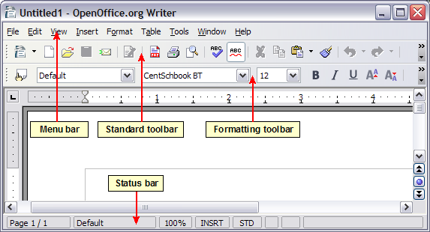Figure 1: The main Writer workspace in Print Layout view

Changing document views
Writer has several ways to view a document: Print Layout, Web Layout, Full Screen, and Zoom. To access these choices, go to the View menu. The only document view option with a submenu is Zoom.

Creating a new document
You can create a new, blank document in Writer in several ways:
- Press the Control+N keys. A new empty document opens. If you already have a document open, the new document appears in a new window.
- Use File > New > Text Document. The result is the same as pressing the Control+N keys.
- Click the New button on the main toolbar .

Creating a document from a template
You can use templates to create new documents in Writer. Templates serve as the foundation of a series of documents, making sure they all have a similar layout. For example, all the documents of this User Guide are based on the same template. By doing this, all the documents look alike; they have the same headers and footers, use the same fonts, and so on.
A new OpenOffice.org installation does not contain many templates, but you can add new templates to your installation and use them for new documents. This is explained in Chapter 12 (Working with Templates). Many more templates can be downloaded from http://extensions.services.openoffice.org/ and other websites.
Once you have templates on your system, you can create new documents based on them by using File > New > Templates and Documents. This opens a window where you can choose the template you want to use for your document.
The example shown in Figure 2 uses a template called “Book” in the My Templates folder. Select it, then click Open. A new document is created based on the formats defined in the template.
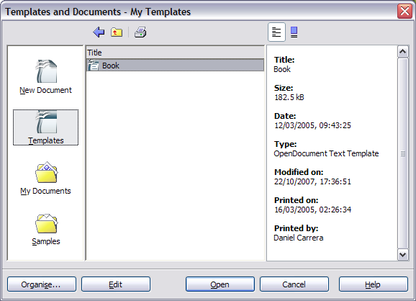Figure 2. Creating a document from a template

Saving a document
Save Writer documents the same way you save other documents. For more information, see Chapter 3 (File Management in OpenOffice.org).

Saving as a Microsoft Word document
You may need to share your documents with other people who do not use OOo, but use Microsoft Word instead. Fortunately, OOo can read and write Word files (but not Word 2007; that capability is coming in OOo 3.0). To save a document as a Microsoft Word file:
- First save your document in OOo’s format (.odt). If you do not, any changes you made since the last time you saved will only appear in the Microsoft Word version of the document.
- Then click File > Save As. The Save As window (Figure 3) appears.
- In the Save as type drop-down menu, select the type of Word format you need.
- Click Save.
From this point on, all changes you make to the document will occur only in the Microsoft Word document. You have actually changed the name of your document. If you want to go back to working with the OOo version of your document, you must open it again.
Tip | To have OOo save documents by default in the Microsoft Word file format, go to Tools > Options > Load/Save. In the section named Default file format, under Document Type, select Text Document, then under Always save as, select the preferred file format. See also “Choosing options for loading and saving documents” in Chapter 5 (Setting up OpenOffice.org).
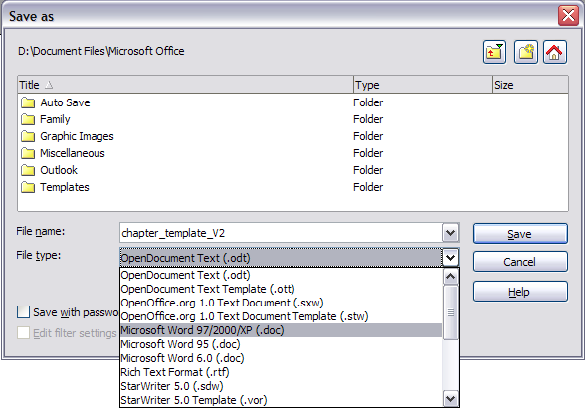Figure 3. Saving a file in Microsoft Word format

Working with text
Working with text (selecting, copying, pasting, moving) in Writer is similar to working with text in any other program. OOo also has some convenient ways to select items that are not next to each other, select a vertical block of text, move paragraphs quickly, and paste unformatted text.

Selecting items that are not consecutive
To select nonconsecutive items (as shown in Figure 4) using the mouse:
- Select the first piece of text.
- Hold down the Control key and use the mouse to select the next piece of text.
- Repeat as often as needed.
- Now you can work with the selected text (copy it, delete it, change the style, or whatever).
Note | Macintosh users: substitute the Command key when instructions in this chapter say to use the Control key.
To select nonconsecutive items using the keyboard:
- Select the first piece of text. (For more information about keyboard selection of text, see the topic “Navigating and selecting with the keyboard” in the Help.)
- Press Shift+F8. This puts Writer in “ADD” mode. The word ADD appears on the status bar.
- Use the arrow keys to move to the start of the next piece of text to be selected. Hold down the Shift key and select the next piece of text.
- Repeat as often as needed.
- Now you can work with the selected text.
- Press Esc to exit from this mode.
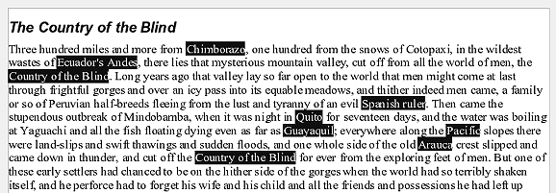Figure 4: Selecting items that are not next to each other

Selecting a vertical block of text
(New in OOo 2.4) You can now select a vertical block or “column” of text that is separated by spaces or tabs (as you might see in text pasted from e-mails, program listings, or other sources), using OOo’s block selection mode. To chang to block selection mode, use Edit > Selection Mode > Block Area, or click several times in the status bar on STD until it changes to BLK.
Now highlight the selection, using mouse or keyboard, as shown in Figure 5.
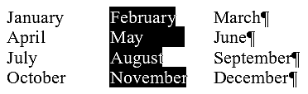Figure 5: Selecting a vertical block of text

Cutting, copying, and pasting text
Cutting and copying text in Writer is similar to cutting and copying text in other applications. You can use the mouse or the keyboard for these operations.
Cut: Use Edit > Cut or the keyboard shortcut Control+X or the Cut icon on the toolbar.
Copy: Use Edit > Copy or the keyboard shortcut Control+C or the Copy icon.
Paste: Use Edit > Paste or the keyboard shortcut Control+V or the Paste icon.
If you simply click on the Paste icon, any formatting the text has (such as bold or italics) is retained. To make the pasted text take on the formatting of the surrounding text where it is being pasted, click the triangle to the right of the Paste icon and select Unformatted text from the menu (Figure 6).
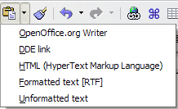Figure 6: Paste menu

Moving paragraphs quickly
- Put the cursor anywhere in the paragraph.
- Press and hold the Control key and then press the up-arrow or down-arrow key.
The paragraph will move to before the previous paragraph or after the next paragraph in your document. To move more than one paragraph at a time, select at least part of both paragraphs before pressing the Control+arrow keys.
If you are using the Solaris operating system, the key combination is Control+AltGr+arrow keys.
Tip | If your paragraphs suddenly jump from one place to another, the most likely reason is that you have accidentally pressed one of these key combinations.

Finding and replacing text and formatting
Writer has a Find and Replace feature that automates the process of searching for text inside a document. In addition to finding and replacing words and phrases, you can:
- Use regular expressions (wildcards) to fine-tune a search (see the Help for details).
- Find and replace specific formatting (see the Writer Guide for more information).
- Find and replace paragraph styles (see the Writer Guide for more information).
To display the Find & Replace dialog (Figure 7), use the keyboard shortcut Control+F or select Edit > Find & Replace.
- Type the text you want to find in the Search for box.
- To replace the text with different text, type the new text in the Replace with box.
- You can select various options such as matching the case, matching whole words only, or doing a search for similar words. (See below for some other choices.)
- When you have set up your search, click Find. To replace text, click Replace instead.
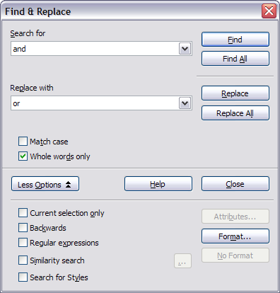Figure 7: Expanded Find & Replace dialog
Tip | If you click Find All, OOo selects all instances of the search text in the document. Similarly, if you click Replace All button, OOo will replace all matches.
Caution   | Use Replace All with caution; otherwise, you may end up with some hilarious (and highly embarrassing) mistakes. A mistake with Replace All might require a manual, word-by-word, search to fix.

Inserting special characters
A special character is one not found on a standard English keyboard. For example, © ¾ æ ç ñ ö ø ¢ are all special characters. To insert a special character:
- Place the cursor where you want the character to appear.
- Click Insert > Special Character to open the Special Characters window (Figure 8).
- Select the characters you wish to insert, in order, then click OK. The selected characters are shown in the lower left of the dialog. As you select a character, it is shown on the lower right, along with its numerical code.
Note | Different fonts include different special characters. If you do not find a particular special character, try changing the Font selection.
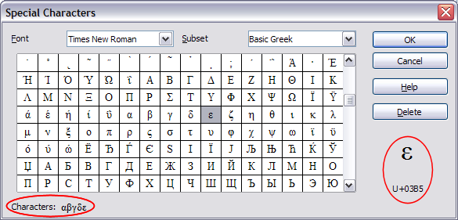Figure 8: The Special Characters window, where you can insert special characters.
Tip | Notice that the characters selected appear in the bottom-left corner of the window.

Setting tab stops and indents
The horizontal ruler shows both the default tab stops and any that you have defined. To set the measurement unit and the spacing of default tab stops, go to Tools > Options > OpenOffice.org Writer > General.
You can also set or change the measurement unit by right-clicking on the ruler to open a list of units, as shown in Figure 9. Click on one of them to change the ruler to that unit.
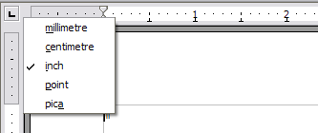Figure 9: Ruler showing default tab stops
Double-click on a blank part of the ruler to open the Indents & Spacing page of the Paragraph dialog. Double-click on the ruler itself to open the Tabs page of the Paragraph dialog (Figure 10) and fine-tune tab stop settings.
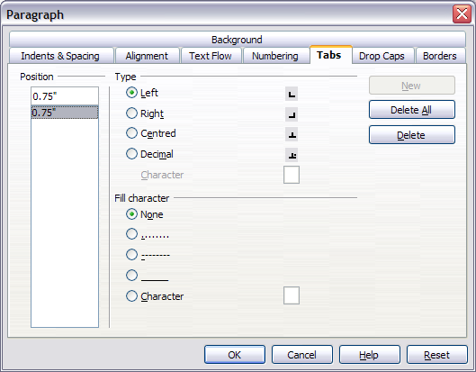Figure 10: The Tabs page of the Paragraph dialog, where you can adjust tab settings

Checking spelling
Writer provides a spelling checker, which can be used in two ways.
AutoSpellcheck checks each word as it is typed and displays a wavy red line under any misspelled words. When the word is corrected, the line disappears.
To perform a separate spelling check on the document (or a text selection) click the Spellcheck button. This checks the document or selection and opens the Spellcheck dialog if any misspelled words are found.
Here are some more features of the spelling checker:
- You can change the dictionary language (for example, to Spanish, French or German) on the Spellcheck dialog.
- You can add a word to the dictionary. Click Add in the Spellcheck dialog and pick the dictionary to add it to.
- The Options dialog of the Spellcheck tool has a number of different options such as whether to check uppercase words and words with numbers. It also allows you to manage custom dictionaries, that is, add or delete dictionaries, and add or delete words in a dictionary.
- On the Font tab of the Paragraph Styles dialog, you can set paragraphs to be checked in a specific language (different from the rest of the document). See Chapter 7 (Working with Styles) in the Writer Guide for more information.

Using AutoCorrect
Writer’s AutoCorrect function has a long list of common misspellings and typing errors, which it corrects automatically. For example, “hte” will be changed to “the”. Select Tools > AutoCorrect to open the AutoCorrect dialog. There you can define which strings of text are corrected and how. In most cases, the defaults are fine.
Tip | AutoCorrect is turned on by default. To turn it off, uncheck Format > AutoFormat > While Typing.
- To stop Writer from replacing a specific spelling, use Tools > AutoCorrect > Replace, highlight the word pair and click Delete.
- To add a new spelling to correct, type it into the Replace and With boxes and click New.
- See the different tabs of the dialog for the wide variety of other options available to fine-tune AutoCorrect.
Tip | AutoCorrect can be used as a quick way to insert special characters. For example, (c) will be autocorrected to ©. You can add your own special characters.

Using word completion
If Word Completion is enabled, Writer tries to guess which word you are typing and offers to complete the word for you. To accept the suggestion, press Enter. Otherwise continue typing.
Tip | Many people prefer not to use Word Completion. If you do not want to use it, select Tools > AutoCorrect > Word Completion and uncheck Enable Word Completion.
You can customize word completion from the Tools > AutoCorrect > Word Completion page:
- Add (append) a space automatically after an accepted word.
- Show the suggested word as a tip (hovering over the word) rather than completing the text as you type.
- Change the maximum number of words remembered for word completion and the length of the smallest words to be remembered.
- Delete specific entries from the word completion list.
- Change the key that accepts a suggested entry—the options are Right arrow, End key, Return (Enter), and Space bar.
Note | Automatic word completion only occurs after you type a word for the second time in a document.

Using AutoText
AutoText allows you to assign text, tables, graphics and other items to a key combination. For example, rather than typing “Senior Management” every time you use that phrase, you might just type “sm” and press F3. Or you can save a formatted Note (like the one on this page) as AutoText and then insert a copy by typing “note” and pressing F3.
To assign some text to an AutoText shortcut:
- Type the text into your document.
- Select the text so it is highlighted.
- Select Edit > AutoText (or press Control+F3).
- Enter a name for your shortcut. Writer will suggest a one-letter shortcut, which you can change.
- Click the AutoText button on the right and select New (text only) from the menu.
- Click Close to return to your document.
Tip | If the only option under the AutoText button is Import, either you have not entered a name for your AutoText or there is no text selected in the document.
AutoText is especially powerful when assigned to fields. See Chapter 14 (Working with Fields) in the Writer Guide for more information.

Inserting dashes and non-breaking spaces
You can insert a dash by using the Special Characters window or by using AutoCorrect. For more about AutoCorrect, see “Controlling OOO’s AutoCorrect functions” in Chapter 5 (Setting up OpenOffice.org) and “Using AutoCorrect” on page 10 in this chapter.
– is an en-dash; that is, a dash the width of the letter “n” in the font you are using. It is U+2013 (scroll down to the General Punctuation section in the Special Characters window). To enter an en-dash using AutoCorrect, type at least one character, a space, two hyphens, another space, and at least one more letter, then a space. The two hyphens will be replaced by an en-dash.
— is an em-dash; that is, a dash the width of the letter “m” in the font you are using. It is U+2014. To enter it using AutoCorrect, type at least one character, two hyphens, and at least one more character, then a space. The two hyphens will be replaced by an em-dash.
To insert a non-breaking space (to keep characters together, for example in a telephone number), press Control+Space on the keyboard.

Formatting text

Using styles
Styles are central to using Writer. Styles enable you to easily format your document consistently, and to change the format with minimal effort. Often, when you format your document in Writer, you are using styles whether you realize it or not. A style is a named set of formatting options. Writer defines several types of styles, for different types of elements: characters, paragraphs, pages, frames, and lists. The use of styles is described in detail in Chapter 6 (Introduction to Styles) and Chapter 7 (Working with Styles) in the Writer Guide.

Formatting paragraphs
You can apply many formats to paragraphs using the buttons on the Formatting toolbar. Figure 11 shows the Formatting toolbar as a floating toolbar, customized to show only the buttons for paragraph formatting.
Tip | It is highly recommended that you use paragraph styles rather than manually formatting paragraphs, especially for long or standardized documents. For information on the advantages of styles, and how to use them, see Chapter 13 (Working with Styles) in this book and Chapters 6 and 7 in the Writer Guide.
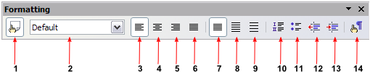

1 | Open Styles and Formatting Window | 5 | Align Right | 10 | Numbering On/Off
 | Open Styles and Formatting Window | 6 | Justified | 11 | Bullets On/Off
2 | Apply Style | 7 | Line Spacing: 1 | 12 | Decrease Indent
3 | Align Left | 8 | Line Spacing: 1.5 | 13 | Increase Indent
4 | Centred | 9 | Line Spacing: 2 | 14 | Paragraph format dialog
Figure 11: The Formatting toolbar, showing buttons for paragraph formatting
Figure 12 shows examples of the different alignment options.
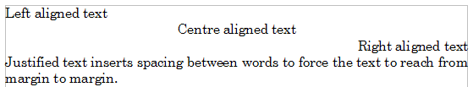Figure 12: Different text alignment options

Formatting characters
You can apply many formats to characters using the buttons on the Formatting toolbar. Figure 13 shows the Formatting toolbar as a floating toolbar, customized to show only the buttons for character formatting.
Tip | It is highly recommended that you use character styles rather than manually formatting characters. For information on the advantages of styles, and how to use them, see Chapter 6 (Introduction to Styles) in the Writer Guide.
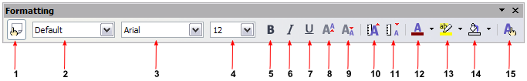
1 | Open Styles and Formatting Window | 6 | Italic | 12 | Font Colour
 | Open Styles and Formatting Window | 7 | Underline | 13 | Highlighting
2 | Apply Style | 8 | Superscript | 14 | Background Colour
3 | Font Name | 9 | Subscript | 15 | Open Character Format Dialog
4 | Font Size | 10 | Increase Font |  | Open Character Format Dialog
5 | Bold | 11 | Reduce Font
Figure 13: The Formatting toolbar, showing buttons for character formatting
Tip | To remove manual formatting, select the text and click Format > Default Formatting, or right-click and select Default Formatting.

Autoformatting
You can set Writer to automatically format parts of a document according to the choices made on the Options page of the AutoCorrect dialog (Tools > AutoCorrect > Options).
Tip | If you notice unexpected formatting changes occurring in your document, this is the first place to look for the cause.
Some common unwanted or unexpected formatting changes include:
- Horizontal lines. If you type three or more hyphens (---), underscores (___) or equal signs (===) on a line and then press Enter, the paragraph is replaced by a horizontal line as wide as the page. The line is actually the lower border of the preceding paragraph.
- Bulleted and numbered lists. A bulleted list is created when you type a hyphen (-), star (*), or plus sign (+), followed by a space or tab at the beginning of a paragraph. A numbered list is created when you type a number followed by a period (.), followed by a space or tab at the beginning of a paragraph. Automatic numbering is only applied to paragraphs formatted with the Default, Text body or Text body indent paragraph styles.
To turn autoformatting on or off, go to Format > AutoFormat and select or delete the items on the sub menu.

Creating numbered or bulleted lists
There are several ways to create numbered or bulleted lists:
- Use autoformatting, as described above.
- Use list (numbering) styles, as described in Chapter 7 (Working with Styles) in the Writer Guide.
- Use the Numbering and Bullets icons on the paragraph formatting toolbar (see Figure 11). This method is described here.
To produce a numbered or bulleted list, select the paragraphs in the list, and then click the appropriate icon on the toolbar.
Note | It is a matter of personal preference whether you type your information first, then apply Numbering/Bullets, or apply them as you type.

Using the Bullets and Numbering toolbar
You can create nested lists (where one or more list items has a sublist under it, as in an outline) by using the buttons on the Bullets and Numbering toolbar (Figure 14). You can move items up or down the list, or create subpoints, and even change the style of bullets. Use View > Toolbars > Bullets and Numbering to see the toolbar.
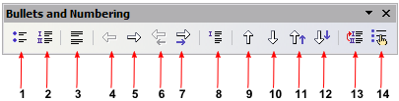

1 | Bullets On/Off | 6 | Move Up (One Level) with Sub-points | 10 | Move Down
2 | Numbering On/Off | 6 | Move Up (One Level) with Sub-points | 11 | Move Up in Sub-points
3 | Numbering Off | 7 | Move Down (One Level) with Sub-points | 12 | Move Down in Sub-points
4 | Up One Level | 8 | Insert Unnumbered Entry | 13 | Restart Numbering
5 | Up One Level | 9 | Move Up | 14 | Bullets and Numbering
Figure 14: Bullets and Numbering toolbar

Hyphenating words
To turn automatic hyphenation of words on or off:
- Press F11 to open the Styles and Formatting window (Figure 15).
- On the Paragraph Styles page of the Styles and Formatting window, right-click on Default in the list and select Modify.
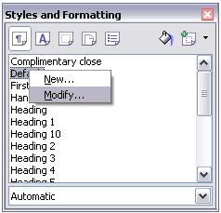
Figure 15: Modifying a style
- On the Paragraph Style dialog, go to the Text Flow page (see Figure 16).
- Under Hyphenation, select or deselect the Automatically checkbox. Click OK to save.
Note | Turning on hyphenation for the Default paragraph style affects all other paragraph styles that are based on Default. You can individually change other styles so that hyphenation is not active; for example, you might not want headings to be hyphenated. Any styles that are not based on Default are not affected. For more on paragraph styles, see Chapter 6 (Introduction to Styles) and Chapter 7 (Working with Styles) in the Writer Guide.
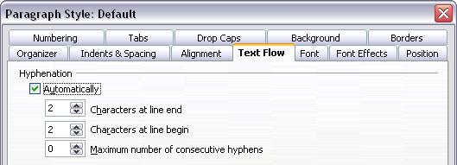
Figure 16: Turning on automatic hyphenation
You can also set hyphenation choices through Tools > Options > Language Settings > Writing Aids. In Options, near the bottom of the dialog, scroll down to the find the hyphenation settings (see Figure 17).
Figure 17: Setting hyphenation options
Notes | Hyphenation options set on the Writing Aids dialog are effective only if hyphenation is turned on through paragraph styles.  Choices on the Writing Aids dialog for “characters before line break” and “characters after line break” override settings in paragraphs styles for “characters at line end” and “characters at line begin”. This is a bug.
To enter a conditional hyphen inside a word, press Control+minus sign. The word is hyphenated at this position when it is at the end of the line, even if automatic hyphenation for this paragraph is switched off.
To insert non-breaking hyphen, press Control+Shift+minus sign.

Undoing and redoing changes
To undo the most recent change, press Control+Z, or click the Undo icon on the Standard toolbar, or select Edit > Undo from the menu bar.
The Edit menu shows the latest change that can be undone, as shown in Figure 18.
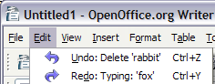Figure 18: Edit > Undo last action
Click the small triangle to the right of the Undo icon to get a list of all the changes that can be undone (Figure 19). You can select multiple changes and undo them at the same time.
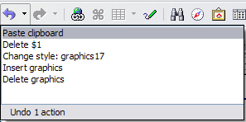Figure 19: List of actions that can be undone
After changes have been undone, Redo becomes active. To redo a change, select Edit > Redo, or press Control+Y or click on the Redo icon . As with Undo, click on the triangle to the right of the arrow to get a list of the changes that can be reapplied.
To modify the number of changes OpenOffice.org remembers, select Tools > Options > OpenOffice.org > Memory and change Undo number of steps. Be aware that asking OOo to remember more changes consumes more computer memory.

Tracking changes to a document
You can use several methods to keep track of changes made to a document.
- Make your changes to a copy of the document (stored in a different folder, or under a different name, or both), then use Writer to combine the two files and show the differences. Click Edit > Compare Document. This technique is particularly useful if you are the only person working on the document, as it avoids the increase in file size and complexity caused by the other methods.
- Save versions that are stored as part of the original file. However, this method can cause problems with documents of non-trivial size or complexity, especially if you save a lot of versions. Avoid this method if you can.
- Use Writer’s change marks (often called “redlines” or “revision marks”) to show where you have added or deleted material, or changed formatting. Later, you or another person can review and accept or reject each change.
Tip | Not all changes are recorded. For example, changing a tab stop from align left to align right, and changes in formulas (equations) or linked graphics are not recorded.

Recording changes
See Chapter 2 (Setting up Writer) in the Writer Guide for instructions on setting up how changes will be displayed.
- To begin tracking (recording) changes, click Edit > Changes > Record.
To show or hide the display of changes, click Edit > Changes > Show.
Tip | Hover the mouse pointer over a marked change; you will see a Help Tip showing the type of change, the author, date, and time of day for the change. If Extended Tips are enabled, you will also see any comments recorded for this change.
- To entera comment on a marked change , place the cursor in the area of the change and then click Edit > Changes > Comment. (See Figure 20.) In addition to being displayed as an extended tip, the comment is also displayed in the list in the Accept or Reject Changes dialog.
You can move from one marked change to the next by using the arrow buttons.
If no comment has been recorded for a change, the Text field is blank.
- To stop recording changes, click Edit > Changes > Record again.
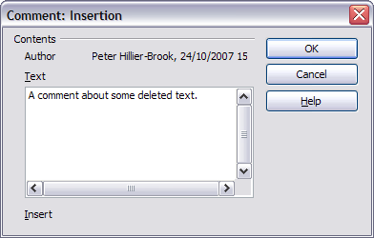Figure 20: Inserting a comment during change recording

Inserting notes
To insert a note that is not associated with a recorded change:
- Place the cursor at the text you want to comment on, then click Insert > Note.
- On the Insert Note dialog (Figure 21), type your note. Click Author to insert your initials and the date and time.
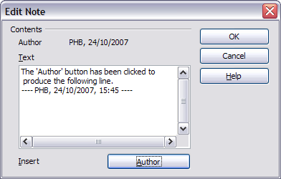Figure 21: Inserting a note
To view a note, move the mouse pointer over the note marker (displayed as a small yellow rectangle). Writer displays the note in a Tip above the text. You can also double-click on the note to see it inside the Edit Note dialog. If you have trouble viewing or selecting notes this way, you can use the Navigator instead: expand the list of notes, select the one you want, right-click on it, and select Edit to display the Edit Note dialog.
The Edit Note dialog looks much like the Insert Note dialog, with the addition of forward and back arrow buttons if the document contains more than one note.
Tip | You can change the color of the note marker using the Tools > Options > OpenOffice.org > Appearance dialog.

Accepting or rejecting changes and comments
- Click Edit > Changes > Accept or Reject. The Accept or Reject Changes dialog (Figure 22) opens.
- When you select a change in the dialog, the actual text is highlighted in the document, so you can see what the editor changed.
- Click Accept or Reject to accept or reject the selected change. You can also click Accept All or Reject All if you do not want to review the changes individually.
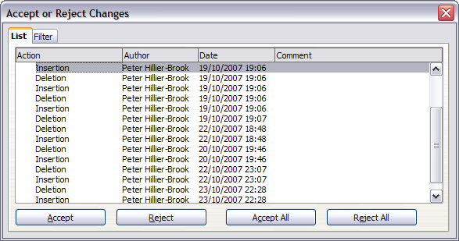Figure 22: The List tab of the Accept or Reject Changes dialog
Changes that have not yet been accepted or rejected are displayed in the list. Accepted changes are removed from the list and appear in the text without any marking.
To show only the changes of certain people, or only the changes made on specific days, or various other restrictions, use the Filter tab on the Accept or Reject Changes dialog. After specifying the filter criteria, return to the List tab to see those changes that meet your criteria.

Formatting pages
Writer provides several ways for you to control page layouts:
- Page styles
- Columns
- Frames
- Tables
- Sections
For more information, see Chapter 4 (Formatting Pages) in the Writer Guide.
Tip | Page layout is usually easier if you show text, object, table, and section boundaries in Tools > Options > OpenOffice.org > Appearance, and paragraph ends, tabs, breaks, and other items in Tools > Options > OpenOffice.org Writer > Formatting Aids.

Which layout method to choose?
The best layout method varies depending on what the final document should look like and what sort of information will be in the document. Here are some examples.
For a book similar to this user guide, with one column of text, some figures without text beside them, and some other figures with descriptive text, use page styles for basic layout, and tables to place figures beside descriptive text when necessary. | 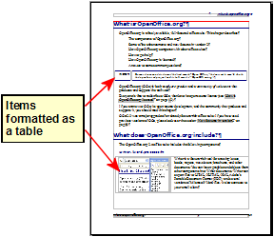
For an index or other document with two columns of text, where the text continues from the left-hand column to the right-hand column and then to the next page, all in sequence (also known as “snaking columns” of text), use page styles (with two columns). If the title of the document (on the first page) is full-page width, put it in a single-column section. | 
For a newsletter with complex layout, two or three columns on the page, and some articles that continue from one page to some place several pages later, use page styles for basic layout. Place articles in linked frames and anchor graphics to fixed positions on the page if necessary. | 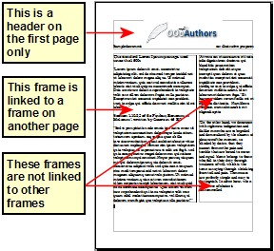
For a document with terms and translations to appear side-by-side in what appear to be columns, use a table to keep items lined up, and so you can type in both “columns”. | 

Creating headers and footers
A header is an area that appears at the top of a page. A footer appears at the bottom of the page. Information, such as page numbers inserted into a header or footer, displays on every page of the document with that page style.
To insert a header, click Insert > Header > Default (or the page style, if not Default) as shown in Figure 23.
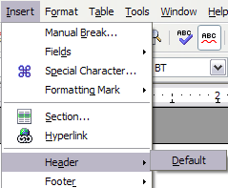
Figure 23: Inserting headers and footers
Other information such as document titles and chapter titles is often put into the header or footer. These items are best added as fields. That way, if something changes, the headers and footers are updated automatically. Here is one common example.
To insert the document title into the header:
- Click File > Properties > Description and enter a title for your document.
- Add a header (Insert > Header > Default).
- Place the cursor in the header part of the page.
- Select Insert > Fields > Title. The title should appear on a gray background (which does not show when printed and can be turned off).
- To change the title for the whole document, go back to File > Properties > Description.
Fields are covered in detail in Chapter 14 (Working with Fields) in the Writer Guide.
For more about headers and footers, see Chapter 4 (Formatting Pages) and Chapter 6 (Introduction to Styles) in the Writer Guide.

Numbering pages
To automatically number pages:
- Insert a header or footer, as described in “Creating headers and footers” on page 22.
- Place the cursor in the header or footer where you want the page number to appear and click Insert > Fields > Page Number.

Including the total number of pages
To include the total number of pages (as in “page 1 of 12”):
- Type the word “page” and a space, then insert the page number as above
- Press the spacebar once, type the word “of” and a space, then click Insert > Fields > Page Count.
Note | The Page Count field inserts the total number of pages in the document, as shown on the Statistics tab of the document’s Properties window (File > Properties). If you restart page numbering anywhere in the document, then the total page count may not be what you want. See Chapter 4 (Formatting Pages) in the Writer Guide for more information.

Restarting page numbering
Often you will want to restart the page numbering at 1, for example on the page following a title page or a table of contents. In addition, many documents have the “front matter” (such as the table of contents) numbered with Roman numerals and the main body of the document numbered in Arabic numerals, starting with 1.
You can restart page numbering in two ways.
Method 1:
- Place the cursor in the first paragraph of the new page.
- Click Format > Paragraph.
- On the Text Flow tab of the Paragraph dialog (Figure 16 on page 15), select Breaks.
- Select Insert and then With Page Style and specify the page style to use.
- Specify the page number to start from, and then click OK.
Tip | Method 1 is also useful for numbering the first page of a document with a page number greater than 1. For example, you may be writing a book, with each chapter in a separate file. Chapter 1 may start with page 1, but Chapter 2 could begin with page 25 and Chapter 3 with page 51.
Method 2:
- Insert > Manual break.
- By default, Page break is selected on the Insert Break dialog (Figure 24).
- Choose the required page Style.
- Select Change page number.
- Specify the page number to start from, and then click OK.
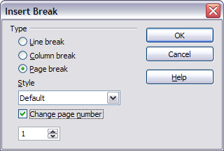
Figure 24: Restarting page numbering after a manual page break

Changing page page margins
You can change page margins in two ways:
- Using the page rulers—quick and easy, but does not have fine control.
- Using the Page Style dialog—can specify margins to two decimal places.
Note | If you change the margins using the rulers, the new margins affect the page style and will be shown in the Page Style dialog the next time you open it.
To change margins using the rulers:
- The gray sections of the rulers are the margins (see Figure 25). Put the mouse cursor over the line between the gray and white sections. The pointer turns into a double-headed arrow.
- Hold down the left mouse button and drag the mouse to move the margin.
Figure 25: Moving the margins
Tip | The small arrows on the ruler are used for indenting paragraphs. They are often in the same place as the page margins, so you need to be careful to move the margin marker, not the arrows. Place the mouse pointer between the arrows and, when the pointer turns into a double-headed arrow, you can move the margin (the indent arrows will move with it).
To change margins using the Page Style dialog:
- Right-click anywhere on the page and select Page from the pop-up menu.
- On the Page tab of the dialog, type the required distances in the Margins boxes.

Creating a table of contents
Writer’s table of contents feature lets you build an automated table of contents from the headings in your document. Before you start, make sure that the headings are styled consistently. For example, you can use the Heading 1 style for chapter titles and the Heading 2 and Heading 3 styles for chapter subheadings.
Although tables of contents can be customized extensively in Writer, often the default settings are all you need. Creating a quick table of contents is simple:
- When you create your document, use the following paragraph styles for different heading levels (such as chapter and section headings): Heading 1, Heading 2, and Heading 3. These are what will appear in your table of contents. You can use more levels of headings, but the default setting is to use only the first three levels in the table of contents.
- Place the cursor where you want the table of contents to be inserted.
- Select Insert > Indexes and Tables > Indexes and Tables.
- Change nothing in the Insert Index/Table dialog. Click OK.
If you add or delete text (so that headings move to different pages) or you add, delete, or change headings, you need to update the table of contents. To do this:
- Place the cursor within the table of contents.
- Right-click and select Update Index/Table from the pop-up menu.
Note | If you cannot place your cursor in the table of contents, choose Tools > Options > OpenOffice.org Writer > Formatting Aids, and then select Enable in the Cursor in protected areas section.
You can customize an existing table of contents at any time. Right-click anywhere in it and select Edit Index/Table from the pop-up menu. Chapter 12 (Creating Tables of Contents, Indexes and Bibliographies) of the Writer Guide describes in detail all the customizations you can choose.

Creating indexes and bibliographies
Indexes and bibliographies work in a similar way to tables of contents. Chapter 12 (Creating Tables of Contents, Indexes and Bibliographies) of the Writer Guide describes the process in detail. In addition to alphabetical indexes, other types of indexes supplied with Writer include those for illustrations, tables, and objects, and you can even create a user-defined index. For example, you might want an index containing only the scientific names of species mentioned in the text, and a separate index containing only the common names of species. Before creating some types of indexes, you first need to create index entries embedded in your Writer document.

Printing from Writer
This section describe some general features of printing from Writer. For details on printing brochures, envelopes, and mailing labels, see Chapter 5 (Printing, Faxing, Exporting, and E-mailing) in the Writer Guide.
For quick printing, click the Print File Directly icon to send the entire document to the default printer defined for your computer.
Note | (New in OOo 2.3) You can change the action of the Print File Directly icon to send the document to the printer defined for the document instead of the default printer for the computer. Go to Tools > Options > Load/Save > General and select the Load printer settings with the document checkbox.
For more control over printing, use File > Print to display the Print dialog (Figure 26). On the Print dialog, you can choose:
- Which printer to use (if more than one are installed on your system) and the properties of the printer—for example, orientation (portrait or landscape), which paper tray to use, and what paper size to print on. The properties available depend on the selected printer; consult the printer’s documentation for details.
- What pages to print, how many copies to print, and in what order to print them.
  - Use dashes to specify page ranges and commas or semicolons to separate ranges; for example: 1, 5, 11–14, 34–40.
  - Selection is the highlighted part of a page or pages.
- What items to print. Click the Options button to display the Printer Options dialog (Figure 27).
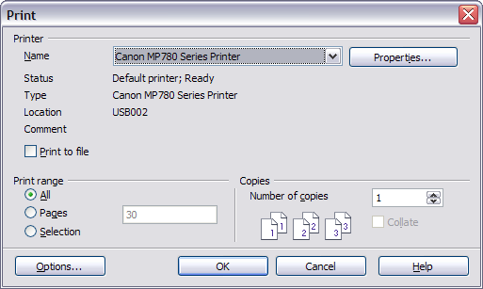Figure 26. The Print dialog

Selecting print options for a document
Selections on the Printer Options dialog apply to this printing of this document only. To specify default printing options for Writer, see Chapter 5 (Setting up OpenOffice.org).
Some items of interest on the Printer Options dialog (Figure 27) include:
- In the Contents section, you might choose not to print graphics or page background in drafts, for example (to save toner or ink).
- In the Pages section, you can choose:
  - Print only left (even-numbered) pages or only right (odd-numbered) pages. These settings are useful when you want to print on both sides of the page, but do not have a printer that handles this automatically.
  - Print in reversed page order.
  - Brochure—see Chapter 5 (Printing, Faxing, Exporting, and E-mailing) of the Writer Guide for details.
- In the Notes section, you can choose whether to print any notes that have been added to your document (using Insert > Note), and where to print the notes.

Selecting default print options
Selections on the Printer Options dialog over-ride any default settings. To specify default settings for printing, use Tools > Options > OpenOffice.org Writer > Print. The page displayed contains the same choices as the Printer Options dialog. See Chapter 5 in the Writer Guide for more about this dialog.
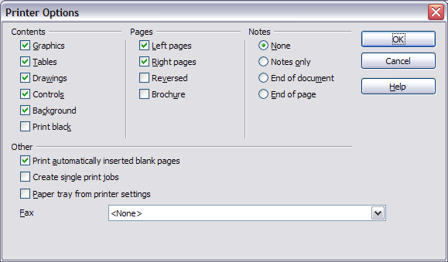Figure 27. Printer Options dialog
Other printer settings are found in Tools > Options > OpenOffice.org > Print. See Chapter 5 (Setting up OpenOffice.org) for more about this dialog. Use this page to specify quality settings for printing, and whether to have OOo warn you if the paper size ororientation of your document does not match the printer settings.

Previewing pages before printing
The normal page view in Writer shows what each page will look like when printed. If you are designing a document to be printed double-sided, you may want to see what facing pages look like. OOo provides a way to do this in Page Preview.
- Click File > Page Preview, or click the Page Preview button .
The Writer window changes to display the current page and the following page, and shows the Page Preview toolbar (Figure 28) in place of the Formatting toolbar.
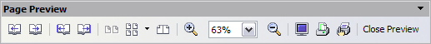Figure 28. Page Preview toolbar
- Click the Book Preview icon to display left and right pages in their correct orientation.
- To print the document in this page view, click the Print page view icon to open the Print dialog (Figure 26). Choose your options and click OK to print as usual.
- To choose margins and other options for the printout, click the Print options page view icon to display the Print Options dialog (Figure 29).
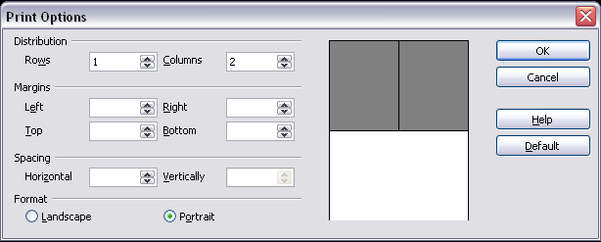Figure 29. Print Options dialog

