Apache OpenOffice
Version 4.1
Writer Guide

Chapter 15
Using Forms in Writer
AOO Documentation Team

Copyright
This document is Copyright © 2025 by The Apache Software Foundation. You may distribute it and/or modify it under the terms of the Creative Commons Attribution License, version 3.0 or later (https://creativecommons.org/licenses/by/3.0/).
Apache, Apache OpenOffice, and OpenOffice.org are trademarks of the Apache Software Foundation. Used with permission.
Acknowledgments
This book is updated from a previous version (by the OOoAuthors team), with additional material adapted from Getting Started with LibreOffice 3.4 (by the ODF Authors Team).
Publication date and software version
Published 14 July 2025. Based on Apache OpenOffice 4.1.

Contents
Chapter 15
Using Forms in Writer 1
Introduction to Forms 4
When to Use Forms 4
Alternatives to Using Forms in Writer 5
Creating a Simple Form 5
Create a Document 5
Open the Form Toolbars 5
Activate Design Mode 6
Insert Form Controls 6
Configure Controls 6
Use the Form 7
Form Controls Reference 7
Example: a Simple Form 12
Create the Document 12
Add Form Controls 12
Configure Form Controls 15
Finishing Touches 17
Accessing Data Sources 17
Creating a Database 18
Accessing an Existing Data Source 20
Creating a Form for Data Entry 21
Entering Data into a Form 23
Advanced Form Customization 24
Linking a Macro to a Form Control 24
Read-Only Documents 25
Fine-Tuning Database Access Permissions 25
Form Control Formatting Options 26
XForms 27

Introduction to Forms
This chapter covers the use of forms within Writer documents. Most of the information here also applies to forms in other Apache OpenOffice (AOO) components, but there are some differences.
The chapter presents information on using forms in four main sections: setting up a basic form, an example for creating a form, linking a form to a data source, and finally some advanced techniques.

When to Use Forms
A standard text document displays information: a letter, report, or brochure, for example. Typically, the reader may edit everything or nothing in the document. A form has sections that are not to be edited, and other sections that are designed for the reader to make changes. For example, a questionnaire has an introduction and questions (which do not change) and spaces for the reader to enter answers.
OpenOffice offers several ways to enter information into a form, including check boxes, option buttons, text boxes, pull-down lists, and other items, collectively known as form controls.
Forms are used in three ways:
- To create a simple document for the recipient to complete, such as a questionnaire sent out to a group of people who fill it in and return it.
- To link into a database or data source and allow the user to enter information. Someone taking orders might enter the information into a database using a form.
- To view information held in a database or data source. A librarian might call up information about books.
Using forms to access a database offers a fast and easy way to build up complex graphical interfaces for the user. Your form can include not only the fields that link up to the data source but also text, graphics, tables, drawings and other elements.
A typical way to use a simple form is:
- You design the form, then save it when you are happy with it.
- You send the form to others (for example, by email).
- They fill in the form, save it and send it back to you.
- You open the form and see what their answers are.
Tip | By using a data source, or setting a form to update over the web, you can automatically gather data. However, both of those can be complex. If your experience with web content is limited, you might prefer to keep things simple, and forgo this technique.

Alternatives to Using Forms in Writer
The Base component of OpenOffice provides an alternative way to access a data source. There are a lot of similarities between forms in Base and Writer, but one may be better for a particular task than the other. Base is appropriate only if the form accesses a data source; you would not use it for simple forms.
Most other OpenOffice components—Calc, Impress, and Draw—also support forms in almost the same way that Writer does.

Creating a Simple Form
This section explains how to create a simple form without any links to a data source or database, and without advanced customization.

Create a Document
There is nothing special to be done when creating a document to use as a form. Create a new Writer document with File > New > Text document.

Open the Form Toolbars
Two toolbars control form creation: Form Controls and Form Design. Select View > Toolbars > Form Controls and View > Toolbars > Form Design to show them both. The Form Controls toolbar has a button for each of the most commonly used controls.
You can also open the Form Design toolbar from the Form Controls toolbar. Some less commonly used controls are on a third toolbar—More Controls—also opened from the Form Controls toolbar.
You can dock these toolbars in different places on the Writer window, or leave them floating. Figure 1 shows the three toolbars floating.
See “Form Controls Reference” on page 7 for descriptions of the tools on these toolbars.
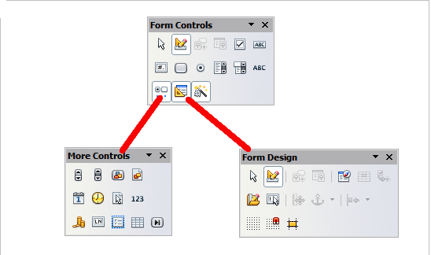
Figure 1: The Form Control, More Controls and Form Design Toolbars

Activate Design Mode
Click the Design Mode On/Off button on the Form Controls toolbar to turn design mode on. (Click it again when you want to turn it off.) This activates the buttons for inserting form controls and selects controls for editing.
When design mode is off, the form behaves as it would for the end user. Buttons can be pressed, check boxes selected, list items selected, and so on.

Insert Form Controls
- To insert a form control into the document, click the control’s icon to select it. The mouse pointer changes to look like this:
- Click in the document where you want the control to appear. (You can move it later.)
- Holding the left mouse button down, drag the control to size it. Some controls have a fixed size symbol followed by the name of the control (for example, Check Box or Option Button).
- The control button remains active, so you can insert several controls of the same type without needing to go back to the toolbar.
- To change to another tool, click its icon on the toolbar.
- To stop inserting controls, click on the Select button on the Form Controls toolbar, or click on any of the controls you have just inserted. The mouse pointer changes back to its normal appearance.
Tip | Holding down Shift when creating a form control makes the control square. If you press Shift when resizing an existing control, its proportions are kept the same.

Note | When you insert a group box, list box, or combo box, a wizard is launched to guide you through the setup. If you prefer not to run the wizard, click the Wizards On/Off button on the Form Controls toolbar.

Configure Controls
After inserting the controls, you need to configure them to look and behave as you want. Right-click on a form control within your document and select Control from the pop-up (context) menu to open the Properties dialog box for the selected control. Double-clicking on a form control also opens this dialog box.
The Properties dialog box has three tabs: General, Data, and Events. For simple forms, only the General tab is of real use. With this tab you can set the look and feel of the control. See “Configure Form Controls” on page 15 and “Form Control Formatting Options” on page 26 for more information, and the descriptions in the Help for details. Configuration for use with a database is discussed in “Creating a Form for Data Entry” on page 21.
The fields on this dialog box vary with the type of control. For example:
- Some controls have visible labels, such as Push Button and Option Button. The label text can be set.
- The Combo Box contains a list of options to choose from. Set these in the List entries box, which is not visible in the figure.
Notice the scroll bar in this dialog box. You can use the scroll bar or enlarge the dialog box to see additional fields.
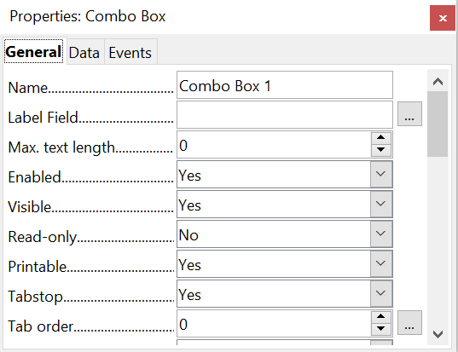

Figure 2: Example of the Properties dialog box for a form control

Use the Form
To use the form, leave design mode by clicking the Design Mode On/Off button to deactivate it. Save the form document.

Form Controls Reference
Form Control Toolbar
Select | Selects a form control to perform some other action on it.
Design mode on/off | Toggles between design mode on (to edit forms) and design mode off (to use forms).
Control | Launches the form control properties dialog box. This dialog box can be kept open as different controls are selected.
Form | Launches form properties dialog box, controlling properties for the form as a whole, such as which data source it connects to.
Check Box | A box that can be selected or deselected on the form. You can label the box.
Text Box | A control to create a box into which the form user can type any text.
Formatted Field | A control allowing numeric formatting options. For example, you can set maximum and minimum values for the number entered, or the number type (decimal places, scientific, currency).
Push Button | Creates a button that can be linked to a macro. The label is the name that appears on the button.
Option Button | Creates an option button (also known as a radio button). When multiple buttons are grouped together, only one can be selected at a time. The easiest way to group multiple buttons is to use the Group Box button on the More Controls toolbar, with wizards enabled.
List Box | Creates a list of options as a pull-down menu that the user can choose from. If wizards are on, creating a list box launches the List Box Wizard. This wizard is only useful if your form is linked to a data source.  If the form is not linked to a data source, turn wizards off and create an empty list box. Then click the control button and, in the List Entries option on the General tab, enter the options you want to appear on the list.
Combo Box | As with a List Box, you set up a list of choices. In addition, a panel at the top either displays the choice made or allows the form user to type in something else. This works the same as the List Box in a simple form, but they are different if the form is connected to a data source.
Label Field | A text label. The difference between this and just typing on the page is that, as a control, you can link a label field to macros so, for example, something happens when the mouse passes over it or clicks on it.
More Controls | Launches the More Controls toolbar.
Form Design | Launches the Form Design toolbar, which can also be opened with View > Toolbars > Form Design.
Wizards On/Off | Some form controls (List Box and Combo Box) have optional wizards. If you do not want the wizard to launch when you create one of these controls, use the Wizards On/Off button to switch wizards off.
More Controls Toolbar
Spin Button | Allows form users to choose a number by cycling through the list of numbers. You can specify maximum, minimum, default, and the step between numbers.  This control is not commonly used in Writer, as the number is not displayed. In Calc, however, a Data tab appears on the Control Properties dialog box, so you can link the spin button to a cell.
Scroll bar | Creates a scroll bar, with a number of options to define the exact appearance.  This control is not commonly used in Writer. In Calc, a Data tab appears on the Control Properties dialog box, allowing you to link the scroll bar to a cell.
Image Button | Behaves exactly like a push button, but displays as an image. Choose the image in the Graphics option on the General tab in the Control Properties dialog box.
Image Control | Only useful when the form is connected to a data source and a field in the data source exists that can hold images. You can add new images to the database or retrieve and display images from it.
Date Field | Stores a date. You need to configure the earliest and latest dates the field will accept, the default date, and the date format. You can add a spinner.
Time Field | Works like a date field but specifies a time.
File Selection | Allows a user to select a file, either by typing the path and name directly or by clicking on a Browse button and choosing the file from a dialog box.
Numeric Field | Displays a number. You need to specify formatting, maximum, minimum, and default values. You can add a spinner.
Currency Field | Works like a numeric field; additionally you can add a currency symbol.
Pattern Field | Pattern fields are useful when the form links into a data source. Specify an Edit Mask to restrict what a user can enter into the field. Specify a Literal Mask to restrict which data is displayed from the data source.
Group Box | The group box control has two different uses depending on whether wizards are on or off.  If wizards are on, creating a group box launches the Group Element wizard. This creates a group of options buttons (in which only one may be selected at a time). In most cases, using a group box is the best way to create a set of option buttons.  If wizards are off, a group box is simply a visual box to group together different controls. It has no effect on the way the controls operate.
Table Control | Table Control is only useful with a data source. If no data source is specified, you will be prompted to choose one in the Table Element Wizard. You then pick the fields to display and, when design mode is off, the data appears in the table. The table also includes controls to step through the records.  Records can be added, deleted, and modified in the table.
Navigation Bar | A navigation bar is the same as the Form Navigation toolbar (View > Toolbars > Form Navigation), but can be placed anywhere in the document and be resized.
Form Design Toolbar
Select | Selects a form control to perform an action on it.
Design mode on/off | Toggles between design mode on (to edit forms) and design mode off (to use forms).
Control | Launches the form control properties dialog box. This dialog box can be kept open as different controls are selected.
Form | Launches the form properties dialog box, controlling properties for the form as a whole, such as which data source it connects to.
Form Navigator | The Form Navigator is a utility displaying all the forms and controls in the current document. It allows you to edit and delete them easily.  If you use the Form Navigator, it's recommended that you give your controls names (in the properties dialog box). The name appears in the navigator so, for example, if you have ten text boxes, you can tell which is which.
Add Field | Add Field is only useful if you have specified a data source for the form. If no data source is specified, an empty box opens.  If you have specified a data source, Add Field opens a list of all the fields in the specified table, which you can then drag and drop onto the page. The fields are placed on the page with the name of the field before them.  This is a quick and easy way to create a form from a data source.
Activation Order | Allows you to specify the order in which focus shifts between controls. You can test the order by leaving design mode and using Tab to switch between the controls.
Open in Design Mode | Opens the current form in design mode (to edit the form rather than entering data into it).
Automatic Control Focus | If activated, focus is set to the first form control.
Position and Size | Launches the Position and Size dialog box, allowing you to specify both by typing in precise values, rather than dragging the control. You can also lock the size or position, so they do not get changed accidentally. For some controls, you can rotate and set the slant and corner radius.
Change Anchor | Just as with a frame, any form control can be anchored to page, paragraph, or character and also anchored as a character (meaning that it behaves like any other character on the page).
Alignment | The Alignment button is disabled unless the control is anchored as a character. You can align a control in different ways, for example so the top of the control lines up with the top of the text or the bottom lines up with the bottom of the text.
Display Grid | Displays a grid of dots on the page, to help you line up controls.
Snap to Grid | When a control is brought close to a grid point or line, it will snap to the grid. This makes it is easier to line up controls.
Guides when Moving | When a control is being moved, lines extend from the control horizontally and vertically to help you position it accurately.

Example: a Simple Form

Create the Document
Open a new document (File > New > Text Document). It is a good idea to write down the outline of the document, without form controls, though of course it can easily be changed later.
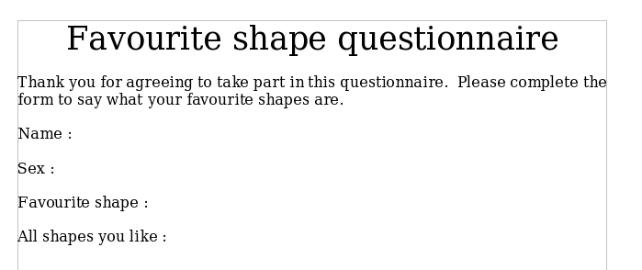Figure 3: Initial document without form controls

Add Form Controls
The next step is to add the form controls to the document. We will have four controls:
- Name is a text box.
- Sex is two option buttons, male or female.
- Favorite shape is a list of options.
- All shapes you like is a series of check boxes.
To add these controls:
- Select View > Toolbars > Form Controls to open the Form Control toolbar.
- If the buttons are not active, click the Design Mode On/Off button to activate them.
- Click the Text Box button , then click in the document and, with the left mouse button held down, drag the shape of the Name text box to approximately the size you want.
- Make sure the Wizards On/Off button is on (shaded with a border). Click the More Controls button to launch the More Controls toolbar.
- On the More Controls toolbar, click the Group Box button . Draw a group box by the Sex: entry. The Group Element Wizard opens.
  - On the first page of the wizard, enter two names for the options fields: Male and Female. Click the >> button after each entry. Click Next >>.
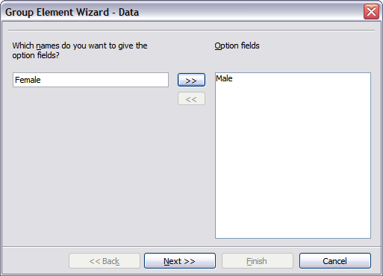Figure 4: Specifying names for option fields
  - On the next page, select the option No, one particular field is not going to be selected. Click Next>>.
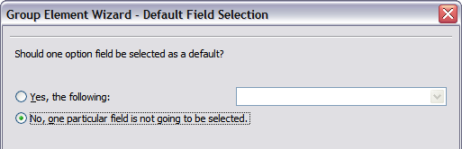Figure 5: Selecting a default field
  - Give a value to your fields. Typically, you would give one field the value 1 and the other field the value 2. If there are more than 2 option fields, you would give them values of 3, 4, and so on. Click Next >>.
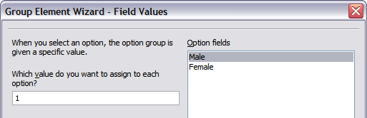Figure 6: Assigning field values
- You can either delete the caption or give a caption to your Group Box. Then click Finish.
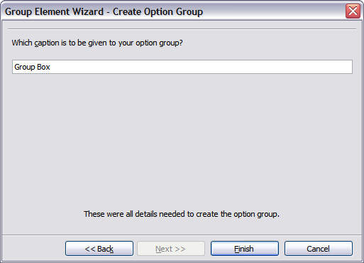Figure 7: Create Caption Option
- Now create the list box. On the Form Controls toolbar, click the Wizards On/Off button to turn wizards off. Click the List Box button and draw a list box by Favorite Shape in the document. This will just be an empty pane for now.
- Finally, create four check boxes by All shapes you like. Click on the Checkbox button and then draw out four check boxes, side by side across the page.
You should now have a document looking something like Figure 8.
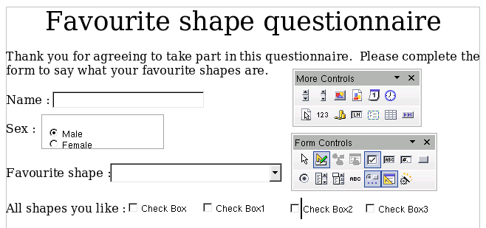Figure 8: Document with form controls

Configure Form Controls
No further configuration is required to the Name and Sex fields, but you can, if you wish, give a name to each control and change the appearance of the controls.
The list box must be configured to add the list of options. The checkboxes must be configured to add in the names (instead of Check Box, Check Box1, and so forth). Here are instructions to configure these controls:
- Be sure design mode is on. Double-click on the List Box control within the document to open the control’s Properties dialog box. Select the General tab.
- In the List Entries box (scroll down if it is not visible), type the names of the shapes (Circle, Triangle, Square, Pentagon) following each entry by Shift + Enter. Press Enter when you finish the list. You should end up with a line saying“Circle”; “Triangle” ; “Square”; “Pentagon”:
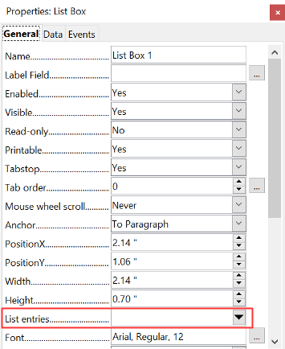Figure 9: Properties dialog box for a list box
- Click on the first Checkbox. The Properties dialog box stays open but changes to show the properties for the checkbox.
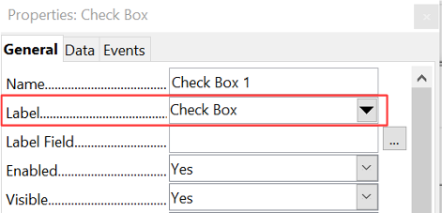Figure 10: Top part of Properties dialog box for a check box
- Change the Label field from Check Box to Circle and press Enter. The cursor moves to Label Field and the label on the checkbox in the document changes immediately.
- Click on each of the other three check boxes in turn. Change the Label in the Properties dialog box to Triangle, Square, and Pentagon in turn.
- Close the Properties dialog box.
- Turn design mode off and close the two Controls toolbars.
You have now completed the form, which should look something like Figure 11.
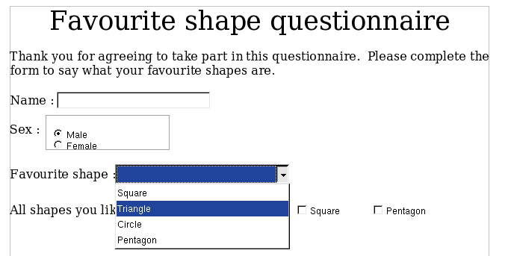Figure 11: Completed form

Finishing Touches
The form is complete, but you are free to make further changes to the document. If you're sending this out to other people to complete, you'd probably want to make the document read-only, thereby ensuring that users would be able to fill in the form, but not able to make any changes to it.
To make the document read-only, select File > Properties > Security > Open file read-only.
Note | If the document is read-only, anyone filling-in the form will need to use File > Save As to save the document.

Accessing Data Sources
The most common use for a form is as the source of input for a database. You can provide a form that allows users to enter information into a contacts database and, because it is part of a Writer document, the form can contain graphics, formatting, tables, and other elements. So, modifying the form is as simple as editing a document.
OpenOffice can access numerous data sources. These include relational databases like MySQL and Oracle, spreadsheets and text files. As a general rule, databases can be accessed for read and write; other data sources, such as spreadsheets, are often read-only.
Tip | To see the list of supported data source types for your operating system, choose File > New > Database. On the first page of the Database Wizard (Figure 12), select Connect to an existing database and then open the drop-down list. An example is shown in Figure 15.

Creating a Database
Chapter 8 (Getting Started with Base) in the Getting Started guide covers in more detail how to create a database, including installing the required Java Runtime Environment (JRE). Here we give a short guide to creating a very simple database with AOO Base.
- Select File > New > Database to start the Database Wizard (Figure 12).
- Select Create a new database and click Next.
- On the next page, select Yes, register the database for me and Open the database for editing. Registering the database just means that it can be accessed from other AOO components such as Writer and Calc. You need to do this if you want to link your forms into it.
- Click Finish and save your new database, giving it a name. Unlike creating other documents in AOO, databases must be saved when you first create them.
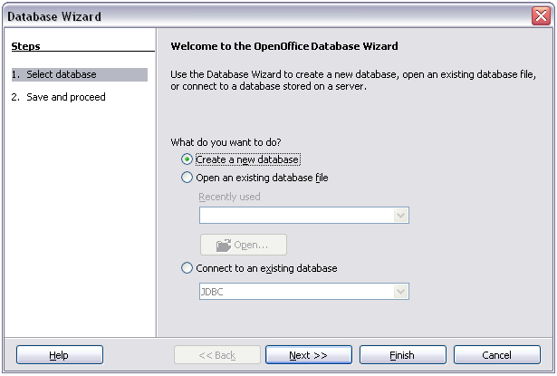Figure 12: Database Wizard
After saving the database, you should see the main Base window (Figure 13), which contains three panels. The left-hand panel is Database, with icons for Tables, Queries, Forms, and Reports.
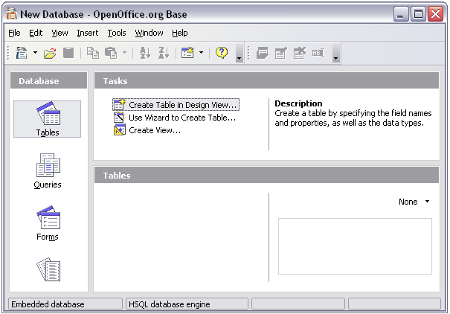Figure 13: Main Base window
The next step is to create a table. Again, this is covered in more detail in Chapter 8 (Getting Started with Base) in the Getting Started guide. Here we are going to create a small table as an example.
- Choose Tables in the left-hand column, then choose Create Table in Design View under Tasks.
- Use the Table Design window to tell Base which fields to create. We will have just three fields: Name, Address, and Telephone.
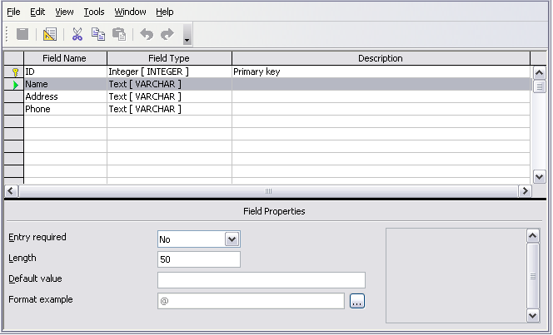Figure 14: Database table design
- On the first line, enter under Field Name ID and set the Field Type to Integer [INTEGER]. In the gray box at the left of the line, right-click and select Primary Key, bringing up a key icon in the box. In the Field Properties at the bottom of the window is an Auto Value option; change this to Yes.
Tip | Setting up the Primary Key field with Auto Value set to Yes is an important step. If this is not done, your form may be much trickier to use, and may even generate errors for the user. Be careful with this step!

- On three lines, enter under Field Name Name, Address, and Telephone. Accept the default Field Type of Text [VARCHAR] and leave Description blank.
- Save the table (File > Save). You will be prompted to name it. The name can be anything you like.
- Finally, save the whole database from the main Base window (File > Save).

Accessing an Existing Data Source
If you have an existing data source, such as a spreadsheet or database, you simply need to tell OpenOffice about it. This is called registering a data source.
To register an existing data source:
- Select File > New > Database to launch the Database Wizard.
- Select Connect to an existing database and choose the type from the drop-down list.
- Click Next and follow the instructions to select the database to register (the exact process varies between different types of data source).
- In Step 3: Save and proceed, check that Yes, register the database for me is selected. Deselect Open the database for editing – you just need to register it, not edit it through Base.
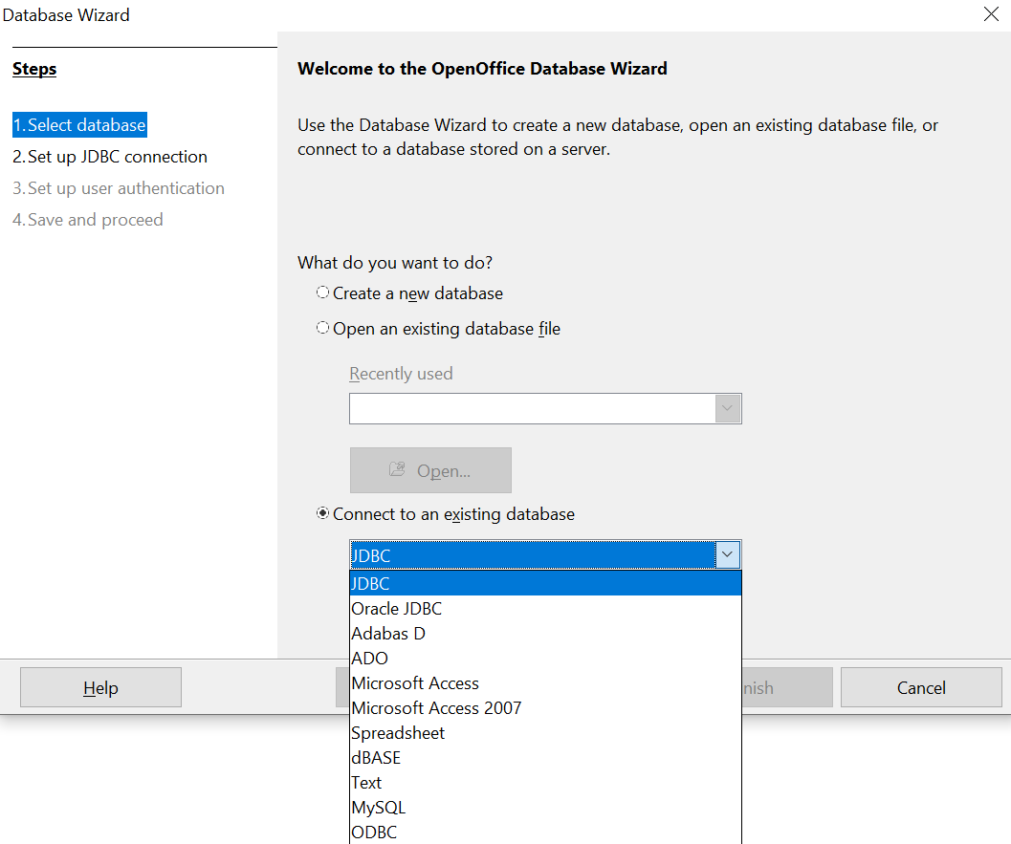

Figure 15: Using the Database Wizard to connect to an existing database

Creating a Form for Data Entry
Whether you created a new database, or already had a data source, it must be registered with OpenOffice (see above). Once registered, linking your form to it is simple. Follow these steps to create a new form and link it to a registered data source.
- Create a new document in Writer (File > New > Text Document).
- Design your form, without putting in the actual fields (you can always change it later).
- Show the Form Controls toolbar (View > Toolbars > Form Controls).
- Click the Design Mode On/Off button to put the document into design mode, if necessary. With design mode off, most of the toolbar buttons are grayed out. If the Design Mode button is also grayed out, click on the Select button to activate it.
- Click the Text Box button . Click in the document and, holding down the left mouse button, drag the mouse to create a text box for the first form field (for example, Name, if you are linking to the database created above).
- Click the Text Box button again and drag the mouse to draw another field. Additional fields, of any type, can be added in the same way (click and drag).
So far, you've followed the same steps you used when you created your first form. Now you can link your form with the data source you registered.
- Click the Form button in the Form Controls toolbar, or right-click on any of the fields you inserted and select Form, to open the Form Properties dialog box.
- In the Form Properties dialog box, click on the Data tab.
  - Set Data Source to be the data source you registered.
  - Set Content Type to be Table.
  - Set Content to be the name of the table you want to access.
  - Close the dialog box.
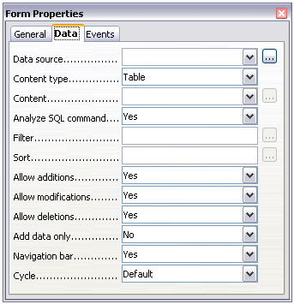Figure 16: Form properties, connecting to a data source
- For each form control in turn, launch the Properties dialog box. Click on the control to select it (so small green boxes appear around it). Then either right-click and select Control or click on the Control button on the Form Controls toolbar.
- In the Properties dialog box, click on the Data tab (Figure 17). If you set up the form correctly, the Data Field option will contain a list of the different fields in the data source (for example, Name, Address, and Telephone). Select the field you want.
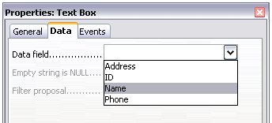Figure 17: Form control properties, Data tab
- Repeat for each control in turn until all have been assigned to a field.
Tip | If you created a database in AOO Base and your Primary Key field had Auto Value set to Yes, that field does not need to be part of the form. If Auto Value was set to No, you will have to include it and have your users enter a unique value into that field whenever they make a new entry.

Entering Data into a Form
Once you have created a form and tied it to a database, you want to use it to enter data into your data source, or modify data already there.
- Make sure that the form is not in design mode. In the Form Controls toolbar, click on the Design Mode On/Off button . If design mode is off, most of the buttons on the toolbar will be grayed out.
- Make sure that the Form Navigation toolbar is on (View > Toolbars > Form Navigation). This toolbar normally appears at the bottom of the window.
Figure 18: Form Navigation toolbar
- If there is existing data in the data source, use the control buttons on the Form Navigation toolbar to look at different records. You can amend data in a record by editing the values in the form. To submit the changes, press the Enter key with the cursor in the last field. The record is saved, and the next record is displayed.
- If there is no data in the form, you can start entering information by typing into the fields of the form. To submit the new record, press the Enter key with the cursor in the last field.
- Other functions can be performed from the Form Navigation toolbar, including deleting a record and adding a new record.

Advanced Form Customization

Linking a Macro to a Form Control
You can set any form control (for example, text box or button) to perform an action when triggered by some event. To see the full list of events, right-click on the form control when the design mode is on, select Control and click on the Events tab.
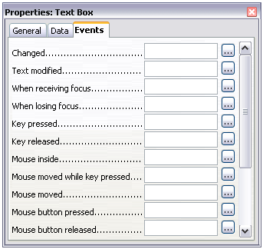
Figure 19: Control properties, Events tab
To assign a macro to an event:
- Create the macro.
- Be sure the form is in design mode. Right-click on the form control, select Control and click on the Events tab.
- Click the browse button to bring up the Assign action dialog box (Figure 20).
- Click the Macro button and select the macro from the list in the Macro Selector dialog box. You return to the Assign action dialog box. Repeat as needed, then click OK to close the dialog box.
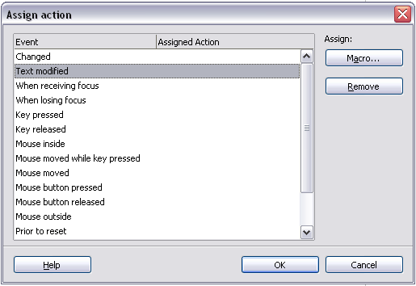
Figure 20: Assign action dialog box
Macros can also be assigned to events relating to the form as a whole. To assign these, right-click on a form control in the document, select Form and click on the Events tab.

Read-Only Documents
Having created your form, you want whoever is using it to be able to access the information stored in the database, or complete the form, without changing the layout. To do this, make the document read-only by selecting File > Properties > Security > Open file read-only.

Fine-Tuning Database Access Permissions
By default, when a database is accessed from a form, any changes can be made to it: records can be added, deleted, and amended. You may not want that behavior. For example, you may want users to be able only to add new records or to be prohibited from deleting existing records.
In design mode, right-click on a form control and select Form from the pop-up menu. On the Data tab of the Form Properties dialog box are a number of options: Allow additions, Allow deletions, Allow modifications and Add data only. Set each of these to Yes or No to control the access users have to the data source.
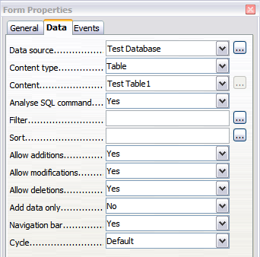Figure 21: Data Properties of a Form
Individual fields can also be protected. This might be useful if you wanted a user to be able to modify some parts of a record but only view others, such as a stock list where item descriptions are fixed and quantities can be modified.
To make an individual field read-only, in design mode, right-click on the form control within the document and select Control from the pop-up menu. Select the General tab and set Read-only to Yes.

Form Control Formatting Options
You can customize the way form controls look and behave in a number of ways. These are all accessed in design mode. Right-click on the form control, select Control from the pop-up menu and select the General tab in the Properties dialog box.
- Set a label for the control in the Label box (not to be confused with the box called Label Field). Some form controls, such as push buttons and option buttons, have visible labels that can be set. Others, such as text boxes, do not.
- Set whether the form control will print out if the document is printed with the Print option.
- Use the Font setting to set the font, typeface, and size for a field’s label or for text typed into a field. This setting does not affect the size of check boxes or option buttons.
- For a text box, you can set the maximum text length. This is very useful when adding records into a database. Every database text field has a maximum length and, if the data entered is too long, AOO displays an error message. By setting the maximum text length of the form control to be the same as that of the database field, this error can be avoided.
- You can set the default option for a form control. By default, a control is blank, or has every option unselected. You can set the control to start with a particular option or list item selected.
- For controls where a password is being entered, setting the Password character (for example, to *) displays only that character, but saves what the user really types.
- You can add additional information and help text for a form control.
- Other formatting controls such as background color, 3-D look, text formatting, scroll bars, and borders allow you to further define how the control appears.

XForms
XForms are a type of web form, developed by the World Wide Web Consortium (W3C). OpenOffice supports the XForms 1.0 open standard for creating web forms with XML.
In OpenOffice, an XForms document is a special type of Writer document. XForms use the same controls as the ordinary forms described in this chapter.
After you create and save an XForms document, you can open the document, fill out the form, and submit the changes to a server.
A detailed discussion of XForms is beyond the scope of this chapter, as it is related more to databases than word processing. A good tutorial introduction is J. David Eisenberg’s XForms and OpenDocument in OpenOffice.org, available from http://opendocument.xml.org/files/xforms_ooo_06_10_25.pdf. Another good resource is Valden Longhurst’s Using XForms and the OpenDocument format in OpenOffice.org and StarOffice, https://wiki.openoffice.org/wiki/Documentation/Using_XForms.

