DSCM evaluation report
Prepared for the OpenOffice.org steering committee meeting, Mar. 9th 2009
Author: Jens-Heiner Rechtien
March 6, 2009

The Task
Compare available and widely used open source Distributed Source Code Management (DSCM) systems to choose one for the future OpenOffice.org development.

Summary
Of the three proposed DSCM systems candidates (Mercurial, Bazaar, Git) two, Mercurial and Git, are clearly able to support OpenOffice.org development now. The author thinks that Bazaar might also be a suitable choice in the near future but Bazaar is currently still a bit behind the other two.
Choosing between Mercurial and Git is a bit like choosing emacs vs. vi. Both are powerful and flexible tools, both have great similarities in the way they do work but the underlying philosophies are quite different. Git is probably the most flexible open source DSCM currently on the market. To use this flexibility it is required to have an understanding of the underlying concepts which makes it some times arcane to use. Mercurial does a better job of abstracting the user interface from the underlying concepts but relies on a number of extensions to achieve flexibility. Admittedly most of these extension are bundled with the standard Mercurial client.
On the performance side Git and Mercurial emphasize different operations. As a generalization one can say that Git optimizes for full tree operations whereas Mercurial performs better for single file operations. Both systems need high I/O bandwidth to perform well, as expected, but aren't necessarily worse than Subversion on slow remote volumes.
Prior experience suggests that it is very important to execute a limited pilot project before we commit ourselves to a specific DSCM. A pilot is only possible in a meaningful way if there is a possibility to do fast incremental conversions from SVN to the DSCM in question. This criteria is fulfilled for both Git and Mercurial. Bazaar supports incremental conversions as well, but they are currently a bit too slow and memory consuming to be practical on a commit by commit basis. This may change in near future as the conversion part is currently actively developed.
The author prefers Mercurial slightly over Git for OpenOffice.org development on the ground of the perceived shallower learning curve.

Table of Contents
DSCM evaluation report 1
The Task 1
Summary 1
Introduction 2
Subversion disappointments 3
SCM Requirements 3
Mercurial, Bazaar and Git: changes since the last evaluation 3
Mercurial 3
Bazaar 4
Git 4
Point to point comparison 5
Performance comparison 6
Things we don't like 6
Mercurial 6
Bazaar 7
Git 7
Conclusion 7
Appendix A: DSCM deployment infrastructure 8
Appendix B: Requirements for the next OpenOffice.org SCM tool 9
Mandatory requirements 9
Things we'll consider strongly in favor of a new SCM 10
Nice to have 10

Introduction
The ESC meeting decided on the Feb. 2008 meeting to migrate the OpenOffice.org code base from CVS to Subversion as a first step and to reevaluate the open source DSCM market later a second time. The reason was that no DSCM (with the possible exception of Git) at that time seemed mature enough to support the OpenOffice.org development but it was also noted that all of them were very actively developed and improved by the day. The tentative time frame for the reevaluation was one year.
In Sep. 2008 we migrated from CVS to Subversion. We were very careful in making certain that the migration to Subversion did not preclude a later migration to a DSCM. As an example, we limited the migrated history to trunk (main development line) only and additionally migrated only the last version of binary files. The first measure ensures that the conversion process could pick optimal change sets and the second reduced unnecessary binary data which wouldn't much hurt a Subversion repository but certainly unnecessarily inflates a DSCM repository. Both measures together, reduced the Subversion repository size from 90 GB to 6 GB. This translates to vastly reduced DSCM sizes when converted from Subversion. A handcrafted carefully packed trial Git repository without these measures is about 4 GB in size, whereas a standard conversion from the current trimmed SVN repository occupies less than 1 GB, a huge improvement if the repository needs to be in every local working tree.
All three DSCMs underwent major modifications – and so did Subversion. The purpose of this paper is to determine if the DSCMs are now ready for OpenOffice.org development and if this is the case give some discussion ground for choosing the best suitable one.

Subversion disappointments
Why not just stay with Subversion? The Feb. 2008 ESC meeting agreed that a distributed SCM would suit OpenOffice.org development best, it was just not clear if the DSCMs were up to the task and which one to choose. Subversion as an intermediate step seemed to be the best way to proceed with the urgently needed replacement of CVS.
After some month of practical experiences working with Subversion it is clear that Subversion has some shortcomings which do affect OpenOffice.org. Beside the obvious fact that it doesn't allow a distributed way of developing OpenOffice.org the following points were most often mentioned:
- Merge tracking was seriously broken with SVN clients 1.5.0-1.5.4 leading to very slow merges. This affected the re-basing of child workspaces and integrations. Situation has improved with SVN client 1.5.5 but is still not optimal.
- File moves inside the repository tree are simulated by deleting and adding files This allows to preserve the history over file moves. But changes to a file introduced concurrently to a file move may get lost. This is especially bad because Subversion does not provide much in the line of detecting this situation.
- SSH authentication round-trip takes ~3 seconds. Not a problem for a single command, but hurts for many commands in a row.
- Less important: working with Subversion URLs feels somewhat clumsy for many developers.
A carefully deployed DSCM solution should be able to address all these points.

SCM Requirements
OpenOffice.org has a number of somewhat uncommon requirements regarding a SCM system, most of them due to the vast amount of data and data-history which need to be tracked. Before we started out looking for a new SCM system we collected a requirement list which can be found here: http://wiki.services.openoffice.org/wiki/SCM_Requirements. This list has been reproduced in Appendix B.

Mercurial, Bazaar and Git: changes since the last evaluation

Mercurial
Mercurial is implemented in python and some C for speed. It's arguably easy to use, easy to extend, very good documented and fast enough even for projects of the size of OpenOffice.org. The current version is now 1.12. The version evaluated in the last report was 0.95. Major changes since then (partial list):
- major speedup in many areas
- extension to deal with CRLF
- vastly improved import from SVN
- improved copy/rename handling (merge!)
- named branches
In the last report we excluded Mercurial from further evaluation because of two reasons (citing from the report):
- Represented branches as different repositories. With 500 live branches in OOo (meaning 500 required conversions) we felt that this is prohibitive for OOo development.
- The “plain trunk” simplified import already took such a prohibitive long time (estimated four weeks on a reasonably sized machine) that we never came up with a reasonable test repository.
Mercurial now offers the so called “named branches” feature which deals with point 1. Our migration strategy changed as well, only releases code lines DEV300, OOO310 and newer than will be in the master repository, everything else is in the CWS repositories.
The import from SVN to Mercurial is the now fastest for the three DSCMs. Import for trunk/branches/tags takes about a night on a fast machine, it's quite easy to additionally convert CWSs to their own repository with some additional time. Import can be done incrementally for trunk, enabling us to do a Mercurial pilot if we wish to do so. Import to a named branch (currently only the OOO310 lives on a named branch) is buggy.

Bazaar
Bazaar also implemented in python with extensions in C for performance. It's very flexible, easy to extend and reasonably easy to use and has good documentation. Bazaar is in the process of changing its repository format which makes it fast enough to import the OOo code base from SVN.
The current version is1.12, in the last report we evaluated version 1.0. Major changes since then (only a partial list):
- performance improvements all over the place
- stacked branches
- new repository format with smaller more efficient index files
- improved merge
- updated server protocol
- improved hooks
In the last evaluation we excluded bazaar because we weren't able to create an import. Unfortunately importing our SVN repository is still difficult with the current version of bazaar (1.12) due to memory requirements and import speed. Jelmer Vernooij from the bazaar team works on improving it and reported success with a new experimental bazaar repository format. Unfortunately this repository reached us late to do extensive tests with it.
Incremental import is supported but requires much time so that it is somewhat impracticable on a commit by commit basis.

Git
Git is the third DSCM system we evaluated. It is very flexible, powerful and fast tool, implemented in C and perl.. The flexibility comes with a price, although the documentation is quite extensive nowadays it's sometimes hard to read and to understand. Git requires a working knowledge of its concepts which leads to a somewhat steeper learning curve than Mercurial or bazaar. We last evaluated version 1.5.4, current is 1.6.1.3. Major changes since then (only a partial list):
- performance and functionality improvements all over the place
- a number of git commands have been rewritten in C
- better Windows support (via cygwin and a msys port)
- vast increase in available documentation (books, web books, tutorials etc)
Import from SVN is not as fast as for Mercurial but still fast enough. Incremental import is possible, thus enabling us to do a pilot if we wish to do so. Git also enables bridging between a local git repository and an upstream Subversion repositories. This bridging has been tested and is in active use by OOo developers.

Point to point comparison

 | Mercurial | Bazaar | Git
development | active | very active | very active
repository size (no tree) | ~ 1GB | ~2 GB | ~ 980 MB
performance | fast, optimized for single file operations | ? | fast, optimized for tree operations
files/dirs in repository | ~76000 [O(files in tree)]  (one revlog per file) | ? | ~ 3500 (1 big pack + indexes)
file move aware merges | yes | yes | yes
supports pull/merge resyncs | yes | yes | yes
supports rebase | yes, via standard extension | yes, via plugin | yes, it is actually a very common operation
supports “rewriting the history” | yes, via standard extension | no | yes, it is actually a very common operation
Windows support | good | good | ok, some tools don't don't have gui support
binary support | all files are handled as binaries | all files are handled as binaries | all files are handled as binaries
CR/LF fix for text files on Windows | via extension | ? | via (inheritable) hooks
learning curve  <c> merge –help | wc -l  with <c> = [hg|bzr|git] | ok  20 | ?  88 | steep but manageable  272
documentation | very good | good | vast but sometimes hard to read
extensibility | via python extensions | via python plugins | C or shell/perl scripting

Performance comparison
Git and Mercurial have slightly different performance characteristics, which is probably the direct result of the different storage strategies. In general Git is faster on tree operations, Mercurial is faster on single file operations.
Any (non-network) operations on trees hosted on local disks are very fast for both systems, often less than 1s with “warm” buffers.
Many OOo developers store their working copies on NFS servers to be able to develop for several platforms (Solaris, Linux, Windows, MacOSX) at once. The following tables show some typical numbers against a badly loaded NFS server and can be considered as worst case scenario.
Full tree operations | Linux: git | Linux: hg | Windows: hg
status (1st run) | 13m 29s | 01m 38s
(2nd run) | 01m 02s | 00m 44s
(3rd run) | 00m 31s | 00m 36s
diff (1st run) | 00m 38s | 00m 33s | 20m 53s
(2nd run) | < 1s | 00m 28s | 18m 55s
(3rd run) | < 1s | 00m 01s | 19m 11s
log (1st run) | 00m 08s | 00m 48s
(2nd run) | 00m 06s | 00m 45s
(3rd run) | 00m 06s | 00m 45s

Commit 15 files | Linux: git | Linux: hg | Windows: hg
commit (1sr run) | 00m 34s | 00m 06s
 | 00m 32s | 00m 03s

Single file operations | Linux: git | Linux: hg | Windows: hg
annotate (1st run) | 00m 26s | 00m 03s | 00m 06s
(2nd run) | 00m 12s | 00m 01s | 00m 03s
(3rd run) | 00m 12s | 00m 01s | 00m 03s

Things we don't like

Mercurial
- Tag handling: Tag handling is a bit obscure in Mercurial. Tagging a version creates it own revision. This leads to the curios fact that if one clones a repository up to a certain revision via
$ hg clone -r “milestone” <master repository>
a subsequent
$ hg tags
will show all tags but “milestone”. Not intuitive.
Tags are kept in a regular file in the repository. This file gets merged and can even conflict, causing confusion.
- Multiple branches in repository: The handling is not as intuitive as branches in git.
- Heads: Developer will need to learn the concept of having multiple heads in their repository, some of which can be “named”, some not.

Bazaar
- Branch handling: branches are directories in Bazaar, not internal names like they are in git or Mercurial (named branches)

Git
- The git command documentation is sometimes hard to understand, many curious concepts, many options, just as in the worst Unix documentation tradition.
- Changes need to be “staged” before they are committed. This will invariably lead to “forgotten” commits in the beginning. Of course, there is a switch to “git commit“ which will do it with one command, but …
- Conflict free merges are auto committed. The author finds this a bit dangerous.

Conclusion
All three evaluated DSCMs are implemented around the concept of “directed acyclic graphs”, but the philosophies and implementation are quite different.
The current versions of Git and Mercurial are both able to support OpenOffice.org development. With the upcoming new repository format this might as well be the case for Bazaar. In this paper the author wasn't able to verify this due to the late arrival of a full import from SVN.
Choosing between Git and Mercurial is ultimately a matter of taste. Neither the feature sets nor the performance numbers do allow us to set one of them conclusively over the other.
In very simplified terms the OpenOffice.org community has the choice between the slightly greater flexibility of Git and the somewhat easier accessible Mercurial. The author prefers Mercurial slightly over git because of the shallower learning curve. However, it is perfectly possible to come to another conclusion with another valuation of the flexibility/accessibility trade off.

Appendix A: DSCM deployment infrastructure
OpenOffice.org child workspaces are feature or topic branches with some additional meta data added. Working with a number of repositories representing feature branches is absolutely normal for DSCM managed projects so there are not many special considerations necessary. Two requirements deserve mentioning here:
- The huge existing OOo history leads to sizable repositories (~ 1 GB for Mercurial and git, ~2 GB for bazaar). Since band width will always be a limiting factor the number of pulling/pushing lager numbers of change sets over the network should be minimized.
- OpenOffice.org domain developers should be able to publish their CWS early in a public place, preferably on the same server as the master repository.
Both requirements taken together can be met by a server side clone mechanism. A tentative picture of a possible deployment infrastructure is shown in Illustration 1.
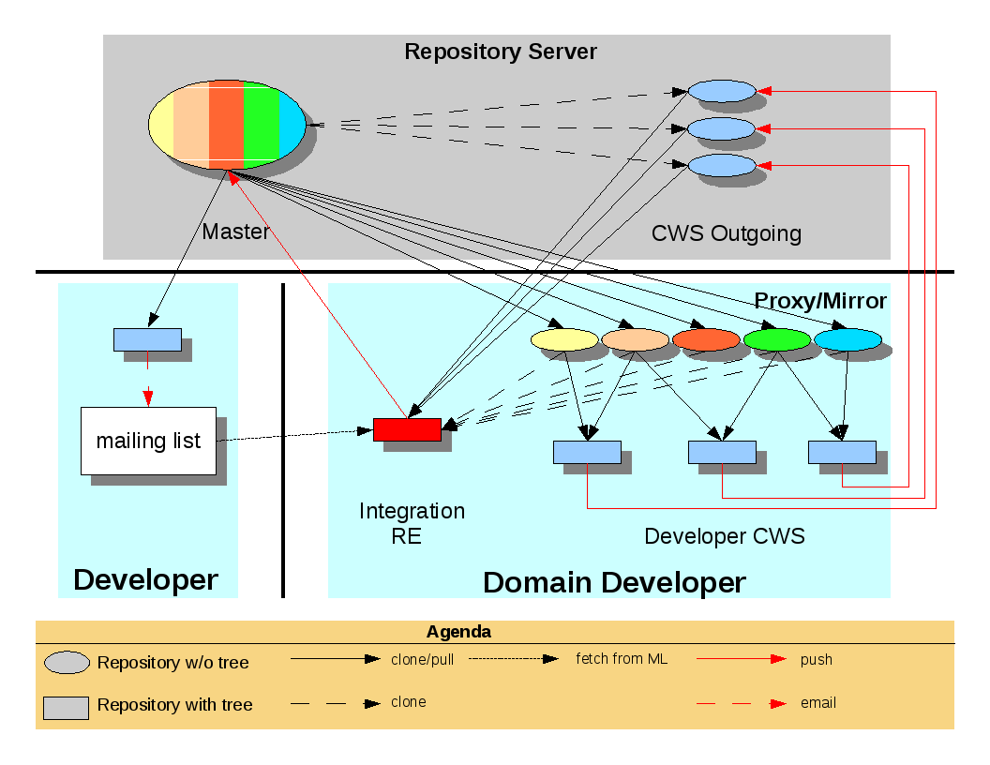Illustration 1: Deployment infrastructure

Appendix B: Requirements for the next OpenOffice.org SCM tool
[Taken from: http://wiki.services.openoffice.org/wiki/SCM_Requirements]
We want a SCM tool which fits our development model, not modifying the development model to fit a SCM tool.

Mandatory requirements
- The SCM tool and its repository format must be stable enough to support a code base of the size of OpenOffice.org (this is self evident). The best way to prove this is the successful use in other large software projects.
- Clients for the SCM tool have to be available for the major development platforms (Linux, MacOSX, Solaris, Windows) and should be available for most of the OpenOffice.org platforms.
- The new SCM should support the subset of CVS which is used in every day life, such as "status", "diff", "annotate", "log" etc in a reasonable way. I'm certain that every modern SCM does this, CVS sets the lower bar here.
- The general operation of the SCM should not be significantly slower than CVS, at least the important things: "commit", "diff", "log" etc. If some seldom used operations like "annotations", "history" are slower than this is probably not much of problem.
- The SCM tool must easily support the concept of branches.
  - Branch creation must be light weight. We create branches even for one liner fixes in single files (bugfix CWS).
  - It must be possible to repeatedly update (resync) a branch to a newer version (milestone) of the trunk or a release branch. We create branches that live for many months with constant work on them (huge feature CWS).
  - If the update (resync) operation is expensive (in terms of merge time and repository size) than branching and resyncing must be possible on a subset of the tree, let's say only on a number of modules.
- The SCM must easily support the concept of tags
  - Tag creation must be lightweight. We create regularly new milestones which needs to be tagged (milestone tags). If the repeated update mechanism for the branches requires tagging to prevent multiple merging as CVS does, than this is even more important (anchor tags).
- There must be an easy way to share changes on a branch even before the branch is ready for integration. There is a need to do cross merging between branches from time to time. Usually not a complete changeset is cross merged but just single selected pieces (pulling selected fixes from another CWS).
  - Note: with a centralized SCM tool this requirement is inherent fulfilled, but for a distributed SCM tool this requires the setup of a publishing framework.
- The pushing of changes into a public visible repository must be adequately secured by an authentication mechanism. We cannot risk someone trying to sneak bad code (back doors, encumbered code, embarrassing stuff) into our code base. OpenOffice.org has now a public visibility that makes that kind of attack more likely and is huge enough that certain code changes might go unnoticed for a long time.
  - Note: this is also something which comes more a or less natural to a centralized SCM tool but needs to be set up for a DSCM.
- There must be a way to replicate the "one-and-true" repository into remote r/o repositories to reduce network load.
  - Note: now this is one thing that DSCM can do by design but needs to be set up for centralized SCM tools.
- It must be possible to preserve the history of trunk, all release branches and all active CWS branches during import in the new SCM tool. The import should not take an unreasonable amount of time.
- Proper handling of binary files.

Things we'll consider strongly in favor of a new SCM
- If the SCM tool is a drop in replacement for CVS.
- If the SCM tool allows easy integration in a development framework such as commit messages, correlation of commits with issues etc.
- If the SCM tool plays nice with CEE from collab.net (our site hosting software).
- If it's enough to modify our CWS tooling to work with new the SCM tool without inventing completely new authentication and publishing schemes.
- An easy scriptable interface or client libraries with multiple language bindings (Perl preferred).
- Easily traverses firewalls.
- A web browsable interface.
- Available Bonsai and Tinderbox integration.
- If it's easy to replicate "the one-and-true" repository at least for r/o access.
- The ability rename/move files with full history preservation.
- The ability to rename/move directories with full history preservation.
- Atomic commits.
- The repository will be accessed by non-developers, too, thus an understandable interface and good documentation is desirable.
- Ability to handle more heads, and to cross-merge changes
  - There exist quite a lot of 'flavors' of OpenOffice.org - vanilla up-stream, StarOffice, ooo-build (Novell version, Debian version, Win32 version, ...), MacOSX port, ... The new SCM should be able to handle the scenario where a branch is already merged in one of the heads, but cross-merged to vanilla upstream later after approval. (Easy with DSCM, not sure about centralized SCM.)

Nice to have
- Be able to fully work offline.
- Familiar commands to reduce retraining effort.
- Integration into popular IDEs like netbeans and eclipse.
- Before/during the conversion we should change tabs in c/c++ files to spaces (as the current OOo coding standards recommend)

The upcoming SVN client 1.6 has reportedly some support for detecting “tree conflicts” as they call these situations.

