

Calc Guide
Chapter 10
Linking Calc Data
Sharing data in and out of Calc
This PDF is designed to be read onscreen, two pages at a time. If you want to print a copy, your PDF viewer should have an option for printing two pages on one sheet of paper, but you may need to start with page 2 to get it to print facing pages correctly. (Print this cover page separately.)

Copyright
This document is Copyright © 2006–2010 by its contributors as listed in the section titled Authors. You may distribute it and/or modify it under the terms of either the GNU General Public License, version 3 or later, or the Creative Commons Attribution License, version 3.0 or later.
All trademarks within this guide belong to their legitimate owners.
Authors
John Kane
Peter Kupfer
Iain Roberts
Rob Scott
Nikita Telang
Jean Hollis Weber
James Andrew
Claire Wood
Feedback
Please direct any comments or suggestions about this document to: authors@documentation.openoffice.org
Publication date and software version
Published 17 June 2010. Based on OpenOffice.org 3.2.
Contents
Copyright 2
Why use multiple sheets? 5
Setting up multiple sheets 5
Identifying sheets 5
Inserting new sheets 6
Inserting sheets from a different spreadsheet 7
Renaming sheets 8
Referencing other sheets 9
Creating the reference with the mouse 9
Creating the reference with the keyboard 11
Referencing other documents 11
Creating the reference with the mouse 11
Creating the reference with the keyboard 12
Hyperlinks and URLs 13
Relative and absolute hyperlinks 13
Creating hyperlinks 14
Editing hyperlinks 16
Removing hyperlinks 16
Linking to external data 17
Using the External Data dialog 17
Using the Navigator 18
How to find the required data range or table 20
Linking to registered data sources 22
Viewing data sources 24
Editing data sources 24
Launching Base to work on data sources 25
Using data sources in Calc spreadsheets 25
Embedding spreadsheets 26
Object Linking and Embedding (OLE) 26
Other OLE objects 28
Non-linked OLE object 29
Linked OLE object 29
Dynamic Data Exchange (DDE) 30
DDE link in Calc 30
DDE link in Writer 31

Why use multiple sheets?
Chapter 1 introduced the concept of multiple sheets in a spreadsheet. Multiple sheets help keep information organized; once you link those sheets together, you unleash the full power of Calc. Consider this case.
John is having trouble keeping track of his personal finances. He has several bank accounts and the information is scattered and disorganized. He can’t get a good grasp on his finances until he can see everything at once.
To resolve this, John decided to track his finances in OOo Calc. John knows Calc can do simple mathematical computations to help him keep a running tab of his accounts, and he wants to set up a summary sheet so that he can see all of his account balances at once.
This can be accomplished easily.
Note | For users with experience using Microsoft Excel, a Calc sheet is called either a sheet or worksheet in Excel. What Excel calls a workbook, Calc calls a spreadsheet (the whole document).

Setting up multiple sheets
Chapter 1 gives a detailed explanation of how to set up multiple sheets in a spreadsheet. Here is a quick review.

Identifying sheets
When you open a new spreadsheet it has, by default, three sheets named Sheet1, Sheet2, and Sheet3. Sheets in Calc are managed using tabs at the bottom of the spreadsheet, as shown below.
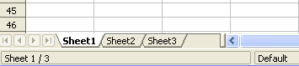Figure 1: Default sheet tabs

Inserting new sheets
There are several ways to insert a new sheet. The first step, in all cases, is to select the sheet that will be next to the new sheet. Then do any of the following:
- Select Insert > Sheet from the menu bar, or
- Right-click on the tab and select Insert Sheet, or
- Click in an empty space at the end of the line of sheet tabs.

Figure 2: Creating a new sheet
Click here to create a new sheet
Each method opens the Insert Sheet dialog. Here you can choose to put the new sheet before or after the selected sheet and how many sheets to insert.
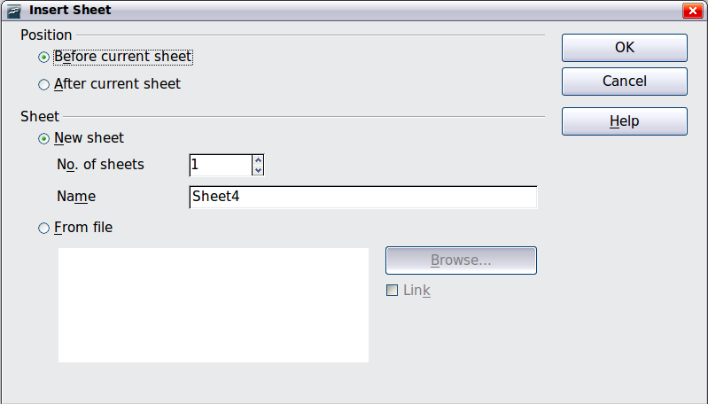
Figure 3. Insert Sheet dialog
We need 6 sheets, one for each of the 5 accounts and one as a summary sheet so we will add 3 more. We also want to name each of these sheets for the account they represent: Summary, Checking Account, Savings Account, Credit Card 1, Credit Card 2, and Car Loan.
We have two choices: insert 3 new sheets and rename all 6 sheets afterwards; or rename the existing sheets, then insert the 3 new sheets one at a time, renaming each new sheet during the insert step.
To insert sheets and rename afterwards:
- In the Insert Sheet dialog, choose the position for the new sheets (in this example, we use After current sheet).
- Choose New sheet and 3 as the No. of sheets. (Three sheets are already provided by default.) Because you are inserting more than one sheet, the Name box is not available.
- Click OK to insert the sheets.
- For the next steps, go to “Renaming sheets” on page 8.
To insert sheets and name them at the same time:
- Rename the existing sheets Summary, Checking Account, and Savings Account, as described in “Renaming sheets” on page 8.
- In the Insert Sheet dialog, choose the position for the first new sheet.
- Choose New sheet and 1 as the No. of sheets. The Name box is now available.
- In the Name box, type a name for this new sheet, for example Credit Card 1.
- Click OK to insert the sheet.
- Repeat steps 1–4 for each new sheet, giving them the names Credit Card 2 and Car Loan.

Inserting sheets from a different spreadsheet
On the Insert Sheet dialog, you can also add a sheet from a different spreadsheet file (for example, another Calc or Excel spreadsheet), by choosing the From file option. Click Browse and select the file; a list of the available sheets appears in the box. Select the sheet to import. If, after you select the file, no sheets appear you probably selected an invalid file type (not a spreadsheet, for example).
Tip | For a shortcut to inserting a sheet from another file, choose Insert > Sheet from file from the menu bar. The Insert Sheet dialog opens with the From file option preselected, and then the Insert dialog opens on top of it.
If you prefer, select the Link option to insert the external sheet as a link instead as a copy. This is one of several ways to include “live” data from another spreadsheet. (See also “Linking to external data” on page 17.) The links can be updated manually to show the current contents of the external file; or, depending on the options you have selected in Tools > Options > OpenOffice.org Calc > General > Updating, whenever the file is opened.

Renaming sheets
Sheets can be renamed at any time. To give a sheet a more meaningful name:
- Enter the name in the name box when you create the sheet, or
- Double click on the sheet tab, or
- Right-click on a sheet tab, select Rename Sheet from the pop-up menu and replace the existing name.
Note | If you want to save the spreadsheet to Microsoft Excel format, the following characters are not allowed in sheet names: \ / ? * [ ] : and ' as the first or last character of the name.
Your sheet tab area should now look like this.
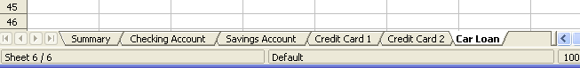Figure 4: Six renamed sheets
Now we will set up the account ledgers. This is just a simple summary that includes the previous balance plus the amount of the current transaction. For withdrawals, we enter the current transaction as a negative number so the balance gets smaller. A basic ledger is shown in Figure 5.
This ledger is set up in the sheet named Checking Account. The total balance is added up in cell F3. You can see the equation for it in the formula bar. It is the summary of the opening balance, cell C3, and all of the subsequent transactions.
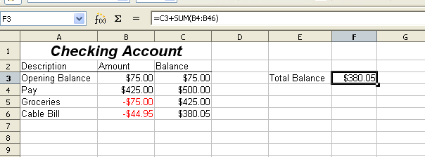Figure 5: Checking ledger

Referencing other sheets
On the Summary sheet we display the balance from each of the other sheets. If you copy the example in Figure 5 onto each account, the current balances will be in cell F3 of each sheet.
There are two ways to reference cells in other sheets: by entering the formula directly using the keyboard or by using the mouse. We will look at the mouse method first.

Creating the reference with the mouse
On the Summary sheet, set up a place for all five account balances, so we know where to put the cell reference. Figure 6 shows a summary sheet with a blank Balance column. We want to place the reference for the checking account balance in cell B3.
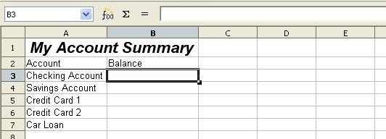Figure 6: Blank summary
To make the cell reference in cell B3, select the cell and follow these steps.
- Click on the = icon next to the input line. The icons change and an equals sign appears in the input line as in Figure 7.
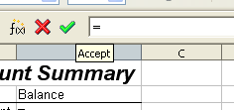
Figure 7: Equal sign in input line
- Now, click on the sheet tab for the sheet containing the cell to be referenced. In this case, that is the Checking Account sheet as shown in Figure 8.
Figure 8: Click on the checking account tab
- Click on cell F3 (where the balance is) in the Checking Account sheet. The phrase ‘Checking Account’.F3 should appear in the input line as in Figure 9.
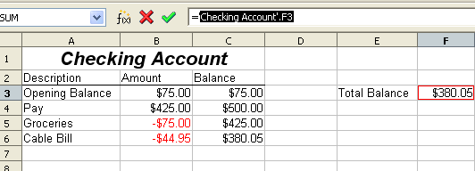Figure 9: Cell reference selected
- Click the green checkmark in the input line to finish.
- The Summary sheet should now look like Figure 10.
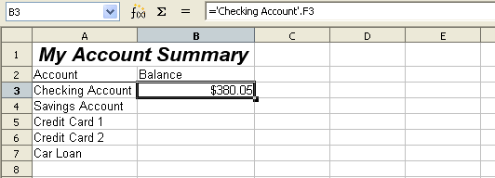Figure 10: Finished checking account reference

Creating the reference with the keyboard
From Figure 10, you can deduce how the cell reference is constructed. The reference has two parts: the sheet name (‘Checking Account’) and the cell reference (F3). Notice that they are separated by a period.
Note | The sheet name is in single quotes because it contains a space, and the mandatory period (.) always falls outside any quotes.
So, you can fill in the Savings Account cell reference by just typing it in. Assuming that the balance is in the same cell (F3) in the Savings Account sheet, the cell reference should be =’Savings Account’.F3 (see Figure 11).
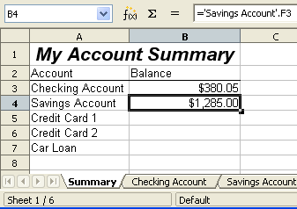Figure 11: Savings account reference

Referencing other documents
John decides to keep his family account information in a different spreadsheet file from his own summary. Fortunately Calc can link different files together. The process is the same as described for different sheets in a single spreadsheet, but we add one more step to indicate which file the sheet is in.

Creating the reference with the mouse
To create the reference with the mouse, both spreadsheets need to be open. Select the cell in which the formula is going to be entered.
- Click the = icon next to the input line.
- Switch to the other spreadsheet (the process to do this will vary depending on which operating system you are using).
- Select the sheet (Savings Account) and then the reference cell (F3).
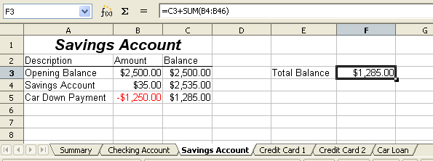
Figure 12: Selecting the savings account reference cell
- Switch back to the original spreadsheet.
- Click on the green check mark on the input line.
Your spreadsheet should now resemble Figure 13.
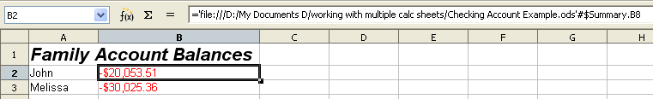Figure 13: Linked files
You will get a good feel for the format of the reference if you look closely at the input line. Based on this line you can create the reference using the keyboard.

Creating the reference with the keyboard
Typing the reference is simple once you know the format the reference takes. The reference has three parts to it:
- Path and file name
- Sheet name
- Cell
Looking at Figure 13 you can see the the general format for the reference is
=’file:///Path & File Name’#$SheetName.CellName
Note | The reference for a file has three forward slashes /// and the reference for a hyperlink has two forward slashes //.

Hyperlinks and URLs
Hyperlinks can be used in Calc to jump to a different location from within a spreadsheet and can lead to other parts of the current file, to different files or even to web sites.

Relative and absolute hyperlinks
Hyperlinks can be stored within your file as either relative or absolute.
A relative hyperlink says, Here is how to get there starting from where you are now (meaning from the folder in which your current document is saved) while an absolute hyperlink says, Here is how to get there no matter where you start from.
An absolute link will stop working only if the target is moved. A relative link will stop working only if the start and target locations change relative to each other. For instance, if you have two spreadsheets in the same folder linked to each other and you move the entire folder to a new location, a relative hyperlink will not break.
To change the way that OOo stores the hyperlinks in your file, select Tools > Options > Load/Save > General and choose if you want URLs saved relatively when referencing the File System, or the Internet, or both.
Calc will always display an absolute hyperlink. Don’t be alarmed when it does this even when you have saved a relative hyperlink—this ‘absolute’ target address will be updated if you move the file.
Note | Make sure that the folder structure on your computer is the same as the file structure on your web server if you save your links as relative to the file system and you are going to upload pages to the Internet.
Tip | When you rest the mouse pointer on a hyperlink, a help tip displays the absolute reference, since OOo uses absolute path names internally. The complete path and address can only be seen when you view the result of the HTML export (saving the spreadsheet as an HTML file), by loading the HTML file as Text, or by opening it with a text editor.

Creating hyperlinks
When you type text that can be used as a hyperlink (such as a website address or URL), Calc formats it automatically, creating the hyperlink and applying to the text a color and background shading. If this does not happen, you can enable this feature using Tools > AutoCorrect Options > Options and selecting URL Recognition.
Tips | To change the color of hyperlinks, go to Tools > Options > OpenOffice.org > Appearance, scroll to Unvisited links and/or Visited links, pick the new colors and click OK. Caution: this will change the color for all hyperlinks in all components of OpenOffice.org—this may not be what you want.
You can also insert and modify links using the Hyperlink dialog. To display the dialog, click the Hyperlink icon on the Standard toolbar or choose Insert > Hyperlink from the menu bar. To turn existing text into a link, highlight it before opening the dialog.
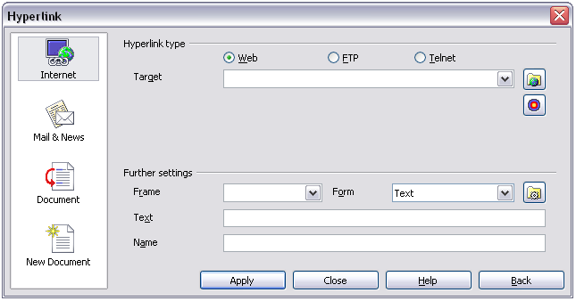
Figure 14. Hyperlink dialog showing details for Internet links
On the left side, select one of the four categories of hyperlinks:
- Internet: the hyperlink points to a web address, normally starting with http://
- Mail & News: the hyperlink opens an email message that the pre-addressed to a particular recipient
- Document: the hyperlink points to a place in either the current document or another existing document
- New document: the hyperlink creates a new document.
The top right part of the dialog changes according to the choice made for the hyperlink category from the left panel. A full description of all the choices, and their interactions, is beyond the scope of this chapter. Here is a summary of the most common choices used in spreadsheets.
For an Internet hyperlink, choose the type of hyperlink (Web, FTP, or Telnet), and enter the required web address (URL).
For a Mail and News hyperlink, specify whether it is a mail or news link, the receiver address and for email, also the subject.
For a Document hyperlink, specify the document path (the Open File button opens a file browser); leave this blank if you want to link to a target in the same spreadsheet. Optionally specify the target in the document (for example a specific sheet). Click on the Target in document icon to open the Navigator where you can select the target, or if you know the name of the target, you can type it into the box.
For a New Document hyperlink, specify whether to edit the newly created document immediately (Edit now) or just create it (Edit later), and enter the file name and the type of document to create (text, spreadsheet, etc.). The Select path button opens a directory picker dialog.
The Further settings section in the bottom right of the dialog is common to all the hyperlink categories, although some choices are more relevant to some types of links.
- Set the value of Frame to determine how the hyperlink will open. This applies to documents that open in a Web browser.
- Form specifies if the link is to be presented as text or as a button. Figure 15 shows a link formatted as a button.
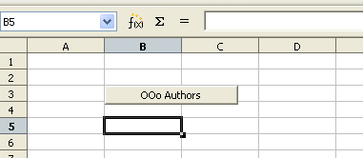Figure 15: OOo Authors hyperlink as button
- Text specifies the text that will be visible to the user. If you do not enter anything here, Calc will use the full URL or path as the link text. Note that if the link is relative and you move the file, this text will not change, though the target will.
- Name is applicable to HTML documents. It specifies text that will be added as a NAME attribute in the HTML code behind the hyperlink.
- Events button: this button will be activated to allow Calc to react to events for which the user has written some code (macro). This function is not covered in this chapter.
Note | A hyperlink button is a type of form control. As with all form controls, it can be anchored or positioned by right-clicking on the button in design mode. More information about forms can be found in Chapter 15 of the Writer Guide.  For the button to work , the spreadsheet must not be in design mode. To toggle design mode on and off, view the Form Controls toolbar (View > Toolbars > Form Controls) and click the Design Mode On/Off button .

Editing hyperlinks
To edit an existing link, place the cursor anywhere in the link and click the Hyperlink icon on the Standard toolbar or select Insert > Hyperlink from the menu bar. The Hyperlink dialog (Figure 14) opens. If the Hyperlink is in button form, the spreadsheet must have Design Mode on in order to edit the Hyperlink. Make your changes and click Apply. If you need to edit several hyperlinks, you can leave the Hyperlink dialog open until you have edited all of them. Be sure to click Apply after each one. When you are finished, click Close.

Removing hyperlinks
You can remove the clickable link from hyperlink text—leaving just the text—by right-clicking on the link and selecting Default Formatting. This option is also available from the Format menu. You may then need to re-apply some formatting in order for it to match the rest of your document.
To erase the link text or button from the document completely, select it and press the Backspace or Delete key.

Linking to external data
You can insert tables from HTML documents, and data located within named ranges from an OpenOffice.org Calc or Microsoft Excel spreadsheet, into a Calc spreadsheet. (To use other data sources, including database files in OOo Base, see “Linking to registered data sources” on page 22.)
You can do this in two ways: using the External Data dialog or using the Navigator. If your file has named ranges or named tables, and you know the name of the range or table you want to link to, using the External Data dialog method is quick and easy. However, if the file has several tables, and you want to pick only one of them, you may not be able to easily determine which is which; in that case, the Navigator method may be easier.

Using the External Data dialog
- Open the Calc document where the external data is to be inserted. This is the target document.
- Select the cell where the upper left-hand cell of the external data is to be inserted.
- Choose Insert > Link to External Data.
- On the External Data dialog (Figure 16), type the URL of the source document or click the [...] button to open a file selection dialog. Press Enter to get Calc to load the list of available tables.
- In the Available tables/range list, select the named ranges or tables you want to insert. You can also specify that the ranges or tables are updated every (number of) seconds.
- Click OK to close the dialog and insert the linked data.
Notes | - The Available tables/ranges list remains empty until you press Enter after typing the URL of the source. If you select the source document using the […] button, then pressing Enter is not required.  - The OK button remains unavailable (grayed out) until you select one or more tables/ranges in the list. You can hold down the Ctrl key while clicking on tables/ranges to select more than one.  - No images are imported
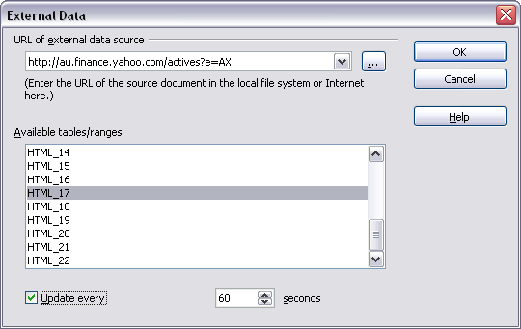Figure 16: Selecting a table or range in a source document from the Web

Using the Navigator
- Open the OpenOffice.org Calc spreadsheet in which the external data is to be inserted (target document).
- Open the document from which the external data is to be taken (source document). If the source document is a Web page, choose Web Page Query (OpenOffice.org Calc) as the file type.
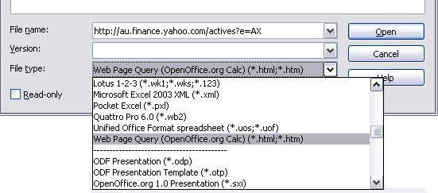
Figure 17: Opening a file using the Web Page Query filter
- In the target document, press F5 to open the Navigator.
- At the bottom of the Navigator, select the source document. (In Figure 18, the source is named actives.)
The Navigator now shows the range names or the tables contained in the source document (the example contains range names; other documents have a list of tables). Click on the + next to Range names to display the list.
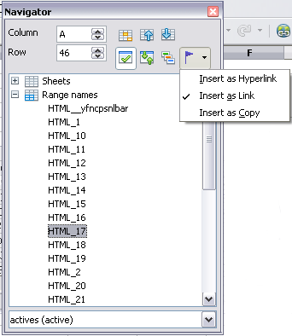
Figure 18: Selecting a data range in a source document, to be inserted as a link
- In the Navigator, select the Insert as Link drag mode, as shown in Figure 18.
- Select the required range or table and drag it from the Navigator into the target document, to the cell where you want the upper left-hand cell of the data range to be.
- In the target document, check the Navigator. Instead of a + by Range names, it shows a + by Linked areas. Click the + to see the same range name (see Figure 19).
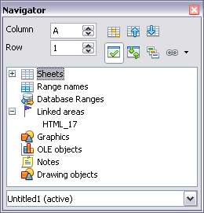
Figure 19: Linked areas in target spreadsheet

How to find the required data range or table
The examples above show that the import filter gave names to the data rangers (tables) in the sample web page starting from HTML_1. It also created two additional range names (not visible in the illustration):
HTML_all – designates the entire document
HTML_tables – designates all HTML tables in the document
If the data tables in the source HTML document have been given names (using the ID attribute on the TABLE tag), or the external spreadsheet includes named ranges, those names appear in the list along with the ranges Calc has sequentially numbered.
If the data range or table you want is not named, how can you tell which one to select?
Go to the source document, which you opened in Calc. In the Navigator, double-click on a range name: that range is highlighted on the sheet (see Figure 20).
If the Formula Bar is visible, the range name is also displayed in the Name box at the left-hand end (see Figure 21).
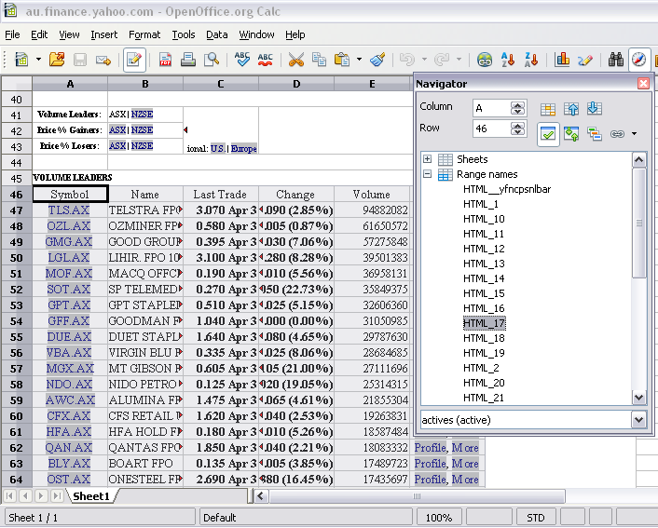Figure 20: Using the Navigator to find a data range name
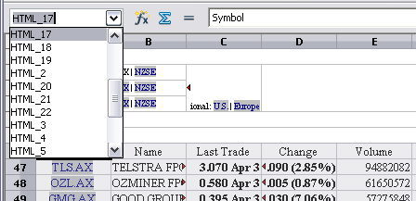Figure 21: Using the Name box to find a data range name

Linking to registered data sources
You can access a variety of databases and other data sources and link them into Calc documents.
First you need to register the data source with OpenOffice.org. (To register means to tell OOo what type of data source it is and where the file is located.) The way to do this depends on whether or not the data source is a database in *.odb format.
To register a data source that is in *.odb format:
- Choose Tools > Options > OpenOffice.org Base > Databases.
- Click the New button (below the list of registered databases) to open the Create Database Link dialog (Figure 22).
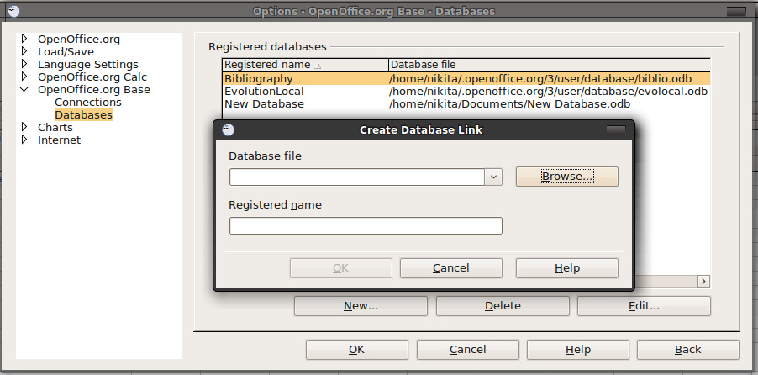Figure 22: Registering databases
- Enter the location of the database file, or click Browse to open a file browser and select the database file.
- Type a name to use as the registered name for the database and click OK. The database is added to the list of registered databases. The OK button is enabled only when both fields are filled in.
To register a data source that is not in *.odb format:
- Choose File > New > Database to open the Database Wizard.
- Select Connect to an existing database. The choices for database type depend on your operating system. For example, Microsoft Access and other Microsoft products are not among the choices if you are using Linux. In our example, we chose dBASE.
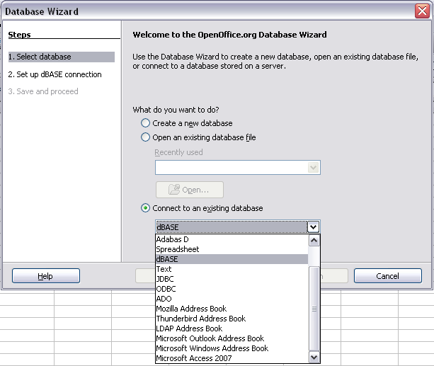Figure 23: Registering a database using the Database Wizard
- Click Next. Type the path to the database file or click Browse and use the Open dialog to navigate to and select the database file before clicking Open.
- Click Next. Select Yes, register the database for me, but clear the checkbox marked Open the database for editing.
- Click Finish. Name and save the database in the location of your choice. Note: changes made to the *.odb do not affect the original dBASE file.
Once a data source has been registered, it can be used by any OOo component (for example Calc).

Viewing data sources
Open a document in Calc. To view the data sources available, press F4 or select View > Data Sources from the menu bar. The Data Source View pane opens above the spreadsheet. A list of registered databases is in the Data Explorer area on the left. (The built-in Bibliography database is included in the list.)
To view each database, click on the + to the left of the name of the database. (This has been done for the Automobile database in Figure 24.) Click on the + next to Tables to view the individual tables.
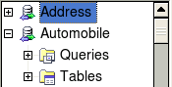Figure 24: Databases
Now click on a table to see all the records held in it. The data records are displayed on the right side of the Data Source View pane. To see more columns, you can click the Explorer On/Off button to hide the Data Explorer area.
At the top of the Data Source View pane, below the Calc toolbars, is the Table Data bar. This toolbar includes buttons for saving records, editing data, finding records, sorting, filtering, and other functions. For more details about this toolbar, see the Help for data source browser.
Below the records is the Form Navigation bar, which shows which record is selected and the total number of records. To the right are five tiny buttons; the first four move backwards or forwards through the records, or to the beginning or end.

Figure 25: Data Source View navigation buttons

Editing data sources
Some data sources (such as spreadsheets) cannot be edited in the data source view.
In editable data sources, records can be edited, added, or deleted. If you cannot save your edits, you need to open the database in Base and edit it there; see “Launching Base to work on data sources”. You can also hide columns and make other changes to the display.

Launching Base to work on data sources
You can launch OOo Base at any time from the Data Source View pane. Right-click on a database or the Tables or Queries icons and select Edit Database File. Once in Base, you can edit, add, and delete tables, queries, forms, and reports.
For more about using Base, see Chapter 8 (Getting Started with Base) in the Getting Started guide.

Using data sources in Calc spreadsheets
Data from the tables in the data source pane can be placed into Calc documents in a variety of ways.
You can select a cell or an entire row in the data source pane and drag and drop the data into the spreadsheet. The data is inserted at the place where you release the mouse button.
An alternative method uses the Data to Text icon and will include the column headings above the data you insert:
- Click the cell of the spreadsheet which you want to be the top left of your data including the column names.
- Press F4 to open the database source window and select the table containing the data you want to use.
- Select the rows of data you want to add to the spreadsheet:
  - Click the gray box to the left of the row you want to select if only selecting one row. That row is highlighted.
  - To select multiple adjacent rows, hold down the Shift key while clicking the gray box of the rows you need.
  - To select multiple separate rows, hold down the Control key while selecting the rows. The selected rows are highlighted.
  - To select all the rows, click the gray box in the upper left corner. All rows are highlighted.
- Click the Data to text icon to insert the data into the spreadsheet cells.
You can also drag the data source column headings (field names) onto your spreadsheet to create a form for viewing and editing individual records one at a time. Follow these steps:
- Click the gray box at the top of the column (containing the field name you wish to use) to highlight it.
- Drag and drop the gray box to where you want the record to appear in the spreadsheet.
- Repeat until you have moved all of the fields you need to where you want them.
- Close the Data Source window: press F4.
- Save the spreadsheet and click the Edit File button on the Standard toolbar, to make the spreadsheet read-only. All of the fields will show the value for the data of the first record you selected.
- Add the Form Navigation toolbar: View > Toolbars > Form Navigation. By default, this toolbar opens at the bottom of the Calc window, just above the status bar.
- Click the arrows on the Form Navigation toolbar to view the different records of the table. The number in the Record box changes as you move through the records. The data in the fields changes to correspond to the data for that particular record number. You can also search for a specific record, sort and filter records, and do other tasks using this toolbar.

Embedding spreadsheets
Spreadsheets can be embedded in other OOo files. This is often used in Writer or Impress documents so that Calc data can be used in a text document. You can embed the spreadsheet as either an OLE or DDE object. The difference between a DDE object and a Linked OLE object is that a Linked OLE object can be edited from the document in which it is added as a link, but a DDE object cannot.
For example, if a Calc spreadsheet is pasted into a Writer document as a DDE object, then the spreadsheet cannot be edited in the Writer document. But if the original Calc spreadsheet is updated, the changes are automatically made in the Writer document. If the spreadsheet is inserted as a Linked OLE object into the Writer document, then the spreadsheet can be edited in the Writer as well as in the Calc document and both documents are in sync with each other.

Object Linking and Embedding (OLE)
The major benefit of an OLE (Object Linking and Embedding) object is that it is quick and easy to edit the contents just by double-clicking on it. You can also insert a link to the object that will appear as an icon rather than an area showing the contents itself.
OLE objects can be linked to a target document or be embedded in the target document. Linking inserts information which will be updated with any subsequent changes to the original file, while embedding inserts a static copy of the data. If you want to edit the embedded spreadsheet, double-click on the object.
To embed a spreadsheet as an OLE object in a presentation:
- Place the cursor in the document and location you want the OLE object to be.
- Select Insert > Object > OLE Object. The dialog below opens.
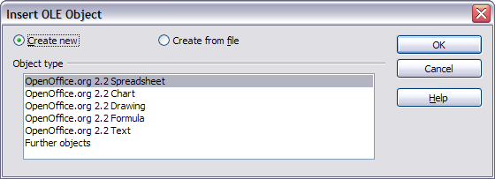Figure 26: Insert OLE object dialog
- You can either create a new OLE object or create from a file.
To create a new object:
- Select Create new and select the object type among the available options.
Note | “Further objects” is only available if you are using the Windows operating system.
- Click OK. An empty container is placed in the slide.
- Double-click on the OLE object to enter the edit mode of the object. The application devoted to handling that type of file will open the object.
Note | If the object inserted is handled by OpenOffice.org, then the transition to the program to manipulate the object will be seamless; in other cases the object opens in a new window and an option in the File menu becomes available to update the object you inserted.
To insert an existing object:
- To create from a file, select Create from file. The dialog changes to look like Figure 27.
- To insert the object as a link, select the Link to file option. Otherwise, the object will be embedded.
- Click Search, select the required file in the Open dialog, then click Open. A section of the inserted file is shown in the document.
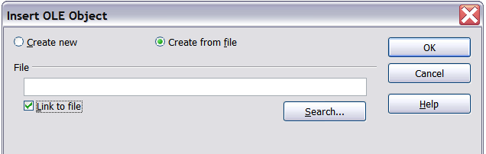Figure 27: Inserting an object as a link

Other OLE objects
Under Windows, the Insert OLE Object dialog box has an extra entry, Further objects, as shown in Figure 26.
- Double-click on the entry Further objects to open the dialog shown below.
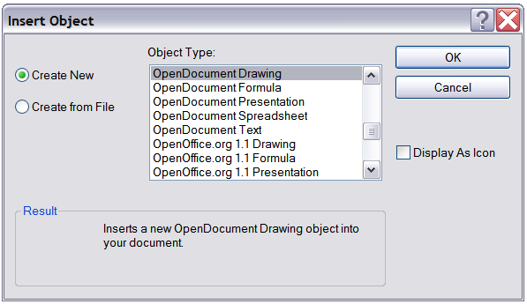
Figure 28: Inserting an OLE object under Windows
- Select Create New to insert a new object of the type selected in the Object Type list, or select Create from File to create a new object from a file.
- If you choose Create from File, the dialog shown below opens. Click Browse and choose the file to insert. The inserted file object is editable by the Windows program that created it.
If instead of inserting an object, you want to insert a link to an object, select the Display As Icon option.
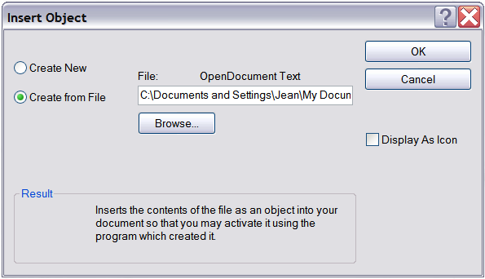Figure 29: Insert object from a file

Non-linked OLE object
If the OLE object is not linked, it can be edited in the new document. For instance, if you insert a spreadsheet into a Writer document, you can essentially treat it as a Writer table (with a little more power). To edit it, double-click on it.

Linked OLE object
When the spreadsheet OLE object is linked, if you change it in Writer it will change in Calc; if you change it in Calc, it will change in Writer. This can be a very powerful tool if you create reports in Writer using Calc data, and want to make a quick change without opening Calc.
Note | You can only edit one copy of a spreadsheet at a time. If you have a linked OLE spreadsheet object in an open Writer document and then open the same spreadsheet in Calc, the Calc spreadsheet will be a read-only copy.

Dynamic Data Exchange (DDE)
DDE is an acronym for Dynamic Data Exchange, a mechanism whereby selected data in document A can be pasted into document B as a linked, ‘live’ copy of the original. It would be used, for example, in a report written in Writer containing time-varying data, such as sales results sourced from a Calc spreadsheet. The DDE link ensures that, as the source spreadsheet is updated so is the report, thus reducing the scope for error and reducing the work involved in keeping the Writer document up to date.
DDE is a predecessor of OLE. With DDE, objects are linked through file reference, but not embedded. You can create DDE links either within Calc cells in a Calc sheet, or in Calc cells in another OOo doc such as in Writer.

DDE link in Calc
Creating a DDE link in Calc is similar to creating a cell reference. The process is a little different, but the result is the same.
- In Calc, select the cells that you want to make the DDE link to.
- Copy them: Edit > Copy or Ctrl+C.
- Go to the place in the spreadsheet where you want the link to be.
- Select Edit > Paste Special.
- When the Paste Special dialog opens, select the Link option on the bottom left of the dialog (Figure 30). Click OK.
The cells now reference the copied data, and the formula bar shows a reference beginning with {=DDE.
If you now edit the original cells, the linked cells will update.
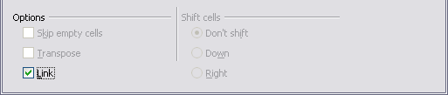
Figure 30: Location of Link option on Paste Special dialog in Calc

DDE link in Writer
The process for creating a DDE link from Calc to Writer is similar to creating a link within Calc.
- In Calc, select the cells to make the DDE link to. Copy them.
- Go to the place in your Writer document where you want the DDE link. Select Edit > Paste Special.
- Select DDE Link (Figure 31). Click OK.
Now the link has been created in Writer. When the Calc spreadsheet is updated, the table in Writer is automatically updated.
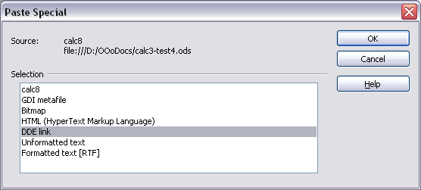Figure 31: Paste Special dialog in Writer, with DDE link selected

