

Getting Started Guide
Chapter 15
Using Fontwork
Creating Graphical Text Art Objects

Copyright
This document is Copyright © 2005–2008 by its contributors as listed in the section titled Authors. You may distribute it and/or modify it under the terms of either the GNU General Public License, version 3 or later (http://www.gnu.org/licenses/gpl.html), or the Creative Commons Attribution License, version 3.0 (http://creativecommons.org/licenses/by/3.0/) or later.
All trademarks within this guide belong to their legitimate owners.

Authors
Agnes Belzunce
Daniel Carrera
Iain Roberts
Jean Hollis Weber
Peter Kupfer
Peter Hillier-Brook

Feedback
Please direct any comments or suggestions about this document to:
authors@user-faq.openoffice.org

Publication date and software version
Published 21 April 2008. Based on OpenOffice.org 2.4.
Contents
Copyright i
Authors i
Feedback i
Acknowledgments i
Publication date and software version i
What is Fontwork? 1
The Fontwork toolbars 1
Creating a Fontwork object 1
Editing a Fontwork object 3
Using the Fontwork toolbar 3
Using the Formatting toolbar 4
Line options 5
Area options 6
Positioning options 7
Using menu options 8
Moving and resizing Fontwork objects 9

What is Fontwork?
With Fontwork you can create graphical text art objects for making your work more attractive. There are many different settings for text art objects (line, area, position, size, and more), so you have a large choice. You will surely find one that fits your document.
Fontwork is available with each component of OpenOffice.org (OOo), but you will notice small differences in the way that each component displays it.

The Fontwork toolbars
You can use two different toolbars for creating and editing a Fontwork object.
- Go to View > Toolbars > Fontwork.
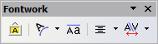
Figure 1. The floating Fontwork toolbar
- If you click on an existing Fontwork object, the Formatting toolbar changes to display the Fontwork options as in Figure 8. The contents of this toolbar vary depending on the OOo component with which it is being used.

Creating a Fontwork object
- On the Drawing or Fontwork toolbar, click the Fontwork Gallery icon . If the Drawing toolbar is not visible, go to View > Toolbars > Drawing to display it.
- In the Fontwork Gallery dialog (Figure 2), select a Fontwork style, then click OK. The Fontwork object will appear in your document. Notice the blue squares around the edge (indicating that the object is selected) and the yellow dot; these are discussed in “Moving and resizing Fontwork objects” on page 8.
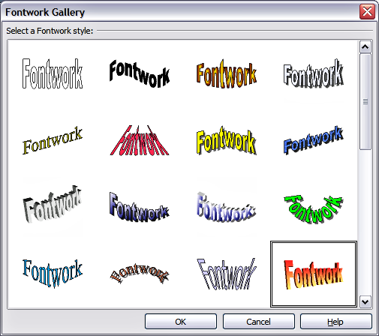Figure 2. The Fontwork Gallery
- Double-click the object to edit the Fontwork text. Type your own text in place of the black Fontwork text that appears over the object (Figure 3).

Figure 3. Editing Fontwork text
- Click anywhere in a free space or press Esc to apply your changes.

Editing a Fontwork object
Now that the Fontwork object is created, you can edit some of its attributes. To do this, you can use the Fontwork toolbar, the Formatting toolbar, or menu options as described in this section.

Using the Fontwork toolbar
Make sure that the Fontwork toolbar, shown in Figure 1, is visible. If you do not see it, go to View > Toolbars > Fontwork.
Click on the different icons to edit Fontwork objects:
Fontwork Shape: Edits the shape of the selected object. You can choose from a palette of shapes, as shown in Figure 4.
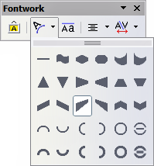
Figure 4. Fontwork toolbar showing palette of shapes

Fontwork Same Letter Heights: Changes the height of characters in the object. Toggles between normal height (some characters taller than others, for example capital letters, d, h, l and others) and all letters the same height. See Figure 5.
Figure 5. Left: normal letters; right: same letter heights
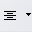
Fontwork Alignment: Changes the alignment of characters. Choices are left align, center, right align, word justify, and stretch justify. The effects of the text alignment can only be seen if the text spans over two or more lines. In the stretch justify mode, all the lines are filled completely.
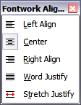
Figure 6: The extended alignment toolbar
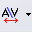
Fontwork Character Spacing: Changes the character spacing and kerning in the object. For custom spacing, input a percentage value: 100% is normal spacing; less than 100% is tight spacing; more than 100% is expanded spacing.
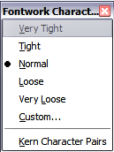
Figure 7: The extended character spacing toolbar

Using the Formatting toolbar
Now let us go further and customize the Fontwork object with several more attributes.
Click on the Fontwork object. The Formatting toolbar changes to show all the options for editing the object. (For example, the toolbar shown in Figure 8 appears when you use Fontwork in Writer.)
Note that in this figure the toolbar has been un-docked for ease of illustration: unless you have chosen to “float” the toolbar in this way, it will appear in its default, docked position somewhere below the menu bar.
On the Formatting toolbar you have a large choice of options for customizing your object. These choices are the same as the ones for other drawing objects. You can read about them in more detail in the Draw Guide.
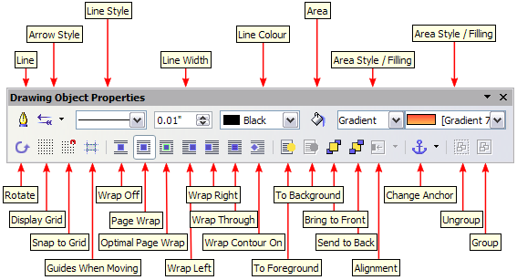Figure 8. Formatting toolbar with a Fontwork object selected in Writer

Line options
Line icon: Opens a dialog (Figure 9) with three tabs: Line, Line Styles, Arrow Styles.
- Use the Line tab to edit the most common properties of the line around the selected Fontwork object, by choosing from previously-defined attributes including line style, line color, and arrow styles.
- Use the Lines Styles and Arrow Styles tabs to edit the properties of line and arrow styles, and define new styles.
Arrow Style icon: Choose from the different arrow styles.
Line Style box: Choose from the available line styles.
Line Width box: Set the width of the line.
Line Color box: Select the color of the line.
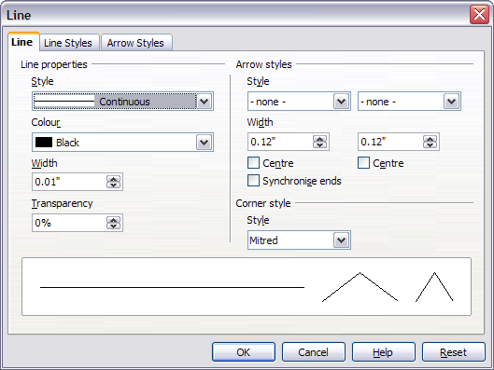Figure 9. Line options dialog

Area options
Area icon: Opens a dialog (Figure 10) with seven tabs: Area, Shadow, Transparency, Colors, Gradients, Hatching, Bitmaps.
- Area tab: Choose from the predefined list a color, bitmap, gradient or hatching pattern to fill the selected object.
- Shadow tab: Set the shadow properties of the selected object.
- Transparency tab: Set the transparency properties of the selected object.
- Colors tab: Modify the available colors or add new ones to appear on the Area tab.
- Gradients tab: Modify the available gradients or add new ones to appear on the Area tab.
- Hatching tab: Modify the available hatching patterns or add new ones to appear on the Area tab.
- Bitmaps tab: Create simple bitmap patterns and import bitmaps, to make them available on the Area tab.
Area Style / Filling boxes: Select the type of the fill of the selected object. For more detailed settings, use the Area icon.
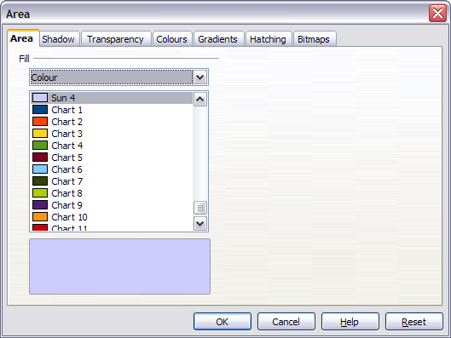Figure 10. Area options dialog

Positioning options
Rotate icon: Rotate the selected object manually using the mouse to drag the object.
To Foreground icon: Moves the selected object in front of the text.
To Background icon: Moves the selected object behind the text.
Alignment icon: Modifies the alignment of the selected objects.
Bring to front icon: Moves the selected object in front of the others.
Send to back icon: Moves the selected object behind the others.
Change Anchor icon: Switch between anchoring options:
- To Page - The object keeps the same position in relation to the page margins. It does not move as you add or delete text.
- To Paragraph - The object is associated with a paragraph and moves with the paragraph. It may be placed in the margin or another location.
- To Character - The object is associated with a character but is not in the text sequence. It moves with the paragraph but may be placed in the margin or another location. This method is similar to anchoring to a paragraph.
- As Character - The object is placed in the document like any character and moves with the paragraph as you add or delete text before the object.
Ungroup icon: Ungroups the selected objects, so you can manage them individually .
Group icon: Groups the selected objects, so you can manage them as a single object.

Using menu options
You can use some the choices on the Format menu to anchor, align, arrange and group selected Fontwork objects, wrap text around them, and flip them horizontally and vertically.
You can also right-click on a Fontwork object and choose many of the same options from the pop-up menu. In addition, the pop-up menu provides quick access to the Line, Area, Text, and Position and Size dialogs. The Line and Area dialogs are described on pages 5 and 6. The Text dialog offers only a few options for Fontwork objects and is not discussed here.
On the Position and Size dialog (Figure 11), you can enter precise values concerning size and position. For more information, see the Draw Guide.
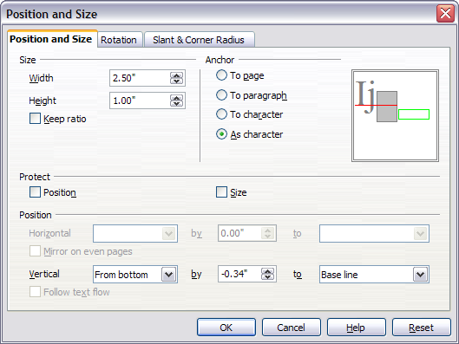Figure 11. Position and Size dialog

Moving and resizing Fontwork objects
When you select a Fontwork object, eight blue squares (known as handles) appear around the edge of the object, as shown in Figure 3. You can drag these handles to resize the object.
A yellow dot also appears on the object. This dot may be along an edge of the object, or it may be somewhere else; see Figure 12 for an example. If you hover the pointer over this yellow dot, the pointer turns into a hand symbol. You can drag the dot in different directions to distort the object.
Figure 12. Yellow dot
Hovering the pointer over other parts of the object turns the pointer into the usual symbol for dragging the object to another part of the page.
For precise control of the location and size of the object, use the Position and Size dialog (Figure 11).

