

Writer Guide
Chapter 14
Working with Fields

Copyright
This document is Copyright © 2005, 2006 by its contributors as listed in the section titled Authors. You can distribute it and/or modify it under the terms of either the GNU General Public License, version 2 or later (http://www.gnu.org/licenses/gpl.html), or the Creative Commons Attribution License, version 2.5 or later (http://creativecommons.org/licenses/by/2.5/).
All trademarks within this guide belong to their legitimate owners.

Authors
Jean Hollis Weber
John Kane
Agnes Belzunce
Gary Schnabl

Feedback
Maintainer: Jean Hollis Weber
Please direct any comments or suggestions about this document to:
authors@user-faq.openoffice.org

Acknowledgments
Most of this chapter is adapted and updated from Chapter 5, “Getting the Most from Fields” in Jean Hollis Weber’s book OpenOffice.org Writer: The Free Alternative to Microsoft Word, O’Reilly Community Press, 2004.

Publication date and software version
Published 22 October 2006. Based on OpenOffice.org 2.0.4.
Contents
Copyright i
Authors i
Feedback i
Acknowledgments i
Publication date and software version i
Introduction to fields 1
Quick and easy field entry 1
Using document properties to hold information that changes 1
Using other fields to hold information that changes 3
Using AutoText to insert often-used fields 4
Defining your own numbering sequences 5
Create a number range variable 5
Use AutoText to insert a number range field 7
Using automatic cross-references 7
Prepare items as targets for cross-referencing 8
Using bookmarks 8
Setting references 8
Insert cross-references 9
Using fields in headers and footers 11
Using fields instead of outline numbering for chapter numbers 12
Tricks for working with fields 13
Keyboard shortcuts for fields 13
Fixing the contents of fields 13
Converting fields into text 13
Developing conditional content 13
Choose the types of conditional content to use 14
Conditional text 14
Hidden text 14
Hidden paragraphs 14
Hidden sections 14
Plan your conditional content 14
Choose or define a variable 15
Define a logical expression (condition) involving the selected variable 15
Create the variable 15
DocInformation fields 15
User-defined variable field 15
Apply the condition to the content 17
Conditional text 17
Hidden text 18
Hidden paragraphs 18
Hidden sections 19
Change the value of the variable 20
Editing hidden paragraphs and sections 20
Using placeholder fields 21

Introduction to fields
Fields are extremely useful features of Writer. They are used for data that changes in a document, such as the current date or the total number of pages. This chapter describes how to use a few of them.
TIP | Fields have a gray background when viewed on screen, unless you have deselected the Field shadings checkbox or changed the color of field shadings on the Appearance page of the Options – OpenOffice.org dialog box. This gray background will not show when you print the file to hardcopy or PDF.  To turn field shadings on or off quickly, choose View > Field Shadings or press Control+F8.

Quick and easy field entry
You can quickly insert common fields into your document by choosing Insert > Fields from the menu bar and selecting the required field from the list, as shown in Figure 1.
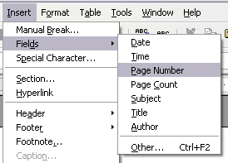Figure 1: Inserting common fields

Using document properties to hold information that changes
The Properties dialog box for any document contains locations on the Description tab (Figure 2) and the User Defined tab (Figure 3) for information that you might want to include in your document, especially if it is information that might change during the course of the project. To display this dialog box, click File > Properties.
Later in this chapter, we will see how to use this information in fields. You can return to this dialog box at any time and change the information you entered. When you do so, all of the references to that information will change wherever they appear in the document. For example, you might need to change the contents of the Title field from the draft title to the production title.
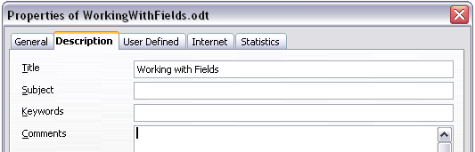Figure 2: The Description tab of the document’s Properties dialog box
The User Defined tab provides four fields for you to use, as required. You can change the default names for these fields to more meaningful names. The example in Figure 3 shows that three of the defaults have been changed: Info 1 to Chapter subtitle, Info 2 to Chapter number, and Info 3 to Name of guide.
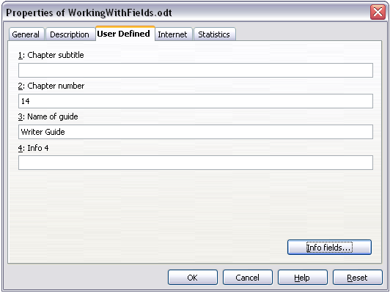Figure 3: The User Defined tab of the document’s Properties dialog box
To change these field names, click the Info fields button near the bottom of the dialog box. In the small pop-up dialog box (Edit Field Names, not shown here), type the field names you want and then click OK.

Using other fields to hold information that changes
One way that people use fields is to hold information that is likely to change during the course of a project. For example, the name of a manager, a product, or even your entire company may change just before the document is due to be printed. If you have inserted the changeable information as fields, you can change the information in one place, and it will automatically change in all the places where that field occurs.
Writer provides several places where you can store the information referred to by a field. We will look at some of them here.
Seven document properties (Time, Date, Title, Subject, Author, Page Number, and Page Count) are on the Insert > Fields menu (Figure 1). To insert one of these fields, click on it in the menu.
Other document properties are on the DocInformation and Document tabs of the Fields dialog box (Figure 4 and Figure 5), reached by clicking Insert > Fields > Other.
To insert one of these fields, select it in the Type list and then select from the Select and Format lists if choices appear. Finally, click Insert.
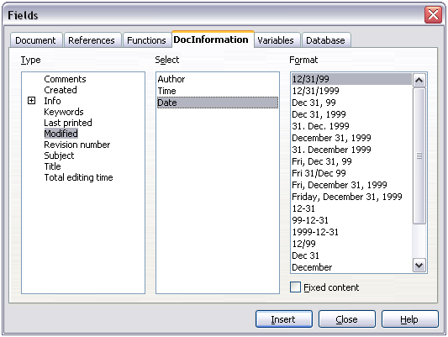Figure 4: Inserting a Date Modified field using the DocInformation tab of the Fields dialog box
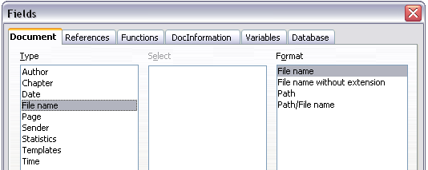Figure 5: Inserting a File name field using the Document tab of the Fields dialog box
Some of these items are picked up from the User Data page of the Options dialog box, so make sure the information on that page is correct.
TIP | Although these fields are often used to hold information that changes, you can make the content unchangeable by selecting the Fixed content checkbox (visible in Figure 4) when inserting the field. If necessary, you can come back to this dialog box later and deselect this checkbox to make the field variable again.

Using AutoText to insert often-used fields
If you use the same fields often, you will want a quick and easy way to insert them. Use AutoText for this purpose. To define an AutoText entry for a field:
- Insert a field into your document, as described previously.
- Select the field, and then click Edit > AutoText (or press Ctrl+F3).
- On the AutoText dialog box (Figure 6), choose the group where this new entry will be stored (in this example, it is going into My AutoText), type a name for the entry, and change the suggested shortcut if you wish.
- Click the AutoText button and click New to have the entry inserted as a field. Do not choose New (text only) because the AutoText entry will be plain text, not a field. Click Close to close the AutoText dialog box.
- Now whenever you want to insert this field at the cursor position, type the shortcut, and then press F3.
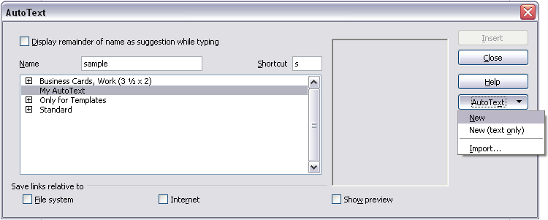Figure 6: Creating a new AutoText entry

Defining your own numbering sequences
You may want to define your own numbering sequences to use in situations where you do not always want the number at the start of the paragraph or where you want more control than the built-in numbering choices give you.
This topic describes how to create and use a numbering sequence, using a “number range variable” field.

Create a number range variable
To create a number range variable using Arabic (1, 2, 3) numbers:
- Place the insertion point in a blank paragraph in your document.
- Click Insert > Fields > Other and select the Variables tab (Figure 7).
- In the Type list, select Number range. In the Format list, select Arabic (1 2 3). Type whatever you want in the Name field. (I have used Step in this example.)
- Click Insert. The name of the variable (Step) now appears in the Selection list, and a number field (showing 1) appears at the insertion point in your document. The Fields dialog box remains open, so you may need to move it out of the way to see the field in the document.
- Hover the mouse pointer over this number field and you will see the field code of
Step = Step+1. If you click several more times on the Insert button in the Fields dialog box, the numbers 2, 3, 4, and so on will appear in the document.
- Now you may want to create another field to restart the Step sequence at 1, so you can use the same sequence name more than once in your document (for example, to begin each set of instructions).
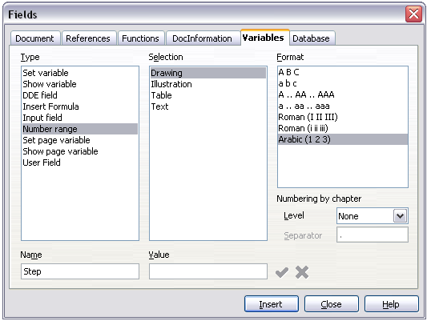Figure 7: Defining a number range variable
- To create this new field, open the Fields dialog box to the Variables tab. Make sure the variable name Step appears in the Name box. In the Value box, type Step=1, as shown in Figure 8. Click Insert. Now hover the mouse pointer over the new field in your document and you will see the field code of Step = Step=1.
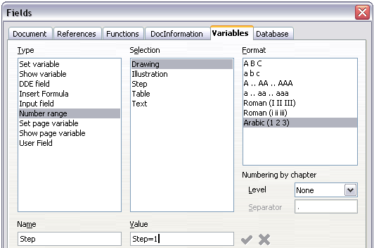Figure 8: Defining a field to restart a number range variable

Use AutoText to insert a number range field
You certainly do not want to go through all of that every time you want to put in a step number. Instead, create two AutoText entries, one for the Step = Step=1 field (call it Step1, for example) and one for the Step = Step+1 field (StepNext). See “Using AutoText to insert often-used fields” on page 4.
You can create similar fields for substeps or other sequences that you want to be numbered with letters (a, b, c), Roman numerals (i, ii, iii), or some other sequence. In the Fields dialog box, choose the required format in the Format list when creating the field codes.
TIP | If a user-defined variable is not in use in the document, the icon next to the Value box is active. You can delete the variable by clicking this icon. To remove a variable that is used in the current document, first delete from the document all fields using that variable, and then remove the variable from the list.

Using automatic cross-references
If you type in references to other parts of the document, those references can easily get out of date if you reword a heading, add or remove figures, or reorganize topics. Replace any typed cross-references with automatic ones and, when you update fields, all the references will update automatically to show the current wording or page numbers. The References tab of the Fields dialog box (Figure 9) lists some items, such as bookmarks, figures, tables, and user-defined number range variables. Other items that you might expect to be listed, such as headings, are not shown.
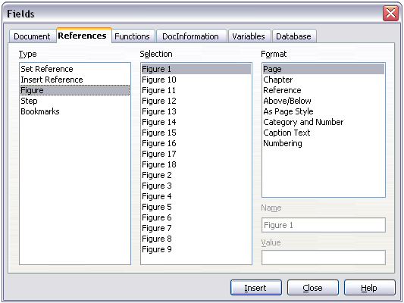
Figure 9: The References tab of the Fields dialog box

Prepare items as targets for cross-referencing
Before you can insert a cross-reference to anything that is not automatically shown on the References tab, such as a heading, you must prepare or “set” that heading as an item to be referenced. To do this, you can either use bookmarks or set references.

Using bookmarks
Bookmarks are listed in the Navigator and can be accessed directly from there with a single mouse click. In HTML documents, bookmarks are converted to anchors that you can jump to via hyperlink.
- Select the text you want to bookmark. Click Insert > Bookmark.
- On the Insert Bookmark dialog box (Figure 10), the larger box lists any previously defined bookmarks. Type a name for this bookmark in the top box. Click OK.
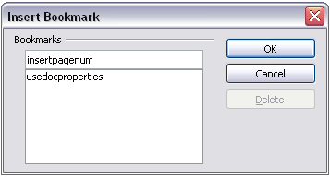Figure 10: Inserting a bookmark

Setting references
- Click Insert > Cross reference.
- On the References tab of the Fields dialog box (Figure 11), click Set Reference in the Type list. The Selection list shows any references that have been defined.
You can leave this page open while you set many headings as references.
- Click in the document and highlight the text of the first heading to be used as a target for a cross-reference. Click on the Fields dialog box. The text of the heading will appear in the Value box in the lower right of the dialog box. In the Name box, type some text by which you can identify this heading.
- Click Insert. The text you typed in the Name box now appears in the Selection list.
- Repeat steps 3 and 4 as often as required.
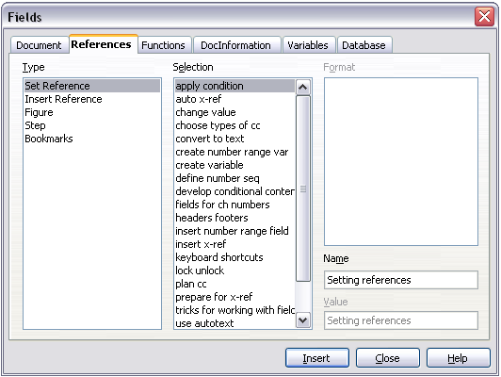Figure 11: Setting text to be used as a target for a cross-reference

Insert cross-references
To insert a cross-reference to a heading or other text:
- In your document, place the cursor where you want the cross-reference to appear.
- If the Fields dialog box is not open, click Insert > Cross Reference. On the References tab of the Fields dialog box (Figure 12), in the Type list, click Insert Reference or Bookmarks (depending on how you set your references).
You can leave this page open while you insert many cross-references.
- Click on the required item in the Selection list, which shows the bookmarks or references that have been defined. In the Format list, choose the type of reference required. Usually this will be Reference (to insert the full text of the reference or bookmark) or Page (to insert the number of the page the referenced or bookmarked text is on). Click Insert.
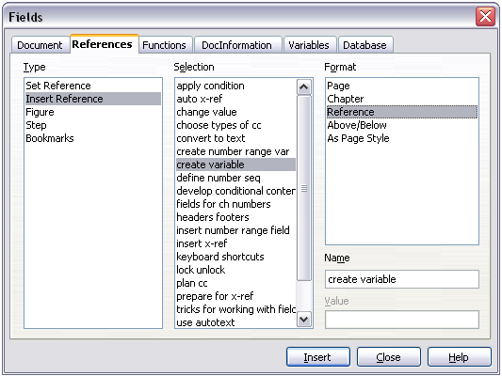Figure 12: Inserting a cross-reference to a heading
To insert a cross-reference to an item (such as a figure caption) that you have previously inserted into the document as a numbering-sequence field:
- In your document, place the cursor where you want the cross-reference to appear. If the Fields dialog box is not already open, click Insert > Cross-reference.
- On the References tab of the Fields dialog box (Figure 9), select Figure in the Type list.
- Click on the required item in the Selection list, which shows the list of figures that have previously been inserted into the document. The Format list shows different choices from those given for headings. Choose the type of reference required. Usually this will be Category and Number (to insert the word “Figure” and its number), Reference (to insert the word “Figure” with its number and the full text of the caption), or Page (to insert the number of the page the figure is on).
- Click Insert.

Using fields in headers and footers
You can insert fields into headers or footers, using techniques described earlier in this chapter:
- To insert a page number, document title, author, creation date and time, current date and time, or total page count field, use document properties (see page 1).
- You can insert a cross-reference to a bookmark or a set reference.
- If you have used Heading 1 for your chapter titles, you can use a document field to insert the current chapter title, so it changes from one chapter to the next. See Figure 13, which calls chapter titles “names”. If you have used outline numbering on your Heading 1, you can choose whether to include these numbers in the field.
- You can insert cross-references to other heading levels by specifying a value in the Layer box in the lower right of the Document tab of the Fields dialog box (Figure 13). That is, Layer 1 = Heading 1, Layer 2 = Heading 2, and so on.
A cross-reference field in the header of a page picks up the first heading of that level on the page, and a field in the footer picks up the last heading of that level.
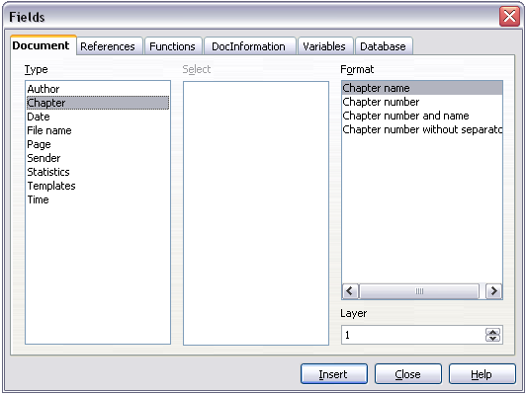Figure 13: Inserting the current chapter name and number into your document
- To include the chapter number with the page number, position the cursor just before the Page field you inserted. Click Insert > Fields > Other. On the Document tab of the Fields dialog box, select Chapter in the Type column and Chapter number without separator in the Format column. Click Insert.
Go to the header or footer where you inserted this field, type the character you want to appear between the chapter number and the page number—for example, a period or a dash.
The table of contents will not automatically pick up these chapter numbers, so you will need to make a change on the Indexes and Tables menu item, as described in Chapter 12, “Creating Tables of Contents, Indexes, and Bibliographies”.
- You can add a page count to the footer—for example “Page 9 of 12”. Type the word “Page” and a space in front of the Page field. Type a space, the word “of”, and a space after the Page field. Then click Insert > Fields > Page Count.

Using fields instead of outline numbering for chapter numbers
The technique in “Using fields in headers and footers” on page 11, combined with outline-numbered chapter headings (described in Chapter 7, “Working with Styles”), works well when you want the field to show information for the current chapter. But what if you want to use a cross-reference to refer to a different chapter? You cannot bookmark or set a reference to the chapter number part of a heading created using outline numbering.
TIP | If you use this technique, some other features will not work because Writer does not recognize the field as chapter numbers. For example, you will not be able to include chapter numbers with the page numbers in headers or footers, or the table of contents, using the technique described in “Using fields in headers and footers” on page 11.
To have chapter numbers that update automatically and can be used in cross-referencing, use a number range field.
- Define your number range variable, as described in “Defining your own numbering sequences” on page 5. I have called this variable Chapter.
- To insert the field into your Heading 1, type Chapter<space>. Click Insert > Fields > Other. On the Variables tab, pick Number range, Chapter, Arabic (1 2 3). Click Insert. You will need to do this manually for each Heading 1.
- Select the entire text of the first Heading 1, including the word “Chapter” and the chapter number, and set a reference to it.
- You can now insert a cross-reference to this heading anywhere in your document.
Tip | You can also use this technique for easier management of appendix numbering. Keep your appendix headings in the Heading 1 style, define a separate number range sequence for appendix numbers (choosing “A,B,C” for the number format), and type Appendix<space><insert appendix number field> in the Heading 1 paragraph. You can then use the same page styles for chapters and appendixes, and the same field in the header or footer of chapters and appendixes.

Tricks for working with fields

Keyboard shortcuts for fields
Here are some handy keyboard shortcuts to use when working with fields:
Ctrl+F2 Open the Fields dialog box.
Ctrl+F8 Field shadings on/off.
Ctrl+F9 Show/hide field names.
F9 Update fields.

Fixing the contents of fields
You can specify Fixed content for many items on the Document and DocInformation tabs so the field contents do not update. For example, you might use a field to insert the creation date of a document, and you would not want that date to change. In another place you might use a date field to show the current date, which you do want to change; in that case, deselect Fixed content when you insert the field.

Converting fields into text
Writer does not provide any easy way to convert field contents into text. To do this, you need to copy the field contents and paste them back as unformatted text. This is not a very good solution if you have hundreds of fields that you want to change, but you could use a macro to automate the process.

Developing conditional content
Conditional content is text and graphics that are included or excluded depending on a condition you specify.
A simple example is a reminder letter for an overdue account. The first and second reminders might have a subject line of “Reminder Notice”, but the third reminder letter might have the subject “Final Notice” and a different final paragraph.
A more complex example is a software manual for a product that comes in two versions, Pro and Lite. Both product versions have much in common, but the Pro version includes some features that are not in the Lite version. If you use conditional content, you can maintain one file containing information for both versions and print (or create online help) customized for each version. You do not have to maintain two sets of the information that is the same for both versions, so you will not forget to update both versions when something changes.

Choose the types of conditional content to use
This section describes several Writer features that can help you design and maintain conditional content. You can use one or any combination of these features in the same document.

Conditional text
With conditional text, you can have two alternative texts (a word, phrase, or sentence). One text will be displayed and printed if the condition you specify is met, and the other will be displayed and printed if the condition is not met. You cannot include graphics or edit the text except in the field dialog (not in the body of the document). You also cannot format part of the text (for example, bolding one word but not the others), but you can format the field to affect all of the field contents (for example, bolding all of the words). You cannot include a cross-reference or other field in the text.

Hidden text
With hidden text (a word, phrase, or sentence), you have only two choices: show or hide. If the condition you specify is met, the text is hidden; if the condition is not met, the text is displayed. The disadvantages are the same as for conditional text: you cannot include graphics, edit the text in the body of the document, format part of the text, or include a field.

Hidden paragraphs
Hidden paragraphs are like any other paragraogs, but you can specify a condition under which the paragraph is not displayed or printed. A blank paragraph can also be hidden—for example, if a database field has no content for the current record. This is very useful when merging an address into a letter: if you allow two lines for the street address and the database record uses only one line, you can prevent the blank line from appearing in your document. You can include graphics, edit the text in the body of the document, format any part of the text, and include fields.

Hidden sections
Hidden sections are like hidden paragraphs, but they can include more than one paragraph—for example, a heading plus one or more paragraphs. However, a section cannot contain less than a paragraph, so you cannot use this method for single words or phrases. The contents of a hidden section behave just like the contents of any other part of the document, but you can specify a condition under which the section is not displayed or printed. In addition, you can password protect a section.

Plan your conditional content
Conditions are what programmers call logical expressions. You must formulate a logical expression for each condition because a condition is always either true (met) or false (not met). You can use the same condition in many places in your document, for different types of conditional content.
To make conditional content work, you need to:
- Choose or define a variable.
- Define a logical expression (condition) involving the selected variable.

Choose or define a variable
You can use the following variables in your condition:
- User-defined variables
- Predefined OpenOffice.org variables, which use statistical values from the document properties
- User data
- Database field contents—for example from your address book
You cannot use internal variables (for example, page number or chapter name) to formulate conditions.
The examples in this chapter use user-defined variables.

Define a logical expression (condition) involving the selected variable
The condition compares a specified fixed value with the contents of a variable or database field.
To formulate a condition, use the same elements as you would to create a formula: operators, mathematical and statistical functions, number formats, variables, and constants. The possible operators are given in the online help; look in the index under “operators: in formulas”. You can define quite complex expressions, but in most cases a simple condition will do the job.

Create the variable
To create your variable, click Insert > Fields > Other. You can use choices found on the DocInformation, Variables, and Database tabs.

DocInformation fields
“Using document properties to hold information that changes” on page 1 described how to set up a user-defined document property. You can use that document property as the variable in your condition statement, or you can create another document property field specifically for conditions.

User-defined variable field
To set up a variable or user field:
- Place the cursor where you want the field to be inserted.
- On the Fields dialog box, select the Variables tab (Figure 14).
- Select Set variable in the Type list and Text in the Format list. Type a name for the variable in the Name box, and a value in the Value box. I have chosen “ProLite” for the name (to remind me that this variable is related to the two product versions), and I set the value as “Lite” because I can remember “If it is the Lite version, then this text should be hidden.”
- Select Invisible so the field does not show in the document. Click Insert, then click Close.
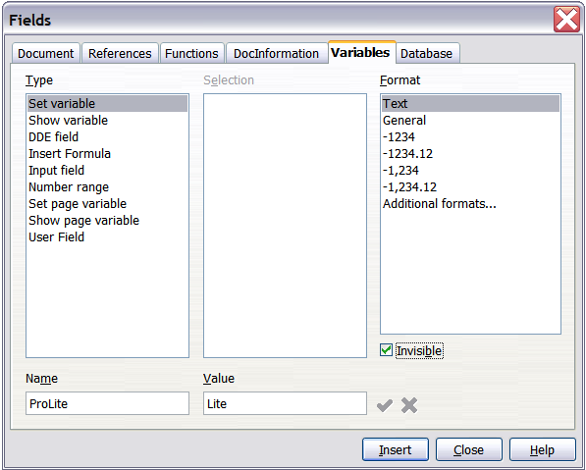
Figure 14: Defining a variable to use with conditional content
- A small gray mark should be visible where you inserted the field. Hover the mouse pointer over this mark and you will see the field formula ProLite = Lite. We will come back to this field later.
TIPS | Because the gray mark is so small, you may have trouble finding it again, especially if you have other fields in the document. You may prefer to leave the variable field visible while you work, and change it to invisible just before you create final copy.  At any time, you can place the insertion point just before the field and click Edit > Fields or right-click the field, and then click Fields on the pop-up menu. On the Edit Fields dialog box (Figure 18), select or deselect the Invisible checkbox.

Apply the condition to the content
Now that you have defined the variable, you can use it in a condition statement. This topic describes some of the possibilities.

Conditional text
First, let us set up some conditional text that will insert the words “Great Product Lite” into the Lite version and “Great Product Pro” into the Pro version of the manual. You would use this field whenever you want to mention the name of the product.
- Place the cursor where you want one of these phrases to appear. (You can move or delete it later, if you wish.)
- Open the Fields dialog box by clicking Insert > Fields > Other, select the Functions tab, and select Conditional text in the Type list.
- As shown in Figure 15, type ProLite EQ "Lite" in the Condition box, Great Product Lite in the Then box, and Great Product Pro in the Else box.
Note | These fields are case-sensitive, and quotation marks are required around a text value such as Lite.
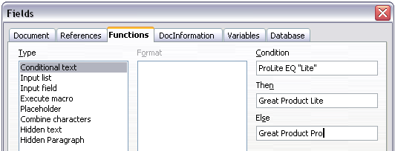Figure 15: Inserting conditional text
- Click Insert to insert the field, then click Close. You should see Great Product Lite in your text.
Tip | If you want to insert this field into your text in many places (as you probably would for a product name), create an AutoText entry for it. See “Using AutoText to insert often-used fields” on page 4 for instructions.

Hidden text
You might use hidden text for words or short phrases that describe features of Great Product Pro that are not found in the Lite version. You can reuse the same field in several places in your document—for example, by copying and pasting it.
To create a hidden text field:
- Click Insert > Fields > Other and select the Functions tab.
- Select Hidden text in the Type list, as shown in Figure 16.
- Type ProLite EQ "Lite" in the Condition box and type the required text in the Hidden text box. Remember, this is the text that is hidden if the condition is true.
- Click Insert to create and insert the field.
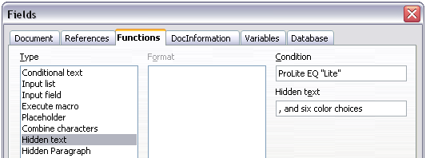Figure 16: Creating a condition for hidden text

Hidden paragraphs
Tip | To enable hidden paragraphs, remove the check mark from View > Hidden Paragraphs. When this option is selected, you cannot hide any paragraph.
A paragraph is hidden if the condition is true. To hide a paragraph:
- Click in the paragraph to be hidden.
- Click Insert > Fields > Other and select the Functions tab (Figure 16).
- Select Hidden paragraph in the Type list.
- For this example,type ProLite EQ "Lite" in the Condition box.
- Click Insert to create and insert the field. If an extra paragraph mark appears, delete it.

Hidden sections
A conditional section is hidden if the condition is true. To create a conditional section:
- Select the text that you want to be included in the conditional section. (You can edit this text later, just as you can edit any other text.)
- Click Insert > Section. On the Insert Section dialog box (Figure 17), select the Hide checkbox and enter the condition in the with Condition box. You can also give the section a name, if you wish. Click Insert to insert the section into your document.
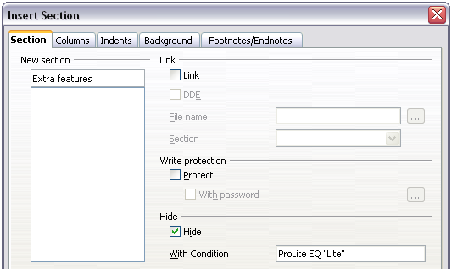Figure 17: Creating a section to be hidden when a specified condition is met
To show the hidden section so you can edit it:
- Click Format > Sections.
- On the Edit Sections dialog box, select the section from the list.
- Deselect the Hide checkbox, and then click OK. You can now edit the contents of the section. Afterwards, you can click Format > Sections again and select the Hide checkbox to hide the section again.
To make the hidden section a normal part of the document (that is, to remove the section markers, but not the contents of the section):
- Show the hidden section, as described above.
- On the Edit Sections dialog box, select the section from the list.
- Click Remove. The contents of the section are now a normal part of the document.

Change the value of the variable
- Find the variable field you created in “Create the variable” on page 15.
- Click once just in front of this field, then right-click and click Fields on the pop-up menu.
- On the Edit Fields: Variables dialog box (Figure 18), change the value of the variable to Pro.
- If you have set fields to update automatically, all of the conditional and hidden text that uses this variable as a condition will change.
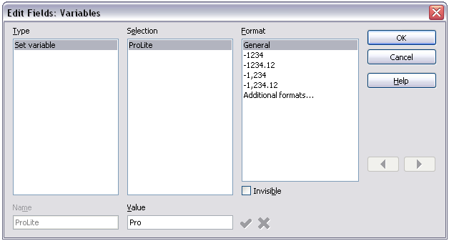Figure 18: Changing the value of the variable
Tip | To turn on automatic updating of fields, click Tools > Options > OpenOffice.org Writer > General, and select Fields under Update: Automatically.

Editing hidden paragraphs and sections
To show all the hidden paragraphs and sections so you can edit their contents, change the value of the variable to something that the conditions will not recognize. In our example, you could change the value to 1.
The technique does not affect the display of hidden and conditional text, which can only be edited in the Edit Fields dialog.

Using placeholder fields
A placeholder field prompts you to enter something (text, a table, a frame, a graphic, or an object).
To insert a placeholder field into a document:
- On the Functions tab of the Fields dialog box, select Placeholder in the Type column and select what the placeholder is for in the Format column.
- In the Placeholder box, type the text that you want to appear in the placeholder field.
- In the Reference box, type the text that you want to display as a help tip when you rest the mouse pointer over the field.
Figure 19 shows the results of inserting a placeholder field for a graphic.
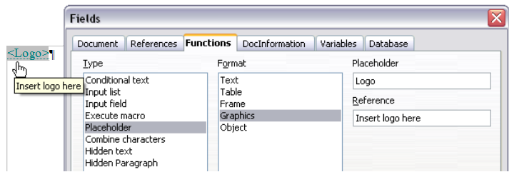
Figure 19: Inserting a placeholder field
Because the <Logo> field is a graphics placeholder, when you click on the field in the document, the Insert picture dialog box opens, prompting you to select a graphic (picture). When you select a picture and click Open, the picture replaces the field in the document.
Similarly, clicking on a table placeholder field opens the Insert Table dialog box, clicking on a frame placeholder field opens the Frame dialog box, and clicking on an object placeholder field opens the Insert OLE Object dialog box. The text placeholder field is different: you simply click on it and type some text in the Placeholder box, which replaces the field.

