Software Specification Document
OpenOffice
In the word processing program, insert diagonal table header into the fisrt cell of the table.

Specification Status
Last Change | April 5 2007
Status

Abstract
The Writer does not have the functionality of inserting Asian styled diagonal header into a table, we want to add this feature so that Asian users will be freed from the labor of drawing diagonal header manually.

i-Team Members
Role | First Name, Last Name, Initials | E-Mail Address
Specification Owner | Shi Zhoubo | Shizhoubo@ch2000.com.cn
Development
Quality Assurance | <First Name, Last Name (Initials)> | <User@openoffice.org>
Documentation | Shi Zhoubo | Shizhoubo@ch2000.com.cn
Other roles | <First Name, Last Name (Initials)> | <User@openoffice.org>
<State reason here, if one role is not represented in i-Team.>

Contents
Abstract 1
i-Team Members 1
References and Reference Documents 3
Acronyms and Abbreviations 3
1 Introduction to Diagonal Header 4
2 Competitive Analysis 4
3 Detailed Specification 5
3.1 Reason: 5
3.2 The idea: 5
3.3 Analysis on the table header styles 8
3.4 Operation analysis 10
3.4.1 Inserting the diagonal header 10
3.4.2 Diagonals co-adjust with table's first cell 10
3.4.3 The text contents can only be positioned within the first cell 11
3.4.4 The properties of diagonals and labels 11
4 Migration 11
5 Configuration 11
6 Changes to the File Format 11
6.1 Draw-diagonal 12
6.2 Draw-text 13

References and Reference Documents
Reference Document | Check | Location (URL)
OpenOffice-org-Specification-Template.ott | Available | F:\FUNC\OpenOffice-org-Specification-Template.ott

Acronyms and Abbreviations
Acronym / Abbreviation | Definition
None | None

Introduction to Diagonal Header
A Diagonal Table Header is a special table cell that is divided by several diagonals into parts, and each part has its own label.
Complex tables involving diagonal headers are widely used in Asian Countries ( Illustration 1 ), people use the labels within the diagonal header to illustrate the categories of different areas within the table.

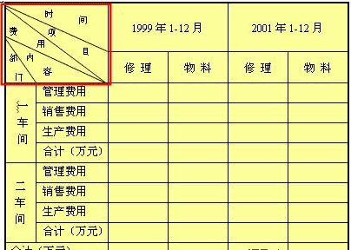
Illustration 1 : A complex table

Competitive Analysis
Microsoft Word introduced this feature in its Chinese edition since Word 2000 (Microsoft Word 2000 Product Enhancements Guide). A menu command 绘制斜线表头 ( Chinese meaning “Draw Diagonal Header” ) in the menu Table ( Illustration 2 )invokes a 插入斜线表头 （ Chinese meaning “Insert Diagonal Header” ) dialog ( Illustration 3 ), in which the user can select the style of the diagonal header, the font size and the text of the label.

Illustration 2: Draw Diagonal Header in MS Office Word 2003

Illustration 3: Insert Diagonal Header dialog in MS Office Word 2003

Illustration 4: A diagonal header in MS Office Word 2003
A diagonal header in MS Office Word 2003 is composed with grouped graphic lines and text boxes. The diagonal header can not adjust itself according to the table cell automatically.

Detailed Specification

Reason:
Presently Writer does not provide such functionality to insert predefined diagonal table header, which means users have to lay the header lines and labels manually, furthermore, whenever the top-left cell is adjusted, each of the lines and labels have to be adjusted accordingly manually. Adding a feature that automatically inserts ,adjusts and removes diagonal headers would bring great convenience to these users.

The idea:
In Writer, add a menu command diagonal table header in the main menu of Table.
The menu item is only enabled when the cursor is located in a table, and the first cell of the table is not protected. Selecting the menu item creates a diagonal table header dialog box, which gives the user options to configure the diagonal table header. The options includes the table header style, the font sizes and the text of the labels.

The edit box after Label 3 should be disabled when a style with one diagonal is selected.

8  1  6 | 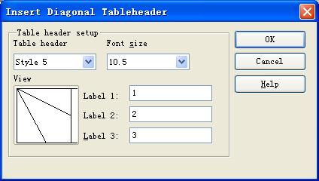 | 10  11  12  4  5  3  2  9  7
Illustration 5: The layout of insert diagonal table header dialog box
Table 1: User Interface elements of Illustration 5
# | Type | Properties |  | Comment
1 |  | Control Properties  State: Modal  Closable: Yes  Resizable: No  Always On Top: Yes  A11Y Text: None  Other...: None |  | the dialog box of insert diagonal table header is a mode window, it's size can't be changed and it show always on the top of others.
1 |  | String English  N/A | String German  N/A
2 |  | Control Properties  Enabled: Yes  Maximum Row Count: 14  Visible Row Count: 7  Initially Selected Item: 1  ToolTip Text: None  A11Y Text: None  Other...: None |  | This is a combo box and it contain 14 diagonal line style, the first one is default.
2 |  | String English  N/A | String German  N/A
3 |  | Control Properties  Features: Picture preview box |  | This control can browse and show pictures, it can be changed by the selection of combo box, when user select the different style of diagonal
3 |  | String English  N/A | String German  N/A
4 |  | Control Properties  Enabled: Yes  Editable: Yes  Initial Text Inside Field: None  Drag Enabled: No  Initial Caret Position: 0  KeyMap: Default KeyMap |  | This is text editor box, it edits text of the first diagonal table was inserted by user.
4 |  | String English  N/A | String German  N/A
5 |  | Control Properties  Enabled: Yes  Editable: Yes  Initial Text Inside Field: None  Drag Enabled: No  Initial Caret Position: 0  KeyMap: Default KeyMap |  | This is text editor box, it edits text of the second diagonal table was inserted by user.
5 |  | String English  N/A | String German  N/A
6 |  | Control Properties  Enabled: Yes  Editable: Yes  Initial Text Inside Field: None  Drag Enabled: No  Initial Caret Position: 0  KeyMap: Default KeyMap |  | This is text editor box, it edits text of the third diagonal table was inserted by user.
6 |  | String English  N/A | String German  N/A
7 |  | Control Properties  Enabled: Yes  Maximum Row Count: 30  Visible Row Count: 7  Initially Selected Item: 6  ToolTip Text: None  A11Y Text: None  Other...: None |  | This is combo box, it contains 30 font sizes to select, the range of the font size as the same of the word processor program, the original font size is 10.5 point, also is the 6th item.
7 |  | String English  N/A | String German  N/A
8 |  | Control Properties  Enabled: Yes |  | This is a static label, it is the introduction for the font size.
8 |  | String English  N/A | String German  N/A
9 |  | Control Properties  Enabled: Yes |  | This is a static label, it is the introduction for the diagonal line style
9 |  | String English  N/A | String German  N/A
10 |  | Control Properties  Enabled: Yes  Icon: No  Resizeable: No  Has Menu: No |  | This is a button, after user finish setting of style and size for diagonal line, click this button to insert Diagonal table header.  。
10 |  | String English  Yes | String German  N

11 |  | Control Properties  Enabled: Yes  Icon: No  Resizeable: No  Has Menu: No |  | This is cancel button to exit from this dialog.
11 |  | String English  Yes | String German  N
12 |  | Control Properties  Enabled: Yes  Icon: No  Resizeable: No  Has Menu: No |  | This is a help button, click this button will get help information。
12 |  | String English  Yes | String German  N

When user finishes the configuration and clicks the button of OK, the diagonal header is inserted into the first cell of the table.

Analysis on the table header styles
There are 14 diagonal header styles, they can be divided into 3 basic categories.
The first category is the simplest: one diagonal splits the cell into two parts, with one label illustrates the row header while the other illustrates the column header( Illustration 6 ):

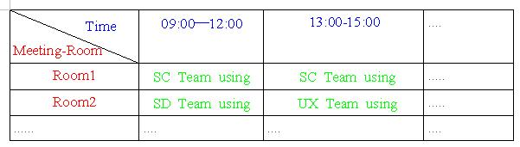
Illustration 6: Simple diagonal header

The second category has two diagonals and a additional center part, the label of which illustrates the table cells not in header( Illustration 7 ).

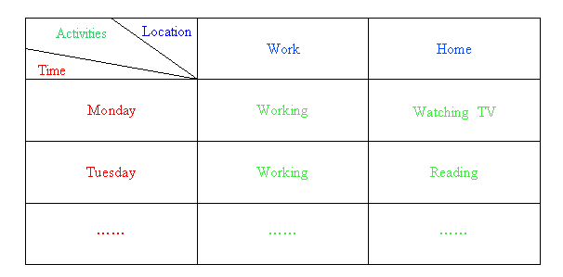
Illustration 7: Diagonal header with center part

The third category has sub rows / columns under rows / columns, the label of the center part is used to illustrate the the sub rows / columns.
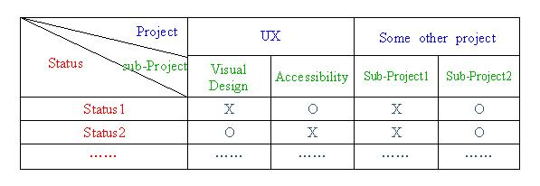
Illustration 8: Diagonal header with sub rows / columns

There are many header styles can be applied when using two diagonal lines, see below:

Style 2 | Style 5 | Style 9 | Style 12

Style 3 | Style 4 | Style 6 | Style 7 | Style 10 | Style 11 | Style 13 | Style 14

Illustration 9:Table Header style with two diagonal lines

Operation analysis

Inserting the diagonal header
The diagonal table header can only be inserted into the first table cell.

Diagonals co-adjust with table's first cell
When size or position of the first table cell is changed, diagonals are automatically adjusted to fit the cell border ( Illustration 10, 11 ):

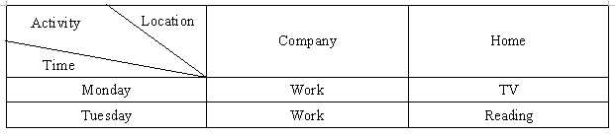
Illustration 10: Not changed
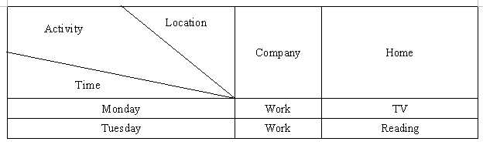
Illustration 11: Changed

The text contents can only be positioned within the first cell
User cannot move the labels out of the first table cell.

The properties of diagonals and labels
A diagonal has the same properties as a graphic line, thus any property operations that apply to graphic lines also applies to diagonals.
A label has the same properties as a no-bordered text box.

Migration
Not applicable as this is a new feature

Configuration
This feature doesn't need to be stored in configuration path.

Changes to the File Format
Add two element in “shape”
The two element can only be set for the table-header.
<define name="shape">
<choice>
<ref name="draw-rect"/>
<ref name="draw-line"/>
<ref name="draw-polyline"/>
<ref name="draw-polygon"/>
<ref name="draw-regular-polygon"/>
<ref name="draw-path"/>
<ref name="draw-circle"/>
<ref name="draw-ellipse"/>
<ref name="draw-g"/>
<ref name="draw-page-thumbnail"/>
<ref name="draw-frame"/>
<ref name="draw-measure"/>
<ref name="draw-caption"/>
<ref name="draw-connector"/>
<ref name="draw-control"/>
<ref name="dr3d-scene"/>
<ref name="draw-custom-shape"/>
<group>
<zeroOrMore>
<ref name="draw-diagonal"/>
<ref name="draw-text"/>
</zeroOrMore>
</group>
</choice>
</define>

Draw-diagonal
The draw:diagonal element specifies the specific-line in the table-header.
<define name="draw-diagonal">
<element name="draw:diagonal">
<ref name="draw-diagonal-anchor-attlist"/>
<ref name="draw-diagonal-z-index-attlist"/>
<ref name="draw-diagonal-style-name"/>
<ref name="draw-diagonal-text-style-name-attlist"/>
<ref name="draw-line-attlist"/>
<ref name="draw-diagonal-text"/>
</element>
</define>

<define name="draw-diagonal-anchor-attlist" combine="interleave">
<attribute name="text:anchor-type">
<choice>
<value>page</value>
<value>frame</value>
<value>paragraph</value>
<value>char</value>
<value>as-char</value>
</choice>
</attribute>
</define>

<define name="draw-diagonal-z-index-attlist">
<attribute name="draw:z-index">
<ref name="nonNegativeInteger"/>
</attribute>
</define>

<define name="draw-diagonal-style-name">
<attribute name="draw:style-name">
<ref name="styleNameRef"/>
</attribute>
</define>

<define name="draw-diagonal-text-style-name-attlist">
<attribute name="draw:text-style-name">
<ref name="styleNameRef"/>
</attribute>
</define>

<define name="draw-line-attlist" combine="interleave">
<attribute name="svg:x1">
<ref name="coordinate"/>
</attribute>
<attribute name="svg:y1">
<ref name="coordinate"/>
</attribute>
<attribute name="svg:x2">
<ref name="coordinate"/>
</attribute>
<attribute name="svg:y2">
<ref name="coordinate"/>
</attribute>
</define>

<define name="draw-diagonal-text">
<ref name="draw-diagonal-text-p"/>
</define>

<define name="draw-diagonal-text-p">
<element name="text:p">
<ref name="paragraph-content"/>
</element>
</define>

The attributes that may be associated with the <draw:diagonal> element are:
•Style, Z-Index
•Text anchor
•Start point
•End point

Draw-text
The draw:text element specifies the text between diagonal in the table-header.
<define name="draw-text">
<element name="draw:text">
<ref name="draw-diagonal-anchor-attlist"/>
<ref name="draw-diagonal-z-index-attlist"/>
<ref name="draw-diagonal-style-name"/>
<ref name="draw-diagonal-text-style-name-attlist"/>
<ref name="draw-diagonal-text-position-attlist"/>
<ref name="draw-diagonal-text"/>
</element>
</define>
<define name="draw-diagonal-text-position-attlist">
<attribute name="svg:width">
<ref name="length"/>
</attribute>
<attribute name="svg:height">
<ref name="length"/>
</attribute>
<attribute name="svg:x">
<ref name="coordinate"/>
</attribute>
<attribute name="svg:y">
<ref name="coordinate"/>
</attribute>
</define>

The attributes that may be associated with the <draw:text> element are:
•Position, Size, Style, Z-Index
•Text anchor
Open Issues
Issue | Initials | Date
NONE
Document Change History
Rev. | Change | Initials | Date
1 | Initial created | Shi Zhoubo | July 31st, 2007
2 | Updated according to Lutz Hoeger's comments. | Shi Zhoubo | September 6th, 2007
3
<...>

