

Calc Guide

Using Spreadsheets in OpenOffice.org

This PDF is designed to be read onscreen, two pages at a time. If you want to print a copy, your PDF viewer should have an option for printing two pages on one sheet of paper, but you may need to start with page 2 to get it to print facing pages correctly. (Print this cover page separately.)

Copyright
This document is Copyright © 2005–2010 by its contributors as listed in the section titled Authors. You may distribute it and/or modify it under the terms of either the GNU General Public License, version 3 or later, or the Creative Commons Attribution License, version 3.0 or later. Note that Chapter 8, Using the DataPilot, is licensed under the Creative Commons Attribution-Share Alike License, version 3.0.
All trademarks within this guide belong to their legitimate owners.
Authors
Rick Barnes Peter Kupfer
James Andrew Krishna Aradhi
Andy Brown Stephen Buck
Bruce Byfield Martin J. Fox
T. J. Frazier Stigant Fyrwitful
Spencer E. Harpe Regina Henschel
Peter Hillier-Brook John Kane
Kirk Emma Kirsopp
Jared Kobos Sigrid Kronenberger
Shelagh Manton Alexandre Martins
Kashmira Patel Anthony Petrillo
Andrew Pitonyak Iain Roberts
Hazel Russman Gary Schnabl
Rob Scott Sowbhagya Sundaresan
Nikita Telang Barbara M Tobias
John Viestenz Jean Hollis Weber
Stefan Weigel Sharon Whiston
Claire Wood Linda Worthington
Michele Zarri Magnus Adielsson
Sandeep Samuel Medikonda
Feedback
Please direct any comments or suggestions about this document to: authors@documentation.openoffice.org
Publication date and software version
Published 8 September 2010. Based on OpenOffice.org 3.2.
Contents
Chapter 1
Introducing Calc 9
What is Calc? 10
Spreadsheets, sheets, and cells 10
Parts of the main Calc window 11
Starting new spreadsheets 16
Opening existing spreadsheets 17
Opening CSV files 18
Saving spreadsheets 19
Navigating within spreadsheets 23
Selecting items in a sheet or spreadsheet 27
Working with columns and rows 30
Working with sheets 32
Viewing Calc 33
Using the Navigator 38
Chapter 2
Entering, Editing, and Formatting Data 41
Introduction 42
Entering data using the keyboard 42
Speeding up data entry 45
Sharing content between sheets 48
Validating cell contents 49
Editing data 51
Formatting data 53
Autoformatting cells and sheets 59
Formatting spreadsheets using themes 60
Using conditional formatting 61
Hiding and showing data 63
Sorting records 65
Finding and replacing in Calc 67
Chapter 3
Creating Charts and Graphs 72
Introduction 73
Creating a chart 73
Editing charts 78
Formatting charts 84
Formatting 3D charts 87
Formatting the chart elements 91
Resizing and moving the chart 93
Gallery of chart types 95
Chapter 4
Using Styles and Templates in Calc 105
What is a template? 106
What are styles? 106
Types of styles in Calc 107
Accessing styles 108
Applying cell styles 109
Applying page styles 111
Modifying styles 111
Creating new (custom) styles 116
Copying and moving styles 117
Deleting styles 119
Creating a spreadsheet from a template 119
Creating a template 120
Editing a template 121
Adding templates using the Extension Manager 123
Setting a default template 124
Associating a spreadsheet with a different template 125
Organizing templates 126
Chapter 5
Using Graphics in Calc 129
Graphics in Calc 130
Adding graphics (images) 130
Modifying images 136
Using the picture context menu 142
Using Calc’s drawing tools 145
Positioning graphics 148
Creating an image map 151
Chapter 6
Printing, Exporting, and E-mailing 154
Quick printing 155
Controlling printing 155
Using print ranges 159
Page breaks 163
Headers and footers 164
Exporting to PDF 167
Exporting to XHTML 173
Saving as Web pages (HTML) 174
E-mailing spreadsheets 174
Digital signing of documents 175
Removing personal data 176
Chapter 7
Using Formulas and Functions 177
Introduction 178
Setting up a spreadsheet 178
Creating formulas 180
Understanding functions 197
Strategies for creating formulas and functions 203
Finding and fixing errors 205
Examples of functions 210
Using regular expressions in functions 215
Advanced functions 217
Chapter 8
Using the DataPilot 218
Introduction 219
Examples with step by step instructions 219
DataPilot functions in detail 241
Function GETPIVOTDATA 267
Chapter 9
Data Analysis 271
Introduction 272
Consolidating data 272
Creating subtotals 275
Using “what if” scenarios 277
Using other “what if” tools 281
Working backwards using Goal Seek 288
Using the Solver 290
Chapter 10
Linking Calc Data 294
Why use multiple sheets? 295
Setting up multiple sheets 295
Referencing other sheets 299
Referencing other documents 301
Hyperlinks and URLs 303
Linking to external data 307
Linking to registered data sources 312
Embedding spreadsheets 316
Chapter 11
Sharing and Reviewing Documents 322
Introduction 323
Sharing documents (collaboration) 323
Recording changes 326
Adding comments to changes 329
Adding other comments 330
Reviewing changes 332
Merging documents 335
Comparing documents 337
Saving versions 337
Chapter 12
Calc Macros 340
Introduction 341
Using the macro recorder 341
Write your own functions 345
Accessing cells directly 353
Sorting 354
Conclusion 356
Chapter 13
Calc as a Simple Database 357
Introduction 358
Associating a range with a name 359
Sorting 365
Filters 367
Calc functions similar to database functions 375
Database-specific functions 387
Conclusion 388
Chapter 14
Setting up and Customizing Calc 389
Introduction 390
Choosing options that affect all of OOo 390
Choosing options for loading and saving documents 396
Choosing options for Calc 400
Controlling Calc’s AutoCorrect functions 409
Customizing the user interface 410
Adding functionality with extensions 420
Appendix A
Keyboard Shortcuts 422
Introduction 423
Navigation and selection shortcuts 423
Function and arrow key shortcuts 425
Cell formatting shortcuts 426
DataPilot shortcuts 427
Appendix B
Description of Functions 428
Functions available in Calc 429
Mathematical functions 430
Financial analysis functions 435
Statistical analysis functions 449
Date and time functions 458
Logical functions 462
Informational functions 463
Database functions 466
Array functions 468
Spreadsheet functions 470
Text functions 475
Add-in functions 479
Appendix C
Calc Error Codes 484
Introduction to Calc error codes 485
Error codes displayed within cells 486
General error codes 487
Index 490
Calc Guide

Chapter 1
Introducing Calc
Using Spreadsheets in OpenOffice.org
This PDF is designed to be read onscreen, two pages at a time. If you want to print a copy, your PDF viewer should have an option for printing two pages on one sheet of paper, but you may need to start with page 2 to get it to print facing pages correctly. (Print this cover page separately.)

Copyright
This document is Copyright © 2005–2010 by its contributors as listed in the section titled Authors. You may distribute it and/or modify it under the terms of either the GNU General Public License, version 3 or later, or the Creative Commons Attribution License, version 3.0 or later.
All trademarks within this guide belong to their legitimate owners.
Authors
Rick Barnes
Peter Kupfer
Jean Hollis Weber
Krishna Aradhi
Andy Brown
Alexandre Martins
Anthony Petrillo
Gary Schnabl
Barbara M Tobias
Feedback
Please direct any comments or suggestions about this document to: authors@documentation.openoffice.org
Publication date and software version
Published 21 June 2010. Based on OpenOffice.org 3.2.
Contents
Copyright 2
What is Calc? 5
Spreadsheets, sheets, and cells 5
Parts of the main Calc window 6
Title bar 6
Menu bar 6
Toolbars 7
Formula Bar 8
Individual cells 9
Sheet tabs 9
Status bar 9
Starting new spreadsheets 11
Opening existing spreadsheets 12
Opening CSV files 13
Saving spreadsheets 14
Password protection 15
Saving a document automatically 15
Saving as a Microsoft Excel document 15
Saving as a CSV file 17
Saving in other formats 18
Navigating within spreadsheets 18
Going to a particular cell 18
Moving from cell to cell 18
Moving from sheet to sheet 21
Selecting items in a sheet or spreadsheet 22
Selecting cells 22
Selecting columns and rows 24
Selecting sheets 24
Working with columns and rows 25
Inserting columns and rows 25
Deleting columns and rows 26
Working with sheets 27
Inserting new sheets 27
Deleting sheets 28
Renaming sheets 28
Viewing Calc 28
Using zoom 28
Freezing rows and columns 29
Splitting the screen 31
Using the Navigator 33
Moving quickly through a document 35
Choosing a drag mode 35

What is Calc?
Calc is the spreadsheet component of OpenOffice.org (OOo). You can enter data (usually numerical) in a spreadsheet and then manipulate this data to produce certain results.
Alternatively, you can enter data and then use Calc in a ‘What if...’ manner by changing some of the data and observing the results without having to retype the entire spreadsheet or sheet.
Other features provided by Calc include:
- Functions, which can be used to create formulas to perform complex calculations on data
- Database functions, to arrange, store, and filter data
- Dynamic charts; two new types of charts—Bubble Charts and Filled Net Charts—have been introduced in OOo 3.2
- Macros, for recording and executing repetitive tasks; scripting languages supported include OpenOffice.org Basic, Python, BeanShell, and JavaScript
- Ability to open, edit, and save Microsoft Excel spreadsheets
- Import and export of spreadsheets in multiple formats, including HTML, CSV, PDF, and PostScript
Note | If you want to use macros written in Microsoft Excel using the VBA macro code in OOo, you must first edit the code in the OOo Basic IDE editor.

Spreadsheets, sheets, and cells
Calc works with elements called spreadsheets. Spreadsheets consist of a number of individual sheets, each sheet containing cells arranged in rows and columns. A particular cell is identified by its row number and column letter.
Cells hold the individual elements—text, numbers, formulas, and so on—that make up the data to display and manipulate.
Each spreadsheet can have many sheets, and each sheet can have many individual cells. In Calc 3.x, each sheet can have a maximum of 65,536 rows and a maximum of 1024 columns, for a total of over 67 million cells.

Parts of the main Calc window
When Calc is started, the main window looks similar to Figure 1.
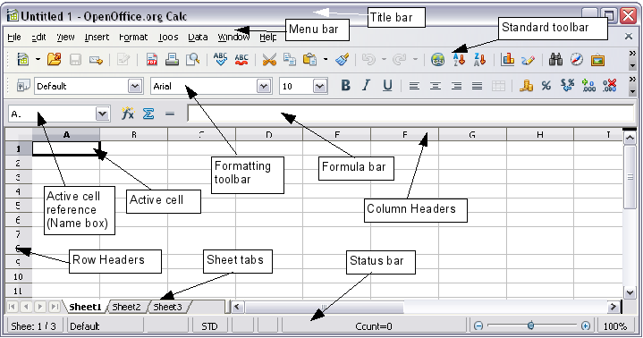
Figure 1: Parts of the Calc window
Note | If any part of the Calc window in Figure 1 is not shown, you can display it using the View menu. For example, View > Status Bar will toggle (show or hide) the Status Bar. It is not always necessary to display all the parts, as shown; show or hide any of them, as desired.

Title bar
The Title bar, located at the top, shows the name of the current spreadsheet. When the spreadsheet is newly created, its name is Untitled X, where X is a number. When you save a spreadsheet for the first time, you are prompted to enter a name of your choice.

Menu bar
Under the Title bar is the Menu bar. When you choose one of the menus, a submenu appears with other options. You can modify the Menu bar, as discussed in Chapter 14 (Setting up and Customizing Calc).
- File contains commands that apply to the entire document such as Open, Save, Wizards, Export as PDF, and Digital Signatures.
- Edit contains commands for editing the document such as Undo, Changes, Compare Document, and Find and Replace.
- View contains commands for modifying how the Calc user interface looks such as Toolbars, Full Screen, and Zoom.
- Insert contains commands for inserting elements such as cells, rows, columns, sheets, and pictures into a spreadsheet.
- Format contains commands for modifying the layout of a spreadsheet such as Styles and Formatting, Paragraph, and Merge Cells.
- Tools contains functions such as Spelling, Share Document, Cell Contents, Gallery, and Macros.
- Data contains commands for manipulating data in your spreadsheet such as Define Range, Sort, Filter, and DataPilot.
- Window contains commands for the display window such as New Window, Split, and Freeze.
- Help contains links to the Help file bundled with the software, What's This?, Support, Registration, and Check for Updates.

Toolbars
Three toolbars are located under the Menu bar by default: the Standard toolbar, the Formatting toolbar, and the Formula Bar.
The icons (buttons) on these toolbars provide a wide range of common commands and functions. You can also modify these toolbars, as discussed in Chapter 14 (Setting up and Customizing Calc).
Placing the mouse pointer over any of the icons displays a small box, called a tooltip. It gives a brief explanation of the icon’s function. For a more detailed explanation, choose Help > What’s This? and hover the mouse pointer over the icon. To turn this feature off again, click once or press the Esc key twice. Tips and extended tips can be turned on or off from Tools > Options > OpenOffice.org > General.
In the Formatting toolbar, the three boxes on the left are the Apply Style, Font Name, and Font Size lists (see Figure 2). They show the current settings for the selected cell or area. (The Apply Style list may not be visible by default.) Click the down-arrow to the right of each box to open the list.
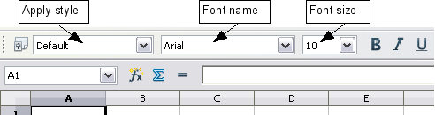
Figure 2: Apply Style, Font Name and Font Size lists
Note | If any of the icons (buttons) in Figure 2 is not shown, you can display it by clicking the small triangle at the right end of the Formatting toolbar, selecting Visible Buttons in the drop-down menu, and selecting the desired icon (for example, Apply Style) in the drop-down list. It is not always necessary to display all the toolbar buttons, as shown; show or hide any of them, as desired.

Formula Bar
On the left hand side of the Formula Bar is a small text box, called the Name Box, with a letter and number combination in it, such as D7. This combination, called the cell reference, is the column letter and row number of the selected cell.
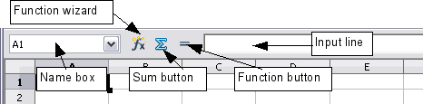
Figure 3: Formula Bar
To the right of the Name Box are the the Function Wizard, Sum, and Function buttons.
Clicking the Function Wizard button opens a dialog from which you can search through a list of available functions. This can be very useful because it also shows how the functions are formatted.
In a spreadsheet the term function covers much more than just mathematical functions. See Chapter 7 for more details.
Clicking the Sum button inserts a formula into the current cell that totals the numbers in the cells above the current cell. If there are no numbers above the current cell, then the cells to the left are placed in the Sum formula.
Clicking the Function button inserts an equals (=) sign into the selected cell and the Input line, thereby enabling the cell to accept a formula.
When you enter new data into a cell, the Sum and Equals buttons change to Cancel and Accept buttons .
The contents of the current cell (data, formula, or function) are displayed in the Input line, which is the remainder of the Formula Bar. You can either edit the cell contents of the current cell there, or you can do that in the current cell. To edit inside the Input line area, click in the area, then type your changes. To edit within the current cell, just double-click the cell.

Individual cells
The main section of the screen displays the cells in the form of a grid, with each cell being at the intersection of a column and a row.
At the top of the columns and at the left end of the rows are a series of gray boxes containing letters and numbers. These are the column and row headers. The columns start at A and go on to the right, and the rows start at 1 and go down.
These column and row headers form the cell references that appear in the Name Box on the Formula Bar (see Figure 3). You can turn these headers off by selecting View > Column & Row Headers.

Sheet tabs
At the bottom of the grid of cells are the sheet tabs. These tabs enable access to each individual sheet, with the visible (active) sheet having a white tab. Clicking on another sheet tab displays that sheet, and its tab turns white. You can also select multiple sheet tabs at once by holding down the Control key while you click the names.

Status bar
The Calc status bar provides information about the spreadsheet and convenient ways to quickly change some of its features.
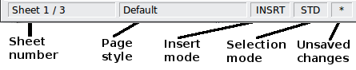
Figure 4: Left end of Calc status bar
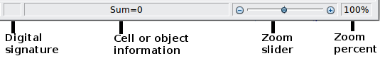
Figure 5: Right end of Calc status bar
Sheet sequence number ()
Shows the sequence number of the current sheet and the total number of sheets in the spreadsheet. The sequence number may not correspond with the name on the sheet tab.
Page style ()
Shows the page style of the current sheet. To edit the page style, double-click on this field. The Page Style dialog opens.
Insert mode ()
Click to toggle between INSRT (Insert) and OVER (Overwrite) modes when typing. This field is blank when the spreadsheet is not in a typing mode (for example, when selecting cells).
Selection mode ()
Click to toggle between STD (Standard), EXT (Extend), and ADD (Add) selection. EXT is an alternative to Shift+click when selecting cells. See page 27 for more information.
Unsaved changes ()
An asterisk (*) appears here if changes to the spreadsheet have not been saved.
Digital signature ()
If the document has not been digitally signed, double-clicking in this area opens the Digital Signatures dialog, where you can sign the document. See Chapter 6 (Printing, Exporting, and E-mailing) for more about digital signatures.
If the document has been digitally signed, an icon shows in this area. You can double-click the icon to view the certificate. A document can be digitally signed only after it has been saved.
Cell or object information ()
Displays information about the selected items. When a group of cells is selected, the sum of the contents is displayed by default; you can right-click on this field and select other functions, such as the average value, maximum value, minimum value, or count (number of items selected).
When the cursor is on an object such as a picture or chart, the information shown includes the size of the object and its location.
Zoom ()—new in OOo 3.1
To change the view magnification, drag the Zoom slider or click on the + and – signs. You can also right-click on the zoom level percentage to select a magnification value or double-click to open the Zoom & View Layout dialog.

Starting new spreadsheets
You can create a new, blank spreadsheet from the Start Center (Welcome to OpenOffice.org), from within Calc, or from any other component of OOo such as from Writer or Draw.
From the Start Center
Click the Spreadsheet  icon.
From the Menu bar
Choose File > New > Spreadsheet.
From a toolbar
If a document is open in any component of OOo (for example, Writer), you can use the New Document icon on the Standard toolbar. If you already have a spreadsheet open, clicking this button opens a new spreadsheet in a new window. From any other component of OOo (for example, Writer), click the down-arrow and choose spreadsheet.
From the keyboard
If you already have a spreadsheet open, you can press Control+N to open a new spreadsheet in a new window.
From a template
Calc documents can also be created from templates. Follow the above procedures, but instead of choosing Spreadsheet, choose the Templates icon from the Start Center or File > New >Templates and Documents from the Menu bar or toolbar. On the Templates and Documents window, navigate to the appropriate folder and double-click on the required template. A new spreadsheet, based on the selected template, opens.
A new OpenOffice.org installation does not contain many templates, but you can add more by downloading them from http://extensions.services.openoffice.org/ and installing them as described in Chapter 14 (Customizing Calc).
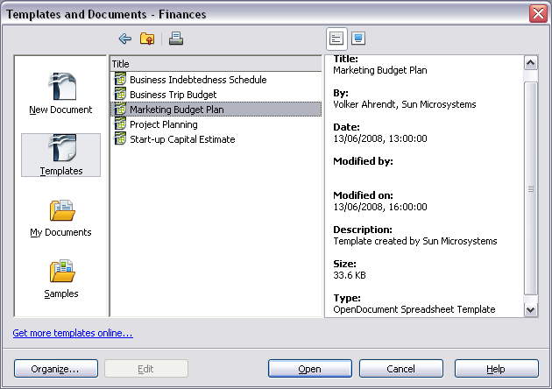Figure 6: Starting a new spreadsheet from a template

Opening existing spreadsheets
You can open an existing spreadsheet from the Start Center or from any component of OOo. Calc can open spreadsheets in a wide range of file formats, including Microsoft Excel (*.xls and *.xlsx).
From the Start Center
Click the Open a document  icon.
From the Menu bar
Choose File > Open.
From a toolbar
Click the Open icon on the Standard toolbar.
From the keyboard
Press the key combination Control+O.
Each of these options displays the Open dialog, where you can locate the spreadsheet that you want to open.
Tip | You can also use the Recent Documents list to open a spreadsheet. This list is located on the File menu, directly below Open. The list displays the last 10 files that were opened in any of the OOo components.

Opening CSV files
Comma-separated-values (CSV) files are text files that contain the cell contents of a single sheet. Each line in a CSV file represents a row in a spreadsheet. Commas, semicolons, or other characters are used to separate the cells. Text is put in quotation marks; numbers are written without quotation marks.
To open a CSV file in Calc:
- Choose File > Open.
- Locate the CSV file that you want to open.
- If the file has a *.csv extension, select the file and click Open.
- If the file has another extension (for example, *.txt), select the file, select Text CSV (*csv;*txt;*xls) in the File type box (scroll down into the spreadsheet section to find it) and then click Open.
- On the Text Import dialog (Figure 7), select the Separator options to divide the text in the file into columns.
You can preview the layout of the imported data at the bottom of the dialog. Right-click a column in the preview to set the format or to hide the column.
If the CSV file uses a text delimiter character that is not in the Text delimiter list, click in the box, and type the character.
- Click OK to open the file.
Caution   | If you do not select Text CSV (*csv;*txt;*xls) as the file type when opening the file, the document opens in Writer, not Calc.
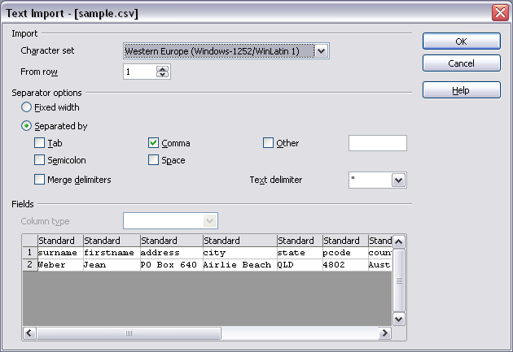Figure 7: Text Import dialog, with Comma (,) selected as the separator and double quotation mark (“) as the text delimiter.

Saving spreadsheets
Spreadsheets can be saved in three ways.
From the Menu bar
Choose File > Save (or Save All or Save As).
From the toolbar
Click the Save button on the Standard toolbar. If the file has been saved and no subsequent changes have been made, this button is grayed-out and not clickable.
From the keyboard
Press the key combination Control+S.
If the spreadsheet has not been saved previously, then each of these actions will open the Save As dialog. There you can specify the spreadsheet name and the location in which to save it.
Note | If the spreadsheet has been previously saved, then saving it using the Save (or Save All) command will overwrite an existing copy. However, you can save the spreadsheet in a different location or with a different name by selecting File > Save As.

Password protection
To protect an entire document from being viewable without a password, use the option on the Save As dialog to enter a password. This option is only available for files saved in OpenDocument formats or the older OpenOffice.org 1.x formats.
On the Save As dialog, select the Save with password option, and then click Save. You will be prompted to type the same password in two fields. If the passwords match, the OK button becomes active. Click OK to save the document as password-protected. If the passwords do not match, you will be prompted to type the password again.
OOo uses a very strong encryption mechanism that makes it almost impossible to recover the contents of a document in case you lose the password.

Saving a document automatically
You can choose to have Calc save your spreadsheet automatically at regular intervals. Automatic saving, like manual saving, overwrites the last saved state of the file. To set up automatic file saving:
- Choose Tools > Options > Load/Save > General.
- Click on Save AutoRecovery information every. This enables the box to set the interval. The default value is 15 minutes. Enter the value you want by typing it or by pressing the up or down arrow keys.

Saving as a Microsoft Excel document
If you need to exchange files with users of Microsoft Excel, they may not know how to open and save *.ods files. Only Microsoft Excel 2007 with Service Pack 2 (SP2) can do this. Users of Microsoft Excel 2007, 2003, XP, and 2000 can also download and install a free OpenDocument Format (ODF) plugin from Sun Microsystems.
Some users of Microsoft Excel may be unwilling or unable to receive *.ods files. (Perhaps their employer does not allow them to install the plug-in.) In this case, you can save a document as a Excel file (*.xls or *.xlsx).
- Important—First save your spreadsheet in the file format used by OpenOffice.org, *.ods. If you do not, any changes you may have made since the last time you saved it will only appear in the Microsoft Excel version of the document.
- Then choose File > Save As.
- On the Save As dialog (Figure 8), in the File type (or Save as type) drop-down menu, select the type of Excel format you need. Click Save.
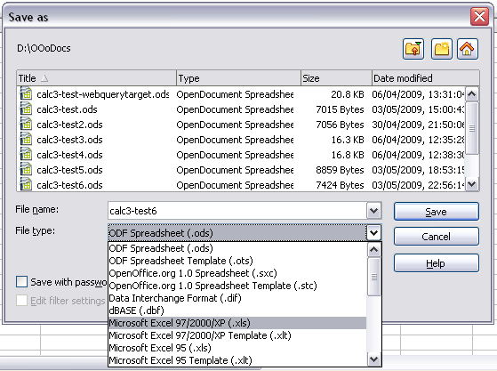
Figure 8. Saving a spreadsheet in Microsoft Excel format
Caution | From this point on, all changes you make to the spreadsheet will occur only in the Microsoft Excel document. You have actually changed the name of your document. If you want to go back to working with the *.ods version of your spreadsheet, you must open it again.
Tip | To have Calc save documents by default in a Microsoft Excel file format, go to Tools > Options > Load/Save > General. In the section named Default file format and ODF settings, under Document type, select Spreadsheet, then under Always save as, select your preferred file format.

Saving as a CSV file
To save a spreadsheet as a comma separate value (CSV) file:
- Choose File > Save As.
- In the File name box, type a name for the file.
- In the File type list, select Text CSV (*.csv;*.txt;*.xls) and click Save.
You may see the message box shown below. Click Keep Current Format.
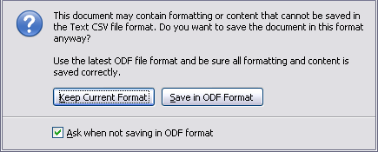
- In the Export of text files dialog (Figure 9), select the options you want and then click OK.
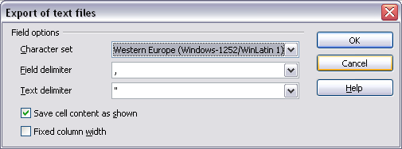Figure 9: Choosing options when exporting to Text CSV

Saving in other formats
Calc can save spreadsheets in a range of formats, including HTML (Web pages), through the Save As dialog. Calc can also export spreadsheets to the PDF and XHTML file formats. See Chapter 6 (Printing, Exporting, and E-mailing) for more information.

Navigating within spreadsheets
Calc provides many ways to navigate within a spreadsheet from cell to cell and sheet to sheet. You can generally use whatever method you prefer.

Going to a particular cell
Using the mouse
Place the mouse pointer over the cell and click.
Using a cell reference
Click on the little inverted black triangle just to the right of the Name Box (Figure 3). The existing cell reference will be highlighted. Type the cell reference of the cell you want to go to and press Enter. Cell references are case insensitive: a3 or A3, for example, are the same. Or just click into the Name Box, backspace over the existing cell reference, and type in the cell reference you want and press Enter.
Using the Navigator
Click on the Navigator button in the Standard toolbar (or press F5) to display the Navigator. Type the cell reference into the top two fields, labeled Column and Row, and press Enter. In Figure 22 on page 39, the Navigator would select cell A7. For more about using the Navigator, see page 38.

Moving from cell to cell
In the spreadsheet, one cell normally has a darker black border. This black border indicates where the focus is (see Figure 10). The focus indicates which cell is enabled to receive input. If a group of cells is selected, they have a highlight color (usually gray), with the focus cell having a dark border.
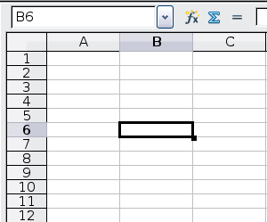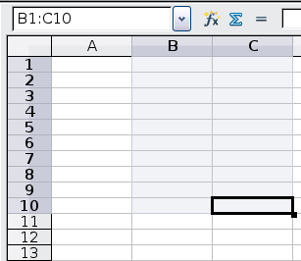
Figure 10. (left) One selected cell and (right) a group of selected cells
Using the mouse
To move the focus using the mouse, simply move the mouse pointer to the cell where you want the focus to be and click the left mouse button. This action changes the focus to the new cell. This method is most useful when the two cells are a large distance apart.
Using the Tab and Enter keys
- Pressing Enter or Shift+Enter moves the focus down or up, respectively.
- Pressing Tab or Shift+Tab moves the focus to the right or to the left, respectively.
Using the arrow keys
Pressing the arrow keys on the keyboard moves the focus in the direction of the arrows.
Using Home, End, Page Up and Page Down
- Home moves the focus to the start of a row.
- End moves the focus to the column furthest to the right that contains data.
- Page Down moves the display down one complete screen and Page Up moves the display up one complete screen.
- Combinations of Control (often represented on keyboards as Ctrl) and Alt with Home, End, Page Down (PgDn), Page Up (PgUp), and the arrow keys move the focus of the current cell in other ways. Table 1 describes the keyboard shortcuts for moving about a spreadsheet.
Tip | Use one of the four Alt+Arrow key combinations to resize the height or width of a cell. (For example: Alt+↓ increases the height of a cell.)
Table 1. Moving from cell to cell using the keyboard
Key Combination | Movement
→ | Right one cell
← | Left one cell
↑ | Up one cell
↓ | Down one cell
Control+→ | To the next column to the right containing data in that row or to Column AMJ
Control+← | To the next column to the left containing data in that row or to Column A
Control+↑ | To the next row above containing data in that column or to Row 1
Control+↓ | To the next row below containing data in that column or to Row 65536
Control+Home | To Cell A1
Control+End | To lower right-hand corner of the rectangular area containing data
Alt+Page Downn | One screen to the right (if possible)
Alt+Page Up | One screen to the left (if possible)
Control+Page Down | One sheet to the right (in sheet tabs)
Control+Page Up | One sheet to the left (in sheet tabs)
Tab | To the next cell on the right
Shift+Tab | To the next cell on the left
Enter | Down one cell (unless changed by user)
Shift+Enter | Up one cell (unless changed by user)

Customizing the effects of the Enter key
You can customize the direction in which the Enter key moves the focus, by selecting Tools > Options > OpenOffice.org Calc > General.
The four choices for the direction of the Enter key are shown on the right hand side of Figure 11. It can move the focus down, right, up, or left. Depending on the file being used or on the type of data being entered, setting a different direction can be useful.
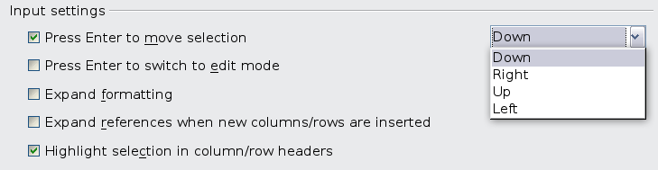
Figure 11: Customizing the effect of the Enter key
The Enter key can also be used to switch into and out of the editing mode. Use the first two options under Input settings in Figure 11 to change the Enter key settings.

Moving from sheet to sheet
Each sheet in a spreadsheet is independent of the others, though they can be linked with references from one sheet to another. There are three ways to navigate between different sheets in a spreadsheet.
Using the keyboard
Pressing Control+Page Down moves one sheet to the right and pressing Control+Page Up moves one sheet to the left.
Using the mouse
Clicking on one of the sheet tabs at the bottom of the spreadsheet selects that sheet.
If you have a lot of sheets, then some of the sheet tabs may be hidden behind the horizontal scroll bar at the bottom of the screen. If this is the case, then the four buttons at the left of the sheet tabs can move the tabs into view. Figure 12 shows how to do this.
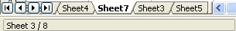

Figure 12. Sheet tab arrows
Move to the first sheet
Move left one sheet
Move right one sheet
Move to the last sheet
Sheet tabs
Notice that the sheets here are not numbered in order. Sheet numbering is arbitrary; you can name a sheet as you wish.
Note | The sheet tab arrows that appear in Figure 12 only appear if you have some sheet tabs that can not be seen. Otherwise, they appear faded as in Figure 1.

Selecting items in a sheet or spreadsheet

Selecting cells
Cells can be selected in a variety of combinations and quantities.
Single cell
Left-click in the cell. The result will look like the left side of Figure 10. You can verify your selection by looking in the Name Box.
Range of contiguous cells
A range of cells can be selected using the keyboard or the mouse.
To select a range of cells by dragging the mouse:
- Click in a cell.
- Press and hold down the left mouse button.
- Move the mouse around the screen.
- Once the desired block of cells is highlighted, release the left mouse button.
To select a range of cells without dragging the mouse:
- Click in the cell which is to be one corner of the range of cells.
- Move the mouse to the opposite corner of the range of cells.
- Hold down the Shift key and click.
Tip | You can also select a contiguous range of cells by first clicking in the STD field on the status bar and changing it to EXT, before clicking in the opposite corner of the range of cells in step 3 above. If you use this method, be sure to change EXT back to STD or you may find yourself extending the selection unintentionally.
To select a range of cells without using the mouse:
- Select the cell that will be one of the corners in the range of cells.
- While holding down the Shift key, use the cursor arrows to select the rest of the range.
The result of any of these methods looks like the right side of Figure 10.
Tip | You can also directly select a range of cells using the Name Box. Click into the Name Box as described in “Using a cell reference” on page 23. To select a range of cells, enter the cell reference for the upper left-hand cell, followed by a colon (:), and then the lower right-hand cell reference. For example, to select the range that would go from A3 to C6, you would enter A3:C6.
Range of noncontiguous cells
- Select the cell or range of cells using one of the methods above.
- Move the mouse pointer to the start of the next range or single cell.
- Hold down the Control key and click or click-and-drag to select another range of cells to add to the first range.
- Repeat as necessary.
Tip | You can also select a noncontiguous range of cells by first clicking twice in the STD field on the status bar to change it to ADD, before clicking on a cell that you want to add to the range of cells in step 3 above. This method works best when adding single cells to a range. If you use this method, be sure to change ADD back to STD or you may find yourself adding more selections unintentionally.

Selecting columns and rows
Entire columns and rows can be selected very quickly in OOo.
Single column or row
To select a single column, click on the column identifier letter (see Figure 1).
To select a single row, click on the row identifier number.
Multiple columns or rows
To select multiple columns or rows that are contiguous:
- Click on the first column or row in the group.
- Hold down the Shift key.
- Click the last column or row in the group.
To select multiple columns or rows that are not contiguous:
- Click on the first column or row in the group.
- Hold down the Control key.
- Click on all of the subsequent columns or rows while holding down the Control key.
Entire sheet
To select the entire sheet, click on the small box between the A column header and the 1 row header.
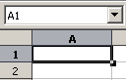

Figure 13. Select All box
Select All
You can also press Control+A to select the entire sheet.

Selecting sheets
You can select either one or multiple sheets. It can be advantageous to select multiple sheets at times when you want to make changes to many sheets at once.
Single sheet
Click on the sheet tab for the sheet you want to select. The active sheet becomes white (see Figure 12).
Multiple contiguous sheets
To select multiple contiguous sheets:
- Click on the sheet tab for the first desired sheet.
- Move the mouse pointer over the sheet tab for the last desired sheet.
- Hold down the Shift key and click on the sheet tab.
All the tabs between these two sheets will turn white. Any actions that you perform will now affect all highlighted sheets.
Multiple noncontiguous sheets
To select multiple noncontiguous sheets:
- Click on the sheet tab for the first desired sheet.
- Move the mouse pointer over the sheet tab for the second desired sheet.
- Hold down the Control key and click on the sheet tab.
- Repeat as necessary.
The selected tabs will turn white. Any actions that you perform will now affect all highlighted sheets.
All sheets
Right-click any one of the sheet tabs and choose Select All Sheets from the pop-up menu.

Working with columns and rows

Inserting columns and rows
Columns and rows can be inserted individually or in groups.
Note | When you insert a single new column, it is inserted to the left of the highlighted column. When you insert a single new row, it is inserted above the highlighted row.  Cells in the new columns or rows are formatted like the corresponding cells in the column or row before (or to the left of) which the new column or row is inserted.
Single column or row
Using the Insert menu:
- Select the cell, column, or row where you want the new column or row inserted.
- Choose either Insert > Columns or Insert > Rows.
Using the mouse:
- Select the cell, column, or row where you want the new column or row inserted.
- Right-click the header of the column or row.
- Choose Insert Rows or Insert Columns.
Multiple columns or rows
Multiple columns or rows can be inserted at once rather than inserting them one at a time.
- Highlight the required number of columns or rows by holding down the left mouse button on the first one and then dragging across the required number of identifiers.
- Proceed as for inserting a single column or row above.

Deleting columns and rows
Columns and rows can be deleted individually or in groups.
Single column or row
A single column or row can be deleted by using the mouse:
- Select the column or row to be deleted.
- Choose Edit > Delete Cells from the menu bar.
Or,
- Right-click on the column or row header.
- Choose Delete Columns or Delete Rows from the pop-up menu.
Multiple columns or rows
Multiple columns or rows can be deleted at once rather than deleting them one at a time.
- Highlight the required columns or rows by holding down the left mouse button on the first one and then dragging across the required number of identifiers.
- Proceed as for deleting a single column or row above.
Tip | Instead of deleting a row or column, you may wish to delete the contents of the cells but keep the empty row or column. See Chapter 2 (Entering, Editing, and Formatting Data) for instructions.

Working with sheets
Like any other Calc element, sheets can be inserted, deleted, and renamed.

Inserting new sheets
There are several ways to insert a new sheet. The first step for all of the methods is to select the sheets that the new sheet will be inserted next to. Then any of the following options can be used.
- Choose Insert > Sheet from the menu bar.
- Right-click on the sheet tab and choose Insert Sheet.
- Click in an empty space at the end of the line of sheet tabs.
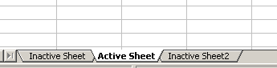

Figure 14. Creating a new sheet
Click here to insert a new sheet
Each method will open the Insert Sheet dialog. Here you can select whether the new sheet is to go before or after the selected sheet and how many sheets you want to insert. If you are inserting only one sheet, there is the opportunity to give the sheet a name.
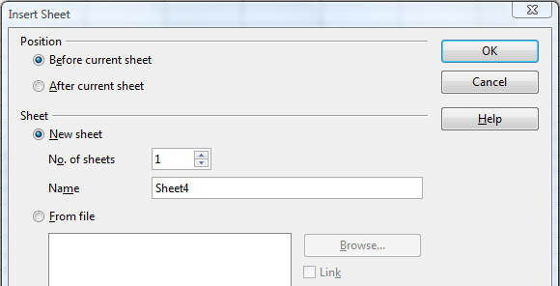Figure 15: Insert Sheet dialog

Deleting sheets
Sheets can be deleted individually or in groups.
Single sheet
Right-click on the tab of the sheet you want to delete and choose Delete Sheet from the pop-up menu, or choose Edit > Sheet > Delete from the Menu bar. Either way, an alert will ask if you want to delete the sheet permanently. Click Yes.
Multiple sheets
To delete multiple sheets, select them as described earlier, then either right-click over one of the tabs and choose Delete Sheet from the pop-up menu, or choose Edit > Sheet > Delete from the Menu bar.

Renaming sheets
The default name for the a new sheet is SheetX, where X is a number. While this works for a small spreadsheet with only a few sheets, it becomes awkward when there are many sheets.
To give a sheet a more meaningful name, you can:
- Enter the name in the Name box when you create the sheet, or
- Right-click on a sheet tab and choose Rename Sheet from the pop-up menu; replace the existing name with a different one.
- (New in OOo3.1) Double-click on a sheet tab to pop up the Rename Sheet dialog.
Note | Sheet names must start with either a letter or a number; other characters including spaces are not allowed. Apart from the first character of the sheet name, allowed characters are letters, numbers, spaces, and the underscore character. Attempting to rename a sheet with an invalid name will produce an error message.

Viewing Calc

Using zoom
Use the zoom function to change the view to show more or fewer cells in the window.
In addition to using the Zoom slider (new in OOo 3.1) on the Status bar (see page 16), you can open the Zoom dialog and make a selection on the left-hand side.
- Choose View > Zoom from the Menu bar, or
- Double-click on the percentage figure in the Status bar at the bottom of the window.
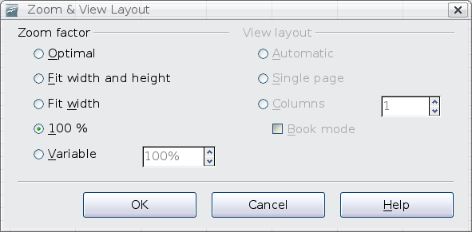Figure 16. Zoom dialog
Optimal
Resizes the display to fit the width of the selected cells. To use this option, you must first highlight a range of cells.
Fit Width and Height
Displays the entire page on your screen.
Fit Width
Displays the complete width of the document page. The top and bottom edges of the page may not be visible.
100%
Displays the document at its actual size.
Variable
Enter a zoom percentage of your choice.

Freezing rows and columns
Freezing locks a number of rows at the top of a spreadsheet or a number of columns on the left of a spreadsheet or both. Then when scrolling around within the sheet, any frozen columns and rows remain in view.
Figure 17 shows some frozen rows and columns. The heavier horizontal line between rows 3 and 14 and the heavier vertical line between columns C and H denote the frozen areas. Rows 4 through 13 and columns D through G have been scrolled off the page. The first three rows and columns remained because they are frozen into place.
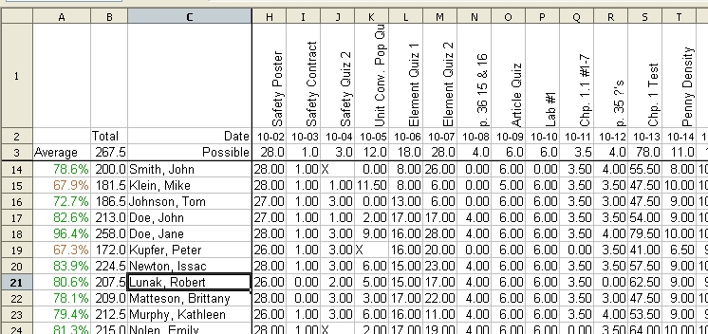
Figure 17. Frozen rows and columns
You can set the freeze point at one row, one column, or both a row and a column as in Figure 17.
Freezing single rows or columns
- Click on the header for the row below where you want the freeze or for the column to the right of where you want the freeze.
- Choose Window > Freeze.
A dark line appears, indicating where the freeze is put.
Freezing a row and a column
- Click into the cell that is immediately below the row you want frozen and immediately to the right of the column you want frozen.
- Choose Window > Freeze.
Two lines appear on the screen, a horizontal line above this cell and a vertical line to the left of this cell. Now as you scroll around the screen, everything above and to the left of these lines will remain in view.
Unfreezing
To unfreeze rows or columns, choose Window > Freeze. The check mark by Freeze will vanish.

Splitting the screen
Another way to change the view is by splitting the window, also known as splitting the screen. The screen can be split horizontally, vertically, or both. You can therefore have up to four portions of the spreadsheet in view at any one time.
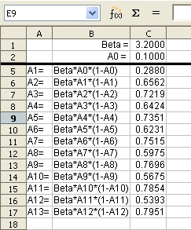
Figure 18. Split screen example
Why would you want to do this? Imagine you have a large spreadsheet and one of the cells has a number in it that is used by three formulas in other cells. Using the split-screen technique, you can position the cell containing the number in one section and each of the cells with formulas in the other sections. Then you can change the number in the cell and watch how it affects each of the formulas.

Splitting the screen horizontally
To split the screen horizontally:
- Move the mouse pointer into the vertical scroll bar, on the right-hand side of the screen, and place it over the small button at the top with the black triangle.
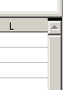

Figure 19. Split screen bar on vertical scroll bar
Split screen bar
- Immediately above this button, you will see a thick black line (Figure 19). Move the mouse pointer over this line, and it turns into a line with two arrows (Figure 20).

Figure 20. Split-screen bar on vertical scroll bar with cursor
- Hold down the left mouse button. A gray line appears, running across the page. Drag the mouse downwards and this line follows.
- Release the mouse button and the screen splits into two views, each with its own vertical scroll bar. You can scroll the upper and lower parts independently.
Notice in Figure 18, the Beta and the A0 values are in the upper part of the window and other calculations are in the lower part. Thus, you can make changes to the Beta and A0 values and watch their effects on the calculations in the lower half of the window.
Tip | You can also split the screen using a menu command. Click in a cell immediately below and to the right of where you wish the screen to be split, and choose Window > Split.

Splitting the screen vertically
To split the screen vertically:
- Move the mouse pointer into the horizontal scroll bar at the bottom of the screen and place it over the small button on the right with the black triangle.
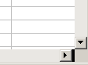

Figure 21: Split bar on horizontal scroll bar
Split screen bar
- Immediately to the right of this button is a thick black line (Figure 21). Move the mouse pointer over this line and it turns into a line with two arrows.
- Hold down the left mouse button, and a gray line appears, running up the page. Drag the mouse to the left and this line follows.
- Release the mouse button, and the screen is split into two views, each with its own horizontal scroll bar. You can scroll the left and right parts of the window independently.

Removing split views
To remove a split view, do any of the following:
- Double-click on each split line.
- Click on and drag the split lines back to their places at the ends of the scroll bars.
- Choose Window > Split to remove all split lines at the same time.

Using the Navigator
In addition to the cell reference boxes (labeled Column and Row), the Navigator provides several other ways to move quickly through a spreadsheet and find specific items.
To open the Navigator, click its icon on the Standard toolbar, or press F5, or choose View > Navigator on the Menu bar, or double-click on the Sheet Sequence Number in the Status Bar. You can dock the Navigator to either side of the main Calc window or leave it floating. (To dock or float the Navigator, hold down the Control key and double-click in an empty area near the icons at the top.)
The Navigator displays lists of all the objects in a spreadsheet document, grouped into categories. If an indicator (plus sign or arrow) appears next to a category, at least one object of this kind exists. To open a category and see the list of items, click on the indicator.
To hide the list of categories and show only the icons at the top, click the Contents icon . Click this icon again to show the list.
Table 2 summarizes the functions of the icons at the top of the Navigator.
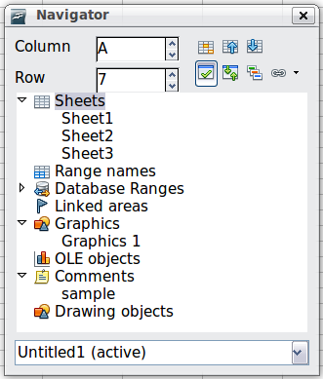
Figure 22: The Navigator in Calc
Table 2: Function of icons in the Navigator
Icon | Action
 | Data Range. Specifies the current data range denoted by the position of the cell cursor.
 | Start/End. Moves to the cell at the beginning or end of the current data range, which you can highlight using the Data Range button.
 | Contents. Shows or hides the list of categories.
 | Toggle. Switches between showing all categories and showing only the selected category.
 | Displays all available scenarios. Double-click a name to apply that scenario. See Chapter 7 (Data Analysis) for more information.
 | Drag Mode. Choose hyperlink, link, or copy. See “Choosing a drag mode” for details.

Moving quickly through a document
The Navigator provides several convenient ways to move around a document and find items in it:
- To jump to a specific cell in the current sheet, type its cell reference in the Column and Row boxes at the top of the Navigator and press the Enter key; for example, in Figure 22 the cell reference is A7.
- When a category is showing the list of objects in it, double-click on an object to jump directly to that object’s location in the document.
- To see the content in only one category, highlight that category and click the Toggle icon. Click the icon again to display all the categories.
- Use the Start and End icons to jump to the first or last cell in the selected data range.
Tip | Ranges, scenarios, pictures, and other objects are much easier to find if you have given them informative names when creating them, instead of keeping Calc’s default Graphics 1, Graphics 2, Object 1, and so on, which may not correspond to the position of the object in the document.

Choosing a drag mode
Sets the drag and drop options for inserting items into a document using the Navigator.
Insert as Hyperlink
Creates a hyperlink when you drag and drop an item into the current document.
Insert as Link
Inserts the selected item as a link where you drag and drop an object into the current document.
Insert as Copy
Inserts a copy of the selected item where you drag and drop in the current document. You cannot drag and drop copies of graphics, OLE objects, or indexes.

Calc Guide

Chapter 2
Entering, Editing, and Formatting Data
This PDF is designed to be read onscreen, two pages at a time. If you want to print a copy, your PDF viewer should have an option for printing two pages on one sheet of paper, but you may need to start with page 2 to get it to print facing pages correctly. (Print this cover page separately.)

Copyright
This document is Copyright © 2005–2010 by its contributors as listed in the section titled Authors. You may distribute it and/or modify it under the terms of either the GNU General Public License, version 3 or later, or the Creative Commons Attribution License, version 3.0 or later.
All trademarks within this guide belong to their legitimate owners.
Authors
Peter Kupfer
Andy Brown
Stephen Buck
Iain Roberts
Hazel Russman
Barbara M. Tobias
Jean Hollis Weber
Jared Kobos
Feedback
Please direct any comments or suggestions about this document to: authors@documentation.openoffice.org
Acknowledgments
The sections on speeding up data entry, hiding and showing data, and sorting records are revised from articles written by Bruce Byfield and first published on the Linux Journal website; used with permission.
Publication date and software version
Published 20 June 2010. Based on OpenOffice.org 3.2.
Contents
Copyright 2
Introduction 5
Entering data using the keyboard 5
Entering numbers 5
Entering text 5
Entering numbers as text 5
Entering dates and times 6
Entering special characters 6
Inserting dashes 7
Deactivating automatic changes 7
Speeding up data entry 8
Using the Fill tool on cells 8
Using a fill series 9
Defining a fill series 10
Using selection lists 11
Sharing content between sheets 11
Validating cell contents 12
Editing data 14
Removing data from a cell 14
Replacing all the data in a cell 15
Changing part of the data in a cell 15
Formatting data 16
Formatting multiple lines of text 16
Using automatic wrapping 16
Using manual line breaks 17
Shrinking text to fit the cell 17
Formatting numbers 18
Formatting the font 19
Choosing font effects 19
Setting cell alignment and orientation 20
Formatting the cell borders 21
Formatting the cell background 22
Autoformatting cells and sheets 22
Defining a new AutoFormat 23
Formatting spreadsheets using themes 23
Using conditional formatting 24
Hiding and showing data 26
Outline group controls 26
Filtering which cells are visible 27
Sorting records 28
Finding and replacing in Calc 30
Finding and replacing formulas or values 31
Finding and replacing text 32
Finding and replacing cell styles 32
Using wildcards (regular expressions) 32

Introduction
You can enter data into Calc in several ways: using the keyboard, the mouse (dragging and dropping), the Fill tool, and selection lists. Calc also provides the ability to enter information into multiple sheets of the same document at the same time.
After entering data, you can format and display it in various ways.

Entering data using the keyboard
Most data entry in Calc can be accomplished using the keyboard.

Entering numbers
Click in the cell and type in the number using the number keys on either the main keyboard or the numeric keypad.
To enter a negative number, either type a minus (–) sign in front of it or enclose it in parentheses (brackets), like this: (1234).
By default, numbers are right-aligned and negative numbers have a leading minus symbol.

Entering text
Click in the cell and type the text. Text is left-aligned by default.

Entering numbers as text
If a number is entered in the format 01481, Calc will drop the leading 0. (Exception: see Tip below.) To preserve the leading zero, for example for telephone area codes, type an apostrophe before the number, like this: '01481.
The data is now treated as text and displayed exactly as entered. Typically, formulas will treat the entry as a zero and functions will ignore it.
Tip | Numbers can have leading zeros and still be regarded as numbers (as opposed to text) if the cell is formatted appropriately. Right-click on the cell and chose Format Cells > Numbers. Adjust the leading zeros setting to add leading zeros to numbers.
Note | When a plain apostrophe is used to allow a leading 0 to be displayed, it is not visible in the cell after the Enter key is pressed. If “smart quotes” are used for apostrophes, the apostrophe remains visible in the cell.  To choose the type of apostrophe, use Tools > AutoCorrect Options > Custom Quotes. The selection of the apostrophe type affects both Calc and Writer.
Caution | When a number is formatted as text, take care that the cell containing the number is not used in a formula because Calc will ignore the value.

Entering dates and times
Select the cell and type the date or time. You can separate the date elements with a slash (/) or a hyphen (–) or use text such as 10 Oct 03. Calc recognizes a variety of date formats. You can separate time elements with colons such as 10:43:45.

Entering special characters
A “special” character is one not found on a standard English keyboard. For example, © ¾ æ ç ñ ö ø ¢ are all special characters. To insert a special character:
- Place the cursor in your document where you want the character to appear.
- Click Insert > Special Character to open the Special Characters dialog (Figure 23).
- Select the characters (from any font or mixture of fonts) you wish to insert, in order; then click OK. The selected characters are shown in the bottom left of the dialog. As you select each character, it is shown alone at the bottom right, along with the numerical code for that character.
Note | Different fonts include different special characters. If you do not find a particular special character you want, try changing the Font selection.
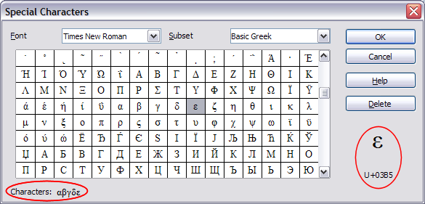Figure 23: The Special Characters dialog

Inserting dashes
To enter en and em dashes, you can use the Replace dashes option under Tools > AutoCorrect Options. This option replaces two hyphens, under certain conditions, with the corresponding dash.
In the following table, the A and B represent text consisting of letters A to z or digits 0 to 9.
Text that you type: | Result
A - B (A, space, minus, space, B) | A – B (A, space, en-dash, space, B)
A -- B (A, space, minus, minus, space, B) | A – B (A, space, en-dash, space, B)
A--B (A, minus, minus, B) | A—B (A, em-dash, B)
A-B (A, minus, B) | A-B (unchanged)
A -B (A, space, minus, B) | A -B (unchanged)
A --B (A, space, minus, minus, B) | A –B (A, space, en-dash, B)

Deactivating automatic changes
Calc automatically applies many changes during data input, unless you deactivate those changes. You can also immediately undo any automatic changes with Ctrl+Z.
AutoCorrect changes
Automatic correction of typing errors, replacement of straight quotation marks by curly (custom) quotes, and starting cell content with an uppercase (capital) letter are controlled by Tools > AutoCorrect Options. Go to the Custom Quotes, Options, or Replace tabs to deactivate any of the features that you do not want. On the Replace tab, you can also delete unwanted word pairs and add new ones as required.
AutoInput
When you are typing in a cell, Calc automatically suggests matching input found in the same column. To turn the AutoInput on and off, set or remove the check mark in front of Tools > Cell Contents > AutoInput.
Automatic date conversion
Calc automatically converts certain entries to dates. To ensure that an entry that looks like a date is interpreted as text, type an apostrophe at the beginning of the entry. The apostrophe is not displayed in the cell.

Speeding up data entry
Entering data into a spreadsheet can be very labor-intensive, but Calc provides several tools for removing some of the drudgery from input.
The most basic ability is to drop and drag the contents of one cell to another with a mouse. Many people also find AutoInput helpful. Calc also includes several other tools for automating input, especially of repetitive material. They include the Fill tool, selection lists, and the ability to input information into multiple sheets of the same document.

Using the Fill tool on cells
At its simplest, the Fill tool is a way to duplicate existing content. Start by selecting the cell to copy, then drag the mouse in any direction (or hold down the Shift key and click in the last cell you want to fill), and then choose Edit > Fill and the direction in which you want to copy: Up, Down, Left or Right.
Caution | Choices that are not available are grayed out, but you can still choose the opposite direction from what you intend, which could cause you to overwrite cells accidentally.
Tip | A shortcut way to fill cells is to grab the “handle” in the lower right-hand corner of the cell and drag it in the direction you want to fill. If the cell contains a number, the number will fill in series. If the cell contains text, the same text will fill in the direction you chose.
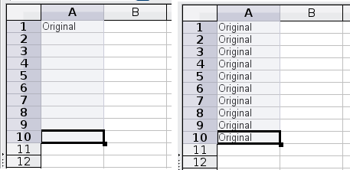
Figure 24: Using the Fill tool

Using a fill series
A more complex use of the Fill tool is to use a fill series. The default lists are for the full and abbreviated days of the week and the months of the year, but you can create your own lists as well.
To add a fill series to a spreadsheet, select the cells to fill, choose Edit > Fill > Series. In the Fill Series dialog, select AutoFill as the Series type, and enter as the Start value an item from any defined series. The selected cells then fill in the other items on the list sequentially, repeating from the top of the list when they reach the end of the list.
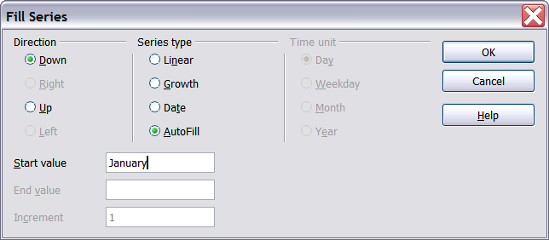
Figure 25: Specifying the start of a fill series (result is in Figure 26)
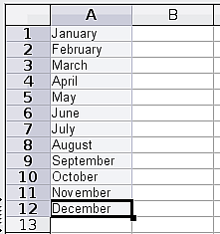
Figure 26: Result of fill series selection shown in Figure 25
You can also use Edit > Fill > Series to create a one-time fill series for numbers by entering the start and end values and the increment. For example, if you entered start and end values of 1 and 7 with an increment of 2, you would get the sequence of 1, 3, 5, 7.
In all these cases, the Fill tool creates only a momentary connection between the cells. Once they are filled, the cells have no further connection with one another.

Defining a fill series
To define your own fill series, go to Tools > Options > OpenOffice.org Calc > Sort Lists. This dialog shows the previously-defined series in the Lists box on the left, and the contents of the highlighted list in the Entries box.
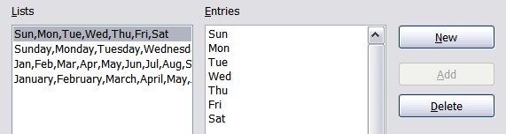
Figure 27: Predefined fill series
Click New. The Entries box is cleared. Type the series for the new list in the Entries box (one entry per line), and then click Add.
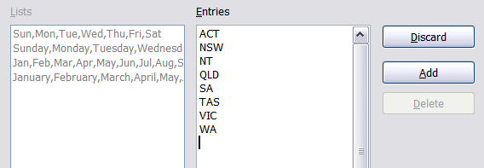
Figure 28: Defining a new fill series

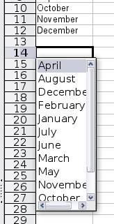
Using selection lists
Selection lists are available only for text, and are limited to using only text that has already been entered in the same column.
To use a selection list, select a blank cell and press Ctrl+D. A drop-down list appears of any cell in the same column that either has at least one text character or whose format is defined as Text. Click on the entry you require.

Sharing content between sheets
You might want to enter the same information in the same cell on multiple sheets, for example to set up standard listings for a group of individuals or organizations. Instead of entering the list on each sheet individually, you can enter it in all the sheets at once. To do this, select all the sheets (Edit > Sheet > Select), then enter the information in the current one.
Caution | This technique overwrites any information that is already in the cells on the other sheets—without any warning. For this reason, when you are finished, be sure to deselect all the sheets except the one you want to edit. (Ctrl+click on a sheet tab to select or deselect the sheet.)

Validating cell contents
When creating spreadsheets for other people to use, you may want to make sure they enter data that is valid or appropriate for the cell. You can also use validation in your own work as a guide to entering data that is either complex or rarely used.
Fill series and selection lists can handle some types of data, but they are limited to predefined information. To validate new data entered by a user, select a cell and use Data > Validity to define the type of contents that can be entered in that cell. For example, a cell might require a date or a whole number, with no alphabetic characters or decimal points; or a cell may not be left empty.
Depending on how validation is set up, the tool can also define the range of values that can be entered and provide help messages that explain the content rules you have set up for the cell and what users should do when they enter invalid content. You can also set the cell to refuse invalid content, accept it with a warning, or—if you are especially well-organized—start a macro when an error is entered.
Validation is most useful for cells containing functions. If cells are set to accept invalid content with a warning, rather than refusing it, you can use Tools > Detective > Mark Invalid Data to find the cells with invalid data. The Detective marks with a circle any cells containing invalid data.
Note that a validity rule is considered part of a cell’s format. If you select Format or Delete All from the Delete Contents window, then it is removed. (Repeating the Detective’s Mark Invalid Data command then removes the invalid data circle, because the data is no longer invalid.) If you want to copy a validity rule with the rest of the cell, use Edit > Paste Special > Paste Formats or Paste All.
Figure 29 shows the choices for a typical validity test. Note the Allow blank cells option under the Allow list.
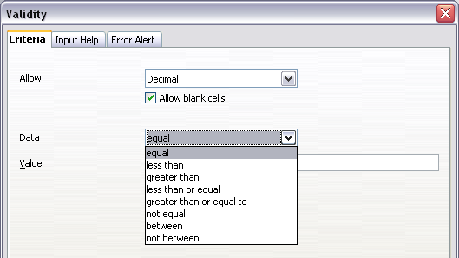Figure 29: Typical validity test choices.
The validity test options vary with the type of data selected from the Allow list. For example, Figure 30 shows the choices when a cell must contain a cell range.
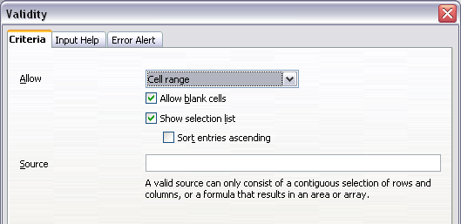Figure 30: Validity choices for a cell range.
To provide input help for a cell, use the Input Help page of the Validity dialog (Figure 31). To show an error message when an invalid value is entered, use the Error Alert page (Figure 32). Be sure to write something helpful, explaining what a valid entry should contain—not just “Invalid data—try again” or something similar.
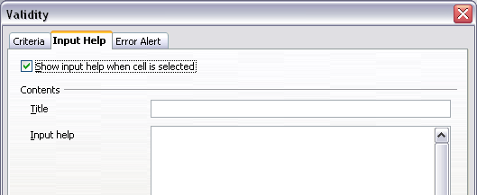Figure 31: Defining input help for a cell
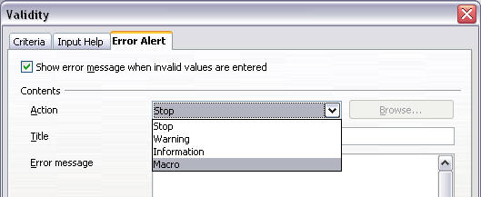Figure 32: Defining an error message for a cell with invalid data

Editing data
Editing data is done is in much the same way as entering it. The first step is to select the cell containing the data to be edited.

Removing data from a cell
Data can be removed (deleted) from a cell in several ways.
Removing data only
The data alone can be removed from a cell without removing any of the formatting of the cell. Click in the cell to select it, and then press the Backspace key.
Removing data and formatting
The data and the formatting can be removed from a cell at the same time. Press the Delete key (or right-click and choose Delete Contents, or use Edit > Delete Contents) to open the Delete Contents dialog (Figure 33). From this dialog, different aspects of the cell can be deleted. To delete everything in a cell (contents and format), check Delete all.
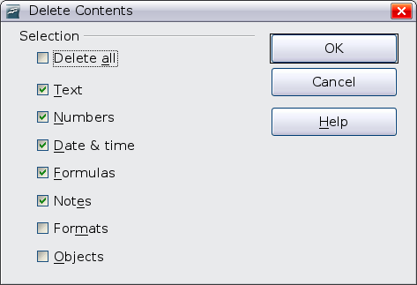
Figure 33: Delete Contents dialog

Replacing all the data in a cell
To remove data and insert new data, simply type over the old data. The new data will retain the original formatting.

Changing part of the data in a cell
Sometimes it is necessary to change the contents of cell without removing all of the contents, for example if the phrase “See Dick run” is in a cell and it needs to be changed to “See Dick run fast.” It is often useful to do this without deleting the old cell contents first.
The process is the similar to the one described above, but you need to place the cursor inside the cell. You can do this in two ways.
Using the keyboard
After selecting the appropriate cell, press the F2 key and the cursor is placed at the end of the cell. Then use the keyboard arrow keys to move the cursor through the text in the cell.
Using the mouse
Using the mouse, either double-click on the appropriate cell (to select it and place the cursor in it for editing), or single-click to select the cell and then move the mouse pointer up to the input line and click into it to place the cursor for editing.

Formatting data
The data in Calc can be formatted in several ways. It can either be edited as part of a cell style so that it is automatically applied, or it can be applied manually to the cell. Some manual formatting can be applied using toolbar icons. For more control and extra options, select the appropriate cell or cells range, right-click on it, and select Format Cells. All of the format options are discussed below.
Note | All the settings discussed in this section can also be set as a part of the cell style. See Chapter 4 (Using Styles and Templates) for more information.

Formatting multiple lines of text
Multiple lines of text can be entered into a single cell using automatic wrapping or manual line breaks. Each method is useful for different situations.

Using automatic wrapping
To set text to wrap at the end of the cell, right-click on the cell and select Format Cells (or choose Format > Cells from the menu bar, or press Ctrl+1). On the Alignment tab (Figure 34), under Properties, select Wrap text automatically. The results are shown in Figure 35.
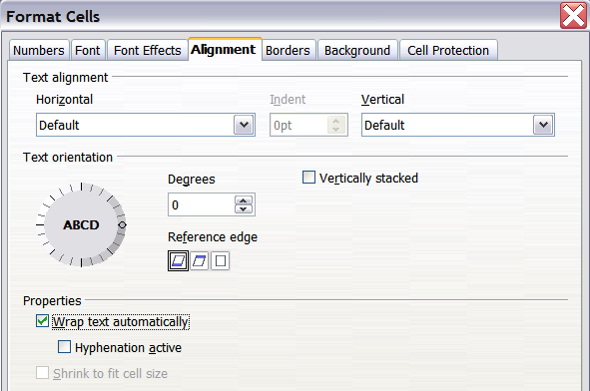
Figure 34: Format Cells > Alignment dialog
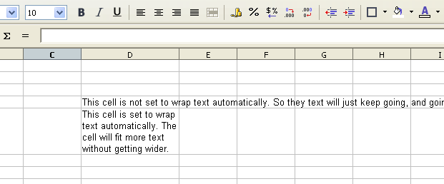
Figure 35: Automatic text wrap

Using manual line breaks
To insert a manual line break while typing in a cell, press Ctrl+Enter. This method does not work with the cursor in the input line. When editing text, first double-click the cell, then single-click at the position where you want the line break.
When a manual line break is entered, the cell width does not change. Figure 36 shows the results of using two manual line breaks after the first line of text.
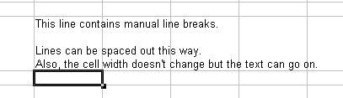
Figure 36: Cell with manual line breaks

Shrinking text to fit the cell
The font size of the data in a cell can automatically adjust to fit in a cell. To do this, select the Shrink to fit cell option in the Format Cells dialog (Figure 34). Figure 37 shows the results.
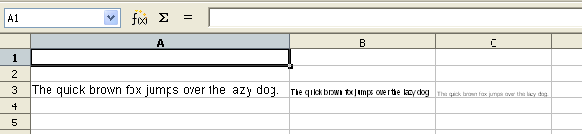
Figure 37: Shrinking font size to fit cells

Formatting numbers
Several different number formats can be applied to cells by using icons on the Formatting toolbar. Select the cell, then click the relevant icon. Some icons may not be visible in a default setup; click the down-arrow at the end of the Formatting bar and select other icons to display.
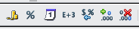
Figure 38: Number format icons. Left to right: currency, percentage, date, exponential, standard, add decimal place, delete decimal place.
For more control or to select other number formats, use the Numbers tab (Figure 39) of the Format Cells dialog.
- Apply any of the data types in the Category list to the data.
- Control the number of decimal places and leading zeros.
- Enter a custom format code.
The Language setting controls the local settings for the different formats such as the date order and the currency marker.
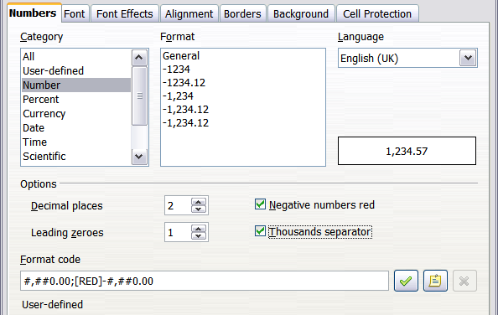
Figure 39: Format Cells > Numbers

Formatting the font
To quickly choose the font used in a cell, select the cell, then click the arrow next to the Font Name box on the Formatting toolbar and choose a font from the list.
Tip | To choose whether to show the font names in their font or in plain text, go to Tools > Options > OpenOffice.org > View and select or deselect the Show preview of fonts option in the Font Lists section. For more information, see Chapter 14 (Setting Up and Customizing Calc).
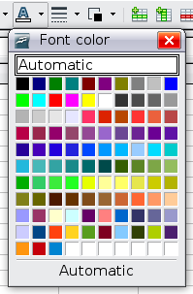
To choose the size of the font, click the arrow next to the Font Size box on the Formatting toolbar. For other formatting, you can use the Bold, Italic, or Underline icons.
To choose a font color, click the arrow next to the Font Color icon to display a color palette. Click on the required color.
(To define custom colors, use Tools > Options > OpenOffice.org > Colors. See Chapter 14 for more information.)
To specify the language of the cell (useful because it allows different languages to exist in the same document and be spell checked correctly), use the Font tab of the Format Cells dialog. See Chapter 4 for more information.

Choosing font effects
The Font Effects tab (Figure 40) of the Format Cells dialog offers more font options.
Overlining and underlining
You can choose from a variety of overlining and underlining options (solid lines, dots, short and long dashes, in various combinations) and the color of the line.
Strikethrough
The strikethrough options include lines, slashes, and Xs.
Relief
The relief options are embossed (raised text), engraved (sunken text), outline, and shadow.
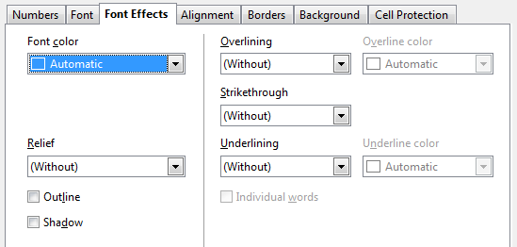Figure 40: Format Cells > Font Effects

Setting cell alignment and orientation
Some of the cell alignment and orientation icons are not shown by default on the Formatting toolbar. To show them, click on the small arrow at the right-hand end of the toolbar and select them from the list of icons.
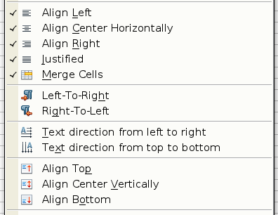
Figure 41: Cell alignment and orientation
Some of the alignment and orientation icons are available only if you have Asian or CTL (Complex Text Layout) languages enabled (in Tools > Options > Language Settings > Languages). If you choose an unavailable icon from the list, it does not appear on the toolbar.
For more control and other choices, use the Alignment tab (Figure 34) of the Format Cells dialog to set the horizontal and vertical alignment and rotate the text. If you have Asian languages enabled, then the Text orientation section shows an extra option (labeled Asian layout mode) under the Vertically stacked option, as shown in Figure 41.
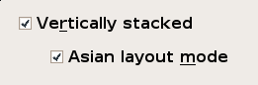
Figure 42: Asian layout mode option
The difference in results between having Asian layout mode on or off is shown in Figure 43.
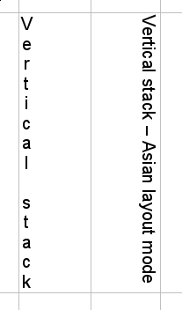
Figure 43: Types of vertical stacking

Formatting the cell borders
To quickly choose a line style and color for the borders of a cell, click the small arrows next to the Line Style and Line Color icons on the Formatting toolbar. If the Line Style and Line Color icons are not displayed in the formatting toolbar, select the down arrow on the right side of the bar, then Visible Buttons. In each case, a palette of choices is displayed.
For more control, including the spacing between the cell borders and the text, use the Borders tab of the Format Cells dialog. There you can also define a shadow. See Chapter 4 for details.
Note | The cell border properties apply to a cell, and can only be changed if you are editing that cell. For example, if cell C3 has a top border (which would be equivalent visually to a bottom border on C2), that border can only be removed by selecting C3. It cannot be removed in C2.

Formatting the cell background
To quickly choose a background color for a cell, click the small arrow next to the Background Color icon on the Formatting toolbar. A palette of color choices, similar to the Font Color palette, is displayed.
(To define custom colors, use Tools > Options > OpenOffice.org > Colors. See Chapter 14 for more information.)
You can also use the Background tab of the Format Cells dialog. See Chapter 4 for details.

Autoformatting cells and sheets
You can use the AutoFormat feature to quickly apply a set of cell formats to a sheet or a selected cell range.
- Select the cells that you want to format, including the column and row headers.
- Choose Format > AutoFormat.
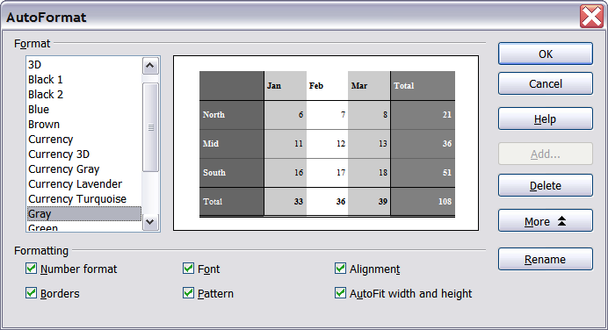
Figure 44: Choosing an AutoFormat
Note | If the selected cell range does not have column and row headers, AutoFormat is not available.
- To select which properties (number format, font, alignment, borders, pattern, autofit width and height) to include in an AutoFormat, click More. Select or deselect the required options.
- Click OK.
If you do not see any change in color of the cell contents, choose View > Value Highlighting from the menu bar.

Defining a new AutoFormat
You can define a new AutoFormat that is available to all spreadsheets.
- Format a sheet.
- Choose Edit > Select All.
- Choose Format > AutoFormat. The Add button is now active.
- Click Add.
- In the Name box of the Add AutoFormat dialog, type a meaningful name for the new format.
- Click OK to save. The new format is now available in the Format list in the AutoFormat dialog.

Formatting spreadsheets using themes
Calc comes with a predefined set of formatting themes that you can apply to your spreadsheets.
It is not possible to add themes to Calc, and they cannot be modified. However, you can modify their styles after you apply them to a spreadsheet.
To apply a theme to a spreadsheet:
- Click the Choose Themes icon in the Tools toolbar. If this toolbar is not visible, you can show it using View > Toolbars > Tools.
The Theme Selection dialog appears. This dialog lists the available themes for the whole spreadsheet.
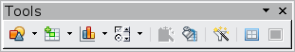
- In the Theme Selection dialog, select the theme that you want to apply to the spreadsheet.
As soon as you select a theme, some of the properties of the custom styles are applied to the open spreadsheet and are immediately visible.
- Click OK. If you wish, you can now go to the Styles and Formatting window to modify specific styles. These modifications do not change the theme; they only change the appearance of this specific spreadsheet document.

Using conditional formatting
You can set up cell formats to change depending on conditions that you specify. For example, in a table of numbers, you can show all the values above the average in green and all those below the average in red.
Note | To apply conditional formatting, AutoCalculate must be enabled. Choose Tools > Cell Contents > AutoCalculate.
Conditional formatting depends upon the use of styles. If you are not familiar with styles, please refer to Chapter 4. An easy way to set up the required styles is to format a cell the way you want it and click the New Style from Selection icon in the Styles and Formatting window.
After the styles are set up, here is how to use them.
- In your spreadsheet, select the cells to which you want to apply conditional formatting.
- Choose Format > Conditional Formatting from the menu bar.
- On the Conditional Formatting dialog (Figure 45), enter the conditions. Click OK to save. The selected cells are now formatted in the relevant style.
Cell value is / Formula is
Specifies whether conditional formatting is dependent on a cell value or on a formula. If you select cell value is, the Cell Value Condition box is displayed, as shown in the example. Here you can choose from conditions including less than, greater than, between, and others.
Parameter field
Enter a reference, value, or formula in the parameter field, or in both parameter fields if you have selected a condition that requires two parameters. You can also enter formulas containing relative references.
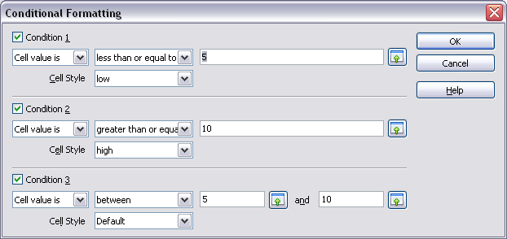Figure 45: Conditional formatting dialog
Cell style
Choose the cell style to be applied if the specified condition matches. The style must have been defined previously.
See the Help for more information and examples of use.
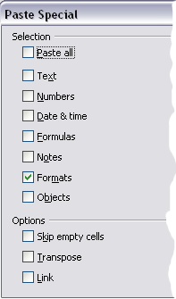
To apply the same conditional formatting later to other cells:
- Select one of the cells that has been assigned conditional formatting.
- Copy the cell to the clipboard.
- Select the cells that are to receive this same formatting.
- Choose Edit > Paste Special.
- On the Paste Special dialog, in the Selection area, select only the Formats option. Make sure all other options are not selected. Click OK.

Hiding and showing data
When elements are hidden, they are neither visible nor printed, but can still be selected for copying if you select the elements around them. For example, if column B is hidden, it is copied when you select columns A and C. When you need a hidden element again, you can reverse the process, and show the element.
To hide or show sheets, rows, and columns, use the options on the Format menu or the right-click (context) menu. For example, to hide a row, first select the row, and then choose Format > Row > Hide (or right-click and choose Hide).
To hide or show selected cells, choose Format > Cells from the menu bar (or right-click and choose Format Cells). On the Format Cells dialog, go to the Cell Protection tab.
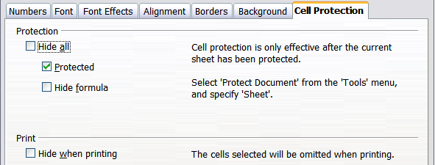
Figure 46: Hiding or showing cells

Outline group controls
If you are continually hiding and showing the same cells, you can simplify the process by creating outline groups, which add a set of controls for hiding and showing the cells in the group that are quick to use and always available.
If the contents of cells falls into a regular pattern, such as four cells followed by a total, then you can use Data > Group and Outline > AutoOutline to have Calc add outline controls based on the pattern. Otherwise, you can set outline groups manually by selecting the cells for grouping, then choosing Data > Group and Outline > Group. On the Group dialog, you can choose whether to group the selected cells by rows or columns.
When you close the dialog, the outline group controls are visible between either the row or column headers and the edges of the editing window. The controls resemble the tree-structure of a file-manager in appearance, and can be hidden by selecting Data > Group and Outline > Hide Details. They are strictly for online use, and do not print.
The basic outline controls have plus or minus signs at the start of the group to show or hide hidden cells. However, if outline groups are nested, the controls have numbered buttons for hiding the different levels.
If you no longer need a group, place the mouse cursor in any cell in it and select Data > Group and Outline > Ungroup. To remove all groups on a sheet, select Data > Group and Outline > Remove.
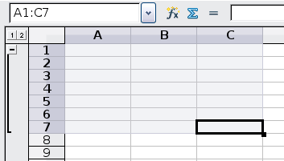
Figure 47: Outline group controls

Filtering which cells are visible
A filter is a list of conditions that each entry has to meet in order to be displayed. You can set three types of filters from the Data > Filter sub-menu.
Automatic filters add a drop-down list to the top row of a column that contains commonly used filters. They are quick and convenient and almost as useful with text as with numbers, because the list includes every unique entry in the selected cells.
In addition to these unique entries, automatic filters include the option to display all entries, the ten highest numerical values, and all cells that are empty or not empty, as well as a standard filterthat you can customize (see below). However, they are somewhat limited. In particular, they do not allow regular expressions, so you cannot use them to display cell contents that are similar but not identical.
Standard filters are more complex than automatic filters. You can set as many as three conditions as a filter, combining them with the operators AND and OR. Standard filters are mostly useful for numbers, although a few of the conditional operators, such as = and < > can also be used for text.
Other conditional operators for standard filters include options to display the largest or smallest values, or a percentage of them. Useful in themselves, standard filters take on added value when used to further refine automatic filters.
Advanced filters are structured similarly to standard filters. The differences are that advanced filters are not limited to three conditions, and their criteria are not entered in a dialog. Instead, advanced filters are entered in a blank area of a sheet, then referenced by the advanced filter tool in order to apply them.

Sorting records
Sorting rearranges the visible cells on the sheet. In Calc, you can sort by up to three criteria, which are applied one after another. Sorts are handy when you are searching for a particular item, and become even more powerful after you have filtered data.
In addition, sorting is often useful when you add new information. When a list is long, it is usually easier to add new information at the bottom of the sheet, rather than inserting rows in the proper places. After you have added the information, you can sort it to update the sheet.
Highlight the cells to be sorted, then select Data > Sort to open the Sort dialog (Figure 48) or click the Sort Ascending or Sort Descending toolbar buttons. Using the dialog, you can sort the selected cells using up to three columns, in either ascending (A-Z, 1-9) or descending (Z-A, 9-1) order.
Tip | You can define a custom sort order if the supplied alphanumeric ones do not fit your requirements. See “Defining a fill series” on page 47 for instructions.
On the Options tab of the Sort dialog (Figure 49), you can choose the following options.
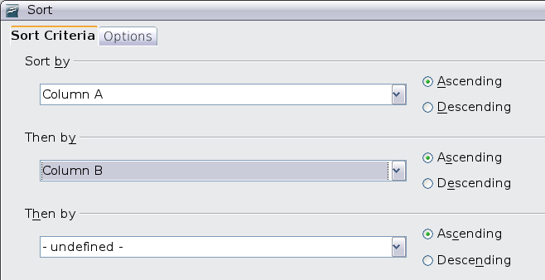
Figure 48: Choosing the criteria and order of sorting
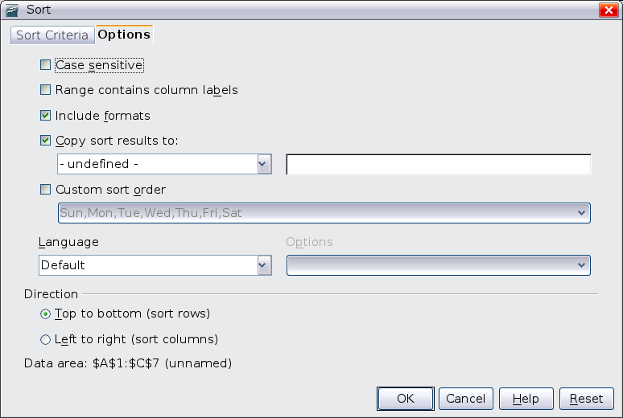
Figure 49: Options for sorting
Case sensitive
If two entries are otherwise identical, one with an upper case letter is placed before one with a lower case letter in the same position if the sort is descending; if the sort is ascending, then the entry with an upper case letter is placed after one with a lower case letter in the same position.
Range contains column labels
Does not include the column heading in the sort.
Include formats
A cell's formatting is moved with its contents. If formatting is used to distinguish different types of cells, then use this option.
Copy sort results to
Sets a spreadsheet address to which to copy the sort results. If a range is specified that does not have the necessary number of cells, then cells are added. If a range contains cells that already have content, then the sort fails.
Custom sort order
Select the box, then choose from the drop-down list one of the sort orders defined in Tools > Options > OpenOffice.org Calc > Sort Lists.
Direction
Sets whether rows or columns are sorted. The default is to sort by columns unless the selected cells are in a single column.

Finding and replacing in Calc
In spreadsheet documents you can search for text, formulas, and styles. You can navigate from one occurrence to the next using Find, or you can highlight all matching cells at once using Find All, then apply another format or replace the cell contents by other content.
Text and numbers in cells may have been entered directly or may be the result of a calculation. The search method you use depends on the type of data you are searching for.
Tip | Cell contents can be formatted in different ways. For example, a number can be formatted as a currency, to be displayed with a currency symbol. You see the currency symbol in the cell, but you cannot search for it.
By default, Calc searches the current sheet. To search through all sheets of the document, click More Options, then select Search in all sheets option.
Caution | Use Replace All with caution; otherwise, you may end up with some highly embarrassing mistakes. A mistake with Replace All might require a manual, word-by-word search to fix, if it is not discovered in time to undo it.
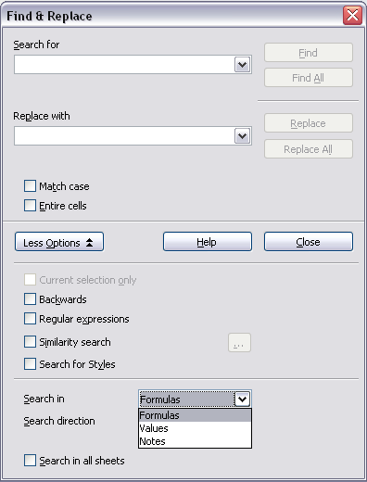Figure 50: Expanded Find & Replace dialog

Finding and replacing formulas or values
You can use the Find & Replace dialog to search in formulas or in the displayed values that result from a calculation.
- To open the Find & Replace dialog, use the keyboard shortcut Control+F or select Edit > Find & Replace.
- Click More Options to expand the dialog.
- Select Formulas or Values in the Search in drop-down list.
- Formulas finds parts of the formulas.
- Values finds the results of the calculations.
- Type the text you want to find in the Search for box.
- To replace the text with different text, type the new text in the Replace with box.
- When you have set up your search, click Find. To replace text, click Replace instead.

Finding and replacing text
- Open the Find & Replace dialog, click More Options to expand the dialog, and select Values or Notes in the Search in drop-down list.
- Type the text you want to find in the Search for box.
- To replace the text with different text, type the new text in the Replace with box.
- Click Find, Find All, Replace, or Replace All.
When you click Find, Calc selects the next cell that contains your text. You can edit the text, then click Find again to advance to the next found cell. If you closed the dialog, you can press Ctrl+Shift+F to find the next cell without opening the dialog.
When you click Find All, Calc selects all cells that contain your entry. Now you can, for example, apply a cell style to all of them at once.

Finding and replacing cell styles
To quickly change all the paragraphs of one (unwanted) style to another (preferred) style:
- On the expanded Find & Replace dialog, select Search for Styles. The Search for and Replace with boxes now contain a list of styles.
- Select the styles you want to search for and replace.
- Click Find, Find All, Replace, or Replace All.

Using wildcards (regular expressions)
Wildcards (also known as regular expressions) are combinations of characters that instruct OOo how to search for something. Regular expressions are very powerful but not very intuitive. They can save time and effort by combining multiple finds into one.
To use wildcards and regular expressions when searching and replacing:
- On the Find & Replace dialog, click More Options to see more choices. On this expanded dialog, select the Regular expressions option.
- Type the search text, including the wildcards, in the Search for box and the replacement text (if any) in the Replace with box.
- Click Find, Find All, Replace, or Replace All (not recommended).
Tip | The online help describes many of the regular expressions and their uses.
The following points are interesting to Calc users:
- In Calc, regular expressions are applied separately to each cell. So a search for r.d will match red in cell A1 but will not match r in cell A2 and d (or ed) in cell A3. (The regular expression r.d means “try to match r followed by any other character followed by d.”)
- When a match is found, the whole cell is shown highlighted, but only the text found will be replaced. For example, searching for brown will highlight a cell containing redbrown clay, and replacing with nothing will leave the cell containing red clay.
- If Find is used twice in a row, the second time with Current selection only activated, then the second search will evaluate the whole of each selected cell, not just the strings found which caused the cells to be selected in the first search. For example, searching for joh?n, then activating Current selection only and searching for sm.th will find cells containing Jon Smith and Smythers, Johnathon.
- If a cell contains a hard line break (entered by Ctrl+Enter), this may be found by \n. For example if a cell contains red hard_line_break clay then searching for d\nc and replacing with nothing leaves the cell containing relay.
- The hard line break acts to mark “end of text” as understood by the regular expression special character $ (in addition of course to the end of text in the cell). For example, if a cell contains red hard_line_break clay then a search for d$ replacing with al leaves the cell with real hard_line_break clay. Note that with this syntax the hard line break is not replaced—it simply marks the end of text.
- Using \n in the Replace with box will replace with the literal characters \n, not a hard line break.
- The Find & Replace dialog has an option to search Formulas, Values, or Notes. This applies to any search, not just one using regular expressions. Searching with the Formulas option would find SUM in a cell containing the formula =SUM(A1:A6). If a cell contains text instead of a function, the text will still be found - so that the simple text SUMMARY in a cell would also give a match to SUM using the Formulas option.
- Searching for the regular expression ^$ will not find empty cells. This is intentional—the rationale being to avoid performance issues when selecting a huge number of cells. Note that empty cells will not be found even if you are only searching a selection.
- Find .+ (or similar) and Replace with & effectively re-enters the contents of cells. This can be used to strip formatting automatically applied by Calc (often needed to clean data imported from the clipboard or badly formatted files), for example, to convert text strings consisting of digits into actual numbers (the cells must first be correctly formatted numbers). The leading apostrophes, telling Calc to treat the numbers as text, are removed.
See Chapter 7 (Using Formulas and Functions) for the use of regular expressions within formulas.

Calc Guide

Chapter 3
Creating Charts and Graphs
Presenting information visually
This PDF is designed to be read onscreen, two pages at a time. If you want to print a copy, your PDF viewer should have an option for printing two pages on one sheet of paper, but you may need to start with page 2 to get it to print facing pages correctly. (Print this cover page separately.)

Copyright
This document is Copyright © 2010 by its contributors as listed in the section titled Authors. You may distribute it and/or modify it under the terms of either the GNU General Public License, version 3 or later, or the Creative Commons Attribution License, version 3.0 or later.
All trademarks within this guide belong to their legitimate owners.
Authors
Richard Barnes
John Kane
Peter Kupfer
Shelagh Manton
Alexandre Martins
Anthony Petrillo
Sowbhagya Sundaresan
Jean Hollis Weber
Linda Worthington
Feedback
Please direct any comments or suggestions about this document to: authors@documentation.openoffice.org
Acknowledgments
Shelagh Manton and Jean Hollis Weber updated the OOo2.x chapter written by the other authors to 3.x.
Publication date and software version
Published 21 June 2010. Based on OpenOffice.org 3.2.
Contents
Copyright 2
Introduction 5
Creating a chart 5
Choosing a chart type 7
Changing data ranges and axes labels 8
Selecting data series 9
Adding or changing titles, legend, and grids 10
Editing charts 10
Changing the chart type 11
Adding or removing chart elements 11
Data labels 12
Trend lines 14
Mean value lines 15
Y error bars 15
Formatting charts 16
Moving chart elements 18
Changing the chart area background 18
Changing the chart graphic background 19
Changing colors 19
Formatting 3D charts 19
Rotation and perspective 20
Appearance 21
Illumination 21
Rotating 3D charts interactively 22
Formatting the chart elements 23
Formatting axes and inserting grids 23
Formating data labels 24
Choosing and formatting symbols 24
Resizing and moving the chart 25
Using the Position and Size dialog 26
Gallery of chart types 27
Column charts 27
Bar charts 27
Pie charts 28
Area charts 29
Line charts 31
Scatter or XY charts 31
Bubble charts 32
Net charts 33
Stock charts 34
Column and line charts 35

Introduction
Charts and graphs can be powerful ways to convey information to the reader. OpenOffice.org Calc offers a variety of different chart and graph formats for your data.
Using Calc, you can customize charts and graphs to a considerable extent. Many of these options enable you to present your information in the best and clearest manner.
For readers who are interested in effective ways to present information graphically, two excellent introductions to the topic are William S. Cleveland’s The elements of graphing data, 2nd edition, Hobart Press (1994) and Edward R. Tufte’s The Visual Display of Quantitative Information, 2nd edition, Graphics Press (2001).

Creating a chart
To demonstrate the process of making charts and graphs in Calc, we will use the small table of data in Figure 51.
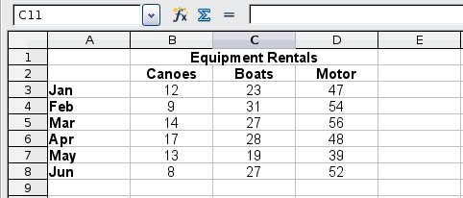
Figure 51: Table of data for charting examples
To create a chart, first highlight (select) the data to be included in the chart. The selection does not need to be in a single block, as shown in Figure 52; you can also choose individual cells or groups of cells (columns or rows). See Chapter 1 (Introducing Calc) for more about selecting cells and ranges of cells.
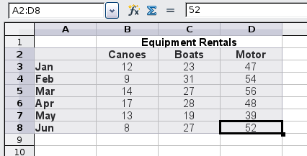
Figure 52: Selecting data for plotting
Next, open the Chart Wizard dialog using one of two methods.
- Choose Insert > Chart from the menu bar.
- Or, click the Chart icon on the main toolbar.
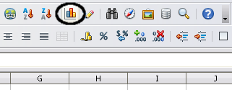
Figure 53: Insert chart from main toolbar
Either method inserts a sample chart on the worksheet, opens the Formatting toolbar, and opens the Chart Wizard, as shown in Figure 54.
Tip | Before choosing the Chart Wizard, place the cursor anywhere in the area of the data. The Chart Wizard will then do a fairly good job of guessing the range of the data. Just be careful that you have not included the title of your chart.
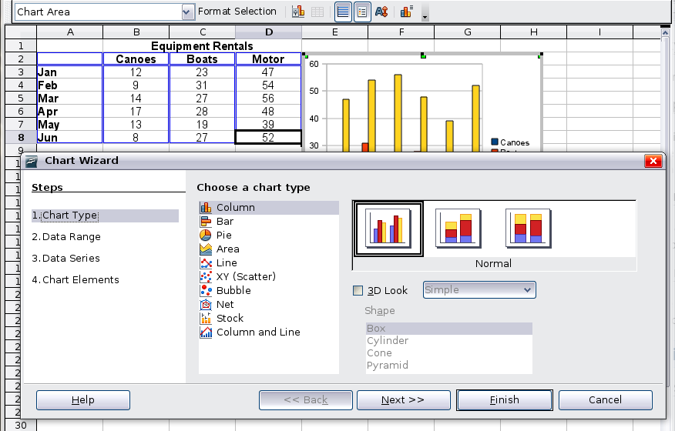
Figure 54: Chart Wizard, Step 1—Choose a chart type

Choosing a chart type
The Chart Wizard includes a sample chart with your data. This sample chart updates to reflect the changes you make in the Chart Wizard.
The Chart Wizard has three main parts: a list of steps involved in setting up the chart, a list of chart types, and the options for each chart type. At any time you can go back to a previous step and change selections.
Calc offers a choice of 10 basic chart types, with a few options for each type of chart. The options vary according to the type of chart you pick.
The first tier of choice is for two-dimensional (2D) charts. Only those types which are suitable for 3D (Column, Bar, Pie, and Area) give you an option to select a 3D look.
On the Choose a chart type page (Figure 54), select a type by clicking on its icon. The preview updates every time you select a different type of chart, and provides a good idea of what the finished chart will look like.
The current selection is highlighted (shown with a surrounding box) on the Choose a chart type page. The chart’s name is shown just below the icons. For the moment, we will stick to the Column chart and click on Next again.

Changing data ranges and axes labels
In Step 2, Data Range, you can manually correct any mistakes you have made in selecting the data.
On this page you can also change the way you are plotting the data by using the rows—rather than the columns—as data series. This is useful if you use a style of chart such as Donut or Pie to display your data.
Lastly, you can choose whether to use the first row or first column, or both, as labels on the axes of the chart.
You can confirm what you have done so far by clicking the Finish button, or click Next to change some more details of the chart.
We will click Next to see what we can do to our chart using the other pages of the Wizard.
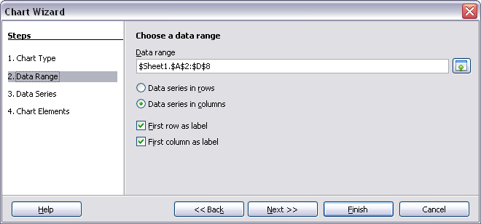
Figure 55: Changing data ranges and axes labels

Selecting data series
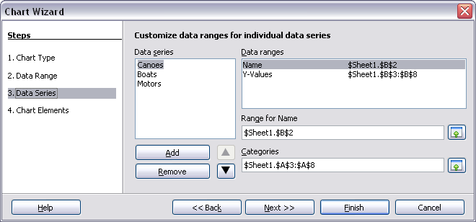
Figure 56: Amending data series and ranges
On the Data Series page, you can fine tune the data that you want to include in the chart. Perhaps you have decided that you do not want to include the data for canoes. If so, highlight Canoes in the Data series box and click on Remove. Each named data series has its ranges and its individual Y-values listed. This is useful if you have very specific requirements for data in your chart, as you can include or leave out these ranges.
Tip | You can click the Shrink button next to the Range for Name box to work on the spreadsheet itself. This is handy if your data ranges are larger than ours and the Chart Wizard is in the way.
Another way to plot any unconnected columns of data is to select the first data series and then select the next series while holding down the Ctrl key. Or you can type the columns in the text boxes. The columns must be separated by semi-colons. Thus, to plot B3:B11 against G3:G11, type the selection range as B3:B11;G3:G11.
The two data series you are selecting must be in separate columns or rows. Otherwise Calc will assume that you are adding to the same data series.
Click Next to deal with titles, legend and grids.

Adding or changing titles, legend, and grids
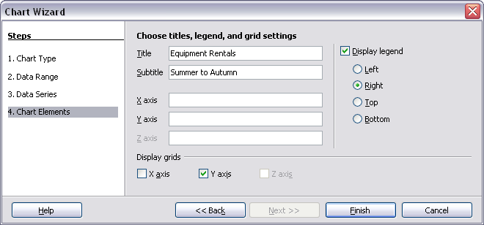
Figure 57: Titles, legend and grids
On the Chart Elements page, you can give your chart a title and, if desired, a subtitle. Use a title that draws the viewers’ attention to the purpose of the chart: what you want them to see. For example, a better title for this chart might be The Performance of Motor and Other Rental Boats.
It may be of benefit to have labels for the x axis or the y axis. This is where you give viewers an idea as to the proportion of your data. For example, if we put Thousands in the y axis label of our graph, it changes the scope of the chart entirely. For ease of estimating data you can also display the x or y axis grids by selecting the Display grids options.
You can leave out the legend or include it and place it to the left, right, top or bottom.
To confirm your selections and complete the chart, click Finish.

Editing charts
After you have created a chart, you may find things you would like to change. Calc provides tools for changing the chart type, chart elements, data ranges, fonts, colors, and many other options, through the Insert and Format menus, the right-click (context) menu, and the Chart toolbar.

Changing the chart type
You can change the chart type at any time. To do so:
- First select the chart by double-clicking on it. The chart should now be surrounded by a gray border.
- Then do one of the following:
- Choose Format > Chart Type from the menu bar.
- Click the chart type icon on the Formatting toolbar.
- Right-click on the chart and choose Chart Type.
In each case, a dialog similar to the one in Figure 54 opens. See page 75 for more information.

Adding or removing chart elements
Figures 58 and 59 show the elements of 2D and 3D charts.
The default 2D chart includes only two of those elements:
- Chart wall contains the graphic of the chart displaying the data.
- Chart area is the area surrounding the chart graphic. The (optional) chart title and the legend (key) are in the chart area.
The default 3D chart also has the chart floor, which is not available in 2D charts.
Chart area
Chart wall
Chart title
Legend
Axis labels
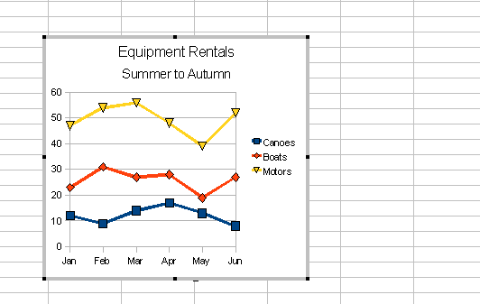Figure 58: Elements of 2D chart
Chart floor
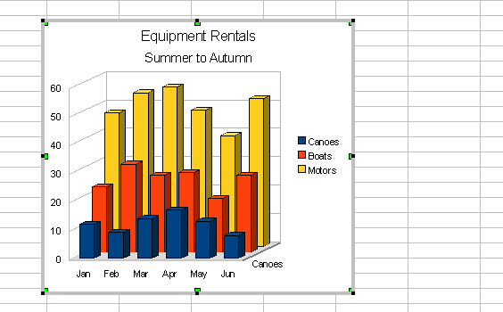Figure 59: Elements of 3D chart
You can add other elements using the commands on the Insert menu. The various choices open dialogs in which you can specify details.
First select the chart so the green sizing handles are visible. This is done with a single click on the chart.
The dialogs for Titles, Legend, Axes, and Grids are self-explanatory. The others are a bit more complicated, so we’ll take a look at them here.

Data labels
Data labels put information about each data point on the chart. They can be very useful for presenting detailed information, but you need to be careful to not create a chart that is too cluttered to read.
Choose Insert > Data Labels. The options are as follows.
Show value as number
Displays the numeric values of the data points. When selected, this option activates the Number format... button.
Number format...
Opens the Number Format dialog, where you can select the number format. This dialog is very similar to the one for formatting numbers in cells, described in Chapter 2 (Entering, Editing, and Formatting Data).
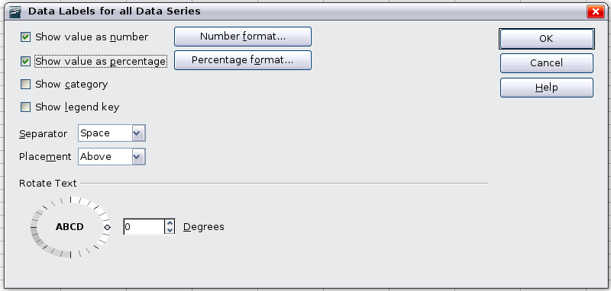
Figure 60: Data Labels dialog
Show value as percentage
Displays the percentage value of the data points in each column. When selected, this option activates the Percentage format... button.
Percentage format...
Opens the Number Format dialog, where you can select the percentage format.
Show category
Shows the data point text labels.
Show legend key
Displays the legend icons next to each data point label.
Separator
Selects the separator between multiple text strings for the same object.
Placement
Selects the placement of data labels relative to the objects.
Figure 71 on page 95 shows examples of values as text (neither Show value as number nor Show value as percentage selected) and values as percentages, as well as when data values are used as substitutes for legends or in conjunction with them.

Trend lines
When you have a scattered grouping of points in a graph, you may want to show the relationship of the points. A trend line is what you need. Calc has a good selection of regression types you can use for trend lines: linear, logarithm, exponential, and power. Choose the type that comes closest to passing through all of the points.
To insert trend lines for all data series, double-click the chart to enter edit mode. Choose Insert > Trend Lines, then select the type of trend line from None, Linear, Logarithmic, Exponential, or Power. You can also choose whether to show the equation for the trend line and the coefficient of determination (R2).
To insert a trend line for a single data series, first select the data series in the chart, and then right-click and choose Insert > Trend Line from the context menu. The dialog for a single trend line is similar to the one below but has a second tab (Line), where you can choose attributes (style, color, width, and transparency) of the line.
To delete a single trend line or mean value line, click the line, then press the Del key.
To delete all trend lines, choose Insert > Trend Lines, then select None.
A trend line is shown in the legend automatically.
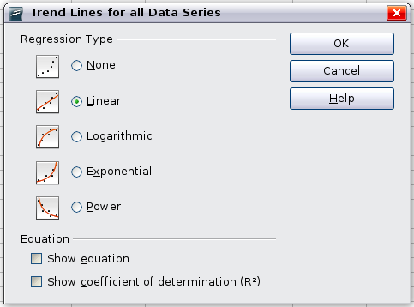
Figure 61: Trend Lines dialog
If you insert a trend line on a chart type that uses categories, such as Line or Column, then the numbers 1, 2, 3, … are used as x-values to calculate the trend line.
The trend line has the same color as the corresponding data series. To change the line properties, select the trend line and choose Format Trend Line. This opens the Line tab of the Trend Lines dialog.
To show the trend line equation, select the trend line in the chart, right-click to open the context menu, and choose Insert Trend Line Equation.
When the chart is in edit mode, OpenOffice.org gives you the equation of the trend line and the correlation coefficient. Click on the trend line to see the information in the status bar. To show the equation and the correlation coefficient, select the line and choose Insert R2 and Trend Line Equation.
For more details on the regression equations, see the topic Trend lines in charts in the Help.

Mean value lines
If you select mean value lines, Calc calculates the average of each selected data series and places a colored line at the correct level in the chart.

Y error bars
If you are presenting data that has a known possibility of error, such as social surveys using a particular sampling method, or you want to show the measuring accuracy of the tool you used, you may wish to show error bars on the chart. Select the chart and choose Insert > Y Error Bars.
Several options are provided on the Y Error Bars dialog (Figure 62). You can only choose one option at a time. You can also choose whether the error indicator shows both positive and negative errors, or only positive or only negative.
- Constant value – you can have separate positive and negative values.
- Percentage – choose the error as a percentage of the data points.
- In the drop-down list:
- Standard error
- Variance – shows error calculated on the size of the biggest and smallest data points
- Standard deviation – shows error calculated on standard deviation
- Error margin – you designate the error
- Cell range – calculates the error based on cell ranges you select. The Parameters section at the bottom of the dialog changes to allow selection of the cell ranges.
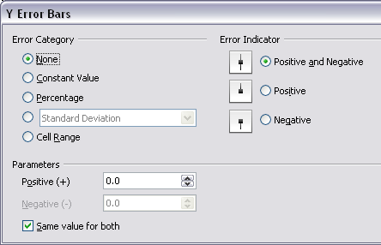Figure 62: Specifying the parameters of error bars

Formatting charts
The Format menu has many options for formatting and fine-tuning the appearance of your charts.
Double-click the chart so that it is enclosed by a gray border indicating edit mode; then, select the chart element that you want to format. Choose Format from the menu bar, or right-click to display a pop-up (context) menu relevant to the selected element. The formatting choices are as follows.
Format Selection
Opens a dialog in which you can specify the area fill, borders, transparency, characters, font effects, and other attributes of the selected element of the chart (see page 91).
Position and Size
Opens a dialog (see page 94).
Arrangement
Provides two choices: Bring Forward and Send Backward, of which only one may be active for some items. Use these choices to arrange overlapping data series.
Title
Formats the titles of the chart and its axes.
Legend
Formats the location, borders, background, and type of the legend.
Axis
Formats the lines that create the chart as well as the font of the text that appears on both the X and Y axes.
Grid
Formats the lines that create a grid for the chart.
Chart Wall, Chart Floor, Chart Area
Described in the following sections.
Chart Type
Changes what kind of chart is displayed and whether it is two- or three-dimensional.
Data Ranges
Explained on page 76 (Figure 55 and Figure 56).
3D View
Formats 3D charts (see page 87).
Note | Chart Floor and 3D View are only available for a 3D chart. These options are unavailable (grayed out) if a 2D chart is selected.
In most cases you need to select the exact element you want to format. Sometimes this can be tricky to do with the mouse, if the chart has many elements, especially if some of them are small or overlapping. If you have Tooltips turned on (in Tools > Options > OpenOffice.org > General > Help, select Tips), then as you move the mouse over each element, its name appears in the Tooltip. Once you have selected one element, you can press Tab to move through the other elements until you find the one you want. The name of the selected element appears in the Status Bar.

Moving chart elements
You may wish to move or resize individual elements of a chart, independent of other chart elements. For example, you may wish to move the legend to a different place. Pie charts allow moving of individual wedges of the pie (in addition to the choice of “exploding” the entire pie).
- Double-click the chart so that it is enclosed by a gray border.
- Double-click any of the elements—the title, the legend, or the chart graphic. Click and drag to move the element. If the element is already selected, then move the pointer over the element to get the move icon (small hand), then click, drag and move the element.
- Release the mouse button when the element is in the desired position.
Note | If your graphic is 3D, round red handles appear which control the three-dimensional angle of the graphic. You cannot resize or reposition the graphic while the round red handles are showing. With the round red handles showing, Shift + Click to get the green resizing handles. You can now resize and reposition your 3D chart graphic. See the following tip.
Tip | You can resize the chart graphic using its green resizing handles (Shift + Click, then drag a corner handle to maintain the proportions). However, you cannot resize the title or the key.

Changing the chart area background
The chart area is the area surrounding the chart graphic, including the (optional) main title and key.
- Double-click the chart so that it is enclosed by a gray border.
- Choose Format > Chart Area.
- On the Chart Area dialog (Figure 63), choose the desired format settings.
On the Area tab, you can change the color, or choose a hatch pattern, bitmap or some preset gradients. Click on the drop-down box to see the options. Patterns are probably more useful than color if you have to print out your chart in black and white.
You can also use the Transparency tab to change the area’s transparency. If you used a preset gradient from the Area tab, you can see the different parameters of which it is composed.
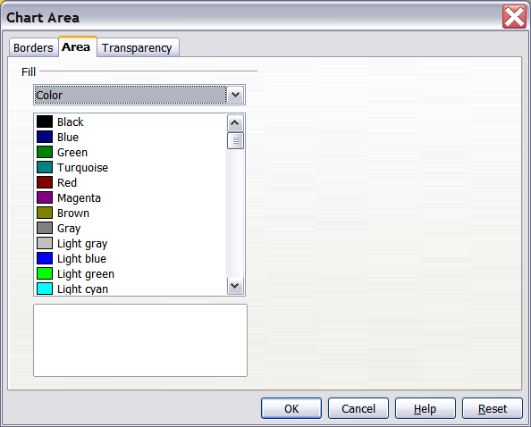Figure 63: Chart Area dialog

Changing the chart graphic background
The chart wall is the area that contains the chart graphic.
- Double-click the chart so that it is enclosed by a gray border.
- Choose Format > Chart Wall. The Chart Wall dialog has the same formatting options as described in “Changing the chart area background” above.
- Choose your settings and click OK.

Changing colors
If you need a different color scheme from the default for the charts in all your documents, go to Tools > Options > Charts > Default Colors, which has a much wider range of colors to choose from. Changes made in this dialog affect the default chart colors for any chart you make in future.

Formatting 3D charts
Use Format > 3D View to fine tune 3D charts. The 3D View dialog has three pages, where you can change the perspective of the chart, whether the chart uses the simple or realistic schemes, or your own custom scheme, and the illumination which controls where the shadows will fall.

Rotation and perspective
To rotate a 3D chart or view it in perspective, enter the required values on the Perspective page of the 3D View dialog. You can also rotate 3D charts interactively; see page 90.
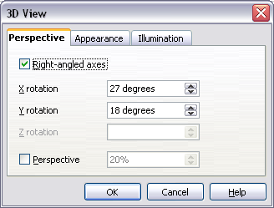
Figure 64: Rotating a chart
Some hints for using the Perspective page:
- Set all angles to 0 for a front view of the chart. Pie charts and donut charts are shown as circles.
- With Right-angled axes enabled, you can rotate the chart contents only in the X and Y direction; that is, parallel to the chart borders.
- An x value of 90, with y and z set to 0, provides a view from the top of the chart. With x set to –90, the view is from the bottom of the chart.
- The rotations are applied in the following order: x first, then y, and z last.
- When shading is enabled and you rotate a chart, the lights are rotated as if they are fixed to the chart.
- The rotation axes always relate to the page, not to the chart’s axes. This is different from some other chart programs.
- Select the Perspective option to view the chart in central perspective as through a camera lens instead of using a parallel projection.
Set the focus length with the spin button or type a number in the box. 100% gives a perspective view where a far edge in the chart looks approximately half as big as a near edge.

Appearance
Use the Appearance page to modify some aspects of a 3D chart’s appearance.
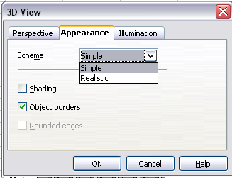Figure 65: Modifying appearance of 3D chart
Select a scheme from the list box. When you select a scheme, the options and the light sources are set accordingly. If you select or deselect a combination of options that is not given by the Realistic or Simple schemes, you create a Custom scheme.
Select Shading to use the Gouraud method for rendering the surface. Otherwise, a flat method is used. The flat method sets a single color and brightness for each polygon. The edges are visible, soft gradients and spot lights are not possible. The Gouraud method applies gradients for a smoother, more realistic look. Refer to the Draw Guide for more details on shading.
Select Object Borders to draw lines along the edges.
Select Rounded Edges to smooth the edges of box shapes. In some cases this option is not available.

Illumination
Use the Illumination page (Figure 66) to set the light sources for the 3D view. Refer to the Draw Guide for more details on setting the illumination.
Click any of the eight buttons to switch a directed light source on or off. By default, the second light source is switched on. It is the first of seven normal, uniform light sources. The first light source projects a specular light with highlights.
For the selected light source, you can then choose a color and intensity in the list just below the eight buttons. The brightness values of all lights are added, so use dark colors when you enable multiple lights.
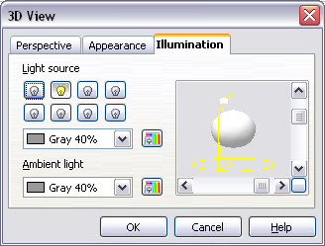Figure 66: Setting the illumination
Each light source always points at the middle of the object initially. To change the position of the light source, use the small preview inside this page. It has two sliders to set the vertical and horizontal position of the selected light source.
The button in the corner of the small preview switches the internal illumination model between a sphere and a cube.
Use the Ambient light list to define the ambient light which shines with a uniform intensity from all directions.

Rotating 3D charts interactively
In addition to using the Perspective page of the 3D View dialog to rotate 3D charts, you can also rotate them interactively.
Select the Chart Wall, then hover the mouse pointer over a corner handle or the rotation symbol found somewhere on the chart. The cursor changes to a rotation icon.
Press and hold the left mouse button and drag the corner in the direction you wish. A dashed outline of the chart is visible while you drag, to help you see how the result will look.

Formatting the chart elements
Depending on the purpose of your document, for example a screen presentation or a printed document for a black and white publication, you might wish to use more detailed control over the different chart elements to give you what you need.
To format an element, left-click on the element that you wish to change, for example one of the axes. The element will be highlighted with green squares. Then, right-click and choose an item from the context menu. Each chart element has its own selection of items. In the next few sections we explore some of the options.

Formatting axes and inserting grids
Sometimes you need to have a special scale for one of the axes of your chart, or you need smaller grid intervals, or you want to change the formating of the labels on the axis. After highlighting the axis you wish to change, right-click and choose one of the items from the pop-up menu.
Choosing Format Axis opens the dialog shown in (Figure 67). On the Scale tab, you can choose a logarithmic or linear scale (default), how many marks you need on the line, where the marks are to appear, and the increments (intervals) of the scale. You must first deselect the Automatic option in order to modify the value for any scale.
On the Label tab (Figure 68), you can choose whether to show or hide the labels and how to handle them when they won’t all fit neatly into one row (for example, if the words are too long).
Not shown here are the tab with options for choosing a font, formatting the lines, and positioning the elements of the line and interval marks.
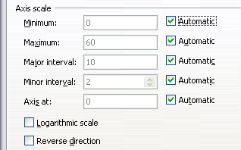
Figure 67: Formatting axis scales
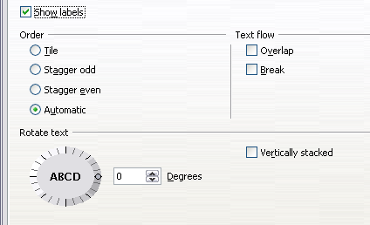
Figure 68: Formatting axis labels

Formating data labels
You can choose properties for the labels of the data series. Carefully click on the chart element, then right-click and choose the property you want to change. This opens a dialog with several tabs where you can change the color of the label text, the size of the font, and other attributes. The Label tab is shown in Figure 68.
On the Data Labels tab, you can choose whether to:
- Show the labels as text
- Show numeric values as a percentage or a number
- Include the legend box as part of the label
These choices are the same as those shown in Figure 60 on page 81.
The text for labels is taken from the column labels and it cannot be changed here. If the text needs to be abbreviated, or if it did not label your graph as you were expecting, you need to change it in the original data table.

Choosing and formatting symbols
In line and scatter charts the symbols representing the points can be changed to a different symbol shape or color through the object properties dialog. Select the data series you wish to change, right-click, and choose Format > Data Series from the context menu.
On the Line tab of the Data Series dialog, in the Icon section, choose from the drop-down list Select > Symbols. Here you can choose no symbol, a symbol from an inbuilt selection, a more exciting range from the gallery, or if you have pictures you need to use instead, you can insert them using Select > From file.
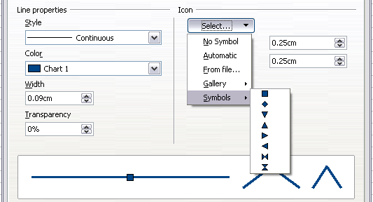
Figure 69: Symbol selection

Resizing and moving the chart
You can resize or move all elements of a chart at the same time, in two ways: interactively, or by using the Position and Size dialog. You may wish to use a combination of both methods: interactive for quick and easy change, then the dialog for precise sizing and positioning.
To resize a chart interactively:
- Click once on the chart to select it. Green sizing handles appear around the chart.
- To increase or decrease the size of the chart, click and drag one of the markers in one of the four corners of the chart. To maintain the correct ratio of the sides, hold the Shift key down while you click and drag.
To move a chart interactively:
- Click on the chart to select it. Green sizing handles appear around the chart.
- Hover the mouse pointer anywhere over the chart. When it changes to the move icon, click and drag the chart to its new location.
- Release the mouse button when the element is in the desired position.

Using the Position and Size dialog
To resize or move a chart using the Position and Size dialog:
- Click on the chart to select it. Green sizing handles appear around the chart.
- Right-click and choose Position and Size from the pop-up menu.
- Make your choices on this dialog.
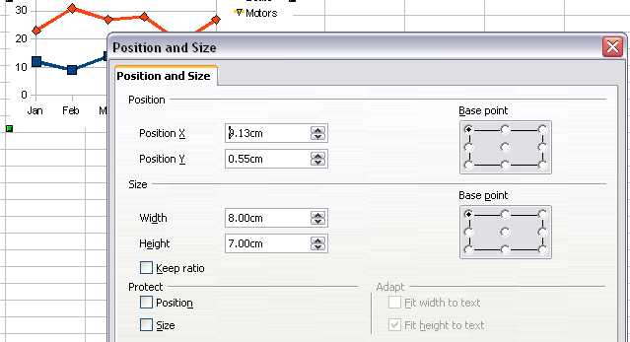
Figure 70: Defining the position and size of an object
Position is defined as an X,Y coordinate relative to a fixed point (the base point), typically located at the upper left of the document. You can temporarily change this base point to make positioning or dimensioning simpler (click on the spot corresponding to the location of the base point in either of the two selection windows on the right side of the dialog—upper for positioning or lower for dimensioning).
The possible base point positions correspond to the handles on the selection frame plus a central point. The change in position lasts only as long as you have the dialog open; when you close this dialog, Calc resets the base point to the standard position.
Tip | The Keep ratio option is very useful. Select it to keep the ratio of width to height fixed while you change the size of an object.
Either or both the size and position can be protected so that they cannot be accidentally changed. Select the appropriate options.
Tip | If you cannot move an object, check to see if its position is protected.

Gallery of chart types
Its important to remember that while your data can be presented with a number of different charts, the message you want to convey to your audience dictates the chart you ultimately use. The following sections present examples of the types of charts that Calc provides, with some of the tweaks that each sort can have and some notes as to what purpose you might have for that chart type. For details, see the Help.

Column charts
Column charts are commonly used for data that shows trends over time. They are best for charts that have a relatively small number of data points. (For large time series a line chart would be better.) It is the default chart type, as it is one of the most useful charts and the easiest to understand.

Bar charts
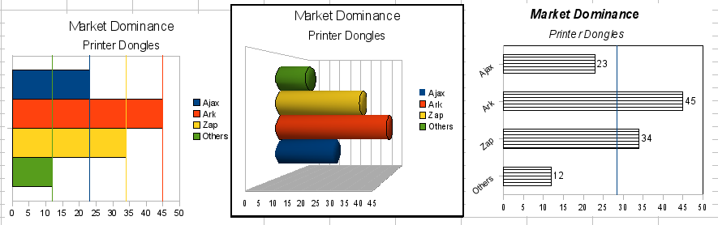
Figure 71: Three bar graph treatments.
Bar charts are excellent for giving an immediate visual impact for data comparison in cases when time is not an important factor, for example, when comparing the popularity of a few products in a marketplace.
- The first chart is achieved quite simply by using the chart wizard with Insert > Grids, deselecting y-axis, and using Insert > Mean Value Lines.
- The second chart is the 3D option in the chart wizard with a simple border and the 3D chart area twisted around.
- The third chart is an attempt to get rid of the legend and put labels showing the names of the companies on the axis instead. We also changed the colors to a hatch pattern.

Pie charts
Pie charts are excellent when you need to compare proportions. For example, comparisons of departmental spending: what the department spent on different items or what different departments spent. They work best with smaller numbers of values, about half a dozen; more than this and the visual impact begins to fade.
As the Chart Wizard guesses the series that you wish to include in your pie chart, you might need to adjust this initially on the Wizard’s Data Ranges page if you know you want a pie chart, or by using the Format > Data Ranges > Data Series dialog.
You can do some interesting things with a pie chart, especially if you make it into a 3D chart. It can then be tilted, given shadows, and generally turned into a work of art. Just don’t clutter it so much that your message is lost, and be careful that tilting does not distort the relatively size of the segments.
You can choose in the Chart Wizard to explode the pie chart, but this is an all or nothing option. If your aim is to accentuate one piece of the pie, you can separate out one piece by carefully highlighting it after you have finished with the Chart Wizard, and dragging it out of the group. When you do this you might need to enlarge the chart area again to regain the original size of the pieces.
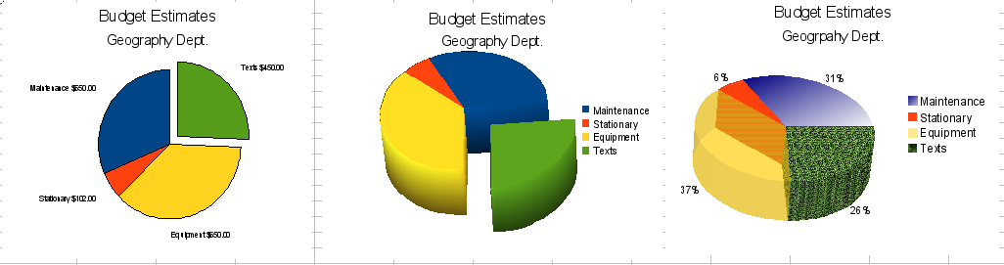
Figure 72: Pie charts
The effects achieved in Figure 72 are explained below:
- 2D pie chart with one part of the pie exploded: Choose Insert > Legend and deselect the Display legend box. Choose Insert > Data Labels and choose Show value as number. Then carefully select the piece you wish to highlight, move the cursor to the edge of the piece and click (the piece will have nine green highlight squares to mark it), and then drag it out from the rest of the pieces. The pieces will decrease in size, so you need to highlight the chart wall and drag it at a corner to increase the size.
3D pie chart with realistic schema and illumination: Choose Format > 3D view > Illumination where you can change the direction of the light, the color of the ambient light, and the depth of the shade. We also adjusted the 3D angle of the disc in the Perspective dialog on the same set of tabs.
The chart updates as you make changes, so you can immediately see the effects.
If you want to separate out one of the pieces, click on it carefully; you should see a wire frame highlight. Drag it out with the mouse and then, if necessary, increase the size of the chart wall.
- 3D pie chart with different fill effects in each portion of the pie: Choose Insert > Data labels and select show value as percentage. Then carefully select each of the pieces so that it has a wire frame highlight and right-click to get the object properties dialog; choose the Area tab. For one we chose a bitmap, for another a gradient and for the third we used the Transparency tab and adjusted the transparency to 50%.

Area charts
An area chart is a version of a line or column graph. It may be useful where you wish to emphasize volume of change. Area charts have a greater visual impact than a line chart, but the data you use will make a difference.
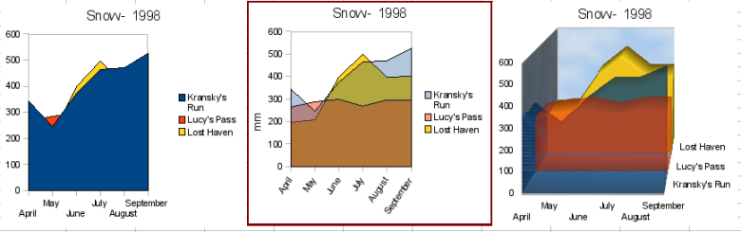
Figure 73: Area charts—the good, the bad, and the ugly
As shown in Figure 73, an area chart is sometimes tricky to use. This may be one good reason to use transparency values in an area chart. After setting up the basic chart using the Chart Wizard, do this:
- Right-click on the Y axis and choose Delete Major Grid. As the data overlaps, some of it is missing behind the first data series. This is not what you want. A better solution is shown in Chart 2.
- After deselecting the Y axis grid, right-click on each data series in turn and choose Format Data Series. On the Transparency tab, set Transparency to 50%. The transparency makes it easy to see the data hidden behind the first data series. Now, right-click on the X axis and choose Format Axis. On the Label tab, choose Tile in the Order section and set the Text orientation to 55 degrees. This places the long labels at an angle.
- To create the third variation, after doing the steps above, right-click and choose Chart Type. Choose the 3D Look option and select Realistic from the drop-down list. We also twisted the chart area around and gave the chart wall a picture of the sky. As you can see, the legend turns into labels on the z-axis. But overall, though it is visually more appealing, it is more difficult to see the point you are trying to make with the data.
Other ways of visualizing the same data series are represented by the stacked area chart or the percentage stacked area chart. The first does what it says: each number of each series is added to the others so that it shows an overall volume but not a comparison of the data. The percentage stacked chart shows each value in the series as a part of the whole. For example in June all three values are added together and that number represents 100%. The individual values are a percentage of that. Many charts have varieties which have this option.
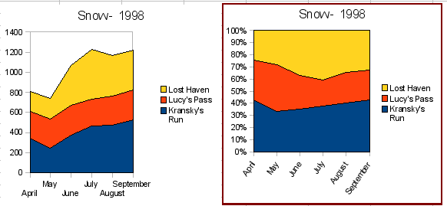
Figure 74: Stacked and percentage stacked area charts

Line charts
A line chart is a time series with a progression. It is ideal for raw data, and useful for charts with plentiful data that show trends or changes over time where you want to emphasize continuity. On line charts, the x-axis is ideal to represent time series data.
Things to do with lines: thicken them, make them 3D, smooth the contours, just use points.
3D lines confuse the viewer, so just using a thicker line often works better.
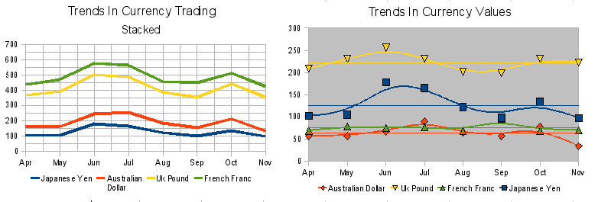
Figure 75: Line charts

Scatter or XY charts
Scatter charts are great for visualizing data that you have not had time to analyze, and they may be the best for data when you have a constant value against which to compare the data; for example, weather data, reactions under different acidity levels, conditions at altitude, or any data which matches two series of numeric data. In contrast to line charts, the x-axis are the left to right labels, which usually indicate a time series.
Scatter charts may surprise those unfamiliar with how they work. While constructing the chart, if you choose Data Range > Data series in rows, the first row of data represents the x-axis. The rest of the rows of data are then compared against the first row data. Figure 76 shows a comparison of three currencies with the Japanese Yen. Even though the table presents the monthly series, the chart does not. In fact the Japanese Yen does not appear; it is merely used as the constant series that all the other data series are compared against.
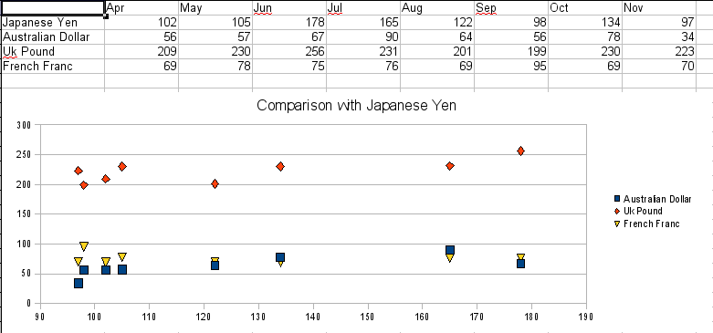
Figure 76: A particularly volatile time in the world currency market.

Bubble charts
A bubble chart is a variation of a scatter chart in which the data points are replaced with bubbles. It shows the relations of three variables in two dimensions. Two variables are used for the position on the X-axis and Y-axis, while the third is shown as the relative size of each bubble. One or more data series can be included in a single chart.
Bubble charts are often used to present financial data. The data series dialog for a bubble chart has an entry to define the data range for the bubbles and their sizes.
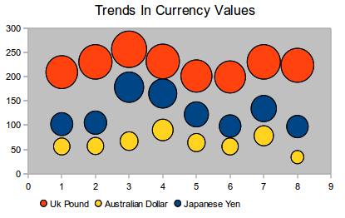
Figure 77: Bubble chart showing three data series

Net charts
A net chart is similar to a polar or radar chart. They are useful for comparing data that are not time series, but show different circumstances, such as variables in a scientific experiment or direction. The poles of the net chart are equivalent to the y-axes of other charts. Generally, between three and eight axes are best; any more and this type of chart becomes confusing. Before and after values can be plotted on the same chart, or perhaps expected and real results, so that differences can be compared.
Types of net charts:
- Figure 78 - Part 1: Plain net chart without grids and with just points, no lines.
- Figure 79 - Part 2: Net chart with lines, points and grid. Axes colors and labels changed. Chart area color = gradient. Points changed to fancy 3D ones.
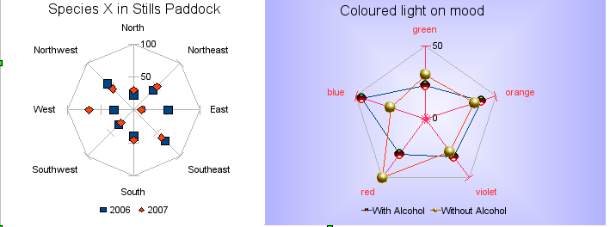
Figure 78: Two net diagrams showing totally fabricated data from totally fictional experiments.
Other varieties of net chart show the data series as stacked numbers or stacked percentages. The series can also be filled with a color. Partial transparency is often best for showing all the series.

Figure 79: Filled net or radar chart

Stock charts
A stock chart is a specialized column graph specifically for stocks and shares. You can choose traditional lines, candlestick, and two-column type charts. The data required for these charts is quite specialized, with series for opening price, closing price, and high and low prices. Of course the x-axis represents a time series.
When you set up a stock chart in the Chart Wizard, the Data Series dialog is very important. You need to tell it which series is for the opening price, closing price, high and low price of the stock and so on. Otherwise the chart may be indecipherable. The sample table for this chapter needed to be changed to fit the data series.
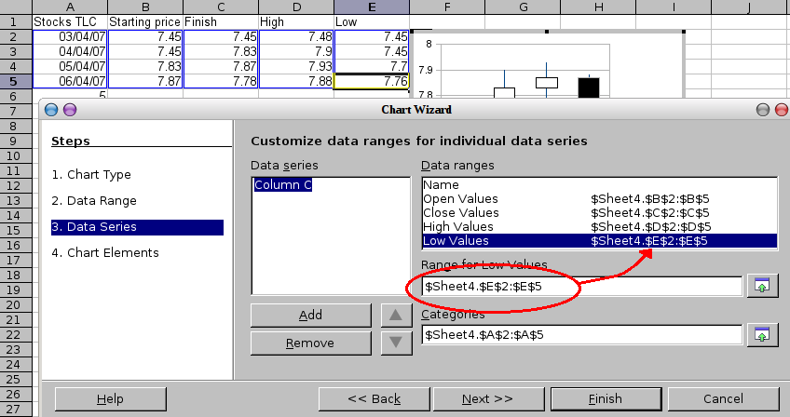Figure 80: Adjusting data series for stock charts.
A nice touch is that OpenOffice.org Chart color-codes the rising and falling shares: white for rising and black for falling in the candlestick chart, and red and blue in the traditional line chart.

Column and line charts
A column and line chart is a combination of two other chart types. It is useful for combining two distinct but related data series, for example sales over time (column) and the profit margin trends (line).
You can choose the number of columns and lines in the Chart Wizard. So for example you might have two columns with two lines to represent two product lines with the sales figures and profit margins of both.
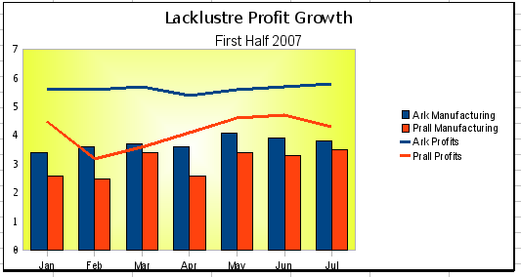
Figure 81: Column and line chart
This chart has manufacturing cost and profit data for two products, over a period of time (six months in 2007). To create this chart, first highlight the table and start the Chart Wizard. Choose Column and Line chart type with two lines and the data series in rows. Then give it a title to highlight the aspect you want to show. The lines are different colors at this stage and don’t reflect the product relationships. When you finish with the Chart Wizard, highlight the chart, click on the line, right-click and chose Format Data Series.
On this tab there are a few things to change: The colors should match the products. So both Ark Manufacturing and profit are blue and Prall is red. The lines need to be more noticeable so make the lines thicker by increasing the width to 0.08.
For the background, highlight the chart wall, right-click and choose Format Wall. On the Area tab, change the drop-down box to show Gradient. Choose one of the preset gradient patterns and make it lighter by going to the Transparency tab and making the gradient 50% transparent.
To make the chart look cleaner without the grid, go to Insert > Grids and deselect the X-axis option.

Calc Guide

Chapter 4
Using Styles and Templates in Calc
Bringing uniformity to your spreadsheets
This PDF is designed to be read onscreen, two pages at a time. If you want to print a copy, your PDF viewer should have an option for printing two pages on one sheet of paper, but you may need to start with page 2 to get it to print facing pages correctly. (Print this cover page separately.)

Copyright
This document is Copyright © 2006–2010 by its contributors as listed in the section titled Authors. You may distribute it and/or modify it under the terms of either the GNU General Public License, version 3 or later, or the Creative Commons Attribution License, version 3.0 or later.
All trademarks within this guide belong to their legitimate owners.
Authors
Andy Brown
T. J. Frazier
Peter Kupfer
Nikita Telang
Jean Hollis Weber
Feedback
Please direct any comments or suggestions about this document to: authors@documentation.openoffice.org
Acknowledgments
Part of the material on page styles is adapted from articles written by Bruce Byfield and first published on the Linux Journal website; used with permission.
Publication date and software version
Published 16 March 2009. Based on OpenOffice.org 3.2.
Contents
Copyright 2
What is a template? 5
What are styles? 5
Types of styles in Calc 6
Cell styles 6
Page styles 7
Accessing styles 7
Applying cell styles 8
Using the Styles and Formatting window 8
Using Fill Format mode 9
Using the Apply Style list 9
Assigning styles to shortcut keys 10
Applying page styles 10
Modifying styles 10
Style organizer 10
Cell style options 12
Numbers 12
Font 12
Font effects 12
Alignment 12
Borders 12
Background 12
Cell protection 12
Page style options 12
Page 13
Borders 14
Background 14
Header 14
Footer 14
Sheet 14
Creating new (custom) styles 15
Creating a new style using the Style dialog 15
Creating a new style from a selection 15
Creating a new style by dragging and dropping 16
Copying and moving styles 16
Deleting styles 18
Creating a spreadsheet from a template 18
Creating a template 19
Editing a template 20
Updating a spreadsheet from a changed template 21
Adding templates using the Extension Manager 22
Setting a default template 23
Setting a custom template as the default 23
Resetting the default template 24
Associating a spreadsheet with a different template 24
Organizing templates 25
Creating a template folder 25
Deleting a template folder 25
Moving a template 26
Deleting a template 26
Importing a template 26
Exporting a template 27

What is a template?
A template is a model that you use to create other documents. For example, you can create a template for invoices that has your company’s logo and address at the top of the page. New spreadsheets created from this template will all have your company’s logo and address on the first page.
Templates can contain anything that regular documents can contain, such as text, graphics, styles, and user-specific setup information such as measurement units, language, the default printer, and toolbar and menu customization.
All documents—text, spreadsheets, presentations, drawings—in OpenOffice.org are based on templates. You can create, or download and install, as many templates as you wish. When you start a new spreadsheet without choosing a specific template (as described in “Creating a spreadsheet from a template“ on page 119), the new spreadsheet is based on the default template for spreadsheets. If you have not specified a default template, OOo uses the blank spreadsheet template that is installed with OOo. See “Setting a default template” on page 124.
This chapter describes how to create, use, modify, and organize templates. We begin by describing styles and their use, as styles are a major component of templates.

What are styles?
A style is a set of formats that you can apply to selected elements in a document to quickly change their appearance. When you apply a style, you apply a whole group of formats at the same time.
Many people manually format spreadsheet cells and pages without paying any attention to styles. They are used to formatting documents according to physical attributes. For example, for the contents of a cell you might specify the font family, font size, and any formatting such as bold or italic.
Styles are logical attributes. Using styles means that you stop saying “font size 14pt, Times New Roman, bold, centered”, and you start saying “Title” because you have defined the “Title” style to have those characteristics. In other words, styles means that you shift the emphasis from what the text (or page, or other element) looks like, to what the text is.
Styles help improve consistency in a document and can greatly speed up formatting. They also make major formatting changes easy. For example, you may decide to change the appearance of all subtotals in your spreadsheet to be 10 pt. Arial instead of 8 pt. Times New Roman after you have created a 15-page spreadsheet; you can change all of the subtotals in the document by simply changing the properties for the subtotal style.
Page styles assist with printing, so you don’t need to define margins, headers and footers, and other printing attributes each time you print a spreadsheet.
This chapter describes the styles OOo Calc offers, what they might be used for, and how to apply styles, change existing styles, and create new styles.

Types of styles in Calc
While some components of OOo offer many style types, Calc offers only two:
- Cell styles include fonts, alignment, borders, background, number formats (for example, currency, date, number), and cell protection.
- Page styles include margins, headers and footers, borders and backgrounds, and the sequence for printing sheets. The page size, orientation, and other attributes of a page style apply only when a spreadsheet is printed; they are not displayed onscreen.

Cell styles
Similar to paragraph styles in OOo Writer, cell styles are the most basic type of style in Calc. You can apply a cell style to a cell and that cell will follow the formatting rules of the style. Five cell styles are supplied with OOo: Default, Heading, Heading1, Result, and Result2.
Initially, the styles are configured so that if you change the font family of Default, then all of the other styles will change to match. We will discuss how to set this up in “Creating new (custom) styles” on page 116. The five standard styles can be seen in use in Figure 82.
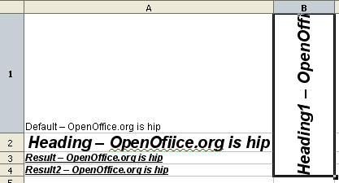Figure 82: Calc cell style types

Page styles
Page styles in Calc are applied to sheets. Although one sheet may print on several pages (pieces of paper), only one page style can be applied to a sheet. If a spreadsheet file contains more than one sheet, the different sheets can have different page styles applied to them. So, for example, a spreadsheet might contain one sheet to be printed in landscape orientation (using the Default page style) and another sheet to be printed in portrait orientation (using the Report page style).
Two page styles are supplied with Calc: Default and Report. The major difference between these two styles is that Report is portrait-oriented and Default is landscape-oriented. You can adjust many settings using page styles. You can also define as many page styles as you wish.
Because spreadsheets are primarily used onscreen and not printed, Calc does not display the page style on the screen. If you want a spreadsheet to fit on a certain page size, you have to carefully control the column width and row height, with only File > Page Preview to guide you.
Despite this limitation, it’s well worth defining page styles for any spreadsheets that you are likely to print. Otherwise, if a need for printing does arise, you may lose time to trial and error.

Accessing styles
The main way to access styles is through the Styles and Formatting window (shown in Figure 83). You can open this window in several ways.
- Keyboard: Press the F11 key.
- Menu: Choose Format > Styles and Formatting.
- Toolbar: Click the icon on the far left of the Formatting toolbar.
The Styles and Formatting window can be docked at the left or right of the main Calc window. To dock or undock the window, hold down the Ctrl key and double-click a gray part of the window next to the icons at the top.
The first button on the top left of the window, 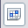, is for cell styles and the second, , is for page styles.
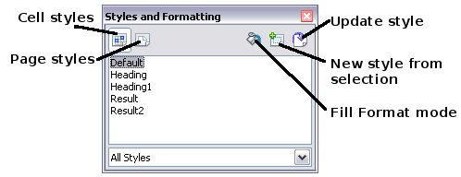
Figure 83: Styles and Formatting window

Applying cell styles
Calc provides several ways to apply cell styles:
- Using the Styles and Formatting window
- Using Fill Format mode
- Using the Apply Style list
- Assigning styles to shortcut keys

Using the Styles and Formatting window
- Ensure the Styles and Formatting window is open by pressing F11 or by selecting Format > Styles and Formatting. Choose the Cell Styles list by clicking the icon.
- Highlight the cell or group of cells to which the styles should be applied.
- Double-click on the cell style name.

Using Fill Format mode
This method is quite useful when you need to apply the same style to many scattered cells.
- Open the Styles and Formatting window and select the style you want to apply.
- Click the Fill Format mode icon . The mouse pointer changes to this icon.
- Position the moving icon on the cell to be styled and click the mouse button.
- To quit Fill Format mode, click the Fill Format mode icon again or close the Styles and Formatting window.
Caution | When this mode is active, a right-click anywhere in the document undoes the last Fill Format action. Be careful not to accidentally right-click and thus undo actions you want to keep.

Using the Apply Style list
You can also add an Apply Style drop-down list to the Formatting toolbar and select a style from the list to apply it to the selected cells:
- Click the down-arrow at the right-hand end of the Formatting toolbar. On the drop-down menu, click Visible Buttons.
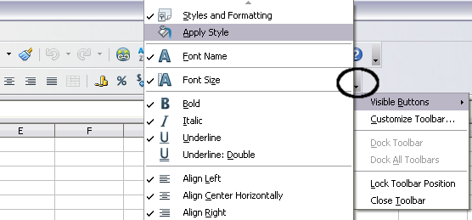
Figure 84: Adding an Apply Style list to the Formatting toolbar
- On the submenu, click Apply Style. The menus close and the Apply Style list now appears on the toolbar between the Styles and Formatting icon and the Font Name list.

Assigning styles to shortcut keys
You can create keyboard shortcuts to apply commonly-used cell or page styles, including custom styles that you have created. See Chapter 14 (Setting up and Customizing Calc) for instructions.

Applying page styles
- Select the sheet to be styled (click on its sheet tab at the bottom of the screen).
- In the Styles and Formatting window, choose the Page Styles list by clicking the icon. Double-click on the required page style.
To find out which page style is in use for a selected sheet, look in status bar.
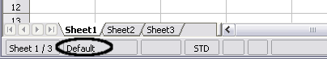
Figure 85: Status bar showing location of page style information below the sheet tabs.

Modifying styles
To modify a style, right-click on its name in the Styles and Formatting window and choose Modify. Make the changes in the Style dialog and click OK to save the changes.
You can also modify a current cell style by selecting an already formatted cell and clicking the Update Style button on the top right hand corner of the Styles and Formatting window.

Style organizer
Right click on the name of a style in the Styles and Formatting window and click Modify to open a Style dialog similar to the one shown in Figure 86.
The Style dialog has several tabs. The Organizer tab, shown in Figure 86 for cell styles, is found in all components of OOo. It provides basic information about the style. The Organizer tab for page styles is similar to the one shown for cell styles.
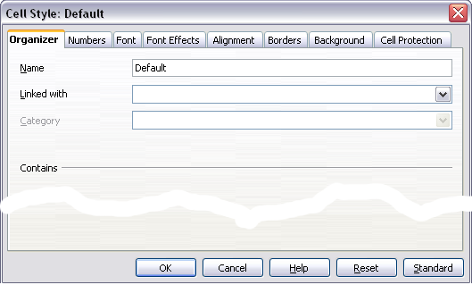
Figure 86: Organizer tab of Cell Style dialog
Name
This is the style’s name. You cannot change the name of a built-in style, but you can change the name of a custom style.
Linked with
This option is only available for cell styles; page styles cannot be linked. If you link cell styles, then when you change the base style (for example, by changing the font from Times to Helvetica), all the linked styles will change as well. Sometimes this is exactly what you want; other times you do not want the changes to apply to all the linked styles. It pays to plan ahead.
For example, you can make a new style called red, in which the only change you want to make is for the cell text to be red. In order to make sure that the rest of the text characteristics are the same as the default style, you can link red with default. Then, any changes you make to default will be automatically applied to red.
Category
In Calc, the only option in this drop-down box is Custom styles.

Cell style options
When editing or creating cell styles, you can set several options, which are similar to those for directly formatting cells. A more detailed coverage of cell formatting is given in Chapter 2 (Entering, Editing, and Formatting Data). A brief summary is provided here.

Numbers
On the Numbers tab, you can control the behavior of the data in a cell with this style. This includes specifying the type of data, the number of decimal places, and the language.

Font
Use the Font tab to choose the font for the cell’s contents..

Font effects
The Font Effects tab offers more font options including underlining, strikethrough, and color.

Alignment
Use the Alignment tab to set the horizontal and vertical alignment for the data in the cells, and rotate the text.

Borders
Use the Borders tab to set the borders for the cells, along with a shadow.

Background
Use the Background tab to choose the background color for a cell.

Cell protection
Use the Cell Protection options to protect cells against certain types of editing.

Page style options
Several of the page style options are described in more detail in Chapter 6 (Printing, Exporting, and E-mailing), because manually formatting a sheet at print time (using Format > Page) actually modifies the page style.

Page
Use the Page tab to edit the overall appearance of the page and its layout. The available options are shown in Figure 87.
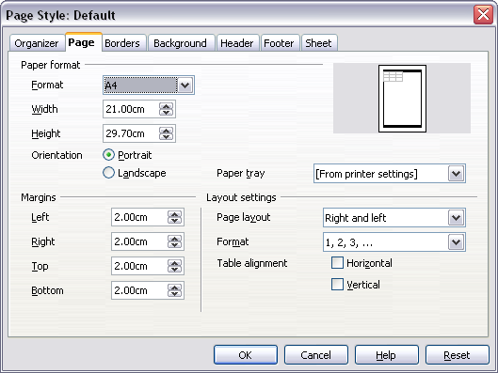
Figure 87: Page Style: Page tab
Paper format
Here you can set a generic paper type to be used. Letter or A4 are most common, but you can also use legal, tabloid, envelope sizes, or user-defined paper types. You can also define the orientation of the page and which print tray for the paper to come from (if your printer has more than one tray).
Margins
Here you can set the margins for the page.
Layout settings: Page layout
Here you can specify whether to apply the formatting to right (odd) pages only, left (even) pages only, or both right and left pages that use the current page style.
Mirrored formats the pages as if you want to bind the printed pages like a book.
The first page of a document is assumed to be an odd page.
Layout settings: Format
This area specifies the page numbering style for this page style.
Layout settings: Table alignment
This option specifies the alignment options for the cells on a printed page, either horizontal or vertical.

Borders
The Border and Background tabs for pages duplicate the tabs of the same name on cell styles, and are over-ridden by the cell style or manual settings. You may choose to ignore the Border and Background tabs altogether in page styles. Both tabs are illustrated with helpful diagrams.
Similar to formatting a cell style, use the Borders tab to choose whether the page should have borders, how large the borders should be, and how far the text will be from the borders.

Background
Use this tab to specify the background for this page style. You can apply either a solid color or a picture as a background.

Header
Use this tab to design and apply the header for this page style. For more detailed instructions on how to format the header, see Chapter 6 (Printing, Exporting, and E-mailing).

Footer
Use this tab to design and apply the footer for this page style. For more detailed instructions on how to format the footer, see Chapter 6.

Sheet
By far the most important settings for Calc page styles are on the Sheet tab. Although the Sheet tab includes an option that sets the first page option, most of its settings involve exactly how your spreadsheet will print. See Chapter 6.

Creating new (custom) styles
You may want to add some new styles. You can do this in two ways:
- Creating a new style using the Style dialog
- Creating a new style from a selection
Note | New styles apply only to this document; they are not be saved in the template. To save new styles in a template, see “Copying and moving styles“ on page 117 and “Creating a template” on page 120.

Creating a new style using the Style dialog
To create a new style using the Style dialog, right-click in the Styles and Formatting window and choose New from the pop-up menu.
(Cell styles only) If you want your new style to be linked with an existing style, first select that style and then right-click and choose New.
If you link styles, then when you change the base style (for example, by changing the font from Times to Helvetica), all the linked styles will change as well. Sometimes this is exactly what you want; other times you do not want the changes to apply to all the linked styles. It pays to plan ahead.
The dialogs and choices are the same for defining new styles and for modifying existing styles.

Creating a new style from a selection
You can create a new cell style by copying an existing manual format.
- Open the Styles and Formatting window and choose the type of style you want to create.
- In the document, select the formatted cell that you want to save as a style.
- In the Styles and Formatting window, click on the New Style from Selection icon .
- In the Create Style dialog, type a name for the new style. The list shows the names of existing custom styles of the selected type. Click OK to save the new style.
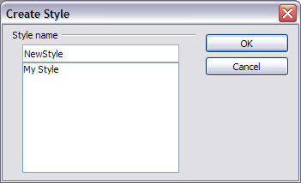
Figure 88: Naming a new style created from a selection.

Creating a new style by dragging and dropping
Select a cell and drag it to the Styles and Formatting window.

Copying and moving styles
Occasionally you may want to copy a style from one spreadsheet to another, or between a spreadsheet and a template, instead of recreating it in the second spreadsheet. You can do this using the Template Management dialog.
- Click File > Templates > Organize.
- In the Template Management dialog (Figure 89), set the lists at the bottom to either Templates or Documents, as needed. The default is Templates on the left and Documents on the right.
Tip | To copy styles from a file that is not open, click the File button. When you return to this dialog, both lists show the selected file as well as all the currently open documents.
- Open the folders and find the templates from and to which you want to copy. Double-click on the name of the template or document, and then double-click the Styles icon to show the list of individual styles (Figure 90).
- To copy a style, hold down the Ctrl key and drag the name of the style from one list to the other.
- Repeat for each style you want to copy. If the receiving template or document has many styles, you may not see any change unless you scroll down in the list. When you are finished, click Close.
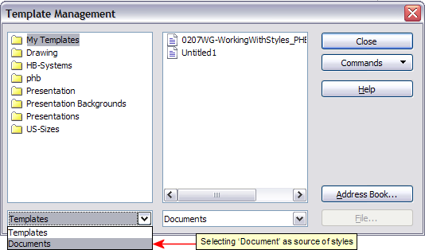
Figure 89: Choosing to copy styles from a document, not a template.
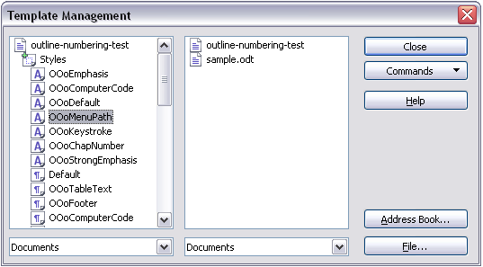
Figure 90: Copying a style from one document to another.

Deleting styles
You cannot remove (delete) any of Calc’s predefined styles, even if you are not using them.
You can remove any user-defined (custom) styles; but before you do, you should make sure the styles are not in use. If an unwanted style is in use, you will want to replace it with a substitute style.
Replacing styles (and then deleting the unwanted ones) can be very useful if you are dealing with a spreadsheet that has been worked on by several people.
To delete unwanted styles, right-click on them (one at a time) in the Styles and Formatting window and click Delete on the pop-up menu. Choose Yes in the confirmation pop-up.

Creating a spreadsheet from a template
To create a spreadsheet from a template:
- From the main menu, choose File > New > Templates and Documents. The Templates and Documents dialog opens. (See Figure 91 for the Windows version of this dialog.)
- In the box on the left, click the Templates icon if it is not already selected. A list of template folders appears in the center box.
- Double-click the folder that contains the template that you want to use. A list of all the templates contained in that folder appears in the center box.
- Select the template that you want to use. You can preview the selected template or view the template’s properties:
  - To preview the template, click the Preview icon. A preview of the template appears in the box on the right.
  - To view the template’s properties, click the Document Properties icon. The template’s properties appear in the box on the right.
- Click Open. The Templates and Documents dialog closes and a new document based on the selected template opens in Calc. You can then edit and save the new document just as you would any other document.
Figure 91: Templates and Documents dialog.

Creating a template
You can create a template from a document:
- Open a new or existing document of the type you want to make into a template (text document, spreadsheet, drawing, presentation).
- Add the content and styles that you want.
- From the main menu, choose File > Templates > Save. The Templates dialog opens (see Figure 92).
- In the New template field, type a name for the new template.
- In the Categories list, click the category to which you want to assign the template. The category you choose has no effect on the template itself; it is simply the folder in which you save the template. Choosing an appropriate folder (category) makes it easier to find the template when you want to use it. You may wish to create a folder for Calc templates.
To learn more about template folders, see “Organizing templates” on page 126.
- Click OK to save the new template.
Figure 92: Saving a new template
Any settings that can be added to or modified in a document can be saved in a template. For example, below are some of the settings (although not a full list) that can be included in a Calc document and then saved as a template for later use:
- Printer settings: which printer, single sided / double sided, and paper size, and so on
- Cell and page styles to be used
Templates can also contain predefined text, saving you from having to type it every time you create a new document. For example, an invoice template might contain your company’s name, address and logo.
You can also save menu and toolbar customizations in templates; see Chapter 14 (Setting up and Customizing Calc) for more information.

Editing a template
You can edit a template’s styles and content, and then, if you wish, you can reapply the template’s styles to documents that were created from that template. (Note that you can only reapply styles. You cannot reapply content.)
To edit a template:
- From the main menu, choose File > Templates > Organize. The Template Management dialog opens.
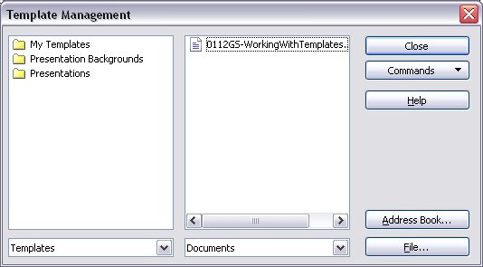Figure 93: Template management dialog
- In the box on the left, double-click the folder that contains the template that you want to edit. A list of all the templates contained in that folder appears underneath the folder name.
- Select the template that you want to edit.
- Click the Commands button and choose Edit from the drop-down menu.
- Edit the template just as you would any other document. To save your changes, choose File > Save from the main menu.

Updating a spreadsheet from a changed template
The next time you open a spreadsheet that was created from the changed template, the following message appears.
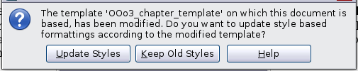
Figure 94: Update styles message
Click Update Styles to apply the template’s changed styles to the spreadsheet. Click Keep Old Styles if you do not want to apply the template’s changed styles to the spreadsheet (but see Caution notice below).
Caution | If you choose Keep Old Styles in the message box shown in Figure 94, that message will not appear again the next time you open the document after changing the template it is based on. You will not get another chance to update the styles from the template, although you can use the macro given in the Note below to re-enable this feature.
Note | To re-enable updating from a template:  - Use Tools > Macros > Organize Macros > OpenOffice.org Basic. Select the document from the list, click the +, and select Standard. If Standard has a + beside it, click that and select a module.  - Name the macro. For example, you could call it FixDocument. If the Edit button is active, click it. If the Edit button is not active, click New, type a module name in the pop-up dialog, and click OK.  - In the Basic window, enter the following:  Sub FixDocV3  ' set UpdateFromTemplate  oDocSettings = ThisComponent.createInstance( _  "com.sun.star.document.Settings" )  oDocSettings.UpdateFromTemplate = True  End Sub 'FixDocV3  - Click the Run BASIC icon, then close the Basic window.  - Save the document.  Next time when you open this document you will have the update from template feature back.

Adding templates using the Extension Manager
The Extension Manager provides an easy way to install collections of templates, graphics, macros, or other add-ins that have been “packaged” into files with a .OXT extension. See Chapter 14 (Setting Up and Customizing Calc) for more about the Extension Manager.
This Web page lists many of the available extensions: http://extensions.services.openoffice.org/.
To install an extension, follow these steps:
- Download an extension package and save it anywhere on your computer.
- In OOo, choose Tools > Extension Manager from the menu bar. In the Extension Manager dialog, click Add.
- A file browser window opens. Find and select the package of templates you want to install and click Open. The package begins installing. You may be asked to accept a license agreement.
- When the package installation is complete, the templates are available for use through File > New > Templates and Documents and the extension is listed in the Extension Manager.
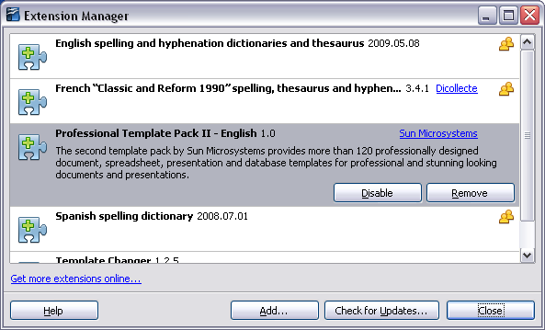
Figure 95: Newly-added package of templates.

Setting a default template
If you create a document by choosing File > New > Text Document (or Spreadsheet, Presentation, or Drawing) from the main menu, OOo creates the document from the Default template for that type of document. You can, however, set a custom template to be the default. You can reset the default later if you choose.

Setting a custom template as the default
You can set any template to be the default, as long as it is in one of the folders displayed in the Template Management dialog.
To set a custom template as the default:
- From the main menu, choose File > Templates > Organize. The Template Management dialog opens.
- In the box on the left, select the folder containing the template that you want to set as the default, then select the template.
- Click the Commands button and choose Set As Default Template from the drop-down menu.
The next time that you create a document by choosing File > New, the document will be created from this template.
Although many important settings can be changed in the Options dialog (see Chapter 14), for example default fonts and page size, more advanced settings (such as page margins) can only be changed by replacing the default template with a new one.

Resetting the default template
To re-enable OOo’s default template for a document type as the default:
- In the Template Management dialog, click any folder in the box on the left.
- Click the Commands button and choose Reset Default Template > Spreadsheet from the drop-down menu.
The next time that you create a spreadsheet by choosing File > New, it will be created from OOo’s default template for spreadsheets.

Associating a spreadsheet with a different template
At times you might want to associate a spreadsheet with a different template, or perhaps you’re working with a spreadsheet that did not start from a template but you now want it associated with a template.
One of the major advantages of using templates is the ease of updating styles in more than one document, as described on page 122. If you update styles by copying them from a different template (as described on page 117), the document has no association with the template from which the styles were loaded—so you cannot use this method. What you need to do is associate the document with the different template.
For best results, the names of styles should be the same in the existing document and the new template. If they are not, you will need to use Search and Replace to replace the old styles with new ones. See Chapter 2 (Entering, Editing, and Formatting Data) for more about replacing styles using Find and Replace.
- Use File > New > Templates and Documents. Choose the template you want. A new file, based on the template, opens. If the template has unwanted text or graphics in it, delete them.
- Open the spreadsheet you want to change. (It opens in a new window.) Press Control+A to select everything in the spreadsheet.
- Switch to the window containing the blank spreadsheet created in step 1, and paste the content into that spreadsheet.
- Save the file under a new name.

Organizing templates
OOo can only use templates that are in OOo template folders. You can create new OOo template folders and use them to organize your templates, and import templates into those folders. For example, you might have one template folder for report templates and another for letter templates. You can also export templates.
To begin, choose File > Templates > Organize from the main menu. The Template Management dialog opens.
Note | All the actions made by the Commands button in the Template Management dialog can be made as well by right-clicking on the templates or the folders.

Creating a template folder
To create a template folder:
- In the Template Management dialog, click any folder.
- Click the Commands button and choose New from the drop-down menu. A new folder called Untitled appears.
- Type a name for the new folder, and then press Enter. OOo saves the folder with the name that you entered.

Deleting a template folder
You cannot delete template folders supplied with OOo or installed using the Extension Manager; you can only delete template folders that you have created.
To delete a template folder:
- In the Template Management dialog, select the folder that you want to delete.
- Click the Commands button and choose Delete from the drop-down menu. A message box appears and asks you to confirm the deletion. Click Yes.

Moving a template
To move a template from one template folder to another template folder:
- In the Template Management dialog, double-click the folder that contains the template you want to move. A list of the templates contained in that folder appears underneath the folder name.
- Click the template that you want to move and drag it to the desired folder. If you do not have the authority to delete templates from the source folder, this action copies the template instead of moving it.

Deleting a template
You cannot delete templates supplied with OOo or installed using the Extension Manager; you can only delete templates that you have created or imported.
To delete a template:
- In the Template Management dialog, double-click the folder that contains the template you want to delete. A list of the templates contained in that folder appears underneath the folder name.
- Click the template that you want to delete.
- Click the Commands button and choose Delete from the drop-down menu. A message box appears and asks you to confirm the deletion. Click Yes.

Importing a template
If the template that you want to use is in a different location, you must import it into an OOo template folder.
To import a template into a template folder:
- In the Template Management dialog, select the folder into which you want to import the template.
- Click the Commands button and choose Import Template from the drop-down menu. A standard file browser window opens.
- Find and select the template that you want to import and click Open. The file browser window closes and the template appears in the selected folder.
- If you want, type a new name for the template, and then press Enter.

Exporting a template
To export a template from a template folder to another location:
- In the Template Management dialog, double-click the folder that contains the template you want to export. A list of the templates contained in that folder appears underneath the folder name.
- Click the template that you want to export.
- Click the Commands button and choose Export Template from the drop-down menu. The Save As window opens.
- Find the folder into which you want to export the template and click Save.

Calc Guide

Chapter 5
Using Graphics in Calc

This PDF is designed to be read onscreen, two pages at a time. If you want to print a copy, your PDF viewer should have an option for printing two pages on one sheet of paper, but you may need to start with page 2 to get it to print facing pages correctly. (Print this cover page separately.)

Copyright
This document is Copyright © 2006–2010 by its contributors as listed in the section titled Authors. You may distribute it and/or modify it under the terms of either the GNU General Public License, version 3 or later, or the Creative Commons Attribution License, version 3.0 or later.
All trademarks within this guide belong to their legitimate owners.
Authors
Jean Hollis Weber
Emma Kirsopp
Peter Kupfer
Alexandre Martins
Kashmira Patel
Iain Roberts
Feedback
Please direct any comments or suggestions about this document to: authors@documentation.openoffice.org
Publication date and software version
Published 24 April 2010. Based on OpenOffice.org 3.2.
Contents
Copyright 2
Graphics in Calc 5
Adding graphics (images) 5
Inserting an image file 5
Insert Picture dialog 6
Drag and drop 7
Linking an image file 7
Embedding linked images 8
Inserting an image from the clipboard 9
Inserting an image from the Gallery 9
Modifying images 11
Using the Picture toolbar 11
Choosing a graphics mode 13
Using graphic filters 13
Adjusting colors 14
Setting transparency 14
Customizing lines, areas, and shadows 14
Cropping pictures 15
Resizing an image 16
Rotating a picture 17
Using the picture context menu 17
Text 17
Position and Size 18
Original Size 18
Description 18
Name 19
Flip 19
Assign Macro 19
Group 19
Using Calc’s drawing tools 20
Set or change properties for drawing objects 22
Resizing a drawing object 23
Grouping drawing objects 23
Positioning graphics 23
Arranging graphics 24
Anchoring graphics 25
Aligning graphics 26
Creating an image map 26

Graphics in Calc
Calc is often used to present data and make forecasts and predictions. Graphics can turn an average document into a memorable one. Calc can import various vector (line drawing) and raster (bitmap) file formats. The most commonly used graphic formats are GIF, JPG, PNG, and BMP. See the Help for a full list of the formats OOo can import.
Graphics in Calc are of three basic types:
- Image files, such as photos, drawings, and scanned images
- Diagrams created using OOo’s drawing tools
- Charts and graphs created using OOo’s Chart facility
This chapter covers images and diagrams. Charts are described in Chapter 3 (Creating Charts and Graphs).
Although using graphics in Calc is very similar to using graphics in any other component of OOo, this chapter explains some of the differences in their use. It also covers some of the more advanced graphics functions and how they can further enhance your spreadsheet.
Note | The term graphics refers to both pictures and drawing objects. Often the word images is used when referring to pictures and other graphics that are not drawing objects.

Adding graphics (images)
Images (also called pictures in OOo), such as corporate logos and photographs of people and products, are probably the most common types of graphics added to a Calc document. They may be downloaded from the Internet, scanned, or created with a graphics program; or they may be photos taken with a digital camera.
Images can be inserted in four ways:
- Using the Insert File dialog
- By dragging and dropping a supported file
- From the gallery
- From the clipboard by copying and pasting

Inserting an image file
Perhaps the most common way to insert graphics is to use an existing file.
To insert an image from a file, use either of the following methods:
- Insert Picture dialog
- Drag and drop

Insert Picture dialog
- Click in the location in the Calc document where you want the image to appear. Do not worry too much about the exact placement of the image at this stage; placement can be changed easily as described in “Positioning graphics” on page 148.
- Choose Insert > Picture > From File from the menu bar, or click the Insert Picture icon on the Picture toolbar).
- On the Insert Picture dialog, navigate to the file to be inserted, select it, and click Open.
Note | The picture is inserted into Calc floating above the cells and anchored to the cell in which the cursor was placed. See “Positioning graphics” on page 148 for more about positioning and anchoring graphics.
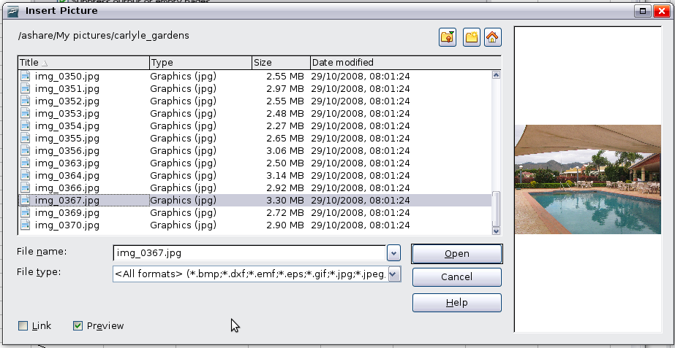
Figure 96: Inserting a picture from a file
At the bottom of the dialog are two options, Preview and Link. Select Preview to view a thumbnail of the selected image on the right, so you can verify that you have the correct file. The Link option is discussed on page 132. When the Link option is not selected, the picture is embedded in the Calc document.
Note | Your Insert Picture dialog may look quite different from the one shown here, depending on your operating system and your choice in Tools > Options > OpenOffice.org > General of whether to use the OOo Open and Save dialogs.

Drag and drop
- Open a file browser window and locate the image you want to insert.
- Drag the image into the Calc document and drop it where you want it to appear. A faint vertical line marks where the image will be dropped. The picture will be anchored to the cell where it was dropped.
This method always embeds (saves a copy of) the image file in the Calc document.

Linking an image file
To create a link to the file containing the image instead of saving a copy of the image in the Calc document, use the Insert picture dialog and select the Link option. The image is then displayed in the document, but when the document is saved, it contains only a reference to the image file—not the image itself. The document and the image remain as two separate files, which are merged temporarily only when you open the document again.
Linking an image has two advantages and one disadvantage:
- Advantage – Linking can reduce the size of the document when it is saved, because the image file itself is not included. The file size is usually not a problem on a modern computer with a reasonable amount of memory, unless the document includes many large graphics files. Calc can handle quite large files.
- Advantage – You can modify the image file separately without changing the document because the link to the file remains valid, and the modified image will appear when you next open the document. This can be a big advantage if you (or someone else, perhaps, a graphic artist) is updating images.
- Disadvantage – If you send the document to someone else, or move it to a different computer, you must also send the image files, or the receiver will not be able to see the linked images. You need to keep track of the location of the images and make sure the recipient knows where to put them on another machine, so the Calc document can find them. For example, you might keep images in a subfolder named Images (under the folder containing the Writer document); the recipient of the Calc file needs to put the images in a subfolder with the same name (under the folder containing the Writer document).
Note | When inserting the same image several times in the document, it might appear beneficial to create links. However, this is not necessary, as OOo embeds in the document only one copy of the image file. (Deleting one or more of the copies does not affect the others.)

Embedding linked images
If you originally linked the images, you can easily embed (save in the Calc document) one or more of them later if you wish. To do so:
- Open the document in Calc.
- Choose Edit > Links from the menu bar.
The Edit Links dialog shows all the linked files. In the Source file list, select the files you want to change from linked to embedded.
- Click the Break Link button.
- Save the Calc document.
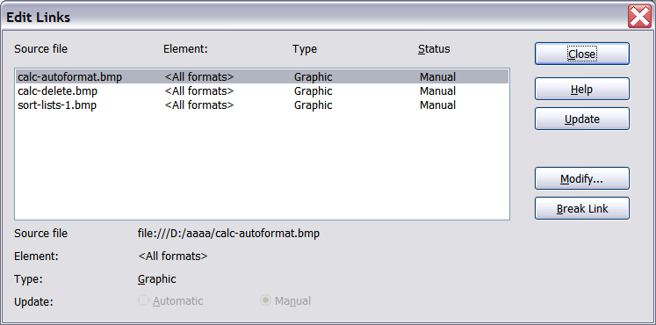
Figure 97: The Edit Links dialog
Note | Going the other way, from embedded to linked, is not so easy—you must delete and reinsert each image, one at a time, selecting the Link option when you do so.

Inserting an image from the clipboard
Using the clipboard, you can copy images into a Calc document from another Calc document, from another component of OOo (Writer, Draw, and so on), and from other programs.
To do this:
- Open both the source document and the Calc document into which you want to copy the image.
- In the source document, select the image to be copied.
- Press Control+C to copy the image to the clipboard.
- Switch to the Calc window.
- Click to place the cursor where the graphic is to be inserted.
- Press Control+V to insert the image.
Caution | If the application from which the graphic was copied is closed before the graphic is pasted into Calc, the image stored on the clipboard could be lost from the clipboard.

Inserting an image from the Gallery
The Gallery provides a convenient way to group reusable objects such as graphics and sounds that you can insert into your documents.
The Gallery is available in all components of OOo. It does not come with many graphics, but you can add your own pictures or find extensions containing more graphics. The Gallery is explained in more detail in Chapter 11 (Graphics, the Gallery, and Fontwork) in the Getting Started guide. For more about extensions, see Chapter 14 (Setting Up and Customizing Calc) in this book.
This section explains the basics of inserting a Gallery image into a Calc document.
- To open the Gallery (Figure 98), click on the Gallery icon (located in the right side of the Standard toolbar) or choose Tools > Gallery from the menu bar.
- Navigate through the Gallery to find the desired picture.
- To insert the picture, either right-click on the picture and choose Insert > Copy or click and drag the picture from the Gallery into the Calc document.
By default, the Gallery is docked above the Calc workspace. To expand the Gallery, position the pointer over the line that divides it from the top of the workspace. When the pointer changes to parallel lines with arrows, click and drag downward. The workspace resizes in response.
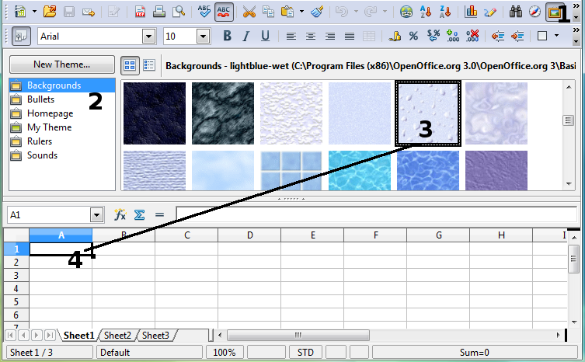
Figure 98: Gallery in Calc
To expand the Gallery without affecting the workspace, undock it so it floats over the workspace. To do so, hold down the Control key and double-click on the upper part of the Gallery next to the View icons. Double-click in the same area while holding down the Control key to dock it again (restore it to its position over the workspace).
When the Gallery is docked, to hide it and view the full Calc workspace, click the Hide/Show button in the middle of the thin bar separating the Gallery from the workspace.
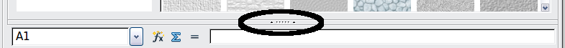
To close the Gallery, choose Tools > Gallery to uncheck the Gallery entry, or click on the Gallery icon again.

Modifying images
When you insert a new image, you may need to modify it to suit the document. This section describes the use of the Picture toolbar, resizing, cropping, and a workaround for rotating a picture. Changes made in Calc do not affect the original picture, whether it is embedded or linked.
Calc provides many tools for working with images. These tools are sufficient for most people’s everyday requirements. However, for professional results it is generally better to use an image manipulation program such as GIMP to modify images (for example, to crop, resize, rotate, and change color values) and then insert the result into Calc. GIMP is an open-source graphics program that can be downloaded from http://www.gimp.org/downloads/.

Using the Picture toolbar
When you insert an image or select one already present in the document, the Picture toolbar appears. You can set it to always be present (View > Toolbars > Picture). Picture control buttons from the Picture toolbar can also be added to the Standard Toolbar. See Chapter 14 (Setting Up and Customizing Calc) for more information.
This toolbar can be either floating or docked. Figure 99 shows the Picture toolbar when it is floating. A brief explanation of the tools is given in Table 3. See the Draw Guide for a more detailed explanation.
Two other toolbars can be opened from this one: the Graphic Filter toolbar, which can be torn off and placed elsewhere on the window, and the Color toolbar, which opens as a separate floating toolbar.
From these three toolbars, you can apply small corrections to the graphic or obtain special effects.
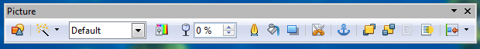Figure 99: The Picture Toolbar
Table 3: Picture toolbar functions (from left to right)
Icon | Name | Behavior
 | From File | Use of this icon is described in “Inserting an image file” on page 130.
 | Filter | Displays the Graphic Filter toolbar. See page 138.
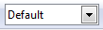 | Graphics Mode | Provides several color modes in the drop-down list. See page 138.
 | Color | Opens the Color toolbar, described on page 139.
 | Transparency | Sets the transparency of the selected image. See page 139.
 | Line | Adjusts the border style of the selected image.
 | Area | Fills an area with the selected color or pattern.
 | Shadow | Adds a drop shadow to the edges of the picture.
 | Crop | Opens the Crop dialog, where you can remove a selected part of the picture. See page 140.
 | Anchor | Toggles between anchoring the image to the cell or to the page. See page 150.
 | Bring to Front | Brings the selected image to the front of the stack. See page 149.
 | Send to Back | Pushes the selected image to the rear of the stack. See page 149.
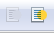 | To Foreground / Background | Allows image to float in the foreground or makes it part of the background (behind the cells). See page 149.
 | Alignment | If two or more pictures are selected, adjusts the horizontal and vertical alignment of the pictures in relation to each other. See page 151.

Choosing a graphics mode
You can change color images to grayscale by selecting the image and then selecting Grayscale from the Graphics mode list.
Table 4: Graphics modes
Graphics mode | Behavior
Default | Keeps the picture the same as it was inserted.
Grayscale | Shows the picture in gradual shades of gray.
Black / White | Converts the picture into a monochromatic black and white image.
Watermark | Makes the picture into a watermark that blends into the background.

Using graphic filters
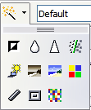
Click the Filter icon to display the Graphic Filter toolbar, which provides options for applying basic photographic and effect filters to images from within Calc. To “tear off” this toolbar and place it anywhere on the screen, click on the three parallel lines and drag it away.
Table 5: Graphic filters and their effects
Icon | Name | Behavior
 | Invert | Inverts the colors in the picture like a negative.
 | Smooth | Applies a Gaussian Blur to the image which softens edges.
 | Sharpen | Sharpens the image.
 | Remove Noise | Applies crude noise reduction.
 | Solarization | Reverses a portion of the tones, then produces pronounced outlines of the highlights.
 | Aging | Applies a Sepia filter.
 | Posterize | Opens a dialog to determine the number of poster colors. This effect is based on the reduction of the number of colors. It makes photos look like paintings.
 | Pop Art | Applies a Pop Art style to the image.
 | Charcoal Sketch | Applies a Charcoal Sketch look to the image.
 | Relief | Displays a dialog for creating reliefs. The position of the imaginary light source that determines the type of shadow can be chosen.
 | Mosaic | Joins small groups of pixels into rectangular areas of the same color. The larger the individual rectangles are, the fewer details the graphic image has.
Caution | Applying OOo picture filters to any image consecutively will progressively degrade the quality of the image. The picture filters used in Calc utilize what is known as a Destructive Editing algorithm, whereby each filter is applied to the image immediately, changing the original data of the image. Successive transformations result in less and less original data remaining, thus compromising the quality of the inserted picture. While this might be acceptable for use in simple documents, it is still recommended that dedicated photo or image editing software be used to perform anything but the simplest of manipulations.

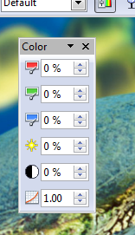
Adjusting colors
Use the Color toolbar to adjust an image’s red, green, and blue channels independently, as well as its brightness, contrast and gamma.

Setting transparency
Modify the percentage value in the Transparency box on the Picture toolbar to make the image more transparent. This is particularly useful when creating a watermark or when wrapping an image in the background.

Customizing lines, areas, and shadows
The Line, Area, and Shadow icons open dialogs where you can customize these elements. Details are in the Draw Guide.

Cropping pictures
When you are only interested in a section of the image for the purpose of your document, you may wish to crop (cut off) parts of it. The user interface in Calc for cropping an image is not very friendly, so it may be a better choice to use a graphics package.
Click the Crop icon to open a dialog where you can select which portion of the image you want to remove.
It is not possible to use the mouse to select the area to be cropped, as you can in Draw. Instead, in the Crop dialog, specify how far from the top, bottom, left and right borders of the image the crop should be, as illustrated in Figure 100. On the thumbnail in the figure, notice that the cropped selection is highlighted with an inner rectangle.
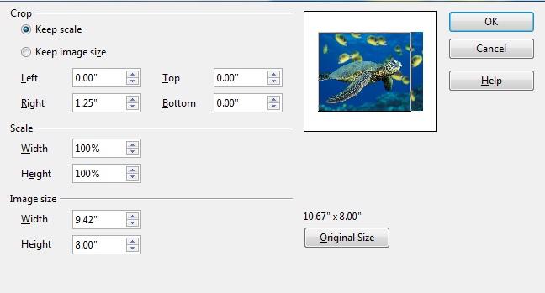
Figure 100: The Crop dialog
On the Crop dialog, you can control the following parameters:
Keep scale / Keep image size
When Keep scale is selected (default), cropping the image does not change the scale of the picture.
When Keep image size is selected, cropping enlarges (for positive cropping values), shrinks (for negative cropping values), or distorts of the image so that the image size remains constant.
Left, Right, Top, and Bottom
The image is cropped by the amount entered in these boxes. For example, a value of 3cm in the Left box cuts 3 cm from the left side of the picture.
- When Keep scale is selected, the size of the image also changes, so in this example the width will be reduced by 3 cm.
- When Keep image size is selected, the remaining part of the image is enlarged (when you enter positive values for cropping) or shrunk (when you enter negative values for cropping) so that the width and height of the image is not changed.
Width and Height
The Width and Height fields under either Scale or Image size change as you enter values in the Left, Right, Top, and Bottom fields. Use the thumbnail next to these fields to determine the correct amount by which to crop.
The cropped shape is always a rectangle; more complex cropped shapes are not possible in Calc. Instead, use a dedicated photo or image editing software for the job, then import the image into Calc.
Note | If you crop an image in Calc, the picture itself is not changed. If you export the document to HTML, the original image is exported, not the cropped image.

Resizing an image
To resize an image.
- Click the picture, if necessary, to show the green resizing handles.
- Position the pointer over one of the green resizing handles. The pointer changes shape giving a graphical representation of the direction of the resizing.
- Click and drag to resize the picture.
- Release the mouse button when satisfied with the new size.
The corner handles resize both the width and the height of the graphic object simultaneously, while the other four handles only resize one dimension at a time.
Tip | To retain the original proportions of the graphic, Shift+click one of the corner handles, then drag. Be sure to release the mouse button before releasing the Shift key.
Resizing a bit-mapped (raster) image such as a photograph adversely affects the resolution, causing some degree of blurring. It is better to use a graphics package to size your picture correctly before inserting it into your document, if possible.
For more accurate resizing, use the Position and Size dialog, described on page 143.

Rotating a picture
Calc does not provide a tool for rotating a picture, but you can use this workaround:
- Open a new Draw or Impress document.
- Insert the image you want to rotate.
- Select the image, then in the Drawing toolbar (shown by default at the bottom of the window in Impress and Draw), select the Rotate icon .
- Rotate the image as desired. Use the red handles at the corners of the picture and move the mouse in the direction you wish to rotate. By default the picture rotates around its center (indicated by a black crosshair), but you can change the pivot point by moving the black crosshair to the desired rotation center.
Tip | To restrict the rotation angle to multiples of 15 degrees keep the Shift key pressed while rotating the image.
- Select the rotated picture by pressing Ctrl+A, then copy the image to the clipboard with Ctrl+C.
- Finish by going back to the Calc document, place the cursor where the image is to be inserted, and press Ctrl+V.

Using the picture context menu
Many of the options accessible from the Picture toolbar can also be reached by right-clicking on an image to pop up a context menu. Some additional options are only available from the context menu; these are described in this section.

Text
Opens a dialog where you can set the options for text that goes over a picture. To write text over a graphic, click on the graphic to select it, and then press Enter. There should be a cursor inside the graphic. Any text entered is part of the graphic, so if the graphic is moved the text will move with it.

Position and Size
Opens the dialog shown below where you can change the size, location, rotation, slant and corner radius of the image.
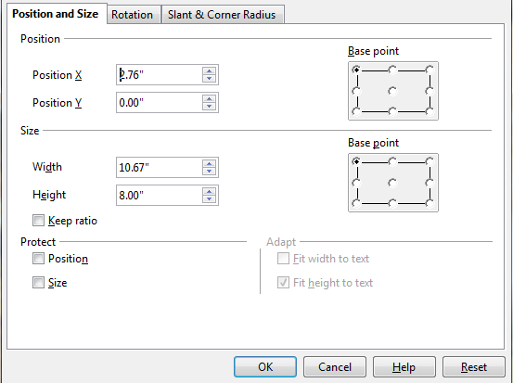Figure 101: Position and Size Dialog

Original Size
Resets the dimensions of the image to the values when it was originally inserted into the document.

Description
You can add metadata in the form of a title and description to the image. This information is used by accessibility tools (such as screen reader software) and as ALT (alternative) attributes if you export the document to HTML.

Name
You can add a custom name to be assigned to the image, to make it easier to find in the Navigator.
Tip | When collaborating with a team on a large, multi-page publication, it may be beneficial to give graphics, figures, and other objects meaningful names and descriptions to aid in clear communication.

Flip
Flips the image either horizontally or vertically.

Assign Macro
Adds programmable functionality to the image. Calc provides rich macro functionality. Macros are introduced in Chapter 12 (Calc Macros).

Group
To group images:
- Select one image, then hold down the Shift key and click in turn on each of the others that you want to include in the group. The invisible “bounding box” (with the 8 green handles) expands to include all the selected images.
- With the images selected, choose Format > Group > Group from the menu bar.
Or hover the mouse pointer over one of the images. When the pointer changes shape from an arrow to a hand, right-click and choose Group > Group from the pop-up menu.
Note | You cannot include drawing objects in a group with pictures.
After images are grouped, the context menu provides other choices (Ungroup and Edit Group) and the Format > Group menu includes Ungroup and Enter Group. For more information about grouping, see the Draw Guide.

Using Calc’s drawing tools
Calc, like the other components of OOo, has a range of tools to create custom drawings. This chapter covers the default options in Calc. For a more detailed explanation of the drawing tools and their uses, see the Draw Guide.
In general, if you need to create complex drawings, it is recommended to use OpenOffice.org Draw or another drawing program.
To begin using the drawing tools, choose View > Toolbars > Drawing. The Drawing toolbar appears at the bottom of the screen. You can tear off this toolbar and move it to a convenient place on the window.
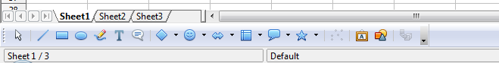Figure 102: The Drawing toolbar showing default icons
Table 6: Drawing toolbar functions (from left to right)
Icon | Name | Behavior
 | Select | Selects objects.
 | Line | Draws a line.
 | Rectangle | Draws a rectangle. To draw a square, hold down Shift while you drag.
 | Ellipse | Draws an ellipse. To draw a circle, hold down Shift while you drag.
 | Freeform Line | Draws a freeform line.
 | Text | Draws a text box with no border.
 | Callouts | Draws a line that ends in a rectangular callout.
 | Basic Shapes | Opens the Basic Shapes toolbar.
 | Symbol Shapes | Opens the Symbol Shapes toolbar.
 | Block Arrows | Opens the Block Arrows toolbar of shapes.
 | Flowcharts | Opens the Flowchart toolbar of shapes.
 | Callouts | Opens the Callouts toolbar of shapes.
 | Stars | Opens the Stars toolbar of shapes.
 | Points | Allows editing of the points of a selected polygon.
 | Fontwork Gallery | Opens the Fontwork Gallery.
 | From File | Inserts a picture using the Insert Picture dialog.
 | Extrusion On/Off | Opens the 3-D Setting toolbar and converts the selected shape (if any) to 3-D.
To display other icons, click the down-arrow at the right-hand end of the toolbar, select Visible Buttons, and then choose the tools you want to appear on the toolbar.
Icon | Name | Behavior
 | Polygon | Draws a line composed of a series of straight line segments. Hold down the Shift key to position new points at 45 degree angles.
 | Curve | Draws a smooth Bézier curve.
 | Arc | Draws an arc.
 | Ellipse Pie | Draws a filled shape that is defined by the arc of an oval and two radius lines in the current document. To draw a circle pie, hold down Shift while you drag.
 | Circle Segment | Draws a filled shape that is defined by the arc of a circle and a diameter line in the current document. To draw an ellipse segment, hold down Shift while you drag.
 | Text Animation | Inserts animated text.
If support for Asian languages has been enabled (in Tools > Options > Language Settings > Languages), two more tools can be added to the Drawing toolbar: Vertical Text and Vertical Callouts.
To use a drawing tool:
- Click in the document where you want the drawing to be anchored. You can change the anchor later, if necessary.
- Select the tool from the Drawing toolbar (Figure 102). The mouse pointer changes to a cross-hair pointer.
- Move the cross-hair pointer to the place in the document where you want the graphic to appear and then click-and-drag to create the drawing object. Release the mouse button. (Some tools have other requirements; see the Help or the Draw Guide for details.)
The selected drawing function remains active, so you can draw another object of the same type.
- To cancel the selected drawing function, press the Esc key or click on the Select icon (the arrow) on the Drawing toolbar.
- You can now change the properties (fill color, line type and weight, anchoring, and others) of the drawing object using either the Drawing Object Properties toolbar (Figure 103) or the choices and dialog boxes reached by right-clicking on the drawing object.

Set or change properties for drawing objects
To set the properties for a drawing object before you draw it:
- On the Drawing toolbar (Figure 102), click the Select tool.
- On the Drawing Object Properties toolbar (Figure 103), click on the icon for each property and select the value you want for that property.
- For more control, or to define new attributes, you can click on the Area or Line icons on the toolbar to display detailed dialogs.
These default properties are applied only to the current document and session. They are is not retained when you close the document, and they do not apply to any other document. The defaults apply to all the drawing objects except text objects.
To change the properties for an existing drawing object, select the object and continue as described above.
Other tools and methods for modifying and positioning graphics are described in “Positioning graphics” below.
1 | Line | 5 | Line Color | 9 | Change Anchor | 13 | Alignment
2 | Arrow Style | 6 | Area | 10 | Bring to Front
3 | Line Style | 7 | Area Style / Filling | 11 | Send to Back
4 | Line Width | 8 | Rotate | 12 | To Foreground / To Background
Figure 103. Drawing Object Properties toolbar

Resizing a drawing object
Select the object, click on one of the eight handles around it and drag it to its new size. For a scaled resizing, select one of the corner handles and keep the Shift key pressed while dragging the handle.
For more control of the size of the object, use the Position and Size dialog (see “Position and Size” on page 143) to set the width and height independently. If the Keep ratio option is selected, then the two dimensions change so that the proportion is maintained, allowing for a scaled resizing.

Grouping drawing objects
To group drawing objects:
- Select one object, then hold down the Shift key and select the others you want to include in the group. The bounding box expands to include all the selected objects.
- With the objects selected, hover the mouse pointer over one of the objects and choose Format > Group > Group from the menu bar or right-click and choose Group > Group from the pop-up menu.
Note | You cannot include an embedded or linked graphic in a group with drawing objects.

Positioning graphics
Graphics can be positioned in OOo Calc to work together and build more complex features.

Arranging graphics
Graphics in a Calc document are maintained in a similar manner to a deck of cards. As you add more images to the document, each image occupies a new layer at the top of the stack. To arrange graphics, you tell Calc to change the order of layers in the stack.
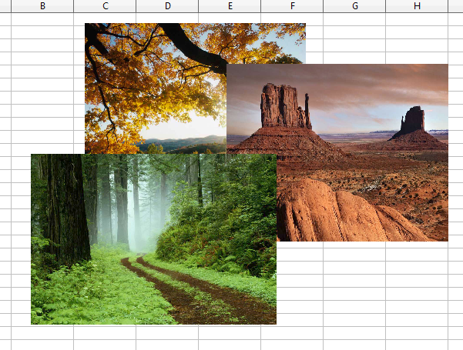Figure 104: Layering effect
Calc provides four basic options to re-arrange the order of images. These options can be accessed from both the Picture toolbar and the picture context menu:
Bring to Front
Places the image on top of any other graphics or text.
Bring Forward
Brings the image one level up in the stack (z-axis). Depending on the number of overlapping objects, you may need to apply this option several times to obtain the desired result.
Send Backward
The opposite of Bring Forward; sends the selected image one level down in the object stack.
Send to Back
Sends the selected graphic to the bottom of the stack, so that other graphics and text cover it.
To Background and To Foreground
An image or a drawing object can be sent to the background as well. This is not the same as Bring Forward and Send Backward, which set the order of a number of overlapping graphics. This feature pushes a graphic behind the cells, allowing cells to be edited without affecting the graphic.
A graphic in the background will have To Foreground as a menu item, instead of To Background.

Anchoring graphics
Anchors tell a graphic where to stay in relation to other items.
Anchor to page
Anchoring a graphic to the page allows it to be positioned in a specific place on the page. The graphic does not move when cells are added or deleted. This is equivalent to an absolute reference. The graphic will always stay by cell B10 if that is where it is placed.
Anchor to cell
Anchoring a graphic to a cell ensures that the graphic always stays with the content it is originally anchored to. If a graphic is anchored to cell B10, and a new row is inserted, the graphic will then be anchored to cell B11. This is equivalent to a relative reference.
For example, in Figure 105 the normal Otto and Tux picture is anchored To Cell B10 (XXX shows where the picture is anchored). The inverse Otto and Tux picture is anchored to the page.
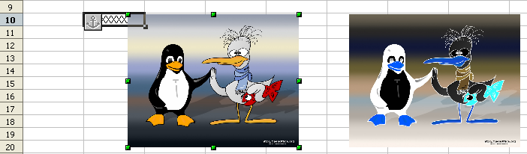Figure 105: Anchoring 1
If two rows are inserted above the pictures, the normal picture (anchored to cell) will shift down two rows and the anchor will change. The inverse picture (anchored to page) will not move. This is illustrated in Figure 106. Note that the anchor symbol and the XXX have moved down to cell B12.
.
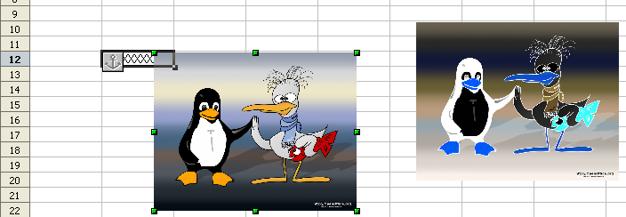Figure 106: Anchoring 2

Aligning graphics
You can align several graphics relative to each other. To do this:
- Select all of the graphics to be aligned (Shift+click on each in turn). The graphics will be surrounded by an invisible bounding box with 8 green handles.
- On the Picture toolbar, click on the Alignment icon and select one of the six options.
Or, position the mouse pointer over any of the graphics. When the pointer changes shape from an arrow to a hand, right-click and choose Alignment, then select from the six options.
The six options include three for aligning the graphics horizontally (left, center, right) and three for aligning the graphics vertically (top, center, bottom).

Creating an image map
An image map defines areas of an image (called hotspots) with hyperlinks to web addresses, other files on the computer, or parts of the same document. Hotspots are the graphic equivalent of text hyperlinks. Clicking on a hotspot causes Calc to open the linked page in the appropriate program (for example, the default browser for an HTML page; OOo Calc for a .ODS file; a PDF viewer for a PDF file). You can create hotspots of various shapes, and include several hotspots in the same image.
To use the image map editor:
- In your OOo document, select the picture where you want to define the hotspots.
- Choose Edit > ImageMap from the menu bar. The ImageMap Editor (Figure 107) opens.
- Use the tools and fields in the dialog (described on the next page) to define the hotspots and links necessary.
- Click the Apply icon to apply the settings.
- When done, click the Save icon to save the imagemap to a file, then click the X in the upper right corner to close the dialog.

Figure 107: The dialog to create or edit an image map
The main part of the dialog shows the image on which the hotspots are defined. A hotspot is identified by a line indicating its shape.
The toolbar at the top of the dialog contains the following tools:
- Apply button: click this button to apply the changes.
- Load, Save, and Select icons.
- Tools for drawing a hotspot shape: these tools work in exactly the same way as the corresponding tools in the Drawing toolbar.
- Edit, Move, Insert, Delete Points: advanced editing tools to manipulate the shape of a polygon hotspot. Select the Edit Points tool to activate the other tools.
- Active icon: toggles the status of a selected hotspot between active and inactive.
- Macro: associates a macro with the hotspot instead of just associating an hyperlink.
- Properties: sets the hyperlink properties and adds the Name attribute to the hyperlink.
Below the toolbar, specify for the selected hotspot:
- Address: the address pointed by the hyperlink. You can also point to an anchor in a document; to do this, write the address in this format: file:///<path>/document_name#anchor_name
- Text: type the text that you want to be displayed when the mouse pointer is moved over the hotspot.
- Frame: where the target of the hyperlink will open: pick among _blank (opens in a new browser window), _self (opens in the active browser window), _top or _parent.
Tip | The value _self for the target frame will work just fine in the vast majority of occasions. It is therefore not recommended to use the other choices unless absolutely necessary.

Calc Guide

Chapter 6
Printing, Exporting, and E-mailing

This PDF is designed to be read onscreen, two pages at a time. If you want to print a copy, your PDF viewer should have an option for printing two pages on one sheet of paper, but you may need to start with page 2 to get it to print facing pages correctly. (Print this cover page separately.)

Copyright
This document is Copyright © 2005–2010 by its contributors as listed in the section titled Authors. You may distribute it and/or modify it under the terms of either the GNU General Public License, version 3 or later, or the Creative Commons Attribution License, version 3.0 or later.
All trademarks within this guide belong to their legitimate owners.
Authors
Jean Hollis Weber
Emma Kirsopp
Peter Kupfer
Shelagh Manton
Kashmira Patel
Linda Worthington
Feedback
Please direct any comments or suggestions about this document to: authors@documentation.openoffice.org
Acknowledgements
Portions of this chapter are taken from articles written by Bruce Byfield and first published on the Linux Journal website; used with permission
Publication date and software version
Published 20 April 2010. Based on OpenOffice.org 3.2.
Contents
Copyright 2
Quick printing 5
Controlling printing 5
Printer options 6
Selecting sheets to print 6
Selecting the page order, details, and scale 7
Using print ranges 9
Defining a print range 9
Adding to the print range 9
Removing a print range 9
Editing a print range 10
Printing rows or columns on every page 11
Defining a custom print range 11
Page breaks 13
Inserting a page break 13
Row break 13
Column break 13
Deleting a page break 13
Headers and footers 14
Setting a header or a footer 14
Header or footer appearance 15
Setting the contents of the header or footer 16
Exporting to PDF 17
Quick export to PDF 17
Controlling PDF content and quality 17
General page of PDF Options dialog 17
Initial View page of PDF Options dialog 19
User Interface page of PDF Options dialog 19
Links page of PDF Options dialog 21
Security page of PDF Options dialog 22
Exporting to XHTML 23
Saving as Web pages (HTML) 24
E-mailing spreadsheets 24
E-mailing a spreadsheet to several recipients 24
Digital signing of documents 25
Removing personal data 26

Quick printing
Click the Print File Directly icon to send the entire document to the default printer defined for your computer.
Note | You can change the action of the Print File Directly icon to send the document to the printer defined for the document instead of the default printer for the computer. Choose Tools > Options > Load/Save > General and the Load printer settings with the document option.

Controlling printing
For more control over printing, use File > Print.
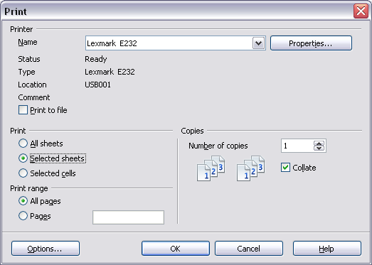
Figure 108. The Print dialog
On the Print dialog, you can choose:
- Which printer to use (if more than one are installed on your system) and the properties of the printer—for example, page orientation (portrait or landscape), which paper tray to use, and what paper size to print on. The properties available depend on the selected printer; consult the printer’s documentation for details.
- What sheets and pages to print, how many copies to print, and in what order to print them. Use dashes to specify page ranges and commas or semicolons to separate ranges; for example: 1, 5, 11–14, 34–40. Selection refers to the highlighted part of a page or pages.
- Whether to print to a printer or to a file.

Printer options
You can set printer options for the current document only or for all spreadsheets.
- To select options for the current document, click the Options button on the bottom left of the Print dialog (Figure 108).
- To set print options permanently, go to Tools > Options > OpenOffice.org Calc > Print. The dialogs for both are very similar.
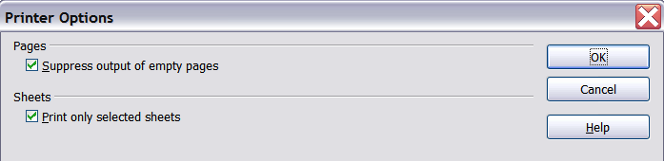
Figure 109. Printer Options dialog

Selecting sheets to print
You can select one or more sheets for printing. This can be useful if you have a large spreadsheet with multiple sheets and only want to print certain sheets. For example, an accountant might record costs over time with one sheet for each month. To print the November and December sheets, follow this procedure.
- Go to the November sheet. Hold down the Control key and click on the tab of the December sheet.
- If you wish to print all of the sheets, choose File > Print and click the Options button.
- Deselect Print only selected sheets. This affects the print preview, export, and printing of your spreadsheet. Click OK.
Note | The Options button is different from the Properties button. Properties deals with the settings of the printer, whereas Options deals with OOo’s settings.

Selecting the page order, details, and scale
To select the page order, details, and scale to be printed:
- Choose Format > Page from the main menu. The Page Style dialog opens; any changes made here are saved in the page style for this spreadsheet.
- Choose the Sheet tab (Figure 110).
- After making your selections (see next page), click OK.
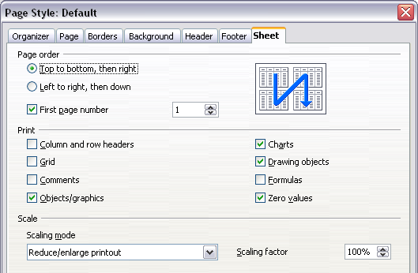
Figure 110. The Sheet tab of the Page Style dialog
Page Order
You can set the order in which pages print. This is especially useful in a large document; for example, controlling the print order can save time if you have to collate the document a certain way.
Where a sheet prints to more than one page of paper, it can be printed either by column, where the first column of pages prints, and then the second column and so on, or by row as shown in the graphic on the top right of the dialog in Figure 110.
Print
You can specify which details to print. These details include:
- Row and column headers
- Sheet grid—prints the borders of the cells as a grid
- Comments—prints the comments defined in your spreadsheet on a separate page, along with the corresponding cell reference
- Objects and graphics
- Charts
- Drawing objects
- Formulas—prints the formulas contained in the cells, instead of the results
- Zero Values—prints cells with a zero value
Note | Remember that since the print detail options are a part of the page’s properties, they are also a part of the page style’s properties. Therefore, different page styles can be set up to quickly change the print properties of the sheets in the spreadsheet.
Scale
Use the scale features to control the number of pages the data will print on. This can be useful if a large amount of data needs to be printed compactly or, if the reader has poor eyesight, text can be enlarged when it prints.
- Reduce/Enlarge printout—scales the data in the printout either larger or smaller. For example, if a sheet would normally print out as four pages (two high and two wide), a scaling of 50% would print as one page (both width and height are halved).
- Fit print range(s) on number of pages—defines exactly how many pages the printout will take up. This option will only reduce a printout, it will not enlarge it. To enlarge a printout, the reduce/enlarge option must be used.
- Fit print range(s) to width/height—defines how high and wide the printout will be, in pages.

Using print ranges
Print ranges have several uses, including printing only a specific part of the data or printing selected rows or columns on every page.

Defining a print range
To define a new print range or modify an existing print range:
- Highlight the range of cells that comprise the print range.
- Choose Format > Print Ranges > Define.
The page break lines display on the screen.
Tip | You can check the print range by using File > Page Preview. OOo will only display the cells in the print range.

Adding to the print range
After defining a print range, you can add more cells to it. This allows multiple, separate areas of the same sheet to be printed, while not printing the whole sheet. After you have defined a print range:
- Highlight the range of cells to be added to the print range.
- Choose Format > Print Ranges > Add. This adds the extra cells to the print range.
The page break lines no longer display on the screen.
Note | The additional print range will print as a separate page, even if both ranges are on the same sheet.

Removing a print range
It may become necessary to remove a defined print range, for example if the whole sheet needs to be printed later.
Choose Format > Print Ranges > Remove. This removes all defined print ranges on the sheet. After the print range is removed, the default page break lines will appear on the screen.

Editing a print range
At any time, you can directly edit the print range, for example to remove or resize part of the print range. Choose Format > Print Ranges > Edit. If you have already selected a print range, the Edit Print Ranges dialog looks something like Figure 111.
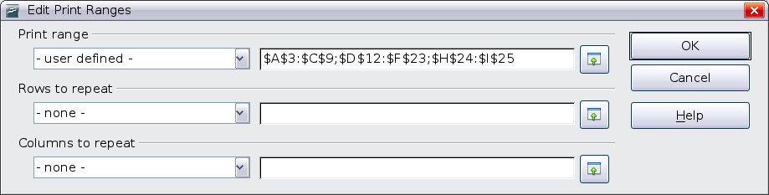
Figure 111: Edit a print range
In this example, three rectangles are selected, each separated by a semicolon. The first is bounded by cell A3 ($A$3) in the top left and cell C9 ($C$9) in the bottom right corners. Clicking anywhere in the text entry box shows the currently selected print range on the screen, with each rectangle in a different color, as in Figure 112.
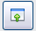
After making any changes, click the Shrink icon next to the text entry box to redisplay the rectangles with their new values.
To re-expand the Edit Print Ranges dialog, click the Shrink icon again.
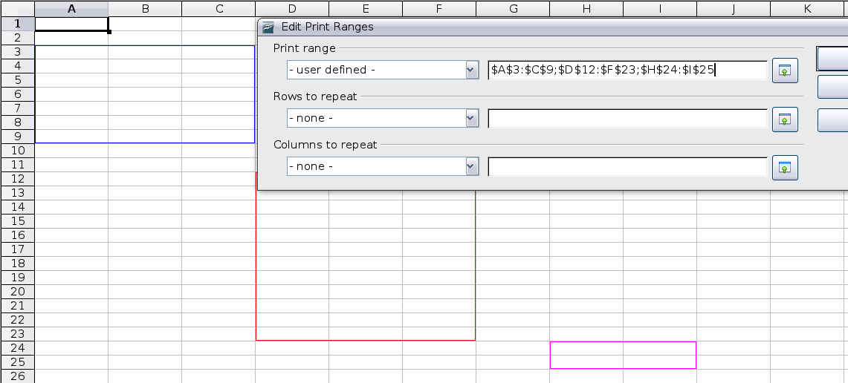
Figure 112: Print range marked by colored boxes

Printing rows or columns on every page
If a sheet is printed on multiple pages, you can set up certain rows or columns to repeat on each printed page.
For example, if the top two rows of the sheet as well as column A need to be printed on all pages, do the following:
- Choose Format > Print Ranges > Edit. On the Edit Print Ranges dialog, type the rows in the text entry box under Rows to repeat. For example, to repeat rows 1 and 2, type $1:$2. This automatically changes Rows to repeat from - none - to - user defined -.
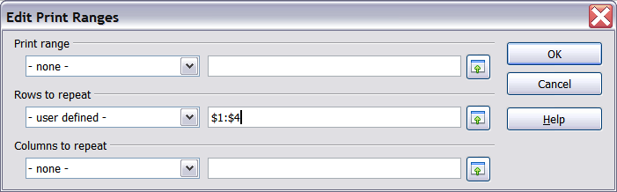
Figure 113: Specifying repeating rows
- To repeat columns, type the columns in the text entry box under Columns to repeat. For example, to repeat column A, type $A. This automatically changes Columns to repeat from - none - to - user defined -.
- Click OK.
Note | You do not need to select the entire range of the rows to be repeated; simply select one cell in each row.

Defining a custom print range
In addition to highlighting a print range for each print job, you can define a range of cells to be used repeatedly. This may be useful if there are different areas of a large spreadsheet that need to be printed for different reports. Several different print ranges can be defined to meet this need.
- To define a print range, use the same procedure as labeling an area of the sheet. Highlight the cells you want to define as a print range and select Insert > Names > Define. (The cells can be highlighted after opening the Define Names dialog as well.)
- On the Define Names dialog (Figure 114), type a name for the range in the text box with the blinking cursor. The name of the range cannot contain any spaces.
- Click the More button in the dialog and then select the Print range option. Click the Add button.
- To include more than one group of cells in the selection, type in the additional ranges. For example, to select the rectangle with A3 as the top left cell and F20 as the bottom right cell, enter
;$A$3:$F$20 or ;A3:F20 (both work and are equivalent) after the initial selection. Make sure that each group of cells is separated with a semicolon.
- Click OK.
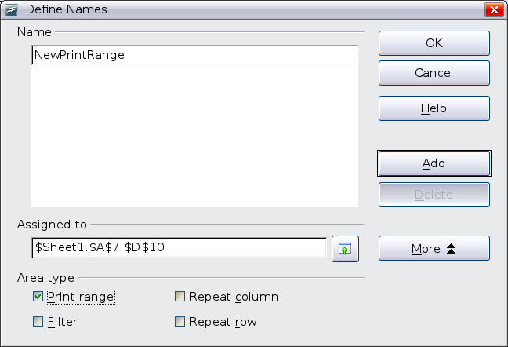
Figure 114: Define Names dialog
To print this range:
- Choose Format > Print Ranges > Edit (Figure 111). The previously defined area now appears in the drop-down box under Print range.
- Select the defined print range and click OK.
This method can be useful to quickly change the print range without highlighting a large area of cells every time.
Note | If the cell range name refers to more than one group of cells, it will not appear in the drop-down list. You will need to type it in or highlight and select it.

Page breaks
While defining a print range can be a powerful tool, it may sometimes be necessary to manually adjust Calc’s printout. To do this, you can use a manual break. A manual break helps to ensure that your data prints properly. You can insert a horizontal page break above, or a vertical page break to the left of, the active cell.

Inserting a page break
To insert a page break:
- Navigate to the cell where the page break will begin.
- Select Insert > Manual Break.
- Select Row Break or Column Break depending on your need.
The break is now set.

Row break
Selecting Row Break creates a page break above the selected cell. For example, if the active cell is H15, then the break is created between rows 14 and 15.

Column break
Selecting Column Break creates a page break to the left of the selected cell. For example, if the active cell is H15, then the break is created between columns G and H.
Tip | To see page break lines more easily on screen, you can change their color. Choose Tools > Options > OpenOffice.org > Appearance and scroll down to the Spreadsheet section.

Deleting a page break
To remove a page break:
- Navigate to a cell that is next to the break you want to remove.
- Select Edit > Delete Manual Break.
- Select Row Break or Column Break depending on your need.
The break is now removed.
Note | Multiple manual row and column breaks can exist on the same page. When you want to remove them, you have to remove each one individually. This may be confusing at times, because although there may be a column break set on the page, when you go to Edit > Manual Break, the Column break choice may not be available (grayed out).  In order to remove the break, you have to be in the cell next to the break. For example, if you set the column break while you are in H15, you can not remove it if you are in cell D15. However, you can remove it from any cell in column H.

Headers and footers
Headers and footers are predefined pieces of text that are printed at the top or bottom of a sheet outside of the sheet area. Headers are set the same way as footers.
Headers and footers are assigned to a page style. You can define more than one page style for a spreadsheet and assign different page styles to different sheets. For more about page styles, see Chapter 4.

Setting a header or a footer
To set a header or footer:
- Navigate to the sheet that you want to set the header or footer for. Select Format > Page.
- Select the Header (or Footer) tab. See Figure 115.
- Select the Header on option.
From here you can also set the margins, the spacing, and height for the header or footer. You can check the AutoFit height box to automatically adjust the height of the header or footer.
Margin
Changing the size of the left or right margin adjusts how far the header or footer is from that side of the page.
Spacing
Spacing affects how far above or below the sheet the header or footer will print. So, if spacing is set to 1.00", then there will be 1 inch between the header or footer and the sheet.
Height
Height affects how big the header or footer will be.
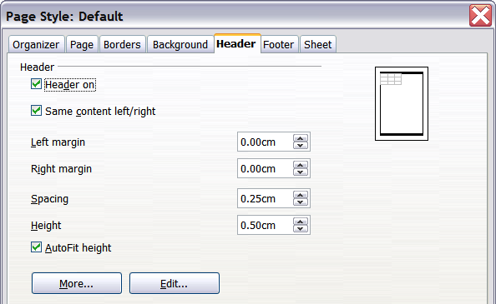
Figure 115: Header dialog

Header or footer appearance
To change the appearance of the header or footer, click the More button in the dialog. This opens the Border/Background dialog.
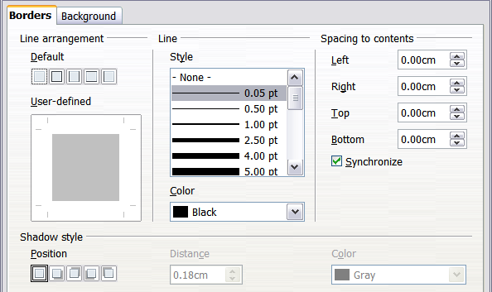
Figure 116: Header/Footer Border/Background dialog
From this dialog you can set the background and border style of the header or footer. See Chapter 4 (Using Styles and Templates) for more information.

Setting the contents of the header or footer
The header or footer of a Calc spreadsheet has three columns for text. Each column can have different contents.
To set the contents of the header or footer, click the Edit button in the header or footer dialog shown in Figure 115 to display the dialog shown in Figure 117.
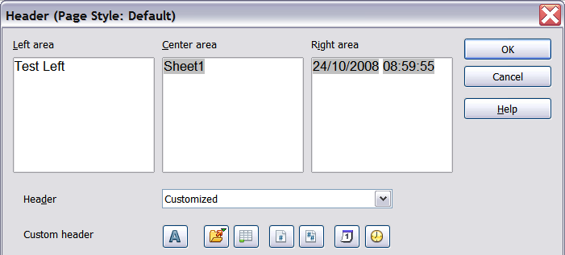
Figure 117: Edit contents of header or footer
Areas
Each area in the header or footer is independent and can have different information in it.
Header
You can select from several preset choices in the Header drop-down list, or specify a custom header using the buttons below the area boxes. (To format a footer, the choices are the same.)
Custom header
Click in the area (Left, Center, Right) that you want to customize, then use the buttons to add elements or change text attributes.
Opens the Text Attributes dialog.
Inserts the total number of pages.
Inserts the File Name field.
Inserts the Date field.
Inserts the Sheet Name field.
Inserts the Time field.
Inserts the current page number.

Exporting to PDF
Calc can export documents to PDF (Portable Document Format). This industry-standard file format is ideal for sending the file to someone else to view using Adobe Reader or other PDF viewers.

Quick export to PDF
Click the Export Directly as PDF icon to export the entire document using your default PDF settings. You are asked to enter the file name and location for the PDF file, but you do not get to choose a page range, the image compression, or other options.

Controlling PDF content and quality
For more control over the content and quality of the resulting PDF, use File > Export as PDF. The PDF Options dialog opens. This dialog has five pages (General, Initial View, User Interface, Links, and Security). Make your selections and click Export. Enter the location and file name of the PDF to be created. Click Save to export the file.

General page of PDF Options dialog
On the General page, you can choose which pages to include in the PDF, the type of compression to use for images (which affects the quality of images in the PDF), and other options.
Range section
- All: Exports the entire document.
- Pages: To export a range of pages, use the format 3-6 (pages 3 to 6). To export single pages, use the format 7;9;11 (pages 7, 9, and 11). You can also export a combination of page ranges and single pages, by using a format like 3-6;8;10;12.
- Selection: Exports whatever content is selected.
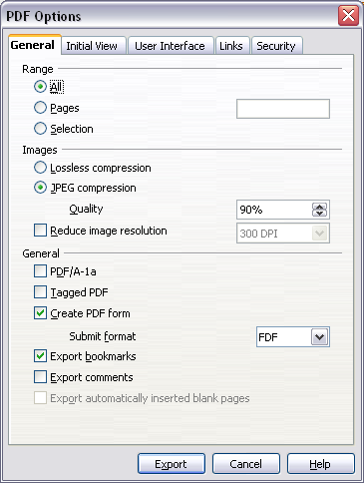
Figure 118: General page of PDF Options dialog
Images section
- Lossless compression: Images are stored without any loss of quality. Tends to make large files when used with photographs. Recommended for other kinds of images or graphics.
- JPEG compression: Allows for varying degrees of quality. A setting of 90% works well with photographs (small file size, little perceptible loss).
- Reduce image resolution: Lower-DPI (dots per inch) images have lower quality. For viewing on a computer screen a resolution of 72dpi (for Windows) or 96dpi (GNU/Linux) is sufficient, while for printing it is generally preferable to use at least 300 or 600 dpi, depending on the capability of the printer. Higher dpi settings greatly increase the size of the exported file.
Note | EPS images with embedded previews are exported only as previews. EPS images without embedded previews are exported as empty placeholders.
General section
- PDF/A-1: PDF/A is an ISO standard established in 2005 for long-term preservation of documents, by embedding all the pieces necessary for faithful reproduction (such as fonts) while forbidding other elements (including forms, security, encryption, and tagged PDF). If you select PDF/A-1, the forbidden elements are greyed-out (not available).
- Tagged PDF: Exports special tags into the corresponding PDF tags. Some tags that are exported are table of contents, hyperlinks, and controls. This option can increase the file size significantly.
- Create PDF form - Submit format: Choose the format for submitting forms from within the PDF file. This setting overrides the control’s URL property that you set in the document. There is only one common setting valid for the whole PDF document: PDF (sends the whole document), FDF (sends the control contents), HTML, and XML. Most often you will choose the PDF format.
- Export bookmarks: Exports sheet names in Calc documents as “bookmarks” (a table of contents list displayed by some PDF readers, including Adobe Reader).
- Export comments: Exports comments in Calc documents as PDF notes. You may not want this!
- Export automatically inserted blank pages: Not available in Calc.

Initial View page of PDF Options dialog
On the Initial View page (Figure 119), you can choose how the PDF opens by default in a PDF viewer. The selections are self-explanatory.

User Interface page of PDF Options dialog
On the User Interface page (Figure 120), you can choose more settings to control how a PDF viewer displays the file. Some of these choices are particularly useful when you are creating a PDF to be used as a presentation or a kiosk-type display.

Figure 119: Initial View page of PDF Options dialog
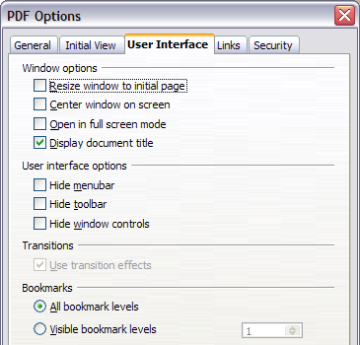
Figure 120: User Interface page of PDF Options dialog
Window options section
- Resize window to initial page: Causes the PDF viewer window to resize to fit the first page of the PDF.
- Center window on screen: Causes the PDF viewer window to be centered on the computer screen.
- Open in full screen mode: Causes the PDF viewer to open full-screen instead of in a smaller window.
- Display document title: Causes the PDF viewer to display the document’s title in the title bar.
User interface options section
- Hide menubar: Causes the PDF viewer to hide the menu bar.
- Hide toolbar: Causes the PDF viewer to hide the toolbar.
- Hide window controls: Causes the PDF viewer to hide other window controls.
Transitions
Not available in Calc.
Bookmarks
Select how many heading levels are displayed as bookmarks, if Export bookmarks is selected on the General page.

Links page of PDF Options dialog
On this page you can choose how links are exported to PDF.

Figure 121: Links page of PDF Options dialog
Export bookmarks as named destinations
If you have defined Writer bookmarks, Impress or Draw slide names, or Calc sheet names, this option exports them as “named destinations” to which Web pages and PDF documents can link.
Convert document references to PDF targets
If you have defined links to other documents with OpenDocument extensions (such as .ODT, .ODS, and .ODP), this option converts the file names to .PDF in the exported PDF document.
Export URLs relative to file system
If you have defined relative links in a document, this option exports those links to the PDF.
Cross-document links
Defines the behavior of links clicked in PDF files.

Security page of PDF Options dialog
PDF export includes options to encrypt the PDF (so it cannot be opened without a password) and apply some digital rights management (DRM) features.
- With an open password set, the PDF can only be opened with the password. Once opened, there are no restrictions on what the user can do with the document (for example, print, copy, or change it).
- With a permissions password set, the PDF can be opened by anyone, but its permissions can be restricted. See Figure 122.

Figure 122: Security page of PDF Options dialog.
- With both the open password and permission password set, the PDF can only be opened with the correct password, and its permissions can be restricted.
Note | Permissions settings are effective only if the user’s PDF viewer respects the settings.
Figure 123 shows the dialog displayed when you click the Set open password button on the Security page of the PDF Options dialog.
After you set a password for permissions, the other choices on the Security page (shown in Figure 122) become available. These selections are self-explanatory.
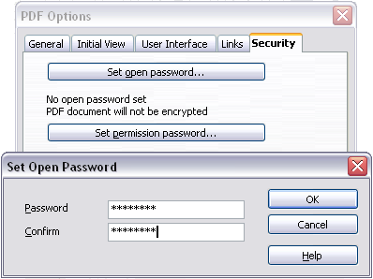
Figure 123: Setting a password to encrypt a PDF

Exporting to XHTML
Calc can export spreadsheets to XHTML. Choose File > Export. On the Export dialog, specify a file name for the exported document, then select the XHTML in the File format list and click the Export button.

Saving as Web pages (HTML)
Calc can save files as HTML documents. Use File > Save As and select HTML Document, or File > Wizards > Web Page.
If the file contains more than one sheet, the additional sheets will follow one another in the HTML file. Links to each sheet will be placed at the top of the document. Calc also allows the insertion of links directly into the spreadsheet using the Hyperlink dialog.

E-mailing spreadsheets
OOo provides several quick and easy ways to send spreadsheets as an e-mail attachment in one of three formats: OpenDocument Spreadsheet (OOo’s default format), Microsoft Excel, or PDF.
To send the current document in OpenDocument format:
- Choose File > Send > Document as E-mail. OpenOffice.org opens your default e-mail program with the spreadsheet (*.ODS) document attached.
- In your e-mail program, enter the recipient, subject, and any text you want to add, then send the e-mail.
File > Send > E-mail as OpenDocument Spreadsheet has the same effect.
If you choose E-mail as Microsoft Excel, OOo first creates a file in Excel format and then opens your e-mail program with the *.XLS file attached.
Similarly, if you choose E-mail as PDF, OOo first creates a PDF using your default PDF settings (as when using the Export Directly as PDF toolbar button) and then opens your email program with the *.PDF file attached.

E-mailing a spreadsheet to several recipients
To e-mail a document to several recipients, you can use the features in your e-mail program or you can use OOo Writer’s mail merge facilities to extract email addresses from an address book.
For details, see Chapter 10 (Printing, Exporting, and E-mailing) in the Getting Started guide.

Digital signing of documents
To sign a document digitally, you need a personal key, the certificate. A personal key is stored on your computer as a combination of a private key, which must be kept secret, and a public key, which you add to your documents when you sign them. You can get a certificate from a certification authority, which may be a private company or a governmental institution.
When you apply a digital signature to a document, a checksum is computed from the document’s content plus your personal key. The checksum and your public key are stored together with the document.
When someone later opens the document on any computer with a recent version of OpenOffice.org, the program will compute the checksum again and compare it with the stored checksum. If both are the same, the program will signal that you see the original, unchanged document. In addition, the program can show you the public key information from the certificate. You can compare this key with the public key that is published on the web site of the certificate authority.
Whenever someone changes something in the document, this change breaks the digital signature.
On Windows operating systems, the Windows features of validating a signature are used. On Solaris and Linux systems, files that are supplied by Thunderbird, Mozilla or Firefox are used. For a more detailed description of how to get and manage a certificate, and signature validation, see “Using Digital Signatures” in the OOo Help.
To sign a document:
- Choose File > Digital Signatures.
- If you have not saved the document since the last change, a message box appears. Click Yes to save the file.
- After saving, you see the Digital Signatures dialog. Click Add to add a public key to the document.
- In the Select Certificate dialog, select your certificate and click OK.
- You see again the Digital Signatures dialog, where you can add more certificates if you want. Click OK to add the public key to the saved file.
A signed document shows an icon in the status bar. You can double-click the icon to view the certificate.

Removing personal data
You may wish to ensure that personal data, versions, notes, hidden information, or recorded changes are removed from files before you send them to other people or create PDFs from them.
In Tools > Options > OpenOffice.org > Security > Options, you can set Calc to remind (warn) you when files contain certain information and remove personal information automatically on saving.
To remove personal and some other data from a file, go to File > Properties. On the General tab, uncheck Apply user data and then click the Reset button. This removes any names in the created and modified fields, deletes the modification and printing dates, and resets the editing time to zero, the creation date to the current date and time, and the version number to 1.
To remove version information, either go to File > Versions, select the versions from the list and click Delete, or use Save As and save the file with a different name.

Calc Guide

Chapter 7
Using Formulas and Functions

This PDF is designed to be read onscreen, two pages at a time. If you want to print a copy, your PDF viewer should have an option for printing two pages on one sheet of paper, but you may need to start with page 2 to get it to print facing pages correctly. (Print this cover page separately.)

Copyright
This document is Copyright © 2007–2010 by its contributors as listed in the section titled Authors. You may distribute it and/or modify it under the terms of either the GNU General Public License, version 3 or later, or the Creative Commons Attribution License, version 3.0 or later.
All trademarks within this guide belong to their legitimate owners.
Authors
Bruce Byfield
Stigant Fyrwitful
Kirk
Barbara M. Tobias
John Viestenz
Claire Wood
Jean Hollis Weber
Martin Fox
Feedback
Please direct any comments or suggestions about this document to: authors@documentation.openoffice.org
Acknowledgments
Portions of this chapter were taken from articles written by Bruce Byfield and first published on the Linux Journal website; they are used with permission and have been heavily rewritten.
Publication date and software version
Published 26 April 2010. Based on OpenOffice.org 3.2.
Contents
Copyright 2
Introduction 5
Setting up a spreadsheet 5
The trap of fixed values 5
Lack of documentation 6
Error-checking formulas 6
Creating formulas 7
Operators in formulas 7
Operator types 9
Arithmetic operators 9
Comparative operators 10
Text operators 11
Reference operators 13
Relative and absolute references 16
Relative referencing 16
Absolute referencing 17
Order of calculation 19
Calculations linking sheets 19
Understanding functions 24
Understanding the structure of functions 25
Nested functions 25
Function Wizard 27
Strategies for creating formulas and functions 30
Place a unique formula in each cell 31
Break formulas into parts and combine the parts 31
Use the Basic editor to create functions 31
Finding and fixing errors 32
Error messages 32
Examples of common errors 33
Err:503 Division by zero 33
#VALUE Non-existent value and #REF! Incorrect references 34
Color coding for input 34
The Detective 35
Examples of functions 37
Basic arithmetic and statistic functions 37
Basic arithmetic 37
Simple statistics 38
Using these functions 40
Rounding off numbers 40
Rounding methods 40
Using regular expressions in functions 42
Advanced functions 44

Introduction
In previous chapters, we have been entering one of two basic types of data into each cell: numbers and text. However, we will not always know what the contents should be. Often the contents of one cell depends on the contents of other cells. To handle this situation, we use a third type of data: the formula. Formulas are equations using numbers and variables to get a result. In a spreadsheet, the variables are cell locations that hold the data needed for the equation to be completed.
A function is a predefined calculation entered in a cell to help you analyze or manipulate data in a spreadsheet. All you have to do is add the arguments, and the calculation is automatically made for you. Functions help you create the formulas needed to get the results that you are looking for.

Setting up a spreadsheet
If you are setting up more than a simple one-worksheet system in Calc, it is worth planning ahead a little. Avoid the following traps:
- Typing fixed values into formulas
- Not including notes and comments describing what the system does, including what input is required and where the formulas come from (if not created from scratch)
- Not incorporating a system of checking to verify that the formulas do what is intended

The trap of fixed values
Many users set up long and complex formulas with fixed values typed directly into the formula.
For example, conversion from one currency to another requires knowledge of the current conversion rate. If you input a formula in cell C1 of =0.75*B1 (for example to calculate the value in Euros of the USD dollar amount in cell B1), you will have to edit the formula when the exchange rate changes from 0.75 to some other value. It is much easier to set up an input cell with the exchange rate and reference that cell in any formula needing the exchange rate. What-if type calculations also are simplified: what if the exchange rate varies from 0.75 to 0.70 or 0.80? No formula editing is needed and it is clear what rate is used in the calculations. Breaking complex formulas down into more manageable parts, described below, also helps to minimise errors and aid troubleshooting.

Lack of documentation
Lack of documentation is a very common failing. Many users prepare a simple worksheet which then develops into something much more complicated over time. Without documentation, the original purpose and methodology is often unclear and difficult to decipher. In this case it is usually easier to start again from the beginning, wasting the work done previously. If you insert comments in cells, and use labels and headings, a spreadsheet can be later modified by you or others and much time and effort will be saved.

Error-checking formulas
Adding up columns of data or selections of cells from a worksheet often results in errors due to omitting cells, wrongly specifying a range, or double-counting cells. It is useful to institute checks in your spreadsheets. For example, set up a spreadsheet to calculate columns of figures, and use SUM to calculate the individual column totals. You can check the result by including (in a non-printing column) a set of row totals and adding these together. The two figures—row total and column total—must agree. If they do not, you have an error somewhere.
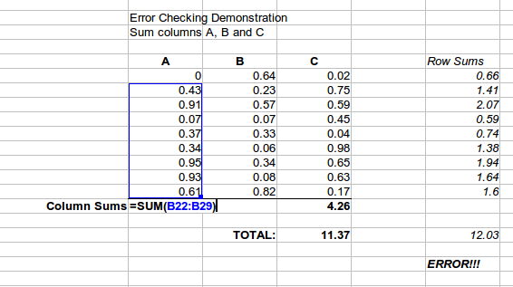
Figure 124: Error checking of formulas
You can even set up a formula to calculate the difference between the two totals and report an error in case a non-zero result is returned (see Figure 124).

Creating formulas
You can enter formulas in two ways, either directly into the cell itself, or at the input line. Either way, you need to start a formula with one of the following symbols: =, + or –. Starting with anything else causes the formula to be treated as if it were text.

Operators in formulas
Each cell on the worksheet can be used as a data holder or a place for data calculations. Entering data is accomplished simply by typing in the cell and moving to the next cell or pressing Enter. With formulas, the equals sign indicates that the cell will be used for a calculation. A mathematical calculation like 15 + 46 can be accomplished as shown in Figure 125.
While the calculation on the left was accomplished in only one cell, the real power is shown on the right where the data is placed in cells and the calculation is performed using references back to the cells. In this case, cells B3 and B4 were the data holders, with B5 the cell where the calculation was performed. Notice that the formula was shown as =B3+B4. The plus sign indicates that the contents of cells B3 and B4 are to be added together and then have the result in the cell holding the formula. All formulas build upon this concept. Other ways of entering formulas are shown in Table 7.
These cell references allow formulas to use data from anywhere in the worksheet being worked on or from any other worksheet in the workbook that is opened. If the data needed was in different worksheets, they would be referenced by referring to the name of the worksheet, for example =SUM(Sheet2.B12+Sheet3.A11).
Note | To enter the = symbol for a purpose other than creating a formula as described in this chapter, type an apostrophe or single quotation mark before the =. For example, in the entry '= means different things to different people, Calc treats everything after the single quotation mark—including the = sign—as text.
Simple Calculation in 1 Cell | Calculation by Reference
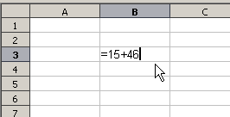 | 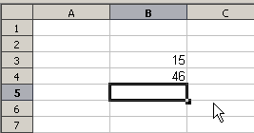
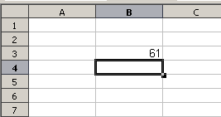 | 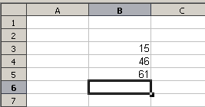
 | 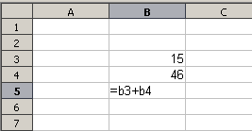
Figure 125: A simple calculation
Table 7: Common ways to enter formulas
Formula | Description
=A1+10 | Displays the contents of cell A1 plus 10.
=A1*16% | Displays 16% of the contents of A1.
=A1*A2 | Displays the result of the multiplication of A1 and A2.
=ROUND(A1;1) | Displays the contents of cell A1 rounded to one decimal place.
=EFFECTIVE(5%;12) | Calculates the effective interest for 5% annual nominal interest with 12 payments a year.
=B8-SUM(B10:B14) | Calculates B8 minus the sum of the cells B10 to B14.
=SUM(B8;SUM(B10:B14)) | Calculates the sum of cells B10 to B14 and adds the value to B8.
=SUM(B1:B65536) | Sums all numbers in column B.
=AVERAGE(BloodSugar) | Displays the average of a named range defined under the name BloodSugar.
=IF(C31>140; "HIGH"; "OK") | Displays the results of a conditional analysis of data from two sources. If the contents of C31 is greater than 140, then HIGH is displayed, otherwise OK is displayed.
Note | Users of Lotus 1-2-3®, Quattro Pro® and other spreadsheet software may be familiar with formulas that begin with +, -, =, (, @, ., $, or #. A mathematical formula would look like +D2+C2 or +2*3. Functions begin with the @ symbol such as @SUM(D2..D7), @COS(@DEGTORAD(30)) and @IRR(GUESS;CASHFLOWS). Ranges are identified such as A1..D3.
Functions can be identified in Table 7 with a word, for example ROUND, followed by parentheses enclosing references or numbers.
It is also possible to establish ranges for inclusion by naming them using Insert > Names, for example BloodSugar representing a range such as B3:B10. Logical functions can also be performed as represented by the IF statement which results in a conditional response based upon the data in the identified cell, for example
=IF(A2>=0;"Positive";"Negative")
A value of 3 in cell A2 would return the result Positive, –9 the result Negative.

Operator types
You can use the following operators in OpenOffice.org Calc: arithmetic, comparative, descriptive, text, and reference.

Arithmetic operators
The addition, subtraction, multiplication and division operators return numerical results. The Negation and Percent operators identify a characteristic of the number found in the cell, for example -37. The example for Exponentiation illustrates how to enter a number that is being multiplied by itself a certain number of times, for example 23 = 2*2*2.
Table 8: Arithmetical operators
Operator | Name | Example
+ (Plus) | Addition | =1+1
– (Minus) | Subtraction | =2–1
– (Minus) | Negation | –5
* (asterisk) | Multiplication | =2*2
/ (Slash) | Division | =10/5
% (Percent) | Percent | 15%
^ (Caret) | Exponentiation | 2^3

Comparative operators
Comparative operators are found in formulas that use the IF function and return either a true or false answer; for example, =IF(B6>G12; 127; 0) which, loosely translated, means if the contents of cell B6 are greater than the contents of cell G12, then return the number 127, otherwise return the number 0.
A direct answer of TRUE or FALSE can be obtained by entering a formula such as =B6>B12. If the numbers found in the referenced cells are accurately represented, the answer TRUE is returned, otherwise FALSE is returned.
Table 9: Comparative operators
Operator | Name | Example
= (equal sign) | Equal | A1=B1
> (Greater than) | Greater than | A1>B1
< (Less than) | Less than | A1<B1
>= (Greater than or equal to) | Greater than or equal to | A1>=B1
<= (Less than or equal to) | Less than or equal to | A1<=B1
<> (Inequality) | Inequality | A1<>B1
If cell A1 contains the numerical value 4 and cell B1 the numerical value 5, the above examples would yield results of FALSE, FALSE, TRUE, FALSE, TRUE, and TRUE.

Text operators
It is common for users to place text in spreadsheets. To provide for variability in what and how this type of data is displayed, text can be joined together in pieces coming from different places on the spreadsheet. Figure 126 shows an example.
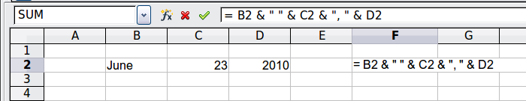
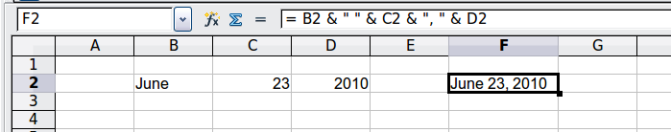
Figure 126: Text concatenation
In this example, specific pieces of the text were found in three different cells. To join these segments together, the formula also adds required spaces and punctuation enclosed within quotation marks, resulting in a formula of =B2 & " " & C2 & ", " & D2. The result is the concatenation into a date formatted in a particular sequence.
Taking this example further, if the result cell is defined as a name, then text concatenation is performed using this defined name. Calc has a CONCATENATE function which performs the same operation.
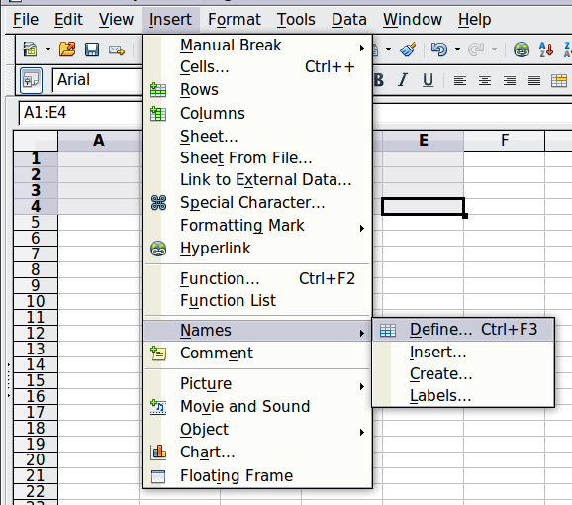
Figure 127: Defining a name for a range of cells
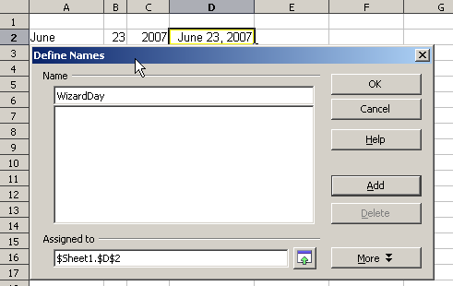Figure 128: Naming a cell or range of cells for inclusion in a formula
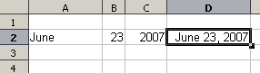
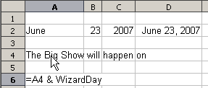
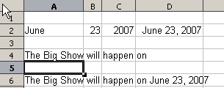
Figure 129: Defining Names on a worksheet

Reference operators
In its simplest form a reference refers to a single cell, but references can also refer to a rectangle or cuboid range or a reference in a list of references. To build such references you need reference operators.
An individual cell is identified by the column identifier (letter) located along the top of the columns and a row identifier (number) found along the left-hand side of the spreadsheet. On spreadsheets read from left to right, the upper left cell is A1.
Range operator
The range operator is written as colon. An expression using the range operator has the following syntax:
reference left : reference right
The range operator builds a reference to the smallest range including both the cells referenced with the left reference and the cells referenced with the right reference.
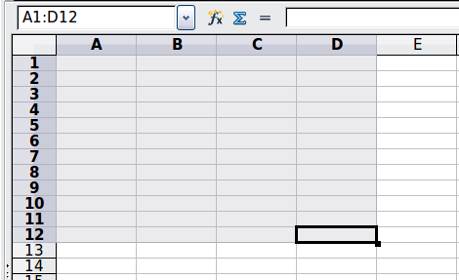
Figure 130: Reference Operator for a range
In the upper left corner of Figure 130 the reference A1:D12 is shown, corresponding to the cells included in the drag operation with the mouse to highlight the range.
Examples
A2:B4 | Reference to a rectangle range with 6 cells, 2 column width × 3 row height. When you click on the reference in the formula in the input line, a border indicates the rectangle.
(A2:B4):C9 | Reference to a rectangle range with cell A2 top left and cell C9 bottom right. So the range contains 24 cells, 3 column width × 8 row height.
Sheet1.A3:Sheet3.D4 | Reference to a cuboid range with 24 cells, 4 column width × 2 row height × 3 sheets depth.
When you enter B4:A2 or A4:B2 directly, then Calc will turn it to A2:B4. So the left top cell of the range is left of the colon and the bottom right cell is right of the colon. But if you name the cell B4 for example with '_start' and A2 with '_end', you can use _start:_end without any error.
Calc can not reference a whole column of unspecified length via A:A or a whole row via 1:1 yet as you might know from other spreadsheet programs. See Issue 20495.
Reference concatenation operator
The concatenation operator is written as a tilde. An expression using the concatenation operator has the following syntax:
reference left ~ reference right
The result of such an expression is a reference list, which is an ordered list of references. Some functions can take a reference list as an argument, SUM, MAX or INDEX for example.
The reference concatenation is sometimes called 'union'. But it is not the union of the two sets 'reference left' and 'reference right' as normally understood in set theory. COUNT(A1:C3~B2:D2) returns 12 (=9+3), but it has only 10 cells when considered as the union of the two sets of cells.
Notice that SUM(A1:C3;B2:D2) is different from SUM( A1:C3~B2:D2) although they give the same result. The first is a function call with 2 parameters, each of them is reference to a range. The second is a function call with 1 parameter, which is a reference list.
Intersection operator
The intersection operator is written as an exclamation mark. An expression using the intersection operator has the following syntax:
reference left ! reference right
If the references refer to single ranges, the result is a reference to a single range, containing all cells, which are both in the left reference and in the right reference.
If the references are reference lists, then each list item from the left is intersected with each one from the right and these results are concatenated to a reference list. The order is to first intersect the first item from the left with all items from the right, then intersect the second item from the left with all items from the right, and so on.
Examples
A2:B4 ! B3:D6
This results in a reference to the range B3:B4, because these cells are inside A2:B4 and inside B3:D4.
(A2:B4~B1:C2) ! (B2:C6~C1:D3)
First the intersections A2:B4!B2:C6, A2:B4!C1:D3, B1:C2!B2:C6 and B1:C2!C1:D3 are calculated. This results in B2:B4, empty, B2:C2, and C1:C2. Then these results are concatenated, dropping empty parts. So the final result is the reference list B2:B4 ~ B2:C2 ~ C1:C2.
You can use the intersection operator to refer a cell in a cross tabulation in an understandable way. If you have columns labeled 'Temperature' and 'Precipitation' and the rows labeled 'January', 'February', 'March', and so on, then the following expression
'February' ! !Temperature'
will reference to the cell containing the temperature in February.
The intersection operator (!) should have a higher precedence than the concatenation operator (~), but do not rely on precedence.
Tip | Always put in parentheses the part that is to be calculated first.

Relative and absolute references
References are the way that we refer to the location of a particular cell in Calc and can be either relative (to the current cell) or absolute (a fixed amount).

Relative referencing
An example of a relative reference will illustrate the difference between a relative reference and absolute reference using the spreadsheet from Figure 131.
- Type the numbers 4 and 11 into cells C3 and C4 respectively of that spreadsheet.
- Copy the formula in cell B5 to cell C5. You can do this by using a simple copy and paste or click and drag B5 to C5 as shown below. The formula in B5 calculates the sum of values in the two cells B3 and B4.
- Click in cell C5. The formula bar shows =C3+C4 rather than =B3+B4 and the value in C5 is 15, the sum of 4 and 11 which are the values in C3 and C4.
In cell B5 the references to cells B3 and B4 are relative references. This means that Calc interprets the formula in B5 and applie it to the cells in the B column and puts the result in the in the cell holding the formula. When you copied the formula to another cell, the same procedure was used to calculate the value to put in that cell. This time the formula in cell C5 referred to cells C3 and C4.
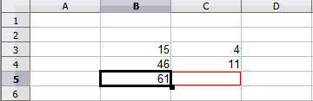
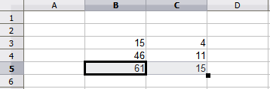Figure 131: Relative references
You can think of a relative address as a pair of offsets to the current cell. Cell B1 is 1 column to the left of Cell C5 and 4 rows above. The address could be written as R[-1]C[-4]. In fact earlier spreadsheets allowed this notation method to be used in formulas.
Whenever you copy this formula from cell B5 to another cell the result will always be the sum of the two numbers taken from the two cells one and two rows above the cell containing the formula.
Relative addressing is the default method of referring to addresses in Calc.

Absolute referencing
You may want to multiply a column of numbers by a fixed amount. A column of figures might show amounts in US Dollars. To convert these amounts to Euros it is necessary to multiply each dollar amount by the exchange rate. $US10.00 would be multiplied by 0.75 to convert to Euros, in this case Eur7.50. The following example shows how to input an exchange rate and use that rate to convert amounts in a column form USD to Euros.
- Input the exchange rate Eur:USD (0.75) in cell D1. Enter amounts (in USD) into cells D2, D3 and D4, for example 10, 20, and 30.
- In cell E2 type the formula =D2*D1. The result is 7.5, correctly shown.
- Copy the formula in cell E2 to cell E3. The result is 200, clearly wrong! Calc has copied the formula using relative addressing - the formula in E3 is =D3*D2 and not what we want which is =D3*D1.
- In cell E2 edit the formula to be =D2*$D$1. Copy it to cells E3 and E4. The results are now 15 and 22.5 which are correct.
Steps 2: Setting the exchange rate of Eur at 7.5, then copying it to E3
Copying formula from E2 to E3 & changing the formula to read absolute reference
Applying the correct formula from E2 to E3
Figure 132: Absolute References
The $ signs before the D and the 1 convert the reference to cell D1 from relative to absolute or fixed. If the formula is copied to another cell the second part will always show $D$1. The interpretation of this formula is “take the value in the cell one column to the left in the same row and multiply it by the value in cell D1”.
Cell references can be shown in four ways:
Reference | Explanation
D1 | Relative, from cell E3: the cell one column to the left and two rows above
$D$1 | Absolute, from cell E3: the cell D1
$D1 | Partially absolute, from cell E3: the cell in column D and two rows above
D$1 | Partially absolute, from cell E3: the cell one column to the left and row 1
Hint | To change references in formulas highlight the cell and press Shift-F4 to cycle through the four different types of references. This is of limited value in more complicated formulas, it is usually quicker to edit the formula by hand.
Knowledge of the use of relative and absolute references is essential if you want to copy and paste formulas and to link spreadsheets.

Order of calculation
Order of calculation refers to the sequence in which numerical operations are performed. Division and multiplication are performed before addition or subtraction. There is a common tendency to expect calculations to be made from left to right as the equation would be read in English. Calc evaluates the entire formula, then based upon programming precedence breaks the formula down executing multiplication and division operations before other operations. Therefore, when creating formulas you should test your formula to make sure that the correct result is being obtained. Following is an example of the order of calculation in operation.
Table 10 – Order of Calculation
Left To Right Calculation | Ordered Calculation
1+3*2+3 = 11  1+3=4, then 4 X 2 = 8, then 8 + 3 = 11 | =1+3*2+3 result 10  3*2=6, then 1 + 6 + 3 = 10
Another possible intention could be:  1+3*2+3 = 20 | The program resolves the multiplication of 3 X 2 before dealing with the numbers being added.
If you intend for the result to be either of the two possible solutions on the left, the way to achieve these results would be to order the formula as:
((1+3) * 2)+3 = 11 | (1+3) * (2+3) = 20

Note | Use parentheses to group operations in the order you intend; for example, =B4+G12*C4/M12 might become =((B4+G12)*C4)/M12.

Calculations linking sheets
Another powerful feature of Calc is the ability to link data through several worksheets. The naming of worksheets can be helpful to identify where specific data may be found. A name such as Payroll or Boise Sales is much more meaningful than Sheet1. The function named SHEET() returns the sheet number in the collection of spreadsheets. There are several worksheets in each book and they are numbered from the left: Sheet1, Sheet2, and so forth. If you drag the worksheets around to different locations among the tabs, the function returns the number referring to the current position of this worksheet.
An example of calculations obtaining data from other work can be seen in a business setting where a business combines revenues and costs of each of its branch operations into a single combined worksheet.
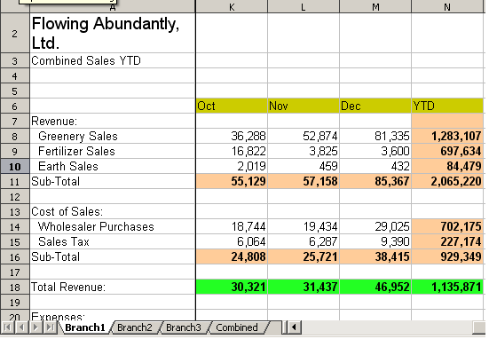 | Sheet containing data for Branch 1.
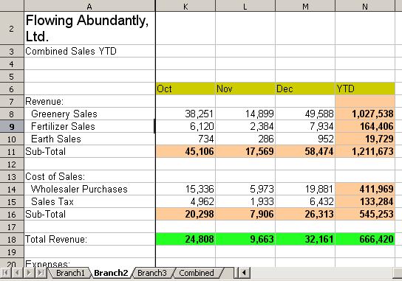 | Sheet containing data for Branch 2.
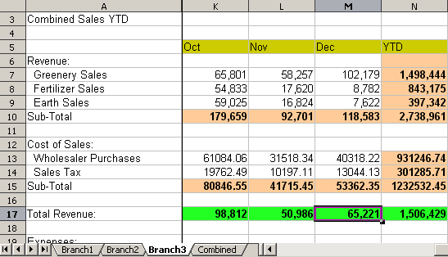 | Sheet containing data for Branch 3.
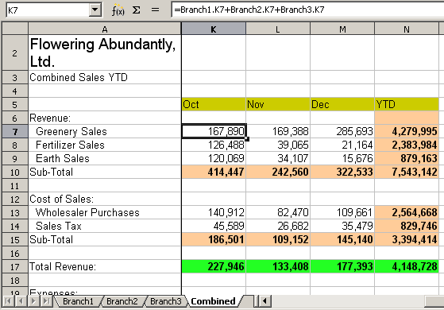 | Sheet containing combined data for all branches.
Figure 133: Combining data from several sheets into a single sheet
The spreadsheets have been set up with identical structures. The easiest way to do this is to set up the first Branch spreadsheet, input data, format cells, and prepare the formulas for the various sums of rows and columns.
- On the worksheet tab, right-click and select Rename Sheet.... Type Branch1. Right-click on the tab again and select Move/Copy Sheet...
- In the Move/Copy Sheet dialog, select the Copy option and select Sheet 2 in the area Insert before. Click OK, right-click on the tab of the sheet Branch1_2 and rename it to Branch2. Repeat to produce the Branch3 and Combined worksheets.
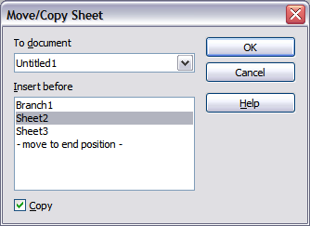Figure 134: Copying a worksheet
- Enter the data for Branch 2 and Branch 3 into the respective sheets. Each sheet stands alone and reports the results for the individual branches.
- In the Combined worksheet, click on cell K7. Type =, click on the tab Branch1, click on cell K7, press +, repeat for sheets Branch2 and Branch3 and press Enter. You now have a formula in cell K1 which adds the revenue from Greenery Sales for the 3 Branches.
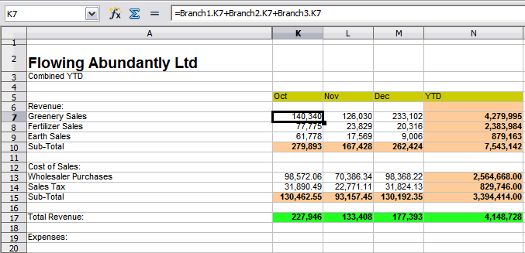Figure 135: Linking sheets—the Combined worksheet showing linking between branch sheets
- Copy the formula, highlight the range K7..N17, click Edit > Paste Special, uncheck the Paste all and Formats boxes in the Selection area of the dialog box and click OK. You will see the following message:
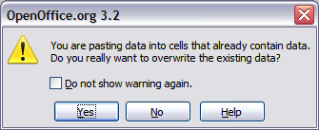
Figure 136: Linking sheets: pasting a formula to a cell range
- Click Yes. You have now copied the formulas into each cell while maintaining the format you set up in the original worksheet. Of course, in this example you would have to tidy the worksheet up by removing the zeros in the non-formatted rows.
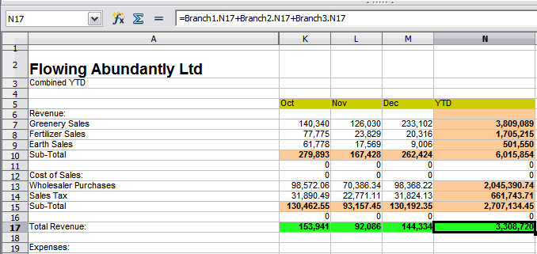Figure 137: Linking Sheets: Copy Paste Special from K7...N17
Note | OOo default is to paste all the attributes of the original cell(s) - formats, notes, objects, text strings and numbers.
The Function Wizard can also be used to accomplish the linking. Use of this Wizard is described in detail in the section on Functions.

Understanding functions
Calc includes over 350 functions to help you analyze and reference data. Many of these functions are for use with numbers, but many others are used with dates and times, or even text. A function may be as simple as adding two numbers together, or finding the average of a list of numbers. Alternatively, it may be as complex as calculating the standard deviation of a sample, or a hyperbolic tangent of a number.
Typically, the name of a function is an abbreviated description of what the function does. For instance, the FV function gives the future value of an investment, while BIN2HEX converts a binary number to a hexadecimal number. By tradition, functions are entered entirely in upper case letters, although Calc will read them correctly if they are in lower or mixed case, too.
A few basic functions are somewhat similar to operators. Examples:
+ | This operator adds two numbers together for a result. SUM() on the other hand adds groups of contiguous ranges of numbers together.
* | This operator multiplies two numbers together for a result. PRODUCT() does the same for multiplying that SUM() does for adding.
Each function has a number of arguments used in the calculations. These arguments may or may not have their own name. Your task is to enter the arguments needed to run the function. In some cases, the arguments have predefined choices, and you may need to refer to the online help or Appendix B (Description of Functions) in this book to understand them. More often, however, an argument is a value that you enter manually, or one already entered in a cell or range of cells on the spreadsheet. In Calc, you can enter values from other cells by typing in their name or range, or—unlike the case in some spreadsheets—by selecting cells with the mouse. If the values in the cells change, then the result of the function is automatically updated.
For compatibility, functions and their arguments in Calc have almost identical names to their counterparts in Microsoft Excel. However, both Excel and Calc have functions that the other lacks. Occasionally, functions with the same names in Calc and Excel have different arguments, or slightly different names for the same argument—neither of which can be imported to the other. However, the majority of functions can be used in both Calc and Excel without any change.

Understanding the structure of functions
All functions have a similar structure. If you use the right tool for entering a function, you can escape learning this structure, but it is still worth knowing for troubleshooting.
To give a typical example, the structure of a function to find cells that match entered search criteria is:
= DCOUNT (Database;Database field;Search_criteria)
Since a function cannot exist on its own, it must always be part of a formula. Consequently, even if the function represents the entire formula, there must be an = sign at the start of the formula. Regardless of where in the formula a function is, the function will start with its name, such as DCOUNT in the example above. After the name of the function comes its arguments. All arguments are required, unless specifically listed as optional.
Arguments are added within the parentheses and are separated by semicolons, with no space between the arguments and the semicolons.
Note | OOo uses the semicolon as an argument list separator, unlike Excel which uses a comma. This is a common mistake made by users accustomed to entering Excel formulas.
Many arguments are a number. A Calc function can take up to thirty numbers as an argument. That may not sound like much at first. However, when you realize that the number can be not only a number or a single cell, but also an array or range of cells that contain several or even hundreds of cells, then the apparent limitation vanishes.
Depending on the nature of the function, arguments may be entered as follows:
"text data" | The quotes indicate text or string data is being entered.
9 | The number nine is being entered as a number.
"9" | The number nine is being entered as text
A1 | The address for whatever is in Cell A1 is being entered

Nested functions
Functions can also be used as arguments within other functions. These are called nested functions.
=SUM(2;PRODUCT(5;7))
To get an idea of what nested functions can do, imagine that you are designing a self-directed learning module. During the module, students do three quizzes, and enter the results in cells A1, A2, and A3. In A4, you can create a nested formula that begins by averaging the results of the quizzes with the formula =AVERAGE(A1:A3). The formula then uses the IF function to give the student feedback that depends upon the average grade on the quizzes. The entire formula would read:
=IF(AVERAGE(A1:A3) >85; "Congratulations! You are ready to advance to the next module"; "Failed. Please review the material again. If necessary, contact your instructor for help")
Depending on the average, the student would receive the message for either congratulations or failure.
Notice that the nested formula for the average does not require its own equal sign. The one at the start of the equation is enough for both formulas.
If you are new to spreadsheets, the best way to think of functions is as a scripting language. We've used simple examples to explain the concept more clearly, but, through nesting of functions, a Calc formula can quickly become complex.
Note | Calc keeps the syntax of a formula displayed in a tool tip next to the cell as a handy memory aid as you type.
A more reliable method is to use the Function List (Figure 135).
Available from the Insert menu, the Function List automatically docks as a pane on the right side of the Calc editing window. If you wish, you can Control+double-click on a blank space at the top of the pane to undock this pane and make it a floating window.
The Function List includes a brief description of each function and its arguments; highlight the function and look at the bottom of the pane to see the description. If necessary, hover the cursor over the division between the list and the description; when the cursor becomes a two-headed arrow, drag it upwards to increase the space for the description. Double-click on a function’s name to add it to the current cell, together with placeholders for each of the function’s arguments.
Using the Function List is almost as fast as manual entry, and has the advantage of not requiring that you memorize a formula that you want to use. In theory, it should also be less error-prone. In practice, though, some users may fumble when replacing the placeholders with values. Another feature is the ability to display the last formulas used.
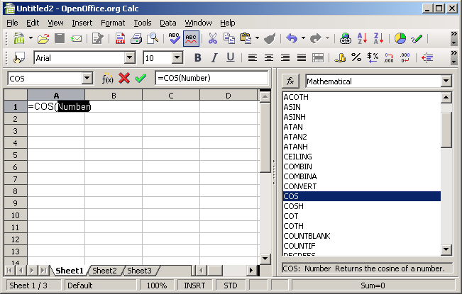Figure 138: Function List docked to right side of Calc window

Function Wizard
The most commonly used input method is the Function Wizard (Figure 139). To open the Function Wizard, choose Insert > Function, or click the fx button on the Function tool bar, or press Ctrl+F2. Once open, the Function Wizard provides the same help features as the Function List, but adds fields in which you can see the result of a completed function, as well as the result of any larger formula of which it is part.
Select a category of functions to shorten the list, then scroll down through the named functions and select the required one. When you select a function its description appears on the right-hand side of the dialog. Double-click on the required function.
The Wizard now displays an area to the right where you can enter data manually in text boxes or click the Shrink button to shrink the wizard so you can select cells from the worksheet.
Figure 139: Function Wizard after shrinking
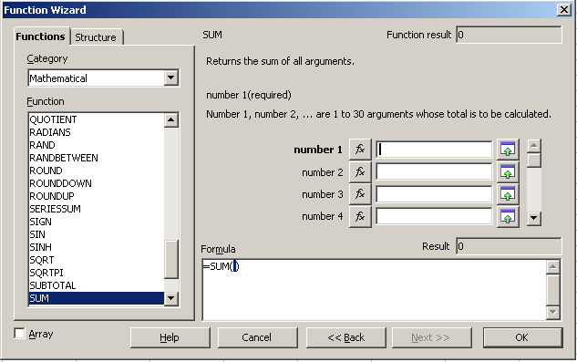Figure 140: Functions page of Function Wizard.
To select cells, either click directly upon the cell or hold down the left mouse button and drag to select the required area.
When the area has been selected, click the Shrink button again to return to the wizard.
If multiple arguments are needed select the next text box below the first and repeat the selection process for the next cell or range of cells. Repeat this process as often as required. The Wizard will accept up to 30 ranges or arguments in the SUM function.
Click OK to accept the function and add it to the cell and get the result.
You can also select the Structure tab (Figure 141) to see a tree view of the parts of the formula. The main advantage over the Function List is that each argument is entered in its own field, making it easier to manage. The price of this reliability is slower input, but this is often a small price to pay, since precision is generally more important than speed when creating a spreadsheet.
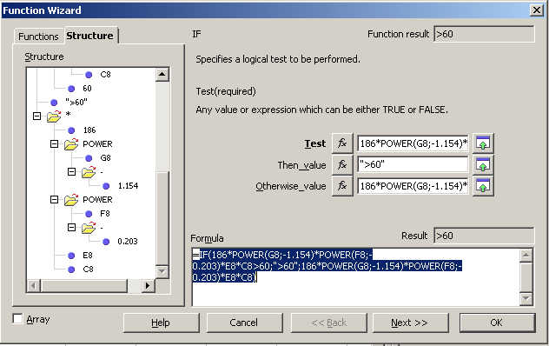Figure 141: Structure page of Function Wizard
After you enter a function on the Input line, press the Enter key or click the Accept button on the Function toolbar to add the function to the cell and get its result.
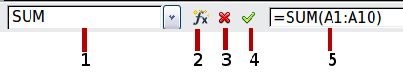
1 | Name Box showing list of common functions
2 | Function Wizard | 4 | Accept
3 | Cancel | 5 | Input Line
Figure 142: The Function toolbar
If you see the formula in the cell instead of the result, then Formulas are selected for display in Tools > Options > OpenOffice.org Calc > View > Display. Deselect Formulas, and the result will display. However, you can still see the formula in the Input line.

Strategies for creating formulas and functions
Formulas that do more than a simple calculation or summation of rows or columns of values usually take a number of arguments. For example, the classic equation of motion s = s0+ vt - ½at2 calculates the position of a body knowing its original position, its final velocity, its acceleration, and the time taken to move from the initial state to the final state.
For ease of presentation, it is good practice to set up a spreadsheet in a manner similar to that shown in Figure 143. In this example, the individual variables are input into cells on the sheet and no editing of the formula (in cell B9) is required.
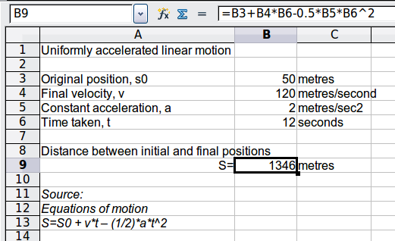
Figure 143: Setting up a formula with arguments
You can take several broad approaches when creating a formula. In deciding which approach to take, consider how many other people will need to use the worksheets, the life of the worksheets, and the variations that could be encountered in use of the formula.
If people other than yourself will use the spreadsheet, make sure that it is easy to see what input is required and where. Explanation of the purpose of the spreadsheet, basis of calculation, input required and output(s) generated are often placed on the first worksheet.
A spreadsheet that you build today, with many complicated formulas, may not be quite so obvious in its function and operation in 6 or 12 months time. Use comments and notes liberally to document your work.
You might be aware that you cannot use negative values or zero values for a particular argument, but if someone else inputs such a value will your formula be robust or simply return a standard (and often not too helpful) Err: message? It is a good idea to trap errors using some form of logic statements or with conditional formatting.

Place a unique formula in each cell
The most basic strategy is to view whatever formulas are needed as simple and with a limited useful life. The strategy is then to place a unique formula in each appropriate cell. This can be recommended only for very simple or “throw away” (single use) spreadsheets.

Break formulas into parts and combine the parts
The second strategy is similar to the first, but instead you break down longer formulas into smaller parts and then combine the parts into the whole. Many examples of this type exist in complex scientific and engineering calculations where interim results are used in a number of places in the worksheet. The result of calculating the flow velocity of water in a pipe may be used in estimating losses due to friction, whether the pipe is flowing full or partially empty, and in optimizing the diameter for the given flow regime.
In all cases you should adopt the basic principles of formula creation described previously.

Use the Basic editor to create functions
A third strategy is to use the Basic editor and create your own functions and macros. This approach would be used where the result would greatly simplify the use of the spreadsheet by the end user and keep the formulas simple with a better chance of avoiding errors. This approach also can make the maintenance easier by having corrections or updates kept in one central location. The use of macros is described in Chapter 12 of this book and is a specialized topic in itself. The danger of overusing macros and custom functions is that the principles upon which the spreadsheet is based become much more difficult to see by a user other than the original author (and sometimes even by the author!).

Finding and fixing errors
It is common to find situations where errors are displayed. Even with all the tools available in Calc to help you to enter formulas, making mistakes is easy. Many people find inputting numbers difficult and many may make a mistake about the kind of entry that a function's argument needs. In addition to correcting errors, you may want to find the cells used in a formula to change their values or to check the answer.
Calc provides three tools for investigating formulas and the cells that they reference: error messages, color coding, and the Detective.

Error messages
The most basic tool is error messages. Error messages display in a formula’s cell or in the Function Wizard instead of the result.
An error message for a formula is usually a three-digit number from 501 to 527, or sometimes an unhelpful piece of text such as NAME?, REF, or VALUE. The error number appears in the cell, and a brief explanation of the error on the right side of the status bar.
Most error messages indicate a problem with how the formula was input, although several indicate that you have run up against a limitation of either Calc or its current settings.
Error messages are not user-friendly, and may intimidate new users. However, they are valuable clues to correcting mistakes. You can find detailed explanations of them in the help, by searching for Error codes in OpenOffice.org Calc. A few of the most common are:
NAME? (525) | No valid reference exists for the argument.
REF (525) | The column, row, or sheet for the referenced cell is missing.
VALUE (519) | The value for one of the arguments is not the type that the argument requires. The value may be entered incorrectly; for example, double-quotation marks may be missing around the value. At other times, a cell or range used may have the wrong format, such as text instead of numbers.
509 | An operator such as an equals sign is missing from the formula.
510 | An argument is missing from the formula.
502 | The column, row, or sheet for the referenced cell is missing.

Examples of common errors

Err:503 Division by zero
This error is the result of dividing a number by either the number zero (0) or a blank cell. There is an easy way to avoid this type of problem. When you have a zero or blank cell displayed, use a conditional function. Figure 144 depicts division of column B by column C yielding 2 errors arising from a zero and a blank cell showing in column C.
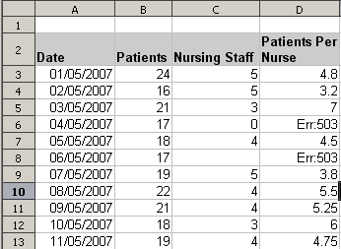
Figure 144: Examples of Err:503, Division by zero.
It is very common to find an error such as this arising from a situation where data was not reported or reported incorrectly. When such an occurrence is possible, an IF function can be used to display the data correctly. The formula =IF(C3>0, B3/C3, "No Report") can be entered. The formula is then copied over the remainder of Column D. The meaning of this formula roughly would be: “If C3 is greater than 0, then compute B3 divided by C3, otherwise enter ‘No Report’”.
It is also possible for the last parameter to use double quotes for a blank to be entered, or a different formula with a standardized number being substituted for the lower number. An example of this might be to use the nursing staff in the unit.
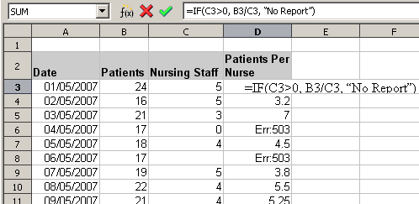Figure 145: Division by zero solution

#VALUE Non-existent value and #REF! Incorrect references
The non-existent value error is also very common. The most common appearance of this error arises when a user copies a formula over a selected area. When copying, it is typical for the program to increment the represented cells. If you were copying downward from cell B3 the program would automatically substitute the cell B4 into the next lower cell and so on until the end of the copying process. If that next cell contains text or a value that is inappropriate for the formula, then this error may result. The difficulty usually occurs when one or more of the parameters in the formula need to be fixed.
Note | To avoid the #VALUE and #REF! errors, give the cell B3 a name such as TotalExpenses. In that way, the program will carry that name to each succeeding formula being copied and remove the need to use the $ to anchor the reference to the TotalExpenses cell.

Color coding for input
Another useful tool when reviewing a formula is the color coding for input. When you select a formula that has already been entered, the cells or ranges used for each argument in the formula are outlined in color.
Calc uses eight colors for outlining referenced cells, starting with blue for the first cell, and continuing with red, magenta, green, dark blue, brown, purple and yellow before cycling through the sequence again.

The Detective
In a long or complicated spreadsheet, color coding becomes less useful. In these cases, consider using the the submenu under Tools > Detective. The Detective is a tool for checking which cells are used as arguments by a formula (precedents) and which other formulas it is nested in (dependents), and tracking errors. It can also be used for tracing errors, marking invalid data (that is, information in cells that is not in the proper format for a function’s argument), or even for removing precedents and dependents.
To use the Detective, select a cell with a formula, then start the Detective. On the spreadsheet, you will see lines ending in circles to indicate precedents, and lines ending in arrows for dependents. The lines show the flow of information.
Use the Detective to assist in following the precedents referred to in a formula in a cell. By tracing these precedents, you frequently can find the source of the errors. Place the cursor in the cell in question and then choose Tools > Detective > Trace Precedents from the menu bar or press Shift+F7. Figure 146 shows a simple example of tracing precedents.
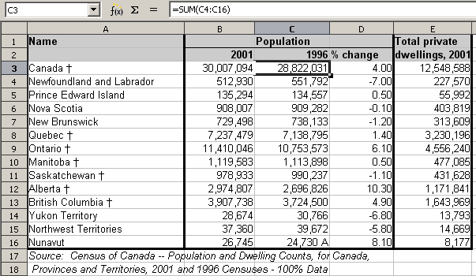
Cursor placed in cell
Figure 146: Tracing precedents using the Detective
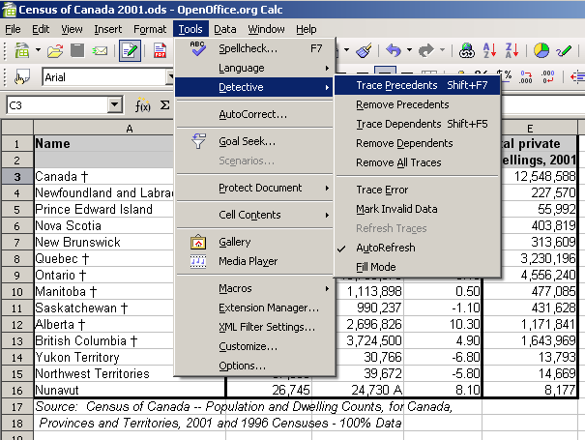
a) Initiate trace by clicking Trace Precedents
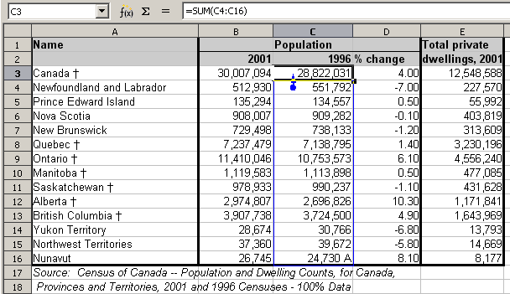
b) Source area highlighted in Blue, with arrow pointing to the calculation cell
(continued): Tracing precedents using the Detective
We are concerned that the number shown in Cell C3 is incorrectly stated. The cause can be seen in the highlighted cells. In this case cell C16 contains both numeric data as well as letters. Removing the letters resolves the problem in the calculation.
In other cases we must trace the error. Use the Trace Error function, found under Tools > Detective > Trace Error, to find the cells that cause the error.

Examples of functions
For novices, functions are one of the most intimidating features of OpenOffice.org's Calc. New users quickly learn that functions are an important feature of spreadsheets, but there are almost four hundred, and many require input that assumes specialized knowledge. Fortunately, Calc includes dozens of functions that anyone can use.

Basic arithmetic and statistic functions
The most basic functions create formulas for basic arithmetic or for evaluating numbers in a range of cells.

Basic arithmetic
The simple arithmetic functions are addition, subtraction, multiplication, and division.
Except for subtraction, each of these operations has its own function:
- SUM for addition
- PRODUCT for multiplication
- QUOTIENT for division.
Traditionally, subtraction does not have a function.
SUM, PRODUCT and QUOTIENT are useful for entering ranges of cells in the same way as any other function, with arguments in brackets after the function name.
However, for basic equations, many users prefer the time-honored computer symbols for these operations, using the plus sign (+) for addition, the hyphen (–) for subtraction, the asterisk (*) for multiplication and the forward slash (/) for division. These symbols are quick to enter without requiring your hands to stray from the keyboard.
A similar choice is also available if you want to raise a number by the power of another. Instead of entering =POWER(A1;2), you can enter =A1^2.
Moreover, they have the advantage that you enter formulas with them in an order that more closely approximates human readable format than the spreadsheet-readable format used by the equivalent function. For instance, instead of entering =SUM (A1:A2), or possibly =SUM (A1;A2), you enter =A1+A2. This almost-human readable format is especially useful for compound operations, where writing =A1*(A2+A3) is briefer and easier to read than =PRODUCT(A1;SUM(A2:A3)).
The main disadvantage of using arithmetical operators is that you cannot directly use a range of cells. In other words, to enter the equivalent of =SUM (A1:A3), you would need to type =A1+A2+A3.
Otherwise, whether you use a function or an operator is largely up to you—except, of course, when you are subtracting. However, if you use spreadsheets regularly in a group setting such as a class or an office, you might want to standardize on an entry format so that everyone who handles a spreadsheet becomes accustomed to a standard input.

Simple statistics
Another common use for spreadsheet functions is to pull useful information out of a list, such as a series of test scores in a class, or a summary of earnings per quarter for a company.
You can, of course, scan a list of figures if you want basic information such as the highest or lowest entry or the average. The only trouble is, the longer the list, the more time you waste and the more likely you are to miss what you’re looking for. Instead, it is usually quicker and more efficient to enter a function. Such reasons explain the existence of a function like COUNT, which does no more than give the total number of entries in the designated cell range.
Similarly, to find the highest or lowest entry, you can use MIN or MAX. For each of these formulas, all arguments are either a range of cells, or a series of cells entered individually.
Each also has a related function, MINA or MAXA, which performs the same function, but treats a cell formatted for text as having a value of 0 (The same treatment of text occurs in any variation of another function that adds an "A" to the end). Either function gives the same result, and could be useful if you used a text notation to indicate, for example, if any student were absent when a test was written, and you wanted to check whether you needed to schedule a makeup exam.
For more flexibility in similar operations, you could use LARGE or SMALL, both of which add a specialized argument of rank. If the rank is 1 used with LARGE, you get the same result as you would with MAX. However, if the rank is 2, then the result is the second largest result. Similarly, a rank of 2 used with SMALL gives you the second smallest number. Both LARGE and SMALL are handy as a permanent control, since, by changing the rank argument, you can quickly scan multiple results.
You would need to be an expert to want to find the Poisson Distribution of a sample, or to find the skew or negative binomial of a distribution (and, if you are, you will find functions in Calc for such things). However, for the rest of us, there are simpler statistical functions that you can quickly learn to use.
In particular, if you need an average, you have a number to choose from. You can find the arithmetical means—that is, the result when you add all entries in a list then divided by the number of entries by enter a range of numbers when using AVERAGE, or AVERAGE A to include text entries and to give them a value of zero.
In addition, you can get other information about the data set:
- MEDIAN: The entry that is exactly half way between the highest and lowest number in a list.
- MODE: The most common entry in a list of numbers.
- QUARTILE:The entry at a set position in the array of numbers. Besides the cell range, you enter the type of Quartile: 0 for the lowest entry, 1 for the value of 25%, 2 for the value of 50%, 3 for 75%, and 4 for the highest entry. Note that the result for types 1 through 3 may not represent an actual item entered.
- RANK: The position of a given entry in the entire list, measured either from top to bottom or bottom to top. You need to enter the cell address for the entry, the range of entries, and the type of rank (0 for the rank from the highest, or 1 for the rank from the bottom.
Some of these functions overlap; for example, MIN and MAX are both covered by QUARTILE. In other cases, a custom sort or filter might give much the same result. Which you use depends on your temperament and your needs. Some might prefer to use MIN and MAX because they are easy to remember, while others might prefer QUARTILE because it is more versatile.

Using these functions
In some cases, you may be able to get similar results to some of these functions by setting up a filter or a custom sort. However, in general, functions are more easily adjusted than filters or sorts, and provide a wide range of possibilities.
At times, you may just want to enter one or more formulas temporarily in a convenient blank cell, and delete it once you have finished. However, if you find yourself using the same functions constantly, you should consider creating a template and including space for all the functions you use, with the cell to their left used as a label for them. Once you have created the template, you can easily update each formula as entries change, either automatically and on-the-fly or pressing the F9 key to update all selected cells.
No matter how you use these functions, you will probably find them simple to use and adaptable for many purposes. By the time you have mastered this handful, you will be ready to try more complex functions.

Rounding off numbers
For statistical and mathematical purposes, Calc includes a variety of ways to round off numbers. If you’re a programmer, you may also be familiar with some of these methods. However, you don’t need to be a specialist to find some of these methods useful. You may want to round off for billing purposes, or because decimal places don’t translate well into the physical world—for instance, if the parts you need come in packages of 100, then the fact you only need 66 is irrelevant to you; you need to round up for ordering. By learning the options for rounding up or down, you can make your spreadsheets more immediately useful.
When you use a rounding function, you have two choices about how to set up your formulas. If you choose, you can nest a calculation within one of the rounding functions. For instance, the formula =ROUND((SUM(A1;A2)) adds the figures in cells A1 and A2, then rounds them off to the nearest whole number. However, even though you don’t need to work with exact figures every day, you may still want to refer to them occasionally. If that is the case, then you are probably better off separating the two functions, placing =SUM(A1;A2) in cell A3, and =ROUND (A3) in A4, and clearly labelling each function.

Rounding methods
The most basic function for rounding numbers in Calc is ROUND. This function will round off a number according to the usual rules of symmetric arithmetic rounding: a decimal place of .4 or less gets rounded down, while one of .5 or more gets rounded up. However, at times, you may not want to follow these rules. For instance, if you are one of those contractors who bills a full hour for any fraction of an hour you work, you would want to always round up so you didn’t lose any money. Conversely, you might choose to round down to give a slight discount to a long-established customer. In these cases, you might prefer to use ROUNDUP or ROUNDDOWN, which, as their names suggest, round a number to the nearest integer above or below it.
All three of these functions require the single argument of number—the cell or number to be rounded. Used with only this argument, all three functions round to the nearest whole number, so that 46.5 would round to 47 with ROUND or ROUNDUP and 46 with ROUNDDOWN. However, if you use the optional count argument, you can specify the number of decimal places to include. For instance, if number was set to 1, then 48.65 would round to 48.7 with ROUND or ROUNDUP and to 48.6 with ROUNDDOWN.
As an alternative to ROUNDDOWN when working with decimals, you can use TRUNC (short for truncate). It takes exactly the same arguments as ROUNDDOWN, so which function you use is a matter of choice. If you aren't working with decimals, you might choose to use INT (short for integer), which takes only the number argument.
Another option is the ODD and EVEN pair of functions. ODD rounds up to the nearest odd number if what is entered in the number argument is a positive number, and rounds down if it is a negative number, while EVEN does the same for an even number.
Options are the CEILING and FLOOR functions. As you can guess from the names, CEILING rounds up and FLOOR rounds down. For both functions, the number that they round to is determined by the closest multiple of the number that you enter as the significance argument. For instance, if your business insurance is billed by the work week, the fact that you were only open three days one week would be irrelevant to your costs; you would still be charged for an entire week, and therefore might want to use CEILING in your monthly expenses.
Conversely, if you are building customized computers and completed 4.5 in a day, your client would only be interested in the number ready to ship, so you might use FLOOR in a report of your progress. If cell E1 contains the value 46.7, =CEILING(E1;7) will return the value 49.
Besides number and significance, both CEILING and FLOOR include an optional argument called mode, which takes a value of 0 or 1. If mode is set to 0, and both the number and the significance are negative numbers, then the result of either function is rounded up; if it is set to 1, and both the number and the significance are negative numbers, then the results are rounded down. In other words, if the number is -11 and the significance is -5, then the result is -10 when the mode is set to 0, but -15 when set to 1.
However, if you are exchanging spreadsheets between Calc and MS Excel, remember that the mode argument is not supported by Excel. If you want the answers to be consistent between the two spreadsheets, set the mode in Calc to -1.
A function somewhat similar to CEILING and FLOOR is MROUND. Like CEILING AND FLOOR, MROUND requires two arguments, although, somewhat confusingly, the second one is called multiple rather than significance, even though the two are identical. The difference between MROUND and CEILING and FLOOR is that MROUND rounds up or down using symmetric arithmetic rounding. For example, if the number is 77 and the multiple is 5, then MROUND gives a result of 75. However, if the multiple is changed to 7, then MROUND's result becomes 77.
Once you become familiar with Calc’s long, undifferentiated list of functions, you can start to decide which is most useful for your purposes.
However, one last point is worth mentioning: If you are working with more than two decimal places, don't be surprised if you don’t see the same number of decimal places on the spreadsheet as you do on the function wizard. If you don’t, the reason is that Tools > Options > OpenOffice.org Calc > Calculate > Decimal Places defaults to 2. Change the number of decimal places, and, if necessary, uncheck the Precision as shown box on the same page, and the spreadsheet will display as expected.

Using regular expressions in functions
A number of functions in Calc allow the use of regular expressions: SUMIF, COUNTIF, MATCH, SEARCH, LOOKUP, HLOOKUP, VLOOKUP, DCOUNT, DCOUNTA, DSUM, DPRODUCT, DMAX, DMIN, DAVERAGE, DSTDEV, DSTDEVP, DVAR, DVARP, DGET.
Whether or not regular expressions are used is selected on the Tools > Options > OpenOffice.org Calc > Calculate dialog.
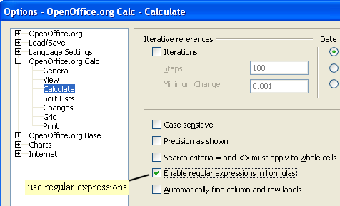Figure 147: Enabling regular expressions in formulas
For example =COUNTIF(A1:A6;"r.d") with Enable regular expressions in formulas selected will count cells in A1:A6 which contain red and ROD.
Additionally if Search criteria = and <> must apply to whole cells is not selected, then Fred, bride, and Ridge will also be counted. If that setting is selected, then it can be overcome by wrapping the expression thus: =COUNTIF(A1:A6;".*r.d.*").
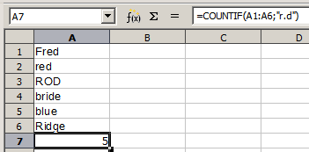Figure 148: Using the COUNTIF function.
Regular expression searches within functions are always case insensitive, irrespective of the setting of the Case sensitive checkbox on the dialog in Figure 147—so red and ROD will always be matched in the above example. This case-insensitivity also applies to the regular expression structures ([:lower:]) and ([:upper:]), which match characters irrespective of case.
Regular expressions will not work in simple comparisons. For example: A1="r.d" will always return FALSE if A1 contains red, even if regular expressions are enabled. It will only return TRUE if A1 contains r.d (r then a dot then d). If you wish to test using regular expressions, try the COUNTIF function: COUNTIF(A1; "r.d") will return 1 or 0, interpreted as TRUE or FALSE in formulas like =IF(COUNTIF(A1; "r.d");"hooray"; "boo").
Activating the Enable regular expressions in formulas option means all the above functions will require any regular expression special characters (such as parentheses) used in strings within formulas, to be preceded by a backslash, despite not being part of a regular expression. These backslashes will need to be removed if the setting is later deactivated.

Advanced functions
As is common with other spreadsheet programs, OOo Calc can be enhanced by user-defined functions or add-ins. Setting up user-defined functions can be done either by using the Basic IDE or by writing separate add-ins or extensions.
The basics of writing and running macros is covered in Chapter 12, Calc Macros. Macros can be linked to menus or toolbars for ease of operation or stored in template modules to make the functions available in other documents.
Calc Add-ins are specialized office extensions which can extend the functionality of OpenOffice.org with new built-in Calc functions. Writing Add-ins requires knowledge of the C++ language, the OOo SDK, and is for experienced programmers. More information is available on the OOo wiki page at http://wiki.services.openoffice.org/wiki/Calc/Add-In/Simple_Calc_Add-In. A number of extensions for Calc have been written and these can be found on the extensions site at http://extensions.services.openoffice.org/. Refer to Chapter 14, Setting up and Customizing Calc, of the Calc Guide for more details.

Calc Guide

Chapter 8
Using the DataPilot

This chapter is adapted from a German original written by Stefan Weigel and translated into English by Sigrid Kronenberger. It is licensed under the Creative Commons Attribution-Share Alike License, version 3.0.
This PDF is designed to be read onscreen, two pages at a time. If you want to print a copy, your PDF viewer should have an option for printing two pages on one sheet of paper, but you may need to start with page 2 to get it to print facing pages correctly. (Print this cover page separately.)

Copyright
This document is Copyright © 2009–2010 by its contributors as listed in the section titled Authors. You may distribute it and/or modify it under the terms of either the GNU General Public License, version 3 or later, or the Creative Commons Attribution License, version 3.0 or later.
All trademarks within this guide belong to their legitimate owners.
Authors
Stefan Weigel
Jean Hollis Weber
Sigrid Kronenberger
Andy Brown
Sharon Whiston
Claire Wood
Feedback
Please direct any comments or suggestions about this document to: authors@documentation.openoffice.org
Acknowledgments
The chapter is adapted from a German original written by Stefan Weigel and translated into English by Sigrid Kronenberger. Andy Brown, Jean Hollis Weber, and Sharon Whiston edited the translation, and Andy Brown recaptured the illustrations from an English version of OpenOffice.org.
Publication date and software version
Published 20 June 2010. Based on OpenOffice.org 3.2.
Contents
Copyright 2
Introduction 5
Examples with step by step instructions 5
Example 1: Sales volume overview 5
Practical problems and questions 6
Solution 6
Advantages 9
Example 2: Timekeeping 13
Practical problems and questions 13
Solution 15
Differences and advantages 19
Example 3: Frequency distribution 20
Solution with a matrix formula 22
Solution with the DataPilot 23
DataPilot functions in detail 27
The database (preconditions) 27
Start 28
Data source 29
Calc spreadsheet 29
Registered data source 30
External data (OLAP) 30
The DataPilot dialog 30
Basic layout 30
More options 31
More settings for the fields 34
Data fields 34
Row and column fields 36
Page fields 39
Working with the results of the DataPilot 39
Start the dialog 39
Change layout by using drag and drop 39
Grouping rows or columns 39
Grouping of categories with scalar values 40
Grouping of categories with date or time values 41
Grouping without the automatic creation of intervals 42
Sorting the result 43
Drilling (showing details) 45
Filtering 46
Updating (refreshing) changed values 47
Cell formatting 48
Multiple data fields 48
Shortcuts 52
Function GETPIVOTDATA 53
Difficulty 53
Syntax 54
First syntax variation 54
Second syntax variation 55

Introduction
Many requests for software support are caused by complicated formulas and solutions to simple day to day procedures. For more efficient and effective solutions use the DataPilot, a tool for combining, comparing, and analyzing large amounts of data easily. By using the DataPilot, you can view different summaries of the source data, display the details of areas of interest, and create reports, whether you are a beginner or an intermediate or advanced user.
This chapter is divided into two sections:
- “Examples with step by step instructions” uses three typical cases to demonstrate the advantages and applications of the DataPilot. Follow the examples to learn how easy it is to use the DataPilot.
- “DataPilot functions in detail” starting on page 241 describes the DataPilot in detail. You can use this part for looking up how a function is used.

Examples with step by step instructions
This section demonstrates some of the possibilities of the DataPilot in typical use cases. By following the step by step instructions, you can recreate the examples and learn about the power of the DataPilot.

Example 1: Sales volume overview
A typical introductory example in courses and books for beginners with spreadsheets is a simple sales volume overview.
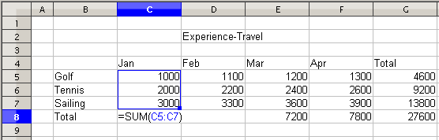
Figure 149: Typical example for beginners
This example demonstrates the user interface and how to insert text and numbers into cells. Useful aids like AutoFill and drag and drop have been demonstrated in other chapters. The most important part is the connection between cells through formulas, for example addition with the plus operator or the SUM function.
This small exercise might be useful for a first contact with the program, but it shows only a very small fraction of the tasks in an office. To create such a sales overview, you also need the original data. That is, before you can use a spreadsheet for creating the sales overview, you need to add many single purchases from different lists and then enter the sums into the relevant cells C5 to F7.

Practical problems and questions
- For displaying additional values for May, June, July, and so on, you need to add extra columns. This means that you have to change the structure of the calculation sheet. This is not only somewhat inefficient from a workflow point of view, it also adds some practical questions: How do references react, if you add more columns or rows to the sum formulas?
- The layout, where the timeline is displayed horizontally, might be less convenient if you add more months. A vertical layout might be a more efficient use of space. How can the table then be transposed? Do you have to enter everything again?
- What if the management asks unexpected questions or adds an additional subdivision for the different sales regions or a constraint of the sales for a given employee. In these cases you again have to manually add all the sums and create different tables in many variations.
- Is it really acceptable and realistic to create such an overview by adding the different values manually? This is really a lot of work and extremely error-prone!

Solution
The most important part of your task in the example is the addition of the Total sales per month cells. This had to be done manually. To do this automatically with the program, just get the data into Calc. You can enter the single numbers by hand or you can import a file from your bookkeeping software. In any case we assume a continuous table that keeps track of all sales in a somewhat primitive form.
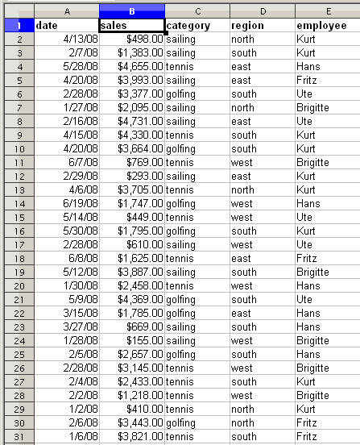
Figure 150: Basic data in Calc
You can create the sales volume overview by following these instructions:
- Select the cell A1 (or any other single cell within the list).
- Select Data > DataPilot > Start. On the Select Source dialog, select Current selection and click OK.
- The DataPilot dialog (Figure 151) has four white layout areas and several fields that look like buttons. These small fields are the titles of the different columns of your list.
  - Move the date field into the Column Fields area.
  - Move the sales field into the Data Fields area.
  - Move the category field into the Row Fields area.
- Click More, to see more options in the lower part of the dialog.
- In the Results to field, select – new sheet – from the drop-down list.
- Click OK.
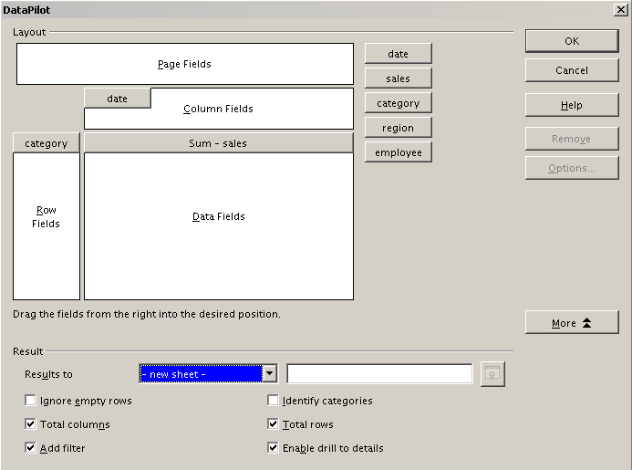
Figure 151: DataPilot dialog
- The result appears on a new sheet. It has the desired structure, but the columns are not yet grouped into months.
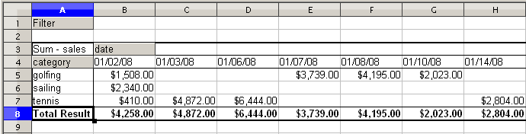
Figure 152: DataPilot result without grouping
- To group the columns, select cell B4 or any other cell that contains a date. Then select Data > Group and Outline > Group. On the Grouping dialog (Figure 153), make sure Intervals and Months are selected in the Group by section, and click OK. The result is now grouped for months (Figure 154).
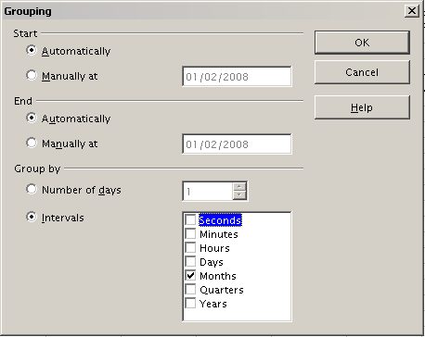Figure 153: Grouping on months
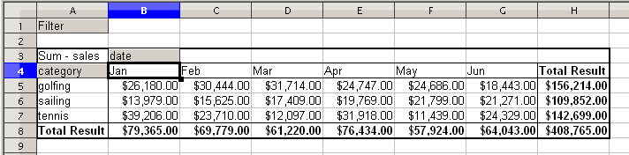
Figure 154: DataPilot result grouped for months
In this result you will recognize the beginners’ example. It is very easy to produce, without any further knowledge about the spreadsheet. You do not have to enter any formulas.

Advantages
- No manual entering or adding of any values is necessary. There is less work and fewer errors.
- The layout is very flexible: months are listed horizontally and fields vertically or vice versa, in two mouse clicks.
- Additional differentiating factors are immediately available.
- Many types of evaluation are possible; for example, number or average instead of sum, accumulated values, comparisons, and so on.
We will now demonstrate some of these advantages.
Starting with the result of Figure 154, drag the Date field under the Category field, as shown in Figure 155.
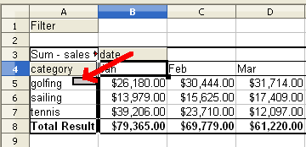Figure 155: Drag Date field under Category field
Now the summary is as shown in Figure 156.
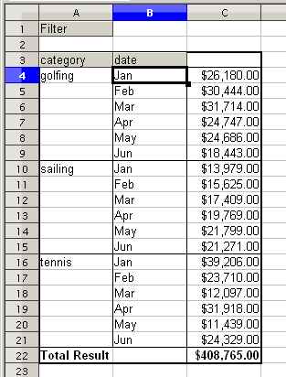
Figure 156: Changed layout
To transpose the table completely, just drag the Category field above the area of the displayed values, to cell C3 (see Figure 157). The result of this action is shown in Figure 158.
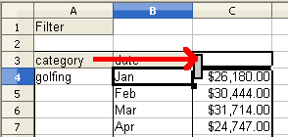
Figure 157: Drag Category field to right of Data field
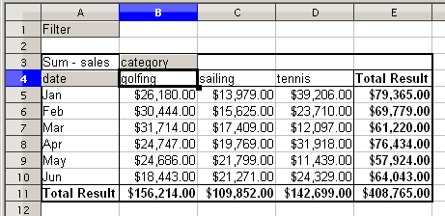
Figure 158: Transposed layout of Figure 156
In contrast to the beginners’ example in Figure 149, it is now very simple to view or add different aspects of the underlying data. For example, to see the values for different regions, do the following:
- Select the cell A3 (or any other single cell that is part of the DataPilot result).
- Select Data > DataPilot > Start to start the DataPilot again.
Drag the Region field into the Row Fields area. Depending on the order you choose for the row fields, the result is either regions with date subdivisions or vice versa.
- Click OK. The result is shown in Figure 159.
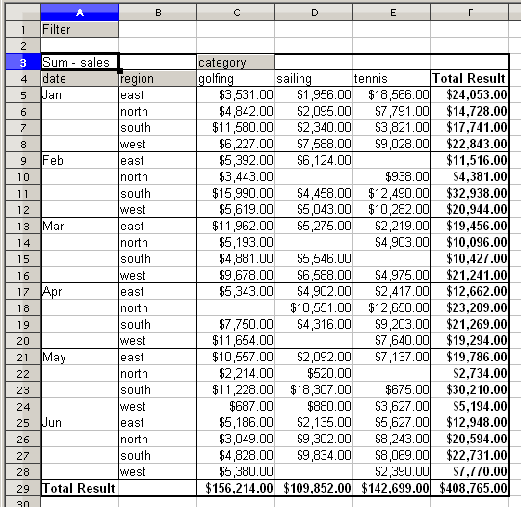
Figure 159: Additional subdivision into regions, added later
In another variation you may want to add the employees.
- Select the cell A3 (or any other single cell that is part of the DataPilot result).
- Select Data > DataPilot > Start, to start the DataPilot again.
  - You do not need the Region field in this case. Drag it out of the layout area.
  - Drag the Employee field into the Page Fields area.
- Click OK. The result is shown in Figure 160.
Fields that you use as page fields are placed in the result above the summary with the name Filter. You then have a drop-down list that you can use to show only the sums of a given employee.
Up to now we have not seen the most powerful features of the DataPilot. The following examples will show you more.
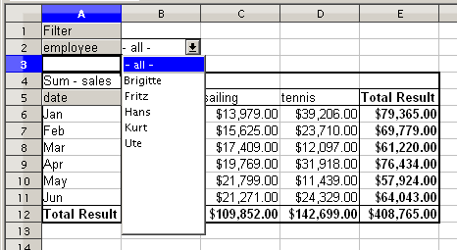
Figure 160: Selection of subtotals for several employees.

Example 2: Timekeeping
This example is often used by consultants and in several variations in user support. The task is to provide a means for one or more users to keep track of working hours.
A typical way of doing this is to create a spreadsheet per month and a sum sheet with all the results of one year. For each employee, there is one file (see Figures 161 and 162 for examples of two pages from the file for one employee).

Practical problems and questions
- It is very difficult and time-consuming to create the timekeeping table: 12 sheets that have to be copied from a raw template and adjusted for each month, and a sheet with all the yearly sums with references to all the other sheets. Users often search for a macro to make the creation easier.
- The file shown contains only the data of one employee. How can you get all the data for all the employees, so that you can have a summary of all the work hours from all employees of a department or the whole company?
- How can you compare employees and/or departments?
- The shown file contains data for one year. How can you compare it with the data of the previous years?
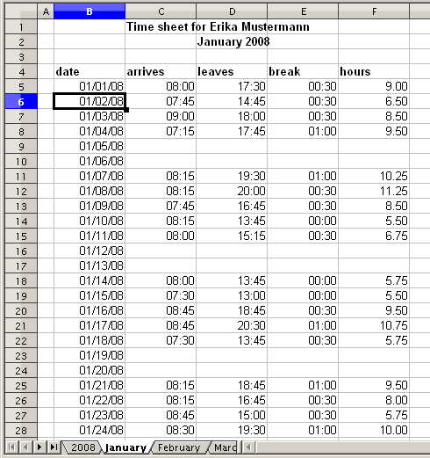
Figure 161: One month of timekeeping for one employee
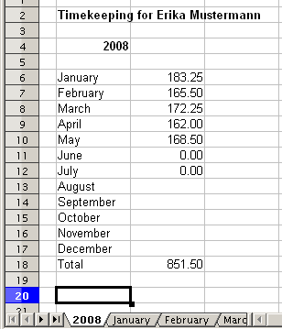
Figure 162: Yearly sums for one employee

Solution
To use the DataPilot for this task, collect all the data into one single table. This can be done either manually or by importing a file from an (electronic) timekeeping machine.
In very simple cases, each employee takes care of their own working hours. If you need calculations that cover several employees, departments, or the whole company, just copy everything into one huge table (Figure 163).
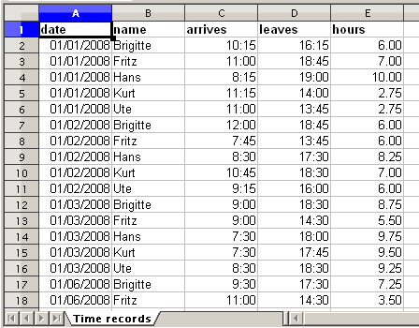
Figure 163: Data basis in Calc
Using the DataPilot requires only 12 mouse clicks and gives you a nice overview within seconds :
- Select the cell A1 (or any other single cell within the list).
- Choose Data > DataPilot > Start and click OK.
- On the DataPilot dialog (Figure 164):
  - Drag date into the Row Fields area.
  - Drag hours into the Data Fields area. Notice that it becomes Sum – hours.
  - Drag name into the Column Fields area.
- Click More to show more options in the lower part of the dialog.
- In the Results to field, select – new sheet – from the drop-down list.
- Click OK.
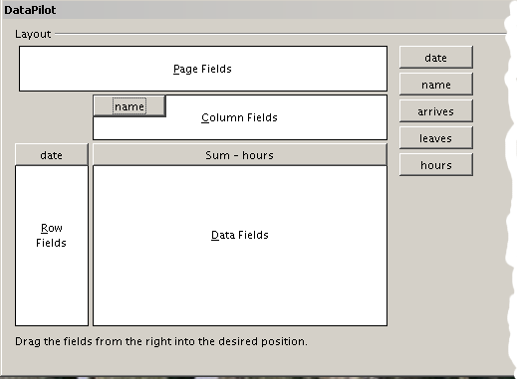Figure 164: Part of DataPilot dialog
The result appears on a new sheet.
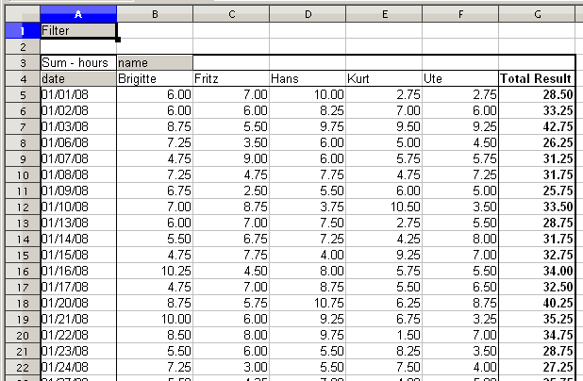
Figure 165: The evaluation, done within seconds with DataPilot
The result is much more powerful than is possible with the classic formula-based calculation. For example, you can summarize the daily results to a monthly result very easily:
- To group together the rows, select the cell A5 (or any other cell that contains a date).
- Choose Data > Group and Outline > Group and click OK. The result is now grouped into months.
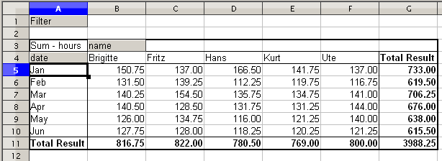
Figure 166: Monthly sums
If you need a result with a percentage, start the DataPilot from this page.
- Select the cell A3 (or any other single cell that contains a result of the DataPilot).
- Choose Data > DataPilot > Start.
- Double-click on Sum – hours to open the Data Field dialog (Figure 167).
- Click on More, to see more options.
- Switch Displayed value > Type to % of column.
- Click OK twice.
The result shows percentages as a decimal number. If you prefer to have a percent format, select the cells and click on the % icon in the menu bar.
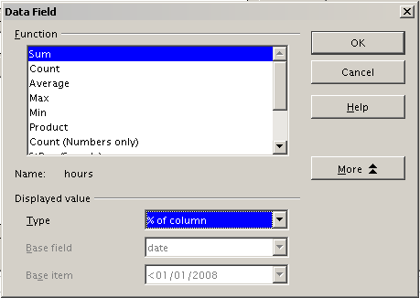
Figure 167: Properties of the data field
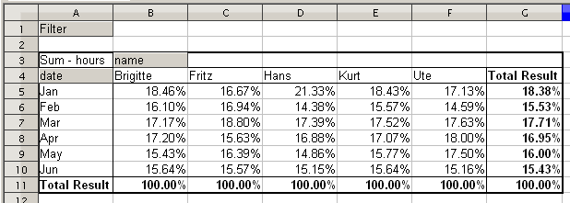
Figure 168: Result with percentages
To get a comparison between employees, start the DataPilot again:
- Select the cell A3 (or any other cell that contains a result of the DataPilot).
- Choose Data > DataPilot > Start.
- Double-click on Sum – hours to open the Data Field dialog.
- Click More, to see more options.
  - Switch the Type of the displayed value to Difference from.
  - Switch the Base Field to name.
  - Switch the Base Item to Brigitte.
- Click OK twice.
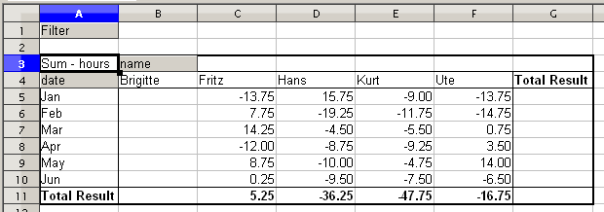
Figure 169: Absolute comparison with Brigitte
As a final example we switch to an accumulated view; that is, continuing sums of all values:
- Choose Data > DataPilot > Start.
- Double-click on Sums – hours to open the Data Field dialog.
- Click More, to see more options.
  - Switch the type of the displayed value to Running total in.
  - Switch the Base Field to Date.
- Click OK twice.
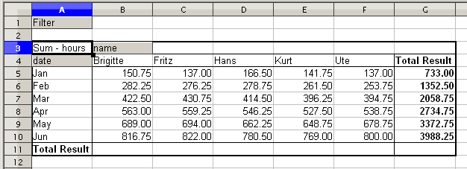
Figure 170: The DataPilot now shows accumulated values

Differences and advantages
These examples show an important aspect of the DataPilot. Normally you have to collect your data according to the way you want the result to be represented. This means you have to use a specific structure and you are stuck with it.
The DataPilot works more like a real database. The source data is collected in a simple spreadsheet that contains all data. Only when you want to look at it do you select which part of the data you want to use.

Example 3: Frequency distribution
For showing the frequency of incidents, Calc uses the function FREQUENCY. This formula has to be used in a so-called matrix formula. This is an advanced feature. Alternatively you can use the DataPilot, which requires almost no knowledge of spreadsheets.
In our example we want to investigate the number of emails that go to the Germanophone support mailing list (users@de.openoffice.org). We want to know how the activity on the list is distributed during the day.
The starting point for this example is the mailbox file of the Thunderbird mail client. The command
grep 'Delivery-Date:' Inbox
creates a text file that contains for the timespan of more than 2 years one line for each message, with date and time (Figure 171).
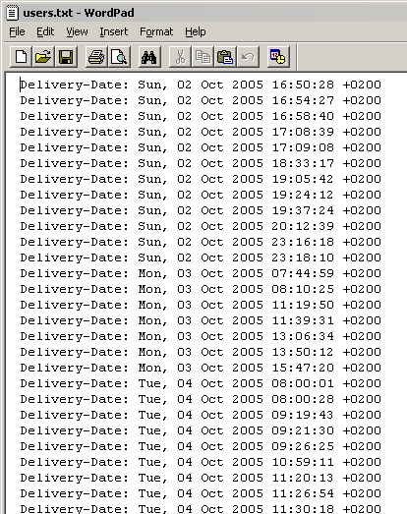
Figure 171: Raw data for the frequency of the messages
To import the data into a table in Calc, open the text file users.txt containing the raw data. The Text Import dialog appears. Here you can choose your import options. Use the following properties:
Separator options: Fixed width
Divide into columns at position 20, 31 and 40
Column types:
Column 1: Hide
Column 2: Date (DMY)
Column 3: Standard
Column 4: Hide
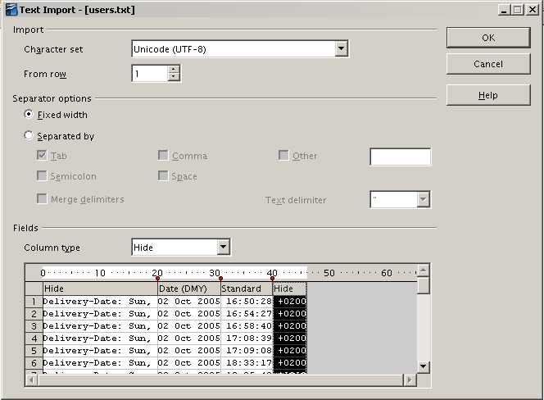
Figure 172: Import settings
Figure 173 shows the imported raw data with a line added at the top containing titles for each column.
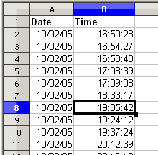
Figure 173: Raw data in Calc

Solution with a matrix formula
To calculate the frequency you have to create 24 classes, one for each hour. In the next column you enter the number of emails with the function FREQUENCY.
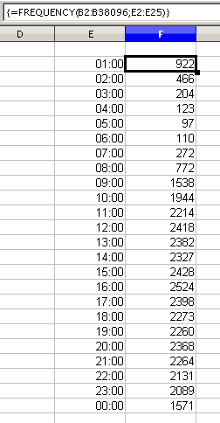
Figure 174: FREQUENCY function in a matrix formula
The first argument is the cell area with the times of all approximately 38,000 emails. The second argument is the cell area E2:E25 that describes the frequency classes. To enter the formula, first select the cell area F2:F25, then enter the formula. Then finish the formula by using the key combination Shift+Ctrl+Enter. This indicates to the program that you want to use a matrix formula. To indicate the matrix formula, the program uses curly brackets.
This technique is most often known only to advanced users.

Solution with the DataPilot
With the DataPilot you can achieve the same result much easier and faster. The solution is also possible for less advanced users. Starting with the raw data (Figure 173), you need only a few mouse clicks.
- Select the cell A1 (or any other cell within the list).
- Choose Data > DataPilot > Start and click OK.
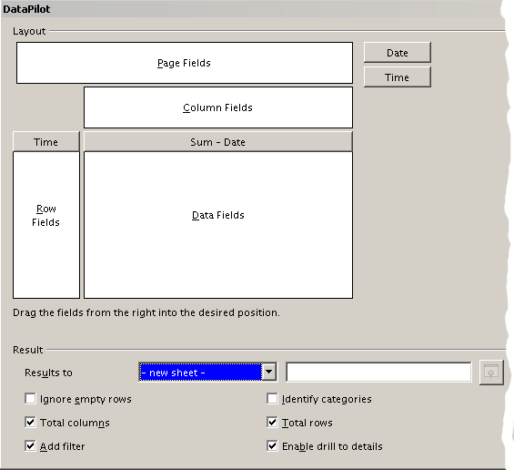
Figure 175: Part of DataPilot dialog
- In the DataPilot:
  - Drag Time into the Row Fields area.
  - Drag Date into the Data Fields area.
- Click More to show more options in the lower part of the dialog.
- Choose – new sheet – for Results to.
- In this case we need to count the number of values, not their sum. Double-click on Sum – Date to open the Data Field dialog and select the function Count (see Figure 176).
- Click OK. As an intermediate result, you get a DataPilot table that has for every time within the raw data a separate line.
Note | This may be a very time-consuming process because of the large number of items. The time does not depend that much on the number of lines but rather on the number of rows needed for the table that contains the results.
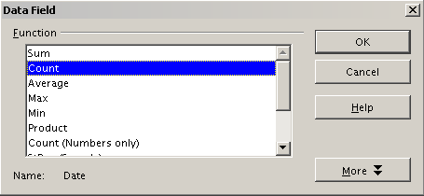
Figure 176: Properties of the data field
- For grouping the rows, select the cell A4 or any other cell that contains a time.
- Choose Data > Group and Outline > Group, select for the interval Hours and click OK. The result is now grouped according to hours.
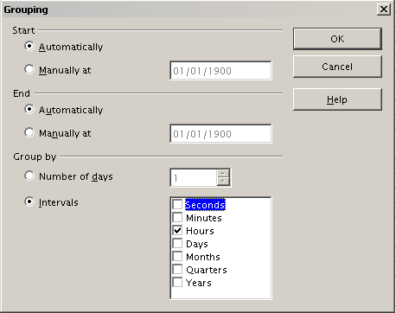
Figure 177: properties for grouping according to hours
- Figure 178 shows the Data Field dialog for the data field Number – Date. Click More and select as type % of column. The result is shown in Figure 180. Figure 179 shows the absolute occurrence.
Whether the relative values are shown as a decimal (0.1) or as a percentage (10%) depends only on the cell formatting itself and has nothing to do with the DataPilot.
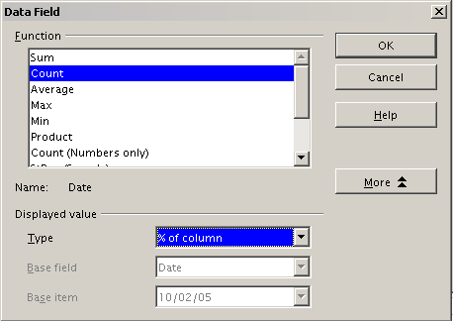
Figure 178: Data Field settings for relative values
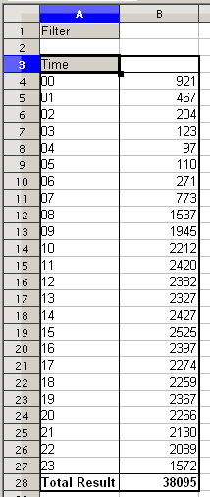
Figure 179: Frequency distribution with the DataPilot
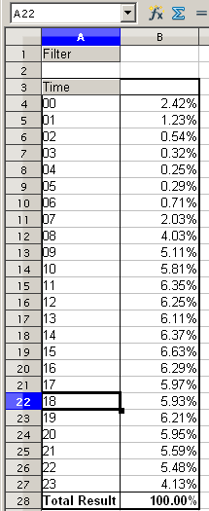
Figure 180: Relative occurrence

DataPilot functions in detail
This part describes the use and options of the DataPilot in detail.

The database (preconditions)
The first thing needed to work with the DataPilot is a list of raw data, similar to a database table, consisting of rows (data sets) and columns (data fields). The field names are in the first row above the list.
The data source could be an external file or database. For the simplest case, where data is contained in a Calc spreadsheet, Calc offers sorting functions that do not require the DataPilot.
For processing data in lists, the program needs to know where in the spreadsheet the table is. The table can be anywhere in the sheet, in any position. A spreadsheet can contains several unrelated tables.
Calc recognizes your lists automatically. It uses the following logic:
Starting from the cell you’ve selected (which must be within your list), Calc checks the surrounding cells in all 4 directions (left, right, above, below). The border is recognized if the program discovers an empty row or column, or if it hits the left or upper border of the spreadsheet.
This means that the described functions can only work correctly if there are no empty rows or columns in your list. Avoid empty lines (for example for formatting). You can format your list by using cell formats.
Rule | No empty rows or empty columns are allowed within lists.
If you select more than one single cell before you start sorting, filtering or calling the DataPilot, then the automatic list recognition is switched off. Calc assumes that the list matches exactly the cells you have selected.
Rule | For sorting, filtering, or using the DataPilot, always select only one cell.
A relatively big source for errors is that you might declare a list by mistake and you sort your list. If you select multiple cells (for example, a whole column) then the sorting mixes up the data that should be together in one row.
In addition to these formal aspects, the logical structure of your table is very important when using the DataPilot.
Rule | Calc lists must have the normal form; that is, they must have a simple linear structure.
When entering the data, do not add outlines, groups, or summaries. This becomes clear when we think about what we could have done wrong in our Sales list example in the section “Examples with step by step instructions” starting at page 219. Here are some mistakes commonly made by inexperienced spreadsheet users:
- You could have made several sheets, for example, a sheet for each group of articles. Analyses are then possible only within each group. Analyses for several groups would be a lot of work.
- In the Sales list, instead of only one column for the amount, you could have made a column for the amounts for each employee. The amounts then had to be entered into the appropriate column. An analysis with the DataPilot would not be possible any more. In contrast, one result of the DataPilot is that you can get results for each employee if you have entered everything in one column.
- You could have entered the amounts in chronological order. At the end of each month you could have made a sum total. In this case, sorting the list for different criteria is not possible because the DataPilot will treat the sum totals the same as any other figure. Getting monthly results is one of the very fast and easy features of the DataPilot.

Start
Start the DataPilot with Data > DataPilot > Start. If the list to be analyzed is in a spreadsheet table, select one cell within this list. Calc recognizes and selects the list automatically for use with the DataPilot.
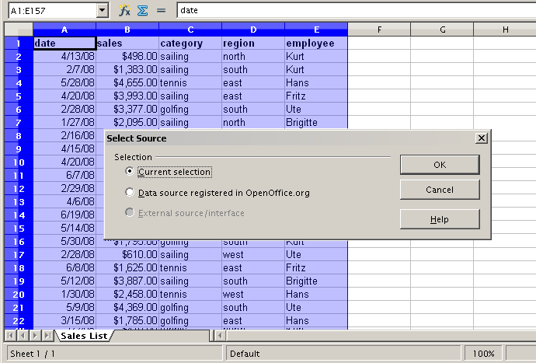
Figure 181: After the start of the DataPilot

Data source
There are usually three possibilities for the DataPilot to have a data source: a Calc spreadsheet, an external data source that has to be registered in OpenOffice.org, and access to an OLAP system (not available at this time).

Calc spreadsheet
The simplest and most often used case is analyzing a list in a Calc spreadsheet. The list might be updated regularly or the data might be imported from a different application.
A huge list can, for example, be copied from a different application and pasted into Calc. The behavior of Calc while inserting the data depends on the format of the data. If the format is acceptable, the data is copied directly into Calc. However, if the data is in plain text, a dialog appears with the text import assistant; see Chapter 1 (Introducing Calc) for more more information.
Calc can import data from a huge number of foreign data formats, for example from other spreadsheets (Excel, Lotus 1, 2, 3), from databases (like dBase), and from simple text files.
The drawback of copying or importing foreign data is that it will not update automatically if there are changes in the source file. With a Calc file you are limited to 65535 rows.

Registered data source
A registered data source in OpenOffice.org is a connection to data held in a database outside Calc. This means that the data to be analyzed will not be saved in Calc. It always uses the data from the original source. Calc is able to use many different data sources and also databases that are created and maintained with OpenOffice.org Base. See Chapter 10 (Linking Calc Data) for more information.

External data (OLAP)
No implementation exists at the moment so this option is not available.

The DataPilot dialog
The function of the DataPilot is managed in two places: first in the DataPilot dialog and second through manipulations of the result in the spreadsheet. This section describes the dialog in detail.

Basic layout
In the DataPilot are four white areas that show the layout of the result. Beside these fields are buttons with the names of the fields in your data source. To define a layout, drag and drop these field buttons into the white areas.
The Data Fields area in the middle must contain at least one field. Advanced users can use more than one field here. For the data field an aggregate function is used. For example, if you move the sales field into the Data Fields area, it appears there as Sum – sales.
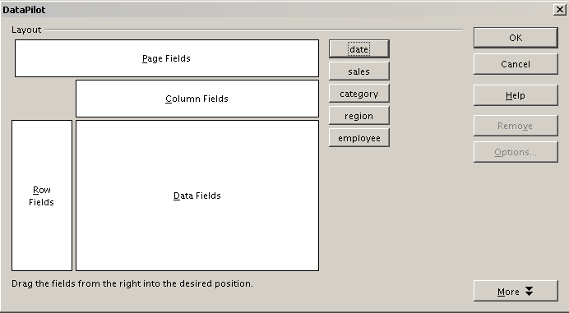
Figure 182: DataPilot dialog
Row Fields and Column Fields indicate in which groups the result will be sorted in the rows and columns. If there are no entries in one of these area, then partial sums will not be provided for the corresponding rows or columns. Often more than one field is used at the same time get partial sums for rows or columns. The order of the fields gives the order of the sums from overall to specific.
For example, if you drag region and employee into the Row Fields area, the sum will be divided into the employees. Within the employees will be the listing for the different regions.
Fields that are placed into the Page Fields area appear in the result above as a drop down list. The summary in your result takes only that part of your base data into account that you’ve selected. For example, if you use employee as a page field, you can filter the result shown for each employee.
To remove a field from the white layout area just drag it to the border and drop it (the cursor will change to a crossed symbol), or click the Remove button.

More options
To expand the DataPilot and show more options, click More.
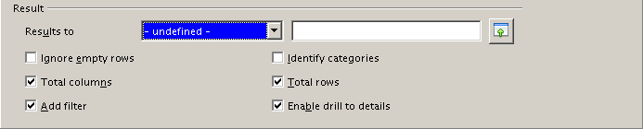
Figure 183: Expanded dialog of the DataPilot
Results to
Results to defines where your result will be shown. If you do not enter anything, the DataPilot will put your result below the list that contains your data. This could result in overwriting any data that is already in that location. To avoid overwriting data, you can leave Results to as – undefined – and enter a cell reference to tell the DataPilot where to show the results. However, a generally better approach is to use - new sheet – to add a new sheet to the spreadsheet file and place the results there.
Ignore empty rows
If the source data is not in the recommended form, this option tells the DataPilot to ignore empty rows.
Identify categories
If the source data has missing entries in a list and does not meet the recommended data structure (see Figure 184), the DataPilot adds it to the listed category above it. If this option is not chosen, then the DataPilot inserts (empty).
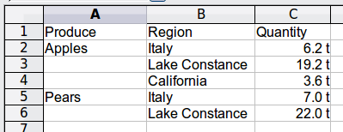
Figure 184: Example of data with missing entries in Column A
The option Identify categories ensures that in this case rows 3 and 4 are added to the product Apples and row 6 is added to Pears (see Figure 185).
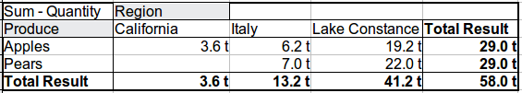Figure 185: DataPilot result with Identify categories selected
Without category recognition, the DataPilot shows an (empty) category (Figure 186).
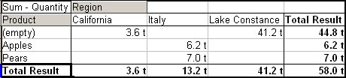Figure 186: DataPilot result without Identify categories selected
Logically, the behavior without category recognition is better. A list with the shown missing entries is also less useful, because you cannot use other functions such as sorting or filtering.
Total columns / total rows
With this option you decide if the DataPilot will show an extra row with the sums of each column or if it adds on the very right a column with the sums of each row. In some cases, an added total sum is useless, for example if your entries are accumulated or in comparisons.
Add filter
Use this option to add or hide the cell labelled Filter above the DataPilot results. This cell is a convenient button for additional filtering options within the DataPilot.
Enable drill to details
If you double-click on a single cell in the DataPilot result, this function gives a more detailed listing of an individual entry. If this function is disabled, the double-click will keep its usual edit function within a spreadsheet.

More settings for the fields
The options discussed in the previous section are valid for the DataPilot in general. Additionally, you can change settings for every field that you have added to the DataPilot layout. Do this either by clicking on the Options button in the DataPilot dialog or by double-clicking on the appropriate field.
There are differences between data fields, row or column fields, and page fields of the DataPilot.

Data fields
In the preferences dialog of a data field you can select the Sum function for accumulating the values from your data source. In many cases you will need the sum function, but other functions (like standard distribution or a counting function) are also available. For example, the counting function can be useful for non-numerical data fields.
On the Data Field dialog, click More to see more options.
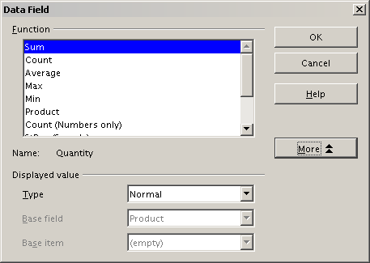
Figure 187: Expanded dialog for a data field
In the Displayed value section, you can choose more possibilities for analysis by using the aggregate function. Depending on the setting for Type, you have to choose a definition for Base field and Base element.
Type | Base field | Base element | Analysis
Normal | — | — | Simple use of the chosen aggregate function (for example, sum)
Difference from | Selection of a field from the data source of the DataPilot (for example, employee) | Selection of an element from the selected base field (for example, Brigitte) | Result as difference to the result of the base element (for example, Sales volume of the employees as difference of the sales volume of Brigitte)
% of | Selection of a field from the data source of the DataPilot (for example, employee) | Selection of an element from the selected base field (for example, Brigitte) | Result as a ratio based on the result of the base element (for example, Sales result of the employee relative to the sales result of Brigitte)
% difference from | Selection of a field from the data source of the DataPilot (for example, employee) | Selection of an element from the selected base field (for example. Brigitte) | Result as relative difference to the result of the base element (for example, Sales volume of the employees as relative difference of the sales volume of Brigitte)
Running total in | Selection of a field from the data source of the DataPilot (for example, date) | — | Result as a continuing sum (for example, Continuing sum of the sales volume for days or months)
% of row | — | — | Result as relative part of the result in the whole row (for example the row sum)
% of column | — | — | Result as relative part of the total column (for example, the column sum)
% of total | — | — | Result as relative part of the overall result (for example the total sum)
Index | — | — | Default result x total result / (row result x column result)

Row and column fields
In the preferences dialog for the row or column fields, you can display the partial sums for each category. Partial sums are deactivated by default. They are only useful if the values in one row or column field can be divided into partial sums for another (sub)field.
Some examples are shown in the next three figures.
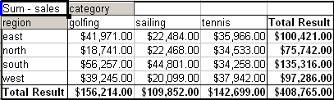
Figure 188: No subdivision with only one row or column field
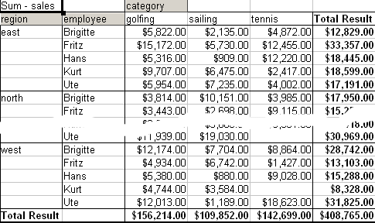
Figure 189: Division of the regions for employees without partial sums
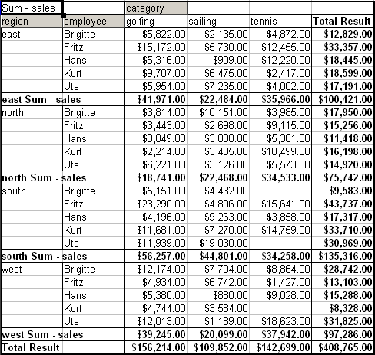
Figure 190: Division of the regions for employees with partial sums
Select the option Automatically to use the aggregate function for the partial results that can also be used for the data fields (see above). To set up the aggregate function for the partial results independently from the overall settings of the DataPilot, select User-defined.
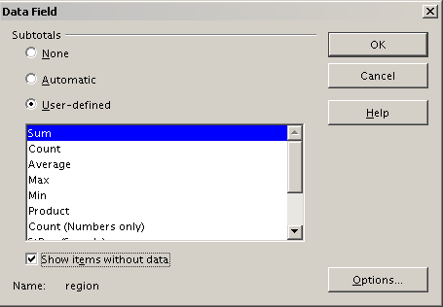
Figure 191: Preferences dialog of a row or column field
Normally, the DataPilot does not show a row or column for categories that have no entries in the underlying database. By choosing the Show items with no data option, you can force this.
For illustration purposes, the data was manipulated in such a way that the employee Brigitte has no sales values for the golfing category.
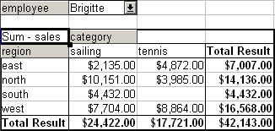
Figure 192: Default setting
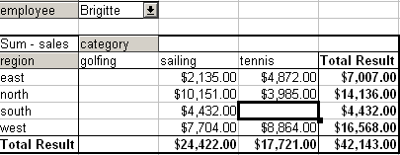
Figure 193: Setting “Show Items with no data”

Page fields
The preferences dialog for page fields is the same as for row and column fields, even though it appears to be useless to do the same settings as described for the row and column fields. With the flexible use of the DataPilot you can often switch the use of the different fields for pages, columns or rows. The fields keep the settings that you made for them. For this, the page field has the same properties as a row or column field. These settings only take effect when you use the field not as page field but as row or column field.

Working with the results of the DataPilot
One very important feature is the flexibility of the DataPilot. An analysis can be changed with only a few mouse clicks. Some functions of the DataPilot can be used only with the results of an analysis.

Start the dialog
Right-click in the area of the resulting table of the DataPilot and choose Start toopen the DataPilot dialog with all current settings.

Change layout by using drag and drop
The easiest and fastest method to change the layout of the DataPilot is drag and drop. Within the result table of the DataPilot, move one of the page, column, or row fields to a different position (see “Examples with step by step instructions” starting on page 219).
You can remove a column, row, or page field from the DataPilot by clicking on and dragging it out of the DataPilot.

Grouping rows or columns
For many analyses or summaries, the categories have to be grouped. You can merge the results in classes or periods. In the DataPilot you do a grouping after you have first made an ungrouped DataPilot table.
You can access the grouping with the menu entry Data > Group and Outline > Group or by pressing F12. It is important that you select the correct cell area. The grouping function is mainly determined by the type of values that have to be grouped. You need to distinguish if you have scalar values, date or time values, or other values, such as text, that you want grouped.
Note | Before you can group, you have to produce a DataPilot with ungrouped data. The time needed for creating a DataPilot depends mostly on the number of columns and rows and not on the size of the basic data. Through grouping you can produce the DataPilot with a small number of rows and columns. The DataPilot can contain a lot of categories, depending on your data source. Computing time may take several minutes.

Grouping of categories with scalar values
For grouping scalar values, select a single cell in the row or column of the category to be grouped.
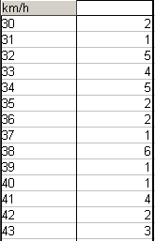
Figure 194: DataPilot without grouping (frequency of the km/h values of a radar control)
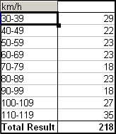
Figure 195: DataPilot with grouping (classes of 10 km/h each)
Choose Data > Group and Outline > Group from the menu bar or press F12; you get the following dialog.
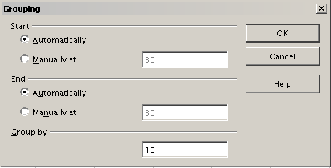
Figure 196: Grouping dialog with scalar categories
You can define in which value range (start/end) the grouping should take place. The default setting is the whole range from smallest to biggest value. In the Grouping after field you can enter the class size, this means the interval size (in this example groups of 10 km/h each).

Grouping of categories with date or time values
For grouping date or time values select a single cell in the column or row of the category that should be grouped. This was demonstrated in all three examples in the section “Examples with step by step instructions” starting on page 219.
With the menu entry Data > Group and Outline > Group or by pressing F12, you get the following dialog.
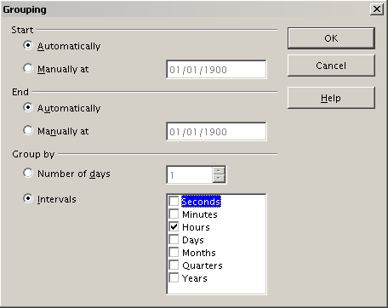
Figure 197: Grouping dialog for categories with dates or times
You can decide in which date or time area (start/end) the grouping should take place. The default setting is the whole area from the earliest to the latest value. In the Group by field you can enter the class size (the interval size), that should be used for grouping.
Possible intervals are: seconds, minutes, hours, days, months, quarters and years. These can be combined, for example grouping of years and within the years according to months.
As alternative you can enter any number of days as grouping interval.
Tip | For grouping the DataPilot in calendar weeks, define the beginning as a Sunday or Monday and manually enter the grouping interval of 7 days.

Grouping without the automatic creation of intervals
If the categories contain text fields, then the automatic creation of intervals isn't possible. You can define for each category of any data type which categories you want to put together in one group.
Every time you use the menu entry Data > Group and Outline > Group or you press F12 and you have more than one cell selected, then all the cells will be selected as one group.
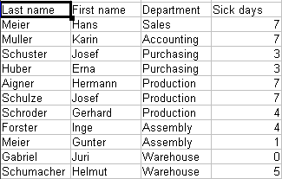
Figure 198: Database with nonscalar categories (departments)
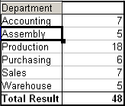
Figure 199: DataPilot with nonscalar categories
For grouping of non scalar categories, select in the result of the DataPilot all single categories that you want to put in one group.
Tip | You can select several non-contiguous cells in one step by pressing and holding the Control key while left-clicking with the mouse.
Choose the Data > Group and Outline > Group from the Menu bar or press F12. Repeat this for all groups that you want to create from the different categories.
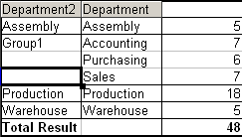
Figure 200: Summary of single categories in one group
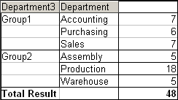
Figure 201: Grouping finished
You can change the automatically given names for the groups and the newly created group field by right-clicking on a name. The DataPilot will remember these settings, even if you change the layout later on. For the following pictures, the dialog was called again (with a right-click) and within the preferences menu the option Automatic was selected.
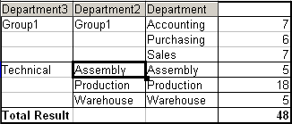
Figure 202: Renamed groups and partial results
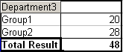
Figure 203: Reduced to the new groups
Note | A well-structured database makes manual sorting within the DataPilot obsolete. In the example shown, you could add another column with the name Department, that has the correct entry for each person based on whether the employee’s department belongs to either the Office or Technical group. The mapping for this (1:n relationship) can be done easily with the VLOOKUP function from Calc.

Sorting the result
The result of any DataPilot is sorted (categories) in columns and rows in an ascending order. You can change the sorting in two ways:
- Sort manually by using drag and drop.
- Sort automatically by choosing the options in the preferences dialog of the row or column field.
Sort manually by using drag and drop
You can change the order within the categories by moving the cells with the category values in the result table of the DataPilot.
Please be aware that in Calc a cell must be selected. It is not enough that this cell contains the cell cursor. The background of a selected cell is marked with a different color. To achieve this, click in one cell with no extra key pressed and redo this by pressing also the Shift or Ctrl key. Another possibility is to keep the mouse button pressed on the cell you want to select, move the mouse to a neighbor cell and move back to your original cell before you release the mouse button.
Sort automatically
- To sort automatically, start the preference options of the row or column field by right-clicking on the table area with the DataPilot result.
- Select Start to open the DataPilot (Figure 151).
- Within the Layout area of the DataPilot, double-click the field you want to sort.
- In the Data Field dialog (Figure 191), click Options to display the Data Field Options dialog (Figure 204).
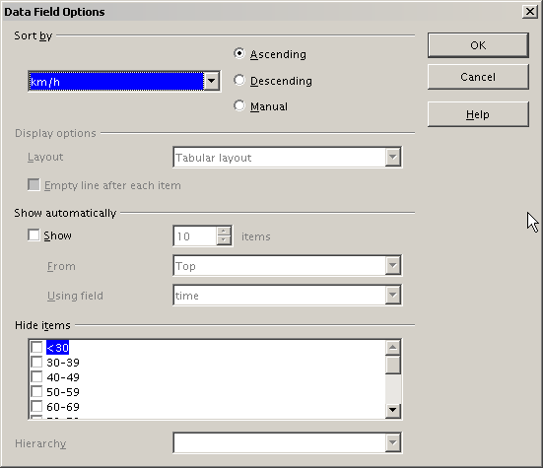
Figure 204: Options for a row or column field
For Sort by select how to display the information, either Ascending or Descending. On the left side is a drop-down list where you can select the field this setting should apply to. With this method you can specify that sorting does not happen according to the categories but according to the results of the data field.

Drilling (showing details)
Drill allows you to show the related detailed data for a single, compressed value in the DataPilot result. To activate a drill, double-click on the cell or choose Data > Group and Outline > Show Details. You have to distinguish two cases:
- The active cell is the category of a row or column field.
In this case drill means an additional breakdown into the categories of another field.
For example, double-click on the cell with the value golfing in the row field region. In this case the values that are aggregated in the golfing category are subdivided according to another field.
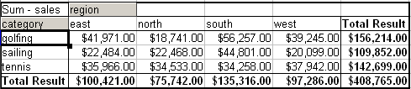
Figure 205: Before the drill down for the category golfing
Since there are more possibilities for subdivision, a dialog appears so you can choose your setting.
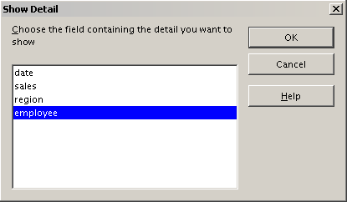
Figure 206: Selection of the field for the subdivision
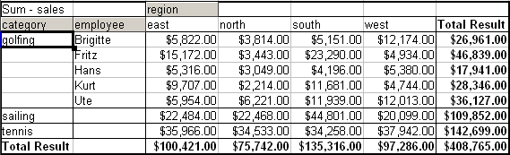
Figure 207: After the drill down
To hide the details again, double-click on the cell containing golfing or choose Data > Group and Outline > Hide Details.
The DataPilot remembers your selection (in our example the employee field), so that for the next drill down for a category in the region field, the dialog does not appear. To remove the employee selection, open the DataPilot dialog by right-clicking and choosing Start, then delete the unwanted selection in the row or column field.
- The active cell is a value of the data field.
In this case drilldown means a listing of all data entries of the data source that aggregates to this value.
Double-click on the cell with the value $18,741 from Figure 205. You now have a new list of all data sets that are included in this value. This list is shown in a new sheet.
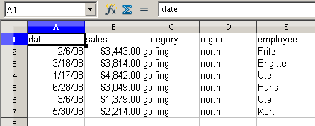
Figure 208: New table sheet after the drilldown for a value in a data field.

Filtering
To limit the DataPilot analysis to a subset of the information that is contained in the data basis, you can filter with the DataPilot.
Note | An Autofilter or default filter used on the sheet has no effect for the analysis of the DataPilot. The DataPilot always uses the complete list that was selected when it was started.
To do this, click Filter on the top left side above the results.
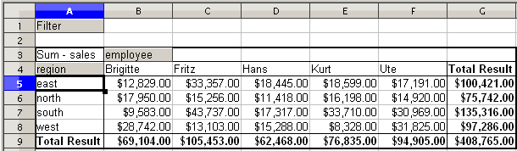
Figure 209: Filter field in the upper left area of the DataPilot
In the Filter dialog, you can define of up to 3 filter options that are used in the same way as Calc’s default filter.
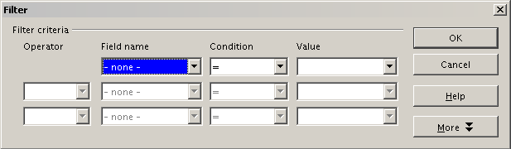
Figure 210: Dialog for defining the filter
Note | Even if they are not called a filter, page fields are a practical way to filter the results. The advantage is that the filtering criteria used are clearly visible.

Updating (refreshing) changed values
After you have created the DataPilot, changes in the source data do not cause an automatic update in the resulting table. You have to always update (refresh) the DataPilot manually.
Changes in the source data could appear in two ways:
- The content of existing data sets has been changed.
For example, you might have changed a sales value afterward. To update the DataPilot, right-click in the result area and choose Refresh (or choose Data > DataPilot > Refresh from the menu bar).
- You have added or deleted data sets in the original list.
In this case the change means that the DataPilot has to use a different area of the spreadsheet for its analysis. A change of the data reference for an existing DataPilot is not possible. You must redo the DataPilot.

Cell formatting
The cells in the results area of the DataPilot are automatically formatted in a simple format by Calc. You can change this formatting using all the tools in Calc, but please note that if you make any change in the design of the DataPilot or any updates, the formatting will return to the that applied automatically by Calc.
For the number format in the data field, Calc uses the number format that is used in the corresponding cell in the source list. In most cases, this is useful (for example, if the values are in the currency format, then the corresponding cell in the result area is also formatted as currency). However, if the result is a fraction or a percentage, the DataPilot does not recognize that this might be a problem; such results must either be without a unit or be displayed as a percentage. Although you can correct the number format manually, the correction stays only until the next update.

Multiple data fields
Until now we have assumed that the layout of the DataPilot contains only one data field. However, it is possible to have several data fields in the middle of the layout. This makes summaries and analyses of multiple aspects possible.
You could, for example, list all the sales values per day and additionally give the number of entries per day. To do this, put both the sales field and the date field into the Data Fields area. For the date field, select the Count-date option for the aggregate function (see Figure 172).
Since every entry has a specific date, this field will give you the number of entries for each date. If you group the values per month, you get an overview with the sales value and the number of closed sales for each category and month (see Figure 170).
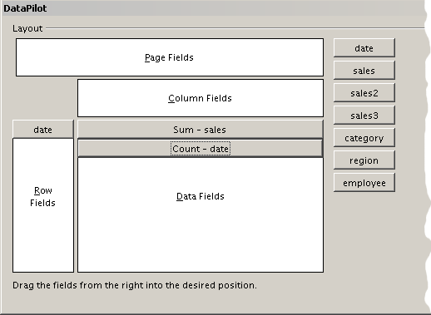
Figure 211: Multiple data fields in the DataPilot
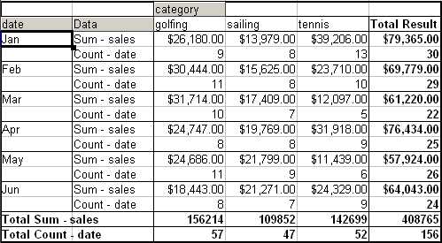
Figure 212: DataPilot shows sales value and number of entries
For manipulating the existing data fields, DataPilot result contains a field called Data. You can move it just like row or column fields by using drag and drop. This is an easy way to archive a different structure for the results (see Figures 213 and 214).
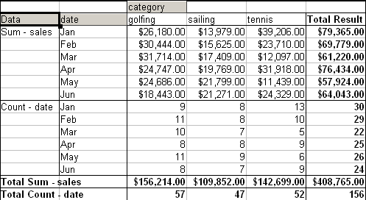
Figure 213: Layout option for presenting the sums and numbers of the sales values
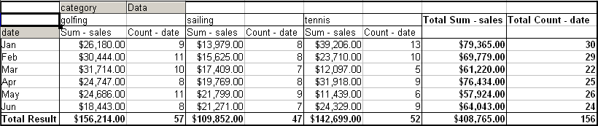
Figure 214: Another layout option for presenting the sums and numbers of the sales values
If you want to put the different data fields in different columns and your DataPilot does not contain another column field or you sort the different data fields in different rows and don’t have another row field, then it is useful to disable the view of the row or column sums
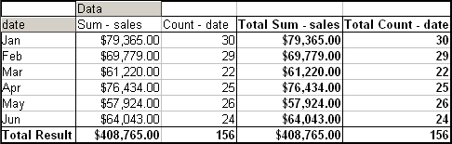
Figure 215: Unnecessary columns
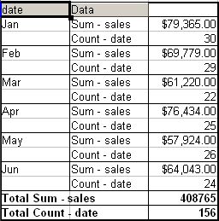
Figure 216: Disabled column sums
A frequent use case for multiple data fields is the aggregation of one value according to different aggregate functions at the same time. You can create a DataPilot that shows you the monthly sales values and shows you additionally the smallest and the largest amounts.
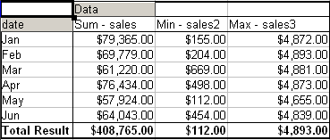
Figure 217: Multiple analyses for the same data field
Unfortunately, Calc does not allow you to use the same data field multiple times. For such multiple analyses you have to duplicate the respective column in the source. This column is then available within the DataPilot; it just happens to have identical values.
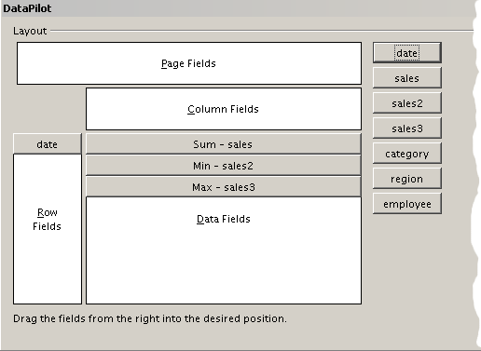
Figure 218: Multiple identical fields for sales value, that have been created as duplicates within your source.

Shortcuts
If you use the DataPilot very often, you might find the frequent use of the menu paths (Data > DataPilot > Start and Data > Group and Outline > Group) inconvenient.
For grouping, a shortcut is already defined: F12. For starting the DataPilot, you can define your own keyboard shortcut. If you prefer to have toolbar icons instead of keyboard shortcuts, you can create a user-defined symbol and add it to either your own custom made toolbar or the Standard toolbar.
For an explanation how to create keyboard shortcuts or add icons to toolbars, see Chapter 14 (Setting Up and Customizing Calc).

Function GETPIVOTDATA
The function GETPIVOTDATA can be used with formulas in Calc if you want to reuse the results from the DataPilot elsewhere in your spreadsheet.

Difficulty
Normally you create a reference to a value by entering the address of the cell that contains the value. For example, the formula =C6*2 creates a reference to cell C6 and returns the doubled value.
If this cell is located in the results area of the DataPilot, it contains the result that was calculated by referencing specific categories of the row and column fields. In Figure 219, the cell C6 contains the sum of the sales values of the employee Hans in the category Sailing. The formula in the cell C12 uses this value.
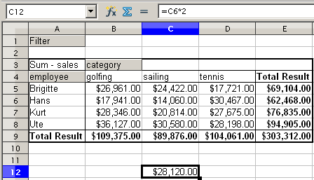
Figure 219: Formula reference to a cell of the DataPilot
If the underlying data or the layout of the DataPilot changes, then you must take into account that the sales value for Hans might appear in a different cell. Your formula still references the cell C6 and therefore uses a wrong value. The correct value is in a different location. For example, in Figure 220, the location is now C7.
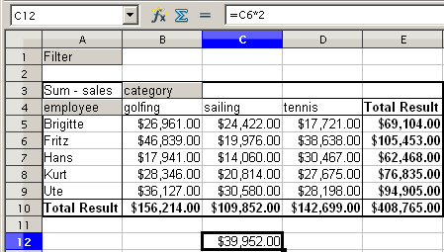
Figure 220: The value that you really want to use can be found now in a different location.
The function GETPIVOTDATA allows you to have a reference to a value inside the DataPilot by using the specific identifying categories for this value.

Syntax
The syntax has two variations:
GETPIVOTDATA(target field, DataPilot; [ Field name / Element; ... ])
GETPIVOTDATA(DataPilot; specification)

First syntax variation
The target field to specify which data field of the DataPilot is used within the function. If your DataPilot has only one data field, this entry is ignored, but you must enter it anyway.
If your DataPilot has more than one data field, then you have to enter the field name from the underlying data source (for example “sales value”) or the field name of the data field itself (for example “sum – sales value”).
The argument DataPilot specifies the DataPilot that you want to use. It is possible that your document contains more than one DataPilot. Enter here a cell reference that is inside the results area of your DataPilot. It might be a good idea to always use the upper left corner cell of your DataPilot, so you can be sure that the cell will always be within your DataPilot even if the layout changes.
Example: GETPIVOTDATA("sales value";A1)
If you enter only the first two arguments, then the function returns the total result of the DataPilot.
You can add more arguments as pairs with field name and element to retrieve specific partial sums. In the example in Figure 221, where we want to get the partial sum of Hans for sailing, the formula in cell C12 would look like this:
=GETPIVOTDATA("sales value";A1;"employee";"Hans";"category";"sailing")
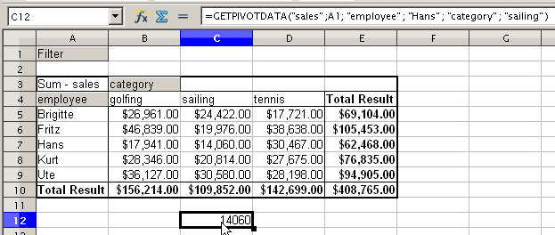Figure 221: First syntax variation

Second syntax variation
The argument DataPilot has to be given in the same way as for the other syntax variation.
For the specifications, enter a list separated by spaces to specify the value you want from the DataPilot. This list must contain the name of the data field, if there is more than one data field, otherwise it is not required. To select a specific partial result, add more entries in the form of Field name[element].
In the example in Figure 222, where we want to get the partial sum of Hans for Sailing, the formula in cell C12 would look like this:
=GETPIVOTDATA(A1;"sales value employee[Hans] category[sailing]")
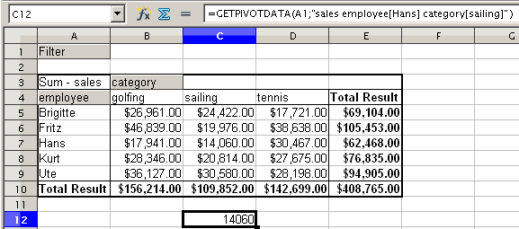Figure 222: Second syntax variation

Calc Guide

Chapter 9
Data Analysis
Using Scenarios, Goal Seek, Solver, others
This PDF is designed to be read onscreen, two pages at a time. If you want to print a copy, your PDF viewer should have an option for printing two pages on one sheet of paper, but you may need to start with page 2 to get it to print facing pages correctly. (Print this cover page separately.)

Copyright
This document is Copyright © 2007–2010 by its contributors as listed in the section titled Authors. You may distribute it and/or modify it under the terms of either the GNU General Public License, version 3 or later, or the Creative Commons Attribution License, version 3.0 or later.
All trademarks within this guide belong to their legitimate owners.
Authors
Jean Hollis Weber
Nikita Telang
James Andrew
Claire Wood
Feedback
Please direct any comments or suggestions about this document to: authors@documentation.openoffice.org
Acknowledgments
Some of this chapter is based on articles originally written by Bruce Byfield and first published on the Linux Journal website. Some examples are taken from the OOo Help.
Publication date and software version
Published 17 June 2010. Based on OpenOffice.org 3.2.
Contents
Copyright 2
Introduction 4
Consolidating data 4
Creating subtotals 7
Using “what if” scenarios 9
Creating scenarios 9
Settings 10
Changing scenarios 11
Changing scenario properties 11
Changing scenario cell values 12
Working with scenarios using the Navigator 12
Tracking values in scenarios 13
Using other “what if” tools 13
Multiple operations in columns or rows 15
Calculating with one formula and one variable 15
Calculating with several formulas simultaneously 17
Multiple operations across rows and columns 19
Calculating with two variables 19
Working backwards using Goal Seek 20
Goal Seek example 21
Using the Solver 22
Solver example 23

Introduction
Once you are familiar with functions and formulas, the next step is to learn how to use Calc's automated processes to quickly perform useful analysis of your data.
Calc includes several tools to help you manipulate the information in your spreadsheets, ranging from features for copying and reusing data, to creating subtotals automatically, to varying information to help you find the answers you need. These tools are divided between the Tools and Data menus.
If you are a newcomer to spreadsheets, these tools can be overwhelming at first. However, they become simpler if you remember that they all depend on input from either a cell or a range of cells that contain the data with which you are working.
You can always enter the cells or range manually, but in many cases it is easier to select the cells with the mouse. Click the Shrink/Maximize icon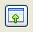 beside a field to temporarily reduce the size of the tool’s window, so you can see the spreadsheet underneath and select the cells required.
Sometimes, you may have to experiment with which data goes into which field, but, once you have found out, you then set a selection of options, many of which can be ignored in any given case. Just keep the basic purpose of each tool in mind, and you should have little trouble with Calc’s function tools.
You don’t need to learn them, especially if your spreadsheet use is simple, but as your manipulation of data becomes more sophisticated, they can save time in making calculations, especially as you start to deal with hypothetical situations. Just as importantly, they can allow you to preserve your work and to share it with other people—or yourself at a later session.
One function tool not mentioned here are DataPilots (also known as pivot tables), but they are a topic that is sufficiently complex that it requires a separate chapter. (See Chapter 8.)

Consolidating data
Data > Consolidate provides a way to combine data from two or more ranges of cells into a new range while running one of several functions (such as Sum or Average) on the data. During consolidation, the contents of cells from several sheets can be combined into one place.
- Open the document containing the cell ranges to be consolidated.
- Choose Data > Consolidate to open the Consolidate dialog. Figure 223 shows this dialog after making the changes described below.
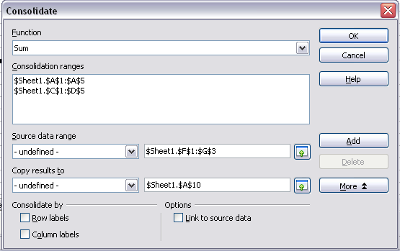Figure 223: Defining the data to be consolidated
- The Source data range list contains any existing named ranges (created using Data > Define Range) so you can quickly select one to consolidate with other areas.
If the source range is not named, click in the field to the right of the drop-down list and either type a reference for the first source data range or use the mouse to select the range on the sheet. (You may need to move the Consolidate dialog or click on the Shrink icon to reach the required cells.)
- Click Add. The selected range is added to the Consolidation ranges list.
- Select additional ranges and click Add after each selection.
- Specify where you want to display the result by selecting a target range from the Copy results to drop-down list.
If the target range is not named, click in the field next to Copy results to and enter the reference of the target range or select the range using the mouse or position the cursor in the top left cell of the target range. Copy results to takes only the first cell of the target range instead of the entire range as is the case for Source data range.
- Select a function from the Function list. This specifies how the values of the consolidation ranges will be calculated. The default setting is Sum, which adds the corresponding cell values of the Source data range and gives the result in the target range.
Most of the available functions are statistical (such as Average, Min, Max, Stdev), and the tool is most useful when you are working with the same data over and over.
- At this point you can click More in the Consolidate dialog to access the following additional settings:
  - Select Link to source data to insert the formulas that generate the results into the target range, rather than the actual results. If you link the data, any values modified in the source range are automatically updated in the target range.
Caution | The corresponding cell references in the target range are inserted in consecutive rows, which are automatically ordered and then hidden from view. Only the final result, based on the selected function, is displayed.
  - Under Consolidate by, select either Row labels or Column labels if the cells of the source data range are not to be consolidated corresponding to the identical position of the cell in the range, but instead according to a matching row label or column label. To consolidate by row labels or column labels, the label must be contained in the selected source ranges. The text in the labels must be identical, so that rows or columns can be accurately matched. If the row or column label of one source data range does not match any that exist in other source data ranges, it is added to the target range as a new row or column.
- Click OK to consolidate the ranges.
- If you are continually working with the same range, then you probably want to use Data > Define Range to give it a name.
The consolidation ranges and target range are saved as part of the document. If you later open a document in which consolidation has been defined, this data is still available.

Creating subtotals
SUBTOTAL is a function listed under the Mathematical category when you use the Function Wizard (Insert > Function). Because of its usefulness, the function has a graphical interface accessible from Data > Subtotals.
As the name suggests, SUBTOTAL totals data arranged in an array—that is, a group of cells with labels for columns. Using the Subtotals dialog, you can select up to three arrays, then choose a statistical function to apply to them. When you click OK, Calc adds subtotal and grand total rows to the selected arrays, using the Result and Result2 cell styles to differentiate those entries. By default, matching items throughout your array will be gathered together as a single group above a subtotal.
To insert subtotal values into a sheet:
- Ensure that the columns have labels.
- Select the range of cells that you want to calculate subtotals for, and then choose Data > Subtotals.
- In the Subtotals dialog, in the Group by list, select the column by which the subtotals need to be grouped. A subtotal will be calculated for each distinct value in this column.
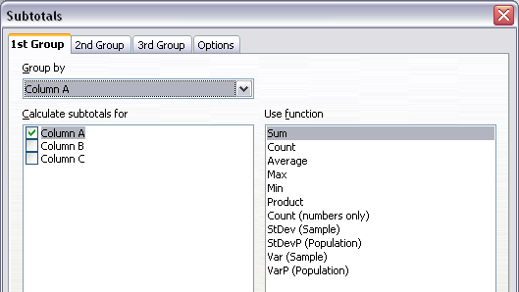Figure 224: Setting up subtotals
- In the Calculate subtotals for box, select the columns containing the values that you want to create subtotals for. If the contents of the selected columns change later, the subtotals are automatically recalculated.
- In the Use function box, select the function that you want to use to calculate the subtotals.
- Click OK.
If you use more than one group, then you can also arrange the subtotals according to choices made on the dialog’s Options page, including ascending and descending order or using one of the predefined custom sorts defined in Tools > Options > OpenOffice.org Calc > Sort Lists.
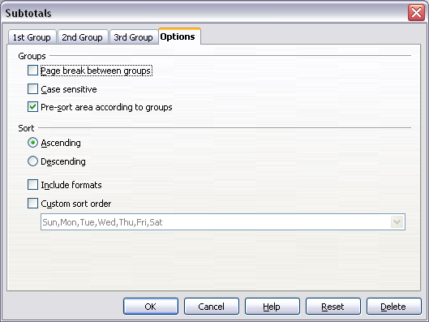Figure 225: Choosing options for subtotals

Using “what if” scenarios
Scenarios are a tool to test “what-if” questions. Each scenario is named, and can be edited and formatted separately. When you print the spreadsheet, only the contents of the currently active scenario are printed.
A scenario is essentially a saved set of cell values for your calculations. You can easily switch between these sets using the Navigator or a drop-down list which can be shown beside the changing cells. For example, if you wanted to calculate the effect of different interest rates on an investment, you could add a scenario for each interest rate, and quickly view the results. Formulas that rely on the values changed by your scenario are updated when the scenario is opened. If all your sources of income used scenarios, you could efficiently build a complex model of your possible income.

Creating scenarios
Tools > Scenarios opens a dialog with options for creating a scenario.
To create a new scenario:
- Select the cells that contain the values that will change between scenarios. To select multiple ranges, hold down the Ctrl key as you click. You must select at least two cells.
- Choose Tools > Scenarios.
- On the Create Scenario dialog (Figure 226), enter a name for the new scenario. It’s best to use a name that clearly identifies the scenario, not the default name as shown in the illustration. This name is displayed in the Navigator and in the title bar of the border around the scenario on the sheet itself.
- Optionally add some information to the Comment box. The example shows the default comment. This information is displayed in the Navigator when you click the Scenarios icon and select the desired scenario.
- Optionally select or deselect the options in the Settings section. See page 278 for more information about these options.
- Click OK to close the dialog. The new scenario is automatically activated.
You can create several scenarios for any given range of cells.
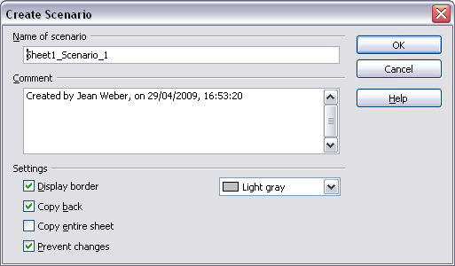Figure 226: Creating a scenario

Settings
The lower portion of the Create Scenario dialog contains several options. The default settings (as shown in Figure 226) are likely to be suitable in most situations.
Display border
Places a border around the range of cells that your scenario alters. To choose the color of the border, use the field to the right of this option. The border has a title bar displaying the name of the active scenario. Click the arrow button to the right of the scenario name to open a drop-down list of all the scenarios that have been defined for the cells within the border. You can choose any of the scenarios from this list at any time.
Copy back
Copies any changes you make to the values of scenario cells back into the active scenario. If you do not select this option, the saved scenario values are never changed when you make changes. The actual behavior of the Copy back setting depends on the cell protection, the sheet protection, and the Prevent changes setting (see Table 11 on page 280).
Caution | If you are viewing a scenario which has Copy back enabled and then create a new scenario by changing the values and selecting Tools > Scenarios, you also inadvertently overwrite the values in the first scenario.  This is easily avoided if you leave the current values alone, create a new scenario with Copy back enabled, and then change the values only when you are viewing the new scenario.
Copy entire sheet
Adds to your document a sheet that permanently displays the new scenario in full. This is in addition to creating the scenario and making it selectable on the original sheet as normal.
Prevent changes
Prevents changes to a Copy back-enabled scenario when the sheet is protected but the cells are not. Also prevents changes to the settings described in this section while the sheet is protected. A fuller explanation of the effect this option has in different situations is given below.

Changing scenarios
Scenarios have two aspects which can be altered independently:
- Scenario properties (the settings described above)
- Scenario cell values (the entries within the scenario border)
The extent to which either of these aspects can be changed is dependent upon both the existing properties of the scenario and the current protection state of the sheet and cells.

Changing scenario properties
If the sheet is protected (Tools > Protect Document > Sheet), and Prevent changes is selected then scenario properties cannot be changed.
If the sheet is protected, and Prevent changes is not selected, then all scenario properties can be changed except Prevent changes and Copy entire sheet, which are disabled.
If the sheet is not protected, then Prevent changes does not have any effect, and all scenario properties can be changed.

Changing scenario cell values
Table 11 summarizes the interaction of various settings in preventing or allowing changes in scenario cell values.
Table 11: Prevent changes behavior for scenario cell value changes
Settings | Change allowed
Sheet protection ON  Scenario cell protection OFF  Prevent changes ON  Copy back ON | Scenario cell values cannot be changed.
Sheet protection ON  Scenario cell protection OFF  Prevent changes OFF  Copy back ON | Scenario cell values can be changed, and the scenario is updated.
Sheet protection ON  Scenario cell protection OFF  Prevent changes ON or OFF  Copy back OFF | Scenario cell values can be changed, but the scenario is not updated due to the Copy back setting.
Sheet protection ON  Scenario cell protection ON  Prevent changes ANY SETTING  Copy back ANY SETTING | Scenario cell values cannot be changed.
Sheet protection OFF  Scenario cell protection ANY SETTING  Prevent changes ANY SETTING  Copy back ANY SETTING | Scenario cell values can be changed and the scenario is updated or not, depending on the Copy back setting.

Working with scenarios using the Navigator
After scenarios are added to a spreadsheet, you can jump to a particular scenario by selecting it from the list in the Navigator.
To find a scenario in the Navigator, click the Scenarios icon in the Navigator. The defined scenarios are listed, along with the comments that were entered when the scenarios were created.
To apply a scenario to the current sheet, double-click the scenario name in the Navigator.
To delete a scenario, right-click the name in the Navigator and choose Delete.
To edit a scenario, including its name and comments, right-click the name in the Navigator and choose Properties. The Edit Properties dialog is the same as the Create Scenario dialog (Figure 226).
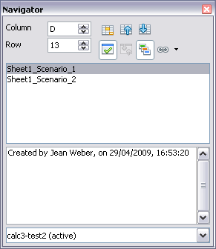Figure 227: Scenarios in the Navigator

Tracking values in scenarios
To learn which values in the scenario affect other values, choose Tools > Detective > Trace Dependents. Arrows point to the cells that are directly dependent on the current cell.

Using other “what if” tools
Like scenarios, Data > Multiple Operations is a planning tool for “what if” questions. Unlike a scenario, the Multiple Operations tool does not present the alternate versions in the same cells or with a drop-down list. Instead, the Multiple Operations tool creates a formula array: a separate set of cells showing the results of applying the formula to a list of alternative values for the variables used by the formula. Although this tool is not listed among the functions, it is really a function that acts on other functions, allowing you to calculate different results without having to enter and run them separately.
To use the Multiple Operations tool, you need two arrays of cells. The first array contains the original or default values and the formulas applied to them. The formulas must be in a range.
The second array is the formula array. It is created by entering a list of alternative values for one or two of the original values.
Once the alternative values are created, you use the Multiple Operations tool to specify which formulas you are using, as well as the original values used by the formulas. The second array is then filled with the results of using each alternative value in place of the original values.
The Multiple Operations tool can use any number of formulas, but only one or two variables. With one variable, the formula array of alternative values for the variables will be in a single column or row. With two variables, you should outline a table of cells such that the alternative values for one variable are arranged as column headings, and the alternative values for the other variable act as row headings.
Setting up multiple operations can be confusing at first. For example, when using two variables, you need to select them carefully, so that they form a meaningful table. Not every pair of variables is useful to add to the same formula array. Yet, even when working with a single variable, a new user can easily make mistakes or forget the relationships between cells in the original array and cells in the formula array. In these situations, Tools > Detective can help to clarify the relations.
You can also make formula arrays easier to work with if you apply some simple design logic. Place the original and the formula array close together on the same sheet, and use labels for the rows and columns in both. These small exercises in organizational design make working with the formula array much less painful, particularly when you are correcting mistakes or adjusting results.
Note | If you export a spreadsheet containing multiple operations to Microsoft Excel, the location of the cells containing the formula must be fully defined relative to the data range.

Multiple operations in columns or rows
In your spreadsheet, enter a formula to calculate a result from values that are stored in other cells. Then, set up a cell range containing a list of alternatives for one of the values used in the formula. The Multiple Operations command produces a list of results adjacent to your alternative values by running the formula against each of these alternatives.
Note | Before you choose the Data > Multiple Operations option, be sure to select not only your list of alternative values but also the adjacent cells into which the results should be placed.
In the Formulas field of the Multiple Operations dialog, enter the cell reference to the formula that you wish to use.
The arrangement of your alternative values dictates how you should complete the rest of the dialog. If you have listed them in a single column, you should complete the field for Column input cell. If they are along a single row, complete the Row input cell field. You may also use both in more advanced cases. Both single and double-variable versions are explained below.
The above can be explained best by examples. Cell references correspond to those in the following figures.
Let’s say you produce toys that you sell for $10 each (cell B1). Each toy costs $2 to make (cell B2), in addition to which you have fixed costs of $10,000 per year (cell B3). How much profit will you make in a year if you sell a particular number of toys?

Calculating with one formula and one variable
- To calculate the profit, first enter any number as the quantity (items sold); in this example, 2000 (cell B4). The profit is found from the formula Profit=Quantity * (Selling price – Direct costs) – Fixed costs. Enter this formula in B5: =B4*(B1-B2)-B3.
- In column D enter a variety of alternative annual sales figures, one below the other; for example, 500 to 5000, in steps of 500.
- Select the range D2:E11, and thus the values in column D and the empty cells (which will receive the results of the calculations) alongside in column E.
- Choose Data > Multiple Operations.
- With the cursor in the Formulas field of the Multiple operations dialog, click cell B5.
- Set the cursor in the Column input cell field and click cell B4. This means that B4, the quantity, is the variable in the formula, which is to be replaced by the column of alternative values. Figure 228 shows the worksheet and the Multiple operations dialog.
- Click OK. The profits for the different quantities are now shown in column E. See Figure 229.
Tip | You may find it easier to mark the required reference in the sheet if you click the Shrink icon to reduce the Multiple operations dialog to the size of the input field. The icon then changes to the Maximize icon; click it to restore the dialog to its original size.
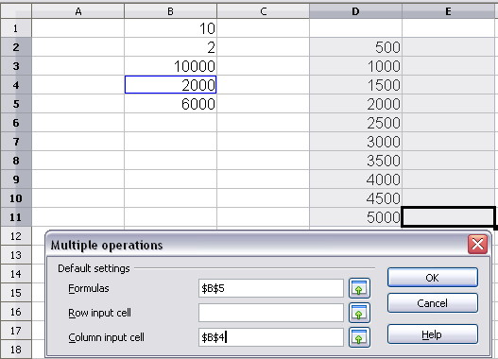
Figure 228: Sheet and Multiple operations dialog showing input
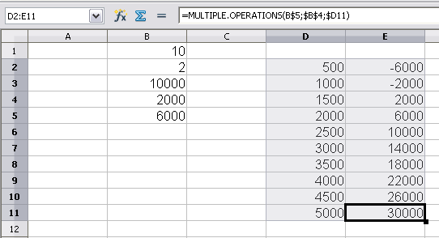
Figure 229: Sheet showing results of multiple operations calculations

Calculating with several formulas simultaneously
- In the sheet from the previous example, delete the contents of column E.
- Enter the following formula in C5: =B5/B4. You are now calculating the annual profit per item sold.
- Select the range D2:F11, thus three columns.
- Choose Data > Multiple Operations.
- With the cursor in the Formulas field of the Multiple operations dialog, select cells B5 and C5.
- Set the cursor in the Column input cell field and click cell B4. Figure 230 shows the worksheet and the Multiple operations dialog.
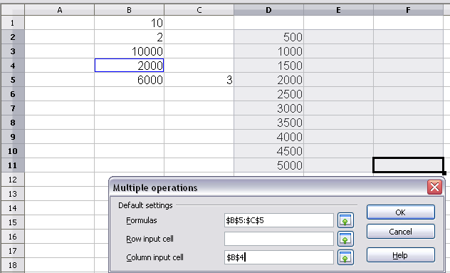Figure 230: Sheet and dialog showing input
- Click OK. Now the profits are listed in column E and the annual profit per item in column F.
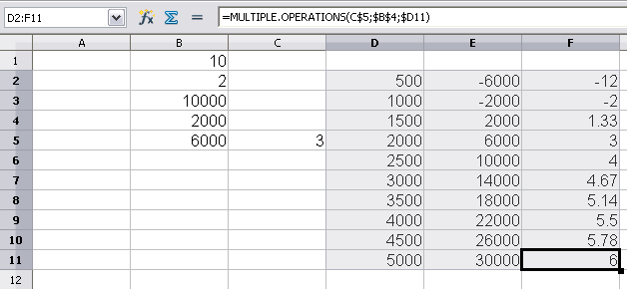Figure 231: Results of multiple operations calculations

Multiple operations across rows and columns
You can carry out multiple operations simultaneously for both columns and rows in so-called cross-tables. The formula must use at least two variables, the alternative values for which should be arranged so that one set is along a single row and the other set appears in a single column. These two sets of alternative values will form column and row headings for the results table produced by the Multiple Operations procedure.
Select the range defined by both data ranges (thus including all of the blank cells that are to contain the results) and choose Data > Multiple operations. Enter the cell reference to the formula in the Formulas field. The Row input cell and the Column input cell fields are used to enter the reference to the corresponding cells of the formula.
Caution | Beware of entering the cell reference of a variable into the wrong field. The Row input cell field should contain not the cell reference of the variable which changes down the rows of your results table, but that of the variable whose alternative values have been entered along a single row.

Calculating with two variables
You now want to vary not just the quantity produced annually, but also the selling price, and you are interested in the profit in each case.
Expand the table shown in Figure 230 above. D2 thru D11 already contain the numbers 500, 1000 and so on, up to 5000. In E1 through H1 enter the numbers 8, 10, 15 and 20.
- Select the range D1:H11.
- Choose Data > Multiple Operations.
- With the cursor in the Formulas field of the Multiple operations dialog, click cell B5 (profit).
- Set the cursor in the Row input cell field and click cell B1. This means that B1, the selling price, is the horizontally entered variable (with the values 8, 10, 15 and 20).
- Set the cursor in the Column input cell field and click cell B4. This means that B4, the quantity, is the vertically entered variable.
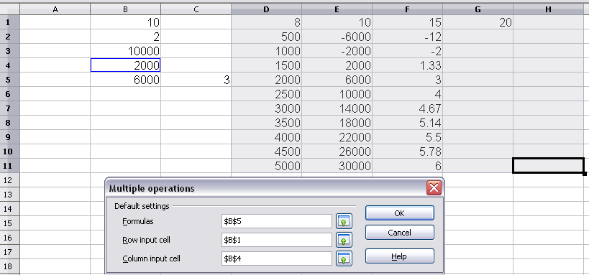Figure 232: Sheet and dialog showing input
- Click OK. The profits for the different selling prices are now shown in the range E2:H11.
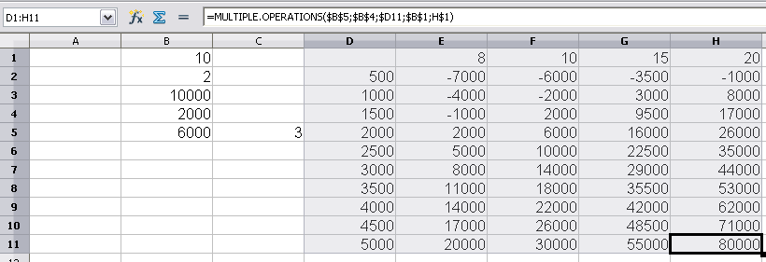Figure 233: Results of multiple operations calculations

Working backwards using Goal Seek
Usually, you create a formula to calculate a result based upon existing values. By contrast, using Tools > Goal Seek you can discover what values will produce the result that you want.
To take a simple example, imagine that the Chief Financial Officer of a company is developing sales projections for each quarter of the forthcoming year. She knows what the company’s total income must be for the year to satisfy stockholders. She also has a good idea of the company’s income in the first three quarters, because of the contracts that are already signed. For the fourth quarter, however, no definite income is available. So how much must the company earn in Q4 to reach its goal? The CFO can enter the projected earnings for each of the other three quarters along with a formula that totals all four quarters. Then she runs a goal seek on the empty cell for Q4 sales, and receives her answer.
Other uses of goal seek may be more complicated, but the method remains the same. Only one argument can be altered in a single goal seek.

Goal Seek example
To calculate annual interest (I), create a table with the values for the capital (C), number of years (n), and interest rate (i). The formula is I = C*n*i.
Let us assume that the interest rate i of 7.5% and the number of years n (1) will remain constant. However, you want to know how much the investment capital C would have to be modified in order to attain a particular return I. For this example, calculate how much capital C would be required if you want an annual return of $15,000.
Enter each of the values mentioned above into adjacent cells (for Capital, C, an arbitrary value like $100,000 or it can be left blank; for number of years, n, 1; for interest rate, i, 7.5%). Enter the formula to calculate the interest, I, in another cell. Instead of C, n, and i, use the reference to the cell with the corresponding value. In our example (Figure 231), this would be =B1*B2*B3.
- Place the cursor in the formula cell (B4), and choose Tools > Goal Seek.
- In the Goal Seek dialog, the correct cell is already entered in the Formula cell field.
- Place the cursor in the Variable cell field. In the sheet, click in the cell that contains the value to be changed, in this example it is B1.
- Enter the desired result of the formula in the Target value field. In this example, the value is 15000. Figure 234 shows the cells and fields.
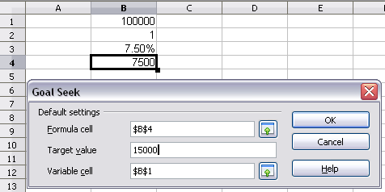Figure 234: Example setup for goal seek
- Click OK. A dialog appears informing you that the Goal Seek was successful. Click Yes to enter the goal value into the variable cell. The result is shown below.
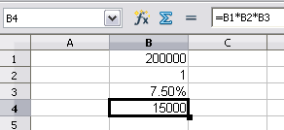Figure 235: Result of goal seek operation

Using the Solver
Tools > Solver amounts to a more elaborate form of Goal Seek. The difference is that the Solver deals with equations with multiple unknown variables. It is specifically designed to minimize or maximize the result according to a set of rules that you define.
Each of these rules defines whether an argument in the formula should be greater than, less than, or equal to the figure you enter. If you want the argument to remain unchanged, you must enter a rule that specifically states that the cell should be equal to its current entry. For arguments that you would like to change, you need to add two rules to define a range of possible values: the limiting conditions. For example, you can set the constraint that one of the variables or cells must not be bigger than another variable, or not bigger than a given value. You can also define the constraint that one or more variables must be integers (values without decimals), or binary values (where only 0 and 1 are allowed).
Once you have finished setting up the rules, click the Solve button to begin the automatic process of adjusting values and calculating results. Depending on the complexity of the task, this may take some time.

Solver example
Let’s say you have $10,000 that you want to invest in two mutual funds for one year. Fund X is a low risk fund with 8% interest rate and Fund Y is a higher risk fund with 12% interest rate. How much money should be invested in each fund to earn a total interest of $1000?
To find the answer using Solver:
- Enter labels and data:
  - Row labels: Fund X, Fund Y, and total, in cells A2 thru A4.
  - Column labels: interest earned, amount invested, interest rate, and time period, in cells B1 thru E1.
  - Interest rates: 8 and 12, in cells D2 and D3.
  - Time period: 1, in cells E2 and E3.
  - Total amount invested: 10000, in cell C4.
- Enter an arbitrary value (0 or leave blank) in cell C2 as amount invested in Fund X.
- Enter formulas:
  - In cell C3, enter the formula C4–C2 (total amount – amount invested in Fund X) as the amount invested in Fund Y.
  - In cells B2 and B3, enter the formula for calculating the interest earned (see Figure 236).
  - In cell B4, enter the formula B2+B3 as the total interest earned.
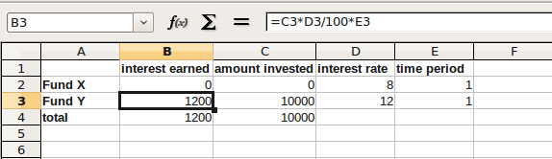Figure 236: Example setup for Solver
- Choose Tools > Solver. The Solver dialog opens.
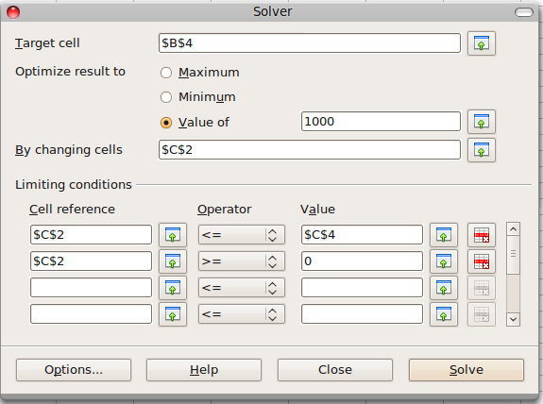Figure 237: The Solver dialog
- Click in the Target cell field. In the sheet, click in the cell that contains the target value. In this example it is cell B4 containing total interest value.
- Select Value of and enter 1000 in the field next to it. In this example, the target cell value is 1000 because your target is a total interest earned of $1000. Select Maximum or Minimum if the target cell value needs to be one of those extremes.
- Click in the By changing cells field and click on cell C2 in the sheet. In this example, you need to find the amount invested in Fund X (cell C2).
- Enter limiting conditions for the variables by selecting the Cell reference, Operator and Value fields. In this example, the amount invested in Fund X (cell C2) should not be greater than the total amount available (cell C4) and should not be less than 0.
- Click OK. A dialog appears informing you that the Solving successfully finished. Click Keep Result to enter the result in the cell with the variable value. The result is shown in Figure 238.
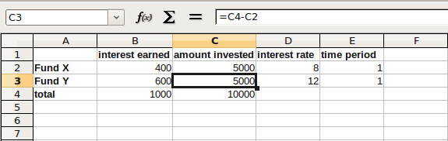Figure 238: Result of Solver operation
Note | The default solver supports only linear equations. For nonlinear programming requirements, try the EuroOffice Solver or Sun’s Solver for Nonlinear Programming [Beta]. Both are available from the OpenOffice.org extensions repository. (For more about extensions, see Chapter 14 (Setting up and Customizing Calc.)

Calc Guide

Chapter 10
Linking Calc Data
Sharing data in and out of Calc
This PDF is designed to be read onscreen, two pages at a time. If you want to print a copy, your PDF viewer should have an option for printing two pages on one sheet of paper, but you may need to start with page 2 to get it to print facing pages correctly. (Print this cover page separately.)

Copyright
This document is Copyright © 2006–2010 by its contributors as listed in the section titled Authors. You may distribute it and/or modify it under the terms of either the GNU General Public License, version 3 or later, or the Creative Commons Attribution License, version 3.0 or later.
All trademarks within this guide belong to their legitimate owners.
Authors
John Kane
Peter Kupfer
Iain Roberts
Rob Scott
Nikita Telang
Jean Hollis Weber
James Andrew
Claire Wood
Feedback
Please direct any comments or suggestions about this document to: authors@documentation.openoffice.org
Publication date and software version
Published 17 June 2010. Based on OpenOffice.org 3.2.
Contents
Copyright 2
Why use multiple sheets? 5
Setting up multiple sheets 5
Identifying sheets 5
Inserting new sheets 6
Inserting sheets from a different spreadsheet 7
Renaming sheets 8
Referencing other sheets 9
Creating the reference with the mouse 9
Creating the reference with the keyboard 11
Referencing other documents 11
Creating the reference with the mouse 11
Creating the reference with the keyboard 12
Hyperlinks and URLs 13
Relative and absolute hyperlinks 13
Creating hyperlinks 14
Editing hyperlinks 16
Removing hyperlinks 16
Linking to external data 17
Using the External Data dialog 17
Using the Navigator 18
How to find the required data range or table 20
Linking to registered data sources 22
Viewing data sources 24
Editing data sources 24
Launching Base to work on data sources 25
Using data sources in Calc spreadsheets 25
Embedding spreadsheets 26
Object Linking and Embedding (OLE) 26
Other OLE objects 28
Non-linked OLE object 29
Linked OLE object 29
Dynamic Data Exchange (DDE) 30
DDE link in Calc 30
DDE link in Writer 31

Why use multiple sheets?
Chapter 1 introduced the concept of multiple sheets in a spreadsheet. Multiple sheets help keep information organized; once you link those sheets together, you unleash the full power of Calc. Consider this case.
John is having trouble keeping track of his personal finances. He has several bank accounts and the information is scattered and disorganized. He can’t get a good grasp on his finances until he can see everything at once.
To resolve this, John decided to track his finances in OOo Calc. John knows Calc can do simple mathematical computations to help him keep a running tab of his accounts, and he wants to set up a summary sheet so that he can see all of his account balances at once.
This can be accomplished easily.
Note | For users with experience using Microsoft Excel, a Calc sheet is called either a sheet or worksheet in Excel. What Excel calls a workbook, Calc calls a spreadsheet (the whole document).

Setting up multiple sheets
Chapter 1 gives a detailed explanation of how to set up multiple sheets in a spreadsheet. Here is a quick review.

Identifying sheets
When you open a new spreadsheet it has, by default, three sheets named Sheet1, Sheet2, and Sheet3. Sheets in Calc are managed using tabs at the bottom of the spreadsheet, as shown below.
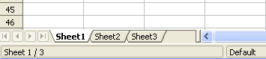Figure 239: Default sheet tabs

Inserting new sheets
There are several ways to insert a new sheet. The first step, in all cases, is to select the sheet that will be next to the new sheet. Then do any of the following:
- Select Insert > Sheet from the menu bar, or
- Right-click on the tab and select Insert Sheet, or
- Click in an empty space at the end of the line of sheet tabs.

Figure 240: Creating a new sheet
Click here to create a new sheet
Each method opens the Insert Sheet dialog. Here you can choose to put the new sheet before or after the selected sheet and how many sheets to insert.
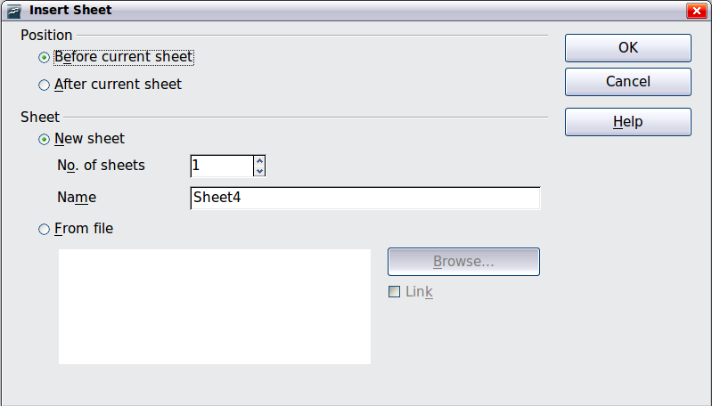
Figure 241. Insert Sheet dialog
We need 6 sheets, one for each of the 5 accounts and one as a summary sheet so we will add 3 more. We also want to name each of these sheets for the account they represent: Summary, Checking Account, Savings Account, Credit Card 1, Credit Card 2, and Car Loan.
We have two choices: insert 3 new sheets and rename all 6 sheets afterwards; or rename the existing sheets, then insert the 3 new sheets one at a time, renaming each new sheet during the insert step.
To insert sheets and rename afterwards:
- In the Insert Sheet dialog, choose the position for the new sheets (in this example, we use After current sheet).
- Choose New sheet and 3 as the No. of sheets. (Three sheets are already provided by default.) Because you are inserting more than one sheet, the Name box is not available.
- Click OK to insert the sheets.
- For the next steps, go to “Renaming sheets” on page 298.
To insert sheets and name them at the same time:
- Rename the existing sheets Summary, Checking Account, and Savings Account, as described in “Renaming sheets” on page 298.
- In the Insert Sheet dialog, choose the position for the first new sheet.
- Choose New sheet and 1 as the No. of sheets. The Name box is now available.
- In the Name box, type a name for this new sheet, for example Credit Card 1.
- Click OK to insert the sheet.
- Repeat steps 1–4 for each new sheet, giving them the names Credit Card 2 and Car Loan.

Inserting sheets from a different spreadsheet
On the Insert Sheet dialog, you can also add a sheet from a different spreadsheet file (for example, another Calc or Excel spreadsheet), by choosing the From file option. Click Browse and select the file; a list of the available sheets appears in the box. Select the sheet to import. If, after you select the file, no sheets appear you probably selected an invalid file type (not a spreadsheet, for example).
Tip | For a shortcut to inserting a sheet from another file, choose Insert > Sheet from file from the menu bar. The Insert Sheet dialog opens with the From file option preselected, and then the Insert dialog opens on top of it.
If you prefer, select the Link option to insert the external sheet as a link instead as a copy. This is one of several ways to include “live” data from another spreadsheet. (See also “Linking to external data” on page 307.) The links can be updated manually to show the current contents of the external file; or, depending on the options you have selected in Tools > Options > OpenOffice.org Calc > General > Updating, whenever the file is opened.

Renaming sheets
Sheets can be renamed at any time. To give a sheet a more meaningful name:
- Enter the name in the name box when you create the sheet, or
- Double click on the sheet tab, or
- Right-click on a sheet tab, select Rename Sheet from the pop-up menu and replace the existing name.
Note | If you want to save the spreadsheet to Microsoft Excel format, the following characters are not allowed in sheet names: \ / ? * [ ] : and ' as the first or last character of the name.
Your sheet tab area should now look like this.
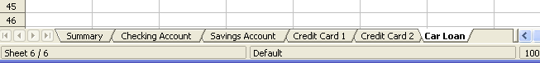Figure 242: Six renamed sheets
Now we will set up the account ledgers. This is just a simple summary that includes the previous balance plus the amount of the current transaction. For withdrawals, we enter the current transaction as a negative number so the balance gets smaller. A basic ledger is shown in Figure 243.
This ledger is set up in the sheet named Checking Account. The total balance is added up in cell F3. You can see the equation for it in the formula bar. It is the summary of the opening balance, cell C3, and all of the subsequent transactions.
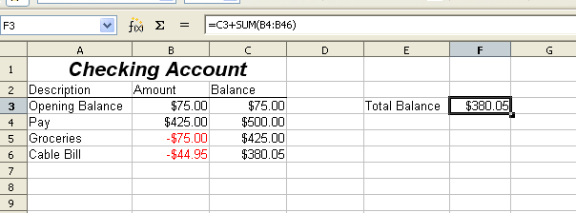Figure 243: Checking ledger

Referencing other sheets
On the Summary sheet we display the balance from each of the other sheets. If you copy the example in Figure 243 onto each account, the current balances will be in cell F3 of each sheet.
There are two ways to reference cells in other sheets: by entering the formula directly using the keyboard or by using the mouse. We will look at the mouse method first.

Creating the reference with the mouse
On the Summary sheet, set up a place for all five account balances, so we know where to put the cell reference. Figure 244 shows a summary sheet with a blank Balance column. We want to place the reference for the checking account balance in cell B3.
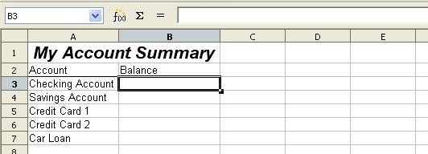Figure 244: Blank summary
To make the cell reference in cell B3, select the cell and follow these steps.
- Click on the = icon next to the input line. The icons change and an equals sign appears in the input line as in Figure 245.
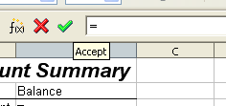
Figure 245: Equal sign in input line
- Now, click on the sheet tab for the sheet containing the cell to be referenced. In this case, that is the Checking Account sheet as shown in Figure 246.
Figure 246: Click on the checking account tab
- Click on cell F3 (where the balance is) in the Checking Account sheet. The phrase ‘Checking Account’.F3 should appear in the input line as in Figure 247.
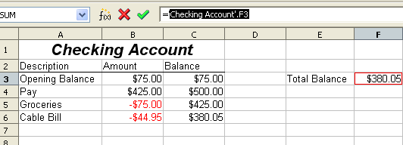Figure 247: Cell reference selected
- Click the green checkmark in the input line to finish.
- The Summary sheet should now look like Figure 248.
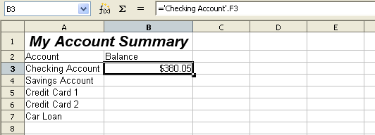Figure 248: Finished checking account reference

Creating the reference with the keyboard
From Figure 248, you can deduce how the cell reference is constructed. The reference has two parts: the sheet name (‘Checking Account’) and the cell reference (F3). Notice that they are separated by a period.
Note | The sheet name is in single quotes because it contains a space, and the mandatory period (.) always falls outside any quotes.
So, you can fill in the Savings Account cell reference by just typing it in. Assuming that the balance is in the same cell (F3) in the Savings Account sheet, the cell reference should be =’Savings Account’.F3 (see Figure 249).
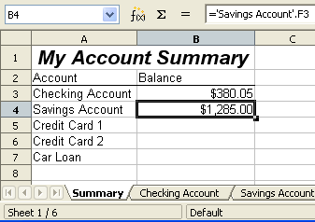Figure 249: Savings account reference

Referencing other documents
John decides to keep his family account information in a different spreadsheet file from his own summary. Fortunately Calc can link different files together. The process is the same as described for different sheets in a single spreadsheet, but we add one more step to indicate which file the sheet is in.

Creating the reference with the mouse
To create the reference with the mouse, both spreadsheets need to be open. Select the cell in which the formula is going to be entered.
- Click the = icon next to the input line.
- Switch to the other spreadsheet (the process to do this will vary depending on which operating system you are using).
- Select the sheet (Savings Account) and then the reference cell (F3).
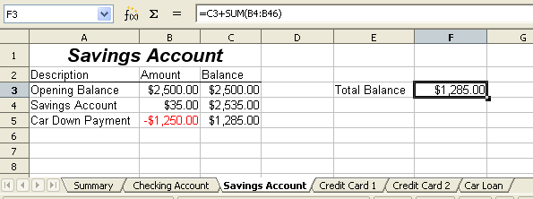
Figure 250: Selecting the savings account reference cell
- Switch back to the original spreadsheet.
- Click on the green check mark on the input line.
Your spreadsheet should now resemble Figure 251.
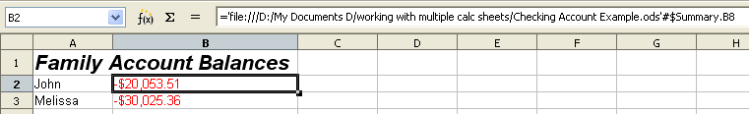Figure 251: Linked files
You will get a good feel for the format of the reference if you look closely at the input line. Based on this line you can create the reference using the keyboard.

Creating the reference with the keyboard
Typing the reference is simple once you know the format the reference takes. The reference has three parts to it:
- Path and file name
- Sheet name
- Cell
Looking at Figure 251 you can see the the general format for the reference is
=’file:///Path & File Name’#$SheetName.CellName
Note | The reference for a file has three forward slashes /// and the reference for a hyperlink has two forward slashes //.

Hyperlinks and URLs
Hyperlinks can be used in Calc to jump to a different location from within a spreadsheet and can lead to other parts of the current file, to different files or even to web sites.

Relative and absolute hyperlinks
Hyperlinks can be stored within your file as either relative or absolute.
A relative hyperlink says, Here is how to get there starting from where you are now (meaning from the folder in which your current document is saved) while an absolute hyperlink says, Here is how to get there no matter where you start from.
An absolute link will stop working only if the target is moved. A relative link will stop working only if the start and target locations change relative to each other. For instance, if you have two spreadsheets in the same folder linked to each other and you move the entire folder to a new location, a relative hyperlink will not break.
To change the way that OOo stores the hyperlinks in your file, select Tools > Options > Load/Save > General and choose if you want URLs saved relatively when referencing the File System, or the Internet, or both.
Calc will always display an absolute hyperlink. Don’t be alarmed when it does this even when you have saved a relative hyperlink—this ‘absolute’ target address will be updated if you move the file.
Note | Make sure that the folder structure on your computer is the same as the file structure on your web server if you save your links as relative to the file system and you are going to upload pages to the Internet.
Tip | When you rest the mouse pointer on a hyperlink, a help tip displays the absolute reference, since OOo uses absolute path names internally. The complete path and address can only be seen when you view the result of the HTML export (saving the spreadsheet as an HTML file), by loading the HTML file as Text, or by opening it with a text editor.

Creating hyperlinks
When you type text that can be used as a hyperlink (such as a website address or URL), Calc formats it automatically, creating the hyperlink and applying to the text a color and background shading. If this does not happen, you can enable this feature using Tools > AutoCorrect Options > Options and selecting URL Recognition.
Tips | To change the color of hyperlinks, go to Tools > Options > OpenOffice.org > Appearance, scroll to Unvisited links and/or Visited links, pick the new colors and click OK. Caution: this will change the color for all hyperlinks in all components of OpenOffice.org—this may not be what you want.
You can also insert and modify links using the Hyperlink dialog. To display the dialog, click the Hyperlink icon on the Standard toolbar or choose Insert > Hyperlink from the menu bar. To turn existing text into a link, highlight it before opening the dialog.
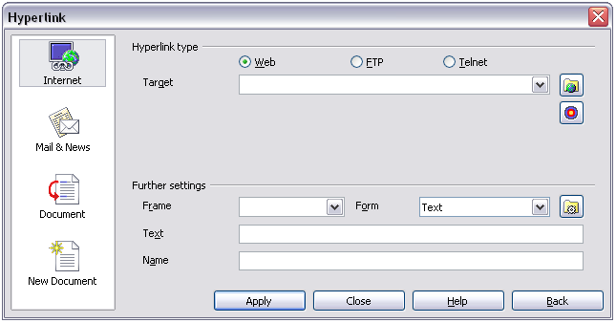
Figure 252. Hyperlink dialog showing details for Internet links
On the left side, select one of the four categories of hyperlinks:
- Internet: the hyperlink points to a web address, normally starting with http://
- Mail & News: the hyperlink opens an email message that the pre-addressed to a particular recipient
- Document: the hyperlink points to a place in either the current document or another existing document
- New document: the hyperlink creates a new document.
The top right part of the dialog changes according to the choice made for the hyperlink category from the left panel. A full description of all the choices, and their interactions, is beyond the scope of this chapter. Here is a summary of the most common choices used in spreadsheets.
For an Internet hyperlink, choose the type of hyperlink (Web, FTP, or Telnet), and enter the required web address (URL).
For a Mail and News hyperlink, specify whether it is a mail or news link, the receiver address and for email, also the subject.
For a Document hyperlink, specify the document path (the Open File button opens a file browser); leave this blank if you want to link to a target in the same spreadsheet. Optionally specify the target in the document (for example a specific sheet). Click on the Target in document icon to open the Navigator where you can select the target, or if you know the name of the target, you can type it into the box.
For a New Document hyperlink, specify whether to edit the newly created document immediately (Edit now) or just create it (Edit later), and enter the file name and the type of document to create (text, spreadsheet, etc.). The Select path button opens a directory picker dialog.
The Further settings section in the bottom right of the dialog is common to all the hyperlink categories, although some choices are more relevant to some types of links.
- Set the value of Frame to determine how the hyperlink will open. This applies to documents that open in a Web browser.
- Form specifies if the link is to be presented as text or as a button. Figure 253 shows a link formatted as a button.
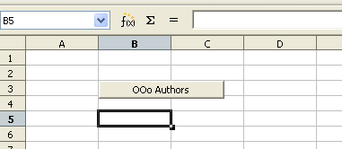Figure 253: OOo Authors hyperlink as button
- Text specifies the text that will be visible to the user. If you do not enter anything here, Calc will use the full URL or path as the link text. Note that if the link is relative and you move the file, this text will not change, though the target will.
- Name is applicable to HTML documents. It specifies text that will be added as a NAME attribute in the HTML code behind the hyperlink.
- Events button: this button will be activated to allow Calc to react to events for which the user has written some code (macro). This function is not covered in this chapter.
Note | A hyperlink button is a type of form control. As with all form controls, it can be anchored or positioned by right-clicking on the button in design mode. More information about forms can be found in Chapter 15 of the Writer Guide.  For the button to work , the spreadsheet must not be in design mode. To toggle design mode on and off, view the Form Controls toolbar (View > Toolbars > Form Controls) and click the Design Mode On/Off button .

Editing hyperlinks
To edit an existing link, place the cursor anywhere in the link and click the Hyperlink icon on the Standard toolbar or select Insert > Hyperlink from the menu bar. The Hyperlink dialog (Figure 252) opens. If the Hyperlink is in button form, the spreadsheet must have Design Mode on in order to edit the Hyperlink. Make your changes and click Apply. If you need to edit several hyperlinks, you can leave the Hyperlink dialog open until you have edited all of them. Be sure to click Apply after each one. When you are finished, click Close.

Removing hyperlinks
You can remove the clickable link from hyperlink text—leaving just the text—by right-clicking on the link and selecting Default Formatting. This option is also available from the Format menu. You may then need to re-apply some formatting in order for it to match the rest of your document.
To erase the link text or button from the document completely, select it and press the Backspace or Delete key.

Linking to external data
You can insert tables from HTML documents, and data located within named ranges from an OpenOffice.org Calc or Microsoft Excel spreadsheet, into a Calc spreadsheet. (To use other data sources, including database files in OOo Base, see “Linking to registered data sources” on page 312.)
You can do this in two ways: using the External Data dialog or using the Navigator. If your file has named ranges or named tables, and you know the name of the range or table you want to link to, using the External Data dialog method is quick and easy. However, if the file has several tables, and you want to pick only one of them, you may not be able to easily determine which is which; in that case, the Navigator method may be easier.

Using the External Data dialog
- Open the Calc document where the external data is to be inserted. This is the target document.
- Select the cell where the upper left-hand cell of the external data is to be inserted.
- Choose Insert > Link to External Data.
- On the External Data dialog (Figure 254), type the URL of the source document or click the [...] button to open a file selection dialog. Press Enter to get Calc to load the list of available tables.
- In the Available tables/range list, select the named ranges or tables you want to insert. You can also specify that the ranges or tables are updated every (number of) seconds.
- Click OK to close the dialog and insert the linked data.
Notes | - The Available tables/ranges list remains empty until you press Enter after typing the URL of the source. If you select the source document using the […] button, then pressing Enter is not required.  - The OK button remains unavailable (grayed out) until you select one or more tables/ranges in the list. You can hold down the Ctrl key while clicking on tables/ranges to select more than one.  - No images are imported
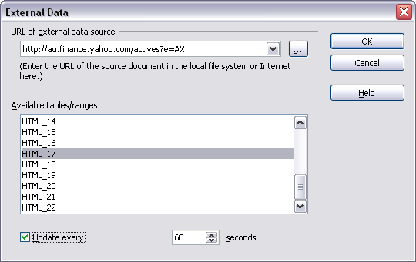Figure 254: Selecting a table or range in a source document from the Web

Using the Navigator
- Open the OpenOffice.org Calc spreadsheet in which the external data is to be inserted (target document).
- Open the document from which the external data is to be taken (source document). If the source document is a Web page, choose Web Page Query (OpenOffice.org Calc) as the file type.
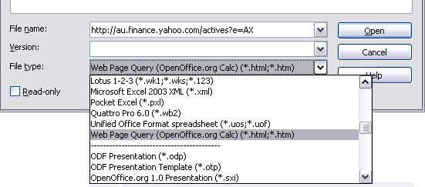
Figure 255: Opening a file using the Web Page Query filter
- In the target document, press F5 to open the Navigator.
- At the bottom of the Navigator, select the source document. (In Figure 256, the source is named actives.)
The Navigator now shows the range names or the tables contained in the source document (the example contains range names; other documents have a list of tables). Click on the + next to Range names to display the list.
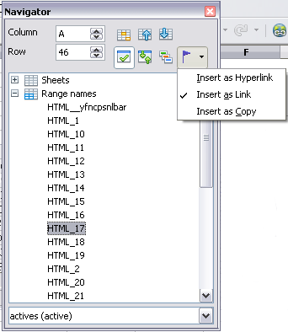
Figure 256: Selecting a data range in a source document, to be inserted as a link
- In the Navigator, select the Insert as Link drag mode, as shown in Figure 256.
- Select the required range or table and drag it from the Navigator into the target document, to the cell where you want the upper left-hand cell of the data range to be.
- In the target document, check the Navigator. Instead of a + by Range names, it shows a + by Linked areas. Click the + to see the same range name (see Figure 257).
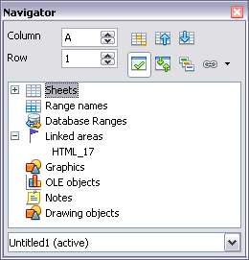
Figure 257: Linked areas in target spreadsheet

How to find the required data range or table
The examples above show that the import filter gave names to the data rangers (tables) in the sample web page starting from HTML_1. It also created two additional range names (not visible in the illustration):
HTML_all – designates the entire document
HTML_tables – designates all HTML tables in the document
If the data tables in the source HTML document have been given names (using the ID attribute on the TABLE tag), or the external spreadsheet includes named ranges, those names appear in the list along with the ranges Calc has sequentially numbered.
If the data range or table you want is not named, how can you tell which one to select?
Go to the source document, which you opened in Calc. In the Navigator, double-click on a range name: that range is highlighted on the sheet (see Figure 258).
If the Formula Bar is visible, the range name is also displayed in the Name box at the left-hand end (see Figure 259).
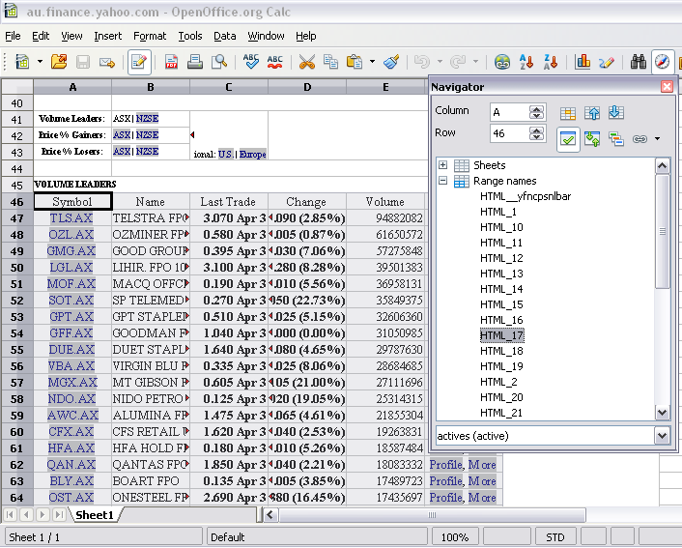Figure 258: Using the Navigator to find a data range name
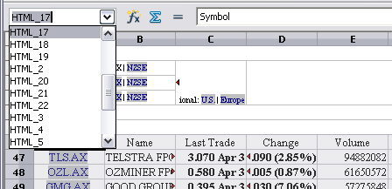Figure 259: Using the Name box to find a data range name

Linking to registered data sources
You can access a variety of databases and other data sources and link them into Calc documents.
First you need to register the data source with OpenOffice.org. (To register means to tell OOo what type of data source it is and where the file is located.) The way to do this depends on whether or not the data source is a database in *.odb format.
To register a data source that is in *.odb format:
- Choose Tools > Options > OpenOffice.org Base > Databases.
- Click the New button (below the list of registered databases) to open the Create Database Link dialog (Figure 260).
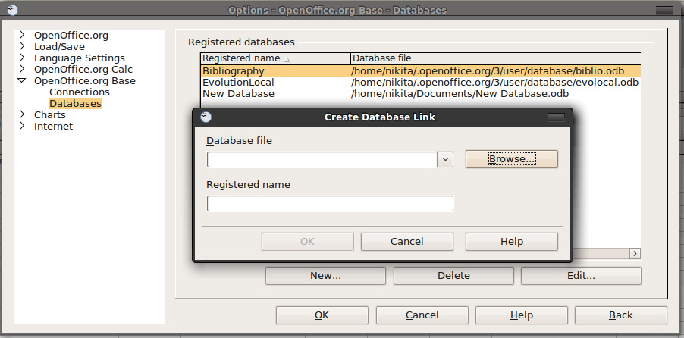Figure 260: Registering databases
- Enter the location of the database file, or click Browse to open a file browser and select the database file.
- Type a name to use as the registered name for the database and click OK. The database is added to the list of registered databases. The OK button is enabled only when both fields are filled in.
To register a data source that is not in *.odb format:
- Choose File > New > Database to open the Database Wizard.
- Select Connect to an existing database. The choices for database type depend on your operating system. For example, Microsoft Access and other Microsoft products are not among the choices if you are using Linux. In our example, we chose dBASE.
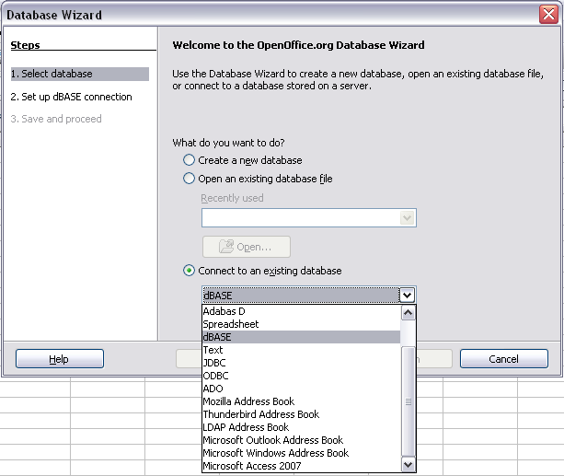Figure 261: Registering a database using the Database Wizard
- Click Next. Type the path to the database file or click Browse and use the Open dialog to navigate to and select the database file before clicking Open.
- Click Next. Select Yes, register the database for me, but clear the checkbox marked Open the database for editing.
- Click Finish. Name and save the database in the location of your choice. Note: changes made to the *.odb do not affect the original dBASE file.
Once a data source has been registered, it can be used by any OOo component (for example Calc).

Viewing data sources
Open a document in Calc. To view the data sources available, press F4 or select View > Data Sources from the menu bar. The Data Source View pane opens above the spreadsheet. A list of registered databases is in the Data Explorer area on the left. (The built-in Bibliography database is included in the list.)
To view each database, click on the + to the left of the name of the database. (This has been done for the Automobile database in Figure 262.) Click on the + next to Tables to view the individual tables.
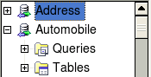Figure 262: Databases
Now click on a table to see all the records held in it. The data records are displayed on the right side of the Data Source View pane. To see more columns, you can click the Explorer On/Off button to hide the Data Explorer area.
At the top of the Data Source View pane, below the Calc toolbars, is the Table Data bar. This toolbar includes buttons for saving records, editing data, finding records, sorting, filtering, and other functions. For more details about this toolbar, see the Help for data source browser.
Below the records is the Form Navigation bar, which shows which record is selected and the total number of records. To the right are five tiny buttons; the first four move backwards or forwards through the records, or to the beginning or end.

Figure 263: Data Source View navigation buttons

Editing data sources
Some data sources (such as spreadsheets) cannot be edited in the data source view.
In editable data sources, records can be edited, added, or deleted. If you cannot save your edits, you need to open the database in Base and edit it there; see “Launching Base to work on data sources”. You can also hide columns and make other changes to the display.

Launching Base to work on data sources
You can launch OOo Base at any time from the Data Source View pane. Right-click on a database or the Tables or Queries icons and select Edit Database File. Once in Base, you can edit, add, and delete tables, queries, forms, and reports.
For more about using Base, see Chapter 8 (Getting Started with Base) in the Getting Started guide.

Using data sources in Calc spreadsheets
Data from the tables in the data source pane can be placed into Calc documents in a variety of ways.
You can select a cell or an entire row in the data source pane and drag and drop the data into the spreadsheet. The data is inserted at the place where you release the mouse button.
An alternative method uses the Data to Text icon and will include the column headings above the data you insert:
- Click the cell of the spreadsheet which you want to be the top left of your data including the column names.
- Press F4 to open the database source window and select the table containing the data you want to use.
- Select the rows of data you want to add to the spreadsheet:
  - Click the gray box to the left of the row you want to select if only selecting one row. That row is highlighted.
  - To select multiple adjacent rows, hold down the Shift key while clicking the gray box of the rows you need.
  - To select multiple separate rows, hold down the Control key while selecting the rows. The selected rows are highlighted.
  - To select all the rows, click the gray box in the upper left corner. All rows are highlighted.
- Click the Data to text icon to insert the data into the spreadsheet cells.
You can also drag the data source column headings (field names) onto your spreadsheet to create a form for viewing and editing individual records one at a time. Follow these steps:
- Click the gray box at the top of the column (containing the field name you wish to use) to highlight it.
- Drag and drop the gray box to where you want the record to appear in the spreadsheet.
- Repeat until you have moved all of the fields you need to where you want them.
- Close the Data Source window: press F4.
- Save the spreadsheet and click the Edit File button on the Standard toolbar, to make the spreadsheet read-only. All of the fields will show the value for the data of the first record you selected.
- Add the Form Navigation toolbar: View > Toolbars > Form Navigation. By default, this toolbar opens at the bottom of the Calc window, just above the status bar.
- Click the arrows on the Form Navigation toolbar to view the different records of the table. The number in the Record box changes as you move through the records. The data in the fields changes to correspond to the data for that particular record number. You can also search for a specific record, sort and filter records, and do other tasks using this toolbar.

Embedding spreadsheets
Spreadsheets can be embedded in other OOo files. This is often used in Writer or Impress documents so that Calc data can be used in a text document. You can embed the spreadsheet as either an OLE or DDE object. The difference between a DDE object and a Linked OLE object is that a Linked OLE object can be edited from the document in which it is added as a link, but a DDE object cannot.
For example, if a Calc spreadsheet is pasted into a Writer document as a DDE object, then the spreadsheet cannot be edited in the Writer document. But if the original Calc spreadsheet is updated, the changes are automatically made in the Writer document. If the spreadsheet is inserted as a Linked OLE object into the Writer document, then the spreadsheet can be edited in the Writer as well as in the Calc document and both documents are in sync with each other.

Object Linking and Embedding (OLE)
The major benefit of an OLE (Object Linking and Embedding) object is that it is quick and easy to edit the contents just by double-clicking on it. You can also insert a link to the object that will appear as an icon rather than an area showing the contents itself.
OLE objects can be linked to a target document or be embedded in the target document. Linking inserts information which will be updated with any subsequent changes to the original file, while embedding inserts a static copy of the data. If you want to edit the embedded spreadsheet, double-click on the object.
To embed a spreadsheet as an OLE object in a presentation:
- Place the cursor in the document and location you want the OLE object to be.
- Select Insert > Object > OLE Object. The dialog below opens.
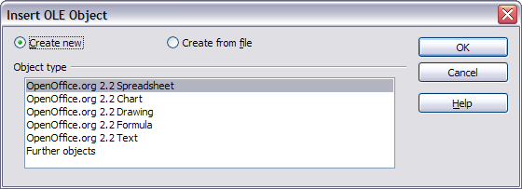Figure 264: Insert OLE object dialog
- You can either create a new OLE object or create from a file.
To create a new object:
- Select Create new and select the object type among the available options.
Note | “Further objects” is only available if you are using the Windows operating system.
- Click OK. An empty container is placed in the slide.
- Double-click on the OLE object to enter the edit mode of the object. The application devoted to handling that type of file will open the object.
Note | If the object inserted is handled by OpenOffice.org, then the transition to the program to manipulate the object will be seamless; in other cases the object opens in a new window and an option in the File menu becomes available to update the object you inserted.
To insert an existing object:
- To create from a file, select Create from file. The dialog changes to look like Figure 265.
- To insert the object as a link, select the Link to file option. Otherwise, the object will be embedded.
- Click Search, select the required file in the Open dialog, then click Open. A section of the inserted file is shown in the document.
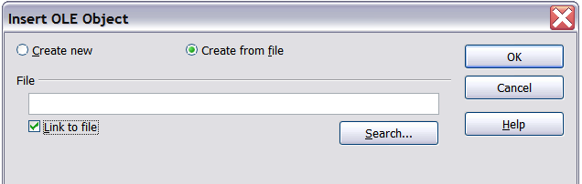Figure 265: Inserting an object as a link

Other OLE objects
Under Windows, the Insert OLE Object dialog box has an extra entry, Further objects, as shown in Figure 266.
- Double-click on the entry Further objects to open the dialog shown below.
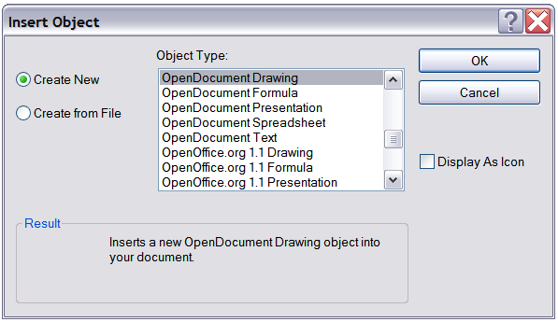
Figure 266: Inserting an OLE object under Windows
- Select Create New to insert a new object of the type selected in the Object Type list, or select Create from File to create a new object from a file.
- If you choose Create from File, the dialog shown below opens. Click Browse and choose the file to insert. The inserted file object is editable by the Windows program that created it.
If instead of inserting an object, you want to insert a link to an object, select the Display As Icon option.
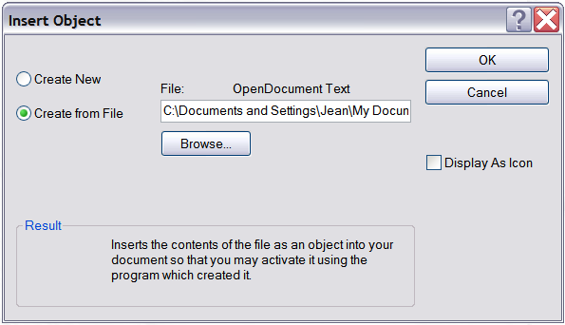Figure 267: Insert object from a file

Non-linked OLE object
If the OLE object is not linked, it can be edited in the new document. For instance, if you insert a spreadsheet into a Writer document, you can essentially treat it as a Writer table (with a little more power). To edit it, double-click on it.

Linked OLE object
When the spreadsheet OLE object is linked, if you change it in Writer it will change in Calc; if you change it in Calc, it will change in Writer. This can be a very powerful tool if you create reports in Writer using Calc data, and want to make a quick change without opening Calc.
Note | You can only edit one copy of a spreadsheet at a time. If you have a linked OLE spreadsheet object in an open Writer document and then open the same spreadsheet in Calc, the Calc spreadsheet will be a read-only copy.

Dynamic Data Exchange (DDE)
DDE is an acronym for Dynamic Data Exchange, a mechanism whereby selected data in document A can be pasted into document B as a linked, ‘live’ copy of the original. It would be used, for example, in a report written in Writer containing time-varying data, such as sales results sourced from a Calc spreadsheet. The DDE link ensures that, as the source spreadsheet is updated so is the report, thus reducing the scope for error and reducing the work involved in keeping the Writer document up to date.
DDE is a predecessor of OLE. With DDE, objects are linked through file reference, but not embedded. You can create DDE links either within Calc cells in a Calc sheet, or in Calc cells in another OOo doc such as in Writer.

DDE link in Calc
Creating a DDE link in Calc is similar to creating a cell reference. The process is a little different, but the result is the same.
- In Calc, select the cells that you want to make the DDE link to.
- Copy them: Edit > Copy or Ctrl+C.
- Go to the place in the spreadsheet where you want the link to be.
- Select Edit > Paste Special.
- When the Paste Special dialog opens, select the Link option on the bottom left of the dialog (Figure 268). Click OK.
The cells now reference the copied data, and the formula bar shows a reference beginning with {=DDE.
If you now edit the original cells, the linked cells will update.
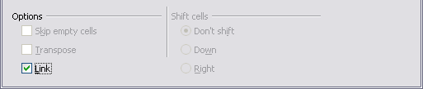
Figure 268: Location of Link option on Paste Special dialog in Calc

DDE link in Writer
The process for creating a DDE link from Calc to Writer is similar to creating a link within Calc.
- In Calc, select the cells to make the DDE link to. Copy them.
- Go to the place in your Writer document where you want the DDE link. Select Edit > Paste Special.
- Select DDE Link (Figure 269). Click OK.
Now the link has been created in Writer. When the Calc spreadsheet is updated, the table in Writer is automatically updated.
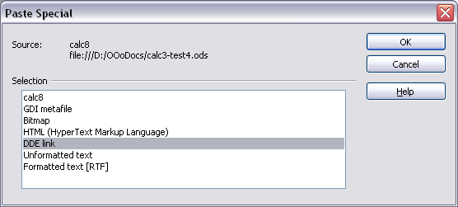Figure 269: Paste Special dialog in Writer, with DDE link selected

Calc Guide

Chapter 11
Sharing and Reviewing Documents
This PDF is designed to be read onscreen, two pages at a time. If you want to print a copy, your PDF viewer should have an option for printing two pages on one sheet of paper, but you may need to start with page 2 to get it to print facing pages correctly. (Print this cover page separately.)

Copyright
This document is Copyright © 2005–2010 by its contributors as listed in the section titled Authors. You may distribute it and/or modify it under the terms of either the GNU General Public License, version 3 or later, or the Creative Commons Attribution License, version 3.0 or later.
All trademarks within this guide belong to their legitimate owners.
Authors
Martin J. Fox
Spencer E. Harpe
Peter Kupfer
Sigrid Kronenberger
Andy Brown
Jean Hollis Weber
Feedback
Please direct any comments or suggestions about this document to: authors@documentation.openoffice.org
Publication date and software version
Published 21 June 2010. Based on OpenOffice.org 3.2.
Contents
Copyright 2
Introduction 4
Sharing documents (collaboration) 4
Setting up a spreadsheet for sharing 4
Opening a shared spreadsheet 5
Saving a shared spreadsheet 6
Recording changes 7
Preparing a document for review (optional) 7
Identifying copies of spreadsheets 8
Recording changes (tutorial) 8
Adding comments to changes 10
Editing change comments 11
Adding other comments 11
Editing comments 12
Formatting comments 13
Finding comments using the Navigator 13
Reviewing changes 13
Viewing changes 14
Accepting or rejecting changes 15
Merging documents 16
Comparing documents 18
Saving versions 18

Introduction
This chapter covers methods for editing shared documents: sharing (collaboration), recording changes, adding comments, reviewing changes, merging and comparing documents, and saving and using document versions. Basic editing techniques are discussed in Chapter 2 (Entering, Editing, and Formatting Data).

Sharing documents (collaboration)
In OpenOffice.org Writer, Impress, and Draw, only one user at a time can open any document for editing. In Calc, many users can open the same spreadsheet for writing at the same time.
Each user who wants to collaborate should be sure to enter a name on the Tools > Options > OpenOffice.org > User Data page.
Some menu commands are not available (grayed out) when change tracking or document sharing is activated.

Setting up a spreadsheet for sharing
At any time, you can set up a spreadsheet for sharing with others. With the spreadsheet document open, choose Tools > Share Document to activate the collaboration features for this document. A dialog opens where you can enable or disable sharing.
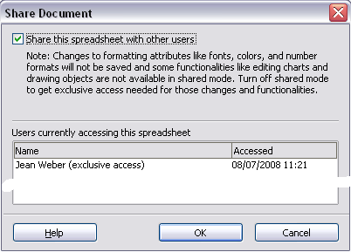
Figure 270: Choosing to share a spreadsheet
To enable sharing, select the box at the top of the dialog, and then click OK. A message appears stating that you must save the document to activate shared mode. Click Yes to continue. The word (shared) is then shown on the title bar after the document’s title.
The Tools > Share Document command can be used to switch the mode for a document from unshared to shared. However, if you want to use a shared document in unshared mode, you need to save the shared document using another name or path. This creates a copy of the spreadsheet that is not shared.

Opening a shared spreadsheet
When you open a spreadsheet document that is in shared mode, a message appears stating that the document is in shared mode and that some features are not available in this mode. After clicking OK, the document is opened in shared mode.
The following features are known to be disabled in a shared spreadsheet document:
Edit > Changes, except for Merge Document
Edit > Compare Document
Edit > Sheet > Move/Copy & Delete
Insert > Cells Shift Cells Down & Shift Cells Right
Insert > Sheet from file
Insert > Names
Insert > Comment
Insert > Picture > From File
Insert > Movie and Sound
Insert > Object
Insert > Chart
Insert > Floating Frame
Format > Sheet > Rename, Tab Color
Format > Merge Cells > Merge and Center, Merge Cells, Split Cells
Format > Print Ranges
Tools > Protect Document
Data > Define Range
Data > Sort
Data > Subtotals
Data > Validity
Data > Multiple Operations
Data > Consolidate
Data > Group and Outline (all)
Data > DataPilot

Saving a shared spreadsheet
When you save a shared spreadsheet, one of several situations may occur:
- If the document was not modified and saved by another user since you opened it, the document is saved.
- If the document was modified and saved by another user since you opened it, one of the following events will occur:
  - If the changes do not conflict, the document is saved, the dialog below appears, and any cells modified by the other user are shown with a red border.
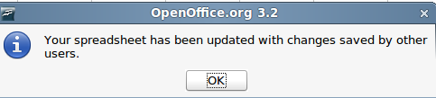
Figure 271: Update message after saving
  - If the changes conflict, the Resolve Conflicts dialog is shown. You must decide for each conflict which version to keep, yours or the other person’s. When all conflicts are resolved, the document is saved. While you are resolving the conflicts, no other user can save the shared document.
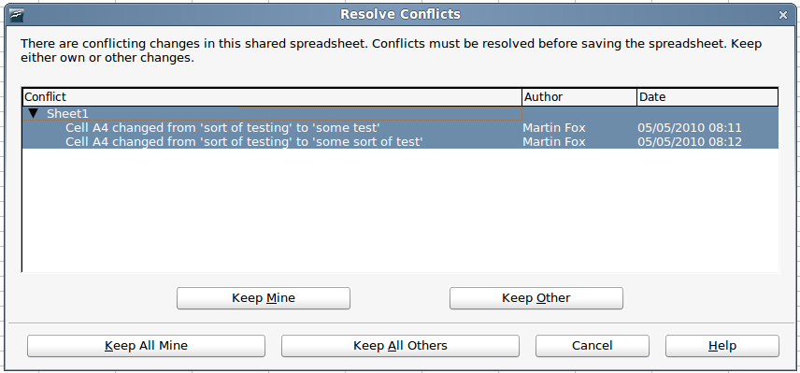
Figure 272: Resolve Conflicts dialog
- If another user is trying to save the shared document and resolve conflicts, you see a message that the shared spreadsheet file is locked due to a merge-in in progress. You can choose to cancel the Save command for now, or retry saving later.
When you successfully save a shared spreadsheet, the document shows the latest version of all changes saved by all users.

Recording changes
You can use several methods to record changes that you or others make to a document.
- You can use change marks to show added material, deleted material, and changes to formatting. Later, you or another person can review the document and accept or reject each change.
- If you are not using file sharing, you can make changes to a copy of the document (stored in a different folder, under a different name, or both), then use Calc to compare the files and show the changes. See page 337.
- You can save versions that are stored as part of the original file. See page 337.
Reviewers can leave comments in the document, either attached to specific changes or standalone.

Preparing a document for review (optional)
When you send a document to someone else to review or edit, you may want to protect it first so that the editor or reviewer does not have to remember to turn on the revision marks. After you have protected the document, any user must enter the correct password in order to turn off protection and accept or reject changes.
- Open the document and make sure that the Edit > Changes > Record menu item has a check mark next to it, indicating that change recording is active.
- (Optional) Click Edit > Changes > Protect Records. On the Protect Records dialog, type a password (twice) and click OK.
Note | Passwords must contain at least five characters.  It is not necessary to password protect the document while preparing it for review.

Identifying copies of spreadsheets
When not using the document sharing feature, it is important to keep track of the different copies of the document. This can be done either in the file name or in the file title. If you have not provided a file title in the spreadsheet’s properties, the spreadsheet’s file name is displayed in the title bar. To set the title of the spreadsheet, select File > Properties > Description.

Recording changes (tutorial)
For this chapter we will work with a budget proposal for a baseball team.
You are the sponsor of a youth baseball team. The coach has submitted a budget to you for the season and you need to edit the costs and return it to her.
You are concerned that if you just make the changes, then the coach won't see the changes you made. You decide to use Calc with the record changes feature turned on, so that the coach can easily see the change you have made.
Figure 273 shows the budget spreadsheet your coach submitted.
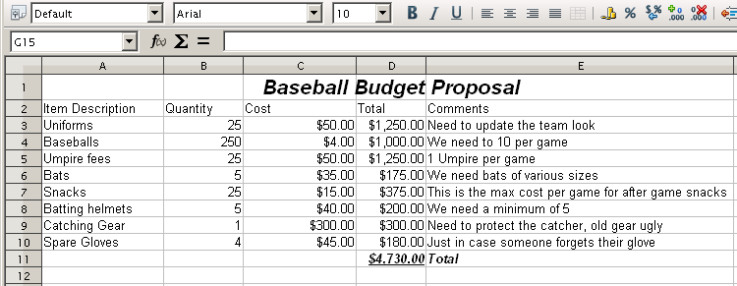Figure 273: Baseball budget spreadsheet
Looking over the figures, you see a few places where money could be saved:
- Post-game snacks can be bought by parents.
- New uniforms can wait; only buy 10 to replace damaged ones.
- Buy cheaper baseballs.
- Only buy 2 spare gloves.
To make these changes, use the record changes feature in Calc. To start recording changes:
- Open the Budget Spreadsheet.
- Select Edit > Changes > Record from the menu bar.
- Begin editing the document.
A colored border, with a dot in the upper left-hand corner, appears around a cell where changes were made (Figure 274). Other reviewers then quickly know which cells were edited. A deleted column or row is marked by a heavy colored bar.
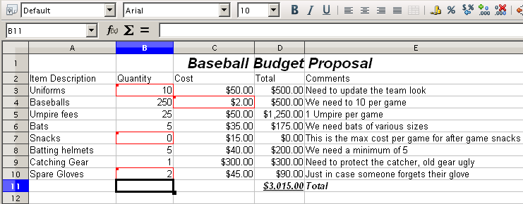Figure 274: Edited document with red border on changed cells
Tip | Some changes, for example cell formatting, are not recorded and marked.
Tip | To change the color that indicates changes, select Tools > Options > OpenOffice.org Calc > Changes.
When you finish editing the document, you can send it to your coach.
You may want to explain your rationale for the changes. You can share your insight in two ways: by adding comments to the changes you made, or by adding general comments to the spreadsheet.

Adding comments to changes
Calc automatically adds to any recorded change a comment that describes what was changed (for example, Cell B4 changed from ‘9’ to ‘4’). Reviewers and authors can add their own comments to explain their reasons for the changes.
To add a comment to a change:
- Make the change to the spreadsheet.
- Select the cell with the change.
- Choose Edit > Changes > Comments. The dialog shown in Figure 275 appears. The automatically-added comment provided by Calc appears in the title bar of this dialog and cannot be edited.
- Type your own comment and click OK.
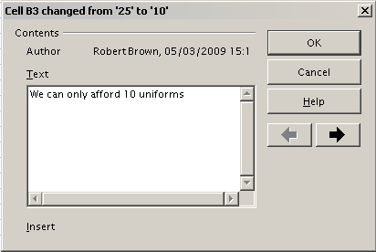Figure 275: Comment dialog
Tip | You can step through your changes one at a time using the left and right arrows on the right hand side of the Comment dialog, and add comments to each change. The title bar for the Comment dialog shows the cell and the change you are commenting on.
After you have added a comment to a changed cell, you can see it by hovering the mouse pointer over the cell, as shown in Figure 276.
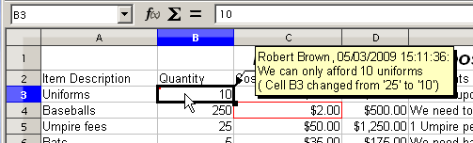Figure 276: Comment added to cell B3
The comment also appears in the dialog when you are accepting and rejecting changes, as shown in the first line of Figure 281 on page 335.

Editing change comments
- Select the cell with the change comment that you want to edit.
- Select Edit > Changes > Comments.
- Edit the comment and click OK.
Tip | You can view your comments one at a time using the left and right arrows located on the right hand side of the Comment dialog. You do not need to click OK after editing each comment; you can save them all at once when you’re done editing.

Adding other comments
Calc provides another type of comments (formerly called “notes”), which authors and reviewers often use to exchange ideas, ask for suggestions, or brainstorm in the document.
To add a comment:
- Select the cell that the comment applies to.
- Select Insert > Comment or right-click and select Insert Comment. (The latter method does not work if the automatic spelling checker is active and the cell contains a misspelled word.) The box shown in Figure 277 appears.
- Type the text of your comment in the box.
- Click outside the box to close it.
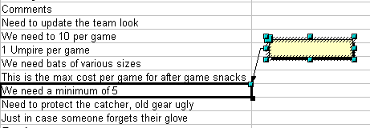Figure 277: Inserting a comment
Now the cell to which you added the comment has a colored dot in the upper right-hand corner, as shown in Figure 278. It does not have a colored border, unless the cell was also changed.
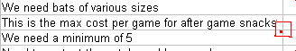
Figure 278: Colored dot in cell containing a comment
Tip | You can change the colors Calc uses for notes by selecting Tools > Options > OpenOffice.org > Appearance.
To view the comment you just added, hover the mouse pointer over the cell that has a comment; the comment appears, as shown below.
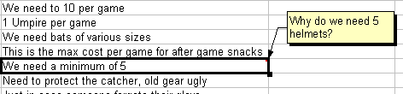Figure 279: Viewing a comment

Editing comments
You can edit and format the text of a comment, just as you do for any other text.
- Right-click on the cell containing the comment marker, and choose Show comment from the pop-up menu.
- Select the comment, then double-click on it. The cursor changes to the usual blinking text-entry cursor, and the Formatting toolbar changes to show text attributes.
- When done, click outside the comment to deselect it. To hide the comment again, right-click on the cell and deselect Show Comment on the pop-up menu.

Formatting comments
You can change the background color, border style, transparency, and other attributes of a comment.
- Right-click on the cell containing the comment marker, and choose Show comment from the pop-up menu.
- Click on the comment itself. The Formatting toolbar changes to show many of the comment formatting options. These are the same as the options for formatting graphics; see Chapter 5 (Using Graphics in Calc) for more information.
You can also right-click on the comment to see a menu of choices, some of which lead to dialogs in which you can fine-tune the formatting; these dialogs are also discussed in Chapter 5.
- When done, click outside the comment to deselect it. To hide the comment again, right-click on the cell and deselect Show Comment on the pop-up menu.

Finding comments using the Navigator
The small comment markers in the corners of cells can be difficult to see, so Calc provides another way to find them, by using the Navigator. If any comments are in the spreadsheet, the Navigator shows a mark (usually a + or an arrow) next to the word Comments. Click on this mark to display a list of comments. Double-click on the comment you want to jump directly to the cell it is associated with.

Reviewing changes
At this point, we are going to change our perspective from the point of view of the team sponsor to that of the coach, so we can see how to review and accept or reject the changes to the document the coach originally wrote.
You are the coach of a youth baseball team and you submitted a potential budget created in Calc to your team sponsor.
Your sponsor has reviewed the document using the record changes feature of Calc. Now, you want to review those changes and accept or reject the counter proposal.
Because the sponsor recorded changes in Calc, you can easily see what changes were made and decide how to act.

Viewing changes
Calc gives you tremendous control over what changes you see when reviewing a document. To change the available filters, select Edit > Changes > Show. The dialog shown in Figure 280 opens.
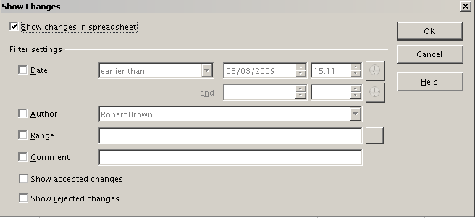Figure 280: Show changes dialog
Using the different settings, you can control which changes appear on screen. You can filter based on:
- Date – Only changes made in a certain time range are displayed.
- Author – Only changes made by a specific author are displayed. This is especially useful if you have multiple reviewers on the document.
- Range – Only changes made in a specific range of cells are displayed. This is especially useful if you have a large spreadsheet and only want to review a part of it.
- Comment – Searches the content of the comments and only displays changes which have comments that match the search criteria.
- Show accepted changes – Only changes you accepted are displayed.
- Show rejected changes – Only changes you rejected are displayed.
Note | You can also access the filter control in the Accept or Reject Changes dialog shown in Figure 281. Click the Filter tab to get a set of options similar to those shown in Figure 280.

Accepting or rejecting changes
When you receive a document back with changes, the beauty of the recording changes system becomes evident. Now, as the original author, you can step through each change and decide how to proceed. To begin this process:
- Open the edited document.
- Select Edit > Changes > Accept or Reject. The dialog shown in Figure 281 appears.
- Calc steps through the changes one at a time. You can choose to accept or reject each change as you go through.
The Comment column by default contains an explanation of the change that was made. If the reviewer added a comment to the change, it is displayed, followed by the description of the change, as in the first line of Figure 281.
If more than one person has reviewed the document, one reviewer may have modified another reviewer’s change. If so, the changes are hierarchically arranged with a plus sign for opening up the hierarchy.
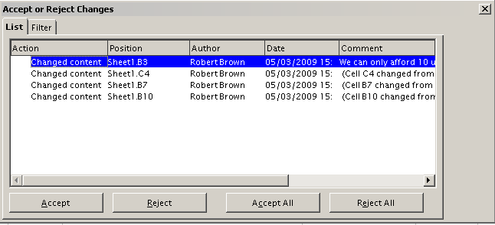Figure 281: Accept or Reject changes dialog
On the Filter tab of this dialog (not shown here), you can choose how to filter the list of changes: by date, author, cell range, or comments containing specific terms. After selecting the filter criteria, switch back to the List tab to see the results.

Merging documents
You submitted your budget proposal to your sponsor, but you sent it to one of your assistant coaches as well. Both of them returned their revised budget to you at the same time.
You could review each document and the changes separately, but to save time, you want to see both of their revisions simultaneously.
To do this, you can use Calc’s merge document feature.
The processes discussed to this point are effective when you have one reviewer at a time. Sometimes, however, multiple reviewers all return edited versions of a document at the same time. In this case, it may be quicker to review all of these changes at once, rather than one review at a time. For this purpose, you can merge documents in Calc.
To merge documents, all of the edited documents need to have recorded changes in them.
- Open the original document.
- Select Edit > Changes > Merge Document.
- A file selection dialog opens. Select a file you want to merge and click OK.
- After the documents merge, the Accept or Reject Changes dialog opens, as in Figure 282, showing changes by more than one reviewer. If you want to merge more documents, close the dialog and then repeat steps 2 and 3.
Now all of the changes are combined into one document and you can accept or reject the changes. Changes from different authors appear in different colors in the document, as shown in Figure 283. In this example, all of the changes from Robert are blue and the changes from Mia are red.
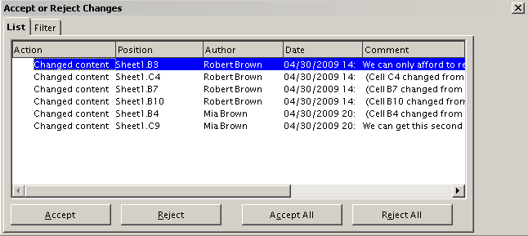Figure 282: Accept or Reject for merged documents
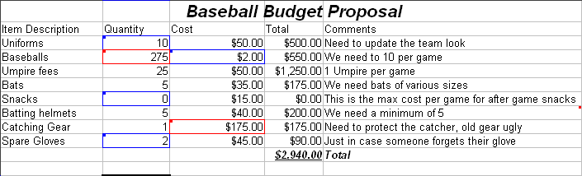Figure 283: Merged documents with different author colors

Comparing documents
Sometimes when sharing documents, reviewers may forget to record the changes they make. This is not a problem with Calc, because Calc can find the changes by comparing documents.
In order to compare documents you need to have the original document and the one that is edited. To compare them:
- Open the edited document that you want to compare with the original document.
- Select Edit > Compare Document.
- An open document dialog appears. Select the original document and click Insert.
Calc finds and marks the changes as follows:
- All data that occurs in the edited document but not in the original is identified as inserted.
- All data that is in your original document but is not in the edited document is identified as deleted.
- All data that is changed, is marked as changed.
From this point you can go through and accept or reject changes as you could normally.

Saving versions
Most documents go through many drafts. It is often useful to save new versions of a document. You can do this by saving a copy of the document (under a different name) after each revision, or you using Calc’s version feature.
Caution | If you do a Save As... of a document with different versions stored in it, the old versions are not saved in the new file.
To use version management in Calc:
- Choose File > Versions. The Versions dialog opens.
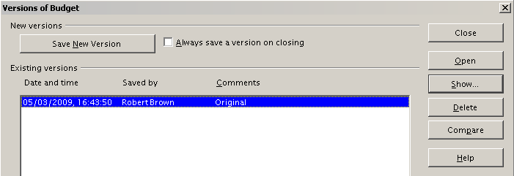Figure 284: Version management dialog
- Click the Save New Version button to save a new version.
- A dialog opens where you can enter comments about this version.
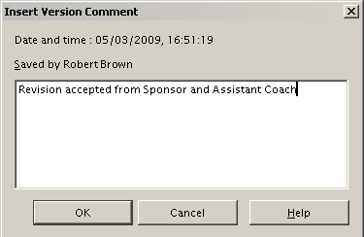Figure 285: Version comment dialog
- After you enter your comment and click OK, the new version is included in the version list.
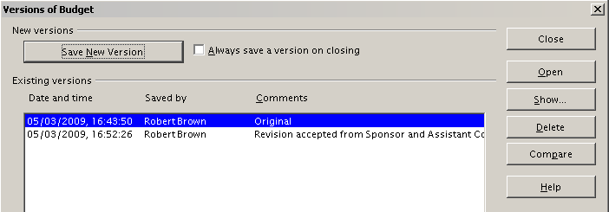Figure 286: Updated version list
Now when you save the file, both versions are saved in the same file. From this point you can:
- Open an old version – Select the version and click the Open button and a read-only version of a previous version opens.
- Compare all versions – Clicking the Compare button performs an action similar to merging documents together. An Accept or Reject Changes dialog opens showing all of the changes through the different versions.
- Review the comments – Select a version and click the Show button to display the full comments made by yourself or other reviewers.
Note | The new file is bigger in size, as if two spreadsheets were saved together.

Calc Guide

Chapter 12
Calc Macros
Automating repetitive tasks
This PDF is designed to be read onscreen, two pages at a time. If you want to print a copy, your PDF viewer should have an option for printing two pages on one sheet of paper, but you may need to start with page 2 to get it to print facing pages correctly. (Print this cover page separately.)

Copyright
This document is Copyright © 2005–2010 by its contributors as listed in the section titled Authors. You may distribute it and/or modify it under the terms of either the GNU General Public License, version 3 or later, or the Creative Commons Attribution License, version 3.0 or later.
All trademarks within this guide belong to their legitimate owners.
Authors
Andrew Pitonyak
Gary Schnabl
Jean Hollis Weber
Claire Wood
Feedback
Maintainer: Andrew Pitonyak [andrew@pitonyak.org]
Please direct any comments or suggestions about this document to: authors@documentation.openoffice.org
Publication date and software version
Published 6 June 2010. Based on OpenOffice.org 3.2.
Contents
Copyright 2
Introduction 4
Using the macro recorder 4
Write your own functions 8
Using a macro as a function 11
Passing arguments to a macro 14
Arguments are passed as values 15
Writing macros that act like built-in functions 16
Accessing cells directly 16
Sorting 17
Conclusion 19

Introduction
A macro is a saved sequence of commands or keystrokes that are stored for later use. An example of a simple macro is one that “types” your address. The OpenOffice.org (OOo) macro language is very flexible, allowing automation of both simple and complex tasks. Macros are especially useful to repeat a task the same way over and over again. This chapter briefly discusses common problems related to macro programming using Calc.

Using the macro recorder
Chapter 13 of the Getting Started guide (Getting Started with Macros) provides a basis for understanding the general macro capabilities in OpenOffice.org using the macro recorder. An example is shown here without the explanations in the Getting Started guide. The following steps create a macro that performs paste special with multiply.
- Open a new spreadsheet.
- Enter numbers into a sheet.
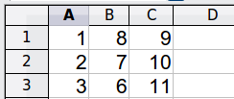
Figure 287: Enter numbers
- Select cell A3, which contains the number 3, and copy the value to the clipboard.
- Select the range A1:C3.
- Use Tools > Macros > Record Macro to start the macro recorder. The Record Macro dialog is displayed with a stop recording button.
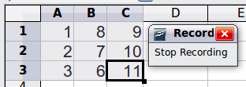
Figure 288: Stop recording button
- Use Edit > Paste Special to open the Paste Special dialog.
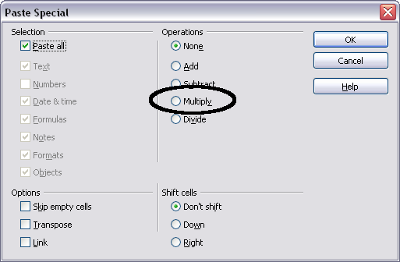
Figure 289: Paste Special dialog
- Set the operation to Multiply and click OK. The cells are now multiplied by 3.
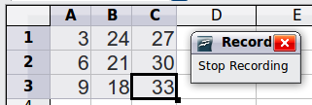
Figure 290: Cells multiplied by 3
- Click Stop Recording to stop the macro recorder. The OpenOffice.org Basic Macros dialog opens.
- Select the current document (see Figure 291). For this example, the current Calc document is Untitled 1. Existing documents show a library named Standard. This library is not created until the document is saved or the library is needed, so at this point your new document does not contain a library. You can create a new library to contain the macro, but this is not necessary.
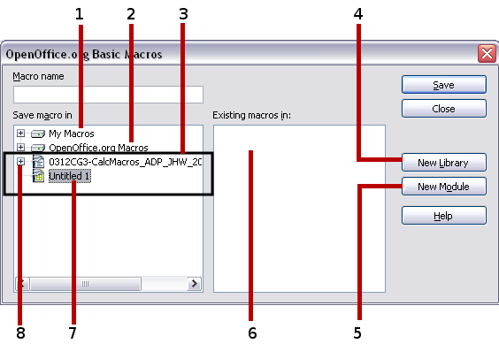
1 | My Macros | 5 | Create new module in library
2 | OpenOffice.org Macros | 6 | Macros in selected library
3 | Open documents | 7 | Current document
4 | Create new library | 8 | Expand/collapse list
Figure 291: Parts of the OpenOffice.org Basic Macros dialog
- Click New Module. If no libraries exist, then the Standard library is automatically created and used. In the New Module dialog, type a name for the new module or leave the name as Module1.
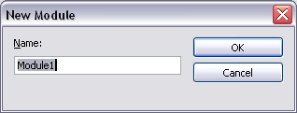
- Click OK to create a new module named Module1. Select the newly created Module1, type PasteMultiply in the Macro name box at the upper left, and click Save. (See Figure 292.)
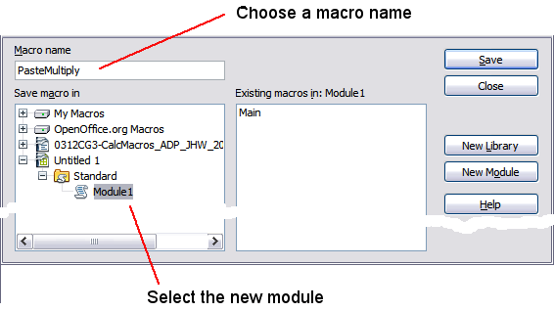
Figure 292: Select the module and name the macro
The created macro is saved in Module1 of the Standard library in the Untitled 1 document. Listing 1 shows the contents of the macro.
Listing 1. Paste special with multiply.
sub PasteMultiply
rem --------------------------------------------------------------
rem define variables
dim document as object
dim dispatcher as object
rem --------------------------------------------------------------
rem get access to the document
document = ThisComponent.CurrentController.Frame
dispatcher = createUnoService("com.sun.star.frame.DispatchHelper")

rem --------------------------------------------------------------
dim args1(5) as new com.sun.star.beans.PropertyValue
args1(0).Name = "Flags"
args1(0).Value = "A"
args1(1).Name = "FormulaCommand"
args1(1).Value = 3
args1(2).Name = "SkipEmptyCells"
args1(2).Value = false
args1(3).Name = "Transpose"
args1(3).Value = false
args1(4).Name = "AsLink"
args1(4).Value = false
args1(5).Name = "MoveMode"
args1(5).Value = 4

dispatcher.executeDispatch(document, ".uno:InsertContents", "", 0, args1())
end sub
More detail on recording macros is provided in Chapter 13 (Getting Started with Macros) in the Getting Started guide; we recommend you read it if you have not already done so. More detail is also provided in the following sections, but not as related to recording macros.

Write your own functions
Calc can call macros as Calc functions. Use the following steps to create a simple macro:
- Create a new Calc document named CalcTestMacros.ods.
- Use Tools > Macros > Organize Macros > OpenOffice.org Basic to open the OpenOffice.org Basic Macros dialog. The Macro from box lists available macro library containers including currently open OOo documents. My Macros contains macros that you write or add to OOo. OpenOffice.org Macros contains macros included with OOo and should not be changed.
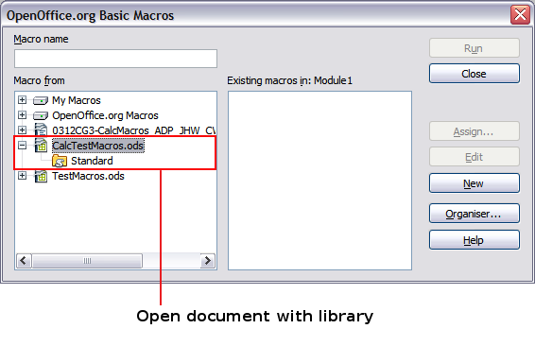
Figure 293: OpenOffice.org Basic Macros dialog
- Click Organizer to open the OpenOffice.org Basic Macro Organizer dialog. On the Libraries tab, select the document to contain the macro.
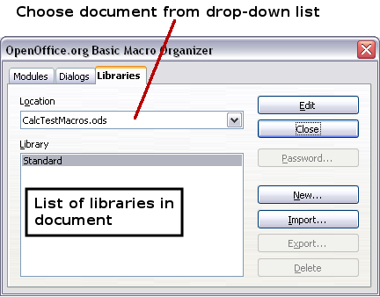
Figure 294: OpenOffice.org Basic Macro Organizer
- Click New to open the New Library dialog.
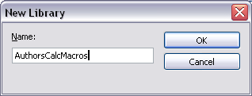
Figure 295: New Library dialog
- Enter a descriptive library name (such as AuthorsCalcMacros) and click OK to create the library. The new library name is shown the library list, but the dialog may show only a portion of the name.
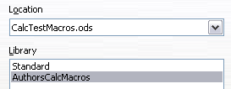
Figure 296: The library is shown in the organizer
- Select AuthorsCalcMacros and click Edit to edit the library. Calc automatically creates a module named Module1 and a macro named Main.
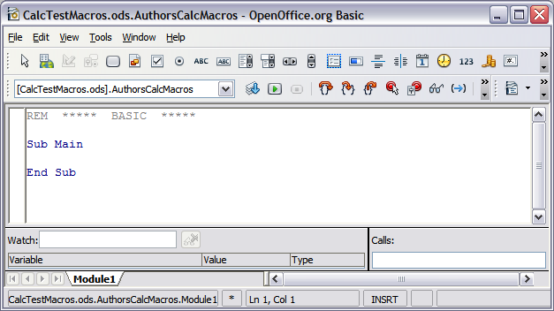
Figure 297: Basic Integrated Development Environment (IDE)
- Modify the code so that it is the same as that shown in Listing 2.The important addition is the creation of the NumberFive function, which returns the number five. The Option Explicit statement forces all variables to be declared before they are used. If Option Explicit is omitted, variables are automatically defined at first use as type Variant.
- Save the modified Module1.
Listing 2. Function that returns five.
REM ***** BASIC *****
Option Explicit

Sub Main

End Sub

Function NumberFive()
NumberFive = 5
End Function

Using a macro as a function
Using the newly created Calc document CalcTestMacros.ods, enter the formula =NumberFive() (see Figure 298). Calc finds the macro and calls it.
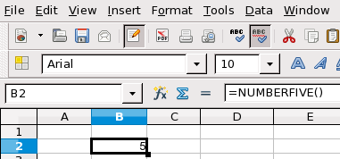
Figure 298: Use the NumberFive() Macro as a Calc function
Tip | Function names are not case sensitive. In Figure 298, you can enter =NumberFive() and Calc clearly shows =NUMBERFIVE().
Save the Calc document, close it, and open it again. Depending on your settings in Tools > Options > OpenOffice.org > Security > Macro Security, Calc will dislay the warning shown in Figure 299 or the one shown in Figure 300. You will need to click Enable Macros, or Calc will not allow any macros to be run inside the document. If you do not expect a document to contain a macro, it is safer to click Disable Macros in case the macro is a virus.
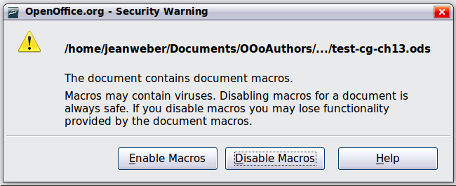
Figure 299: OOo warns you that a document contains macros
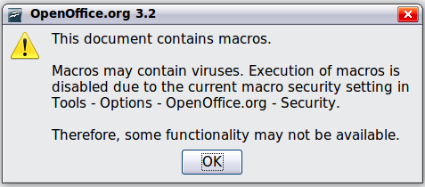Figure 300: Warning if macros are disabled
If you choose to disable macros, then when the document loads, Calc can no longer find the function.
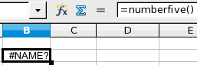
Figure 301: The function is gone
When a document is created and saved, it automatically contains a library named Standard. The Standard library is automatically loaded when the document is opened. No other library is automatically loaded.
Calc does not contain a function named NumberFive(), so it checks all opened and visible macro libraries for the function. Libraries in OpenOffice.org Macros, My Macros, and the Calc document are checked for an appropriately named function (see Figure 291). The NumberFive() function is stored in the AuthorsCalcMacros library, which is not automatically loaded when the document is opened.
Use Tools > Macros > Organize Macros > OpenOffice.org Basic to open the OpenOffice.org Basic Macros dialog (see Figure 302). Expand CalcTestMacros and find AuthorsCalcMacros. The icon for a loaded library is a different color from the icon for a library that is not loaded.
Click the expansion symbol (usually a plus or a triangle) next to AuthorsCalcMacros to load the library. The icon changes color to indicate that the library is now loaded. Click Close to close the dialog.
Unfortunately, the cells containing =NumberFive() are in error. Calc does not recalculate cells in error unless you edit them or somehow change them. The usual solution is to store macros used as functions in the Standard library. If the macro is large or if there are many macros, a stub with the desired name is stored in the Standard library. The stub macro loads the library containing the implementation and then calls the implementation.
- Use Tools > Macros > Organize Macros > OpenOffice.org Basic to open the OpenOffice.org Basic Macros dialog. Select the NumberFive macro and click Edit to open the macro for editing.
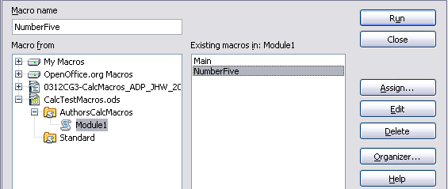
Figure 302: Select a macro and click Edit
- Change the name of NumberFive to NumberFive_Implementation (see Listing 3).
Listing 3. Change the name of NumberFive to NumberFive_Implementation
Function NumberFive_Implementation()
NumberFive_Implementation() = 5
End Function
- In the Basic IDE (see Figure 297), hover the mouse cursor over the toolbar buttons to display the tool tips. Click the Select Macro button to open the OpenOffice.org Basic Macros dialog (see Figure 302).
- Select the Standard library in the CalcTestMacros document and click New to create a new module. Enter a meaningful name such as CalcFunctions and click OK. OOo automatically creates a macro named Main and opens the module for editing.
- Create a macro in the Standard library that calls the implementation function (see Listing 4). The new macro loads the AuthorsCalcMacros library if it is not already loaded, and then calls the implementation function.
- Save, close, and reopen the Calc document. This time, the NumberFive() function works.
Listing 4. Change the name of NumberFive to NumberFive_Implementation.
Function NumberFive()
If NOT BasicLibraries.isLibraryLoaded("AuthorsCalcMacros") Then
BasicLibraries.LoadLibrary("AuthorsCalcMacros")
End If
NumberFive = NumberFive_Implementation()
End Function

Passing arguments to a macro
To illustrate a function that accepts arguments, we will write a macro that calculates the sum of its arguments that are positive —it will ignore arguments that are less than zero (see Listing 5).
Listing 5. PositiveSum calculates the sum of the positive arguments.
Function PositiveSum(Optional x)
Dim TheSum As Double
Dim iRow As Integer
Dim iCol As Integer

TheSum = 0.0
If NOT IsMissing(x) Then
If NOT IsArray(x) Then
If x > 0 Then TheSum = x
Else
For iRow = LBound(x, 1) To UBound(x, 1)
For iCol = LBound(x, 2) To UBound(x, 2)
If x(iRow, iCol) > 0 Then TheSum = TheSum + x(iRow, iCol)
Next
Next
End If
End If
PositiveSum = TheSum
End Function
The macro in Listing 5 demonstrates a couple of important techniques:
- The argument x is optional. If the argument is not optional and it is called without an argument, OOo prints a warning message every time the macro is called. If Calc calls the function many times, then the error is displayed many times.
- IsMissing checks that an argument was passed before the argument is used.
- IsArray checks to see if the argument is a single value, or an array. For example, =PositiveSum(7) or =PositiveSum(A4). In the first case, the number 7 is passed as an argument, and in the second case, the value of cell A4 is passed to the function.
- If a range is passed to the function, it is passed as a two-dimensional array of values; for example, =PositiveSum(A2:B5). LBound and UBound are used to determine the array bounds that are used. Although the lower bound is one, it is considered safer to use LBound in case it changes in the future.
Tip | The macro in Listing 5 is careful and checks to see if the argument is an array or a single argument. The macro does not verify that each value is numeric. You may be as careful as you like. The more things you check, the more robust the macro is, and the slower it runs.
Passing one argument is as easy as passing two: add another argument to the function definition (see Listing 6). When calling a function with two arguments, separate the arguments with a semicolon; for example, =TestMax(3; -4).
Listing 6. TestMax accepts two arguments and returns the larger of the two.
Function TestMax(x, y)
If x >= y Then
TestMax = x
Else
TestMax = y
End If
End Function

Arguments are passed as values
Arguments passed to a macro from Calc are always values. It is not possible to know what cells, if any, are used. For example, =PositiveSum(A3) passes the value of cell A3, and PositiveSum has no way of knowing that cell A3 was used. If you must know which cells are referenced rather than the values in the cells, pass the range as a string, parse the string, and obtain the values in the referenced cells.

Writing macros that act like built-in functions
Although Calc finds and calls macros as normal functions, they do not really behave as built-in functions. For example, macros do not appear in the function lists. It is possible to write functions that behave as regular functions by writing an Add-In. However, this is an advanced topic that is not covered here; see
http://wiki.services.openoffice.org/wiki/SimpleCalcAddIn.

Accessing cells directly
You can access the OOo internal objects directly to manipulate a Calc document. For example, the macro in Listing 7 adds the values in cell A2 from every sheet in the current document. ThisComponent is set by StarBasic when the macro starts to reference the current document. A Calc document contains sheets: ThisComponent.getSheets(). Use getCellByPosition(col, row) to return a cell at a specific row and column.
Listing 7. Add cell A2 in every sheet.
Function SumCellsAllSheets()
Dim TheSum As Double
Dim i As integer
Dim oSheets
Dim oSheet
Dim oCell

oSheets = ThisComponent.getSheets()
For i = 0 To oSheets.getCount() - 1
oSheet = oSheets.getByIndex(i)
oCell = oSheet.getCellByPosition(0, 1) ' GetCell A2
TheSum = TheSum + oCell.getValue()
Next
SumCellsAllSheets = TheSum
End Function
Tip | A cell object supports the methods getValue(), getString(), and getFormula() to get the numerical value, the string value, or the formula used in a cell. Use the corresponding set functions to set appropriate values.
Use oSheet.getCellRangeByName("A2") to return a range of cells by name. If a single cell is referenced, then a cell object is returned. If a cell range is given, then an entire range of cells is returned (see Listing 8). Notice that a cell range returns data as an array of arrays, which is more cumbersome than treating it as an array with two dimensions as is done in Listing 5.
Listing 8. Add cell A2:C5 in every sheet
Function SumCellsAllSheets()
Dim TheSum As Double
Dim iRow As Integer, iCol As Integer, i As Integer
Dim oSheets, oSheet, oCells
Dim oRow(), oRows()

oSheets = ThisComponent.getSheets()
For i = 0 To oSheets.getCount() - 1
oSheet = oSheets.getByIndex(i)
oCells = oSheet.getCellRangeByName("A2:C5")
REM getDataArray() returns the data as variant so strings
REM are also returned.
REM getData() returns data data as type Double, so only
REM numbers are returned.
oRows() = oCells.getData()
For iRow = LBound(oRows()) To UBound(oRows())
oRow() = oRows(iRow)
For iCol = LBound(oRow()) To UBound(oRow())
TheSum = TheSum + oRow(iCol)
Next
Next
Next
SumCellsAllSheets = TheSum
End Function
Tip | When a macro is called as a Calc function, the macro cannot modify any value in the sheet from which the macro was called.

Sorting
Consider sorting the data in Figure 288. First, sort on column B descending and then column A ascending.
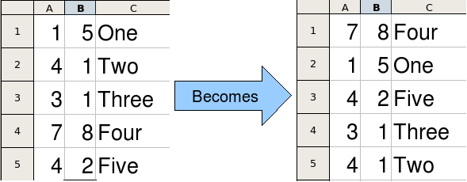
Figure 303: Sort column B descending and column A ascending
The example in Listing 9, however, demonstrates how to sort on two columns.
Listing 9. Sort cells A1:C5 on Sheet 1.
Sub SortRange
Dim oSheet ' Calc sheet containing data to sort.
Dim oCellRange ' Data range to sort.

REM An array of sort fields determines the columns that are
REM sorted. This is an array with two elements, 0 and 1.
REM To sort on only one column, use:
REM Dim oSortFields(0) As New com.sun.star.util.SortField
Dim oSortFields(1) As New com.sun.star.util.SortField

REM The sort descriptor is an array of properties.
REM The primary property contains the sort fields.
Dim oSortDesc(0) As New com.sun.star.beans.PropertyValue

REM Get the sheet named "Sheet1"
oSheet = ThisComponent.Sheets.getByName("Sheet1")

REM Get the cell range to sort
oCellRange = oSheet.getCellRangeByName("A1:C5")

REM Select the range to sort.
REM The only purpose would be to emphasize the sorted data.
'ThisComponent.getCurrentController.select(oCellRange)

REM The columns are numbered starting with 0, so
REM column A is 0, column B is 1, etc.
REM Sort column B (column 1) descending.
oSortFields(0).Field = 1
oSortFields(0).SortAscending = FALSE

REM If column B has two cells with the same value,
REM then use column A ascending to decide the order.
oSortFields(1).Field = 0
oSortFields(1).SortAscending = True

REM Setup the sort descriptor.
oSortDesc(0).Name = "SortFields"
oSortDesc(0).Value = oSortFields()

REM Sort the range.
oCellRange.Sort(oSortDesc())
End Sub

Conclusion
This chapter provides a brief overview on how to create libraries and modules, using the macro recorder, using macros as Calc functions, and writing your own macros without the macro recorder. Each topic deserves at least one chapter, and writing your own macros for Calc could easily fill an entire book. In other words, this is just the beginning of what you can learn!

Calc Guide

Chapter 13
Calc as a Simple Database
A guide for users and macro programmers
This PDF is designed to be read onscreen, two pages at a time. If you want to print a copy, your PDF viewer should have an option for printing two pages on one sheet of paper, but you may need to start with page 2 to get it to print facing pages correctly. (Print this cover page separately.)

Copyright
This document is Copyright © 2005–2010 by its contributors as listed in the section titled Authors. You may distribute it and/or modify it under the terms of either the GNU General Public License, version 3 or later, or the Creative Commons Attribution License, version 3.0 or later.
All trademarks within this guide belong to their legitimate owners.
Authors
Andrew Pitonyak
Feedback
Maintainer: Andrew Pitonyak [andrew@pitonyak.org]
Please direct any comments or suggestions about this document to: authors@documentation.openoffice.org
Publication date and software version
Published 8 June 2010. Based on OpenOffice.org 3.2.
Contents
Copyright 2
Introduction 4
Associating a range with a name 5
Named range 5
Database range 10
Sorting 11
Filters 13
Auto filters 13
Standard filters 14
Advanced filters 18
Manipulating filtered data 21
Calc functions similar to database functions 21
Count and sum cells that match conditions: COUNTIF and SUMIF 23
Ignore filtered cells using SUBTOTAL 24
Using formulas to find data 25
Search a block of data using VLOOKUP 25
Search a block of data using HLOOKUP 26
Search a row or column using LOOKUP 27
Use MATCH to find the index of a value in a range 27
Examples 28
ADDRESS returns a string with a cell’s address 29
INDIRECT converts a string to a cell or range 30
OFFSET returns a cell or range offset from another 30
INDEX returns cells inside a specified range 31
Database-specific functions 33
Conclusion 34

Introduction
A Calc document is a very capable database, providing sufficient functionality to satisfy the needs of many users. This chapter presents the capabilities of a Calc document that make it suitable as a database tool. Where applicable, the functionality is explained using both the GUI (Graphical User Interface) and macros.
Note | Although this document was initially created for macro programmers, the content should be accessible to all users. If you do not use macros, then skip those portions that deal with macros. On the other hand, if you want to learn more about macros, be certain to check out the book OpenOffice.org Macros Explained.
In a database, a record is a group of related data items treated as a single unit of information. Each item in the record is called a field. A table consists of records. Each record in a table has the same structure. A table can be visualized as a series of rows and columns. Each row in the table corresponds to a single record and each column corresponds to the fields. A spreadsheet in a Calc document is similar in structure to a database table. Each cell corresponds to a single field in a database record. For many people, Calc implements sufficient database functionality that no other database program or functionality is required.
While teaching, a spreadsheet might be used as a grading program. Each row represents a single student. The columns represent the grades received on homework, labs, and tests (see Table 12). The strong calculation capability provided in a spreadsheet makes this an excellent choice.
Table 12. Simple grading spreadsheet
 | A | B | C | D | E | F | G
1 | Name | Test 1 | Test 2 | Quiz 1 | Quiz 2 | Average | Grade
2 | Andy | 95 | 93 | 93 | 92 | 93.25
3 | Betty | 87 | 92 | 65 | 73 | 79.25
4 | Bob | 95 | 93 | 93 | 92 | 93.25
5 | Brandy | 45 | 65 | 92 | 85 | 71.75
6 | Frank | 95 | 93 | 85 | 92 | 91.25
7 | Fred | 87 | 92 | 65 | 73 | 79.25
8 | Ilsub | 70 | 85 | 97 | 79 | 82.75
9 | James | 45 | 65 | 97 | 85 | 73
10 | Lisa | 100 | 97 | 100 | 93 | 97.5
11 | Michelle | 100 | 97 | 100 | 65 | 90.5
12 | Ravi | 87 | 92 | 86 | 93 | 89.5
13 | Sal | 45 | 65 | 100 | 92 | 75.5
14 | Ted | 100 | 97 | 100 | 85 | 95.5
15 | Tom | 70 | 85 | 93 | 65 | 78.25
16 | Whil | 70 | 85 | 93 | 97 | 86.25
Tip | Although the choice to associate a row to a record rather than a column is arbitrary, it is almost universal. In other words, you are not likely to hear someone refer to a column of data as a single database record.

Associating a range with a name
In a Calc document, a range refers to a contiguous group of cells containing at least one cell. You can associate a meaningful name to a range, which allows you to refer to the range using the meaningful name. You can create either a database range, which has some database-like functionality, or a named range, which does not. A name is usually associated with a range for one of three reasons:
- Associating a range with a name enhances readability by using a meaningful name.
- If a range is referenced by name in multiple locations, you can point the name to another location and all references point to the new location.
- Ranges associated to a name are shown in the Navigator, which is available by pressing the F5 key or clicking on the icon. The Navigator allows for quick navigation to the associated ranges.

Named range
The most common usage of a named range is, as its name implies, to associate a range of cells to a meaningful name. For example, I created a range named Scores, and then I used the following equation: =SUM(Scores). To create a named range, select the range to define. Use Insert > Names > Define to open the Define Names dialog. Use the Define Names dialog to add and modify one named range at a time.
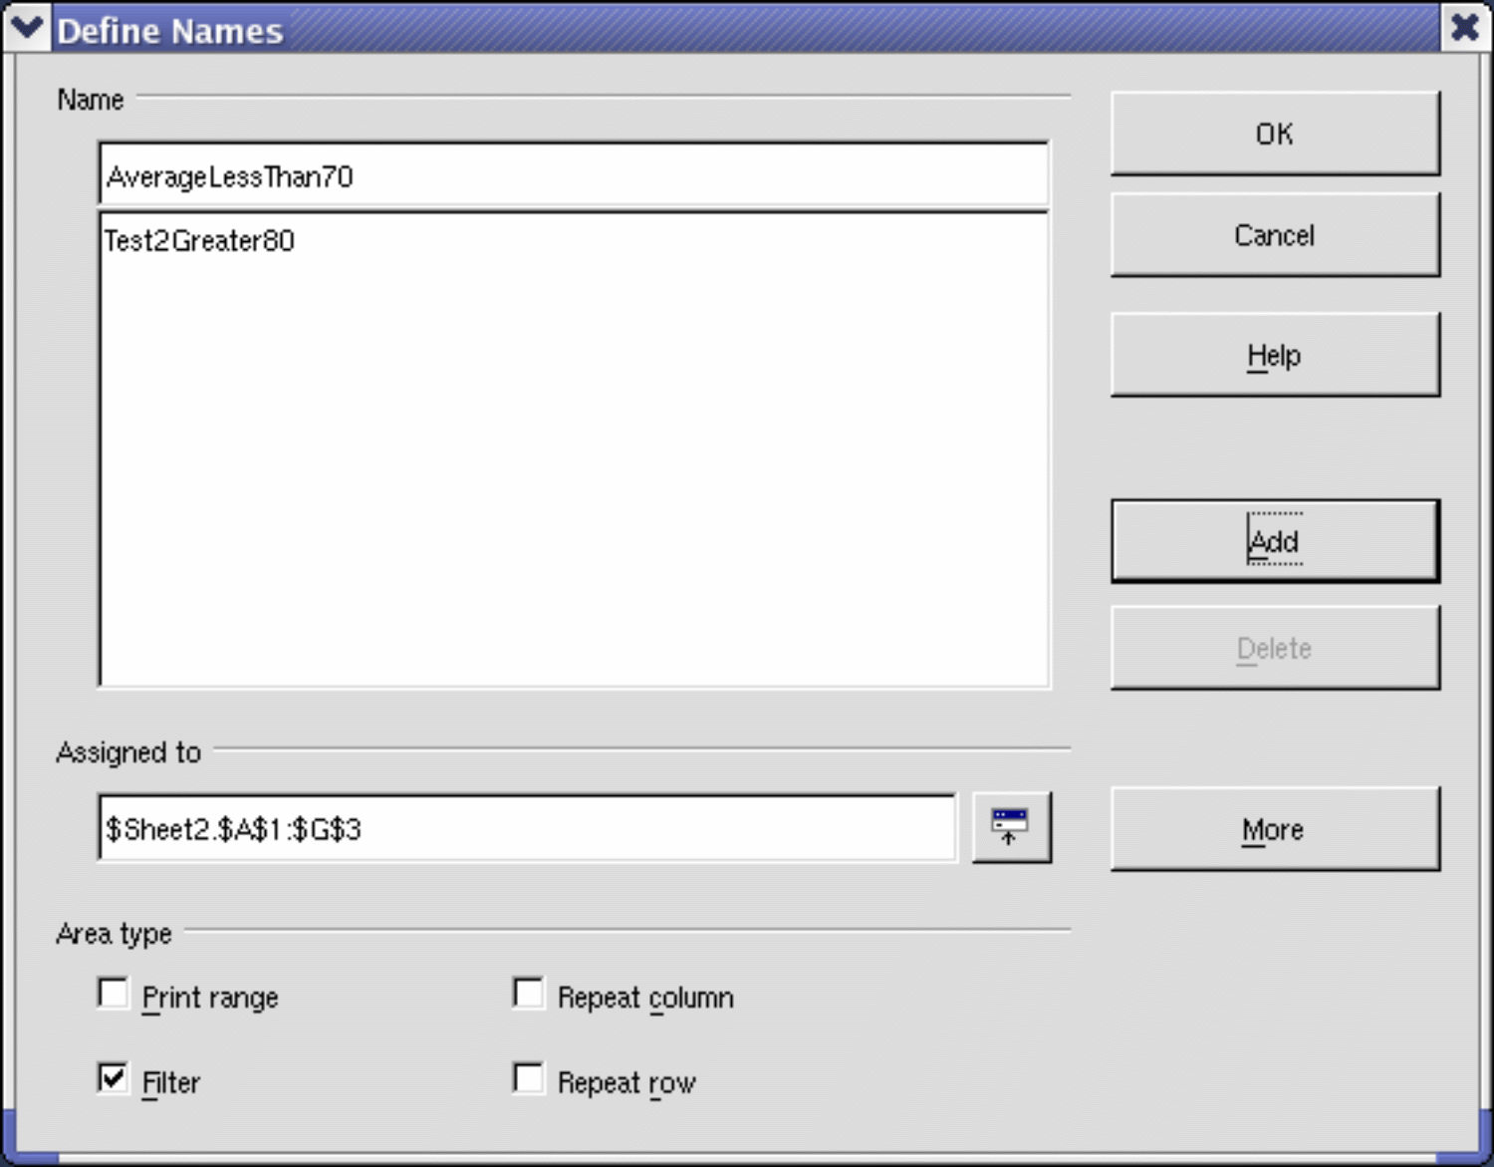
Figure 304. Define a named range.
In a macro, a named range is accessed, created, and deleted using the NamedRanges property of a Calc document. Use the methods hasByName(name) and getByName(name) to verify and retrieve a named range. The method getElementNames() returns an array containing the names of all named ranges. The NamedRanges object supports the method addNewByname, which accepts four arguments; the name, content, position, and type. The macro in Listing 10 creates a named range, if it does not exist, that references a range of cells.
Listing 10. Create a named range that references $Sheet1.$B$3:$D$6.
Sub AddNamedRange()
Dim oRange ' The created range.
Dim oRanges ' All named ranges.
Dim sName$ ' Name of the named range to create.
Dim oCell ' Cell object.
Dim s$

sName$ = "MyNRange"
oRanges = ThisComponent.NamedRanges
If NOT oRanges.hasByName(sName$) Then
REM I can obtain the cell address by obtaining the cell
REM and then extracting the address from the cell.
Dim oCellAddress As new com.sun.star.table.CellAddress
oCellAddress.Sheet = 0 'The first sheet.
oCellAddress.Column = 1 'Column B.
oCellAddress.Row = 2 'Row 3.

REM The first argument is the range name.
REM The second argument is formula or expression to
REM use. The second argument is usually a string that
REM defines a range.
REM The third argument specifies the base address for
REM relative cell references.
REM The fourth argument is a set of flags that define
REM how the range is used, but most ranges use 0.
REM The fourth argument uses values from the
REM NamedRangeFlag constants (see Table 13).
s$ = "$Sheet1.$B$3:$D$6"
oRanges.addNewByName(sName$, s$, oCellAddress, 0)
End If
REM Get a range using the created named range.
oRange = ThisComponent.NamedRanges.getByName(sName$)

REM Print the string contained in cell $Sheet1.$B$3
oCell = oRange.getReferredCells().getCellByPosition(0,0)
Print oCell.getString()
End Sub
The method addNewByname() accepts four arguments; the name, content, position, and type. The fourth argument to the method addNewByName() is a combination of flags that specify how the named range will be used (see Table 13). The most common value is 0, which is not a defined constant value.
Table 13. com.sun.star.sheet.NamedRangeFlag constants.
Value | Name | Description
1 | FILTER_CRITERIA | The range contains filter criteria.
2 | PRINT_AREA | The range can be used as a print range.
4 | COLUMN_HEADER | The range can be used as column headers for printing.
8 | ROW_HEADER | The range can be used as row headers for printing.
The third argument, a cell address, acts as the base address for cells referenced in a relative way. If the cell range is not specified as an absolute address, the referenced range will be different based on where in the spreadsheet the range is used. The relative behavior is illustrated in Listing 11, which also illustrates another usage of a named range—defining an equation. The macro in Listing 11 creates the named range AddLeft, which refers to the equation A3+B3 with C3 as the reference cell. The cells A3 and B3 are the two cells directly to the left of C3, so, the equation =AddLeft() calculates the sum of the two cells directly to the left of the cell that contains the equation. Changing the reference cell to C4, which is below A3 and B3, causes the AddLeft equation to calculate the sum of the two cells that are to the left on the previous row.
Listing 11. Create the AddLeft named range.
Sub AddNamedFunction()
Dim oSheet 'Sheet that contains the named range.
Dim oCellAddress 'Address for relative references.
Dim oRanges 'The NamedRanges property.
Dim oRange 'Single cell range.
Dim sName As String 'Name of the equation to create.

sName = "AddLeft"
oRanges = ThisComponent.NamedRanges
If NOT oRanges.hasByName(sName) Then
oSheet = ThisComponent.getSheets().getByIndex(0)
oRange = oSheet.getCellRangeByName("C3")
oCellAddress = oRange.getCellAddress()
oRanges.addNewByName(sName, "A3+B3", oCellAddress, 0)
End If
End Sub
Tip | Listing 11 illustrates two capabilities that are not widely known. A named range can define a function. Also, the third argument acts as the base address for cells referenced in a relative way.
Select the range containing the headers and the data and then use Insert > Names > Create to open the Create Names dialog (see Figure 305), which allows you to simultaneously create multiple named ranges based on the top row, bottom row, right column or left column. If you choose to create ranges based on the top row, one named range is created for each column header—the header is not included in the named range. Although the header is not included in the range, the text in the header is used to name the range.
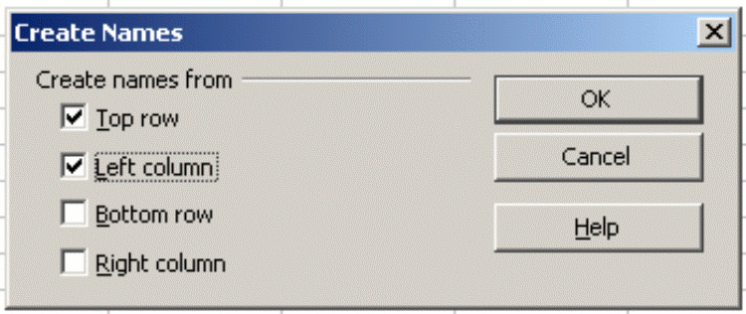Figure 305. Define a named range.
The macro in Listing 12 creates three named ranges based on the top row of a named range.
Listing 12. Create many named ranges.
Sub AddManyNamedRanges()
Dim oSheet 'Sheet that contains the named range.
Dim oAddress 'Range address.
Dim oRanges 'The NamedRanges property.
Dim oRange 'Single cell range.

oRanges = ThisComponent.NamedRanges
oSheet = ThisComponent.getSheets().getByIndex(0)
oRange = oSheet.getCellRangeByName("A1:C20")
oAddress = oRange.getRangeAddress()
oRanges.addNewFromTitles(oAddress, _
com.sun.star.sheet.Border.TOP)
End Sub
The constants in Table 14 determine the location of the headers when multiple ranges are created using the method addNewFromTitles().
Table 14. com.sun.star.sheet.Border constants.
Value | Name | Description
0 | TOP | Select the top border.
1 | BOTTOM | Select the bottom border.
2 | RIGHT | Select the right border.
3 | LEFT | Select the left border.
Caution | It is possible to create multiple named ranges with the same name. Creating multiple ranges with a single command increases the likelihood that multiple ranges will be created with the same name—avoid this if possible.

Database range
Although a database range can be used as a regular named range, a database range also defines a range of cells in a spreadsheet to be used as a database. Each row in a range corresponds to a record and each cell corresponds to a field. You can sort, group, search, and perform calculations on the range as if it were a database.
A database range provides behavior that is useful when performing database related activities. For example, you can mark the first row as headings. To create, modify, or delete a database range, use Data > Define Range to open the Define Data Range dialog (see Figure 306). When you first define a range, the Modify button shown in the example is labeled New.
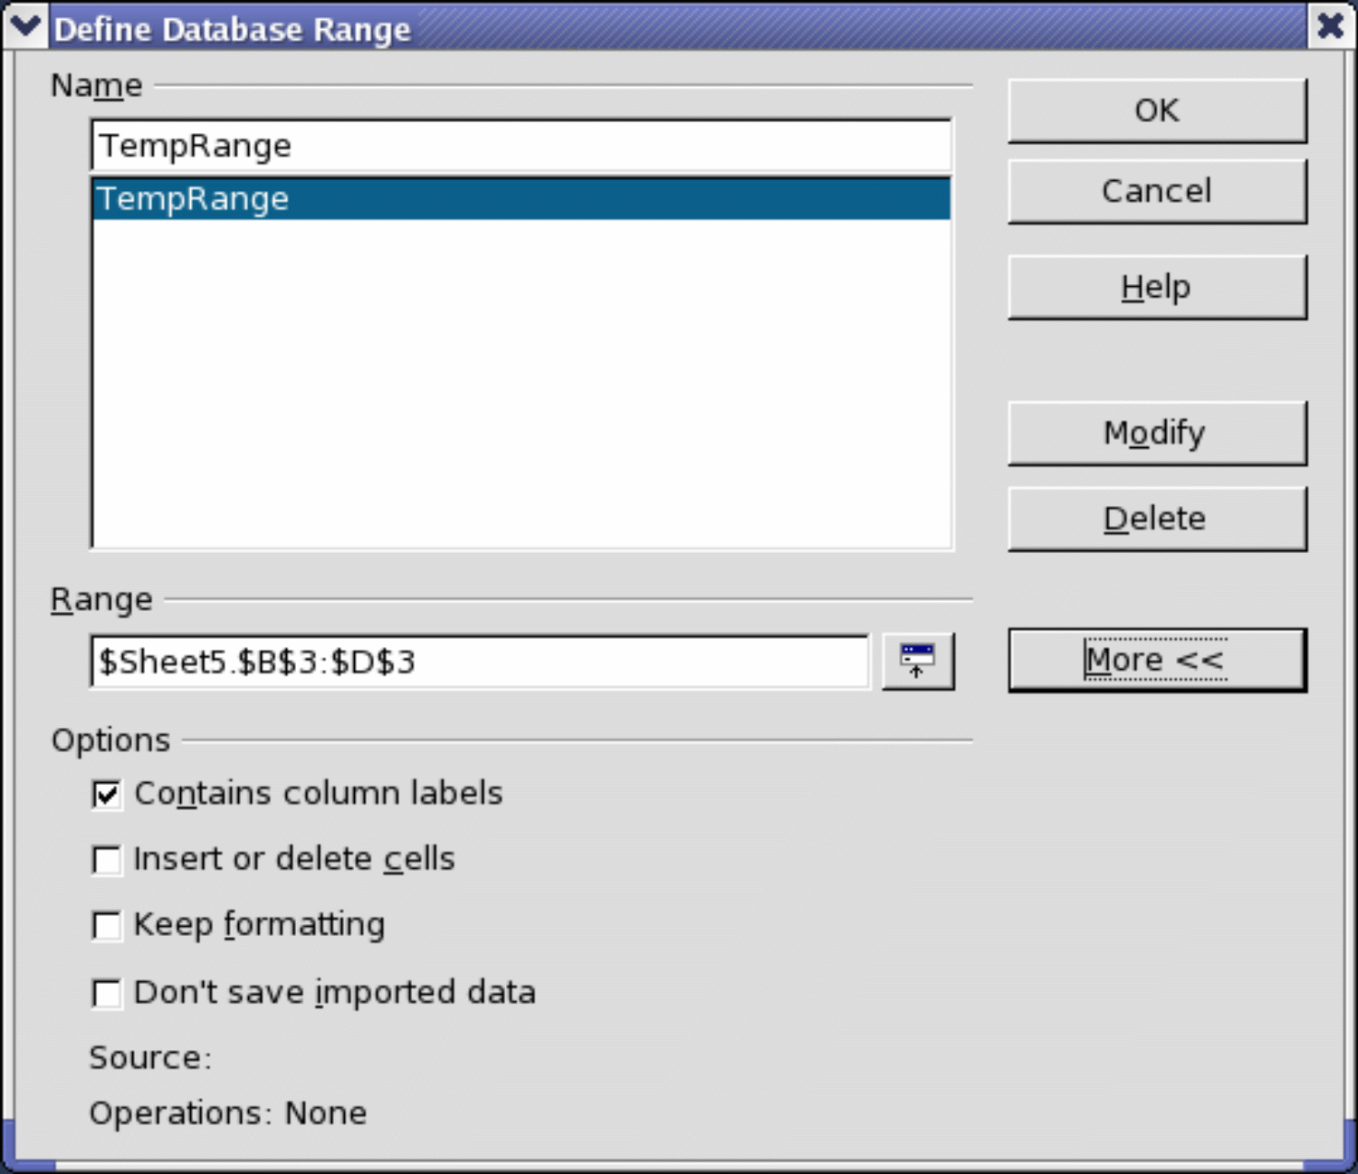Figure 306. Define a database range.
In a macro, a database range is accessed, created, and deleted from the DatabaseRanges property. The macro in Listing 13 creates a database range named MyName and sets the range to be used as an auto filter.
Listing 13. Create a database range and an auto filter.
Sub AddNewDatabaseRange()
Dim oRange 'DatabaseRange object.
Dim oAddr 'Cell address range for the database range.
Dim oSheet 'First sheet, which will contain the range.
Dim oDoc 'Reference ThisComponent with a shorter name.

oDoc = ThisComponent
If NOT oDoc.DatabaseRanges.hasByName("MyName") Then
oSheet = ThisComponent.getSheets().getByIndex(0)
oRange = oSheet.getCellRangeByName("A1:F10")
oAddr = oRange.getRangeAddress()
oDoc.DatabaseRanges.addNewByName("MyName", oAddr)
End If
oRange = oDoc.DatabaseRanges.getByName("MyName")
oRange.AutoFilter = True
End Sub

Sorting
The sorting mechanism in a Calc document rearranges the data in the sheet. The first step in sorting data is to select the data that you want to sort. To sort the data in Table 23, select the cells from A1 to G16—if you include the column headers, indicate this in the sort dialog (see Figure 308). Use Data > Sort to open the Sort dialog (see Figure 307). You can sort by up to three columns or rows at a time.
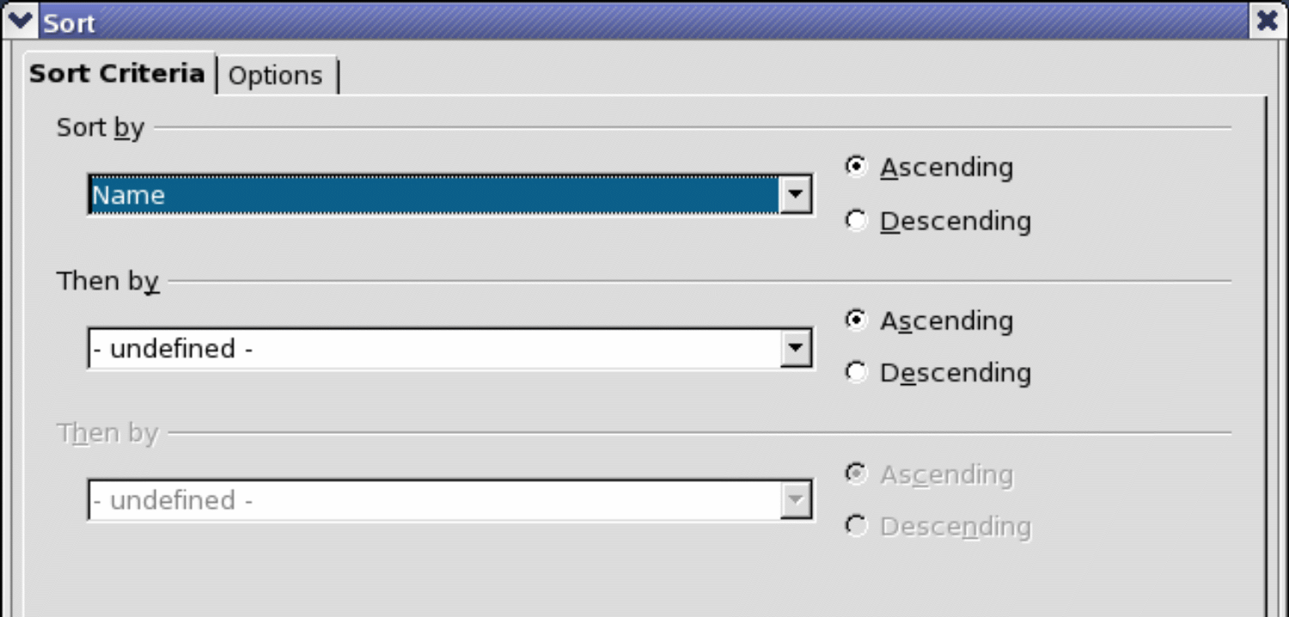Figure 307. Sort by the Name column.
Click on the Options tab (see Figure 308) to set the sort options. Check the Range contains column labels checkbox to prevent column headers from being sorted with the rest of the data. The Sort by list box in Figure 307 displays the columns using the column headers if the Range contains column labels checkbox in Figure 308 is checked. If the Range contains column labels checkbox is not checked, however, then the columns are identified by their column name; Column A, for example.
Normally, sorting the data causes the existing data to be replaced by the newly sorted data. The Copy sort results to checkbox, however, causes the selected data to be left unchanged and a copy of the sorted data is copied to the specified location. You can either directly enter a target address (Sheet3.A1, for example) or select a predefined range.
Check the Custom sort order checkbox to sort based on a predefined list of values. To set your own predefined lists, use Tools > Options > OpenOffice.org Calc > Sort Lists and then enter your own sort lists. Predefined sort lists are useful for sorting lists of data that should not be sorted alphabetically or numerically. For example, sorting days based on their name.
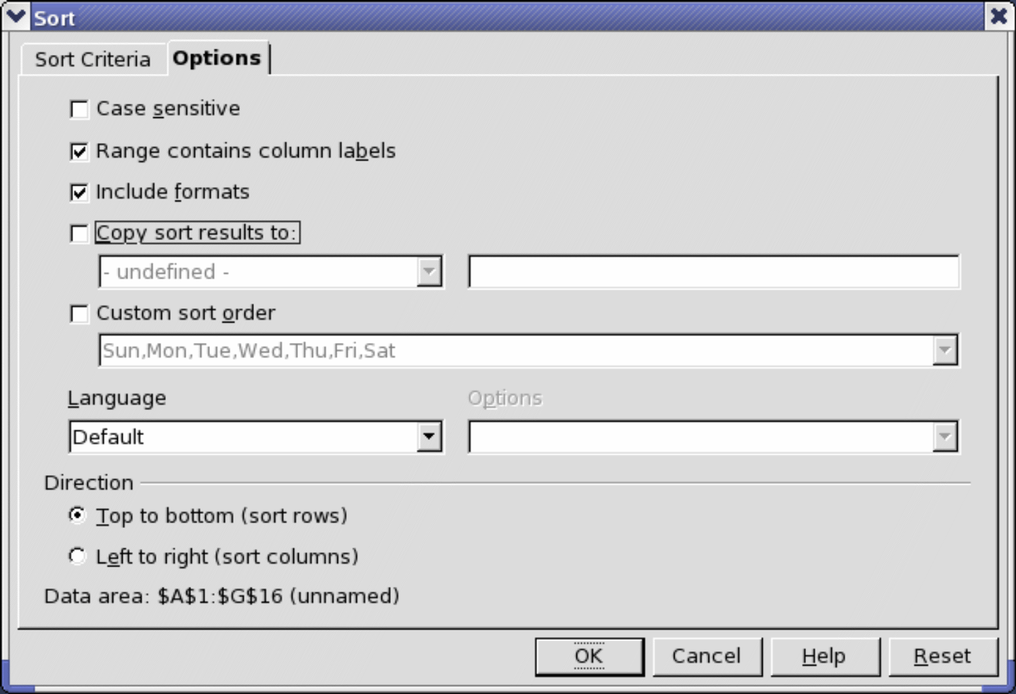Figure 308. Set sort options.
Caution | When a cell is moved during a sort operation, external references to that cell are not updated. If a cell that contains a relative reference to another cell is moved, the reference is relative to the new position when sorting is finished. Know the behavior of references during sorting and do not be alarmed; this is almost always what you want—because the reference is to the right or left in the same row. Also, we have not found a spreadsheet program that exhibits a different behavior for references while sorting.

Filters
Use filters to limit the visible rows in a spreadsheet. Generic filters, common to all sorts of data manipulations, are automatically provided by the auto filter capability. You can also define your own filters.
Caution | After applying a filter, some rows are visible and some rows are not. If you select multiple rows in one operation, you will also select the invisible rows contained between the selected visible rows. Operations, such as delete, act on all of the selected rows. To avoid this problem, you must individually select each of the filtered rows using the control key.

Auto filters
Use auto filters to quickly create easily accessible filters found to be commonly used in many different types of applications. After creating an auto filter for a specific column, a combo box is added to the column. The combo box provides quick access to each of the auto filter types.
- The All auto filter causes all rows to be visible.
- The Standard auto filter opens the Standard Filter dialog and is the same as the standard filter.
- The Top 10 auto filter displays the ten rows with the largest value. If the value 70 is in the top ten values, then all rows containing the value 70 in the filtered column are displayed. In other words, more than ten rows may be displayed.
- An auto filter entry is created for each unique entry in the column.
To create an auto filter, first select the columns to filter. For example, using the data in Table 12, select data in columns B and C. If you do not select the title rows, Calc asks if the title row or the current row should be used. Although you can place the auto filter in any row, only the rows below the auto filter are filtered. Use Data > Filter > AutoFilter to insert the auto filter combo box in the appropriate cell. Finally, use the drop-down arrow to choose an appropriate auto filter (see Figure 309).
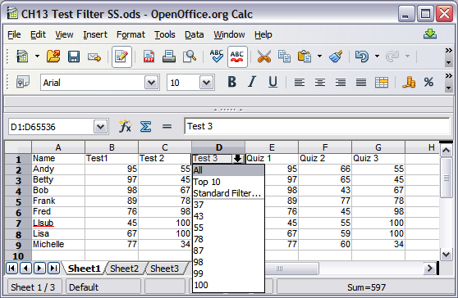
Figure 309: Use an auto filter with column C
Remove an auto filter by repeating the steps to create the auto filter—in other words, the menu option acts as a toggle to turn the auto filter on and off. When an auto filter is removed, the combo box is removed from the cell. The macro in Listing 13 demonstrates creating an auto filter for a range.

Standard filters
Use Data > Filter > Standard Filter to open Standard Filter dialog (see Figure 310) and limit the view based on 1 to 3 filter conditions. Use Data > Filter > Remove Filter to turn off the filter.
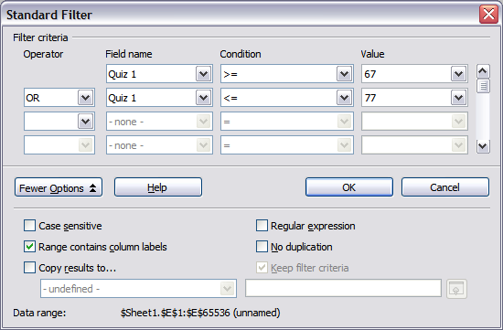
Figure 310: Use the standard filter
The macro in Listing 14 creates a simple filter for the first sheet.
Listing 14. Create a simple sheet filter.
Sub SimpleSheetFilter()
Dim oSheet ' Sheet that will contain the filter.
Dim oFilterDesc ' Filter descriptor.
Dim oFields(0) As New com.sun.star.sheet.TableFilterField

oSheet = ThisComponent.getSheets().getByIndex(0)

REM If argument is True, creates an empty filter
REM descriptor. If argument is False, create a
REM descriptor with the previous settings.
oFilterDesc = oSheet.createFilterDescriptor(True)

With oFields(0)
REM I could use the Connection property to indicate
REM how to connect to the previous field. This is
REM the first field so this is not required.
'.Connection = com.sun.star.sheet.FilterConnection.AND
'.Connection = com.sun.star.sheet.FilterConnection.OR

REM The Field property is the zero based column
REM number to filter. If you have the cell, you
REM can use .Field = oCell.CellAddress.Column.
.Field = 5

REM Compare using a numeric or a string?
.IsNumeric = True

REM The NumericValue property is used
REM because .IsNumeric = True from above.
.NumericValue = 80

REM If IsNumeric was False, then the
REM StringValue property would be used.
REM .StringValue = "what ever"

REM Valid operators include EMPTY, NOT_EMPTY, EQUAL,
REM NOT_EQUAL, GREATER, GREATER_EQUAL, LESS,
REM LESS_EQUAL, TOP_VALUES, TOP_PERCENT,
REM BOTTOM_VALUES, and BOTTOM_PERCENT
.Operator = com.sun.star.sheet.FilterOperator.GREATER_EQUAL
End With

REM The filter descriptor supports the following
REM properties: IsCaseSensitive, SkipDuplicates,
REM UseRegularExpressions,
REM SaveOutputPosition, Orientation, ContainsHeader,
REM CopyOutputData, OutputPosition, and MaxFieldCount.
oFilterDesc.setFilterFields(oFields())
oFilterDesc.ContainsHeader = True
oSheet.filter(oFilterDesc)
End Sub
When a filter is applied to a sheet, it replaces any existing filter for the sheet. Setting an empty filter in a sheet will therefore remove all filters for that sheet (see Listing 15).
Listing 15. Remove the current sheet filter.
Sub RemoveSheetFilter()
Dim oSheet ' Sheet to filter.
Dim oFilterDesc ' Filter descriptor.

oSheet = ThisComponent.getSheets().getByIndex(0)
oFilterDesc = oSheet.createFilterDescriptor(True)
oSheet.filter(oFilterDesc)
End Sub
Listing 16 demonstrates a more advanced filter that filters two columns and uses regular expressions. I noticed some unexpected behavior while working with Listing 16. Although you can create a filter descriptor using any sheet cell range, the filter applies to the entire sheet.
Listing 16. A simple sheet filter using two columns.
Sub SimpleSheetFilter_2()
Dim oSheet ' Sheet to filter.
Dim oRange ' Range to be filtered.
Dim oFilterDesc ' Filter descriptor.
Dim oFields(1) As New com.sun.star.sheet.TableFilterField

oSheet = ThisComponent.getSheets().getByIndex(0)
oRange = oSheet.getCellRangeByName("E12:G19")

REM If argument is True, creates an
REM empty filter descriptor.
oFilterDesc = oRange.createFilterDescriptor(True)

REM Setup a field to view cells with content that
REM start with the letter b.
With oFields(0)
.Field = 0 ' Filter column A.
.IsNumeric = False ' Use a string, not a number.
.StringValue = "b.*" ' Everything starting with b.
.Operator = com.sun.star.sheet.FilterOperator.EQUAL
End With
REM Setup a field that requires both conditions and
REM this new condition requires a value greater or
REM equal to 70.
With oFields(1)
.Connection = com.sun.star.sheet.FilterConnection.AND
.Field = 5 ' Filter column F.
.IsNumeric = True ' Use a number
.NumericValue = 70 ' Values greater than 70
.Operator = com.sun.star.sheet.FilterOperator.GREATER_EQUAL
End With

oFilterDesc.setFilterFields(oFields())
oFilterDesc.ContainsHeader = False
oFilterDesc.UseRegularExpressions = True
oSheet.filter(oFilterDesc)
End Sub

Advanced filters
An advanced filter supports up to eight filter conditions, as opposed to the three supported by the simple filter. The criteria for an advanced filter is stored in a sheet. The first step in creating an advanced filter is entering the filter criteria into the spreadsheet.
- Select an empty space in the Calc document. The empty space may reside in any sheet in any location in the Calc document.
- Duplicate the column headings from the area to be filtered into the area that will contain the filter criteria.
- Enter the filter criteria underneath the column headings (see Table 24). The criterion in each column of a row is connected with AND. The criteria from each row are connected with OR.
Table 15. Example advanced filter criteria
Name | Test 1 | Test 2 | Quiz 1 | Quiz 2 | Average | Grade
="Andy" |  | >80
 |  |  |  |  | <80
Tip | Define named ranges to reference your advanced filter criteria and any destination ranges for filtered data (see Figure 304). Each appropriately configured named range is available in drop down list boxes in the Advanced Filter dialog (see Figure 311).
After creating one or more sets of filter criteria, apply an advanced filter as follows:
- Select the sheet ranges that contain the data to filter.
- Use Data > Filter > Advanced Filter to open the Advanced Filter dialog (see Figure 311).
- Select the range containing the filter criteria and any other relevant options.
- Click OK.
Applying an advanced filter using a macro is simple (see Listing 17). The cell range containing the filter criteria is used to create a filter descriptor, which is then used to filter the range containing the data.
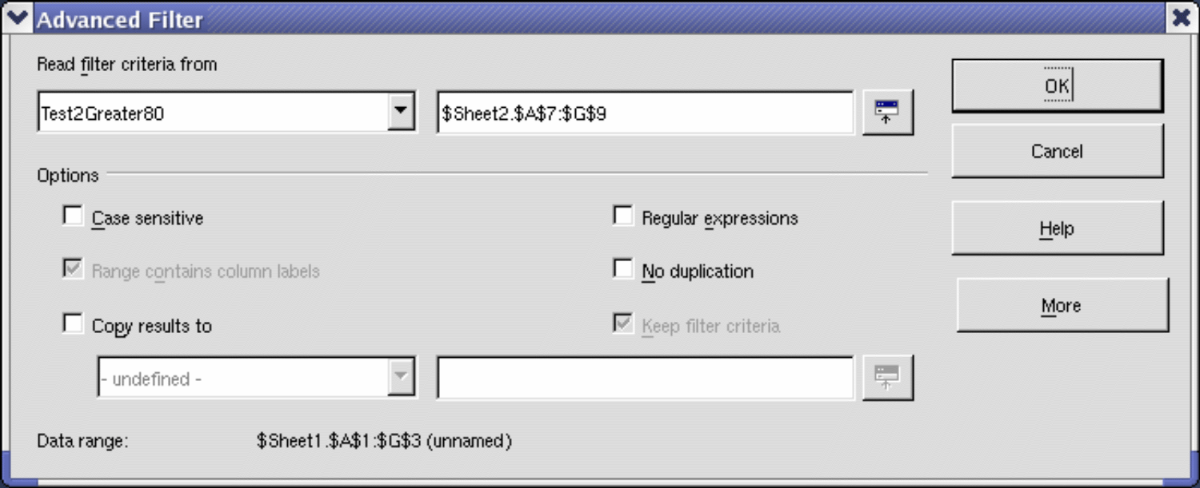Figure 311. Apply an advanced filter using a previously defined named range.
Listing 17. Use an advanced filter.
Sub UseAnAdvancedFilter()
Dim oSheet 'A sheet from the Calc document.
Dim oRanges 'The NamedRanges property.
Dim oCritRange 'Range that contains the filter criteria.
Dim oDataRange 'Range that contains the data to filter.
Dim oFiltDesc 'Filter descriptor.

REM Range that contains the filter criteria
oSheet = ThisComponent.getSheets().getByIndex(1)
oCritRange = oSheet.getCellRangeByName("A1:G3")

REM You can also obtain the range containing the
REM filter criteria from a named range.
REM oRanges = ThisComponent.NamedRanges
REM oRange = oRanges.getByName("AverageLess80")
REM oCritRange = oRange.getReferredCells()

REM The data that I want to filter
oSheet = ThisComponent.getSheets().getByIndex(0)
oDataRange = oSheet.getCellRangeByName("A1:G16")

oFiltDesc = oCritRange.createFilterDescriptorByObject(oDataRange)
oDataRange.filter(oFiltDesc)
End Sub
Change properties on the filter descriptor to change the behavior of the filter (see Table 16).
The filter created in Listing 17 filters the data in place. Modify the OutputPosition property to specify a different output position (see Listing 18). The filter descriptor must be modified before the filter is applied.
Table 16. Advanced filter properties.
Property | Comment
ContainsHeader | Boolean (true or false) that specifies if the first row (or column) contains headers which should not be filtered.
CopyOutputData | Boolean that specifies if the filtered data should be copied to another position in the document.
IsCaseSensitive | Boolean that specifies if the case of letters is important when comparing entries.
Orientation | Specifies if columns (com.sun.star.table.TableOrientation.COLUMNS) or rows (com.sun.star.table.TableOrientation.ROWS) are filtered.
OutputPosition | If if CopyOutputData is True , specifies the position where filtered data are to be copied.
SaveOutputPosition | Boolean that specifies if the OutputPosition position is saved for future calls.
SkipDuplicates | Boolean that specifies if duplicate entries are left out of the result.
UseRegularExpressions | Boolean that specifies if the filter strings are interpreted as regular expressions.
Listing 18. Copy filtered results to a different location.
REM Copy the output data rather than filter in place.
oFiltDesc.CopyOutputData = True

REM Create a CellAddress and set it for Sheet3,
REM Column B, Row 4 (remember, start counting with 0)
Dim x As New com.sun.star.table.CellAddress
x.Sheet = 2
x.Column = 1
x.Row = 3
oFiltDesc.OutputPosition = x
(Advanced material.) The OutputPosition property returns a copy of a struct. Because a copy is returned, it is not possible to set the individual values directly. For example, oFiltDesc.OutputPosition.Row = 2 does not work (because you set the Row on the copy to 2, but do not change the original).

Manipulating filtered data
Filtered data copied to a new location may be selected, modified, and deleted at will. Data that is not copied, however, requires special attention because rows that do not match the filter criteria are simply hidden. OpenOffice.org behaves differently depending on how the cells became hidden and what operation is done.
Cells may be hidden using an outline, data filter, or the hide command. When data is moved by dragging or using cut and paste, all of the cells are moved—including the hidden cells. When copying data, however, filtered data includes only the visible cells and data hidden using an outline or the hide command copies all of the data.

Calc functions similar to database functions
Although every Calc function can be used for database manipulation, the functions in Table 17 are more commonly used as such. Some functions’ names differ only by the letter appended at the end; AVERAGE and AVERAGEA, for example. Functions that do not end with the letter A operate only on numeric values and cells that contain text or are empty are ignored. The corresponding function whose name ends with the letter A, treats text values as a number with the value of zero; blank cells are still ignored.
Table 17. Functions frequently used as database functions.
Function | Description
AVERAGE | Return the average. Ignore empty cells and cells that contain text.
AVERAGEA | Return the average. The value of text is 0 and empty cells are ignored.
COUNT | Count the number of numeric entries; text entries are ignored.
COUNTA | Count the number of non-empty entries.
COUNTBLANK | Return the number of empty cells.
COUNTIF | Return the number of cells that meet the search criteria.
HLOOKUP | Search for a specific value across the columns in the first row of an array. Return the value from a different row in the same column.
INDEX | Return the content of a cell, specified by row and column number or an optional range name.
INDIRECT | Return the reference specified by a text string.
LOOKUP | Return the contents of a cell either from a one-row or one-column range or from an array.
MATCH | Search an array and return the relative position of the found item.
MAX | Return the maximum numeric value in a list of arguments.
MAXA | Return the maximum numeric value in a list of arguments. The value of text is 0.
MIN | Return the minimum numeric value in a list of arguments.
MINA | Return the minimum numeric value in a list of arguments. The value of text is 0.
MEDIAN | Return the median of a set of numbers.
MODE | Return the most common value in a data set. If there are several values with the same frequency, it returns the smallest value. An error occurs when a value doesn’t appear twice.
OFFSET | Return the value of a cell offset by a certain number of rows and columns from a given reference point.
PRODUCT | Return the product of the cells.
STDEV | Estimate the standard deviation based on a sample.
STDEVA | Estimate the standard deviation based on a sample. The value of text is 0.
STDEVP | Calculate the standard deviation based on the entire population.
STDEVPA | Calculate the standard deviation based on the entire population.
SUBTOTAL | Calculate a specified function based on a subset created using AutoFilters.
SUM | Return the sum of the cells.
SUMIF | Calculate the sum for the cells that meet the search criteria.
VAR | Estimate the variance based on a sample.
VARA | Estimate the variance based on a sample. The value of text is 0.
VARP | Estimate the variance based on the entire population.
VARPA | Estimate the variance based on the entire population. The value of a text is 0.
VLOOKUP | Search for a specific value across the rows in the first column of an array. Returns the value from a different column in the same row.
Most of the functions in Table 17 require no explanation, either because they are well understood (SUM, for example) or because if you need to use them then you know what they are (STDEV, for example). Unfortunately, some of the more useful functions are infrequently used because they are not well understood.

Count and sum cells that match conditions: COUNTIF and SUMIF
The COUNTIF and SUMIF functions calculate their values based on search criteria. The search criteria can be a number, expression, text string, or even a regular expression. The search criteria can be contained in a referenced cell or it can be included directly in the function call.
The COUNTIF function counts the number of cells in a range that match specified criteria. The first argument to COUNTIF specifies the range to search and second argument is the search criteria. Table 18 illustrates different search criteria using the COUNTIF function referencing the data shown in Table 12.
The first two arguments for SUMIF serve the same purpose as the arguments for COUNTIF; the range that contains the cells to search and the search criteria. The third and final argument for SUMIF specifies the range to sum. For each cell in the search range that matches the search criteria, the corresponding cell in the sum range is added into the sum.
Table 18. Examples of search criteria for the COUNTIF and SUMIF functions.
Criteria Type | Function | Result | Description
Number | =COUNTIF(B1:C16; 95) | 3 | Finds numeric values of 95.
Text | =COUNTIF(B1:C16; "95") | 3 | Finds numeric or text values of 95.
Expression | =COUNTIF(B1:C16; ">95") | 6 | Finds numeric values greater than 95.
Expression | =COUNTIF(B1:C16; 2*45+5) | 3 | Finds only numeric values of 95.
Regular expression | =COUNTIF(B1:C16; "9.*") | 12 | Finds numbers or text that start with 9.
Reference a cell | =COUNTIF(B1:C16; B3) | 3 | Finds a number or number and text depending on the data type in cell B3.
Regular expression | =SUMIF(A1:A16; "B.*"; B1:B16) | 227 | Sum Column B for names in Col. A starting with the letter B.

Ignore filtered cells using SUBTOTAL
The SUBTOTAL function applies a function (see Table 19) to a range of data, but it ignores cells hidden by a filter and cells that already contain a SUBTOTAL. For example, =SUBTOTAL(2, "B2:B16") counts the number of cells in B2:B16 that are not hidden by a filter.
Table 19. Function index for the SUBTOTAL function.
Function index | Function
1 | AVERAGE
2 | COUNT
3 | COUNTA
4 | MAX
5 | MIN
6 | PRODUCT
7 | STDEV
8 | STDEVP
9 | SUM
10 | VAR
11 | VARP
Tip | Do not forget that the SUBTOTAL function ignores cells that use the SUBTOTAL function. Say you have a spreadsheet that tracks investments. The retirement investments are grouped together with a subtotal. The same is true of regular investments. You can use a single subtotal that includes the entire range without worrying about the subtotal cells.

Using formulas to find data
Calc offers numerous methods to find data in a sheet. For example, Edit > Find & Replace moves the display cursor based on simple and advanced searching. Use Data > Filter to limit what is displayed rather than simply moving the cursor. Calc also offers lookup functions used in formulas, for example a formula to look up a student’s grade based on their test score.

Search a block of data using VLOOKUP
Use VLOOKUP to search the first column (columns are vertical) of a block of data and return the value from another column in the same row. For example, search the first column for the name “Fred” and then return the value in the cell two columns to the right. VLOOKUP supports two forms:
VLOOKUP(search_value; search_range; return_column_index)
VLOOKUP(search_value; search_range; return_column_index; sort_order)
The first argument, search_value, identifies the value to find. The search value can be text, a number, or a regular expression. For example, Fred searches for the text Fred, 4 searches for the number 4, and F.* is the regular expression for finding something that starts with the letter F.
The second argument, search_range, identifies the cells to search; only the first column is searched. For example, B3:G10 searches the same sheet containing the VLOOKUP formula and Sheet2.B3:G10 searches the range B3:G10 on the sheet named Sheet2.
The return_column_index identifies the column to return; a value of 1 returns the first column in the range. The statement =VLOOKUP("Bob"; A1:G9; 1) finds the first row in A1:G9 containing the text Bob, and returns the value in the first column. The first column is the searched column, so the text Bob is returned. If the column index is 2, then the value in the cell to the right of Bob is returned: column B.
The final column, sort_order, is optional. The default value for sort_order is 1, which specifies that the first column is sorted in ascending order; a value of 0 specifies that the data is not sorted. A non-sorted list is searched by sequentially checking every cell in the first column for an exact match. If an exact match is not found, the text #N/A is returned.
A more efficient search routine is used if the data is sorted in ascending order. If one exact match exists, the returned value is the same as for a non-sorted list; but it is faster. If a match does not exist, the largest value in the column that is less than or equal to the search value is returned. For example, searching for 7 in (3, 5, 10) returns 5 because 7 is between 5 and 10. Searching for 27 returns 10, and searching for 2 returns #N/A because there is no match and no value less than 2.
Use VLOOKUP when:
- The data is arranged in rows and you want to return data from the same row. For example, student names with test and quiz scores to the right of the student’s name.
- Searching the first column of a range of data.

Search a block of data using HLOOKUP
Use HLOOKUP to search the first row (rows are horizontal) of a block of data and return the value from a row in the same column. HLOOKUP supports the same form and arguments as VLOOKUP:
HLOOKUP(search_value; search_range; return_row_index)
HLOOKUP(search_value; search_range; return_row_index; sort_order)
Use HLOOKUP when:
- The data is arranged in columns and you want to return data from the same column. For example, student names with test and quiz scores underneath the student’s name.
- Searching the first row of a range of data.

Search a row or column using LOOKUP
LOOKUP is similar to HLOOKUP and VLOOKUP. The search range for the LOOKUP function is a single sorted row or column. LOOKUP has two forms:
LOOKUP(search_value; search_range)
LOOKUP(search_value; search_range; return_range)
The search value is the same as HLOOKUP and VLOOKUP. The search range, however, must be a single row or a single column; for example, A7:A12 (values in column A) or C5:Q5 (values in row 5). If the return_range is omitted, the matched value is returned. Using LOOKUP without a return range is the same as using HLOOKUP or VLOOKUP with a column index of 1.
The return range must be a single row or column containing the same number of elements as the search range. If the search value is found in the fourth cell in the search range, then the value in the fourth cell in the return range is returned. The return range can have a different orientation than the search range. In other words, the search range can be a row and the return range may be a column.
Use LOOKUP when:
- The search data is sorted in ascending order.
- The search data is not stored in the same row, column, or orientation as the return data.

Use MATCH to find the index of a value in a range
Use MATCH to search a single row or column and return the position that matches the search value. Use MATCH to find the index of a value in a range. The supported forms for MATCH are as follows:
=MATCH(search_value; search_range)
=MATCH(search_value; search_range; search_type)
The search value and search range are the same as for LOOKUP. The final argument, search type, controls how the search is performed. A search type of 1, sorted in ascending order, is the default. A search type of -1 indicates that the list is sorted in descending order. A search type of 0 indicates that the list is not sorted. Regular expressions can only be used on an unsorted list.
Use MATCH when:
- You need an index into the range rather than the value.
- The search data is in descending order and the data is large enough that the data must be searched assuming that it is sorted; because it is faster to sort a sorted list.

Examples
Consider the data in Table 23. Each student’s information is stored in a single row. Write a formula to return the average grade for Fred. The problem can be restated as Search column A in the range A1:G16 for Fred and return the value in column F (column F is the sixth column). The obvious solution is =VLOOKUP("Fred"; A2:G16; 6). Equally obvious is =LOOKUP("Fred"; A2:A16; F2:F16).
It is common for the first row in a range to contain column headers. All of the search functions check the first row to see if there is a match and then ignore it if it does not contain a match, in case the first row is a header.
What if the column heading Average is known, but not the column containing the average? Find the column containing Average rather than hard coding the value 6. A slight modification using MATCH to find the column yields =VLOOKUP("Fred"; A2:G16; MATCH("Average"; A1:G1; 0)); notice that the heading is not sorted. As an exercise, use HLOOKUP to find Average and then MATCH to find the row containing Fred.
As a final example, write a formula to assign grades based on a student’s average score. Assume that a score less than 51 is an F, less than 61 is an E, less than 71 is a D, less than 81 is a C, less than 91 is a B, and 91 to 100 is an A. Assume that the values in Table 20 are in Sheet2.
Table 20. Associate scores to a grade.
 | A | B
1 | Score | Grade
2 | 0 | F
3 | 51 | E
4 | 61 | D
5 | 71 | C
6 | 81 | B
7 | 91 | A
The formula =VLOOKUP(83; $Sheet2.$A$2:$B$7; 2) is an obvious solution. Dollar signs are used so that the formula can be copied and pasted to a different location and it will still reference the same values in Table 20.

ADDRESS returns a string with a cell’s address
Use ADDRESS to return a text representation of a cell address based on the row, column, and sheet; ADDRESS is frequently used with MATCH. The supported forms for ADDRESS are as follows:
ADDRESS(row; column)
ADDRESS(row; column; abs)
ADDRESS(row; column; abs; sheet)
The row and column are integer values where ADDRESS(1; 1) returns $A$1. The abs argument specifies which portion is considered absolute and which portion is considered relative (see Table 21); an absolute address is specified using the $ character. The sheet is included as part of the address only if the sheet argument is used. The sheet argument is treated as a string. Using ADDRESS(MATCH("Bob";A1:A5 ; 0); 2) with the data in Table 20 returns $B$2.
Tip | Calc supports numerous powerful functions that are not discussed here. For example, the ROW, COLUMN, ROWS, and COLUMNS statements are not discussed; a curious person would investigate these functions.
Table 21. Values supported by the abs argument to ADDRESS.
Value | Description
1 | Use absolute addressing. This is the default value if the argument is missing or an invalid value is used. ADDRESS(2; 5; 1) returns $E$2.
2 | Use an absolute row reference and a relative column reference. ADDRESS(2; 5; 2; "Blah") returns Blah.E$2.
3 | Use a relative row reference and an absolute column reference. ADDRESS(2; 5; 3) returns $E2.
4 | Use relative addressing. ADDRESS(2; 5; 4) returns E2.

INDIRECT converts a string to a cell or range
Use INDIRECT to convert a string representation of a cell or range address to a reference to the cell or range. Table 22 contains examples accessing data as shown in Table 20.
Table 22. Examples using INDIRECT.
Example | Comment
INDIRECT("A2") | Returns cell A2, which contains Bob.
INDIRECT(G1) | If Cell G1 contains the text A2, then this returns Bob.
SUM(INDIRECT("B1:B5")) | Returns the sum of the range B1:B5, which is 194.
INDIRECT(ADDRESS(2; 1)) | Returns the contents of cell $A$2, which is Bob.

OFFSET returns a cell or range offset from another
Use OFFSET to return a cell or range offset by a specified number of rows and columns from a given reference point. The first argument, specifies the reference point. The second and third arguments specify the number of rows and columns to move from the reference point; in other words, where the new range starts. The OFFSET function has the following syntax:
OFFSET(reference; rows; columns)
OFFSET(reference; rows; columns; height)
OFFSET(reference; rows; columns; height; width)
Tip | If the width or height is included, the OFFSET function returns a range. If both the width and height are missing, a cell reference is returned.
If the height or width are missing, they default to 1. If the height is present, then a range reference is returned rather than a cell reference. Using values from Table 12, Listing 19 uses OFFSET to obtain the quiz scores for the student named Bob.
Listing 19. Complex example of OFFSET.
=SUM(OFFSET(INDIRECT(ADDRESS(MATCH("Bob";A1:A16; 0); 4)); 0; 0; 1; 2))
In its entirety, Listing 19 is complex and difficult to understand. Table 23 isolates each function in Listing 19, providing an easy to understand explanation of how the example works.
Table 23. Breakdown of Listing 19.
Function | Description
MATCH("Bob";A1:A16; 0) | Return 4 because Bob is the fourth entry in column A.
ADDRESS(4; 4) | Return $D$4.
INDIRECT("$D$4") | Convert $D$4 into a reference to the cell D4.
OFFSET($D$4; 0; 0; 1; 2) | Return the range D4:E4.
SUM(D4:E4) | Return the sum of Bob’s quiz scores.
Although Listing 19 works as intended, it breaks easily and unexpectedly. Consider, for example, what happens if the range is changed to A2:A16. MATCH returns an offset into the provided range, so MATCH("Bob";A2:A16 ; 0) returns 3 rather than 4. ADDRESS(3; 4) returns $D$3 rather than $D$4 and Betty’s quiz scores are returned instead of Bob’s. Listing 20 uses a slightly different method to obtain Bob’s quiz scores.
Listing 20. Better use of OFFSET.
=SUM(OFFSET(A1; MATCH("Bob"; A1:A16; 0)-1; 3; 1; 2))
Table 24 contains a description of each function used in Listing 20. To help convince yourself that Listing 20 is better than Listing 19, replace A1 with A2 in both Listing 20 and Table 24 and notice that you still obtain Bob’s quiz scores.
Table 24. Breakdown of Listing 20.
Function | Description
MATCH("Bob";A1:A16; 0)-1 | Return 3 because Bob is the fourth entry in column A.
OFFSET(A1; 3; 3; 1; 2) | Return the range D4:E4.
SUM(D4:E4) | Return the sum of Bob’s quiz scores.
Tip | The first argument to OFFSET can be a range so you can use a defined range name.

INDEX returns cells inside a specified range
INDEX returns the cells specified by a row and column number. The row and column number are relative to the upper left corner of the specified reference range. For example, using =INDEX(B2:D3; 1; 1) returns the cell B2. Table 25 lists shows the syntax for using the INDEX function.
Table 25. Syntax for INDEX.
Syntax | Description
INDEX(reference) | Return the entire range.
INDEX(reference; row) | Return the specified row in the range.
INDEX(reference; row; column) | Return the cell specified by row and column. A row and column of 1 returns the cell in the upper left corner of the range.
INDEX(reference; row; column; range) | A reference range can contain multiple ranges. The range argument specifies which range to use.
The INDEX function can return an entire range, a row, or a single column (see Table 25). The ability to index based on the start of the reference range provides some interesting uses. Using the values shown in Table 12, Listing 21 finds and returns Bob’s quiz scores. Table 26 contains a listing of each function used in Listing 21.
Listing 21. Return Bob’s quiz scores.
=SUM(OFFSET(INDEX(A2:G16; MATCH("Bob"; A2:A16; 0)); 0; 3; 1; 2))
Table 26. Breakdown of Listing 21.
Function | Description
MATCH("Bob";A2:A16; 0) | Return 3 because Bob is the third entry in column A2:A16.
INDEX(A2:A16; 3) | Return A4:G4—the row containing Bob’s quiz scores.
OFFSET(A4:G4; 0; 3; 1; 2) | Return the range D4:E4.
SUM(D4:E4) | Return the sum of Bob’s quiz scores.
Tip | A simple range contains one contiguous rectangular region of cells. It is possible to define a multi-range that contains multiple simple ranges. If the reference consists of multiple ranges, you must enclose the reference or range name in parentheses.
If reference argument to the INDEX function is a multi-range, then the range argument specifies which simple range to use (see Table 27).
Table 27. Using INDEX with a multi-range.
Function | Returns
=INDEX(B2:G2; 1; 2) | 93
=INDEX(B5:G5; 1; 2) | 65
=INDEX((B2:G2;B5:G5); 1; 2) | 93
=INDEX((B2:G2;B5:G5); 1; 2; 1) | 93
=INDEX((B2:G2;B5:G5); 1; 2; 2) | 65

Database-specific functions
Although every Calc function can be used for database manipulation, the functions in Table 28 are specifically designed for use as a database. The descriptions in Table 28 use the following terms interchangeably: row and record, cell and field, and database and all rows.
Table 28. Database functions in a Calc document.
Function | Description
DAVERAGE | Return the average of all fields that matches the search criteria.
DCOUNT | Count the number of records containing numeric data that match the search criteria.
DCOUNTA | Count the number of records containing text data that match the search criteria.
DGET | Return the contents of a field that matches the search criteria.
DMAX | Return the maximum content of a field that matches the search criteria.
DMIN | Return the minimum content of a field that matches the search criteria.
DPRODUCT | Return the product of the fields that matches the search criteria.
DSTDEV | Calculate the standard deviation using the fields that match the search criteria. The fields are treated as a sample.
DSTDEVP | Calculate the standard deviation using the fields that match the search criteria. The fields are treated as the entire population.
DSUM | Return the sum of all fields that matches the search criteria.
DVAR | Calculate the variance using the fields that match the search criteria. The fields are treated as a sample.
DVARP | Calculatesthe variance using the fields that match the search criteria. The fields are treated as the entire population.
The syntax for the database functions are identical.
DCOUNT(database; database field; search criteria)
The database argument is the cell range that defines the database. The cell range should contain the column labels (see Listing 22). The following examples, assume that the data from Table 12 is placed in Sheet 1 and the filter criteria in Table 15 is placed in Sheet 2.
Listing 22. The database argument includes the headers.
=DCOUNT(A1:G16; "Test 2"; Sheet2.A1:G3)
The database field specifies the column on which the function operates after the search criteria is applied and the data rows are selected. The database field can be specified using the column header name or as an integer. If the column is specified as an integer, 0 specifies the entire data range, 1 specifies the first column, 2 specifies the second column, and so on. Listing 23 calculates the average test score for the rows that match the search criteria.
Listing 23. “Test 2” is column 3.
=DAVERAGE(A1:G16; "Test 2"; Sheet2.A1:G3)
=DAVERAGE(A1:G16; 3; Sheet2.A1:G3)
The search criteria is the cell range containing search criteria. The search criteria is identical to the advanced filters; criteria in the same row is connected by AND and criteria in different rows is connected by OR.

Conclusion
A Calc document provides sufficient database functionality to satisfy the needs of most people. The infrequently used database functions, such as OFFSET and INDEX, are worth the time to learn and they can save yourself time in the long run.

Calc Guide

Chapter 14
Setting up and Customizing Calc
This PDF is designed to be read onscreen, two pages at a time. If you want to print a copy, your PDF viewer should have an option for printing two pages on one sheet of paper, but you may need to start with page 2 to get it to print facing pages correctly. (Print this cover page separately.)

Copyright
This document is Copyright © 2009–2010 by its contributors as listed in the section titled Authors. You may distribute it and/or modify it under the terms of either the GNU General Public License, version 3 or later, or the Creative Commons Attribution License, version 3.0 or later.
All trademarks within this guide belong to their legitimate owners.
Authors
Peter Hillier-Brook
Stephen Buck
Regina Henschel
Jean Hollis Weber
Michele Zarri
Feedback
Please direct any comments or suggestions about this document to: authors@documentation.openoffice.org
Acknowledgments
Much of this chapter is taken from material first published in Getting Started with OpenOffice.org 3.
Publication date and software version
Published 8 June 2010. Based on OpenOffice.org 3.2.
Contents
Copyright 2
Introduction 5
Choosing options that affect all of OOo 5
User Data options 6
Print options 6
Color options 6
Security options 8
Appearance options 10
Choosing options for loading and saving documents 11
General Load/Save options 11
VBA Properties Load/Save options 12
Microsoft Office Load/Save options 13
HTML compatibility Load/Save options 14
Choosing options for Calc 15
General options for Calc 15
Metrics section 15
Updating section 16
Input settings section 16
View options for Calc 17
Visual aids section 17
Display section 18
Objects section 19
Window section 19
Zoom section 19
Calculate options 19
Iterative references section 20
Date section 20
Other options 21
Sort Lists options 22
Changes options 23
Grid options 23
Grid section 24
Resolution section 24
Print options 24
Controlling Calc’s AutoCorrect functions 24
Customizing the user interface 25
Customizing the menu font 25
Customizing menu content 25
Creating a new menu 27
Modifying existing menus 27
Adding a command to a menu 28
Modifying menu entries 29
Customizing toolbars 29
Creating a new toolbar 30
Adding a command to a toolbar 31
Choosing icons for toolbar commands 31
Customizing keyboard shortcuts 31
Example: Assigning styles to shortcut keys 33
Saving changes to a file 34
Loading a saved keyboard configuration 34
Resetting the shortcut keys 34
Running macros from key combinations 35
Adding functionality with extensions 35
Installing extensions 35
Using extensions 36

Introduction
This chapter describes some common customizations that you may wish to do. In addition to selecting options from those provided, you can customize menus, toolbars, and keyboard shortcuts, add new menus and toolbars, and assign macros to events. However, you cannot customize context (right-click) menus.
Other customizations are made easy by extensions that you can install from the OpenOffice.org website or from other providers.
Note | Customizations to menus and toolbars can be saved in a template. To do so, first save them in a document and then save the document as a template as described in Chapter 4 (Using Styles and Templates in Calc).

Choosing options that affect all of OOo
This section covers some of the settings that apply to all the components of OpenOffice.org. Other general options are discussed in Chapter 2 (Setting Up OpenOffice.org) in the Getting Started guide.
- Click Tools > Options. The list on the left-hand side varies depending on which component of OOo is open.
- Click the + sign to the left of OpenOffice.org on the left-hand side. A list of subsections drops down.
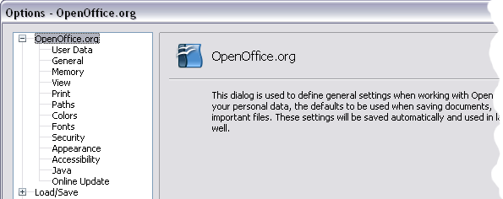
Note | The Back button has the same effect on all pages of the Options dialog. It resets the options to the values that were in place when you opened OpenOffice.org.

User Data options
Calc uses the first and last name stored in the OpenOffice.org – User Data page to fill in the Created and Modified fields in the document properties, and the optional Author field often used in the footer of a printed spreadsheet. Fill in the form on this page.

Print options
Set the print options to suit your default printer and your most common printing method. You can change these settings at any time, either through this dialog or during the printing process (by clicking the Options button on the Print dialog).
In the Options dialog, click OpenOffice.org > Print.
See Chapter 6 (Printing, Exporting, and E-mailing) for more about the options on this page.

Color options
On the OpenOffice.org – Colors page, you can specify colors to use in OOo documents. You can select a color from a color table, edit an existing color, and define new colors. These colors are stored in your color palette and are then available in all components of OOo.
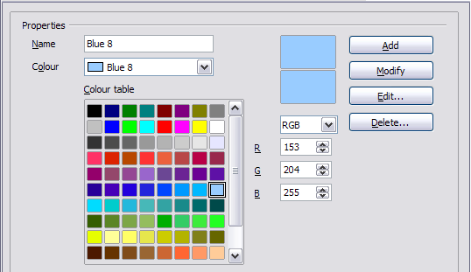Figure 312: Defining colors to use in color palettes in OOo
To modify a color:
- Select the color to modify from the list or the color table.
- Enter the new values that define the color. If necessary, change the settings from RGB (Red, Green, Blue) to CMYK (Cyan, Magenta, Yellow, Black) or vice versa. The changed color appears in the lower of the two color preview boxes at the top.
- Modify the Name as required.
- Click the Modify button. The newly defined color is now listed in the Color table.
Alternatively, click the Edit button to open the Color dialog, shown in Figure 313. Here you can select a color from one of the color windows in the upper area, or you can enter values in the lower area using your choice of RGB, CMYK, or HSB (Hue, Saturation and Brightness) values.
The upper right color window is linked directly with the color input fields in the lower area; as you choose a color in the upper window, the numbers change accordingly. The two color fields at the lower right show the value of the selected color on the left and the currently set value from the color value fields on the right.
Modify the color components as required and click OK to exit the dialog. The newly defined color now appears in the lower of the color preview boxes shown in Figure 312. Type a name for this color in the Name box, then click the Add button. A small box showing the new color is added to the Color table.
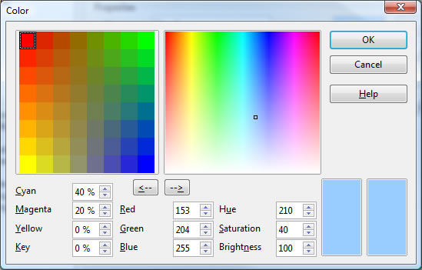
Figure 313: Editing colors
Another way to define or alter colors is through the Colors page of the Area dialog, where you can also save and load palettes, a feature that is not possible here. In Calc, draw a temporary draw object and use the context menu of this object to open the Area dialog. If you load a palette in one component of OOo, it is only active in that component; the other components keep their own palettes.

Security options
Use the OpenOffice.org – Security page to choose security options for saving documents and for opening documents that contain macros.
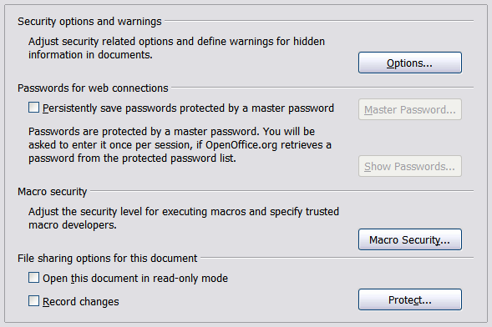Figure 314: Choosing security options for opening and saving documents
Security options and warnings
If you record changes, save multiple versions, or include hidden information or notes in your documents, and you do not want some of the recipients to see that information, you can set warnings to remind you to remove this information, or you can have OOo remove some information automatically. Note that (unless removed) much of this information is retained in a file whether the file is in OpenOffice.org’s default OpenDocument format, or has been saved to other formats, including PDF.
Click the Options button to open a separate dialog with specific choices (Figure 315).
Remove personal information on saving. Select this option to always remove user data from the file properties when saving the file. To manually remove personal information from specific documents, deselect this option and then use the Delete button under File > Properties > General.
Ctrl-click required to follow hyperlinks. In older versions of OOo, clicking on a hyperlink in a document opened the linked document. Now you can choose whether to keep this behavior (by unchecking this box). Many people find creation and editing of documents easier when accidental clicks on links do not activate the links.
The other options on this dialog should be self-explanatory.
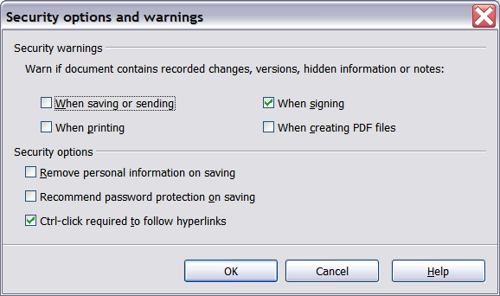Figure 315: Security options and warnings dialog
Passwords for web connections
You can enter a master password to enable easy access to sites that require a user name and password.
Persistently save passwords protected by a master password. If enabled, OOo securely stores all passwords that you use to access files from web servers. You can retrieve the passwords from the list after you enter the master password.
Macro security
Click the Macro Security button to open the Macro Security dialog (not shown here), where you can adjust the security level for executing macros and specify trusted sources.
File sharing options for this document
Select the Open this document in read-only mode option to restrict this document to be opened in read-only mode only. This option protects the document against accidental changes. It is still possible to edit a copy of the document and save that copy with the same name as the original.
Select the Record changes option to enable recording changes. This is the same as Edit > Changes > Record. To allow other users of this document to apply changes, but prevent them from disabling change recording, click the Protect button and enter a password.

Appearance options
On the OpenOffice.org – Appearance page, you can specify which items are visible and the colors used to display various items.
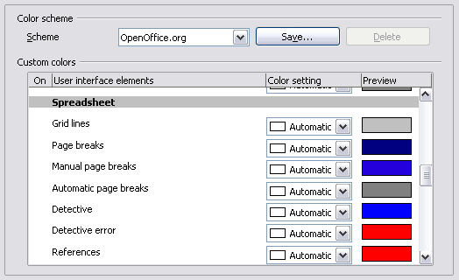
Figure 316: Changing the color of grid points in Calc
Scroll down in the page until you find Spreadsheet.
To change the default color for grid points, click the down-arrow by the color and select a new color from the pop-up box.
If you wish to save your color changes as a color scheme, click Save, type a name in the Scheme box; then click OK.

Choosing options for loading and saving documents
You can set the Load/Save options to suit the way you work. This chapter describes only a few of the options, those more relevant to working with Calc. See Chapter 2 (Setting Up OpenOffice.org) in the Getting Started guide for a description of the other options.
If the Options dialog is not already open, click Tools > Options. Click the + sign to the left of Load/Save to display the list of load/save options pages.
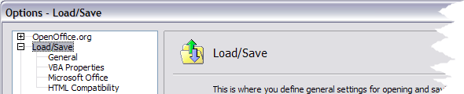Figure 317: Load/Save options

General Load/Save options
Most of the choices on the Load/Save – General page are familiar to users of other office suites. Those specific to OpenOffice.org are in the Default file format and ODF settings section.
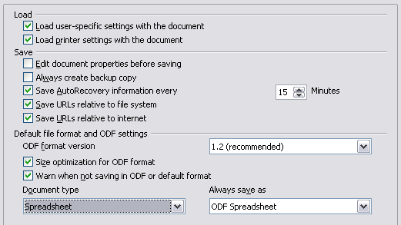
Figure 318: Choosing Load and Save options
ODF format version
OpenOffice.org by default saves documents in OpenDocument Format (ODF) version 1.2. While this allows for improved functionality, there may be backwards compatibility issues. When a file saved in ODF 1.2 is opened in an earlier version of OpenOffice.org (using ODF 1.0/1.1), some of the advanced features may be lost. Two notable examples are the functions ADDRESS and INDIRECT and the formatting of numbered lists. If you plan to share documents with people who are still using older versions of OpenOffice.org, it is recommended that you save the document using ODF version 1.0/1.1.
Size optimization for ODF format
OpenOffice.org documents are XML files. When you select this option, OOo writes the XML data without indents and line breaks. If you want to be able to read the XML files in a text editor in a structured form, deselect this option.
Document type
If you routinely share documents with users of Microsoft Excel, you might want to change the Always save as attribute for spreadsheets to one of the Excel formats.

VBA Properties Load/Save options
On the Load/Save – VBA Properties page, you can choose whether to keep any macros in Microsoft Office documents that are opened in OpenOffice.org.
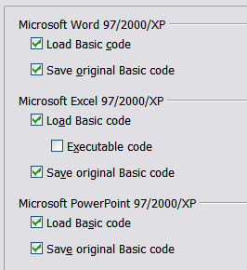Figure 319: Choosing Load/Save VBA Properties
- If you choose Save original Basic code, the macros will not work in OpenOffice.org but are retained if you save the file into Microsoft Office format.
- If you choose Load Basic code to edit, the changed code is saved in an OpenOffice.org document but is not retained if you save into an Microsoft Office format.
- If you are importing a Microsoft Excel file containing VBA code, you can select the option Executable code. Whereas normally the code is preserved but rendered inactive (if you inspect it with the StarBasic IDE you will notice that it is all commented), with this option the code is ready to be executed.

Microsoft Office Load/Save options
On the Load/Save – Microsoft Office page, you can choose what to do when importing and exporting Microsoft Office OLE objects (linked or embedded objects or documents such as spreadsheets or equations).
Select the [L] options to convert Microsoft OLE objects into the corresponding OpenOffice.org OLE objects when a Microsoft document is loaded into OOo (mnemonic: “L” for “load”).
Select the [S] options to convert OpenOffice.org OLE objects into the corresponding Microsoft OLE objects when a document is saved in a Microsoft format (mnemonic: “S” for “save”).
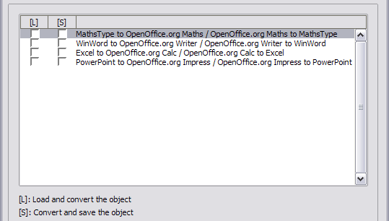Figure 320: Choosing Load/Save Microsoft Office options

HTML compatibility Load/Save options
Choices made on the Load/Save – HTML Compatibility page (Figure 321) affect HTML pages imported into OpenOffice.org and those exported from OOo. See HTML documents; importing/exporting in the Help for more information.
The main items of interest for Calc users are in the Export section: OpenOffice.org Basic and Display warning.
Export - OpenOffice.org Basic
Select this option to include OOo Basic macros (scripts) when exporting to HTML format. You must activate this option before you create the OpenOffice.org Basic macro; otherwise the script will not be inserted. OpenOffice.org Basic macros must be located in the header of the HTML document. Once you have created the macro in the OpenOffice.org Basic IDE, it appears in the source text of the HTML document in the header.
If you want the macro to run automatically when the HTML document is opened, choose Tools > Customize > Events. See Chapter 12 (Calc Macros) for more information.
Export - Display warning
When the OpenOffice.org Basic option (see above) is not selected, the Display warning option becomes available. If the Display warning option is selected, then when exporting to HTML a warning is shown that OpenOffice.org Basic macros will be lost.
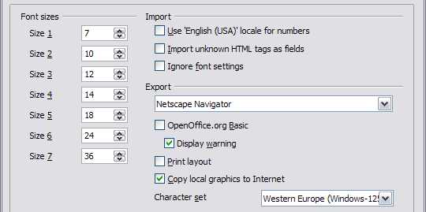
Figure 321: Choosing HTML compatibility options

Choosing options for Calc
In the Options dialog, click the + sign to the left of OpenOffice.org Calc on the left-hand side. A list of subsections drops down.
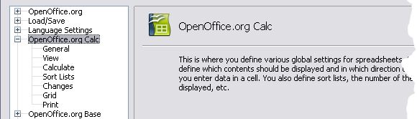

General options for Calc
In the Options dialog, choose OpenOffice.org Calc > General.
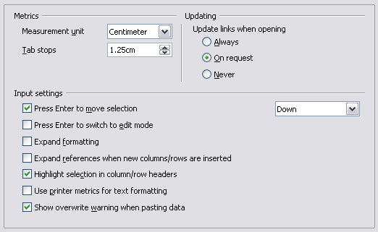Figure 322: Selecting general options for Calc

Metrics section
Choose the unit of measurement used in spreadsheets and the default tab stops distance.

Updating section
Choose whether to update links when opening a document always, only on request, or never. Regardless of this setting, you can manually update links at any time. You might want to avoid updating links when opening documents if they often contain many charts or linked graphics that would slow down loading.

Input settings section
Press Enter to move selection
Specifies that pressing Enter moves the cursor to another cell. If this option is selected, you can also choose the direction the cursor moves: up, down, left, or right. If this option is not selected, pressing Enter completes data entry for a cell but does not move the cursor.
Press Enter to switch to edit mode
Specifies that pressing Enter puts the selected cell into edit mode.
Expand formatting
Specifies whether to automatically apply the formatting attributes of an inserted cell to empty adjacent cells. If, for example, an inserted cell has the bold attribute, this attribute will also apply to empty adjacent cells. However, cells that already have a special format will not be modified by this function. To see the affected range, press Ctrl+* (multiplication sign on the number pad). The format will also apply to all new values inserted within this range.
Expand references when new columns/rows are inserted
Specifies whether to expand references when inserting columns or rows adjacent to the reference range. This is only possible if the reference range, where the column or row is inserted, originally spanned at least two cells in the desired direction.
Example: If the range A1:B1 is referenced in a formula and you insert a new column after column B, the reference is expanded to A1:C1. If the range A1:B1 is referenced and a new row is inserted under row 1, the reference is not expanded, since there is only a single cell in the vertical direction.
If you insert rows or columns in the middle of a reference area, the reference is always expanded.
Highlight selection in column/row headings
Specifies whether to highlight column and row headers in the selected columns or rows.
Use printer metrics for text formatting
Specifies that printer metrics are applied for printing and also for formatting the display on the screen. If this option is not selected, a printer-independent layout is used for screen display and printing.
Show overwrite warning when pasting data
Specifies that, when you paste cells from the clipboard to a cell range that is not empty, a warning appears.

View options for Calc
In the Options dialog, choose OpenOffice.org Calc > View.
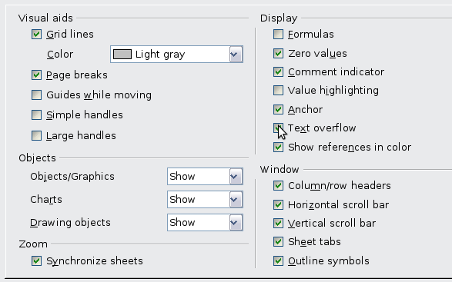
Figure 323: Selecting view options for Calc

Visual aids section
Specifies which lines are displayed.
Grid lines
Specifies whether to display grid lines between the cells when viewed onscreen. If this option is selected, you can also specify the color for the grid lines in the current document. The color choice overrides the selection made in Tools > Options > OpenOffice.org > Appearance > Spreadsheet > Grid lines.
For printing, choose Format > Page > Sheet and mark the Grid option.
Page breaks
Specifies whether to view the page breaks within a defined print area.
Guides while moving
Specifies whether to view guides when moving drawings, frames, graphics and other objects. These guides help you align objects.
Simple handles
Specifies whether to display the handles (the eight points on a selection box) as simple squares without a 3D effect.
Large handles
Specifies that larger than normal handles (the eight points on a selection box) are displayed.

Display section
Select various options for the screen display.
Formulas
Specifies whether to show formulas instead of results in the cells.
Zero values
Specifies whether to show numbers with the value of 0.
Comment indicator
Specifies that a small rectangle is shown in the top right corner of the cell when a comment exists for that cell. The text of the comment is shown when you hover the pointer over the cell, if tips are enabled under Tools > Options > OpenOffice.org > General.
To display a comment permanently, right-click on the cell and select Show comment from the pop-up menu.
Value highlighting
Select this option to highlight all values in the sheet. Text is highlighted in black; numbers in blue; and formulas, logical values, dates, and so on, in green.
When this command is active, any colors assigned in the document are not displayed.
Anchor
Specifies whether the anchor icon is displayed when an inserted object, such as a graphic, is selected.
Text overflow
If a cell contains text that is wider than the width of the cell, the text is displayed over empty neighboring cells in the same row. If there is no empty neighboring cell, a small triangle at the cell border indicates that the text continues.
Show references in color
Specifies that each reference is highlighted in color in the formula. The cell range is also enclosed by a colored border as soon as the cell containing the reference is selected for editing.

Objects section
Specifies whether to display or hide objects in three object groups: objects and graphics; charts; and drawing objects.

Window section
Specifies whether some elements are visible onscreen: column/row headers, horizontal scrollbar, vertical scrollbar, sheet tabs, and outline symbols.
If the Sheet tabs option is not selected, you can only switch between the sheets by using the Navigator.
Note that there is a slider between the horizontal scrollbar and the sheet tabs that may be set to one end.

Zoom section
Select the Synchronize sheets option to apply any selected zoom factor to all sheets in the spreadsheet. If this option is not selected, separate zoom factors can be applied to individual sheets.

Calculate options
In the Options dialog, choose OpenOffice.org Calc > Calculate.
Use this page to define the calculation settings for spreadsheets.
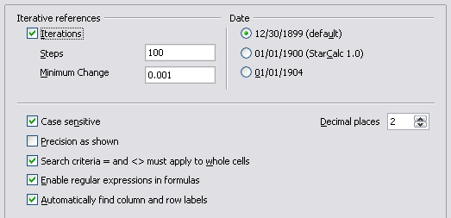
Figure 324: Calc calculation options

Iterative references section
Iterative references are formulas that are continuously repeated until the problem is solved. In this section you can choose the number of approximation steps carried out during iterative calculations and the degree of precision of the answer.
Iterations
Select this option to enable iterations. If this options is not selected, an iterative reference causes an error message.
Steps
Sets the maximum number of iteration steps.
Minimum Change
Specifies the difference between two consecutive iteration step results. If the result of the iteration is lower than the minimum change value, then the iteration will stop.

Date section
Select the start date for the internal conversion from days to numbers.
12/30/1899 (default)
Sets 12/30/1899 as day zero.
01/01/1900 (StarCalc 1.0)
Sets 1/1/1900 as day zero. Use this setting for StarCalc 1.0 spreadsheets containing date entries.
01/01/1904
Sets 1/1/1904 as day zero. Use this setting for spreadsheets that are imported in a foreign format.

Other options
Specify a variety of options relevant to spreadsheet calculation.
Case sensitive
Specifies whether to distinguish between upper and lower case in texts when comparing cell contents. The EXACT text function is always case-sensitive, independent of the settings in this dialog.
Decimal places
Defines the number of decimals to be displayed for numbers with the Standard number format. The numbers are displayed as rounded numbers, but are not saved as rounded numbers.
Precision as shown
Specifies whether to make calculations using the rounded values displayed in the sheet. Charts will be shown with the displayed values. If this option is not selected, the displayed numbers are rounded, but they are calculated internally using the non-rounded number.
Search criteria = and <> must apply to whole cells
Specifies that the search criteria you set for the Calc database functions must match the whole cell exactly. When this option is selected, Calc behaves exactly like MS Excel when searching cells in the database functions.
This search: | Has this result:
win | Finds win, but not win95, os2win, or upwind
win.* | Finds win and win95, but not os2win or upwind
.*win | Finds win and os2win, but not win95 or upwind
.*win.* | Finds win, win95, os2win, and upwind
If this option is not selected, the win search pattern acts like .*win.* —the search pattern can be at any position within the cell when searching with the Calc database functions.
Enable regular expressions in formulas
Specifies that regular expressions are enabled when searching and also for character string comparisons. This relates to the database functions, and to VLOOKUP, HLOOKUP and SEARCH.
Automatically find column and row labels
Specifies that you can use the text in any cell as a label for the column below the text or the row to the right of the text. The text must consist of at least one word and must not contain any operators.
Example: Cell E5 contains the text Europe. Below, in cell E6, is the value 100 and in cell E7 the value 200. If the Automatically find column and row labels option is selected, you can write the following formula in cell A1: =SUM(Europe).

Sort Lists options
In the Options dialog, choose OpenOffice.org Calc > Sort Lists. Sort lists are used for more than sorting, for example filling a series of cells during data entry. In addition to the supplied lists, you can define and edit your own lists, as described in “Defining a fill series” in Chapter 2 (Entering, Editing, and Formatting Data).
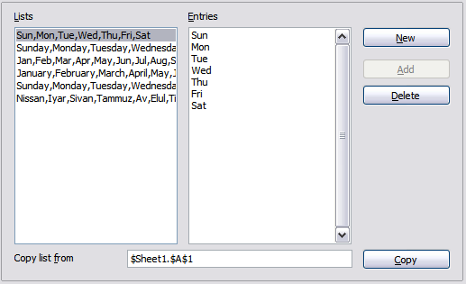Figure 325: Defining sorting lists in Calc

Changes options
In the Options dialog, choose OpenOffice.org Calc > Changes.
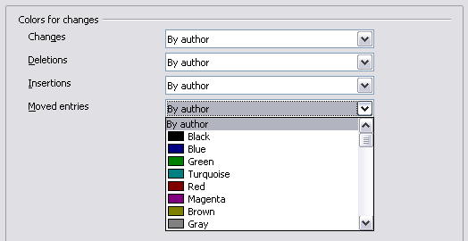
Figure 326: Calc options for highlighting changes
On this page you can specify options for highlighting recorded changes in spreadsheets. You can assign specific colors for insertions, deletions, and other changes, or you can let Calc assign colors based on the author of the change; in the latter case, one color will apply to all changes made by that author.

Grid options
The Grid page defines the grid settings for spreadsheets. Using a grid helps you determine the exact position of any charts or other objects you may add to a spreadsheet. You can also set this grid in line with the snap grid.
If you have activated the snap grid but wish to move or create individual objects without snap positions, you can press the Ctrl key to deactivate the snap grid for as long as needed.
In the Options dialog, choose OpenOffice.org Calc > Grid.
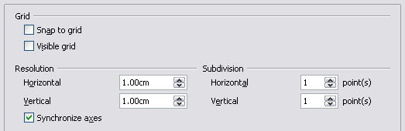Figure 327: Calc grid options

Grid section
Snap to grid activates the snap function.
Visible grid displays grid points on the screen. These points are not printed.

Resolution section
Here you can set the unit of distance for the spacing between horizontal and vertical grid points and subdivisions (intermediate points) of the grid.
Synchronize axes changes the current grid settings symmetrically.

Print options
In the Options dialog, choose OpenOffice.org Calc > Print. See Chapter 6 (Printing, Exporting, and E-mailing) for more about the options on this page.

Controlling Calc’s AutoCorrect functions
Some people find some or all of the items in OOo’s AutoCorrect function annoying because they change what you type when you do not want it changed. Many people find some of the AutoCorrect functions quite helpful; if you do, then select the relevant options. But if you find unexplained changes appearing in your document, this is a good place to look to find the cause.
To open the AutoCorrect dialog, click Tools > AutoCorrect Options. (You need to have a document open for this menu item to appear.)
In Calc, this dialog has four tabs, as shown below. Options are described in the Help; many will be familiar to users of other office suites.
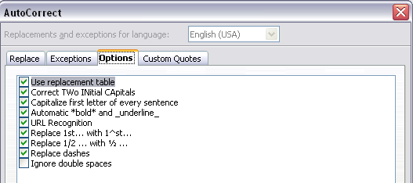Figure 328: The AutoCorrect dialog in Calc

Customizing the user interface

Customizing the menu font
If you want to change the menu font from that supplied by OOo to the system font for your operating system, do this:
- Choose Tools > Options > OpenOffice.org > View.
- Check Use system font for user interface and click OK.

Customizing menu content
In addition to changing the menu font, you can add and rearrange items on the menu bar, add items to menus, and make other changes.
To customize menus:
- Choose Tools > Customize.
- On the Customize dialog, pick the Menus page (Figure 329).
- In the Save In drop-down list, choose whether to save this changed menu for Calc or for a selected document.
- In the section OpenOffice.org Calc Menus, select from the Menu drop-down list the menu that you want to customize. The list includes all the main menus as well as sub-menus, that is menus that are contained under another menu. For example, in addition to File, Edit, View, and so on, there is File | Send and File |Templates. The commands available for the selected menu are shown in the central part of the dialog.
- To customize the selected menu, click on the Menu or Modify buttons. You can also add commands to a menu by clicking on the Add button. These actions are described in the following sections. Use the up and down arrows next to the Entries list to move the selected menu item to a different position.
- When you have finished making all your changes, click OK to save them.
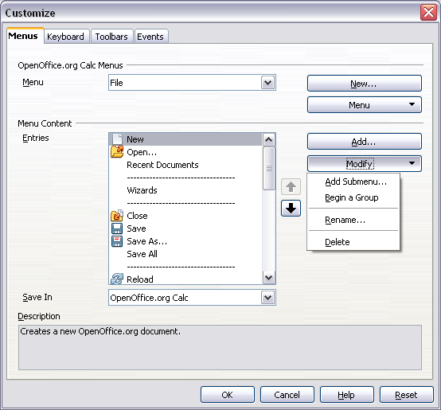
Figure 329: The Menus page of the Customize dialog

Creating a new menu
In the Customize dialog, click New to display the dialog shown in Figure 330.
- Type a name for your new menu in the Menu name box.
- Use the up and down arrow buttons to move the new menu into the required position on the menu bar. Click OK to save.
The new menu now appears on the list of menus in the Customize dialog. (It will appear on the menu bar itself after you save your customizations.)
After creating a new menu, you need to add some commands to it, as described in “Adding a command to a menu” on page 413.
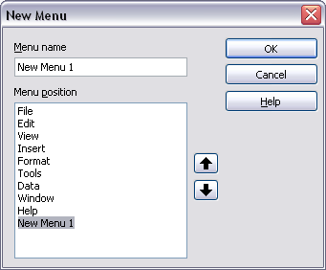
Figure 330: Adding a new menu

Modifying existing menus
To modify an existing menu, select it in the Menu list and click the Menu button to drop down a list of modifications: Move, Rename, Delete. Not all of these modifications can be applied to all the entries in the Menu list. For example, Rename and Delete are not available for the supplied menus.
To move a menu (such as File), choose Menu > Move. A dialog similar to the one shown in Figure 330 (but without the Menu name box) opens. Use the up and down arrow buttons to move the menu into the required position.
To move submenus (such as File | Send), select the main menu (File) in the Menu list and then, in the Menu Content section of the dialog, select the submenu (Send) in the Entries list and use the arrow keys to move it up or down in the sequence. Submenus are easily identified in the Entries list by a small black triangle on the right hand side of the name.
In addition to renaming, you can specify a keyboard shortcut that allows you to select a menu command when you press Alt+ an underlined letter in a menu command.
- Select a menu or menu entry.
- Click the Menu button and select Rename.
- Add a tilde (~) in front of the letter that you want to use as an accelerator. For example, to select the Save All command by pressing Alt+V, enter Sa~ve All.

Adding a command to a menu
You can add commands to the supplied menus and to menus you have created. On the Customize dialog, select the menu in the Menu list and click the Add button in the Menu Content section of the dialog.
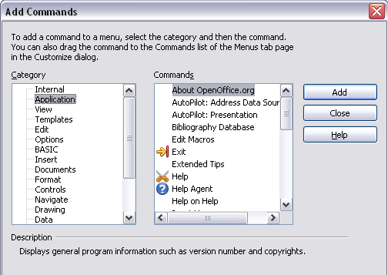
Figure 331: Adding a command to a menu
On the Add Commands dialog, select a category and then the command, and click Add. The dialog remains open, so you can select several commands. When you have finished adding commands, click Close. Back on the Customize dialog, you can use the up and down arrow buttons to arrange the commands in your preferred sequence.

Modifying menu entries
In addition to changing the sequence of entries on a menu or submenu, you can add submenus, rename or delete the entries, and add group separators.
To begin, select the menu or submenu in the Menu list near the top of the Customize page, then select the entry in the Entries list under Menu Content. Click the Modify button and choose the required action from the drop-down list of actions.
Most of the actions should be self-explanatory. Begin a group adds a separator line after the highlighted entry.

Customizing toolbars
You can customize toolbars in several ways, including choosing which icons are visible and locking the position of a docked toolbar, as described in Chapter 1 (Introducing OpenOffice.org) of the Getting Started guide. This section describes how to create new toolbars and add other icons (commands) to the list of those available on a toolbar.
To get to the toolbar customization dialog, do any of the following:
- On the toolbar, click the arrow at the end of the toolbar and choose Customize Toolbar.
- Choose View > Toolbars > Customize from the menu bar.
- Choose Tools > Customize from the menu bar and pick the Toolbars page (Figure 332).
To customize toolbars:
- In the Save In drop-down list, choose whether to save this changed toolbar for Calc or for a selected document.
- In the section OpenOffice.org Calc Toolbars, select from the Toolbar drop-down list the toolbar that you want to customize.
- You can create a new toolbar by clicking on the New button, or customize existing toolbars by clicking on the Toolbar or Modify buttons, and add commands to a toolbar by clicking on the Add button. These actions are described below.
- When you have finished making all your changes, click OK to save them.
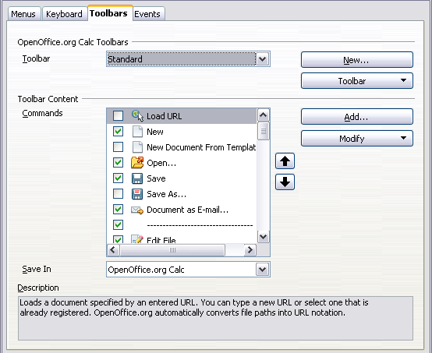
Figure 332: The Toolbars page of the Customize dialog

Creating a new toolbar
To create a new toolbar:
- Choose Tools > Customize > Toolbars from the menu bar.
- Click New. On the Name dialog, type the new toolbar's name and choose from the Save In drop-down list where to save this changed menu: for Calc or for a selected document.
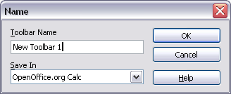
The new toolbar now appears on the list of toolbars in the Customize dialog. After creating a new toolbar, you need to add some commands to it, as described below.

Adding a command to a toolbar
If the list of available buttons for a toolbar does not include all the commands you want on that toolbar, you can add commands. When you create a new toolbar, you need to add commands to it.
- On the Toolbars page of the Customize dialog, select the toolbar in the Toolbar list and click the Add button in the Toolbar Content section of the dialog.
- The Add Commands dialog is the same as for adding commands to menus (Figure 331). Select a category and then the command, and click Add. The dialog remains open, so you can select several commands. When you have finished adding commands, click Close. If you insert an item which does not have an associated icon, the toolbar will display the full name of the item: the next section describes how to choose an icon for a toolbar command.
- Back on the Customize dialog, you can use the up and down arrow buttons to arrange the commands in your preferred sequence.
- When you are done making changes, click OK to save.

Choosing icons for toolbar commands
Toolbar buttons usually have icons, not words, on them, but not all of the commands have associated icons.
To choose an icon for a command, select the command and click Modify > Change icon. On the Change Icon dialog (Figure 333), scroll through the available icons, select one, and click OK to assign it to the command.
To use a custom icon, create it in a graphics program and import it into OOo by clicking the Import button on the Change Icon dialog. Custom icons must be 16 x 16 or 26 x 26 pixels in size and cannot contain more than 256 colors.

Customizing keyboard shortcuts
In addition to using the built-in keyboard shortcuts (listed in Appendix A), you can define your own. You can assign shortcuts to standard OOo functions or your own macros and save them for use with the entire OpenOffice.org suite or only for Calc.
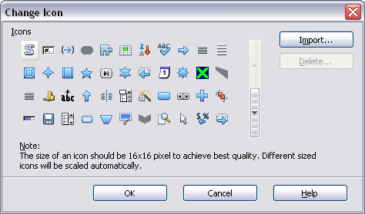
Figure 333: Change Icon dialog
Caution | Be careful when reassigning your operating system’s or OOo’s predefined shortcut keys. Many key assignments are universally understood shortcuts, such as F1 for Help, and are always expected to provide certain results. Although you can easily reset the shortcut key assignments to the OOo defaults, changing some common shortcut keys can cause confusion, frustration and possible data loss or corruption, especially if other users share your computer.
To adapt shortcut keys to your needs, use the Customize dialog, as described below.
- Select Tools > Customize > Keyboard. The Keyboard page of the Customize dialog opens.
- To have the shortcut key assignment available only with Calc, select Calc in the upper right corner of the page; otherwise select OpenOffice.org to make it available to every component.
- Next select the required function from the Category and Function lists.
- Now select the desired shortcut keys in the Shortcut keys list and click the Modify button at the upper right.
- Click OK to accept the change. Now the chosen shortcut keys will execute the function chosen in step 3 above whenever they are pressed.
Note | All existing shortcut keys for the currently selected Function are listed in the Keys selection box. If the Keys list is empty, it indicates that the chosen key combination is free for use. If it were not, and you wanted to reassign a shortcut key combination that is already in use, you must first delete the existing key.  Shortcut keys that are greyed-out in the listing on the Customize dialog, such as F1 and F10, are not available for reassignment.

Example: Assigning styles to shortcut keys
You can configure shortcut keys to quickly assign styles in your document.
- On the Keyboard page of the Customize dialog, choose the shortcut keys you want to assign a style to. In this example, we have chosen Ctrl+3.
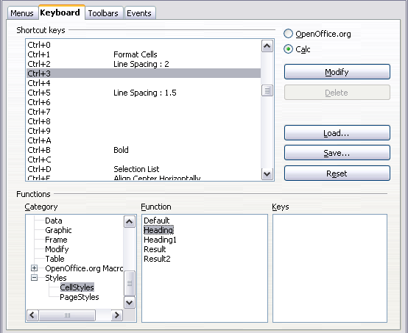
Figure 334: Assigning a cell style to a key combination
- In the Functions section at the bottom of the dialog, scroll down in the Category list to Styles. Click the + sign to expand the list of styles.
- Choose the category of style. (This example uses a cell style, but you can also choose page styles.) The Function list now displays the names of the available styles for the selected category. The example shows OOo’s predefined cell styles.
- To assign Ctrl+3 to be the shortcut key combination for the Heading style, select Heading in the Function list, and then click Modify. Ctrl+3 now appears in the Keys list on the right, and Heading appears next to Ctrl+3 in the Shortcut keys box at the top.
- Make any other required changes, and then click OK to save these settings and close the dialog.

Saving changes to a file
Changes to the shortcut key assignments can be saved in a keyboard configuration file for use at a later time, thus permitting you to create and apply different configurations as the need arises. To save keyboard shortcuts to a file:
- After making your keyboard shortcut assignments, click the Save button on the Customize dialog.
- In the Save Keyboard Configuration dialog, select All files from the Save as Type list.
- Next enter a name for the keyboard configuration file in the File name box, or select an existing file from the list. If you need to, browse to find a file from another location.
- Click Save. A confirmation dialog appears if you are about to overwrite an existing file, otherwise there will be no feedback and the file will be saved.

Loading a saved keyboard configuration
To load a saved keyboard configuration file and replace your existing configuration, click the Load button on the Customize dialog, and then select the configuration file from the Load Keyboard Configuration dialog.

Resetting the shortcut keys
To reset all of the keyboard shortcuts to their default values, click the Reset button near the bottom right of the Customize dialog. Use this feature with care as no confirmation dialog will be displayed; the defaults will be set without any further notice or user input.

Running macros from key combinations
You can also define shortcut key combinations that will run macros. These shortcut keys are strictly user-defined; none are built in. For more information on macros, see Chapter 12 (Calc Macros).

Adding functionality with extensions
An extension is a package that can be installed into OpenOffice.org to add new functionality.
Although individual extensions can be found in different places, the official OpenOffice.org extension repository is at http://extensions.services.openoffice.org/. Some extensions are free of charge; others are available for a fee. Check the descriptions to see what licenses and fees apply to the ones that interest you.

Installing extensions
To install an extension, follow these steps:
- Download an extension and save it anywhere on your computer.
- In OOo, select Tools > Extension Manager from the menu bar. In the Extension Manager dialog (Figure 335), click Add.
- A file browser window opens. Find and select the extension you want to install and click Open. The extension begins installing. You may be asked to accept a license agreement.
- When the installation is complete, the extension is listed in the Extension Manager dialog.
Tip | To get extensions that are listed in the repository, you can open the Extension Manager and click the Get more extensions here link. You do not need to download them separately as in step 1 above.
Note | To install a shared extension, you need write access to the OpenOffice.org installation directory.
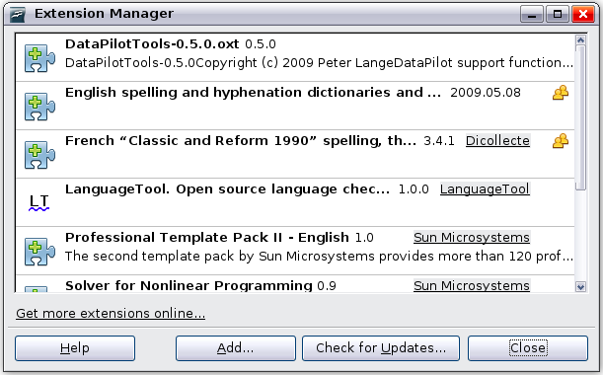
Figure 335: Installing an extension

Using extensions
This section describes a few of the extensions to Calc. In each case, you need to install the extension as described in the previous section.
rofessional Template Pack II
Provides more than 120 templates for Writer, Calc, and Impress. Available in several languages. After you have installed this extension, you will find the templates under File > New > Templates and Documents.
Solver for Nonlinear Programming
Calc ships with a solver engine for linear programming only. This extension adds more solvers, which are capable of handling nonlinear problems as well as linear ones:
- DEPS - Differential Evolution & Particle Swarm Optimization
- SCO - Social Cognitive Optimization
DataPilot Tools for OpenOffice.org Calc
Adds some utility functions that make using the DataPilot easier:
- Display the current source range for a DataPilot
- Change the source range for a DataPilot
- Refresh all DataPilots on the current sheet
Calc Guide

Appendix A
Keyboard Shortcuts
This PDF is designed to be read onscreen, two pages at a time. If you want to print a copy, your PDF viewer should have an option for printing two pages on one sheet of paper, but you may need to start with page 2 to get it to print facing pages correctly. (Print this cover page separately.)

Copyright
This document is Copyright © 2005–2010 by its contributors as listed in the section titled Authors. You may distribute it and/or modify it under the terms of either the GNU General Public License, version 3 or later, or the Creative Commons Attribution License, version 3.0 or later.
All trademarks within this guide belong to their legitimate owners.
Authors
Richard Barnes
Peter Kupfer
Iain Roberts
Magnus Adielsson
Sandeep Samuel Medikonda
Jean Hollis Weber
Feedback
Please direct any comments or suggestions about this document to: authors@documentation.openoffice.org
Acknowledgments
Much credit for this work is due to the unselfish efforts of Bill Wilson and Dr. Bob Smith.
Publication date and software version
Published 16 March 2010. Based on OpenOffice.org 3.2.
Contents
Copyright 2
Introduction 4
Navigation and selection shortcuts 4
Function and arrow key shortcuts 6
Cell formatting shortcuts 7
DataPilot shortcuts 8

Introduction
You can use Calc without a pointing device such as a mouse or trackball, by using its built-in keyboard shortcuts.
OOo has a general set of keyboard shortcuts, available in all components, and a component-specific set directly related to the work of that component.
For help with OOo’s keyboard shortcuts or using OOo with a keyboard only, search the OOo online help using the “shortcut” or “accessibility” keywords.
In addition to using the built-in keyboard shortcuts listed in this Appendix, you can define your own. See Chapter 14 (Setting Up and Customizing Calc) for instructions.
Formatting and editing shortcuts are described in Chapter 2 (Entering, Editing, and Formatting Data).

Navigation and selection shortcuts
Table 29: Spreadsheet navigation shortcuts
Shortcut Keys | Effect
Ctrl+Home | Moves the cursor to the first cell in the sheet (cell A1).
Ctrl+End | Moves the cursor to the last cell on the sheet that contains data.
Home | Moves the cursor to the first cell of the current row.
End | Moves the cursor to the last cell of the current row in a column containing data.
Ctrl+Left Arrow | Moves the cursor to the left edge of the current data range. If the column to the left of the cell that contains the cursor is empty, the cursor moves to the next column to the left that contains data.
Ctrl+Right Arrow | Moves the cursor to the right edge of the current data range. If the column to the right of the cell that contains the cursor is empty, the cursor moves to the next column to the right that contains data.
Ctrl+Up Arrow | Moves the cursor to the top edge of the current data range. If the row above the cell that contains the cursor is empty, the cursor moves up to the next row that contains data.
Ctrl+Down Arrow | Moves the cursor to the bottom edge of the current data range. If the row below the cell that contains the cursor is empty, the cursor moves down to the next row that contains data.
Ctrl+Shift+Arrow | Selects all cells containing data from the current cell to the end of the continuous range of data cells, in the direction of the arrow pressed. If used to select rows and columns together, a rectangular cell range is selected.
Ctrl+Page Up | Moves one sheet to the left. In the page preview it moves to the previous print page.
Ctrl+Page Down | Moves one sheet to the right. In the page preview it moves to the next print page.
Page Up | Moves the viewable rows up one screen.
Page Down | Moves the viewable rows down one screen.
Alt+Page Up | Moves the viewable columns one screen to the left.
Alt+Page Down | Moves the viewable columns one screen to the right.
Shift+Ctrl+Page Up | Adds the previous sheet to the current selection of sheets. If all the sheets in a spreadsheet are selected, this combination only selects the previous sheet. Makes the previous sheet the current sheet.
Shift+Ctrl+Page Down | Adds the next sheet to the current selection of sheets. If all the sheets in a spreadsheet are selected, this combination only selects the next sheet. Makes the next sheet the current sheet.
Ctrl+* | Selects the data range that contains the cursor. A range is a contiguous cell range that contains data and is bounded by empty rows and columns. The “*” key is the multiplication sign on the numeric key pad.
Ctrl+/ | Selects the matrix formula range that contains the cursor. The “/” key is the division sign on the numeric key pad.
Enter — in a selected range | By default, moves the cursor down one cell in a selected range. To specify the direction that the cursor moves, choose Tools > Options > OpenOffice.org Calc > General.

Function and arrow key shortcuts
Table 30: Function key shortcuts
Shortcut Keys | Effect
F1 | Displays the OOo help browser. When the help browser is already open F1 jumps to the main help page.
Shift+F1 | Displays context help.
Ctrl+F1 | Displays the note that is attached to the current cell.
F2 | Switches to Edit mode and places the cursor at the end of the contents of the current cell. If the cursor is in an input box in a dialog that has a minimize button, the dialog is hidden and the input box remains visible. Press F2 again to show the whole dialog.
Ctrl+F2 | Opens the Function Wizard.
Shift+Ctrl+F2 | Moves the cursor to the input line where you can enter a formula for the current cell.
Ctrl+F3 | Opens the Define Names dialog.
F4 | Shows or hides the Database Sources menu.
Shift+F4 | Rearranges the relative or absolute references (for example, A1, $A$1, $A1, A$1) in the input field.
F5 | Shows or hides the Navigator.
Shift+F5 | Traces dependents.
Shift+Ctrl+F5 | Moves the cursor to the Name box.
F7 | Checks spelling in the current sheet.
Ctrl+F7 | Opens the Thesaurus if the current cell contains text.
Shift+F7 | Traces precedents.
F8 | Turns additional selection mode on or off. In this mode, you can use the arrow keys to extend the selection. You can also click in another cell to extend the selection.
Ctrl+F8 | Highlights cells containing numeric values (not text).
F9 | Recalculates all of the formulas in the sheet.
Ctrl+F9 | Updates the selected chart.
F11 | Opens the Styles and Formatting window where you can apply a formatting style to the contents of the cell or to the current sheet.
Shift+F11 | Creates a document template.
Shift+Ctrl+F11 | Updates the templates.
F12 | Groups the selected data range.
Ctrl+F12 | Ungroups the selected data range.
Table 31. Arrow key shortcuts
Shortcut Keys | Effect
Alt+Down Arrow | Increases the height of current row.
Alt+Up Arrow | Decreases the height of current row.
Alt+Right Arrow | Increases the width of the current column.
Alt+Left Arrow | Decreases the width of the current column.
Alt+Shift+Arrow Key | Optimizes the column width or row height based on the current cell.

Cell formatting shortcuts
Ctrl+1 open the Format Cells dialog.
Note | The shortcuts listed in Table 32 do not work under any Linux desktop tested. If you would like to have the functionality described in this table, you must create custom key sequences as explained in Chapter 14 (Setting Up and Customizing Calc).
Note | The shortcut keys shown in Table 32 do not use the number keys on the number pad. They use the number keys above the letter keys on the main keyboard.
Table 32: Formatting shortcut keys
Shortcut Keys | Effect
Ctrl+Shift+1 | Two decimal places, thousands separator
Ctrl+Shift+2 | Standard exponential format
Ctrl+Shift+3 | Standard date format
Ctrl+Shift+4 | Standard currency format
Ctrl+Shift+5 | Standard percentage format (two decimal places)
Ctrl+Shift+6 | Standard format

DataPilot shortcuts
Table 33: DataPilot shortcut keys
Shortcut Keys | Effect
Tab | Changes the focus by moving forward through the areas and buttons of the dialog.
Shift+Tab | Changes the focus by moving backward through the areas and buttons of the dialog.
Up arrow | Moves the focus up one item in the current dialog area.
Down arrow | Moves the focus down one item in the current dialog area.
Left arrow | Moves the focus one item to the left in the current dialog area.
Right arrow | Moves the focus one item to the right in the current dialog area.
Home | Selects the first field in the current layout area.
End | Selects the last field in the current layout area.
Alt+R | Copies or moves the current field into the “Row” area.
Alt+C | Copies or moves the current field into the “Column” area.
Alt+D | Copies or moves the current field into the “Data” area.
Ctrl+Up Arrow | Moves the current field up one place.
Ctrl+Down Arrow | Moves the current field down one place.
Ctrl+Left Arrow | Moves the current field one place to the left.
Ctrl+Right Arrow | Moves the current field one place to the right.
Ctrl+Home | Moves the current field to the first place.
Ctrl+End | Move the current field to the last place.
Alt+O | Displays the options for the current field.
Delete | Removes the current field from the area.

Calc Guide

Appendix B
Description of Functions
This PDF is designed to be read onscreen, two pages at a time. If you want to print a copy, your PDF viewer should have an option for printing two pages on one sheet of paper, but you may need to start with page 2 to get it to print facing pages correctly. (Print this cover page separately.)

Copyright
This document is Copyright © 2005–2010 by its contributors as listed in the section titled Authors. You may distribute it and/or modify it under the terms of either the GNU General Public License, version 3 or later, or the Creative Commons Attribution License, version 3.0 or later.
All trademarks within this guide belong to their legitimate owners.
Authors
Magnus Adielsson
Richard Barnes
Peter Kupfer
Iain Roberts
Jean Hollis Weber
Feedback
Please direct any comments or suggestions about this document to: authors@documentation.openoffice.org
Acknowledgments
Much credit for this work is due to the unselfish efforts of Bill Wilson and Dr. Bob Smith.
Publication date and software version
Published 16 March 2010. Based on OpenOffice.org 3.2.
Contents
Copyright 2
Functions available in Calc 4
Terminology: numbers and arguments 4
Mathematical functions 5
Financial analysis functions 10
A note about dates 10
A note about interest rates 10
Statistical analysis functions 24
Date and time functions 33
Logical functions 37
Informational functions 38
Database functions 41
Array functions 43
Spreadsheet functions 45
Text functions 50
Add-in functions 54

Functions available in Calc
Calc provides all of the commonly used functions found in modern spreadsheet applications. Since many of Calc’s functions require very specific and carefully calculated input arguments, the descriptions in this appendix should not be considered complete references for each function. Refer to the application Help or the OOo wiki for details and examples of all functions. On the wiki, start with http://wiki.services.openoffice.org/wiki/Documentation/How_Tos/Calc:_Functions_listed_by_category
Over 300 standard functions are available in Calc. More can be added through extensions to Calc (see Chapter 14). The following tables list Calc’s functions organized into eleven categories.
Note | Functions whose names end with _ADD are provided for compatibility with Microsoft Excel functions. They return the same results as the corresponding functions in Excel (without the suffix), which though they may be correct, are not based on international standards.

Terminology: numbers and arguments
Some of the descriptions in this appendix define limitations on the number of values or arguments that can be passed to the function. Specifically, functions that refer to the following arguments may lead to confusion.
- Number_1; number_2;... number_30
- Number 1 to 30
- a list of up to 30 numbers
There is a significant difference between a list of numbers (or integers) and the number of arguments a function will accept. For, example the SUM function will only accept a maximum of 30 arguments. This limit does NOT mean that you can only sum 30 numbers, but that you can only pass 30 separate arguments to the function.
Arguments are values separated by semi-colons, and can include ranges which often refer to multiple values. Therefore one argument can refer to several values, and a function that limits input to 30 arguments may in fact accept more then 30 separate numerical values.
This appendix attempts to clarify this situation by using the term arguments, rather than any of the other phrases.

Mathematical functions
Table 34: Mathematical functions
Syntax | Description
ABS(number) | Returns the absolute value of the given number.
ACOS(number) | Returns the inverse cosine of the given number in radians.
ACOSH(number) | Returns the inverse hyperbolic cosine of the given number in radians.
ACOT(number) | Returns the inverse cotangent of the given number in radians.
ACOTH(number) | Returns the inverse hyperbolic cotangent of the given number in radians.
ASIN(number) | Returns the inverse sine of the given number in radians.
ASINH(number) | Returns the inverse hyperbolic sine of the given number in radians.
ATAN(number) | Returns the inverse tangent of the given number in radians.
ATAN2(number_x; number_y) | Returns the inverse tangent of the specified x and y coordinates. Number_x is the value for the x coordinate. Number_y is the value for the y coordinate.
ATANH(number) | Returns the inverse hyperbolic tangent of the given number. (Angle is returned in radians.)
CEILING(number; significance; mode) | Rounds the given number to the nearest integer or multiple of significance. Significance is the value to whose multiple of ten the value is to be rounded up (.01, .1, 1, 10, etc.). Mode is an optional value. If it is indicated and non-zero and if the number and significance are negative, rounding up is carried out based on that value.
COMBIN(count_1; count_2) | Returns the number of combinations for a given number of objects. Count_1 is the total number of elements. Count_2 is the selected count from the elements. This is the same as the nCr function on a calculator.
COMBINA(count_1; count_2) | Returns the number of combinations for a given number of objects (repetition included). Count_1 is the total number of elements. Count_2 is the selected count from the elements.
CONVERT(value; "text"; "text") | Converts a currency value of a European currency into Euros. Value is the amount in the currency to be converted. Text is the official abbreviation for the currency in question (for example, "EUR"). The first Text parameter gives the source value to be converted; the second Text parameter gives the destination value. Both text arguments must be within quotes.
COS(number) | Returns the cosine of the given number (angle in radians).
COSH(number) | Returns the hyperbolic cosine of the given number (angle in radians).
COT(number) | Returns the cotangent of the given number (angle in radians).
COTH(number) | Returns the hyperbolic cotangent of the given number (angle in radians).
COUNTBLANK(range) | Returns the number of empty cells. Range is the cell range in which the empty cells are counted.
COUNTIF(range; criteria) | Returns the number of elements that meet certain criteria within a cell range. Range is the range to which the criteria are to be applied. Criteria indicates the criteria in the form of a number, a regular expression, or a character string by which the cells are counted.
DEGREES(number) | Converts the given number in radians to degrees.
EVEN(number) | Rounds the given number up to the nearest even integer.
EXP(number) | Returns e raised to the power of the given number.
FACT(number) | Returns the factorial of the given number.
FLOOR(number; significance; mode) | Rounds the given number down to the nearest multiple of significance. Significance is the value to whose multiple of ten the number is to be rounded down (.01, .1, 1, 10, etc.). Mode is an optional value. If it is indicated and non-zero and if the number and significance are negative, rounding up is carried out based on that value.
GCD(numbers) | Returns the greatest common divisor of one or more integers. Numbers is a list of up to 30 numbers whose greatest common divisor is to be calculated, separated by semi-colons.
GCD_ADD(numbers) | Returns the greatest common divisor of a list of numbers. Numbers is a list of up to 30 numbers separated by semi-colons.
INT(number) | Rounds the given number down to the nearest integer.
ISEVEN(value) | Returns TRUE if the given value is an even integer, or FALSE if the value is odd. If the value is not an integer, the function evaluates only the integer part of the value.
ISODD(value) | Returns TRUE if the given value is an odd integer, or FALSE if the value is even. If the value is not an integer, the function evaluates only the integer part of the value.
LCM(integer_1; integer_2; ... integer_30) | Returns the least common multiple of one or more integers. Integer_1; integer_2;... integer_30 are integers whose lowest common multiple is to be calculated.
LCM_ADD(numbers) | Numbers is a list of up to 30 numbers separated by semi-colons. The result is the lowest common multiple of a list of numbers.
LN(number) | Returns the natural logarithm based on the constant e of the given number.
LOG(number; base) | Returns the logarithm of the given number to the specified base. Base is the base for the logarithm calculation.
LOG10(number) | Returns the base-10 logarithm of the given number.
MOD(dividend; divisor) | Returns the remainder after a number is divided by a divisor. Dividend is the number which will be divided by the divisor. Divisor is the number by which to divide the dividend.
MROUND(number; multiple) | The result is the nearest integer multiple of the number.
MULTINOMIAL (number(s)) | Returns the factorial of the sum of the arguments divided by the product of the factorials of the arguments. Number(s) is a list of up to 30 numbers separated by semi-colons.
ODD(number) | Rounds the given number up to the nearest odd integer.
PI() | Returns the value of PI to fourteen decimal places.
POWER(base; power) | Returns the result of a number raised to a power. Base is the number that is to be raised to the given power. Power is the exponent by which the base is to be raised.
PRODUCT(number 1 to 30) | Multiplies all the numbers given as arguments and returns the product. Number 1 to number 30 are up to 30 arguments whose product is to be calculated, separated by semi-colons.
QUOTIENT(numerator; denominator) | Returns the integer result of a division operation. Numerator is the number that will be divided. Denominator is the number the numerator will be divided by.
RADIANS(number) | Converts the given number in degrees to radians.
RAND() | Returns a random number between 0 and 1. This number will recalculate every time data is entered or F9 is pressed.
RANDBETWEEN (bottom; top) | Returns an integer random number between bottom and top (inclusive). This number will recalculate when the Control+Shift+F9 key combination is pressed.
ROUND(number; count) | Rounds the given number to a certain number of decimal places according to valid mathematical criteria. Count (optional) is the number of the places to which the value is to be rounded. If the count parameter is negative, only the whole number portion is rounded. It is rounded to the place indicated by the count.
ROUNDDOWN(number; count) | Rounds the given number. Count (optional) is the number of digits to be rounded down to. If the count parameter is negative, only the whole number portion is rounded. It is rounded to the place indicated by the count.
ROUNDUP(number; count) | Rounds the given number up. Count (optional) is the number of digits to which rounding up is to be done. If the count parameter is negative, only the whole number portion is rounded. It is rounded to the place indicated by the count.
SERIESSUM(x; n; m; coefficients) | Returns a sum of powers of the number x in accordance with the following formula:  SERIESSUM(x;n;m;coefficients) = coefficient_1*x^n + coefficient_2*x^(n+m) + coefficient_3*x^(n+2m) +...+ coefficient_i*x^(n+(i-1)m).  x is the number as an independent variable. n is the starting power. m is the increment. Coefficients is a series of coefficients. For each coefficient the series sum is extended by one section. You can only enter coefficients using cell references.
SIGN(number) | Returns the sign of the given number. The function returns the result 1 for a positive sign, –1 for a negative sign, and 0 for zero.
SIN(number) | Returns the sine of the given number (angle in radians).
SINH(number) | Returns the hyperbolic sine of the given number (angle in radians).
SQRT(number) | Returns the positive square root of the given number. The value of the number must be positive.
SQRTPI(number) | Returns the square root of the product of the given number and PI.
SUBTOTAL(function; range) | Calculates subtotals. If a range already contains subtotals, these are not used for further calculations. Function is a value that stands for another function such as Average, Count, Min, Sum, Var. Range is the range whose cells are included.
SUM(number_1; number_2; ... number_30) | Adds all the numbers in a range of cells. Number_1; number_2;... number_30 are up to 30 arguments whose sum is to be calculated. You can also enter a range using cell references.
SUMIF(range; criteria; sum_range) | Adds the cells specified by a given criteria. The search supports regular expressions. Range is the range to which the criteria are to be applied. Criteria is the cell in which the search criterion is shown, or the search criterion itself. Sum_range is the range from which values are summed; if it has not been indicated, the values found in the Range are summed.
SUMSQ(number_1; number_2; ... number_30) | Calculates the sum of the squares of numbers (totaling up of the squares of the arguments) Number_1; number_2;... number_30 are up to 30 arguments, the sum of whose squares is to be calculated.
TAN(number) | Returns the tangent of the given number (angle in radians).
TANH(number) | Returns the hyperbolic tangent of the given number (angle in radians).
TRUNC(number; count) | Truncates a number to an integer by removing the fractional part of the number according to the precision specified in Tools > Options > OpenOffice.org Calc > Calculate. Number is the number whose decimal places are to be cut off. Count is the number of decimal places which are not cut off.

Financial analysis functions

A note about dates
Date values used as parameters for Calc’s financial functions must be entered in a specific manner. For example, a date (entered in the US form) must be surrounded by quotes and with periods separating each value. To represent August 6, 2004, or 8/6/04, you would enter “08.06.2004”. If you do not enter the date values as required by the function, you will not get the correct results. Date formats are locale specific; check the Help for the acceptable formatting.

A note about interest rates
You can enter interest rates in either of two ways:
- As a decimal. To enter an interest rate as a decimal, divide it by 100 before entering it into a function. For example, to compute a loan with a 3.25% interest rate, enter .0325 into the function.
- As a percentage. To enter an interest rate as a percentage, type in the interest rate followed by the % key. For example, to compute a loan with a 3.25% interest rate, enter 3.25% into the function.
If you enter it as 3.25, the function will treat it as a 325% interest rate.
Accounting systems vary in the number of days in a month or a year used in calculations. The following table gives the integers used for the basis parameter used in some of the financial analysis functions.
Table 35: Basis calculation types
Basis | Calculation
0 or missing | US method (NASD), 12 months of 30 days each.
1 | Exact number of days in months, exact number of days in year.
2 | Exact number of days in month, year has 360 days.
3 | Exact number of days in month, year has 365 days.
4 | European method, 12 months of 30 days each.
Table 36: Financial analysis functions
Syntax | Description
ACCRINT(issue; first_interest; settlement; rate; par; frequency; basis) | Calculates the accrued interest of a security in the case of periodic payments. Issue is the issue date of the security. First_interest is the first interest date of the security. Settlement is the maturity date. Rate is the annual nominal rate of interest (coupon interest rate). Par is the par value of the security. Frequency is the number of interest payments per year (1, 2 or 4). Basis indicates how the year is to be calculated.
ACCRINTM(issue; settlement; rate; par; basis) | Calculates the accrued interest of a security in the case of one-off payment at the settlement date. Issue is the issue date of the security. Settlement is the maturity date. Rate is the annual nominal rate of interest (coupon interest rate). Par is the par value of the security. Basis indicates how the year is to be calculated.
AMORDEGRC(cost; date_purchased; first_period; salvage; period; rate; basis) | Calculates the amount of depreciation for a settlement period as degressive amortization. Unlike AMORLINC, a depreciation coefficient that is independent of the depreciable life is used here. Cost is the acquisition cost. Date_purchased is the date of acquisition. First_period is the end date of the first settlement period. Salvage is the salvage value of the capital asset at the end of the depreciable life. Period is the settlement period to be considered. Rate is the rate of depreciation. Basis indicates how the year is to be calculated.
AMORLINC(cost; date_purchased; first_period; salvage; period; rate; basis) | Calculates the amount of depreciation for a settlement period as linear amortization. If the capital asset is purchased during the settlement period, the proportional amount of depreciation is considered. Cost is the acquisition cost. Date_purchased is the date of acquisition. First_period is the end date of the first settlement period. Salvage is the salvage value of the capital asset at the end of the depreciable life. Period is the settlement period to be considered. Rate is the rate of depreciation. Basis indicates how the year is to be calculated.
COUPDAYBS(settlement; maturity; frequency; basis) | Returns the number of days from the first day of interest payment on a security until the settlement date. Settlement is the date of purchase of the security. Maturity is the date on which the security matures (expires). Frequency is the number of interest payments per year (1, 2 or 4). Basis indicates how the year is to be calculated.
COUPDAYS(settlement; maturity; frequency; basis) | Returns the number of days in the current interest period in which the settlement date falls. Settlement is the date of purchase of the security. Maturity is the date on which the security matures (expires). Frequency is the number of interest payments per year (1, 2 or 4). Basis indicates how the year is to be calculated.
COUPDAYSNC(settlement; maturity; frequency; basis) | Returns the number of days from the settlement date until the next interest date. Settlement is the date of purchase of the security. Maturity is the date on which the security matures (expires). Frequency is the number of interest payments per year (1, 2 or 4). Basis indicates how the year is to be calculated.
COUPNCD(settlement; maturity; frequency; basis) | Returns the date of the first interest date after the settlement date, and formats the result as a date. Settlement is the date of purchase of the security. Maturity is the date on which the security matures (expires). Frequency is the number of interest payments per year (1, 2 or 4). Basis indicates how the year is to be calculated.
COUPNUM(settlement; maturity; frequency; basis) | Returns the number of coupons (interest payments) between the settlement date and the maturity date. Settlement is the date of purchase of the security. Maturity is the date on which the security matures (expires). Frequency is the number of interest payments per year (1, 2 or 4). Basis indicates how the year is to be calculated.
COUPPCD(settlement; maturity; frequency; basis) | Returns the date of the interest date prior to the settlement date, and formats the result as a date. Settlement is the date of purchase of the security. Maturity is the date on which the security matures (expires). Frequency is the number of interest payments per year (1, 2 or 4). Basis indicates how the year is to be calculated.
CUMIPMT(rate; NPER; PV; S; E; type) | Calculates the cumulative interest payments (the total interest) for an investment based on a constant interest rate. Rate is the periodic interest rate. NPER is the payment period with the total number of periods. NPER can also be a non-integer value. The rate and NPER must refer to the same unit, and thus both must be calculated annually or monthly. PV is the current value in the sequence of payments. S is the first period. E is the last period. Type is the due date of the payment at the beginning (1) or end (0) of each period.
CUMIPMT_ADD(rate; NPER; PV; start_period; end_period; type) | Calculates the accumulated interest for a period. Rate is the interest rate for each period. NPER is the total number of payment periods. The rate and NPER must refer to the same unit, and thus both must be calculated annually or monthly. PV is the current value. Start_period the first payment period for the calculation. End_period the last payment period for the calculation. Type is the due date of the payment at the beginning (1) or end (0) of each period.
CUMPRINC(rate; NPER; PV; S; E; type) | Returns the cumulative interest paid for an investment period with a constant interest rate. Rate is the periodic interest rate. NPER is the payment period with the total number of periods. NPER can also be a non-integer value. The rate and NPER must refer to the same unit, and thus both must be calculated annually or monthly. PV is the current value in the sequence of payments. S is the first period. E is the last period. Type is the due date of the payment at the beginning (1) or end (0) of each period.
CUMPRINC_ADD(rate; NPER; PV; start_period; end_period; type) | Calculates the cumulative redemption of a loan in a period. Rate is the interest rate for each period. NPER is the total number of payment periods. The rate and NPER must refer to the same unit, and thus both must be calculated annually or monthly. PV is the current value. Start period is the first payment period for the calculation. End period is the last payment period for the calculation. Type is the due date of the payment at the beginning (1) or end (0) of each period.
DB(cost; salvage; life; period; month) | Returns the depreciation of an asset for a specified period using the double-declining balance method. Cost is the initial cost of an asset. Salvage is the value of an asset at the end of the depreciation. Life defines the period over which an asset is depreciated. Period is the length of each period. The life must be entered in the same date unit as the depreciation period. Month (optional) denotes the number of months for the first year of depreciation.
DDB(cost; salvage; life; period; factor) | Returns the depreciation of an asset for a specified period using the arithmetic-declining method. Note that the book value will never reach zero under this calculation type. Cost fixes the initial cost of an asset. Salvage fixes the value of an asset at the end of its life. Life is the number of periods defining how long the asset is to be used. Period defines the length of the period. The period must be entered in the same time unit as the life. Factor (optional) is the factor by which depreciation decreases.
DISC(settlement; maturity; price; redemption; basis) | Calculates the allowance (discount) of a security as a percentage. Settlement is the date of purchase of the security. Maturity is the date on which the security matures (expires). Price is the price of the security per 100 currency units of par value. Redemption is the redemption value of the security per 100 currency units of par value. Basis indicates how the year is to be calculated.
DOLLARDE(fractional _dollar; fraction) | Converts a quotation that has been given as a decimal fraction into a decimal number. Fractional_dollar is a number given as a decimal fraction. (In this number, the decimal value is the numerator of the fraction.) Fraction is a whole number that is used as the denominator of the decimal fraction.
DOLLARFR(decimal _dollar; fraction) | Converts a quotation that has been given as a decimal number into a mixed decimal fraction. The decimal of the result is the numerator of the fraction that would have Fraction as the denominator. Decimal_dollar is a decimal number. Fraction is a whole number that is used as the denominator of the decimal fraction.
DURATION(rate; PV; FV) | Calculates the number of periods required by an investment to attain the desired value. Rate (a constant) is the interest rate to be calculated for the entire duration. Entering the interest rate divided by the periods per year, can calculate the interest after each period. PV is the present value. FV is the desired future value of the investment.
DURATION_ADD (settlement; maturity; coupon; yield; frequency; basis) | Calculates the duration of a fixed interest security in years. Settlement is the date of purchase of the security. Maturity is the date on which the security matures (expires). Coupon is the annual coupon interest rate (nominal rate of interest). Yield is the annual yield of the security. Frequency is the number of interest payments per year (1, 2 or 4). Basis indicates how the year is to be calculated.
EFFECT_ADD(nominal _rate; Npery) | Calculates the effective annual rate of interest on the basis of the nominal interest rate and the number of interest payments per annum. Nominal interest refers to the amount of interest due at the end of a calculation period. Nominal_rate is the annual nominal rate of interest. Npery is the number of interest payments per year.
EFFECTIVE(NOM; P) | Calculates the effective annual rate of interest on the basis of the nominal interest rate and the number of interest payments per annum. Nominal interest refers to the amount of interest due at the end of a calculation period. NOM is the nominal interest. P is the number of interest payment periods per year.
FV(rate; NPER; PMT; PV; type) | Returns the future value of an investment based on periodic, constant payments and a constant interest rate. Rate is the periodic interest rate. NPER is the total number of periods. PMT is the annuity paid regularly per period. PV (optional) is the present cash value of an investment. Type (optional) defines whether the payment is due at the beginning (1) or the end (0) of a period.
FVSCHEDULE(principal; schedule) | Calculates the accumulated value of the starting capital for a series of periodically varying interest rates. Principal is the starting capital. Schedule is a series of interest rates. Schedule has to be entered with cell references.
INTRATE(settlement; maturity; investment; redemption; basis) | Calculates the annual interest rate that results when a security (or other item) is purchased at an investment value and sold at a redemption value with no interest being paid. Settlement is the date of purchase of the security. Maturity is the date on which the security is sold. Investment is the purchase price. Redemption is the selling price. Basis indicates how the year is to be calculated.
IPMT(rate; period; NPER; PV; FV; type) | Calculates the periodic amortization for an investment with regular payments and a constant interest rate. Rate is the periodic interest rate. Period is the period for which the compound interest is calculated. NPER is the total number of periods during which annuity is paid. Period=NPER, if compound interest for the last period is calculated. PV is the present cash value in sequence of payments. FV (optional) is the desired value (future value) at the end of the periods. Type (optional) defines whether the payment is due at the beginning (1) or the end (0) of a period.
IRR(values; guess) | Calculates the internal rate of return for an investment. The values represent cash flow values at regular intervals; at least one value must be negative (payments), and at least one value must be positive (income). Values is an array containing the values. Guess (optional) is the estimated value. If you can provide only a few values, you should provide an initial guess to enable the iteration.
ISPMT(rate; period; total_periods; invest) | Calculates the level of interest for unchanged amortization installments. Rate sets the periodic interest rate. Period is the number of installments for calculation of interest. Total_periods is the total number of installment periods. Invest is the amount of the investment.
MDURATION(settlement; maturity; coupon; yield; frequency; basis) | Calculates the modified Macauley duration of a fixed interest security in years. Settlement is the date of purchase of the security. Maturity is the date on which the security matures (expires). Coupon is the annual nominal rate of interest (coupon interest rate) Yield is the annual yield of the security. Frequency is the number of interest payments per year (1, 2 or 4). Basis indicates how the year is to be calculated.
MIRR(values; investment; reinvest_rate) | Calculates the modified internal rate of return of a series of investments. Values corresponds to the array or the cell reference for cells whose content corresponds to the payments. Investment is the rate of interest of the investments (the negative values of the array) Reinvest_rate is the rate of interest of the reinvestment (the positive values of the array).
NOMINAL(effective_rate; Npery) | Calculates the yearly nominal interest rate, given the effective rate and the number of compounding periods per year. Effective_rate is the effective interest rate Npery is the number of periodic interest payments per year.
NOMINAL_ADD(effective_rate; Npery) | Calculates the yearly nominal rate of interest, given the effective rate and the number of compounding periods per year. Effective_rate is the effective annual rate of interest. Npery is the number of interest payments per year.
NPER(rate; PMT; PV; FV; type) | Returns the number of periods for an investment based on periodic, constant payments and a constant interest rate. Rate is the periodic interest rate. PMT is the constant annuity paid in each period. PV is the present value (cash value) in a sequence of payments. FV (optional) is the future value, which is reached at the end of the last period. Type (optional) defines whether the payment is due at the beginning (1) or the end (0) of a period.
NPV(Rate; value_1; value_2; ... value_30) | Returns the net present value of an investment based on a series of periodic cash flows and a discount rate. Rate is the discount rate for a period. Value_1; value_2;... value_30 are values representing deposits or withdrawals.
ODDFPRICE(settlement; maturity; issue; first_coupon; rate; yield; redemption; frequency; basis) | Calculates the price per 100 currency units par value of a security, if the first interest date falls irregularly. Settlement is the date of purchase of the security. Maturity is the date on which the security matures (expires). Issue is the date of issue of the security. First_coupon is the first interest date of the security. Rate is the annual rate of interest. Yield is the annual yield of the security. Redemption is the redemption value per 100 currency units of par value. Frequency is the number of interest payments per year (1, 2 or 4). Basis indicates how the year is to be calculated.
ODDFYIELD(settlement; maturity; issue; first_coupon; rate; price; redemption; frequency; basis) | Calculates the yield of a security if the first interest date falls irregularly. Settlement is the date of purchase of the security. Maturity is the date on which the security matures (expires). Issue is the date of issue of the security. First_coupon is the first interest period of the security. Rate is the annual rate of interest. Price is the price of the security. Redemption is the redemption value per 100 currency units of par value. Frequency is the number of interest payments per year (1, 2 or 4). Basis indicates how the year is to be calculated.
ODDLPRICE(settlement; maturity; last_interest; rate; yield; redemption; frequency; basis) | Calculates the price per 100 currency units par value of a security, if the last interest date falls irregularly. Settlement is the date of purchase of the security. Maturity is the date on which the security matures (expires). Last_interest is the last interest date of the security. Rate is the annual rate of interest. Yield is the annual yield of the security. Redemption is the redemption value per 100 currency units of par value. Frequency is the number of interest payments per year (1, 2 or 4). Basis indicates how the year is to be calculated.
ODDLYIELD(settlement; maturity; last_interest; rate; price; redemption; frequency; basis) | Calculates the yield of a security if the last interest date falls irregularly. Settlement is the date of purchase of the security. Maturity is the date on which the security matures (expires). Last_interest is the last interest date of the security. Rate is the annual rate of interest. Price is the price of the security. Redemption is the redemption value per 100 currency units of par value. Frequency is the number of interest payments per year (1, 2 or 4). Basis indicates how the year is to be calculated.
PMT(rate; NPER; PV; FV; type) | Returns the periodic payment for an annuity with constant interest rates. Rate is the periodic interest rate. NPER is the number of periods in which annuity is paid. PV is the present value (cash value) in a sequence of payments. FV (optional) is the desired value (future value) to be reached at the end of the periodic payments. Type (optional) defines whether the payment is due at the beginning (1) or the end (0) of a period.
PPMT(rate; period; NPER; PV; FV; type) | Returns for a given period the payment on the principal for an investment that is based on periodic and constant payments and a constant interest rate. Rate is the periodic interest rate. Period is the amortization period. NPER is the total number of periods during which annuity is paid. PV is the present value in the sequence of payments. FV (optional) is the desired (future) value. Type (optional) defines whether the payment is due at the beginning (1) or the end (0) of a period.
PRICE(settlement; maturity; rate; yield; redemption; frequency; basis) | Calculates the market value of a fixed interest security with a par value of 100 currency units as a function of the forecast yield. Settlement is the date of purchase of the security. Maturity is the date on which the security matures (expires). Rate is the annual nominal rate of interest (coupon interest rate). Yield is the annual yield of the security. Redemption is the redemption value per 100 currency units of par value. Frequency is the number of interest payments per year (1, 2 or 4). Basis indicates how the year is to be calculated.
PRICEDISC(settlement; maturity; discount; redemption; basis) | Calculates the price per 100 currency units of par value of a non-interest-bearing security. Settlement is the date of purchase of the security. Maturity is the date on which the security matures (expires). Discount is the discount of a security as a percentage. Redemption is the redemption value per 100 currency units of par value. Basis indicates how the year is to be calculated.
PRICEMAT(settlement; maturity; issue; rate; yield; basis) | Calculates the price per 100 currency units of par value of a security, that pays interest on the maturity date. Settlement is the date of purchase of the security. Maturity is the date on which the security matures (expires). Issue is the date of issue of the security. Rate is the interest rate of the security on the issue date. Yield is the annual yield of the security. Basis indicates how the year is to be calculated.
PV(rate; NPER; PMT; FV; type) | Returns the present value of an investment resulting from a series of regular payments. Rate defines the interest rate per period. NPER is the total number of payment periods. PMT is the regular payment made per period. FV (optional) defines the future value remaining after the final installment has been made. Type (optional) defines whether the payment is due at the beginning (1) or the end (0) of a period.
RATE(NPER; PMT; PV; FV; type; guess) | Returns the constant interest rate per period of an annuity. NPER is the total number of periods, during which payments are made (payment period). PMT is the constant payment (annuity) paid during each period. PV is the cash value in the sequence of payments. FV (optional) is the future value, which is reached at the end of the periodic payments. Type (optional) defines whether the payment is due at the beginning (1) or the end (0) of a period. Guess (optional) determines the estimated value of the interest with iterative calculation.
RECEIVED(settlement; maturity; investment; discount; basis) | Calculates the amount received that is paid for a fixed-interest security at a given point in time. Settlement is the date of purchase of the security. Maturity is the date on which the security matures. Investment is the purchase sum. Discount is the percentage discount on acquisition of the security. Basis indicates how the year is to be calculated.
RRI(P; PV; FV) | Calculates the interest rate resulting from the profit (return) of an investment. P is the number of periods needed for calculating the interest rate. PV is the present value (must be >0). FV is determines what is desired as the cash value of the deposit.
SLN(cost; salvage; life) | Returns the straight-line depreciation of an asset for one period. The amount of the depreciation is constant during the depreciation period. Cost is the initial cost of an asset. Salvage is the value of an asset at the end of the depreciation. Life is the depreciation period determining the number of periods in the depreciation of the asset.
SYD(cost; salvage; life; period) | Returns the arithmetic-declining depreciation rate. Use this function to calculate the depreciation amount for one period of the total depreciation span of an object. Arithmetic declining depreciation reduces the depreciation amount from period to period by a fixed sum. Cost is the initial cost of an asset. Salvage is the value of an asset after depreciation. Life is the period fixing the time span over which an asset is depreciated. Period defines the period for which the depreciation is to be calculated.
TBILLEQ(settlement; maturity; discount) | Calculates the annual return on a treasury bill. Settlement is the date of purchase of the security. Maturity is the date on which the security matures (expires). (The settlement and maturity date must be in the same year.) Discount is the percentage discount on acquisition of the security.
TBILLPRICE(settlement; maturity; discount) | Calculates the price of a treasury bill per 100 currency units. Settlement is the date of purchase of the security. Maturity is the date on which the security matures (expires). Discount is the percentage discount upon acquisition of the security.
TBILLYIELD(settlement; maturity; price) | Calculates the yield of a treasury bill. Settlement is the date of purchase of the security. Maturity is the date on which the security matures (expires). Price is the price (purchase price) of the treasury bill per 100 currency units of par value.
VDB(cost; salvage; life; start; end; factor; type) | Returns the depreciation of an asset for a specified or partial period using a variable declining balance method. Cost is the initial value of an asset. Salvage is the value of an asset at the end of the depreciation. Life is the depreciation duration of the asset. Start is the start of the depreciation entered in the same date unit as the life. End is the end of the depreciation. Factor (optional) is the depreciation factor. FA=2 is double rate depreciation. Type (optional) defines whether the payment is due at the beginning (1) or the end (0) of a period.
XIRR(values; dates; guess) | Calculates the internal rate of return for a list of payments which take place on different dates. The calculation is based on a 365 days per year basis, ignoring leap years. If the payments take place at regular intervals, use the IRR function. Values and dates are a series of payments and the series of associated date values entered as cell references. Guess (optional) is a guess for the internal rate of return. The default is 10%.
XNPV(rate; values; dates) | Calculates the capital value (net present value) for a list of payments which take place on different dates. The calculation is based on a 365 days per year basis, ignoring leap years. If the payments take place at regular intervals, use the NPV function. Rate is the internal rate of return for the payments. Values and dates are a series of payments and the series of associated date values entered as cell references.
YIELD(settlement; maturity; rate; price; redemption; frequency; basis) | Calculates the yield of a security. Settlement is the date of purchase of the security. Maturity is the date on which the security matures (expires). Rate is the annual rate of interest. Price is the price (purchase price) of the security per 100 currency units of par value. Redemption is the redemption value per 100 currency units of par value. Frequency is the number of interest payments per year (1, 2 or 4). Basis indicates how the year is to be calculated.
YIELDDISC(settlement; maturity; price; redemption; basis) | Calculates the annual yield of a non-interest-bearing security. Settlement is the date of purchase of the security. Maturity is the date on which the security matures (expires). Price is the price (purchase price) of the security per 100 currency units of par value. Redemption is the redemption value per 100 currency units of par value. Basis indicates how the year is to be calculated.
YIELDMAT(settlement; maturity; issue; rate; price; basis) | Calculates the annual yield of a security, the interest of which is paid on the date of maturity. Settlement is the date of purchase of the security. Maturity is the date on which the security matures (expires). Issue is the date of issue of the security. Rate is the interest rate of the security on the issue date. Price is the price (purchase price) of the security per 100 currency units of par value. Basis indicates how the year is to be calculated.

Statistical analysis functions
Calc includes over 70 statistical functions which enable the evaluation of data from simple arithmetic calculations, such as averaging, to advanced distribution and probability computations. Several other statistics-based functions are available through the Add-ins which are noted at the end of this appendix.
Table 37: Statistical analysis functions
Syntax | Description
AVEDEV(number1; number2; ... number_30) | Returns the average of the absolute deviations of data points from their mean. Displays the diffusion in a data set. Number_1; number_2; ... number_30 are values or ranges that represent a sample. Each number can also be replaced by a reference.
AVERAGE(number_1; number_2; ... number_30) | Returns the average of the arguments. Number_1; number_2; ... number_30 are numerical values or ranges. Text is ignored.
AVERAGEA(value_1; value_2; ... value_30) | Returns the average of the arguments. The value of a text is 0. Value_1; value_2; ... value_30 are values or ranges.
B(trials; SP; T_1; T_2) | Returns the probability of a sample with binomial distribution. Trials is the number of independent trials. SP is the probability of success on each trial. T_1 defines the lower limit for the number of trials. T_2 (optional) defines the upper limit for the number of trials.
BETADIST(number; alpha; beta; start; end) | Returns the cumulative beta probability density function. Number is the value between Start and End at which to evaluate the function. Alpha is a parameter to the distribution. Beta is a parameter to the distribution. Start (optional) is the lower bound for number. End (optional) is the upper bound for number.
BETAINV(number; alpha; beta; start; end) | Returns the inverse of the cumulative beta probability density function. Number is the value between Start and End at which to evaluate the function. Alpha is a parameter to the distribution. Beta is a parameter to the distribution. Start (optional) is the lower bound for number. End (optional) is the upper bound for number.
BINOMDIST(X; trials; SP; C) | Returns the individual term binomial distribution probability. X is the number of successes in a set of trials. Trials is the number of independent trials. SP is the probability of success on each trial. C = 0 calculates the probability of a single event and C = 1 calculates the cumulative probability.
CHIDIST(number; degrees_freedom) | Returns the probability value that a hypothesis will be confirmed from the indicated chi square. The probability determined by CHIDIST can also be determined by CHITEST. Number is the chi-square value of the random sample used to determine the error probability. Degrees_freedom is the degrees of freedom of the experiment.
CHIINV(number; degrees_freedom) | Returns the inverse of the one-tailed probability of the chi-squared distribution. Number is the value of the error probability. Degrees_freedom is the degrees of freedom of the experiment.
CHITEST(data_B; data_E) | Returns the chi-square distribution from a random distribution of two test series based on the chi-square test for independence. The probability determined by CHITEST can also be determined with CHIDIST, in which case the chi square of the random sample must then be passed as a parameter instead of the data row. Data_B is the array of the observations. Data_E is the range of the expected values.
CONFIDENCE(alpha; STDEV; size) | Returns the (1-alpha) confidence interval for a normal distribution. Alpha is the level of the confidence interval. STDEV is the standard deviation for the total population. Size is the size of the total population.
CORREL(data_1; data_2) | Returns the correlation coefficient between two data sets. Data_1 is the first data set. Data_2 is the second data set.
COUNT(value_1; value_2; ... value_30) | Counts how many numbers are in the list of arguments. Text entries are ignored. Value_1; value_2; ... value_30 are values or ranges which are to be counted.
COUNTA(value_1; value_2; ... value_30) | Counts how many values are in the list of arguments. Text entries are also counted, even when they contain an empty string of length 0. If an argument is an array or reference, empty cells within the array or reference are ignored. value_1; value_2; ... value_30 are up to 30 arguments representing the values to be counted.
COVAR(data_1; data_2) | Returns the covariance of the product of paired deviations. Data_1 is the first data set. Data_2 is the second data set.
CRITBINOM(trials; SP; alpha) | Returns the smallest value for which the cumulative binomial distribution is less than or equal to a criterion value. Trials is the total number of trials. SP is the probability of success for one trial. Alpha is the threshold probability to be reached or exceeded.
DEVSQ(number_1; number_2; ... number_30) | Returns the sum of squares of deviations based on a sample mean. Number_1; number_2; ... number_30 are numerical values or ranges representing a sample.
EXPONDIST(number; lambda; C) | Returns the exponential distribution. Number is the value of the function. Lambda is the parameter value. C is a logical value that determines the form of the function. C = 0 calculates the density function, and C = 1 calculates the distribution.
FDIST(number; degrees_freedom_1; degrees_freedom_2) | Calculates the values of an F probability distribution. Number is the value for which the F distribution is to be calculated. Degrees_freedom_1 is the degrees of freedom in the numerator in the F distribution. Degrees_freedom_2 is the degrees of freedom in the denominator in the F distribution.
FINV(number; degrees_freedom_1; degrees_freedom_2) | Returns the inverse of the F probability distribution. Number is probability value for which the inverse F distribution is to be calculated. Degrees_freedom_1 is the number of degrees of freedom in the numerator of the F distribution. Degrees_freedom_2 is the number of degrees of freedom in the denominator of the F distribution.
FISHER(number) | Returns the Fisher transformation for the given number and creates a function close to a normal distribution.
FISHERINV(number) | Returns the inverse of the Fisher transformation for the given number and creates a function close to a normal distribution.
FORECAST(value; data_Y; data_X) | Extrapolates future values based on existing x and y values. Value is the x value, for which the y value of the linear regression is to be returned. Data_Y is the array or range of known y’s. Data_X is the array or range of known x’s. Does not work for exponential functions.
FTEST(data_1; data_2) | Returns the result of an F test. Data_1 is the first record array. Data_2 is the second record array.
GAMMADIST(number; alpha; beta; C) | Returns the values of a Gamma cumulative distribution. Number is the value for which the Gamma distribution is to be calculated. Alpha is the parameter Alpha of the Gamma distribution. Beta is the parameter Beta of the Gamma distribution. C = 0 calculates the density function, and C = 1 calculates the distribution.
GAMMAINV(number; alpha; beta) | Returns the inverse of the Gamma cumulative distribution. This function allows you to search for variables with different distribution.  Number is the probability value for which the inverse Gamma distribution is to be calculated. Alpha is the parameter Alpha of the Gamma distribution. Beta is the parameter Beta of the Gamma distribution.
GAMMALN(number) | Returns the natural logarithm of the Gamma function, G(x), for the given number.
GAUSS(number) | Returns the standard normal cumulative distribution for the given number.
GEOMEAN(number_1; number_2; ... number_30) | Returns the geometric mean of a sample. Number_1; number_2; ... number_30 are numerical arguments or ranges that represent a random sample.
HARMEAN(number_1; number_2; ... number_30) | Returns the harmonic mean of a data set. Number_1; number_2; ... number_30 are values or ranges that can be used to calculate the harmonic mean.
HYPGEOMDIST(X; n_sample; successes; n_population) | Returns the hypergeometric distribution. X is the number of results achieved in the random sample. N_sample is the size of the random sample. Successes is the number of possible results in the total population. N_population is the size of the total population.
INTERCEPT(data_Y; data_X) | Calculates the y-value at which a line will intersect the y-axis by using known x-values and y-values. Data_Y is the dependent set of observations or data. Data_X is the independent set of observations or data.  Names, arrays or references containing numbers must be used here. Numbers can also be entered directly.
KURT(number_1; number_2; ... number_30) | Returns the kurtosis of a data set (at least 4 values required). Number_1; number_2; ... number_30 are numerical arguments or ranges representing a random sample of distribution.
LARGE(data; rank_c) | Returns the Rank_c-th largest value in a data set. Data is the cell range of data. Rank_c is the ranking of the value (2nd largest, 3rd largest, etc.) written as an integer.
LOGINV(number; mean; STDEV) | Returns the inverse of the lognormal distribution for the given Number, a probability value. Mean is the arithmetic mean of the standard logarithmic distribution. STDEV is the standard deviation of the standard logarithmic distribution.
LOGNORMDIST(number; mean; STDEV) | Returns the cumulative lognormal distribution for the given Number, a probability value. Mean is the mean value of the standard logarithmic distribution. STDEV is the standard deviation of the standard logarithmic distribution.
MAX(number_1; number_2; ... number_30) | Returns the maximum value in a list of arguments. Number_1; number_2; ... number_30 are numerical values or ranges.
MAXA(value_1; value_2; ... value_30) | Returns the maximum value in a list of arguments. Unlike MAX, text can be entered. The value of the text is 0. Value_1; value_2; ... value_30 are values or ranges.
MEDIAN(number_1; number_2; ... number_30) | Returns the median of a set of numbers. Number_1; number_2; ... number_30 are values or ranges, which represent a sample. Each number can also be replaced by a reference.
MIN(number_1; number_2; ... number_30) | Returns the minimum value in a list of arguments. Number_1; number_2; ... number_30 are numerical values or ranges.
MINA(value_1; value_2; ... value_30) | Returns the minimum value in a list of arguments. Here text can also be entered. The value of the text is 0. Value_1; value_2; ... value_30 are values or ranges.
MODE(number_1; number_2; ... number_30) | Returns the most common value in a data set. Number_1; number_2; ... number_30 are numerical values or ranges. If several values have the same frequency, it returns the smallest value. An error occurs when a value does not appear twice.
NEGBINOMDIST(X; R; SP) | Returns the negative binomial distribution. X is the value returned for unsuccessful tests. R is the value returned for successful tests. SP is the probability of the success of an attempt.
NORMDIST(number; mean; STDEV; C) | Returns the normal distribution for the given Number in the distribution. Mean is the mean value of the distribution. STDEV is the standard deviation of the distribution. C = 0 calculates the density function, and C = 1 calculates the distribution.
NORMINV(number; mean; STDEV) | Returns the inverse of the normal distribution for the given Number in the distribution. Mean is the mean value in the normal distribution. STDEV is the standard deviation of the normal distribution.
NORMSDIST(number) | Returns the standard normal cumulative distribution for the given Number.
NORMSINV(number) | Returns the inverse of the standard normal distribution for the given Number, a probability value.
PEARSON(data_1; data_2) | Returns the Pearson product moment correlation coefficient r. Data_1 is the array of the first data set. Data_2 is the array of the second data set.
PERCENTILE(data; alpha) | Returns the alpha-percentile of data values in an array. Data is the array of data. Alpha is the percentage of the scale between 0 and 1.
PERCENTRANK(data; value) | Returns the percentage rank (percentile) of the given value in a sample. Data is the array of data in the sample.
PERMUT(count_1; count_2) | Returns the number of permutations for a given number of objects. Count_1 is the total number of objects. Count_2 is the number of objects in each permutation.
PERMUTATIONA(count_1; count_2) | Returns the number of permutations for a given number of objects (repetition allowed). Count_1 is the total number of objects. Count_2 is the number of objects in each permutation.
PHI(number) | Returns the values of the distribution function for a standard normal distribution for the given Number.
POISSON(number; mean; C) | Returns the Poisson distribution for the given Number. Mean is the middle value of the Poisson distribution. C = 0 calculates the density function, and C = 1 calculates the distribution.
PROB(data; probability: start; end) | Returns the probability that values in a range are between two limits. Data is the array or range of data in the sample. Probability is the array or range of the corresponding probabilities. Start is the start value of the interval whose probabilities are to be summed. End (optional) is the end value of the interval whose probabilities are to be summed. If this parameter is missing, the probability for the Start value is calculated.
QUARTILE(data; type) | Returns the quartile of a data set. Data is the array of data in the sample. Type is the type of quartile. (0 = Min, 1 = 25%, 2 = 50% (Median), 3 = 75% and 4 = Max.)
RANK(value; data; type) | Returns the rank of the given Value in a sample. Data is the array or range of data in the sample. Type (optional) is the sequence order, either ascending (0) or descending (1).
RSQ(data_Y; data_X) | Returns the square of the Pearson correlation coefficient based on the given values. Data_Y is an array or range of data points. Data_X is an array or range of data points.
SKEW(number_1; number_2; ... number_30) | Returns the skewness of a distribution. Number_1; number_2; ... number_30 are numerical values or ranges.
SLOPE(data_Y; data_X) | Returns the slope of the linear regression line. Data_Y is the array or matrix of Y data. Data_X is the array or matrix of X data.
SMALL(data; rank_c) | Returns the Rank_c-th smallest value in a data set. Data is the cell range of data. Rank_c is the rank of the value (2nd smallest, 3rd smallest, etc.) written as an integer.
STANDARDIZE(number; mean; STDEV) | Converts a random variable to a normalized value. Number is the value to be standardized. Mean is the arithmetic mean of the distribution. STDEV is the standard deviation of the distribution.
STDEV(number_1; number_2; ... number_30) | Estimates the standard deviation based on a sample. Number_1; number_2; ... number_30 are numerical values or ranges representing a sample based on an entire population.
STDEVA(value_1; value_2; ... value_30) | Calculates the standard deviation of an estimation based on a sample. Value_1; value_2; ... value_30 are values or ranges representing a sample derived from an entire population. Text has the value 0.
STDEVP(number_1; number_2; ... number_30) | Calculates the standard deviation based on the entire population. Number_1; number_2; ... number_30 are numerical values or ranges representing a sample based on an entire population.
STDEVPA(value_1; value_2; ... value_30) | Calculates the standard deviation based on the entire population. Value_1; value_2; ... value_30 are values or ranges representing a sample derived from an entire population. Text has the value 0.
STEYX(data_Y; data_X) | Returns the standard error of the predicted y value for each x in the regression. Data_Y is the array or matrix of Y data. Data_X is the array or matrix of X data.
TDIST(number; degrees_freedom; mode) | Returns the t-distribution for the given Number. Degrees_freedom is the number of degrees of freedom for the t-distribution. Mode = 1 returns the one-tailed test, Mode = 2 returns the two-tailed test.
TINV(number; degrees_freedom) | Returns the inverse of the t-distribution, for the given Number associated with the two-tailed t-distribution. Degrees_freedom is the number of degrees of freedom for the t-distribution.
TRIMMEAN(data; alpha) | Returns the mean of a data set without the Alpha proportion of data at the margins. Data is the array of data in the sample. Alpha is the proportion of the marginal data that will not be taken into consideration.
TTEST(data_1; data_2; mode; type) | Returns the probability associated with a Student’s t-Test. Data_1 is the dependent array or range of data for the first record. Data_2 is the dependent array or range of data for the second record. Mode = 1 calculates the one-tailed test, Mode = 2 the two- tailed test. Type of t-test to perform: paired (1), equal variance (homoscedastic) (2), or unequal variance (heteroscedastic) (3).
VAR(number_1; number_2; ... number_30) | Estimates the variance based on a sample. Number_1; number_2; ... number_30 are numerical values or ranges representing a sample based on an entire population.
VARA(value_1; value_2; ... value_30) | Estimates a variance based on a sample. The value of text is 0. Value_1; value_2; ... value_30 are values or ranges representing a sample derived from an entire population. Text has the value 0.
VARP(Number_1; number_2; ... number_30) | Calculates a variance based on the entire population. Number_1; number_2; ... number_30 are numerical values or ranges representing an entire population.
VARPA(value_1; value_2; .. .value_30) | Calculates the variance based on the entire population. The value of text is 0. Value_1; value_2; ... value_30 are values or ranges representing an entire population.
WEIBULL(number; alpha; beta; C) | Returns the values of the Weibull distribution for the given Number. Alpha is the Alpha parameter of the Weibull distribution. Beta is the Beta parameter of the Weibull distribution. C indicates the type of function: C= 0 the form of the function is calculated, C=1 the distribution is calculated.
ZTEST(data; number; sigma) | Returns the two-tailed P value of a z test with standard distribution. Data is the array of the data. Number is the value to be tested. Sigma (optional) is the standard deviation of the total population. If this argument is missing, the standard deviation of the sample is processed.

Date and time functions
Use these functions for inserting, editing, and manipulating dates and times. OpenOffice.org handles and computes a date/time value as a number. When you assign the number format “Number” to a date or time value, it is displayed as a number. For example, 01/01/2000 12:00 PM, converts to 36526.5. This is just a matter of formatting; the actual value is always stored and manipulated as a number. To see the date or time displayed in a standard format, change the number format (date or time) accordingly.
To set the default date format used by Calc. go to Tools > Options > OpenOffice.org Calc > Calculate.
Caution | When entering dates, slashes or dashes used as date separators may be interpreted as arithmetic operators. To keep dates from being interpreted as parts of formulas, and thus returning erroneous results, always place them in quotation marks, for example, "12/08/52".
Table 38: Data and time functions
Syntax | Description
DATE(year; month; day) | Converts a date written as year, month, day to an internal serial number and displays it in the cell’s formatting. Year is an integer between 1583 and 9956 or 0 and 99. Month is an integer between 1 and 12. Day is an integer between 1 and 31.
DATEVALUE("Text") | Returns the internal date number for text in quotes. Text is a valid date expression and must be entered with quotation marks.
DAY(number) | Returns the day, as an integer, of the given date value. A negative date/time value can be entered. Number is a time value.
DAYS(date_2; date_1) | Calculates the difference, in days, between two date values. Date_1 is the start date. Date_2 is the end date. If Date_2 is an earlier date than Date_1, the result is a negative number.
DAYS360(date_1; date_2; type) | Returns the difference between two dates based on the 360 day year used in interest calculations. If Date_2 is earlier than Date_1, the function will return a negative number. Type (optional) determines the type of difference calculation: the US method (0) or the European method (≠0).
DAYSINMONTH(date) | Calculates the number of days in the month of the given date.
DAYSINYEAR(date) | Calculates the number of days in the year of the given date.
EASTERSUNDAY(integer) | Returns the date of Easter Sunday for the entered year. Year is an integer between 1583 and 9956 or 0 and 99.
EDATE(start_date; months) | The result is a date a number of Months away from the given Start_date. Only months are considered; days are not used for calculation. Months is the number of months.
EOMONTH(start_date; months) | Returns the date of the last day of a month which falls Months away from the given Start_date. Months is the number of months before (negative) or after (positive) the start date.
HOUR(number) | Returns the hour, as an integer, for the given time value. Number is a time value.
ISLEAPYEAR(date) | Determines whether a given date falls within a leap year. Returns either 1 (TRUE) or 0 (FALSE).
MINUTE(number) | Returns the minute, as an integer, for the given time value. Number is a time value.
MONTH(number) | Returns the month, as an integer, for the given date value. Number is a time value.
MONTHS(start_date; end_date; type) | Calculates the difference, in months, between two date values. Date_1 is the start (earlier) date. Date_2 is the end date. Type is one of two possible values, 0 (interval) or 1 (in calendar months). If Date_2 is an earlier date than Date_1, the result is a negative number.
NETWORKDAYS(start _date; end_date; holidays) | Returns the number of workdays between start_date and end_date. Holidays can be deducted. Start_date is the date from which the calculation is carried out. End_date is the date up to which the calculation is carried out. If the start or end date is a workday, the day is included in the calculation. Holidays (optional) is a list of holidays. Enter a cell range in which the holidays are listed individually.
NOW() | Returns the computer system date and time. The value is updated when your document recalculates. NOW is a function without arguments.
SECOND(number) | Returns the second, as an integer, for the given time value. Number is a time value.
TIME(hour; minute; second) | Returns the current time value from values for hours, minutes and seconds. This function can be used to convert a time based on these three elements to a decimal time value. Hour, minute and second must all be integers.
TIMEVALUE(text) | Returns the internal time number from a text enclosed by quotes in a time entry format. The internal number indicated as a decimal is the result of the date system used under OOo to calculate date entries.
TODAY() | Returns the current computer system date. The value is updated when your document recalculates. TODAY is a function without arguments.
WEEKDAY(number; type) | Returns the day of the week for the given number (date value). The day is returned as an integer based on the type. Type determines the type of calculation: type = 1 (default), the weekdays are counted starting from Sunday (Monday = 0); type = 2, the weekdays are counted starting from Monday (Monday = 1); type = 3, the weekdays are counted starting from Monday (Monday = 0).
WEEKNUM(number; mode) | Calculates the number of the calendar week of the year for the internal date number. Mode sets the start of the week and the calculation type: 1 = Sunday, 2 = Monday.
WEEKNUM_ADD(date; return_type) | Calculates the calendar week of the year for a Date. Date is the date within the calendar week. Return_type sets the start of the week and the calculation type: 1 = Sunday, 2 = Monday.
WEEKS(start_date; end_date; type) | Calculates the difference in weeks between two dates, start_date and end_date. Type is one of two possible values, 0 (interval) or 1 (in numbers of weeks).
WEEKSINYEAR(date) | Calculates the number of weeks in a year until a certain date. A week that spans two years is added to the year in which most days of that week occur.
WORKDAY(start_date; days; holidays) | Returns a date number that can be formatted as a date. You then see the date of a day that is a certain number of Workdays away from the start_date. Holidays (optional) is a list of holidays. Enter a cell range in which the holidays are listed individually.
YEAR(number) | Returns the year as a number according to the internal calculation rules. Number shows the internal date value for which the year is to be returned.
YEARFRAC(start_date; end_date; basis) | Returns a number between 0 and 1, representing the fraction of a year between start_date and end_date. Start_date and end_date are two date values. Basis is chosen from a list of options and indicates how the year is to be calculated.
YEARS(tart_date; end_date; type) | Calculates the difference in years between two dates: the start_date and the end_date. Type calculates the type of difference.

Logical functions
Use the logical functions to test values and produce results based on the result of the test. These functions are conditional and provide the ability to write longer formulas based on input or output.
Table 39: Logical functions
Syntax | Description
AND(logical_value_1; logical_value_2; ...logical_value_30) | Returns TRUE if all arguments are TRUE. If any element is FALSE, this function returns the FALSE value. Logical_value_1; logical_value_2; ...logical_value_30 are conditions to be checked. All conditions can be either TRUE or FALSE. If a range is entered as a parameter, the function uses the value from the range that is in the current column or row. The result is TRUE if the logical value in all cells within the cell range is TRUE
FALSE() | Set the logical value to FALSE. The FALSE() function does not require any arguments.
IF(test; then_value; otherwise_value) | Specifies a logical test to be performed. Test is any value or expression that can be TRUE or FALSE. Then_value (optional) is the value that is returned if the logical test is TRUE. Otherwise_value (optional) is the value that is returned if the logical test is FALSE.
NOT(logical_value) | Reverses the logical value. Logical_value is any value to be reversed.
OR(logical_value_1; logical_value_2; ...logical_value_30) | Returns TRUE if at least one argument is TRUE. Returns the value FALSE if all the arguments have the logical value FALSE. Logical_value_1; logical_value_2; ...logical_value_30 are conditions to be checked. All conditions can be either TRUE or FALSE. If a range is entered as a parameter, the function uses the value from the range that is in the current column or row.
TRUE() | Sets the logical value to TRUE. The TRUE() function does not require any arguments.

Informational functions
These functions provide information (or feedback) regarding the results of a test for a specific condition, or a test for the type of data or content a cell contains.
Table 40: Informational functions
Syntax | Description
CELL(info_type; reference) | Returns information on a cell such as its address, formatting or contents of a cell based on the value of the info_type argument. Info_type specifies the type of information to be returned and comes from a predefined list of arguments. Info_type is not case sensitive, but it must be enclosed within quotes. Reference is the address of the cell to be examined. If reference is a range, the cell reference moves to the top left of the range. If reference is missing, Calc uses the position of the cell in which this formula is located.
CURRENT() | Calculates the current value of a formula at the actual position.
FORMULA(reference) | Displays the formula of a formula cell at any position. The formula will be returned as a string in the Reference position. If no formula cell can be found, or if the presented argument is not a reference, returns the error value #N/A.
ISBLANK(value) | Returns TRUE if the reference to a cell is blank. This function is used to determine if the content of a cell is empty. A cell with a formula inside is not empty. If an error occurs, the function returns a logical or numerical value. Value is the content to be tested.
ISERR(value) | Returns TRUE if the value refers to any error value except #N/A. You can use this function to control error values in certain cells. If an error occurs, the function returns a logical or numerical value. Value is any value or expression in which a test is performed to determine whether an error value not equal to #N/A is present.
ISERROR(value) | The ISERROR tests if the cells contain general error values. ISERROR recognizes the #N/A error value. If an error occurs, the function returns a logical or numerical value. Value is any value where a test is performed to determine whether it is an error value.
ISEVEN_ADD(number) | Tests for even numbers. Returns TRUE (1) if the number returns a whole number when divided by 2.
ISFORMULA(reference) | Returns TRUE if a cell is a formula cell. If an error occurs, the function returns a logical or numerical value. Reference indicates the reference to a cell in which a test will be performed to determine if it contains a reference.
ISLOGICAL(value) | Returns TRUE if the cell contains a logical number format. The function is used in order to check for both TRUE and FALSE values in certain cells. If an error occurs, the function returns a logical or numerical value. Value is the value to be tested for logical number format.
ISNA(value) | Returns TRUE if a cell contains the #N/A (value not available) error value. If an error occurs, the function returns a logical or numerical value. Value is the value or expression to be tested.
ISNONTEXT(value) | Tests if the cell contents are text or numbers, and returns FALSE if the contents are text. If an error occurs, the function returns a logical or numerical value. Value is any value or expression where a test is performed to determine whether it is a text or numbers or a Boolean value.
ISNUMBER(value) | Returns TRUE if the value refers to a number. If an error occurs, the function returns a logical or numerical value. Value is any expression to be tested to determine whether it is a number or text.
ISODD_ADD(number) | Returns TRUE (1) if the number does not return a whole number when divided by 2. Number is the number to be tested.
ISREF(value) | Tests if the content of one or several cells is a reference. Verifies the type of references in a cell or a range of cells. If an error occurs, the function returns a logical or numerical value. Value is the value to be tested, to determine whether it is a reference.
ISTEXT(value) | Returns TRUE if the cell contents refer to text. If an error occurs, the function returns a logical or numerical value. Value is a value, number, Boolean value, or error value to be tested.
N(value) | Returns the number 1, if the parameter is TRUE. Returns the parameter, if the parameter is a number. Returns the number 0 for other parameters. If an error occurs, the function returns a logical or numerical value. Value is the parameter to be converted into a number.
NA() | Returns the error value #N/A.
TYPE(value) | Returns the type of value. If an error occurs, the function returns a logical or numerical value. Value is a specific value for which the data type is determined. Value 1 = number, value 2 = text, value 4 = Boolean value, value 8 = formula, value 16 = error value.

Database functions
This section deals with functions used with data organized as one row of data for one record. The Database category should not be confused with the Base database component in OpenOffice.org. A Calc database is simple a range of cells that comprises a block of related data where each row contains a separate record. There is no connection between a database in OpenOffice.org and the Database category in OOo Calc.
The database functions use the following common arguments:
- Database is a range of cells which define the database.
- Database_field specifies the column where the function operates on after the search criteria of the first parameter is applied and the data rows are selected. It is not related to the search criteria itself. The number 0 specifies the whole data range. To reference a column by using the column header name, place quotation marks around the header name.
- Search_criteria is a cell range containing the search criteria.. Empty cells in the search criteria range will be ignored.
Note | All of the search-criteria arguments for the database functions support regular expressions. For example, “all.*” can be entered to find the first location of “all” followed by any characters. To search for text that is also a regular expression, precede every character with a \ character. You can switch the automatic evaluation of regular expressions on and off in Tools > Options > OpenOffice.org Calc > Calculate.
Table 41: Database average
Syntax | Description
DAVERAGE(database; database_field; search_criteria) | Returns the average of the values of all cells (fields) in all rows (database records) that match the specified search_criteria. The search supports regular expressions.
DCOUNT(database; database_field; search_criteria) | Counts the number of rows (records) in a database that match the specified search_criteria and contain numerical values. The search supports regular expressions. For the database_field parameter, enter a cell address to specify the column, or enter the number 0 for the entire database. The parameter cannot be empty.
DCOUNTA(database; database_field; search_criteria) | Counts the number of rows (records) in a database that match the specified search_criteria and contain numeric or alphanumeric values. The search supports regular expressions.
DGET(database; database_field; search_criteria) | Returns the contents of the referenced cell in a database which matches the specified search_criteria. In case of an error, the function returns either #VALUE! for no row found, or Err502 for more than one cell found.
DMAX(database; database_field; search_criteria) | Returns the maximum content of a cell (field) in a database (all records) that matches the specified search_criteria. The search supports regular expressions.
DMIN(database; database_field; search_criteria) | Returns the minimum content of a cell (field) in a database that matches the specified search_criteria. The search supports regular expressions.
DPRODUCT(database; database_field; search_criteria) | Multiplies all cells of a data range where the cell contents match the search_criteria. The search supports regular expressions.
DSTDEV(database; database_field; search_criteria) | Calculates the standard deviation of a population based on a sample, using the numbers in a database column that match the search_criteria. The records are treated as a sample of data. Note that a representative result of a large population can not be obtained from a sample of fewer than one thousand.
DSTDEVP(database; database_field; search_criteria) | Calculates the standard deviation of a population based on all cells of a data range which match the search_criteria. The records from the example are treated as the whole population.
DSUM(database; database_field; search_criteria) | Returns the total of all cells in a database field in all rows (records) that match the specified search_criteria. The search supports regular expressions.
DVAR(database; database_field; search_criteria) | Returns the variance of all cells of a database field in all records that match the specified search_criteria. The records from the example are treated as a sample of data. A representative result of a large population cannot be obtained from a sample population of fewer than one thousand.
DVARP(database; database_field; search_criteria) | Calculates the variance of all cell values in a database field in all records that match the specified search_criteria. The records are from the example are treated as an entire population.

Array functions
Table 42: Array functions
Syntax | Description
FREQUENCY(data; classes) | Calculates the frequency distribution in a one-column-array. The default value supply and the number of intervals or classes are used to count how many values are omitted on the single intervals. Data is the array of, or reference to, the set of values to be counted. Classes is the array of the class set.
GROWTH(data_Y; data_X; new_data_X; function_type) | Calculates the points of an exponential trend in an array. Data_Y is the Y Data array. Data_X (optional) is the X Data array. New_Data_X (optional) is the X data array, in which the values are recalculated. Function_type is optional. If function_type = 0, functions in the form y = m^x are calculated. Otherwise, y = b*m^x functions are calculated.
LINEST(data_Y; data_X; linear_type; stats) | Returns the parameters of a linear trend. Data_Y is the Y Data array. Data_X (optional) is the X Data array. Linear_Type (optional): If the line goes through the zero point, then set Linear_Type = 0. Stats (optional): If Stats=0, only the regression coefficient is calculated. Otherwise, other statistics will be seen.
LOGEST(data_Y; data_X; function_type; stats) | Calculates the adjustment of the entered data as an exponential regression curve (y=b*m^x). Data_Y is the Y Data array. Data_X (optional) is the X Data array. Function_type (optional): If function_type = 0, functions in the form y = m^x are calculated. Otherwise, y = b*m^x functions are calculated. Stats (optional). If Stats=0, only the regression coefficient is calculated.
MDETERM(array) | Returns the array determinant of an array. This function returns a value in the current cell; it is not necessary to define a range for the results. Array is a square array in which the determinants are defined.
MINVERSE(array) | Returns the inverse array. Array is a square array that is to be inverted.
MMULT(array; array) | Calculates the array product of two arrays. The number of columns for array 1 must match the number of rows for array 2. The square array has an equal number of rows and columns. Array at first place is the first array used in the array product. Array at second place is the second array with the same number of rows.
MUNIT(dimensions) | Returns the unitary square array of a certain size. The unitary array is a square array where the main diagonal elements equal 1 and all other array elements are equal to 0. Dimensions refers to the size of the array unit.
SUMPRODUCT(array 1; array 2; ...array 30) | Multiplies corresponding elements in the given arrays, and returns the sum of those products. Array 1; array 2;...array 30 are arrays whose corresponding elements are to be multiplied. At least one array must be part of the argument list. If only one array is given, all array elements are summed.
SUMX2MY2(array_X; array_Y) | Returns the sum of the difference of squares of corresponding values in two arrays. Array_X is the first array whose elements are to be squared and added. Array_Y is the second array whose elements are to be squared and subtracted.
SUMX2PY2(array_X; array_Y) | Returns the sum of the sum of squares of corresponding values in two arrays. Array_X is the first array whose arguments are to be squared and added. Array_Y is the second array, whose elements are to be added and squared.
SUMXMY2(array_X; array_Y) | Adds the squares of the variance between corresponding values in two arrays. Array_X is the first array whose elements are to be subtracted and squared. Array_Y is the second array, whose elements are to be subtracted and squared.
TRANSPOSE(array) | Transposes the rows and columns of an array. Array is the array in the spreadsheet that is to be transposed.
TREND(data_Y; data_X; new_data_X; linear_Type) | Returns values along a linear trend. Data_Y is the Y Data array. Data_X (optional) is the X Data array. New_data_X (optional) is the array of the X data, which are used for recalculating values. Linear_type is optional. If linear_type = 0, then lines will be calculated through the zero point. Otherwise, offset lines will also be calculated. The default is linear_type <> 0.

Spreadsheet functions
Use spreadsheet functions to search and address cell ranges and provide feedback regarding the contents of a cell or range of cells. You can use functions such as HYPERLINK() and DDE() to connect to other documents or data sources.
Table 43: Spreadsheet functions
Syntax | Description
ADDRESS(row; column; abs; sheet) | Returns a cell address (reference) as text, according to the specified row and column numbers. Optionally, whether the address is interpreted as an absolute address (for example, $A$1) or as a relative address (as A1) or in a mixed form (A$1 or $A1) can be determined. The name of the sheet can also be specified. Row is the row number for the cell reference. Column is the column number for the cell reference (the number, not the letter). Abs determines the type of reference. Sheet is the name of the sheet.
AREAS(reference) | Returns the number of individual ranges that belong to a multiple range. A range can consist of contiguous cells or a single cell. Reference is the reference to a cell or cell range.
CHOOSE(index; value1; ... value30) | Uses an index to return a value from a list of up to 30 values. Index is a reference or number between 1 and 30 indicating which value is to be taken from the list. Value1; ... value30 is the list of values entered as a reference to a cell or as individual values.
COLUMN(reference) | Returns the column number of a cell reference. If the reference is a cell, the column number of the cell is returned; if the parameter is a cell area, the corresponding column numbers are returned in a single-row array if the formula is entered as an array formula. If the COLUMN function with an area reference parameter is not used for an array formula, only the column number of the first cell within the area is determined. Reference is the reference to a cell or cell area whose first column number is to be found. If no reference is entered, the column number of the cell in which the formula is entered is found. Calc automatically sets the reference to the current cell.
COLUMNS(array) | Returns the number of columns in the given reference. Array is the reference to a cell range whose total number of columns is to be found. The argument can also be a single cell.
DDE(server; file; range; mode) | Returns the result of a DDE-based link. If the contents of the linked range or section changes, the returned value will also change. The spreadsheet can be reloaded, or Edit > Links selected, to see the updated links. Cross-platform links, for example from an OpenOffice.org installation running on a Windows machine to a document created on a Linux machine, are not supported. Server is the name of a server application. OpenOffice.org applications have the server name “Soffice”. File is the complete file name, including path. Range is the area containing the data to be evaluated. Mode is an optional parameter that controls the method by which the DDE server converts its data into numbers.
ERRORTYPE(reference) | Returns the number corresponding to an error value occurring in a different cell. With the aid of this number, an error message text can be generated. If an error occurs, the function returns a logical or numerical value. Reference contains the address of the cell in which the error occurs.
HLOOKUP(search_criteria; array; index; sorted) | Searches for a value and reference to the cells below the selected area. This function verifies if the first row of an array contains a certain value. The function returns the value in a row of the array, named in the index, in the same column. The search supports regular expressions.
HYPERLINK(URL) or HYPERLINK(URL; cell_text) | When a cell that contains the HYPERLINK function is clicked, the hyperlink opens. URL specifies the link target. The optional cell_text argument is the text displayed in the cell. If the cell_text parameter is not specified, the URL is displayed.
INDEX(reference; row; column; range) | Returns the content of a cell, specified by row and column number or an optional range name. Reference is a cell reference, entered either directly or by specifying a range name. If the reference consists of multiple ranges, the reference or range name must be enclosed in parentheses. Row (optional) is the row number of the reference range, for which to return a value. Column (optional) is the column number of the reference range, for which to return a value. Range (optional) is the index of the subrange if referring to a multiple range.
INDIRECT(reference) | Returns the reference specified by a text string. This function can also be used to return the area of a corresponding string. Reference is a reference to a cell or an area (in text form) for which to return the contents.
LOOKUP(search_criterion; search_vector; result_vector) | Returns the contents of a cell either from a one-row or one-column range or from an array. Optionally, the assigned value (of the same index) is returned in a different column and row. As opposed to VLOOKUP and HLOOKUP, search and result vectors may be at different positions; they do not have to be adjacent. Additionally, the search vector for the LOOKUP must be sorted, otherwise the search will not return any usable results. The search supports regular expressions. Search_criterion is the value to be searched for; entered either directly or as a reference. Search_vector is the single-row or single-column area to be searched. Result_vector is another single-row or single-column range from which the result of the function is taken. The result is the cell of the result vector with the same index as the instance found in the search vector.
MATCH(search_criterion; lookup_array; type) | Returns the relative position of an item in an array that matches a specified value. The function returns the position of the value found in the lookup_array as a number. Search_criterion is the value which is to be searched for in the single-row or single-column array. Lookup_array is the reference searched. A lookup array can be a single row or column, or part of a single row or column. Type may take the values 1, 0, or –1. This corresponds to the same function in Microsoft Excel. The search supports regular expressions
OFFSET(reference; rows; columns; height; width) | Returns the value of a cell offset by a certain number of rows and columns from a given reference point. Reference is the cell from which the function searches for the new reference. Rows is the number of cells by which the reference was corrected up (negative value) or down. Columns is the number of columns by which the reference was corrected to the left (negative value) or to the right. Height is the optional vertical height for an area that starts at the new reference position. Width is the optional horizontal width for an area that starts at the new reference position.
ROW(reference) | Returns the row number of a cell reference. If the reference is a cell, it returns the row number of the cell. If the reference is a cell range, it returns the corresponding row numbers in a one-column Array if the formula is entered as an array formula. If the ROW function with a range reference is not used in an array formula, only the row number of the first range cell will be returned. Reference is a cell, an area, or the name of an area. If a reference is not indicated, Calc automatically sets the reference to the current cell.
ROWS(array) | Returns the number of rows in a reference or array. Array is the reference or named area whose total number of rows is to be determined.
SHEET(reference) | Returns the sheet number of a reference or a string representing a sheet name. If no parameters are entered, the result is the sheet number of the spreadsheet containing the formula. Reference (optional) is the reference to a cell, an area, or a sheet name string.
SHEETS(reference) | Determines the number of sheets in a reference. If no parameters are entered, the result is the number of sheets in the current document. Reference (optional) is the reference to a sheet or an area.
STYLE(style; time; style2) | Applies a style to the cell containing the formula. After a set amount of time, another style can be applied. This function always returns the value 0, allowing it to be added to another function without changing the value. Style is the name of a cell style assigned to the cell. Time is an optional time range in seconds. Style2 is the optional name of a cell style assigned to the cell after a certain amount of time has passed.
VLOOKUP(search_criterion; array; index; sort_order) | Searches vertically with reference to adjacent cells to the right. If a specific value is contained in the first column of an array, returns the value to the same line of a specific array column named by index. The search supports regular expressions. Search_criterion is the value searched for in the first column of the array. Array is the reference, which must include at least two columns. Index is the number of the column in the array that contains the value to be returned. The first column has the number 1. Sort_order (optional) indicates whether the first column in the array is sorted in ascending order.

Text functions
Use Calc’s text functions to search and manipulate text strings or character codes.
Table 44: Text functions
Syntax | Description
ARABIC(text) | Calculates the value of a Roman number. The value range must be between 0 and 3999. Text is the text that represents a Roman number.
BASE(number; radix; [minimum_length]) | Converts a positive integer to a specified base then into text using the characters from the base's numbering system (decimal, binary, hexadecimal, etc.). Only the digits 0-9 and the letters A-Z are used. Number is the positive integer to be converted. Radix is the base of the number system. It may be any positive integer between 2 and 36. Minimum_length (optional) is the minimum length of the character sequence that has been created. If the text is shorter than the indicated minimum length, zeros are added to the left of the string.
CHAR(number) | Converts a number into a character according to the current code table. The number can be a two-digit or three-digit integer number. Number is a number between 1 and 255 representing the code value for the character.
CLEAN(text) | Removes all non-printing characters from the string. Text refers to the text from which to remove all non-printable characters.
CODE(text) | Returns a numeric code for the first character in a text string. Text is the text for which the code of the first character is to be found.
CONCATENATE(text_1; text_2; ...; text_30) | Combines several text strings into one string. Text_1; text_2; ... text_30 are text passages that are to be combined into one string.
DECIMAL(text; radix) | Converts text with characters from a number system to a positive integer in the base radix given. The radix must be in the range 2 to 36. Spaces and tabs are ignored. The text field is not case-sensitive. Text is the text to be converted. To differentiate between a hexadecimal number, such as A1 and the reference to cell A1, place the number in quotation marks; for example, "A1" or "FACE”. Radix is the base of the number system. It may be any positive integer between 2 and 36.
DOLLAR(value; decimals) | Converts a number to an amount in the currency format, rounded to a specified decimal place. Value is the number to be converted to currency; it can be a number, a reference to a cell containing a number, or a formula which returns a number. Decimals (optional) is the number of decimal places. If no decimals value is specified, all numbers in currency format will be displayed with two decimal places. The currency format is set in the system settings.
EXACT(text_1; text_2) | Compares two text strings and returns TRUE if they are identical. This function is case-sensitive. Text_1 is the first text to compare. Text_2 is the second text to compare.
FIND(find_text; text; position) | Looks for a string of text within another string. Where to begin the search can also be defined. The search term can be a number or any string of characters. The search is case-sensitive. Find_text is the text to be found. Text is the text where the search takes place. Position (optional) is the position in the text from which the search starts.
FIXED(number; decimals; no_thousands_separator) | Specifies that a number be displayed with a fixed number of decimal places and with or without a thousands separator. This function can be used to apply a uniform format to a column of numbers. Number is the number to be formatted. Decimals is the number of decimal places to be displayed. No_thousands_separator (optional) determines whether the thousands separator is used or not. If the parameter is a number not equal to 0, the thousands separator is suppressed. If the parameter is equal to 0 or if it is missing altogether, the thousands separators of the current locale setting are displayed.
LEFT(text; number) | Returns the first character or characters in a text string. Text is the text where the initial partial words are to be determined. Number (optional) is the number of characters for the start text. If this parameter is not defined, one character is returned.
LEN(text) | Returns the length of a string including spaces. Text is the text whose length is to be determined.
LOWER(text) | Converts all uppercase letters in a text string to lowercase. Text is the text to be converted.
MID(text; start; number) | Returns a text segment of a character string. The parameters specify the starting position and the number of characters. Text is the text containing the characters to extract. Start is the position of the first character in the text to extract. Number is the number of characters in the part of the text.
PROPER(text) | Capitalizes the first letter in all words of a text string. Text is the text to be converted.
REPLACE(text; position; length; new_text) | Replaces part of a text string with a different text string. This function can be used to replace both characters and numbers (which are automatically converted to text). The result of the function is always displayed as text. To perform further calculations with a number which has been replaced by text, convert it back to a number using the VALUE function. Any text containing numbers must be enclosed in quotation marks so it is not interpreted as a number and automatically converted to text. Text is text of which a part will be replaced. Position is the position within the text where the replacement will begin. Length is the number of characters in text to be replaced. New_text is the text which replaces text..
REPT(text; number) | Repeats a character string by the given number of copies. Text is the text to be repeated. Number is the number of repetitions. The result can be a maximum of 255 characters.
RIGHT(text; number) | Defines the last character or characters in a text string. Text is the text of which the right part is to be determined. Number (optional) is the number of characters from the right part of the text.
ROMAN(number; mode) | Converts a number into a Roman numeral. The value range must be between 0 and 3999; the modes can be integers from 0 to 4. Number is the number that is to be converted into a Roman numeral. Mode (optional) indicates the degree of simplification. The higher the value, the greater is the simplification of the Roman numeral.
ROT13(text) | Encrypts a character string by moving the characters 13 positions in the alphabet. After the letter Z, the alphabet begins again (Rotation). Applying the encryption function again to the resulting code, decrypts the text. Text: Enter the character string to be encrypted. ROT13(ROT13(Text)) decrypts the code.
SEARCH(find_text; text; position) | Returns the position of a text segment within a character string. The start of the search can be set as an option. The search text can be a number or any sequence of characters. The search is not case-sensitive. The search supports regular expressions. Find_text is the text to be searched for. Text is the text where the search will take place. Position (optional) is the position in the text where the search is to start.
SUBSTITUTE(text; search_text; new text; occurrence) | Substitutes new text for old text in a string. Text is the text in which text segments are to be exchanged. Search_text is the text segment that is to be replaced (a number of times). New text is the text that is to replace the text segment. Occurrence (optional) indicates how many occurrences of the search text are to be replaced. If this parameter is missing, the search text is replaced throughout.
T(value) | Converts a number to a blank text string. Value is the value to be converted. Also, a reference can be used as a parameter. If the referenced cell includes a number or a formula containing a numerical result, the result will be an empty string.
TEXT(number; format) | Converts a number into text according to a given format. Number is the numerical value to be converted. Format is the text which defines the format. Use decimal and thousands separators according to the language set in the cell format.
TRIM(text) | Removes spaces that are in front of a string, or aligns cell contents to the left. Text is the text in which leading spaces are removed, or the cell in which the contents will be left-aligned.
UPPER(text) | Converts the string specified in the text parameter to uppercase. Text is the lower case letters you want to convert to upper case.
VALUE(text) | Converts a text string into a number. Text is the text to be converted to a number.

Add-in functions
Table 45: Add-in functions
Syntax | Description
BESSELI(x; n) | Calculates the modified Bessel function In(x). x is the value on which the function will be calculated. n is the order of the Bessel function.
BESSELJ(x; n) | Calculates the Bessel function Jn(x) (cylinder function). x is the value on which the function will be calculated. n is the order of the Bessel function.
BESSELK(x; n) | Calculates the modified Bessel function Kn(x). x is the value on which the function will be calculated. n is the order of the Bessel function.
BESSELY(x; n) | Calculates the modified Bessel function Yn(x), also known as the Weber or Neumann function. x is the value on which the function will be calculated. n is the order of the Bessel function.
BIN2DEC(number) | Returns the decimal number for the binary number entered. Number is the binary number.
BIN2HEX(number; places) | Returns the hexadecimal number for the binary number entered. Number is the binary number. Places is the number of places to be output.
BIN2OCT(number; places) | Returns the octal number for the binary number entered. Number is the binary number. Places is the number of places to be output.
COMPLEX(real_num; i_num; suffix) | Returns a complex number from a real coefficient and an imaginary coefficient. Real_num is the real coefficient of the complex number. I_num is the imaginary coefficient of the complex number. Suffix is list of options, "i” or "j”.
CONVERT_ADD(number; from_unit; to_unit) | Converts a value from one unit of measure to the corresponding value in another unit of measure. Number is the number to be converted. From_unit is the unit from which conversion is taking place. To_unit is the unit to which conversion is taking place.
DEC2BIN(number; places) | Returns the binary number for the decimal number entered between –512 and 511. Number is the decimal number. Places is the number of places to be output.
DEC2HEX(number; places) | Returns the hexadecimal number for the decimal number entered. Number is the decimal number. Places is the number of places to be output.
DEC2OCT(number; places) | Returns the octal number for the decimal number entered. Number is the decimal number. Places is the number of places to be output.
DELTA(number_1; number_2) | Returns TRUE (1) if both numbers are equal, otherwise returns FALSE (0).
ERF(lower_limit; upper_limit) | Returns values of the Gaussian error integral. Lower_limit is the lower limit of integral. Upper_limit (optional) is the upper limit of the integral. If this value is missing, the calculation takes places between 0 and the lower limit.
ERFC(lower_limit) | Returns complementary values of the Gaussian error integral between x and infinity. Lower limit is the lower limit of integral (x).
FACTDOUBLE(number) | Returns the factorial of the number with increments of 2. If the number is even, the following factorial is calculated: n*(N-2)*(n-4)*...*4*2. If the number is uneven, the following factorial is calculated: n*(N-2)*(n-4)*...*3*1.
GESTEP(number; step) | Returns 1 if number is greater than or equal to step.
HEX2BIN(number; places) | Returns the binary number for the hexadecimal number entered. Number is the hexadecimal number. Places is the number of places to be output.
HEX2DEC(number) | Returns the decimal number for the hexadecimal number entered. Number is the hexadecimal number.
HEX2OCT(number; places) | Returns the octal number for the hexadecimal number entered. Number is the hexadecimal number. Places is the number of places to be output.
IMABS(complex_number) | Returns the absolute value (modulus) of a complex_number. The complex number is entered in the form "x + yi" or "x + yj"
IMAGINARY(complex _number) | Returns the imaginary coefficient of a complex_number. The complex number is entered in the form "x + yi" or "x + yj"
IMARGUMENT(complex _number) | Returns the argument (the phi angle) of a complex_number. The complex number is entered in the form "x + yi" or "x + yj"
IMCONJUGATE(complex _number) | Returns the conjugated complex complement to a complex_number. The complex number is entered in the form "x + yi" or "x + yj"
IMCOS(complex_number) | Returns the cosine of a complex_number. The complex number is entered in the form "x + yi" or "x + yj"
IMDIV(numerator; denominator) | Returns the division of two complex numbers. Numerator, Denominator are entered in the form "x + yi" or "x + yj"
IMEXP(complex_number) | Returns the power of e (the Eulerian number) and the complex number. The complex_number is entered in the form "x + yi" or "x + yj"
IMLN(complex_number) | Returns the natural logarithm of a complex_number. The complex_number is entered in the form "x + yi" or "x + yj”
IMLOG10(complex _number) | Returns the common logarithm of a complex_number. The complex number is entered in the form "x + yi" or "x + yj"
IMLOG2(complex _number) | Returns the binary logarithm of a complex_number. The complex number is entered in the form "x + yi" or "x + yj"
IMPOWER(complex _number; number) | Returns the integer power of a complex_number. The complex number is entered in the form "x + yi" or "x + yj". Number is the exponent.
IMPRODUCT(complex _number; complex_number_1; ...) | Returns the product of up to 29 complex_numbers. The complex numbers are entered in the form "x + yi" or "x + yj"
IMREAL(complex _number) | Returns the real coefficient of a complex_number. The complex number is entered in the form "x + yi" or "x + yj"
IMSIN(complex_number) | Returns the sine of a complex_number. The complex number is entered in the form "x + yi" or "x + yj"
IMSQRT(complex_number) | Returns the square root of a complex_number. The complex numbers are entered in the form "x + yi" or "x + yj"
IMSUB(complex_number_1; complex_number_2) | Returns the subtraction of two complex_numbers. The complex_numbers are entered in the form "x + yi" or "x + yj"
IMSUM(complex_number; complex_number_1; ...) | Returns the sum of up to 29 complex numbers. The complex_numbers are entered in the form "x + yi" or "x + yj"
OCT2BIN(number; places) | Returns the binary number for the octal number entered. Number is the octal number. Places is the number of places to be output.
OCT2DEC(number) | Returns the decimal number for the octal number entered. Number is the octal number.
OCT2HEX(number; places) | Returns the hexadecimal number for the octal number entered. Number is the octal number. Places is the number of places to be output.

Calc Guide

Appendix C
Calc Error Codes
This PDF is designed to be read onscreen, two pages at a time. If you want to print a copy, your PDF viewer should have an option for printing two pages on one sheet of paper, but you may need to start with page 2 to get it to print facing pages correctly. (Print this cover page separately.)

Copyright
This document is Copyright © 2005–2010 by its contributors as listed in the section titled Authors. You may distribute it and/or modify it under the terms of either the GNU General Public License, version 3 or later, or the Creative Commons Attribution License, version 3.0 or later.
All trademarks within this guide belong to their legitimate owners.
Authors
Richard Barnes
Magnus Adielsson
Iain Roberts
Jean Hollis Weber
Feedback
Please direct any comments or suggestions about this document to: authors@documentation.openoffice.org
Acknowledgments
Much credit for an earlier version of this work is due to the unselfish efforts of Bill Wilson and Dr. Bob Smith.
Publication date and software version
Published 24 April 2010. Based on OpenOffice.org 3.2.
Contents
Copyright 2
Introduction to Calc error codes 4
Error codes displayed within cells 5
General error codes 6

Introduction to Calc error codes
Calc provides feedback for errors of miscalculation, incorrect use of functions, invalid cell references and values, and other user initiated mistakes. The feedback may be displayed within the cell that contains the error (Figure 336) or on the status bar (Figure 337) or in both, depending on the type of error. Generally speaking, if the error occurs in the cell that is selected (or contains the cursor), the error message is displayed on the status bar.
As an example, Figure 336 shows the error code returned when a column is too narrow to display the entire formatted date. The date displayed within the input line, 04/05/1998, would fit within the cell without a problem, but the format used by the cell produces the date value Sunday, April 05, 1998.
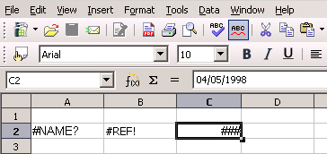Figure 336: Error codes displayed within cells
When the cell displaying the #REF error code in Figure 336 is selected, the status bar displays the error message as shown in Figure 337. This message is more descriptive than the message displayed in the cell, but it still may not provide enough information to correctly diagnose the problem. For fuller explanations, consult the following tables and the Help topic, Error Codes in OpenOffice.org Calc.
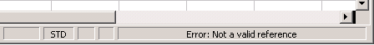Figure 337: An error message displayed in the status bar.
This appendix presents error codes in two tables. This first table explains error messages which are displayed within the cell that actually contains the error. Except in the case of the ### error, they all correspond to a Calc error code number. The second table explains all of the error codes, listed by code number, including those errors codes in the first table.

Error codes displayed within cells
Cell error | Code | Explanation of the error
### | N/A | The column is too narrow to display the complete formatted contents of the cell. This is not really an error value, so there is no corresponding numerical error code. The solutions to this problem are to increase the width of the column. or select Format > Cells > Alignment and click either Wrap text automatically or Shrink to fit cell size to make the text match the current column width.
Err502 | 502 | Function argument is not valid, or more than one matching cell is found by the DGET function.
#NUM! | 503 | A calculation resulted in an overflow of the defined value range.
#VALUE | 519 | The formula within the cell returns a value that does not correspond to the definition of the formula or functions used. This error could also mean that the cell referenced by the formula contains text instead of a number.
#REF! | 524 | The formula within the cell uses a reference that does not exist. Either a column or row description name could not be resolved, or the column, row, or sheet that contains a referenced cell is missing.
#NAME? | 525 | An identifier could not be evaluated: no valid reference, no valid domain name, no column/row label, no macro, incorrect decimal divider, add-in not found. For example, entering in a cell =sum(bob*5) where there is no cell named “bob” or containing the text “bob” generates this error.
#DIV/0! | 532 | Division operator / if the denominator is 0.  Some more functions return this error; see next table for details.

General error codes
The following table is an overview of the most common error messages for OOo Calc.
Note | Errors described as Internal errors should not be encountered by users under normal conditions. Errors listed as Not used are not currently assigned to any error condition and will not occur.
Code | Message | Explanation of the error
501 | Invalid character | Character in a formula is not valid. This error is the same as the Invalid Name error (525) except that it occurs within a formula. The cell containing the error will display the #NAME? error reference.
502 | Invalid argument | Function argument is not valid; for example, a negative number for the root function. This error also occurs if more than one matching cell is found by the DGET function.
503 | Invalid floating point operation (cell displays #NUM!) | Division by 0, or another calculation that results in an overflow of the defined value range (a value too big or too small).
504 | Parameter list error | Function parameter is not valid; for example, text instead of a number, or a domain reference instead of a cell reference.
505 | Internal syntax error | Not used.
506 | Invalid semicolon | Not used.
507 | Pair missing | Not used.
508 | Pair missing | Missing bracket or parenthesis; for example, closing brackets but no opening brackets.
509 | Missing operator | Operator is missing; for example,  "=2(3+4) * ", where the operator between "2" and "(" is missing.
510 | Missing variable | Variable is missing; for example, when two operators are together "=1+*2".
511 | Missing variable | Function requires more variables than are provided; for example, AND() and OR().
512 | Formula overflow | The total number of internal tokens (that is, operators, variables, brackets) in the formula exceeds 512, or the total number of matrices the formula creates exceeds 150. This includes basic functions that receive too large an array as a parameter.
513 | String overflow | An identifier in the formula exceeds 64 KB in size, or a result of a string operation exceeds 64 KB in size.
514 | Internal overflow | Sort operation attempted on too much numerical data (max. 100000) or a calculation stack overflow.
515 | Internal syntax error | Not used.
516 | Internal syntax error | Matrix is expected on the calculation stack, but is not available.
517 | Internal syntax error | Unknown error; for example, a document with a newer function is loaded in an older version of Calc that does not contain the function.
518 | Internal syntax error | Variable is not available.
519 | No result (cell displays #VALUE) | Formula yields a value that does not correspond to the definition, or a cell that is referenced in the formula contains text instead of a number.
520 | Internal syntax error | Compiler creates an unknown compiler code.
521 | Internal syntax error | No result.
522 | Circular reference | Formula refers directly or indirectly to itself and the Iterations option is not selected under Tools > Options > OpenOffice.org Calc > Calculate.
523 | The calculation procedure does not converge | Financial statistics function missed a targeted value, or iterations of circular references do not reach the minimum change within the maximum steps that are set.
524 | Invalid references (cell displays #REF!) | A column or row description name could not be resolved, or the column, row, or sheet that contains a referenced cell is missing.
525 | Invalid names (cell displays #NAME?) | An identifier could not be evaluated; for example, no valid reference, no valid domain name, no column/row label, no macro, incorrect decimal divider, add-in not found.
526 | Internal syntax error | Obsolete, no longer used, but could come from old documents if the result is a formula from a domain.
527 | Internal overflow | References, such as when a cell references a cell, are too encapsulated or deeply nested. This is an internal error and should not be displayed in OOo version 2.0 or greater.
528–531 | — | Not used.
532 | Division by zero | Division operator / if the denominator is 0.  Some more functions return this error; for example:  VARP with less than 1 argument  STDEVP with less than 1 argument  VAR with less than 2 arguments  STDEV with less than 2 arguments  STANDARDIZE with stdev=0  NORMDIST with stdev=0

Index
3
3D chart
appearance 89
area chart 98
bar chart 96
elements 79
formatting 87
illumination 89
line chart 99
moving elements 86
pie chart 96
rotation and perspective 88
rotation, interactive 90
types 75
A
absolute reference 190
advanced functions 217
anchor, visible 403
anchoring of objects 150
appearance of 3D chart 89
appearance options 395
Apply Style list 12, 110
area charts 97
arguments in functions 197, 429
arithmetic operators 182
array functions 468
arrow keys
navigating within spreadsheets 24
assign styles to shortcut keys 111
auto filters 367
AutoCorrect options 409
AutoInput 45
automatic changes, deactivating 44
automatic saving 20
axes labels 76
B
background
cell styles 113
bar charts 95
Base, editing data sources 315
borders
cell styles 113
bubble charts 100
C
Calc options
calculate 404
case sensitive 406
changes 408
dates 405
grid 408
grid lines, viewing 402
guides while moving 403
handles 403
input settings 401
iterative references 405
page breaks, visible 403
screen display 403
sort lists 407
unit of measurement 400
updating links 401
Zoom 404
calculation options 404
calculation order 192
calculations linking sheets 192
case sensitive sorting 66
cell alignment and orientation 57
cell protection 113
cell styles
alignment options 113
applying 109
background 113
border options 113
description 107
Fill Format mode 110
font effects 113
font options 113
linked with 112
numbers 113
cells
description 10, 14
focus 23
hiding and showing 63
information on status bar 15
range 27
selecting 27
validating contents 49
changes
accepting or rejecting 334
adding comments 329
editing comments 330
options 408
recording 327
reviewing 332
viewing 333
chart
appearance of 3D 89
area 79
area background 86
colors 87
creating 73
data labels 80, 92
editing 78
formatting 84
formatting 3D 87
graphic background 87
grids 78
illumination of 3D 89
interactive 3D rotation 90
mean value lines 83
moving elements 86
perspective 88
Position and Size dialog 94
resizing 93
rotation 88
titles 78
trend lines 82
types 95
wall 79
Y error bars 83
chart elements 79
chart type 75, 79
Chart Wizard 74
collaboration 323
color coding for input 207
color options 391
Color toolbar 139
column and line charts 103
column charts 95
columns
deleting 31
freezing 34
hiding and showing 63
inserting 30
selecting 29
comma separated values (CSV) 18, 22
comments
adding 330
editing 331
finding 332
formatting 332
comments on changes
adding 329
editing 330
comparative operators 183
comparing documents 337
concatenation operator 188
consolidating data 272
create document from template 119
creating new spreadsheets 16
cropping 140
CSV files 18, 22
custom sort order 67
customizing
Enter key 26
keyboard shortcuts 416
menus 410
toolbars 414
D
dashes, entering 44
data analysis
consolidating data 272
DataPilot 219
Goal Seek 288
introduction 272
Multiple Operations tool 281
scenarios 277
Solver 290
subtotals 275
data entry
keyboard 42
speeding up 45
data labels on charts 80, 92
data ranges 76
data series 77
data source
data to text 315
editing 314
editing using Base 315
linking 312
registering 312
using in OOo documents 315
viewing 314
data to text 315
database functions 466
database range 364
DataPilot
cell formatting 262
change layout 253
data fields 248
data source 243
dialog 244
examples of use 219
filter 260
GETPIVOTDATA 267
group date or time values 255
group rows or columns 253
group scalar values 254
group without intervals 256
multiple data fields 262
page fields 253
preconditions 241
refresh 261
row or column fields 250
shortcuts 266
sort results 257
starting 242
DataPilot Tools 421
date conversion, automatic 45
date functions 458
dates and times, entering 43
DDE link
description 320
in Calc 320
in Writer 321
default template 124
deleting
columns and rows 31
sheets 33
Detective 208
digital rights management (DRM) 172
digital signature 175
digital signature
status bar indicator 15
documents
comparing 337
merging 335
drag and drop 132
drag mode 40
drawing object properties 147
Drawing Object Properties toolbar 147
drawing objects
grouping 148
properties 147
resizing 148
Drawing toolbar 147
drawing tools 145
Dynamic Data Exchange (DDE) 320
E
e-mailing
several recipients 174
Writer document as attachment 174
editing data
changing the contents of cell 52
removing data from a cell 51
replacing cell data 52
en and em dashes, entering 44
Enter key 26
EPS images in PDF 169
Err:503 Division by zero 206
error codes
common messages 487
displayed within cells 486
introduction 485
error messages 205, 210
error-checking formulas 179
errors, finding and fixing 205
EuroOffice Solver 293
export directly as PDF 167
exporting to PDF 167
Extension Manager 123
extensions
DataPilot Tools 421
installing 420
introduction 420
Professional Template Pack 421
Solver for Nonlinear Programming 421
External Data dialog 307
F
FDF 169
features 10
file sharing options 393, 395
Fill Format mode 110
fill series
defining 47
using 46
Fill tool 45
filled net charts 101
filtering 367
filters
advanced 372
auto 367
standard 368
financial analysis functions 435
find and replace
cell styles 69
Find & Replace dialog 68
formulas or values 68
regular expressions 69
text 69
wildcards 69
fixed values 178
focus 23
formatting
chart 84
data labels 92
symbols 92
formatting
autoformatting cells and sheets 59
cell background 59
cell borders 58
conditional 61
themes 60
formatting data
font 56
font effects 56
manual line breaks 54
multiple lines of text 53
numbers 55
shrinking text 54
wrapping 53
Formatting toolbar 12
formula bar 13
formulas
absolute reference 190
breaking into parts 204
calculation examples 180
concatenation operator 188
definition 178
intersection operator 188
operator types 182
operators in 180
range operator 186
relative reference 189
strategies for creating 203
using the Basic editor to create 204
Function List 199
Function Wizard 13, 200
functions
add-in 479
ADDRESS 383
arguments 197, 352, 429
array 468
basic arithmetic 210
CEILING 214
CONCATENATE 184
COUNTIF 216, 377
database 375, 466
date and time 458
date formats 435
definition 178
description 178
entering 180
examples 210
financial analysis 435
FLOOR 214
HLOOKUP 380
INDEX 385
INDIRECT 384
informational 463
logical 462
LOOKUP 381
macros 345
MATCH 381
mathematical 430
MROUND 215
nested 198
OFFSET 384
overview 197
ROUND 213
ROUNDDOWN 214
ROUNDUP 214
simple statistics 211
spreadsheet 470
statistical analysis 449
structure 198
SUBTOTAL 378
SUMIF 377
terminology 429
text 475
VLOOKUP 379
G
Gallery
Hide/Show button 135
opening 134
GETPIVOTDATA 267
Goal Seek 288
graphic filters 138
graphics
adding 130
anchoring 150
arrangement 149
linking 132
positioning 148
resizing 141
transparency 139
graphics mode 138
grid
options 408
grid lines, viewing 402
grids in charts 78
guides while moving 403
H
headers and footers 115
Hide/Show button 135
hiding and showing data 63
HTML compatibility 399
hyperlinks
absolute 303
creating 304
Ctrl-click to activate 394
editing 306
relative 303
removing 306
I
illumination of 3D chart 89
image map 151
images
adding 130
context menu 142
cropping 140
embedding 133
inserting from file 130
inserting from the clipboard 134
inserting from the Gallery 134
linking 132
modifying 136
resizing 141
rotating 142
informational functions 463
input settings options 401
insert mode 15
Insert Picture dialog 131
inserting
columns and rows 30
sheets 32
interest rates 435
intersection operator 188
K
keyboard data entry 42
keyboard keys
navigating within spreadsheets 24
keyboard shortcuts
arrow keys 425
assigning 416
cell formatting 426
customizing 417
DataPilot 427
function keys 425
introduction 423
loading from a file 419
navigation 423
resetting to default values 419
saving to a file 419
selection 423
L
layout settings
format 115
page layout 114
table alignment 115
legend of chart 78
line charts 99
linking to external data
External Data dialog 307
find required range 310
Navigator 308
load Basic code to edit 398
load/save options 396
logical functions 462
M
macro recorder 341
macro security options 395
macros 420
macros
accessing cells directly 353
arguments 351
arguments in functions 352
as Calc functions 345
introduction 341
organizing 345
recording 341
sorting data 354
main window, description 11
manual line breaks 54
margins 114
mathematical functions 430
mean value lines 83
menu bar 11
menu font, customizing 410
menus
adding commands 413
creating 412
customizing 410
modifying 412
modifying entries 414
merging documents 335
Microsoft Excel 21
Microsoft Office file conversion 398
moving chart elements 86
moving from sheet to sheet 26
Multiple Operations tool 281
multiple sheets
introduction 295
setting up 295
N
named range 359
navigating within spreadsheets
cell reference 23
focus 23
keyboard 24
methods 23
Navigator 23, 38
scenarios 280
nested functions 198
net charts 101
nonlinear programming solver 293
numbers as text, entering 42
numbers, entering 42
O
Object Linking and Embedding (OLE) 316
ODF plugin (Sun) 20
OLE object
linked 319
non-linked 319
other (Windows) 318
OpenDocument Format 397
opening spreadsheets 17
order of calculation 192
outline group controls 63
overlining 56
OXT extension 123
P
page breaks, visible 403
page style on status bar 15
page styles
applying 111
background 115
borders 115
description 107, 108
options 113
sheet settings 115
paper format 114
password protection 20
password-protect PDF 172
PDF
blank page export 169
digital rights management (DRM) 172
encrypt 172
EPS images 169
export documents to 167
form 169
image compression and resolution 168
initial view selection 169
pages to export 167
password-protect 172
security settings 172
tagged 169
user interface settings 169
PDF Options dialog 167
PDF/A-1 169
perspective of chart 88
picture context menu 142
Picture toolbar 136
pictures
linking 132
resizing 141
transparency 139
pie charts 96
Position and Size dialog for chart 94
Position and Size of graphics 143
precision 406
prepare document for review 326
Print dialog 155
print file directly 155
print options 391
printer metrics 402
printing
choosing what to print 155
printer selection 155
protect a document 326
R
range
database 364
named 359
range operators 186
record changes 326
reference operators 186
references in color 404
referencing
other spreadsheets 301
sheets 299
regular expressions 69
enable in formulas 406
in functions 215
relative reference 189
relief options 56
remove personal information on saving 394
removing data from a cell 51
renaming
sheets 33
replacing cell data 52
resolution options 409
rofessional Template Pack 421
rotating images 142
rotation
chart 88
rounding methods 213
rounding off numbers 213
rows
deleting 31
freezing 34
hiding and showing 63
inserting 30
selecting 29
S
save original Basic code 398
saving AutoRecovery info 20
saving spreadsheets
as CSV file 22
as HTML 23
methods 19
to Microsoft Excel format 20
scatter charts 99
scenarios 277
security 20
selecting
cells 27
columns and rows 29
sheets 29
selection list 48
selection mode indicator 15
send document as e-mail 174
shared extension 420
shared spreadsheet
introduction 323
opening 324
saving 325
setting up 323
sheet tabs 14
sheets
deleting 33
description 10
hiding and showing 63
identifying 295
inserting 32, 296
inserting from other spreadsheets 297
navigating 26
referencing 299
renaming 33, 298
searching all 67
selecting 29
sequence number 15
sharing content 48
shrinking text 54
size optimization 397
snap grid 408
Solver 290
Solver for Nonlinear Programming 293, 421
sort lists
options 407
sorting 365
sorting
using macros 354
sorting records
case sensitive 66
sort options 66
sorting data 65
special characters, entering 43
splitting the screen 36
spreadsheet
create from template 119
update from changed template 122
spreadsheet functions 470
spreadsheets
comparing 337
creating new 16
description 10
documentation, internal 179
embedding 316
identifying copies 327
merging 335
opening 17
opening shared spreadsheet 324
saving 19
saving as CSV 22
saving as Microsoft Excel 20
saving shared 325
setting up sharing 323
sharing 323
statistical analysis functions 449
status bar 14
stock charts 102
strikethrough 56
Style dialog 116
style organizer 111
styles
accessing 108
assign to shortcut keys 111
assigning to shortcut keys 418
cell 107
copy 117
create by drag and drop 117
create from selection 116
create using Style dialog 116
delete 119
description 106
linking 116
modifying 111
move 117
organizer 111
page 108, 111
types supported 106
Styles and Formatting window 109
subtotals 275
synchronize axes 409
system font 410
T
template
associate spreadsheet with different template 125
create spreadsheet from 119
delete 127
delete folder 126
description 106
edit 121
export 128
Extension Manager 123
folder 126
import 127
move 127
organize 126
reset default 125
set custom template as default 124
update document styles from 122
text functions 475
text operators 184
text overflow 404
text, entering 42
time functions 458
title bar 11
titles of charts 78
toolbars
adding commands 416
choosing icons for commands 416
creating 415
description 12
tooltip 12
track changes 326
transparency 139
trend lines 82
typing errors, autocorrect 44
U
underlining 56
unsaved changes indicator 15
URL Recognition 304
user data options 391
user interface, customizing 410
V
validating cell contents 49
value highlighting 403
VBA properties load/save options 397
versions
saving 337
viewing Calc 33
viewing data
filters 64
hiding and showing data 63
outline groups 63
visible grid 409
W
wall of chart 79
wildcards 69
X
XML 397
XY charts 99
Y
Y error bars 83
Z
zoom
dialog 34
slider 16
#
#REF! Incorrect references 207
#VALUE Non-existent value 207

In this case the word - undefined – is misleading because the output position is in fact defined.

