Software Specification Document

OpenOffice Calc
Print Output Scaling Factor

Specification Status
Last Change | 2008年六月27日
Status
Abstract
According to the request of the to-do list in Calc OOo community, the feature is to add resizeable margins and scaling factor on page preview in Calc.
i-Team Members
Role | First Name, Last Name, Initials | E-Mail Address
Project Lead | Niklas Nebel | nn@openoffice.org
Specification Owner | Frank Loehmann (FL) | frank.loehmann@sunc.com
User Experience | Frank Loehmann (FL) | frank.loehmann@sunc.com
Development | Maoyonggang(maoyg) | maoyg@openoffice.org
Quality Assurance | Peter Junge | pj@openoffice.org
Documentation | maoyg | maoyg@openoffice.org
Other roles | <First Name, Last Name (Initials)> | <User@openoffice.org>
<State reason here, if one role is not represented in i-Team.>

Contents
Abstract 1
i-Team Members 1
References and Reference Documents 3
Acronyms and Abbreviations 3
1 1. Detailed Specification 4
1.1 Scaling Factor 4
1.2 Scaling Factor: 100% 4
1.3 Scaling Factor: 255% 5
1.4 Scaling Factor: 50% 5
2 Migration 6
3 Configuration 6
4 File Format 6
5 Open Issues 6
Document Change History 7

References and Reference Documents
Reference Document | Check | Location (URL)
Specification Process Entry Check |  | N/A
Product Requirement,, RFE, issue (required) |  | <Please enter location here>
Product Concept Document |  | <Please enter location here>
Competitive Analysis |  | <Please enter location here>
Test Case Specification (required) |  | <Please enter location here>
Software Specification Rules | N/A | N/A
<Other, e.g. references to related specs>

Acronyms and Abbreviations
Acronym / Abbreviation | Definition
<WYSIWYG> | <What You See Is What You Get>

1. Detailed Specification

Scaling Factor
This feature would make the user get immediate feedback when changing this setting and she could see how the printout will look like.

Scaling Factor: 100%
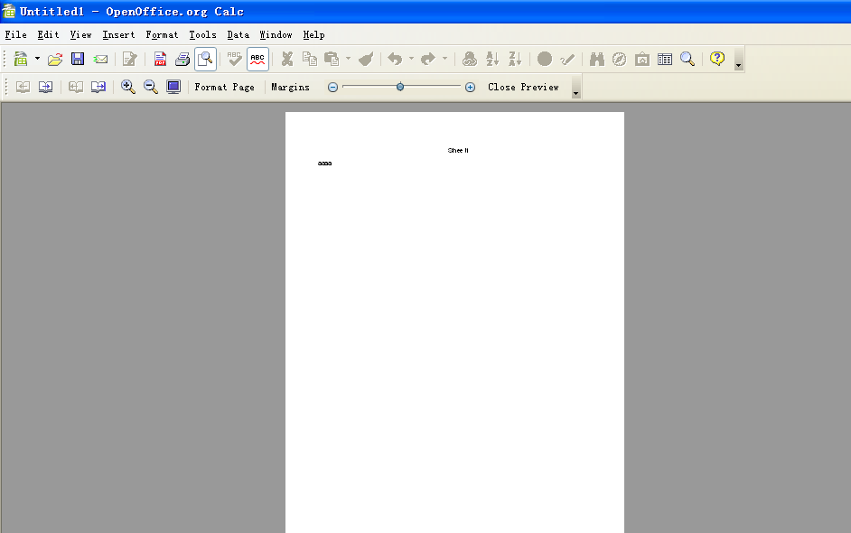
Illustration 1: Scaling factor 100%
The slider can be controlled while hovering over the slider / when the slider gets the focus by:
- Clicking / dragging the zoom slider using the mouse.
- Zoom slider added to change scaling factor live on moving slider.
- Zoom feature removed from tool bar (will be shown in status bar of OOo 3.0).
- Margins” - Button Properties |  | Comment
Tip Hep | Zoom Slider | EN-US

Scaling Factor: 255%
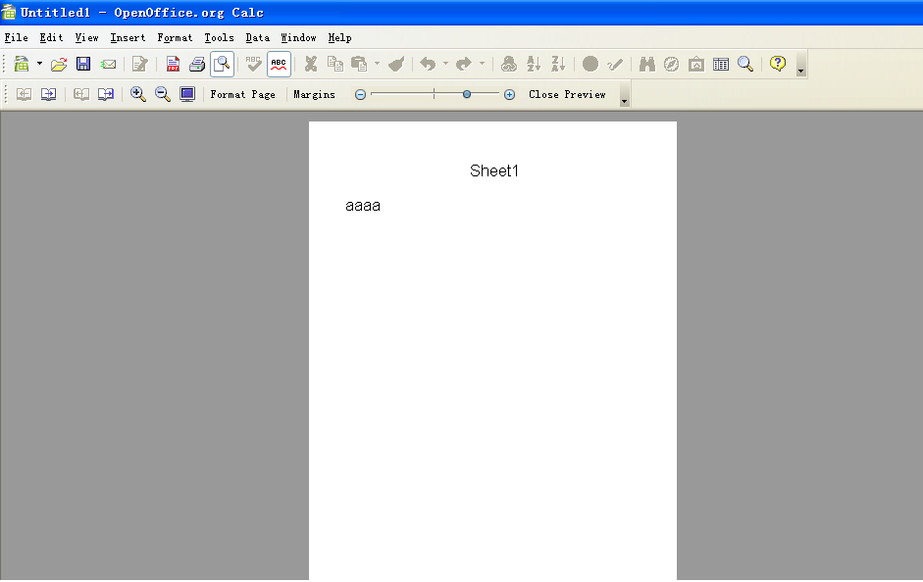

Scaling Factor: 50%
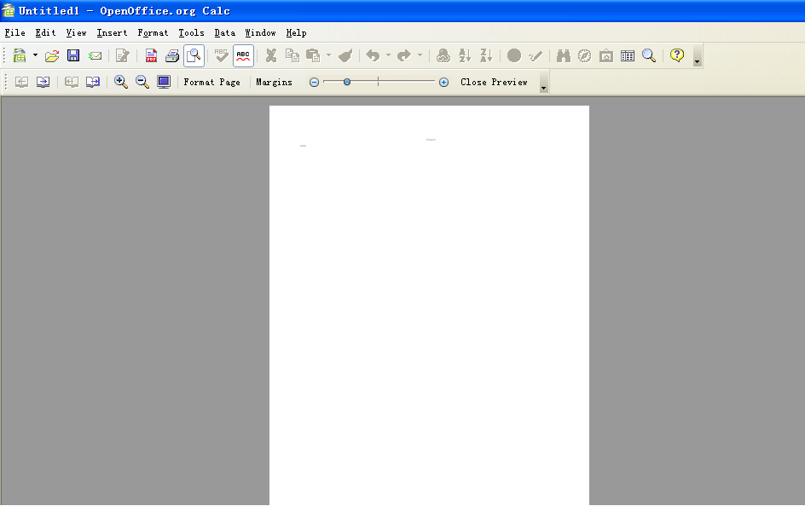

Migration
Not applicable as this is a new feature

Configuration
This feature doesn't need to be stored in configuration path.

File Format
No change to the file format

Open Issues
Issue | Initials | Date

Document Change History
Rev. | Change | Initials | Date
1 | Create spec. from Page Margins Spec. |  | <Format: Dec 31, 2000>
2
3
<...>

