

Calc Guide
Chapter 6
Printing, Exporting, and E-mailing

This PDF is designed to be read onscreen, two pages at a time. If you want to print a copy, your PDF viewer should have an option for printing two pages on one sheet of paper, but you may need to start with page 2 to get it to print facing pages correctly. (Print this cover page separately.)

Copyright
This document is Copyright © 2005–2010 by its contributors as listed in the section titled Authors. You may distribute it and/or modify it under the terms of either the GNU General Public License, version 3 or later, or the Creative Commons Attribution License, version 3.0 or later.
All trademarks within this guide belong to their legitimate owners.
Authors
Jean Hollis Weber
Emma Kirsopp
Peter Kupfer
Shelagh Manton
Kashmira Patel
Linda Worthington
Feedback
Please direct any comments or suggestions about this document to: authors@documentation.openoffice.org
Acknowledgements
Portions of this chapter are taken from articles written by Bruce Byfield and first published on the Linux Journal website; used with permission
Publication date and software version
Published 20 April 2010. Based on OpenOffice.org 3.2.
Contents
Copyright 2
Quick printing 5
Controlling printing 5
Printer options 6
Selecting sheets to print 6
Selecting the page order, details, and scale 7
Using print ranges 9
Defining a print range 9
Adding to the print range 9
Removing a print range 9
Editing a print range 10
Printing rows or columns on every page 11
Defining a custom print range 11
Page breaks 13
Inserting a page break 13
Row break 13
Column break 13
Deleting a page break 13
Headers and footers 14
Setting a header or a footer 14
Header or footer appearance 15
Setting the contents of the header or footer 16
Exporting to PDF 17
Quick export to PDF 17
Controlling PDF content and quality 17
General page of PDF Options dialog 17
Initial View page of PDF Options dialog 19
User Interface page of PDF Options dialog 19
Links page of PDF Options dialog 21
Security page of PDF Options dialog 22
Exporting to XHTML 23
Saving as Web pages (HTML) 24
E-mailing spreadsheets 24
E-mailing a spreadsheet to several recipients 24
Digital signing of documents 25
Removing personal data 26

Quick printing
Click the Print File Directly icon to send the entire document to the default printer defined for your computer.
Note | You can change the action of the Print File Directly icon to send the document to the printer defined for the document instead of the default printer for the computer. Choose Tools > Options > Load/Save > General and the Load printer settings with the document option.

Controlling printing
For more control over printing, use File > Print.
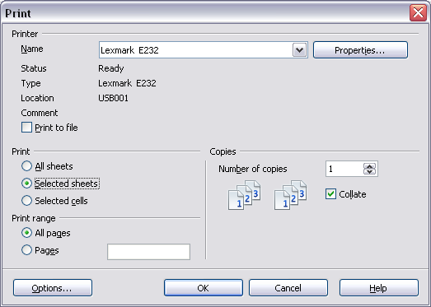
Figure 1. The Print dialog
On the Print dialog, you can choose:
- Which printer to use (if more than one are installed on your system) and the properties of the printer—for example, page orientation (portrait or landscape), which paper tray to use, and what paper size to print on. The properties available depend on the selected printer; consult the printer’s documentation for details.
- What sheets and pages to print, how many copies to print, and in what order to print them. Use dashes to specify page ranges and commas or semicolons to separate ranges; for example: 1, 5, 11–14, 34–40. Selection refers to the highlighted part of a page or pages.
- Whether to print to a printer or to a file.

Printer options
You can set printer options for the current document only or for all spreadsheets.
- To select options for the current document, click the Options button on the bottom left of the Print dialog (Figure 1).
- To set print options permanently, go to Tools > Options > OpenOffice.org Calc > Print. The dialogs for both are very similar.
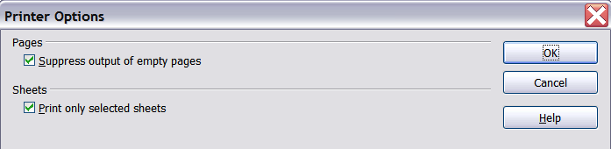
Figure 2. Printer Options dialog

Selecting sheets to print
You can select one or more sheets for printing. This can be useful if you have a large spreadsheet with multiple sheets and only want to print certain sheets. For example, an accountant might record costs over time with one sheet for each month. To print the November and December sheets, follow this procedure.
- Go to the November sheet. Hold down the Control key and click on the tab of the December sheet.
- If you wish to print all of the sheets, choose File > Print and click the Options button.
- Deselect Print only selected sheets. This affects the print preview, export, and printing of your spreadsheet. Click OK.
Note | The Options button is different from the Properties button. Properties deals with the settings of the printer, whereas Options deals with OOo’s settings.

Selecting the page order, details, and scale
To select the page order, details, and scale to be printed:
- Choose Format > Page from the main menu. The Page Style dialog opens; any changes made here are saved in the page style for this spreadsheet.
- Choose the Sheet tab (Figure 3).
- After making your selections (see next page), click OK.
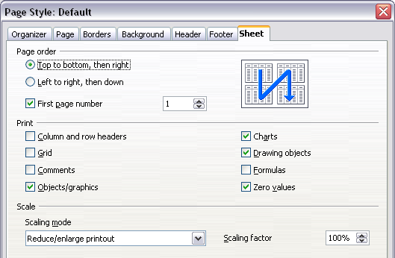
Figure 3. The Sheet tab of the Page Style dialog
Page Order
You can set the order in which pages print. This is especially useful in a large document; for example, controlling the print order can save time if you have to collate the document a certain way.
Where a sheet prints to more than one page of paper, it can be printed either by column, where the first column of pages prints, and then the second column and so on, or by row as shown in the graphic on the top right of the dialog in Figure 3.
Print
You can specify which details to print. These details include:
- Row and column headers
- Sheet grid—prints the borders of the cells as a grid
- Comments—prints the comments defined in your spreadsheet on a separate page, along with the corresponding cell reference
- Objects and graphics
- Charts
- Drawing objects
- Formulas—prints the formulas contained in the cells, instead of the results
- Zero Values—prints cells with a zero value
Note | Remember that since the print detail options are a part of the page’s properties, they are also a part of the page style’s properties. Therefore, different page styles can be set up to quickly change the print properties of the sheets in the spreadsheet.
Scale
Use the scale features to control the number of pages the data will print on. This can be useful if a large amount of data needs to be printed compactly or, if the reader has poor eyesight, text can be enlarged when it prints.
- Reduce/Enlarge printout—scales the data in the printout either larger or smaller. For example, if a sheet would normally print out as four pages (two high and two wide), a scaling of 50% would print as one page (both width and height are halved).
- Fit print range(s) on number of pages—defines exactly how many pages the printout will take up. This option will only reduce a printout, it will not enlarge it. To enlarge a printout, the reduce/enlarge option must be used.
- Fit print range(s) to width/height—defines how high and wide the printout will be, in pages.

Using print ranges
Print ranges have several uses, including printing only a specific part of the data or printing selected rows or columns on every page.

Defining a print range
To define a new print range or modify an existing print range:
- Highlight the range of cells that comprise the print range.
- Choose Format > Print Ranges > Define.
The page break lines display on the screen.
Tip | You can check the print range by using File > Page Preview. OOo will only display the cells in the print range.

Adding to the print range
After defining a print range, you can add more cells to it. This allows multiple, separate areas of the same sheet to be printed, while not printing the whole sheet. After you have defined a print range:
- Highlight the range of cells to be added to the print range.
- Choose Format > Print Ranges > Add. This adds the extra cells to the print range.
The page break lines no longer display on the screen.
Note | The additional print range will print as a separate page, even if both ranges are on the same sheet.

Removing a print range
It may become necessary to remove a defined print range, for example if the whole sheet needs to be printed later.
Choose Format > Print Ranges > Remove. This removes all defined print ranges on the sheet. After the print range is removed, the default page break lines will appear on the screen.

Editing a print range
At any time, you can directly edit the print range, for example to remove or resize part of the print range. Choose Format > Print Ranges > Edit. If you have already selected a print range, the Edit Print Ranges dialog looks something like Figure 4.
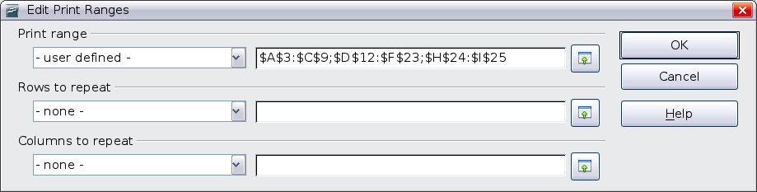
Figure 4: Edit a print range
In this example, three rectangles are selected, each separated by a semicolon. The first is bounded by cell A3 ($A$3) in the top left and cell C9 ($C$9) in the bottom right corners. Clicking anywhere in the text entry box shows the currently selected print range on the screen, with each rectangle in a different color, as in Figure 5.
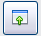
After making any changes, click the Shrink icon next to the text entry box to redisplay the rectangles with their new values.
To re-expand the Edit Print Ranges dialog, click the Shrink icon again.
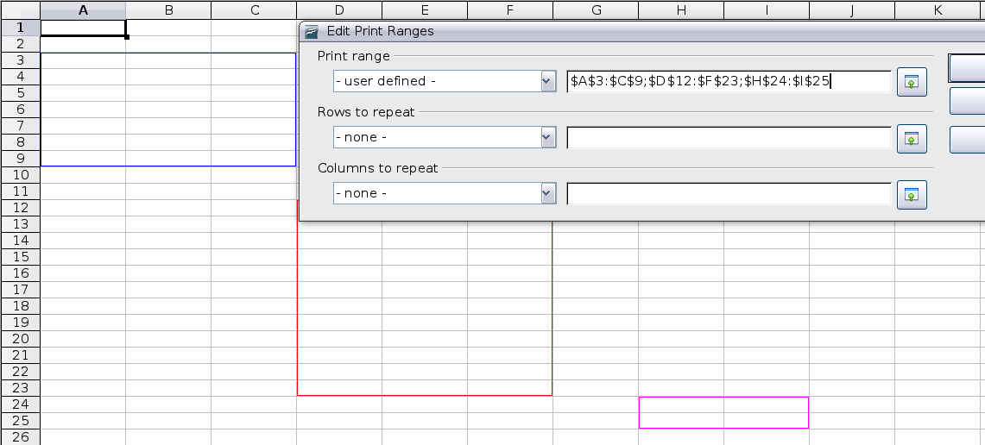
Figure 5: Print range marked by colored boxes

Printing rows or columns on every page
If a sheet is printed on multiple pages, you can set up certain rows or columns to repeat on each printed page.
For example, if the top two rows of the sheet as well as column A need to be printed on all pages, do the following:
- Choose Format > Print Ranges > Edit. On the Edit Print Ranges dialog, type the rows in the text entry box under Rows to repeat. For example, to repeat rows 1 and 2, type $1:$2. This automatically changes Rows to repeat from - none - to - user defined -.
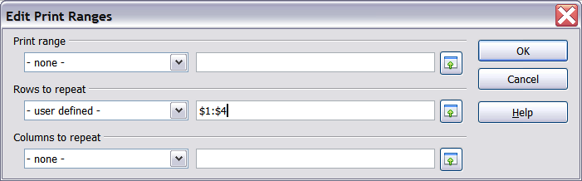
Figure 6: Specifying repeating rows
- To repeat columns, type the columns in the text entry box under Columns to repeat. For example, to repeat column A, type $A. This automatically changes Columns to repeat from - none - to - user defined -.
- Click OK.
Note | You do not need to select the entire range of the rows to be repeated; simply select one cell in each row.

Defining a custom print range
In addition to highlighting a print range for each print job, you can define a range of cells to be used repeatedly. This may be useful if there are different areas of a large spreadsheet that need to be printed for different reports. Several different print ranges can be defined to meet this need.
- To define a print range, use the same procedure as labeling an area of the sheet. Highlight the cells you want to define as a print range and select Insert > Names > Define. (The cells can be highlighted after opening the Define Names dialog as well.)
- On the Define Names dialog (Figure 7), type a name for the range in the text box with the blinking cursor. The name of the range cannot contain any spaces.
- Click the More button in the dialog and then select the Print range option. Click the Add button.
- To include more than one group of cells in the selection, type in the additional ranges. For example, to select the rectangle with A3 as the top left cell and F20 as the bottom right cell, enter
;$A$3:$F$20 or ;A3:F20 (both work and are equivalent) after the initial selection. Make sure that each group of cells is separated with a semicolon.
- Click OK.
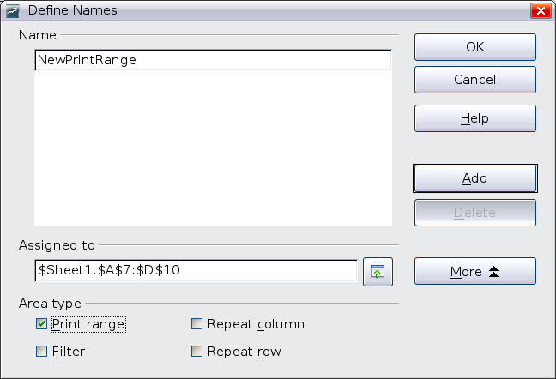
Figure 7: Define Names dialog
To print this range:
- Choose Format > Print Ranges > Edit (Figure 4). The previously defined area now appears in the drop-down box under Print range.
- Select the defined print range and click OK.
This method can be useful to quickly change the print range without highlighting a large area of cells every time.
Note | If the cell range name refers to more than one group of cells, it will not appear in the drop-down list. You will need to type it in or highlight and select it.

Page breaks
While defining a print range can be a powerful tool, it may sometimes be necessary to manually adjust Calc’s printout. To do this, you can use a manual break. A manual break helps to ensure that your data prints properly. You can insert a horizontal page break above, or a vertical page break to the left of, the active cell.

Inserting a page break
To insert a page break:
- Navigate to the cell where the page break will begin.
- Select Insert > Manual Break.
- Select Row Break or Column Break depending on your need.
The break is now set.

Row break
Selecting Row Break creates a page break above the selected cell. For example, if the active cell is H15, then the break is created between rows 14 and 15.

Column break
Selecting Column Break creates a page break to the left of the selected cell. For example, if the active cell is H15, then the break is created between columns G and H.
Tip | To see page break lines more easily on screen, you can change their color. Choose Tools > Options > OpenOffice.org > Appearance and scroll down to the Spreadsheet section.

Deleting a page break
To remove a page break:
- Navigate to a cell that is next to the break you want to remove.
- Select Edit > Delete Manual Break.
- Select Row Break or Column Break depending on your need.
The break is now removed.
Note | Multiple manual row and column breaks can exist on the same page. When you want to remove them, you have to remove each one individually. This may be confusing at times, because although there may be a column break set on the page, when you go to Edit > Manual Break, the Column break choice may not be available (grayed out).  In order to remove the break, you have to be in the cell next to the break. For example, if you set the column break while you are in H15, you can not remove it if you are in cell D15. However, you can remove it from any cell in column H.

Headers and footers
Headers and footers are predefined pieces of text that are printed at the top or bottom of a sheet outside of the sheet area. Headers are set the same way as footers.
Headers and footers are assigned to a page style. You can define more than one page style for a spreadsheet and assign different page styles to different sheets. For more about page styles, see Chapter 4.

Setting a header or a footer
To set a header or footer:
- Navigate to the sheet that you want to set the header or footer for. Select Format > Page.
- Select the Header (or Footer) tab. See Figure 8.
- Select the Header on option.
From here you can also set the margins, the spacing, and height for the header or footer. You can check the AutoFit height box to automatically adjust the height of the header or footer.
Margin
Changing the size of the left or right margin adjusts how far the header or footer is from that side of the page.
Spacing
Spacing affects how far above or below the sheet the header or footer will print. So, if spacing is set to 1.00", then there will be 1 inch between the header or footer and the sheet.
Height
Height affects how big the header or footer will be.
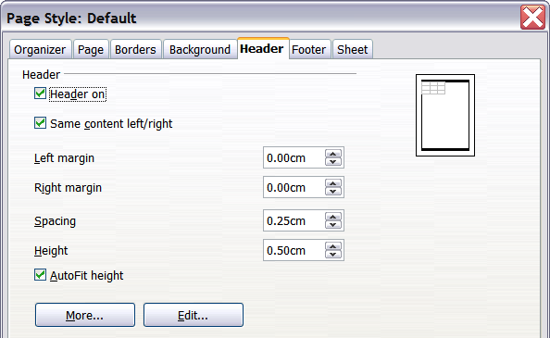
Figure 8: Header dialog

Header or footer appearance
To change the appearance of the header or footer, click the More button in the dialog. This opens the Border/Background dialog.
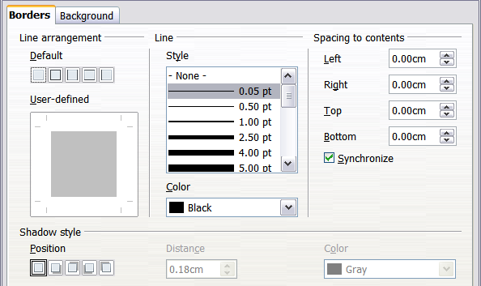
Figure 9: Header/Footer Border/Background dialog
From this dialog you can set the background and border style of the header or footer. See Chapter 4 (Using Styles and Templates) for more information.

Setting the contents of the header or footer
The header or footer of a Calc spreadsheet has three columns for text. Each column can have different contents.
To set the contents of the header or footer, click the Edit button in the header or footer dialog shown in Figure 8 to display the dialog shown in Figure 10.
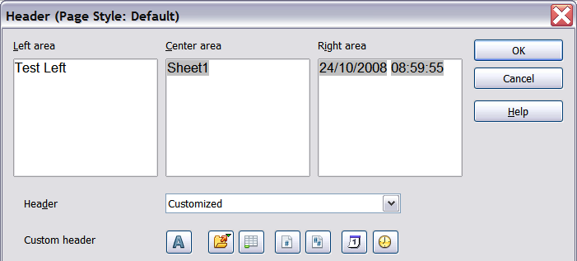
Figure 10: Edit contents of header or footer
Areas
Each area in the header or footer is independent and can have different information in it.
Header
You can select from several preset choices in the Header drop-down list, or specify a custom header using the buttons below the area boxes. (To format a footer, the choices are the same.)
Custom header
Click in the area (Left, Center, Right) that you want to customize, then use the buttons to add elements or change text attributes.
Opens the Text Attributes dialog.
Inserts the total number of pages.
Inserts the File Name field.
Inserts the Date field.
Inserts the Sheet Name field.
Inserts the Time field.
Inserts the current page number.

Exporting to PDF
Calc can export documents to PDF (Portable Document Format). This industry-standard file format is ideal for sending the file to someone else to view using Adobe Reader or other PDF viewers.

Quick export to PDF
Click the Export Directly as PDF icon to export the entire document using your default PDF settings. You are asked to enter the file name and location for the PDF file, but you do not get to choose a page range, the image compression, or other options.

Controlling PDF content and quality
For more control over the content and quality of the resulting PDF, use File > Export as PDF. The PDF Options dialog opens. This dialog has five pages (General, Initial View, User Interface, Links, and Security). Make your selections and click Export. Enter the location and file name of the PDF to be created. Click Save to export the file.

General page of PDF Options dialog
On the General page, you can choose which pages to include in the PDF, the type of compression to use for images (which affects the quality of images in the PDF), and other options.
Range section
- All: Exports the entire document.
- Pages: To export a range of pages, use the format 3-6 (pages 3 to 6). To export single pages, use the format 7;9;11 (pages 7, 9, and 11). You can also export a combination of page ranges and single pages, by using a format like 3-6;8;10;12.
- Selection: Exports whatever content is selected.
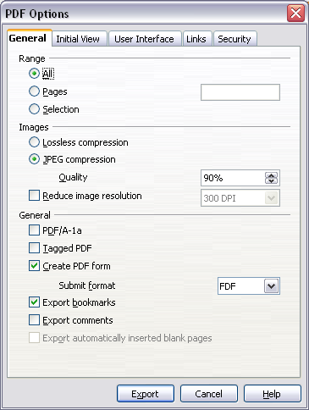
Figure 11: General page of PDF Options dialog
Images section
- Lossless compression: Images are stored without any loss of quality. Tends to make large files when used with photographs. Recommended for other kinds of images or graphics.
- JPEG compression: Allows for varying degrees of quality. A setting of 90% works well with photographs (small file size, little perceptible loss).
- Reduce image resolution: Lower-DPI (dots per inch) images have lower quality. For viewing on a computer screen a resolution of 72dpi (for Windows) or 96dpi (GNU/Linux) is sufficient, while for printing it is generally preferable to use at least 300 or 600 dpi, depending on the capability of the printer. Higher dpi settings greatly increase the size of the exported file.
Note | EPS images with embedded previews are exported only as previews. EPS images without embedded previews are exported as empty placeholders.
General section
- PDF/A-1: PDF/A is an ISO standard established in 2005 for long-term preservation of documents, by embedding all the pieces necessary for faithful reproduction (such as fonts) while forbidding other elements (including forms, security, encryption, and tagged PDF). If you select PDF/A-1, the forbidden elements are greyed-out (not available).
- Tagged PDF: Exports special tags into the corresponding PDF tags. Some tags that are exported are table of contents, hyperlinks, and controls. This option can increase the file size significantly.
- Create PDF form - Submit format: Choose the format for submitting forms from within the PDF file. This setting overrides the control’s URL property that you set in the document. There is only one common setting valid for the whole PDF document: PDF (sends the whole document), FDF (sends the control contents), HTML, and XML. Most often you will choose the PDF format.
- Export bookmarks: Exports sheet names in Calc documents as “bookmarks” (a table of contents list displayed by some PDF readers, including Adobe Reader).
- Export comments: Exports comments in Calc documents as PDF notes. You may not want this!
- Export automatically inserted blank pages: Not available in Calc.

Initial View page of PDF Options dialog
On the Initial View page (Figure 12), you can choose how the PDF opens by default in a PDF viewer. The selections are self-explanatory.

User Interface page of PDF Options dialog
On the User Interface page (Figure 13), you can choose more settings to control how a PDF viewer displays the file. Some of these choices are particularly useful when you are creating a PDF to be used as a presentation or a kiosk-type display.

Figure 12: Initial View page of PDF Options dialog
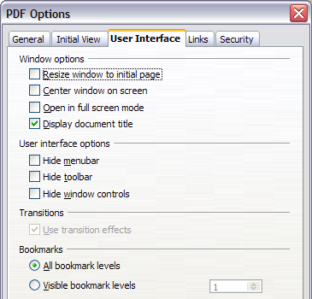
Figure 13: User Interface page of PDF Options dialog
Window options section
- Resize window to initial page: Causes the PDF viewer window to resize to fit the first page of the PDF.
- Center window on screen: Causes the PDF viewer window to be centered on the computer screen.
- Open in full screen mode: Causes the PDF viewer to open full-screen instead of in a smaller window.
- Display document title: Causes the PDF viewer to display the document’s title in the title bar.
User interface options section
- Hide menubar: Causes the PDF viewer to hide the menu bar.
- Hide toolbar: Causes the PDF viewer to hide the toolbar.
- Hide window controls: Causes the PDF viewer to hide other window controls.
Transitions
Not available in Calc.
Bookmarks
Select how many heading levels are displayed as bookmarks, if Export bookmarks is selected on the General page.

Links page of PDF Options dialog
On this page you can choose how links are exported to PDF.

Figure 14: Links page of PDF Options dialog
Export bookmarks as named destinations
If you have defined Writer bookmarks, Impress or Draw slide names, or Calc sheet names, this option exports them as “named destinations” to which Web pages and PDF documents can link.
Convert document references to PDF targets
If you have defined links to other documents with OpenDocument extensions (such as .ODT, .ODS, and .ODP), this option converts the file names to .PDF in the exported PDF document.
Export URLs relative to file system
If you have defined relative links in a document, this option exports those links to the PDF.
Cross-document links
Defines the behavior of links clicked in PDF files.

Security page of PDF Options dialog
PDF export includes options to encrypt the PDF (so it cannot be opened without a password) and apply some digital rights management (DRM) features.
- With an open password set, the PDF can only be opened with the password. Once opened, there are no restrictions on what the user can do with the document (for example, print, copy, or change it).
- With a permissions password set, the PDF can be opened by anyone, but its permissions can be restricted. See Figure 15.

Figure 15: Security page of PDF Options dialog.
- With both the open password and permission password set, the PDF can only be opened with the correct password, and its permissions can be restricted.
Note | Permissions settings are effective only if the user’s PDF viewer respects the settings.
Figure 16 shows the dialog displayed when you click the Set open password button on the Security page of the PDF Options dialog.
After you set a password for permissions, the other choices on the Security page (shown in Figure 15) become available. These selections are self-explanatory.
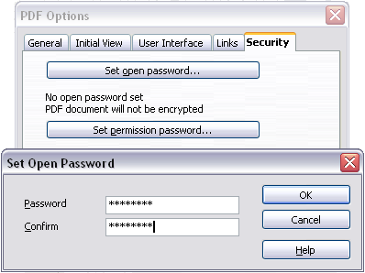
Figure 16: Setting a password to encrypt a PDF

Exporting to XHTML
Calc can export spreadsheets to XHTML. Choose File > Export. On the Export dialog, specify a file name for the exported document, then select the XHTML in the File format list and click the Export button.

Saving as Web pages (HTML)
Calc can save files as HTML documents. Use File > Save As and select HTML Document, or File > Wizards > Web Page.
If the file contains more than one sheet, the additional sheets will follow one another in the HTML file. Links to each sheet will be placed at the top of the document. Calc also allows the insertion of links directly into the spreadsheet using the Hyperlink dialog.

E-mailing spreadsheets
OOo provides several quick and easy ways to send spreadsheets as an e-mail attachment in one of three formats: OpenDocument Spreadsheet (OOo’s default format), Microsoft Excel, or PDF.
To send the current document in OpenDocument format:
- Choose File > Send > Document as E-mail. OpenOffice.org opens your default e-mail program with the spreadsheet (*.ODS) document attached.
- In your e-mail program, enter the recipient, subject, and any text you want to add, then send the e-mail.
File > Send > E-mail as OpenDocument Spreadsheet has the same effect.
If you choose E-mail as Microsoft Excel, OOo first creates a file in Excel format and then opens your e-mail program with the *.XLS file attached.
Similarly, if you choose E-mail as PDF, OOo first creates a PDF using your default PDF settings (as when using the Export Directly as PDF toolbar button) and then opens your email program with the *.PDF file attached.

E-mailing a spreadsheet to several recipients
To e-mail a document to several recipients, you can use the features in your e-mail program or you can use OOo Writer’s mail merge facilities to extract email addresses from an address book.
For details, see Chapter 10 (Printing, Exporting, and E-mailing) in the Getting Started guide.

Digital signing of documents
To sign a document digitally, you need a personal key, the certificate. A personal key is stored on your computer as a combination of a private key, which must be kept secret, and a public key, which you add to your documents when you sign them. You can get a certificate from a certification authority, which may be a private company or a governmental institution.
When you apply a digital signature to a document, a checksum is computed from the document’s content plus your personal key. The checksum and your public key are stored together with the document.
When someone later opens the document on any computer with a recent version of OpenOffice.org, the program will compute the checksum again and compare it with the stored checksum. If both are the same, the program will signal that you see the original, unchanged document. In addition, the program can show you the public key information from the certificate. You can compare this key with the public key that is published on the web site of the certificate authority.
Whenever someone changes something in the document, this change breaks the digital signature.
On Windows operating systems, the Windows features of validating a signature are used. On Solaris and Linux systems, files that are supplied by Thunderbird, Mozilla or Firefox are used. For a more detailed description of how to get and manage a certificate, and signature validation, see “Using Digital Signatures” in the OOo Help.
To sign a document:
- Choose File > Digital Signatures.
- If you have not saved the document since the last change, a message box appears. Click Yes to save the file.
- After saving, you see the Digital Signatures dialog. Click Add to add a public key to the document.
- In the Select Certificate dialog, select your certificate and click OK.
- You see again the Digital Signatures dialog, where you can add more certificates if you want. Click OK to add the public key to the saved file.
A signed document shows an icon in the status bar. You can double-click the icon to view the certificate.

Removing personal data
You may wish to ensure that personal data, versions, notes, hidden information, or recorded changes are removed from files before you send them to other people or create PDFs from them.
In Tools > Options > OpenOffice.org > Security > Options, you can set Calc to remind (warn) you when files contain certain information and remove personal information automatically on saving.
To remove personal and some other data from a file, go to File > Properties. On the General tab, uncheck Apply user data and then click the Reset button. This removes any names in the created and modified fields, deletes the modification and printing dates, and resets the editing time to zero, the creation date to the current date and time, and the version number to 1.
To remove version information, either go to File > Versions, select the versions from the list and click Delete, or use Save As and save the file with a different name.

