

Draw Guide
Chapter 2
Drawing Basic Shapes

Copyright
This document is Copyright © 2005–2008 by its contributors as listed in the section titled Authors. You can distribute it and/or modify it under the terms of either the GNU General Public License, version 3 or later (http://www.gnu.org/licenses/gpl.html), or the Creative Commons Attribution License, version 3.0 (http://creativecommons.org/licenses/by/3.0/) or later.
All trademarks within this guide belong to their legitimate owners.
Authors
Agnes Belzunce
Martin Fox
Gary Schnabl
Wolfgang Uhlig
Jean Hollis Weber
Linda Worthington
Feedback
Please direct any comments or suggestions about this document to:
authors@user-faq.openoffice.org
Acknowledgments
This chapter is based on an original French document written for OpenOffice.org 1.x by Michel Pinquier (translated to English by Alex Thurgood) and previous content revised by Jim Taylor. The chapter was revised for OpenOffice 2.0 by Linda, Daniel, Jean, and Agnes and later translated into German by Wolfgang Uhlig; the German revisions were then translated into English by Martin Fox.
Publication date and software version
Published 9 April 2008. Based on OpenOffice.org 2.4.
Contents
Copyright i
Authors i
Feedback i
Acknowledgments i
Publication date and software version i
Creating simple drawings 1
Custom shapes 1
Drawing basic shapes 1
Drawing a straight line 2
Drawing an arrow 3
Drawing lines and arrows 3
Drawing a rectangle or square 4
Drawing ellipses (ovals) and circles 4
Adding ellipse and arc tools to the Drawing toolbar 5
Drawing elliptical and circular arcs 6
Curves 6
Gluepoints and connectors (basics) 7
Gluepoints 7
Connectors 7
Drawing geometric shapes 8
Basic shapes 9
Symbol shapes 9
Block arrows 10
Flowcharts 10
Callouts 10
Stars and banners 11
Adding text to objects 11
Using dynamic text frames 11
Using text elements in Draw objects 13

Creating simple drawings
You can create 2D and 3D objects in Draw. In this chapter, we restrict ourselves to producing 2D drawing objects. The following chapters describe how to work with and edit such objects.
This chapter describes how to draw simple shapes. All shapes, whether they are simple lines, rectangles, or more complicated shapes, are called objects. This is common notation in vector drawing software.
The drawing tools are found on the Drawing toolbar. Figure 1 shows the standard form of the toolbar, as installed with Draw. You can configure any and all the toolbars to your own needs and add, move, hide, or delete toolbar icons as you wish.
The Drawing toolbar is normally located at the bottom of the window. If you do not see it, activate it from the View > Toolbars menu. As in all OpenOffice.org (OOo) components, you can place the toolbar on the Draw window wherever you wish.
Figure 1: The standard Drawing toolbar
Custom shapes
Draw version 2 offers the ability to create custom shapes. These correspond to autoshapes in Microsoft Office. The shape elements used in version 1 of Draw are still available, but you are encouraged to use custom shapes instead because current and future development of Draw is focused on these, rather than shape elements.
The two types of shapes differ in their properties and are dealt with separately in the relevant chapter of this guide. The main differences relate to the behavior of 3D objects and text handling. Beginners can safely ignore both for the present.
Text frames in Draw version 2 have their own geometric format.
Drawing basic shapes
Basic shapes include:
- Lines
- Arrows
- Rectangles and squares
- Ellipses and circles
- Curves and polygons
- Connectors
- Lines and arrows
Note | When you draw a basic shape or select one for editing, the Info field in the status bar changes to reflect the action taken: Line created, Text frame xxyy selected, and so on.
Figure 2 shows part of the Drawing toolbar with the icons needed in the following sections. The Text icon is also included.
Figure 2: Part of the Drawing toolbar
Drawing a straight line
We begin with the drawing of the simplest element—a straight line.
Click on the Line icon on the Drawing toolbar and place the mouse pointer at the point where you want to start the line (see Figure 3). Drag the mouse while keeping the mouse button pressed. Release the mouse button at the point where you want to end the line.
A blue or green selection handle appears at each end of the line, showing that this is the currently selected object. The colors depend on the standard selection mode—green with a normal selection or blue if you are in the point edit mode (this effect is easily apparent if on the Options toolbar both Simple Handles and Large Handles are switched on.
Holding down the Shift key while you draw a line restricts the angle of the line to a multiple of 45 degrees (0, 45, 90, 135, and so on).
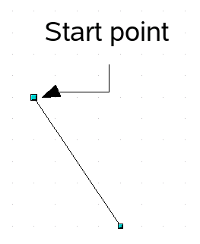Figure 3: Drawing a straight line
Keeping the Ctrl key pressed while drawing a line enables the end of the line to snap to the nearest grid point.
Caution   | The effect of the Ctrl key depends on the settings of the Snap to Grid option on the View->Grid menu:  Snap to Grid on: Ctrl deactivates the snap option for this activity.  Snap to Grid off: Ctrl activates the snap option for this activity.
The spacing (resolution) of the grid points can be adjusted under Tools > Options > OpenOffice.org-Draw > Grid. See also Chapter 8 (Tips and Tricks).
Holding down the Alt key while drawing a line results in the line extending outwards symmetrically from the start point. (The line will extend out equally each side of the starting point). This lets you draw lines by starting from the middle of the line.
The line just drawn has all the standard attributes, such as color and line style. To change any of these line properties, select the line by clicking on it, then right-click and select Line.
While you are working with a line (or other elements), you can look at the information field on the status bar to monitor the activity or status. A description of the current activity or status of the selection is shown when you are working with an element or elements. See Figure 4 for two examples.
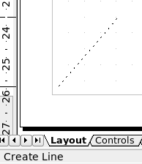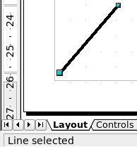Figure 4: The information area in the status bar
Drawing an arrow
Arrows are drawn like lines. Draw classifies arrows as a subgroup of lines: Lines with arrowheads. They are shown in the information field on the status bar only as lines. Click on the Line Ends with Arrow icon to draw an arrow.
Drawing lines and arrows
Click on the small black triangle on the Lines and Arrows icon to open a floating toolbar with ten tools for drawing lines and arrows (Figure 5). Alternatively, you can click directly on the symbol to repeat the last-used command chosen from this toolbar. In both cases, the last-used command will be stored on the toolbar to make it quicker to call it up again.
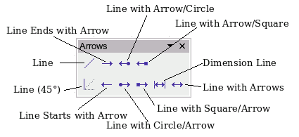Figure 5: Lines and Arrows toolbar
Drawing a rectangle or square
Drawing a rectangle is similar to drawing a straight line, except that you click on the Rectangle icon on the Drawing toolbar, and the (imaginary) line drawn by the mouse corresponds to a diagonal of the rectangle. In addition, you will see the outline of the future rectangle change in shape as you drag the mouse around. The outline is shown as a dashed line until you release the mouse button, when the rectangle is drawn.
Figure 6: Drawing a rectangle
Starting point
Draw considers squares to be rectangles with equal length sides. Hold down the Shift key to draw a square. Hold down the Alt key while dragging with the mouse to create a rectangle with its center (rather than a corner) at the start point.
Drawing ellipses (ovals) and circles
To draw an ellipse (also called an oval) or a circle, click on the Ellipse icon on the main Drawing toolbar. (A circle is simply an ellipse with both axes the same length.) The ellipse drawn is the largest ellipse that fits within the (imaginary) rectangle drawn by the mouse (Figure 7).

Figure 7: Drawing an ellipse
Starting point
There are three ways to draw an ellipse or a circle:
- Holding down the Shift key while dragging with the mouse draws a circle.
- Holding down the Alt key (together with the Shift key) draws a symmetrical ellipse (a circle) with the center point as the starting point.
- Holding down the Ctrl key while dragging with the mouse draws an ellipse or circle that snaps to the nearest grid points.
Note | If you first press and hold the Ctrl key down and then click on one of the icons for Line, Rectangle, Ellipse or Text, a “standard” sized object is drawn automatically in the work area—the size, shape, and color are all standard values. These attributes can be changed later, if desired.
Adding ellipse and arc tools to the Drawing toolbar
In previous versions of Draw, a long-click on the ellipse button opened a new toolbar that contained tools for drawing elliptical and circular arcs. This function is not directly available in Version 2.
If you really need this tool, you can add an Ellipse toolbar to the Drawing toolbar:
- Click on the arrow on the right-hand end of the Drawing toolbar and select Customize Toolbar.
- On the Toolbars page of the Customize dialog, select Drawing in the Toolbar field and click Add.
- In the Add Commands dialog (Figure 8), select Drawing in the Category drop-down menu, select the second Ellipse command in the Commands drop-down menu, and then drag that Ellipse icon from that Commands drop-down menu to the Commands drop-down menu in the Customize dialog. Click Close.
- On the Customize dialog, select the checkbox to enable the new Ellipse command and use the arrow buttons to move it to the desired position on the toolbar.
- If you wish, you can now remove the simple Ellipse icon from the Drawing toolbar by deselecting it.
- Click OK to complete the process.
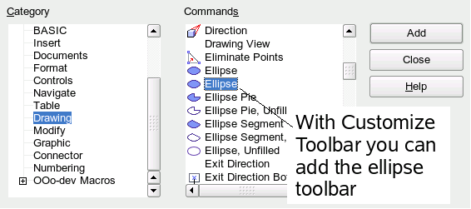Figure 8: Adding the extended Ellipse toolbar
You should now see another Ellipse icon on the Drawing toolbar. If you use this icon instead of the standard Ellipse icon on the Drawing toolbar, all the extended ellipse functions (from Version 1) are available. Clicking on the black arrow by the icon opens the floating Circles and Ovals toolbar (Figure 9).
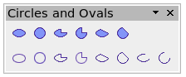Figure 9: Circles and Ovals toolbar
Drawing elliptical and circular arcs
To draw an arc, choose the appropriate Arc symbol. Drag with the mouse to create the circle or ellipse. | 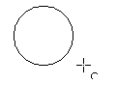
Release the mouse button and move the cursor to the position where you want the arc to start. In the status bar, you can measure the actual angle in degrees. Single-click this point; the circle (or ellipse) disappears and moving the mouse creates the arc. Again, the status bar shows the current angle. | 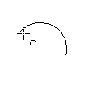
When you have drawn the arc to the length you want, click once more. The drawing of the arc is complete. | 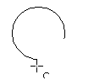
Curves
The tools for drawing curves or polygons are on the toolbar that appears when you click the Curve icon on the Drawing toolbar. This toolbar contains eight tools (Figure 10).
Note | Up to version 2.4 of Draw, hovering the mouse over this icon gives a tooltip of Curve. If you convert the icon to a floating toolbar, however, the title is Lines, as shown in Figure 10. This is rather confusing but is expected to be corrected in a future version.
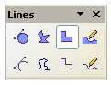

Figure 10: Floating Curves toolbar (incorrectly titled “Lines”)
Freeform Line, Filled
Polygon, Filled
Curve, Filled
Freeform Line
Polygon (45°), Filled
Polygon (45°)
Polygon
Curve
If you move the mouse cursor over one of the icons, a tooltip pops up with a description of the function. For a more detailed description of the handling of Bézier curves (curves and filled curves), see Chapter 10 (Advanced Draw Techniques).
- Polygons: Draw the first line from the start point with the left mouse button held down. As soon as you release the mouse button, a first corner point is drawn, and you can move the mouse to see how the second line will look. Every mouse click sets another corner point. A double-click ends the drawing. A filled polygon automatically joins the last point to the first point to close off the figure and fills it with the current standard fill color. A polygon without filling will not be closed at the end of the drawing.
- Polygon 450: Just as with ordinary polygons, these will be formed from lines but with angles of 45 or 90 degrees between them.
- Freeform Line: With this tool you can draw just like with a pencil. Press and hold the left mouse button and move the mouse. It is not necessary to end the drawing with a double-click. Just release the mouse button and the drawing is completed. If you have selected Freeform Line, Filled, the end point is joined automatically to the start point and the object is filled with the appropriate color.
Gluepoints and connectors (basics)
Gluepoints
All Draw objects have associated invisible gluepoints. Most objects have four gluepoints, as shown in Figure 11.
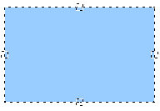Figure 11: Four gluepoints
Note | Gluepoints are not the same as the little blue or green “handles” of an object. The handles are for moving or changing the shape of an object, as described in Chapter 3 (Working with Objects and Object Points), but the gluepoints are used to “glue” a connector to an object.
You can add more gluepoints, and customize gluepoints, using the toolbar of the same name (Figure 12). Gluepoints become visible when you click the Gluepoints icon on the Drawing toolbar and then move the end of a connector over the object. For a more detailed description of the use of gluepoints, see Chapter 9 (Organization Charts, Flow Diagrams, and More).
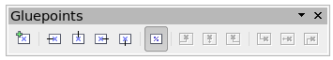Figure 12: Gluepoints toolbar
Connectors
Connectors are lines or arrows whose ends automatically dock to a gluepoint of an object. Connectors are especially useful in drawing organization charts, flow diagrams, and mindmaps. Even when objects are moved or reordered, the connectors remain attached.
Figure 13 shows two Draw objects and a connector.
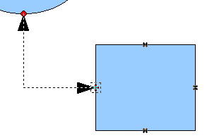Figure 13: A connector between two objects
Draw offers a range of different connectors and connector functions. Open the floating Connectors toolbar by clicking on the Connector icon (Figure 14).
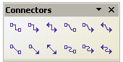

Figure 14: The Connectors toolbar
Line Connector Ends with Arrow
Connector
Connector Ends with Arrow
Connector with Arrows
Line Connector
Straight Connector
Straight Connector Ends with Arrow
Straight Connector with Arrows
Curved Connector with Arrows
Curved Connector
Curved Connector Ends with Arrow
Line Connector with Arrows
For a more detailed description of the use of connectors, see Chapter 9 (Organization Charts, Flow Diagrams, and More).
Drawing geometric shapes
Geometric shapes include:
- Basic shapes
- Symbol shapes
- Block arrows
- Flowcharts
- Callouts
- Stars
Note | Independent of which type of geometric shape you draw or select for editing, the information field in the toolbar shows always only Create Shape or Shape selected.
Figure 15 shows part of the Drawing toolbar with the icons necessary for the following sections. They open floating toolbars with the relevant work tools.
Figure 15: Part of the main Drawing toolbar
Tip | The use of all these tools is similar to that of the Rectangle tool, even though they produce different geometric shapes.
Basic shapes
The Basic Shapes icon 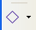 makes available the range of tools for drawing basic shapes (Figure 16).
If you choose the rectangle tool from this toolbar, it looks the same as a rectangle drawn using the Rectangle tool on the Drawing toolbar. The only differences you will see are in the information field in the status bar.
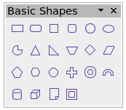Figure 16: Basic shapes toolbar
Symbol shapes
The Symbol Shapes icon brings you to an array of tools for drawing the various symbol shapes (Figure 17).
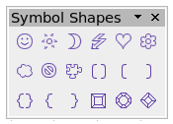Figure 17: Symbol Shapes toolbar
Block arrows
The Block Arrows icon opens the Block Arrows toolbar (Figure 18).
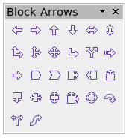Figure 18: Block Arrows
Flowcharts
The tools for drawing flowcharts are accessed by clicking on the Flowcharts icon (Figure 19).
The creation of flowcharts, organization charts, and similar planning tools are described in Chapter 9 (Organization Charts, Flow Diagrams, and More).
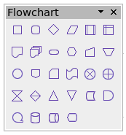Figure 19: Flowchart
Callouts
With the Callouts icon , you can open the Callouts toolbar (Figure 20).
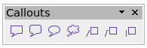Figure 20: Callouts
Note | These new callouts replace the older ones in Version 1. If you still need the older ones, you can add them manually to this or another toolbar.
Stars and banners
These tools are associated with the Stars icon .
You can add text to all these shapes. See “Using text elements in Draw objects” on page 13.
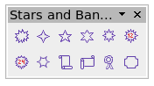Figure 21: Stars and Banners
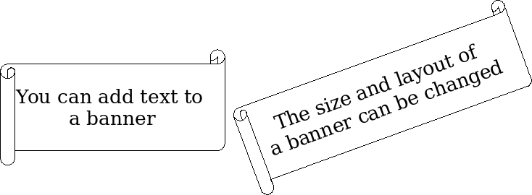
Adding text to objects
Draw offers two ways to add text to a drawing: in a dynamic text frame as an independent Draw object or as text in a previously drawn object. In the latter case, the text is integrated with the object.
Using dynamic text frames
The text tool is activated by clicking on the Text icon for horizontal text or the Vertical Text icon for vertical script (to be able use this latter option, you must activate support for Asian languages under Tools > Options > Language Settings > Languages).
Text frames can be moved and rotated like all draw objects. For more details on text input, see Chapter 10 (Advanced Draw Techniques).
After activating Text command mode, click at the location where you want to position the text. A small text frame appears. It contains only the cursor. You can move the frame, if desired. The Text Formatting toolbar appears (Figure 22), and you can choose the font type, font size, and other text properties and begin to type in your text.
Figure 22: Text Formatting toolbar
The text frame grows with the text. You can insert a line break with the Shift+Enter key combination. The Enter key begins a new paragraph. Neither line breaks nor new paragraphs terminate the text frame.
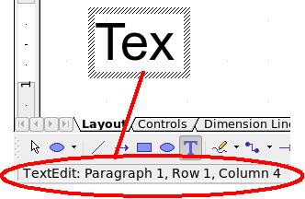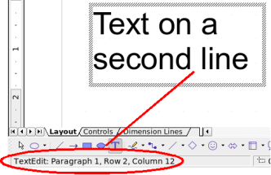
Figure 23: Text input in a dynamic text frame
Observe the information field in the status bar: it shows that you are editing text and also provides details about the current cursor location—paragraph, line, and column numbers.
Text properties can also be changed during text input. Any changes will be reflected from the cursor position onwards (Figure 24).
Figure 24: Changing text properties
Text input – properties changed
After choosing the Text icon, you can also draw a frame with the mouse to contain future text. Line breaks are inserted automatically at the right edge of the frame when the text fills the frame width (Figure 25). You can, however—just like when editing other text—insert your own line breaks, begin new paragraphs, or change any of the text properties.

Figure 25: Text frame
Text input
in a fixed frame – the text wraps automatically
Using text elements in Draw objects
A text element is associated with most Draw objects. By means of these elements, text can be added to an object (see Figure 26).
The exceptions to this are control elements like buttons or list boxes, as well as 3D scenes and their associated elements and groups.
If the Double-click to edit Text icon 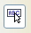 on the Options toolbar is active, you can start editing an object by double-clicking on it (or by pressing F2). In the middle of the Draw object, a black bar indicates the text cursor; start typing to input text. The status bar shows at the lower left “Text Edit” and the position of the cursor within the text.
Text can contain paragraphs, and these can be in the form of bulleted or numbered lists. For a new line without beginning a new paragraph, use (as in text documents) the key combination Shift+Enter. To end the text input, click next to the object or press the Esc key.
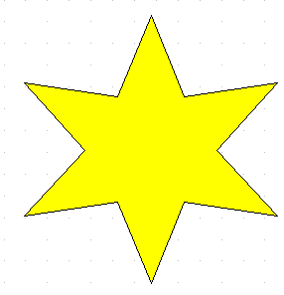 | 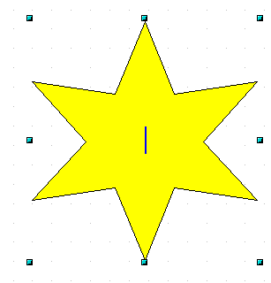 | 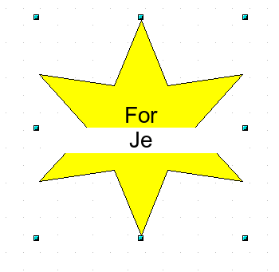 | 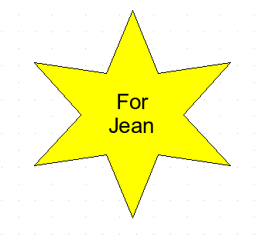
Figure 26: Adding text to objects

